**E-COMMERCE SALES DASHBOARD**

**High Level Design (HLD)**

**Contents**

**1. Introduction**

1.1. Why High Level Design Document?

**2. General Description**

2.1. Product Perspective

2.2. Problem Statement

2.3. Proposed Solution

2.4. TechnicalRequirements

2.5. Data Requirements

2.6. Tools Used

2.7. Constraints

**3. Design Details**

3.1. Process Flow

3.2. Dashboard Features

**4. Performance**

4.1. Re-usability

4.2. Application Compatibility

4.3. Resource Utilization

4.4. User Interface

**5. Conclusion**

**Document Version Control**

|  |  |  |  |
| --- | --- | --- | --- |
| Version | Date | Author | Comments |
| 1.0 | **12-Sep-2024** | **Bhavika Pathak** | **Introduction & Architecture defined** |
|  |  |  |  |
|  |  |  |  |
|  |  |  |  |
|  |  |  |  |

**Abstract**

The **Business Intelligence (BI) E-commerce Sales Dashboard project** is designed to create a comprehensive, data-driven platform that enables businesses to effectively monitor, analyze, and track key performance metrics related to their e-commerce sales operations. As the e-commerce industry continues to grow, the need for tools that can provide clear insights into business performance has become increasingly critical. This project addresses that need by offering a dashboard that integrates various streams of sales data into a centralized location, allowing decision-makers to access real-time information and make informed decisions to optimize business operations.

This **BI dashboard** will focus on a range of key performance indicators (KPIs), such as revenue trends, product performance, customer segmentation, and regional sales distribution. By visualizing these metrics, the dashboard will help business owners and stakeholders easily assess the overall health of their e-commerce activities. The ability to quickly identify trends—both positive and negative—will allow businesses to act swiftly, whether that means capitalizing on emerging opportunities or addressing challenges before they grow into more significant issues.

One of the key components of this project is the **data collection process**, which involves gathering detailed information on a variety of sales-related metrics. This may include data on individual transactions, customer demographics, product categories, and regional sales performance. The data will be sourced from internal systems and e-commerce platforms, typically in the form of CSV files, databases, or other structured formats.

Once the data is collected, it will undergo a rigorous **cleaning and transformation process**. This involves removing any errors, handling missing values, standardizing data formats, and preparing the dataset for analysis. Excel’s **Power Query** feature will be instrumental in this step, allowing for efficient data cleaning and transformation. By ensuring that the data is accurate, consistent, and ready for analysis, the dashboard will provide reliable insights that can be trusted by decision-makers.

Following data preparation, the **visualization phase** of the project will focus on converting raw data into intuitive, easy-to-understand visual representations. Excel’s advanced features, such as **pivot tables, charts, and formulas**, will be utilized to create interactive dashboards that offer users the ability to explore data dynamically. **Pivot tables** will allow users to slice and dice the data across various dimensions (e.g., product categories, time periods, regions), while **charts** will offer clear visual summaries of trends and performance metrics. These visualizations will be customizable and scalable, enabling the dashboard to accommodate the evolving needs of the business.

By leveraging these Excel capabilities, the BI dashboard will serve as a powerful tool for **decision-making**. Stakeholders will be able to track real-time **revenue trends**, monitor which products are performing well, and identify opportunities for optimization in underperforming areas. **Customer segmentation** analysis will provide insights into which demographics are driving the most sales, allowing businesses to tailor their marketing and product development strategies accordingly. Additionally, **regional sales analysis** will enable businesses to identify geographic markets that are performing well or require more attention.

The goal of this project is not just to present data, but to **streamline operations** and enhance business strategy through actionable insights. By providing a comprehensive view of e-commerce performance, the dashboard will enable businesses to make data-driven decisions that can improve profitability, optimize resources, and enhance customer satisfaction.

Furthermore, the dashboard will be designed with **scalability** in mind. As the e-commerce business grows, the dashboard will be capable of handling larger datasets and more complex analyses without compromising performance. This ensures that the tool will remain relevant and useful as the business evolves.

Customization is another key feature of the dashboard, allowing users to tailor reports and visualizations to suit their specific business needs. Whether it's focusing on a particular product category, a specific time frame, or a geographical region, the dashboard will offer flexible reporting options to help businesses focus on what matters most to them.

In conclusion, the **Business Intelligence E-commerce Sales Dashboard project** represents a critical step toward creating a data-driven culture within e-commerce businesses. By providing an intuitive, real-time view of sales performance and key business metrics, the dashboard will empower businesses to make more informed decisions, optimize their operations, and ultimately drive better results. The combination of data collection, cleaning, transformation, and visualization using Excel's advanced features ensures that the dashboard is not only a powerful tool for today but also adaptable for the future needs of the business.

**1. Introduction**

**1.1. Why High-Level Design Document?**

This High-Level Design (HLD) document outlines the architecture and key components of the E-commerce Sales Dashboard project. It serves as a guide for the development and deployment of a Business Intelligence dashboard, detailing the technical requirements, data flow, and design decisions.

**2. General Description**

**2.1. Product Perspective**

The E-commerce Sales Dashboard aims to provide a consolidated view of sales performance metrics, enabling businesses to monitor KPIs such as revenue, sales by category, customer behavior, and regional trends.

**2.2 Problem statement**

E-commerce businesses struggle with fragmented data that hampers timely decision-making. A unified, comprehensive dashboard is needed to integrate sales data, automate reporting, and provide actionable insights to help optimize sales strategies.

**2.3 Proposed Solution**

The proposed solution involves the development of a user-friendly, Excel-based dashboard that integrates sales data and provides visual reports and insights. The solution will allow users to:

* Monitor sales trends
* Analyze product and category performance
* Visualize regional sales distribution
* Track customer behavior and segmentation

**2.4 Technical Requirements**

The technical requirements for the project include:

* Excel as the primary tool for data analysis and visualization.
* The ability to process large datasets without performance issues.
* Integration with existing business systems for data extraction (e.g., CSV exports from e-commerce platforms).
* Implementation of Excel pivot tables, charts, and formulas for data processing.

**2.5 Data Requirements**

The dataset required for the project includes:

* Sales data (order ID, product category, sales amount, date)
* Customer demographics (age, gender, location)
* Product details (category, price, stock)
* Regional sales performance

**2.6 Tools Used**

* **Excel:** for data collection, cleaning, analysis, and visualization.
* **Power Query:** for advanced data transformation and automation.
* **Pivot Tables and Charts:** for summarizing and visualizing data.
* **VLOOKUP, IF, SUMIF:** for formula-based data aggregation.

**2.7 Constraints**

* The dashboard should maintain high performance while handling large datasets.
* The system must be user-friendly for non-technical users to operate without specialized training.
* Data integration must be flexible to handle various e-commerce platforms.

**3. Design Details**

**3.1 Process Flow**

**3.2 Dashboard Features**

The dashboard includes:

* Sales Overview: Total sales, average order value, and revenue trends.
* Product Analysis: Performance by category, top-selling products, and stock levels.
* Customer Insights: Segmentation by location, age, and gender.
* Geographical Insights: Heat maps to visualize sales by region.

**4. Performance**

**4.1 Re-usability**

The dashboard is designed to be reusable and scalable. New data can be easily integrated through automated data refresh mechanisms, and the dashboard can be adapted for different business models.

**4.2 Application Compatibility**

The Excel-based dashboard is compatible across various versions of Microsoft Excel, including cloud-based platforms like Office 365, enabling access on multiple devices.

**4.3 Resource Utilization**

The dashboard efficiently utilizes Excel’s processing power to handle large datasets, using memory optimization techniques and minimizing formula complexity to maintain high performance.

**4.4 User Interface**

The user interface is intuitive and easy to navigate, with interactive charts and pivot tables. The use of slicers and filters allows users to explore data dynamically, drilling down into specific categories, regions, or time periods.

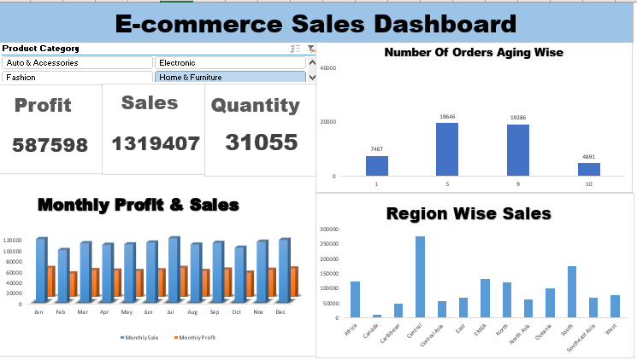

**5.Conclusion**

The **Business Intelligence E-commerce Sales Dashboard** offers a powerful solution for monitoring and analyzing key sales performance metrics. By integrating sales data and providing real-time, actionable insights, the dashboard helps businesses optimize their sales strategy, improve customer targeting, and make data-driven decisions.

The project demonstrates the potential of Excel as a versatile tool for business intelligence, offering scalability, customization, and ease of use for non-technical users. As e-commerce businesses continue to evolve, this dashboard will serve as a valuable tool for tracking sales performance and identifying growth opportunities.