1. Structure Chart

* Draw a structure chart for your game.
* Alternatively, you can sketch out your screens.

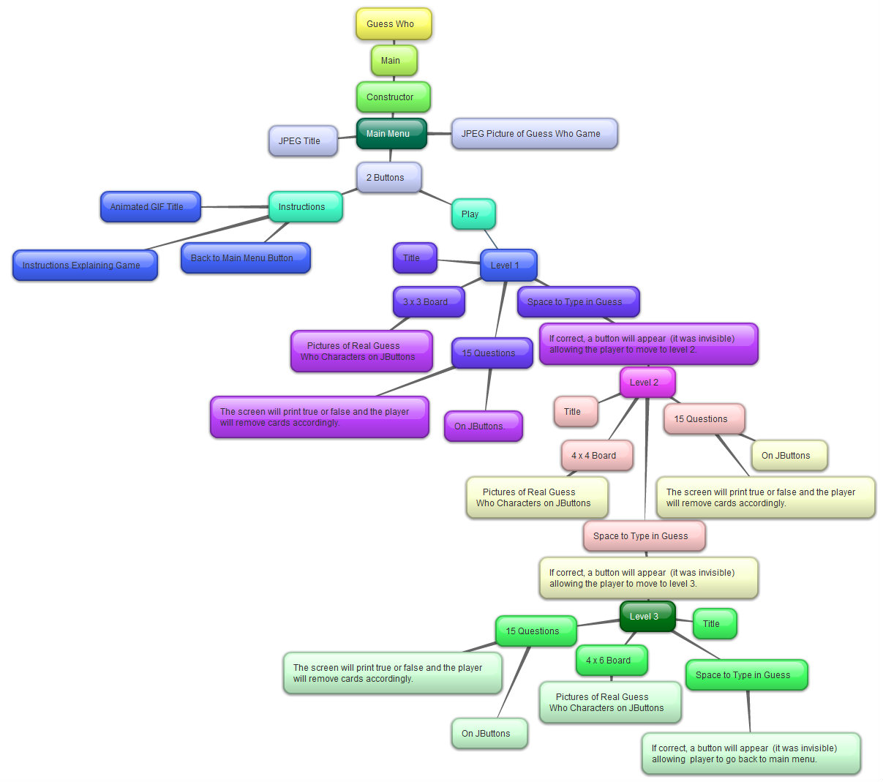

# 2. Brainstorming

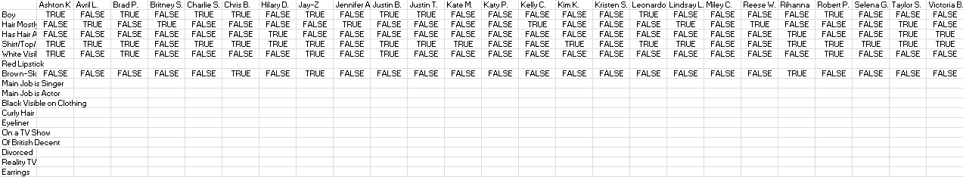

*this is a screen capture of when I began to plan out the game Celebrity Guess Who

(b) Instructions

|  |
| --- |
| 1. A random card will be chosen by the computer. 2. The computer will provide questions that help you figure out who the mystery person is on the computer’s card. The questions will have a “Yes” or “No” / “True” or “False” answer. For instance, your first question could be "Does your mystery person have hair?" 3. Eliminate people with the answers received during each turn. 4. Be sure to narrow your list before asking about a specific mystery person, otherwise, you lose the game. 5. Type in who you believe to be the mystery person. 6. If you are correct, you can move on to the next level.   “How to Play Guess Who”. *eHow.* http://www.ehow.com/how_2054106_play-guess-who.html. (accessed December 9, 2012) |

(c) Pictures

|  |  |  |
| --- | --- | --- |
| *Picture* | *Use* | *Source (Chicago or MLA style)* |
| [Hasbro GUESS WHO?® Game](http://i2-store.walmart.ca/images/WMTCNPE/432/553/432553_Enlarged_1.jpeg) | Introduction Screen Pictures   * The words “Guess Who?” will be used as the title * The picture of the board will be cut out to be used as the main picture | “Hasbro GUESS WHO?® Game.”. *Walmart.* http://www.walmart.ca/en/ip/hasbro-guess-who-game/157352. (accessed December 14, 2012) |
|  | Cards of possible mystery people | “Guess Who? Research...”. *BHardwood.* http://b-harwood1013-dp.blogspot.ca/2011/01/guess-who-research.html. (accessed December 9, 2012) |
| These are the only pictures used as of now but 1 or 2 more may be added in later. | | |

# 3. Design Specifications

|  |  |  |
| --- | --- | --- |
|  | Item client wants included | Is it in the plan? Where?  How well have you included it? |
| 1 | Engaging | * The pictures are from the internet and therefore attractive and are from the original Guess Who game * This is shown in the main menu and in the boards in each level * There is more than one level which is shown branching out of the bubble “Space to Type in Guess” * It is stated that only after the answer is correct can the person move on which is engaging because there is incentive for the player to want to win |
| 2 | Relates to game theory: strategic Decision Making | * The player must eliminate options in order to find the mystery person * The more people they are able to eliminate at once, the quicker they will win the game * This is shown by stating that there are 15 possible questions the player may ask on each screen and according to whether the answer is true or false, the player must eliminate options * The entire game involves asking the best possible questions and the final objective is to *make a decision* about who the mystery person is |
| 3 | Works on a smart board | * The game mainly contains buttons that can be clicked on the smart board * This is shown when it is stated that both the questions and pictures will be on a button * The pictures will also be visible on the smart board * Each screen on the plan contains at least one picture |
| 4 | No errors | * The ideas are planned, hence, no errors and the creation of the concept map * If I stick to the concept map and plan out the specific code before using it, there should be no errors * Error testing is not a part of the coding and therefore is not on the plan |
| 5 | Contains methods | * Different screens will be different methods * Each screen is its own bubble on the concept map e.g. The instructions screen, Level 1, 2 and 3 * The setup (what it will include e.g. title, picture) for each screen is shown therefore, an init method is necessary * The game predominantly contains buttons that will be clicked causing something will happen according to which button is pressed therefore, an actionPerformed ethod is necessary * An example of this would be under Level 1 where it states that there are 15 questions and according to which button is pressed, the computer will print out whether the mystery person has those characteristics * Each screen on the plan contains at least one picture, therefore a createImageIcon method is necessary |
| 6 | Contains arrays | * When it is stated that there are 15 questions on JButtons, this involves a button array * This is also true for the pictures * The true or false statements are also in a 2D array * Therefore, most of the game’s information is declared and initialized in arrays |
| 7 | Efficient | * It is visible on the chart that each of the levels are very similar looking and have similar output * Therefore, loops and if statements can be used |
| 8 | 1-2 players | * When it is stated that the player must click buttons and guess the mystery person, it is implied that it is a one player game |
| 9 | Interesting topic | * The overall effect and purpose of the game, shown throughout the structure chart, makes the game interesting (e.g. the different questions / buttons help the player deduce who the mystery person is) * It is a real game, portrayed by the main menu pictures |
| 10 | Entertaining | * Whether the game is entertaining or not is an overall outcome and is very subjective * As with the idea of it being an interesting topic, this criterion is shown throughout the structure chart * Clicking buttons to find the mystery person and also to receive answers to the questions should be entertaining |
| 11 | Simple, Easy to Use, Intuitive | * The game mainly contains of buttons, which is shown when it is stated that both the questions and pictures will be on a button * There will be a clear set of instructions which is an option on the main menu * It is a real game, portrayed by the main menu pictures, so people may already know how to play |
| 12 | Clear Graphics | * Each screen on the plan contains at least one picture |
| 13 | Comments | * Comments are a part of the code not the structure and so aren’t on the chart * Even so, many bubbles on the chart can be used as the base for comments (e.g. under Level 1 it says there is a 3x3 board – this can be a comment for the method pertaining to Level 1) |