Power BI Customizations Blogs

Blog 1: Beginner’s Guide to Power BI Customizations for Territory-Based Account Analysis

Introduction
Power BI is one of the most popular tools for business intelligence and reporting. But out-of-the-box reports often fall short when it comes to addressing real-world business needs. To truly maximize its potential, Power BI can be customized with advanced features like conditional formatting, multi-page designs, and Row-Level Security (RLS).
In this blog, we’ll walk through a practical example of customizing a Power BI report for territory-based account analysis. Even if you’re a beginner, this guide will help you understand the steps and how you can apply them in your own reports.

Problem Statement
The business needed to analyze accounts by sales territory. The default Power BI report had limitations:
- All territories looked the same on the map, making it difficult to differentiate them.
- Managers had no easy way to drill into account-level details.
- Sensitive account data was visible to everyone, creating compliance risks.
Clearly, a more structured and secure approach was needed.

Solution Approach
- Conditional Formatting for Territory Maps
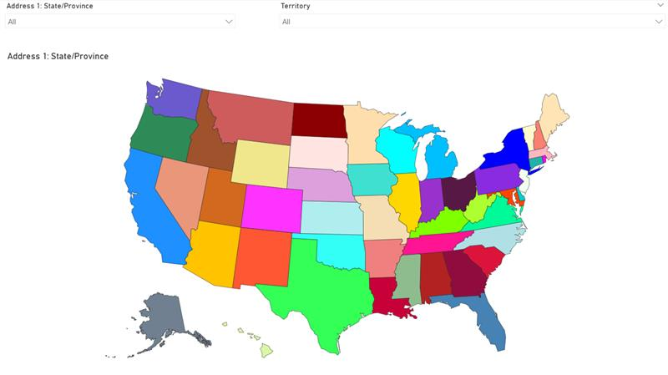

Using DAX, we created a measure to assign each territory a unique color. This helped managers quickly distinguish regions on the map.
2. Multi-Page Report Design
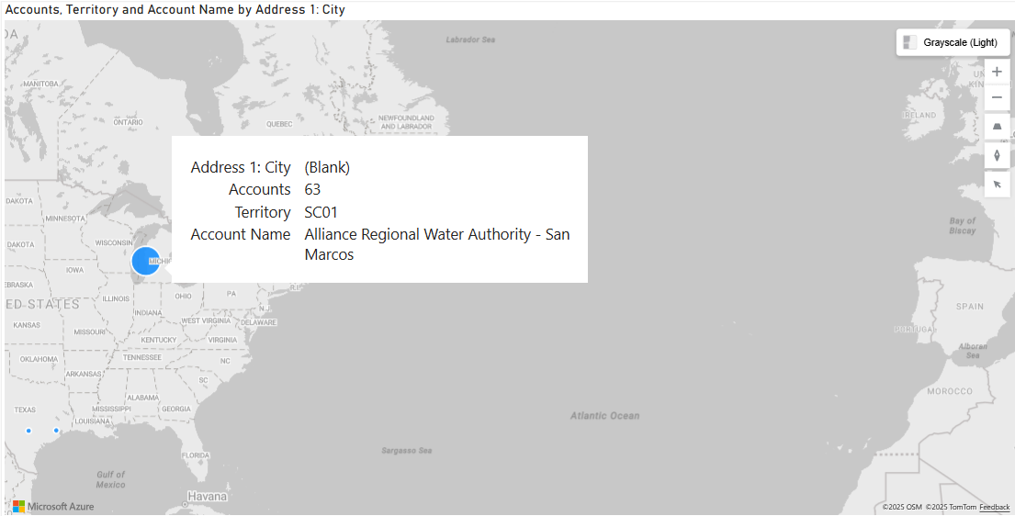
We structured the report across three pages:
- Page 2 – Drill-Through Account Details: Clicking on a territory brings you here to view specific accounts.
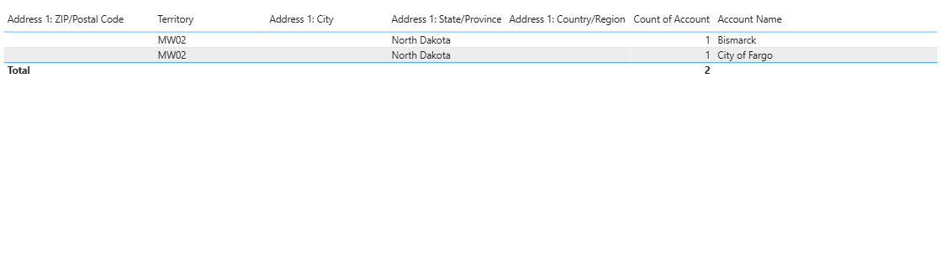
- Page 3 – Tabular Data View: A table version of Page 2 for exporting and validating data.
3. Row-Level Security (RLS)
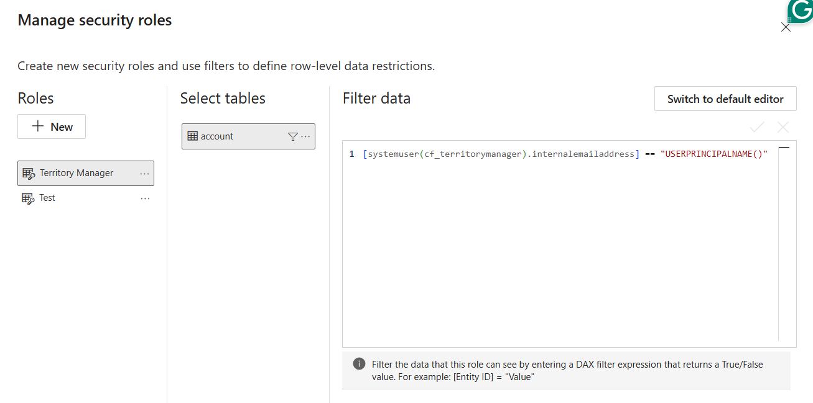

RLS was applied so each Territory Manager only sees data for their assigned region. This not only secures data but also builds trust among users.

Key Learnings
- Beginners can start small: apply conditional formatting to bring clarity to visuals.
- Multi-page design makes reports more user-friendly than cluttering everything on one screen.
- RLS is essential for real-world deployments, ensuring only the right people see the right data.

Conclusion
By customizing Power BI with conditional formatting, multi-page design, and Row-Level Security, even a beginner can create professional-grade reports. These enhancements transform Power BI into a secure, role-based tool that aligns with how businesses actually operate.

Blog 2: Why Clients Need Power BI Customizations for Territory-Based Reporting

Introduction
Data is one of the most valuable assets for modern organizations. But without the right reporting structure, decision-makers struggle to extract meaningful insights. At CloudFronts, we specialize in tailoring Power BI to meet specific client needs.
In this blog, we’ll share how we customized a territory-based account analysis report for a client’s sales team—and why such customizations deliver real business value.

Problem Statement
The client’s leadership team faced three challenges with their existing reports:
1. Lack of clarity: Territories on the map looked identical, creating confusion.
2. No drill-down path: Managers could not move easily from high-level territory views to account-level details.
3. Data security concerns: All managers could see all account data, raising confidentiality issues.
These gaps reduced adoption of the reports and slowed decision-making.

Solution Approach
We delivered a tailored Power BI solution with the following enhancements:
1. High-Impact Visuals with Conditional Formatting
Each territory was assigned a unique color on the map, instantly improving readability.
2. Structured Multi-Page Navigation
- Page 1: Territory Map – for leadership to view performance at a glance.
- Page 2: Drill-Through – for Territory Managers to analyze accounts in detail.
- Page 3: Tabular Data – for operations teams to validate and export account data.
3. Data Security with Row-Level Security (RLS)
Each Territory Manager could only view accounts from their assigned states, ensuring sensitive client data was protected.
4. User Adoption Focus
By mirroring the real workflow of Territory Managers, adoption rates significantly increased.

Key Learnings
- Custom visuals drive clarity: Unique formatting makes reports intuitive.
- Security builds trust: Clients are reassured when their data is properly protected with RLS.
- Role-based design improves efficiency: Reports that align with how teams work reduce training needs and accelerate insights.
- Better adoption leads to ROI: Customized reports quickly become part of daily decision-making, maximizing the value of Power BI investments.

Conclusion
For clients, Power BI customizations are not just a “nice-to-have”—they are a business necessity. By aligning reports with organizational structures, ensuring secure access, and simplifying navigation, businesses gain faster insights, stronger adoption, and higher ROI from their BI investments.
At CloudFronts, we help organizations achieve exactly this—transforming Power BI into a tailored decision-making platform that drives measurable business outcomes.

