# Activity: Encrypt

**Description:** This activity is used to encrypt given string.

**Input:** Text (Input string to encrypt)

**Output:** Result (Encrypted string)

**Example:**

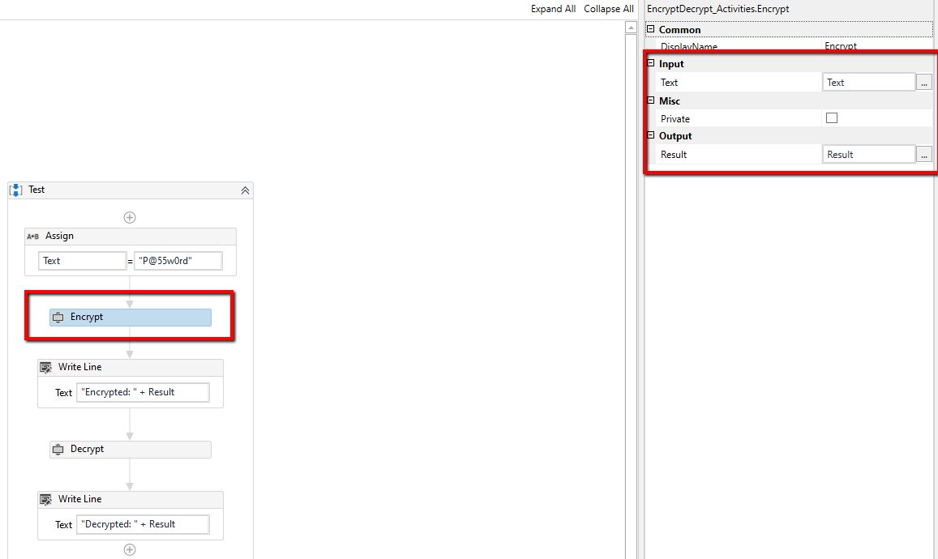

# Activity: Decrypt

**Description:** This activity is used to decrypt given encrypted string.

**Input:** Text (Input string to decrypt)

**Output:** Result (Decrypted string)

**Example:**

