# Activity: Get Worldwide Summary

**Description:** This activity will help to get total number of cases, deaths and recovered information worldwide.

**Input:** No input require.  
**Output:** As highlighted in below image.

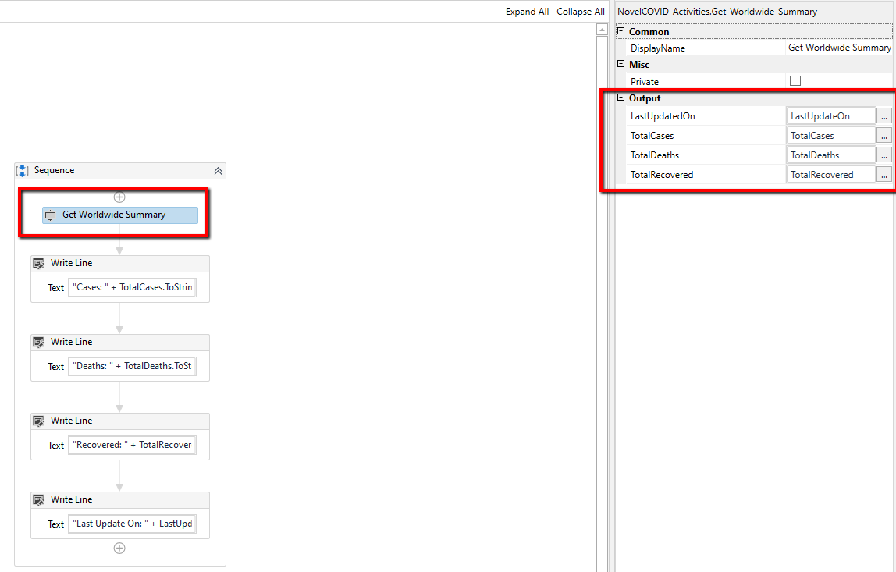

# Activity: Get Country Specific Statistics

**Description:** This activity will help to get country specific CIVID-19 information.

**Input:** Require name of the country for which you want to get information.  
**Output:** As highlighted in below image.

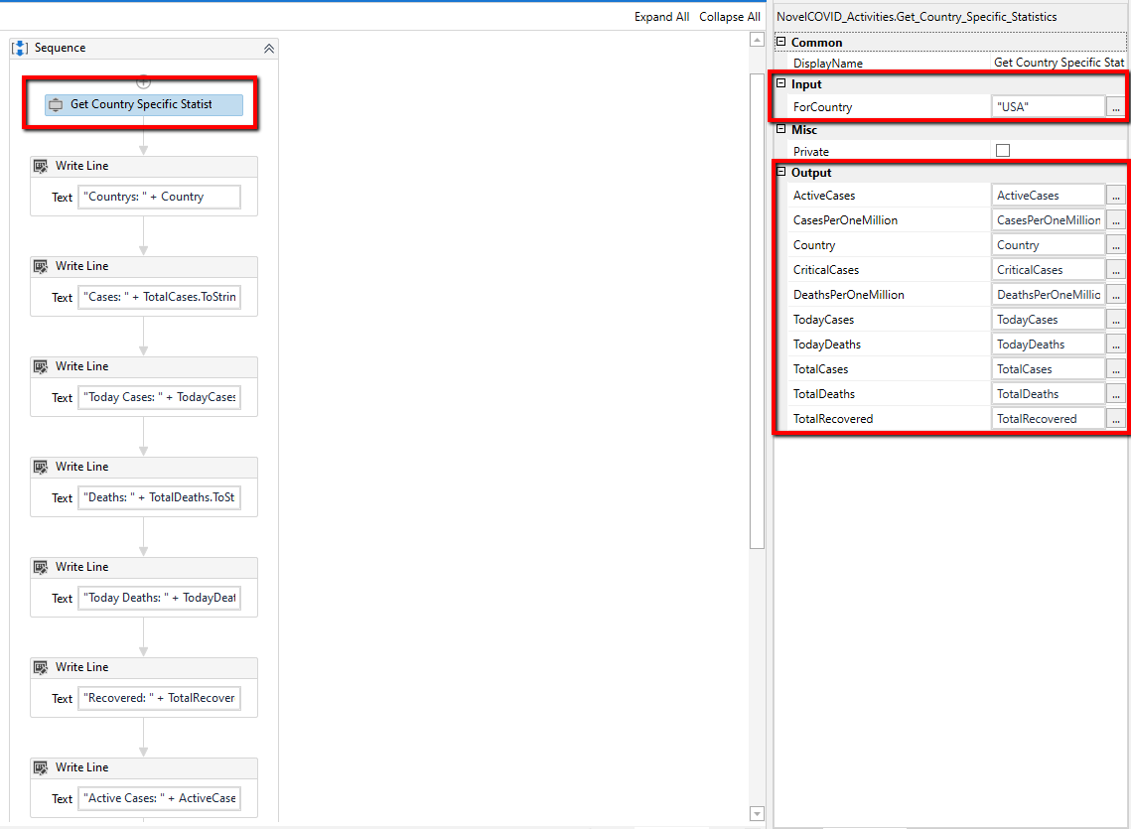

# Activity: Get Worldwide Statistics

**Description:** This activity will return COVID-19 information for each effected countries.

**Input:** None

**Output:** It will return data in JsonArray format

# Activity: Get Country Specific Historical Data

**Description:** This activity will return country specific historical information about COVID-19.

**Input:** ForCountry (country name for which historical data is required)

**Output:** It will return data in JsonObject format

# Activity: Get Worldwide Historical Data

**Description:** This activity will return historical information worldwide about COVID-19.

**Input:** None

**Output:** It will return data in JsonArray format