# **Using String.Contains**

This activity expects 2 input parameters and 1 output parameters. All are mendatory.

**Input Parameter:**

1. Text (String): This is input string
2. Value (String): The string to seek. (Case sensitive)

**Output Parameter:**

1. Result (Boolean): Returns true if the **Value** parameter occurs within this string, or if **Value** is the empty.

**Example:**

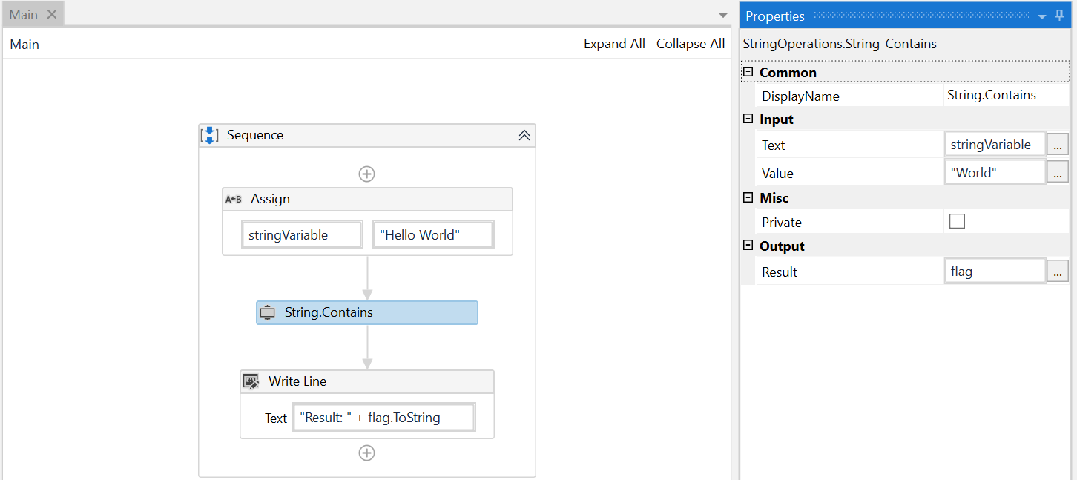

# **Using String.Equals**

This activity expects 3 input parameters and 1 output parameters.

**Input Parameter:**

1. Text (String): This is input string
2. ValueToCompare (String): The string to compare to this instance.
3. IgnoreCase (Boolean): System will ignore case, if it is set to True.

**Output Parameter:**

1. Result (Boolean): Returns true if its value is the same as this instance; otherwise, false.

**Example:**

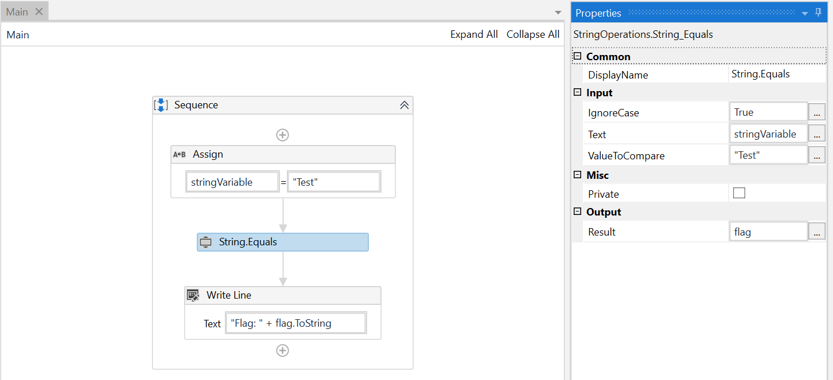

# **Using String.Replace**

This activity expects 3 input parameters and 1 output parameters. All are mendatory.

**Input Parameter:**

1. Text (String): This is input string
2. OldValue (String): The string to be replaced.
3. NewValue (String): The string to replace all occurrences of OldValue.

**Output Parameter:**

1. Result (String): Returns a string that is equivalent to this instance except that all instances of OldValue are replaced with NewValue. If OldValue is not found in the current instance, the method returns the current instance unchanged.

**Example:**

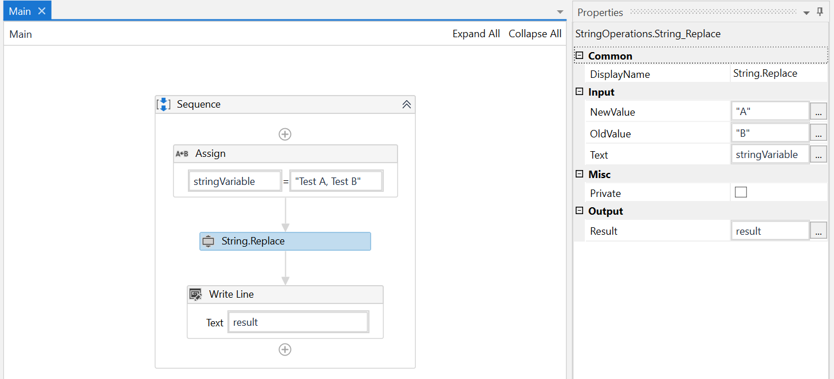

# **Using String.Split**

This activity expects 3 input parameters and 1 output parameters.

**Input Parameter:**

1. Text (String): This is input string
2. Separator (String): A string that delimits the substrings in this string, an empty array that contains no delimiters, or null.
3. RemoveEmptyEntries (Boolean): Set RemoveEmptyEntries to True to omit empty array elements from the array returned; or False to include empty array elements in the array returned.

**Output Parameter:**

1. Result (String): Returns an array whose elements contain the substrings in this string that are delimited by one or more characters in separator.

**Example:**

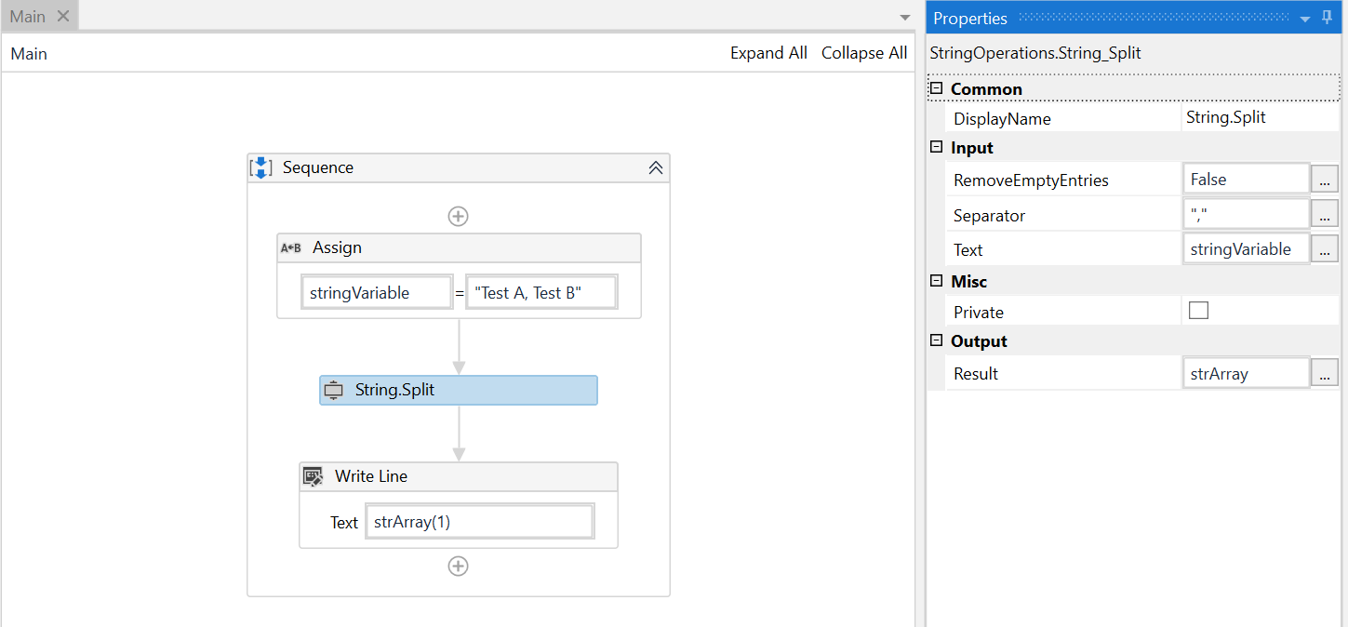

# **Using String.Substring**

This activity expects 3 input parameters and 1 output parameters.

**Input Parameter:**

1. Text (String): This is input string
2. StartIndex (Integer): The zero-based starting character position of a substring in this instance.
3. Length (Integer): The number of characters in the substring.

**Output Parameter:**

1. Result (String): Returns a string that is equivalent to the substring of length length that begins at startIndex in this instance, or System.String.Empty if startIndex is equal to the length of this instance and length is zero.

**Example:**

