AIM
To write a Python program to solve the 8-Puzzle problem using Breadth-First Search (BFS) and find the sequence of moves from the initial state to the goal state.

ALGORITHM
- Start the program.
- Represent the 8-puzzle as a list/tuple of 9 elements, where 0 represents the blank space.
- Read the initial state and goal state from the user.
- Create a queue and insert the initial state into it.
- Maintain a visited set to avoid processing the same state repeatedly.
- Remove the first state from the queue.
- Check whether the current state is equal to the goal state.
- If the goal state is reached, display the sequence of moves.
- Otherwise, find all possible movements of the blank space:
  - Up
  - Down
  - Left
  - Right
- Generate the new states and add unvisited states to the queue.
- Repeat steps 6–10 until the goal state is reached or the queue becomes empty.
- Stop the program.

PROGRAM
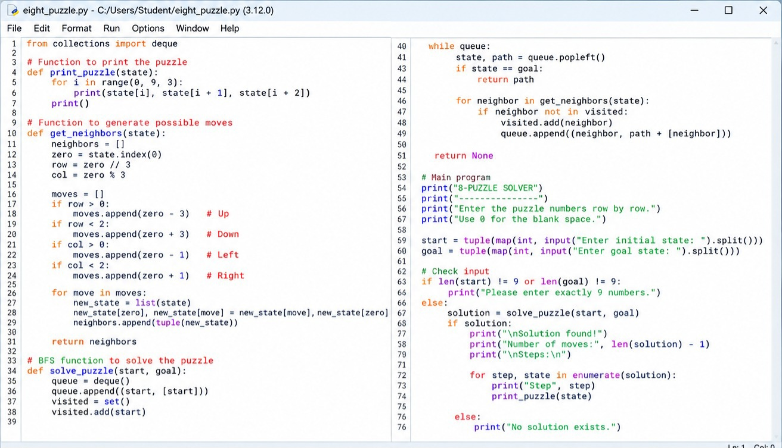
OUTPUT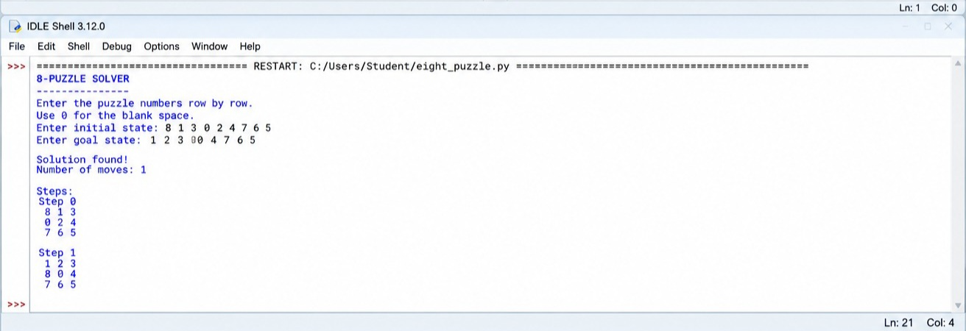

RESULT
The 8-Puzzle problem was successfully solved using the Breadth-First Search (BFS) algorithm in Python, and the sequence of moves from the initial state to the goal state was obtained.

