Experiment-5
Write a python program for Missionaries Cannibal problem
Aim
To write and execute a Python program to solve the Missionaries and Cannibals Problem using Breadth-First Search (BFS) while ensuring that the missionaries are never outnumbered by cannibals.
Algorithm
- Start with 3 missionaries and 3 cannibals on the left bank.
- Place the boat on the left bank.
- Represent each state as (missionaries, cannibals, boat position).
- Check whether each state is valid:
  - Missionaries must not be outnumbered by cannibals on either bank.
  - The number of missionaries and cannibals must be within valid limits.
- Use a queue to perform Breadth-First Search (BFS).
- The boat can carry one or two people.
- Generate all possible valid states by moving the boat between the two banks.
- Store visited states to avoid repeating states.
- Continue until all missionaries and cannibals reach the right bank.
- Display the sequence of states as the solution.

PROGRAM
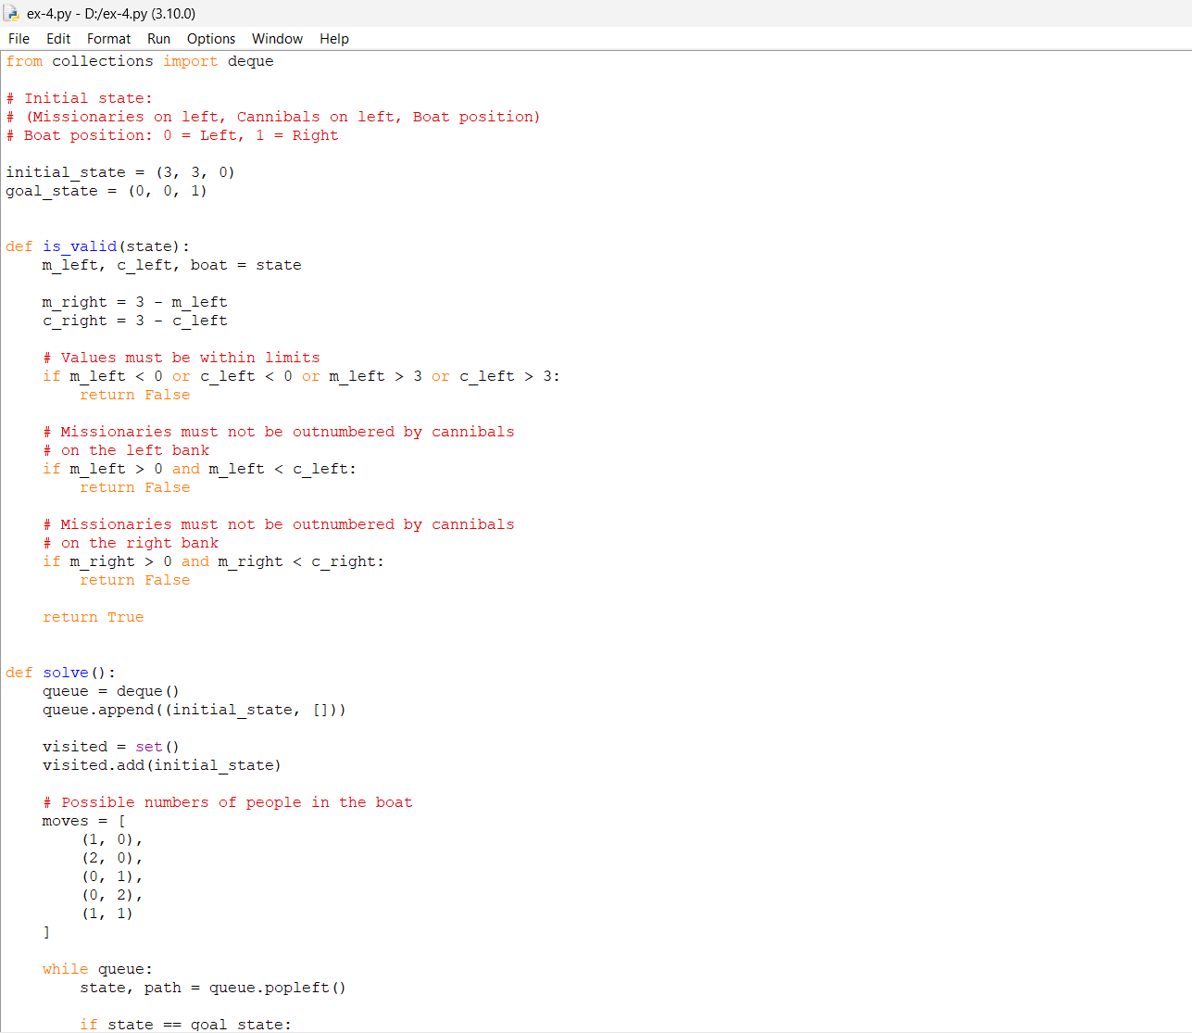
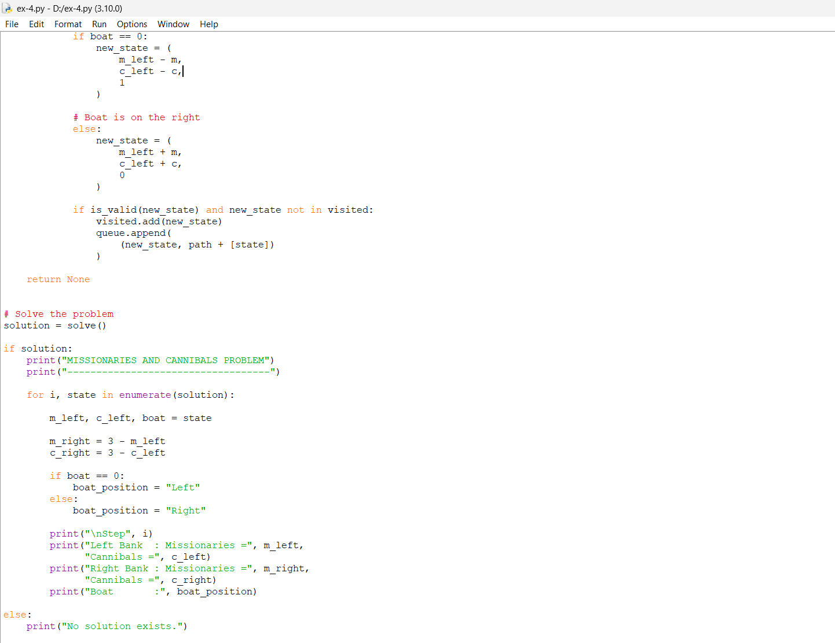
Output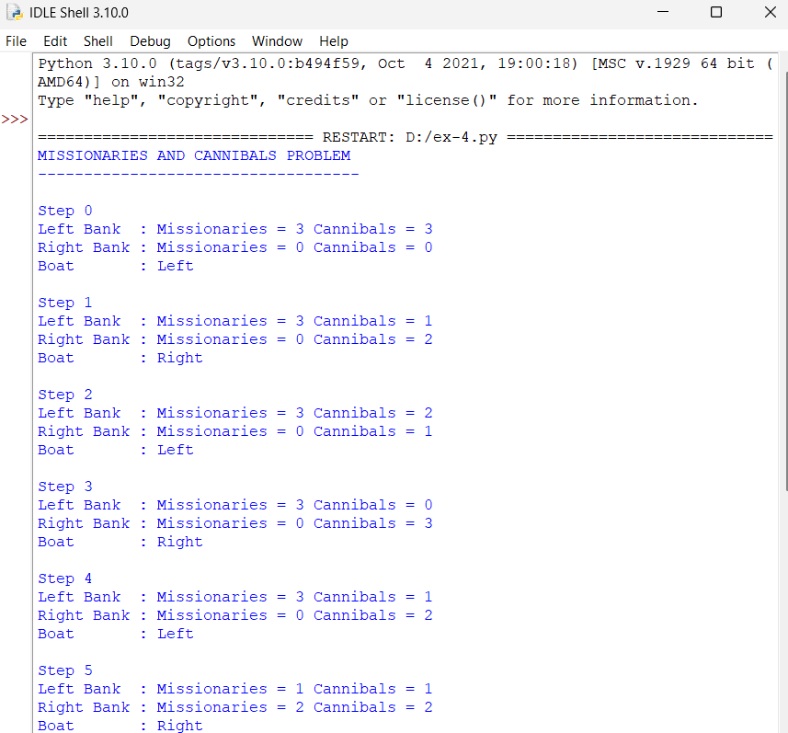

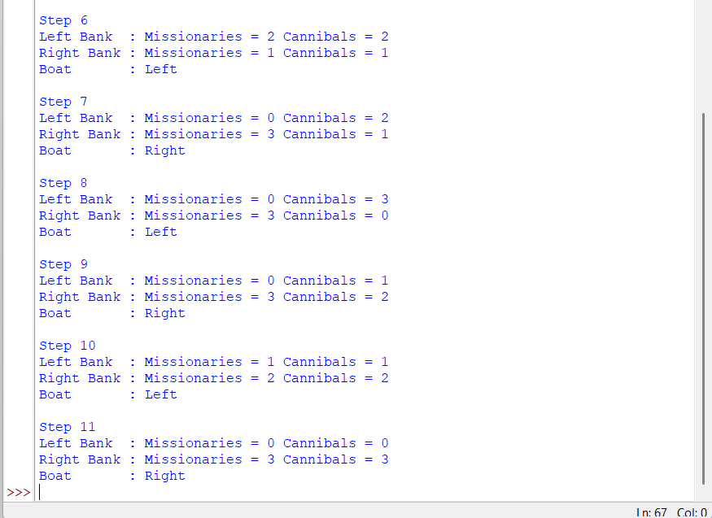

RESULT
The Missionaries and Cannibals Problem was successfully solved using the BFS algorithm . The program finds a valid sequence of boat movements that transfers all 3 missionaries and 3 cannibals safely to the opposite bank.

