Experiment-4
Write a python program for Cript-Arithemetic problem
Aim
To write and execute a Python program to solve a Crypt-Arithmetic problem using permutation and constraint checking, where each letter represents a unique digit.
Algorithm
- Start with the Crypt-Arithmetic equation SEND + MORE = MONEY.
- Identify all unique letters in the equation.
- Assign a different digit from 0 to 9 to each letter.
- Ensure that the first letters S and M are not zero.
- Generate possible digit combinations using permutations.
- Convert the letters into their corresponding numerical values.
- Check whether SEND + MORE = MONEY.
- If the equation is satisfied, display the digit assigned to each letter.
- Display the resulting numerical equation.
- If no combination satisfies the equation, display No solution exists.
Coding
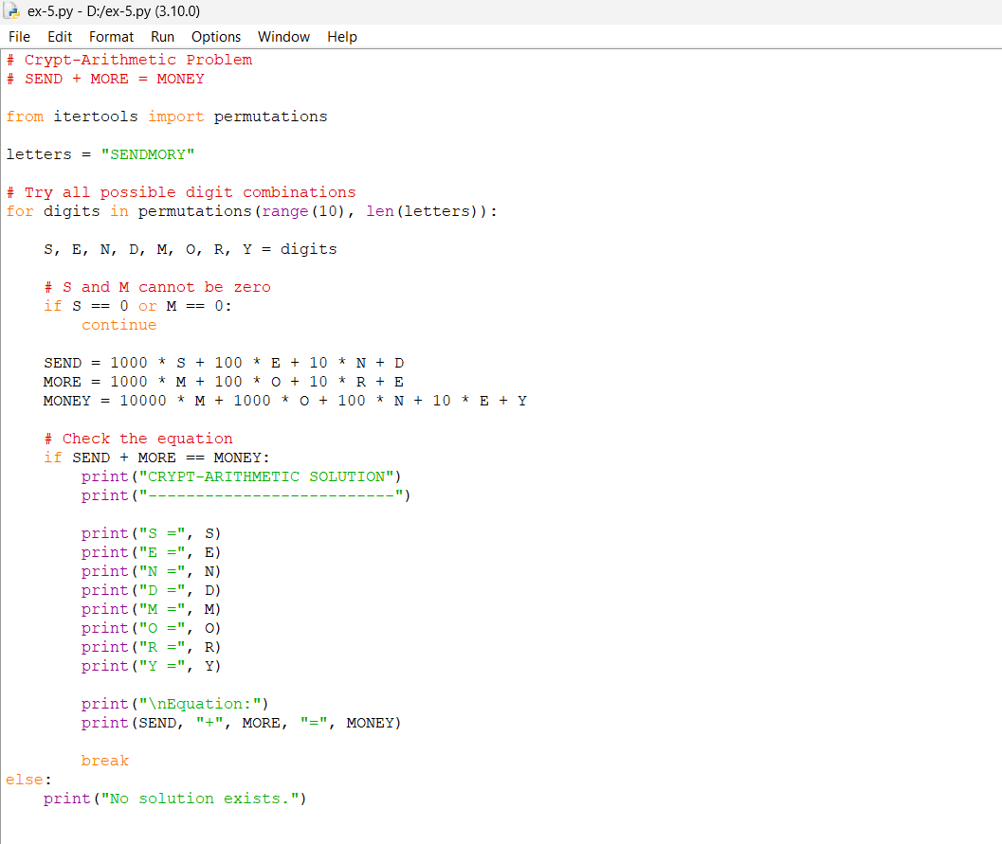
Output
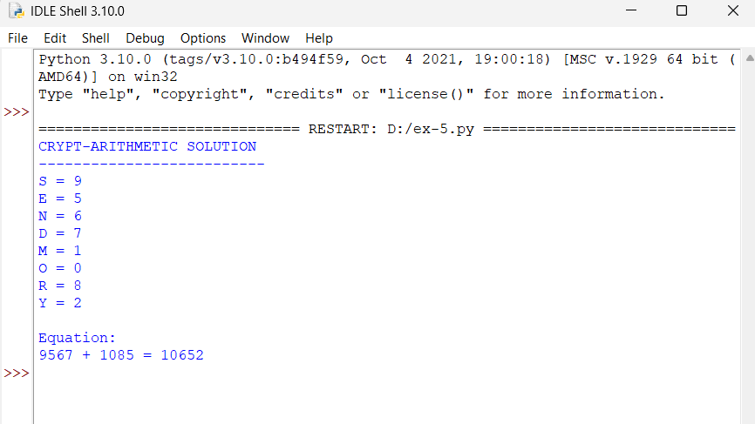

Result
The Crypt-Arithmetic problem was successfully solved using Python 3.10. The program finds a valid digit assignment:
9567 + 1085 = 10652
Thus, the given Crypt-Arithmetic equation is successfully solved.

