Experiment-6
Write A Python Program For Vacuum Cleaner Problem
Aim
To write and execute a Python program to solve the Vacuum Cleaner Problem using a rule-based approach to clean all dirty rooms.
Algorithm
- Start the program.
- Initialize two rooms, A and B, as dirty.
- Place the vacuum cleaner in Room A.
- Check the current room's condition.
- If the room is dirty, clean it and update its status to clean.
- Move the vacuum cleaner to the other room.
- Repeat the cleaning process until both rooms are clean.
- Display the final status of both rooms.
- Stop the program.
Code
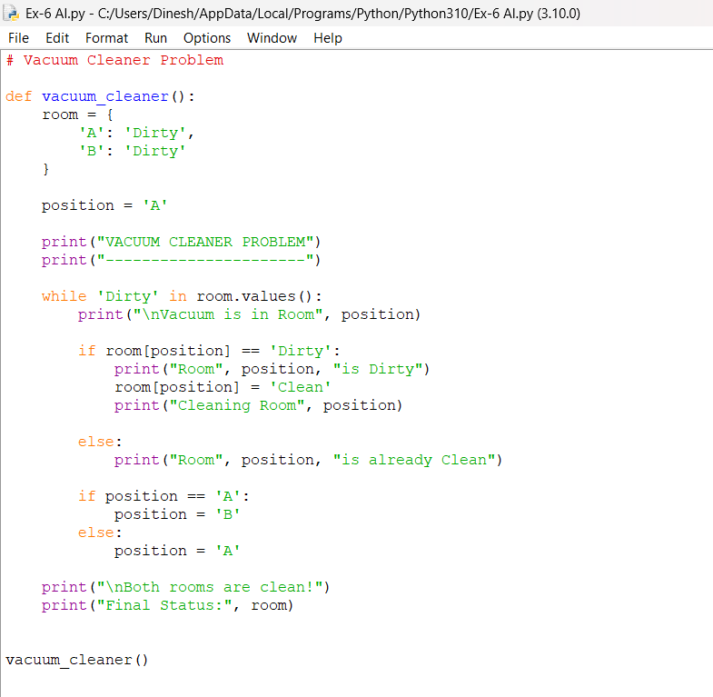
Output
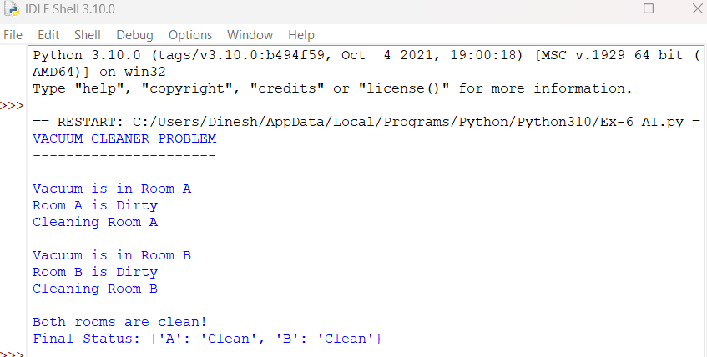
Result
The Vacuum Cleaner Problem was successfully implemented using Python 3.10. The program cleans both Room A and Room B and displays their final status as clean.

