Experiment-3
Write a python program for Water Jug problem
Aim
To write and execute a Python program to solve the Water Jug Problem using Breadth-First Search (BFS) and obtain the required amount of water through a sequence of valid operations.
Algorithm
- Start with two empty jugs of capacities 4 litres and 3 litres.
- Represent the state as (Jug1, Jug2).
- Set the initial state as (0, 0).
- Define the goal as obtaining 2 litres in either jug.
- Use a queue to store possible states.
- Perform the following operations:
  - Fill Jug 1.
  - Fill Jug 2.
  - Empty Jug 1.
  - Empty Jug 2.
  - Pour Jug 1 into Jug 2.
  - Pour Jug 2 into Jug 1.
- Store visited states to avoid repeating the same state.
- Continue generating new states using BFS.
- Stop when a state containing 2 litres is reached.
- Display the sequence of states and the solution.

Coding
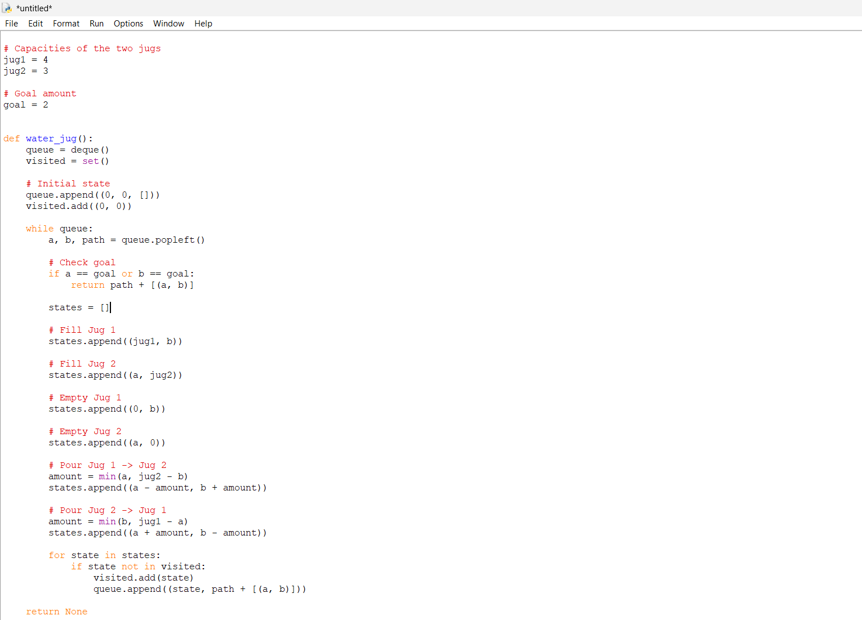
Ouput
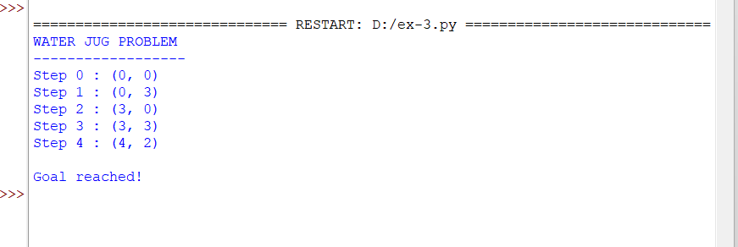
ResultThe Water Jug Problem was successfully solved using the Breadth-First Search (BFS) algorithm. The program finds a sequence of operations to obtain 2 litres of water using 4-litre and 3-litre jugs.

