Module Name: TEST PLAN & RTM
Test Case ID: st_02
Tester Name: Dumraliya Bhavin (Enrollment No: 2504030100273)
Webpage URL: https://www.automationexercise.com/

TC 001:- login page display
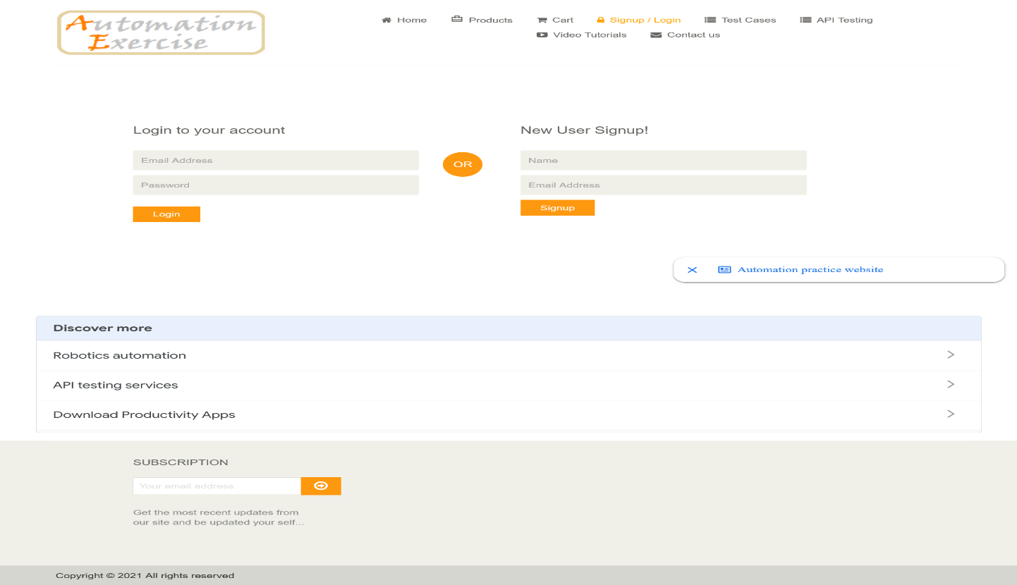
TC 002:- Enter login information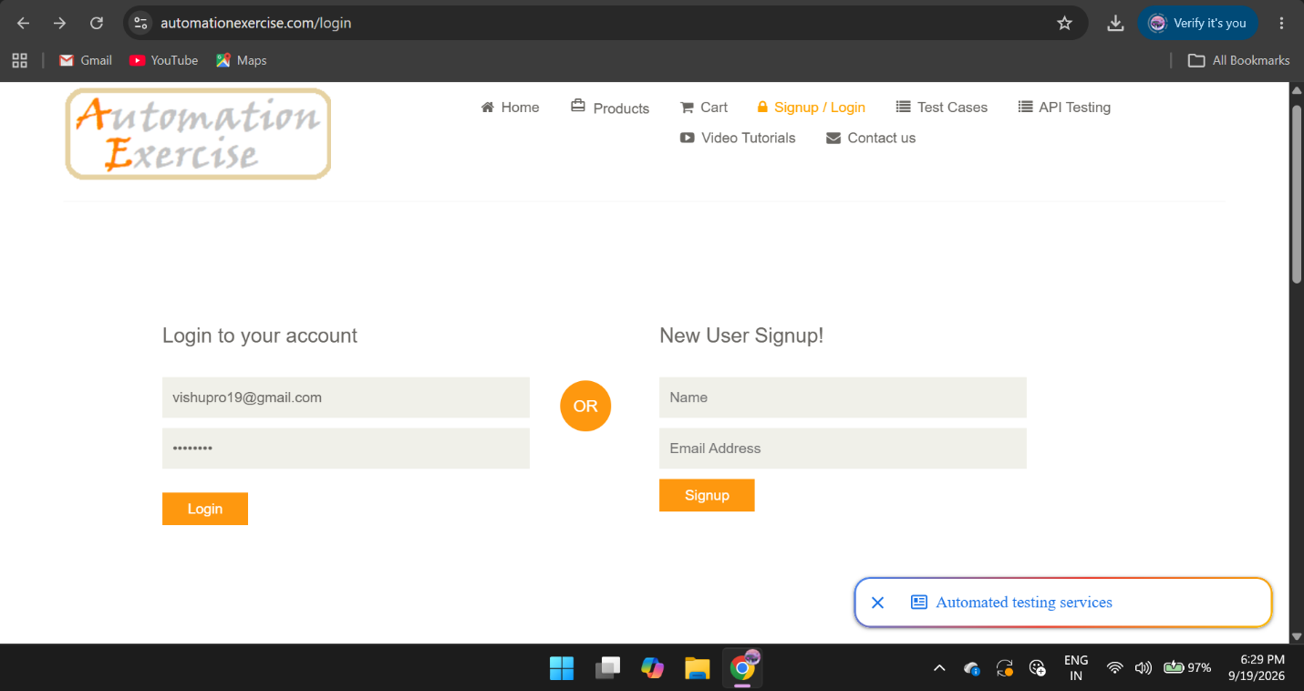
TC 003:-wrong password
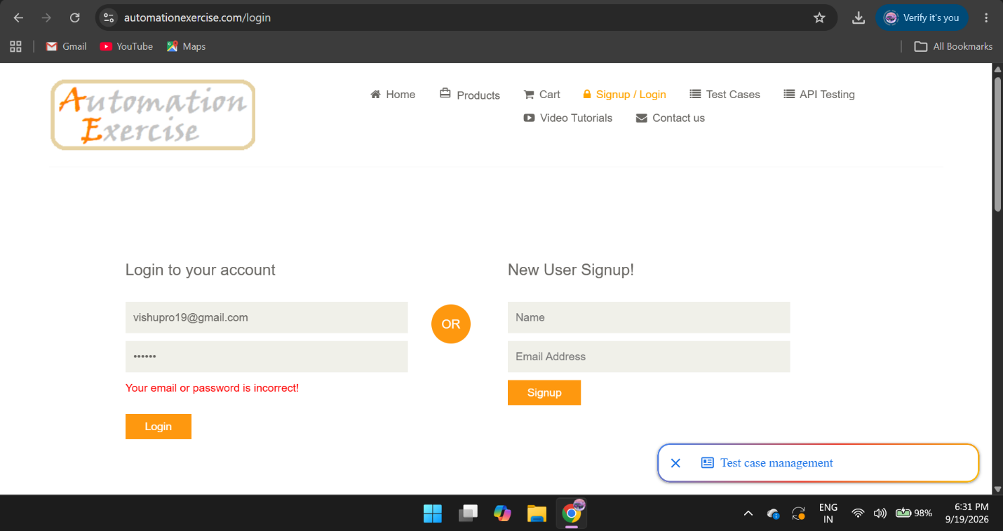
TC 004:-login successful / homepage displayed