Module Name: Requirement reviews & Inspections
Test Case ID: st_03
Tester Name: Dumraliya Bhavin (Enrollment No: 2504030100273)
Webpage URL: https://www.demoblaze.com/

TC 001:-view products
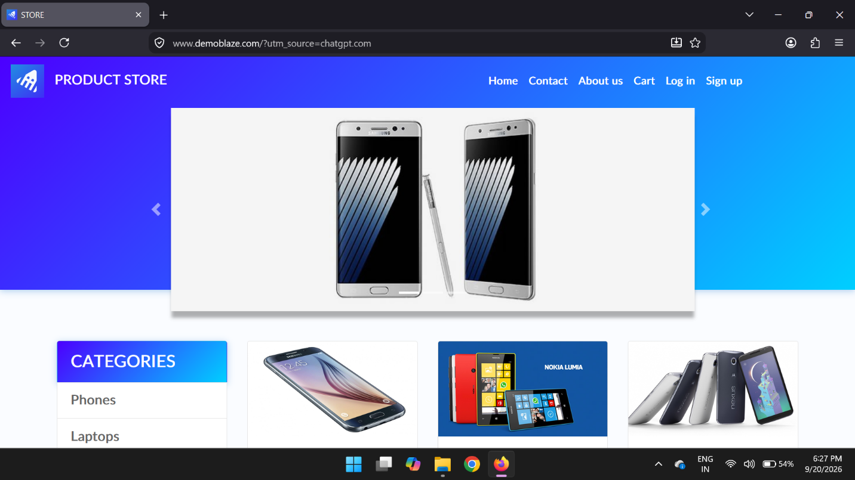
TC 002:-select product/ view details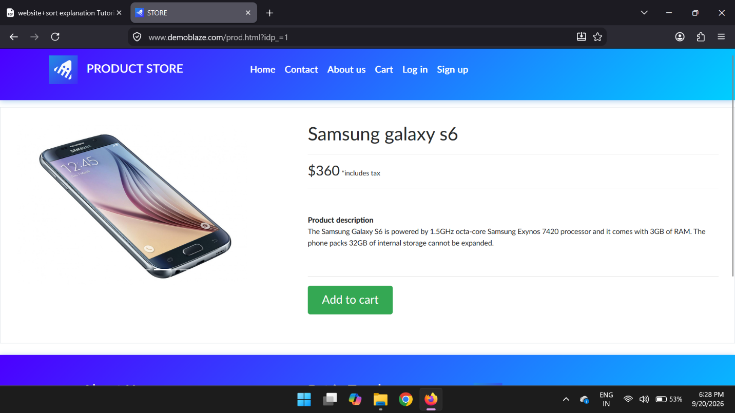

TC 003:-Add product
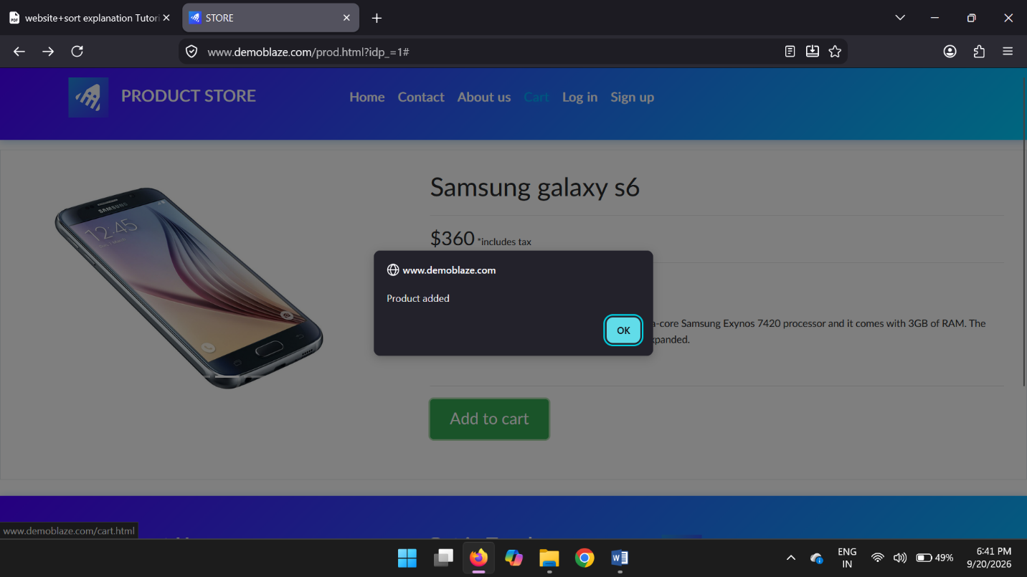
TC 004:-open cart/ verify product in cart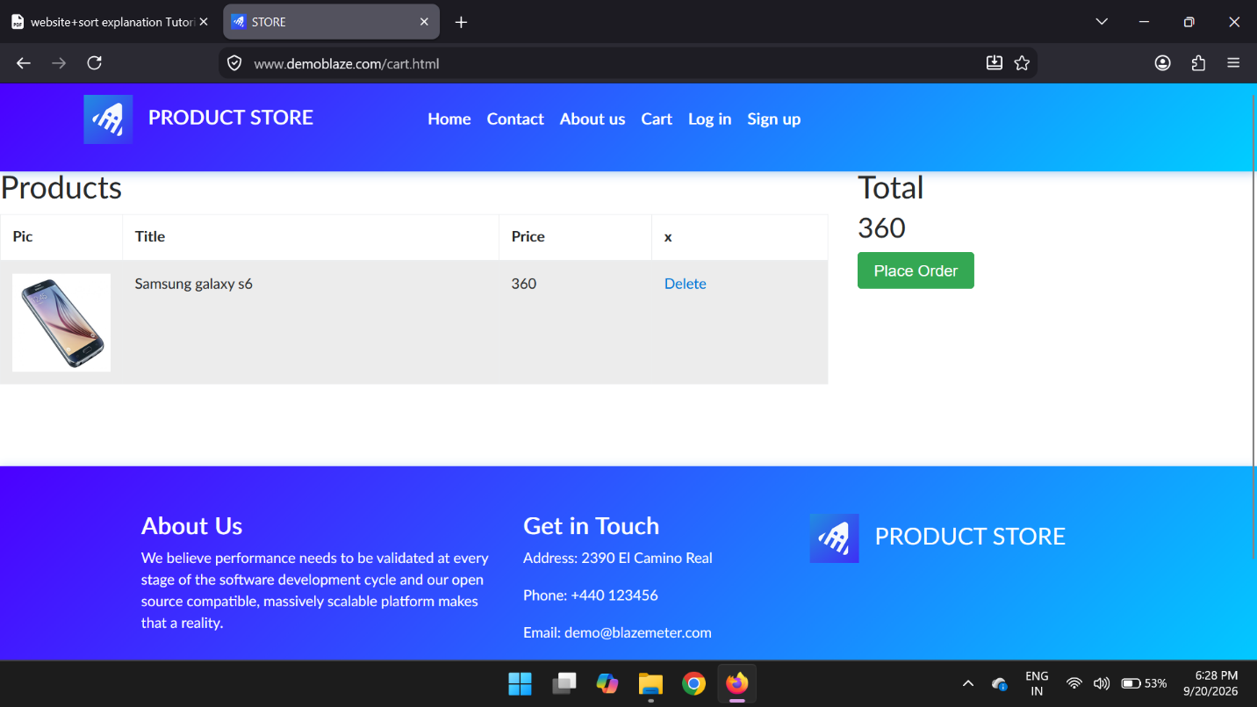
TC 005:-remove item from cart
