Module Name: Functional & Non-Functional Testing
Test Case ID: st_04
Tester Name: Dumraliya Bhavin (Enrollment No: 2504030100273)
Webpage URL: https://www.automationexercise.com/
TC 001:-Login page
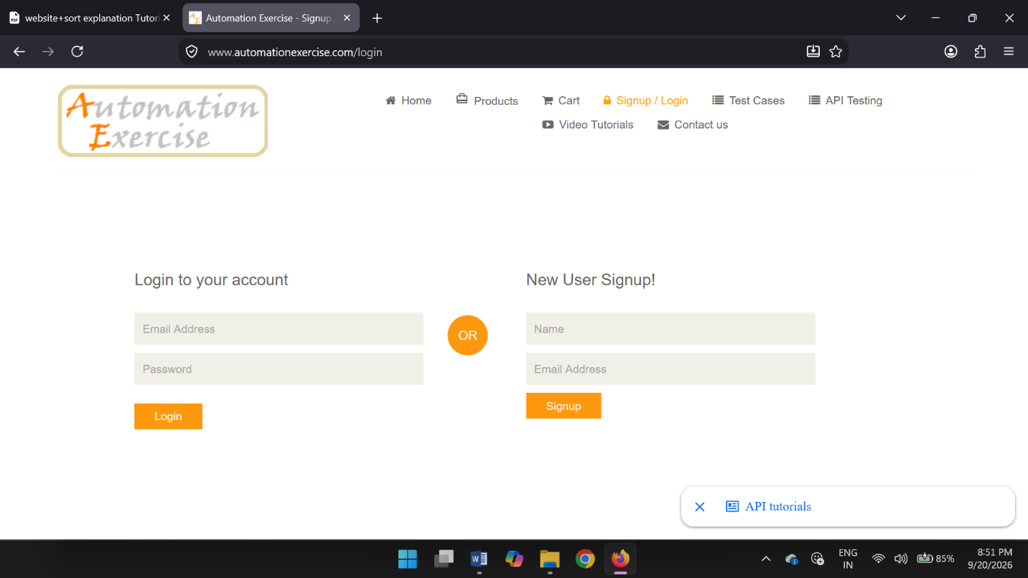
TC 002:-Invalid Email & Password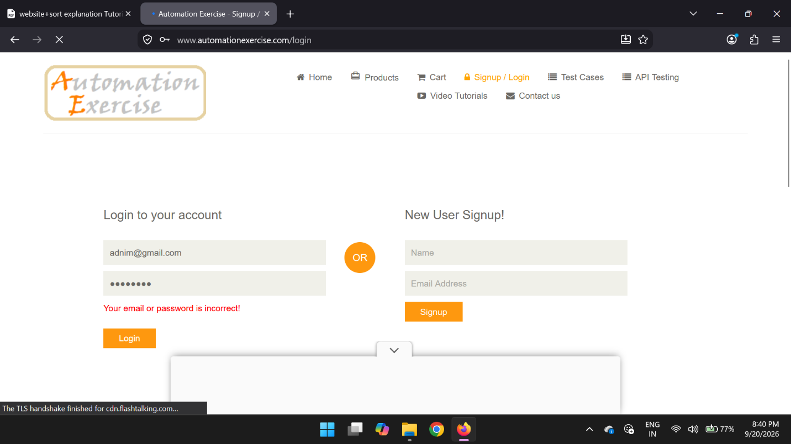

TC 003:-Blank Email
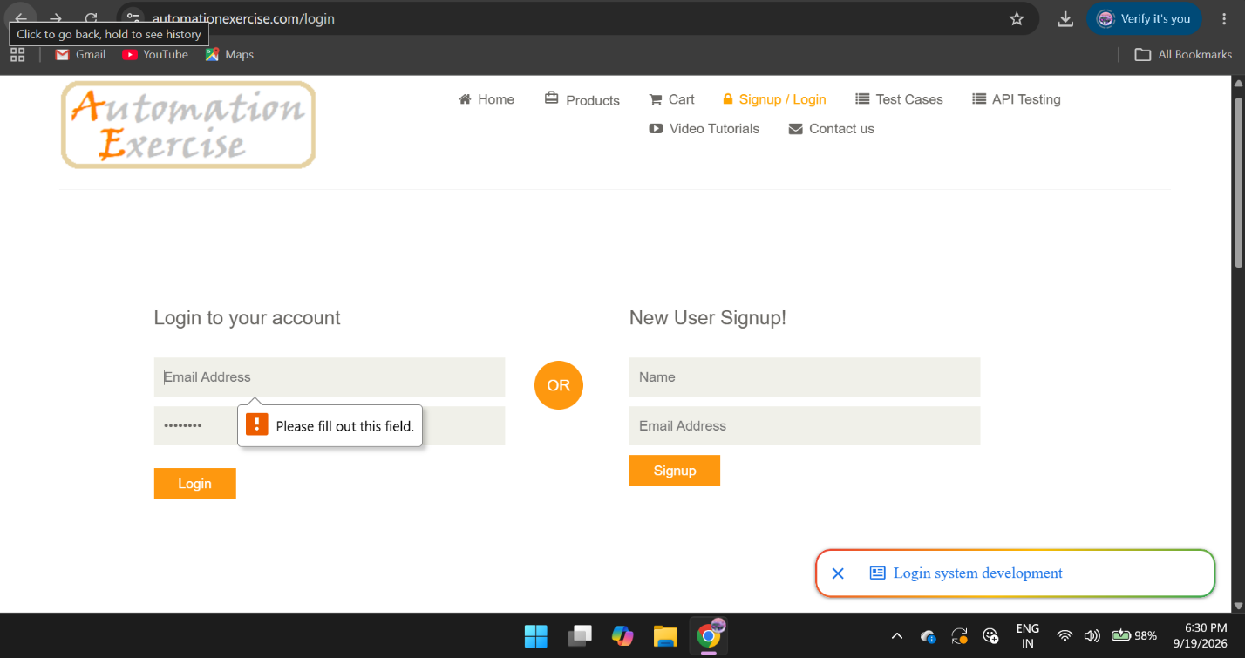
TC 004:-Blank Password
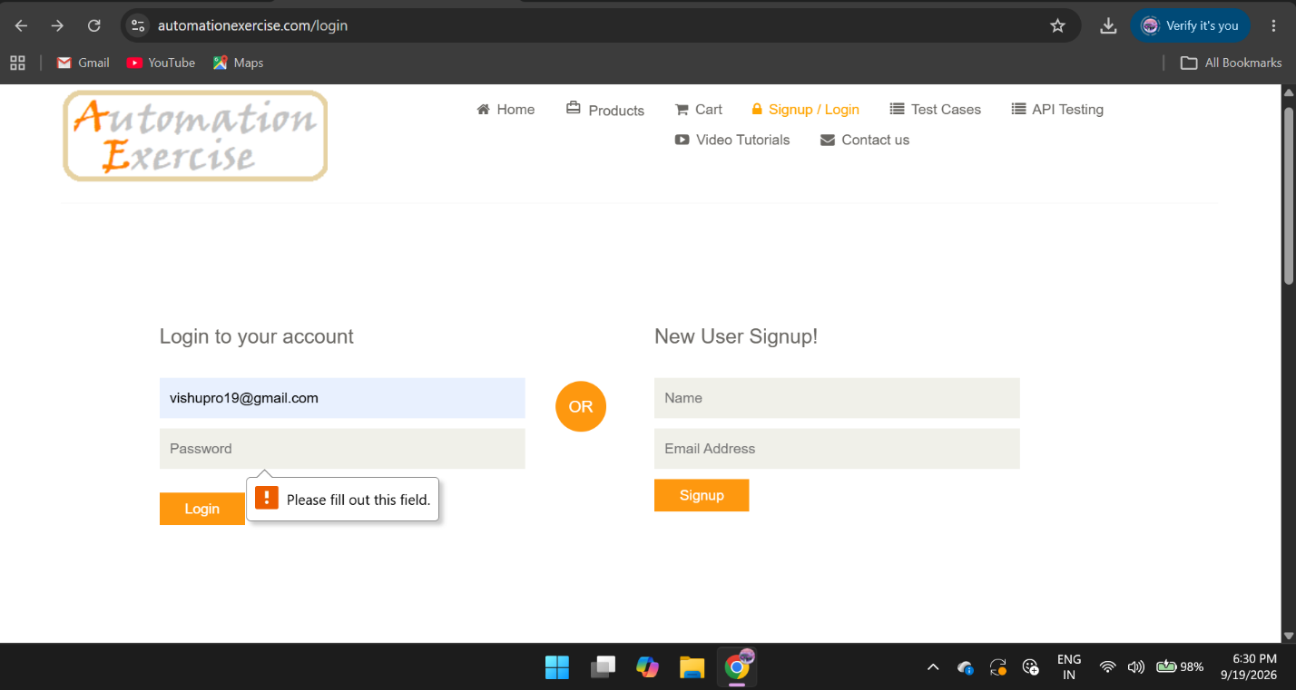

TC 005:-Both blank 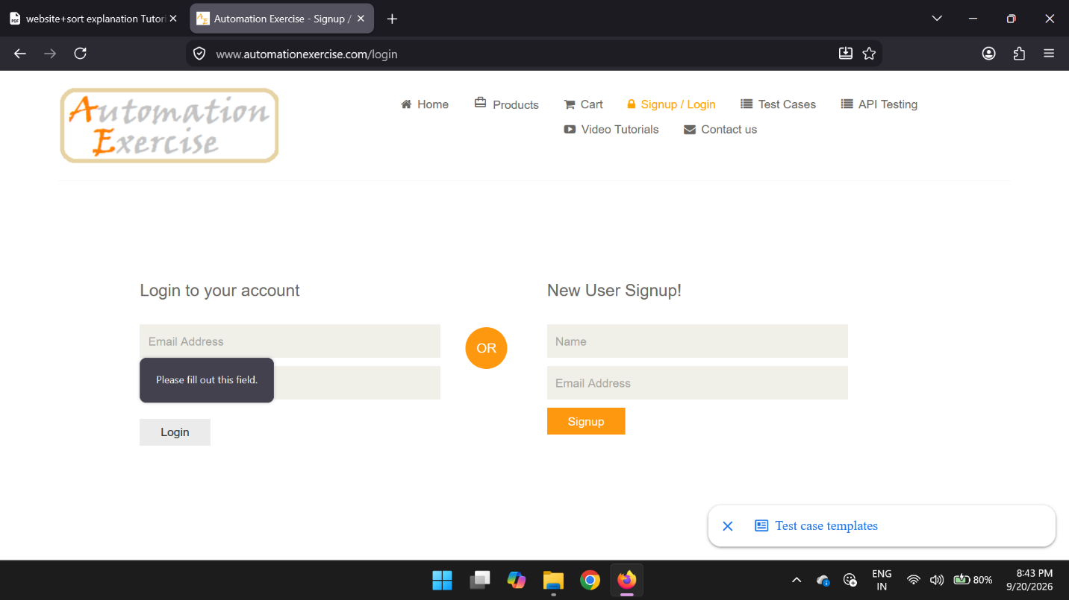
TC 006:-Homepage displayed
