Module Name: Selenium Automation
Test Case ID: st_11
Tester Name: Dumraliya Bhavin (Enrollment No: 2504030100273)
Webpage URL: https://www.automationexercise.com/

Reusable Python code
from selenium import webdriver
from selenium.webdriver.common.by import By
from selenium.webdriver.common.keys import Keys
from selenium.webdriver.support.ui import WebDriverWait
from selenium.webdriver.support import expected_conditions as EC

# Replace with the assigned exercise website URL.
BASE_URL = "https://YOUR-WEBSITE-URL-HERE"

# Update these selectors to match the assigned website.
PRODUCTS_LINK = (By.LINK_TEXT, "Products")
SEARCH_BOX = (By.CSS_SELECTOR, "input[type='search']")
PRODUCT_LINK = (By.XPATH, "//a[contains(., 'YOUR PRODUCT NAME')]")
ADD_TO_CART_BUTTON = (By.XPATH, "//button[contains(., 'Add to cart')]")
CART_LINK = (By.LINK_TEXT, "Cart")

driver = webdriver.Chrome()
wait = WebDriverWait(driver, 10)

try:
# TC-01: Open website
driver.get(BASE_URL)
wait.until(EC.presence_of_element_located((By.TAG_NAME, "body")))
print("TC-01 PASS: Website opened")

# TC-02: Open Products page
wait.until(EC.element_to_be_clickable(PRODUCTS_LINK)).click()
print("TC-02 PASS: Products page opened")

# TC-03: Search for a product
search = wait.until(EC.visibility_of_element_located(SEARCH_BOX))
search.clear()
search.send_keys("YOUR PRODUCT NAME")
search.send_keys(Keys.ENTER)
print("TC-03 PASS: Product search submitted")

# TC-04: Select a product from results
wait.until(EC.element_to_be_clickable(PRODUCT_LINK)).click()
print("TC-04 PASS: Product selected")

# TC-05: Add product to cart
wait.until(EC.element_to_be_clickable(ADD_TO_CART_BUTTON)).click()
print("TC-05 PASS: Add-to-cart button clicked")

# TC-06: Open cart
wait.until(EC.element_to_be_clickable(CART_LINK)).click()
wait.until(EC.presence_of_element_located((By.TAG_NAME, "body")))
print("TC-06 PASS: Cart page opened")

finally:
# Keep the browser open until you have captured the execution screenshot.
input("Press Enter to close the browser...")
driver.quit()

Test Case Details
TC-001: Open website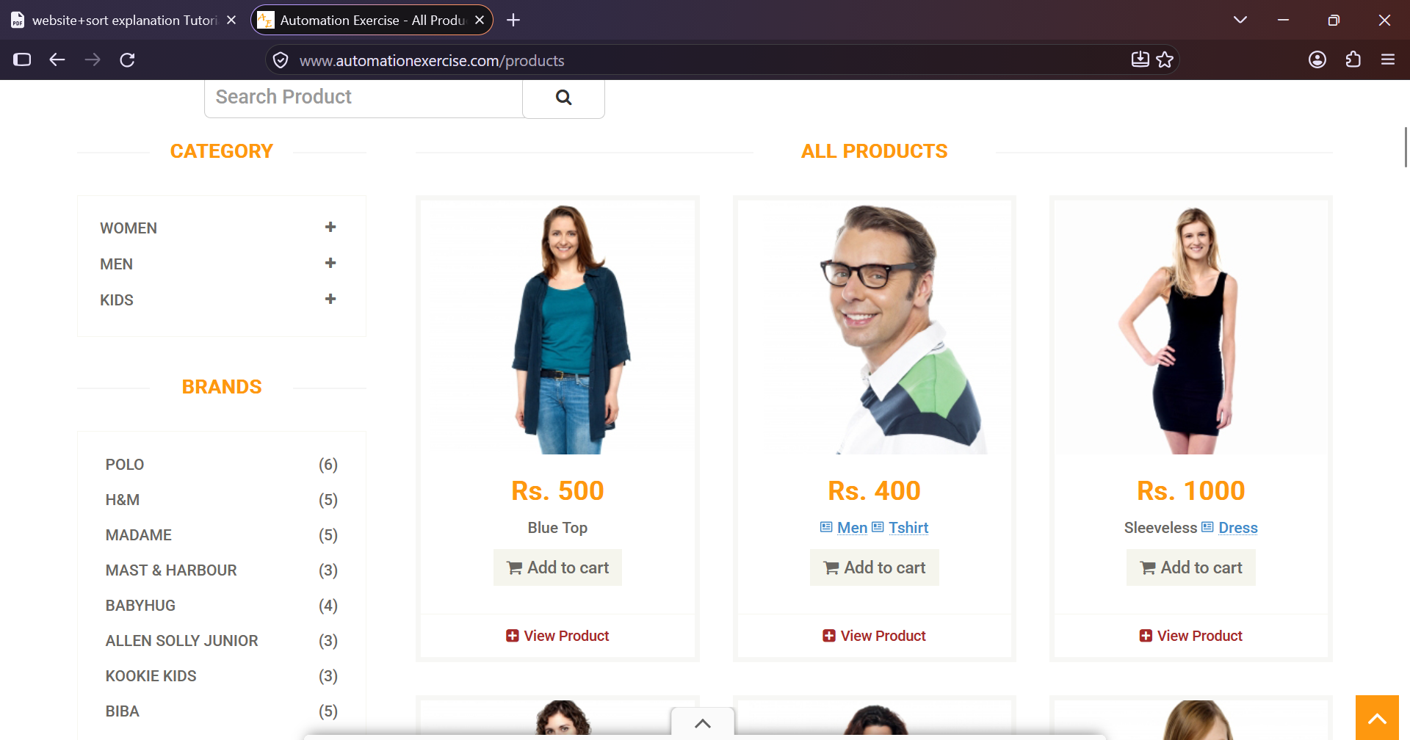
TC-02: Products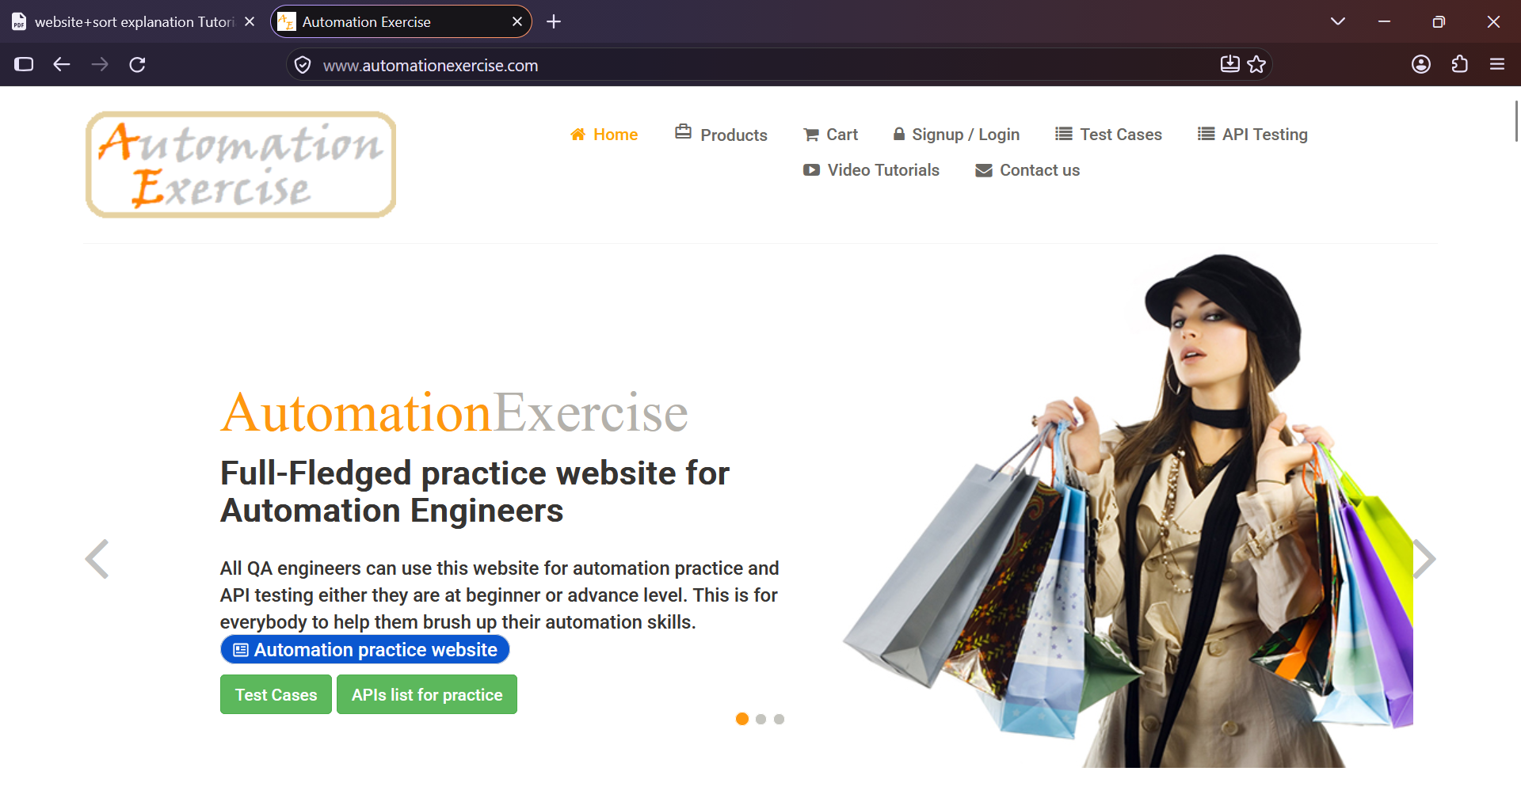
TC-03: Search product 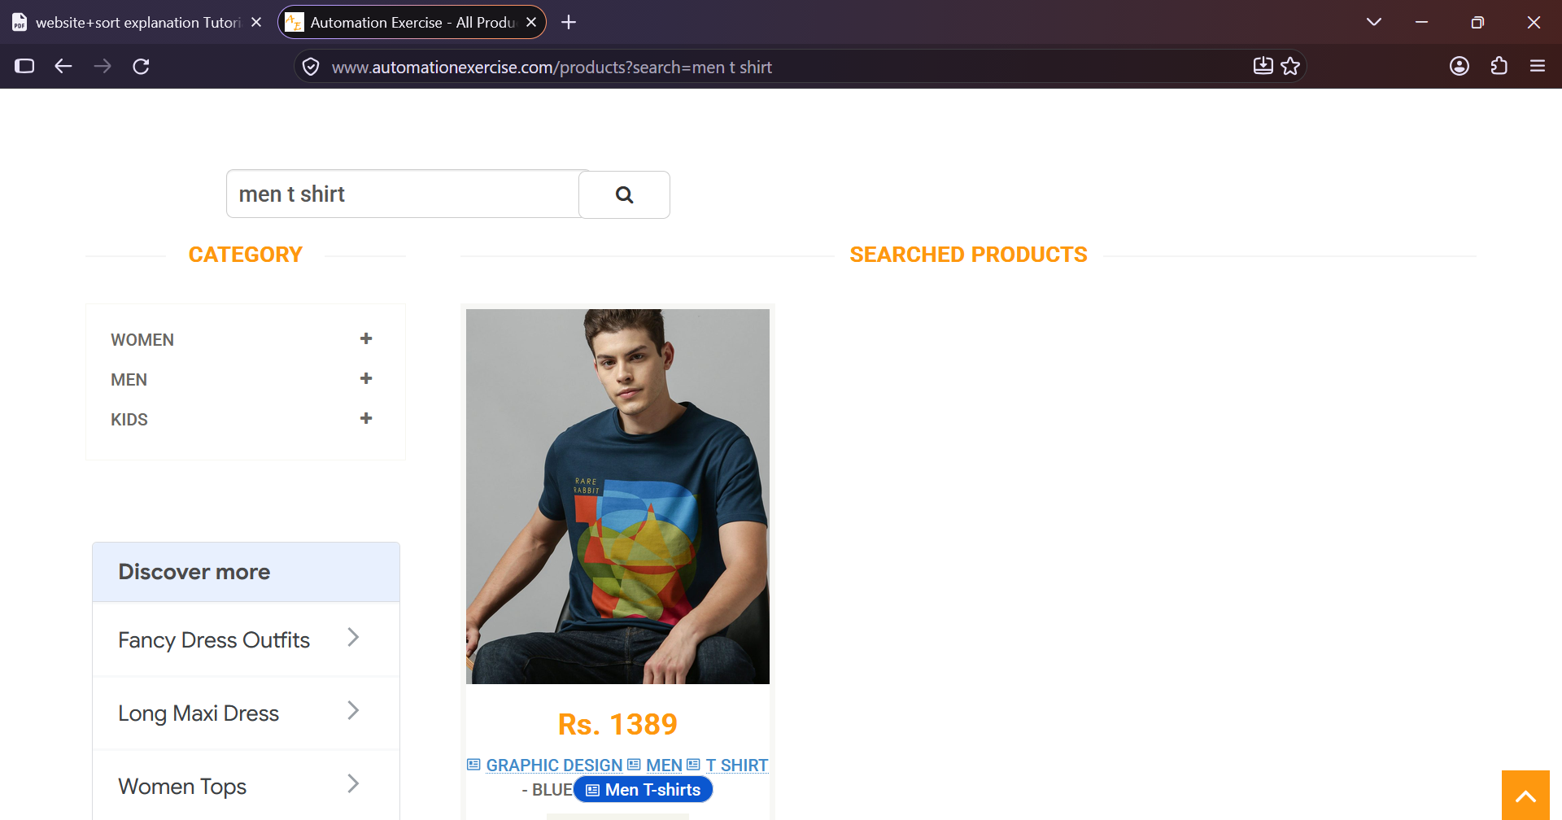
TC-04: Select product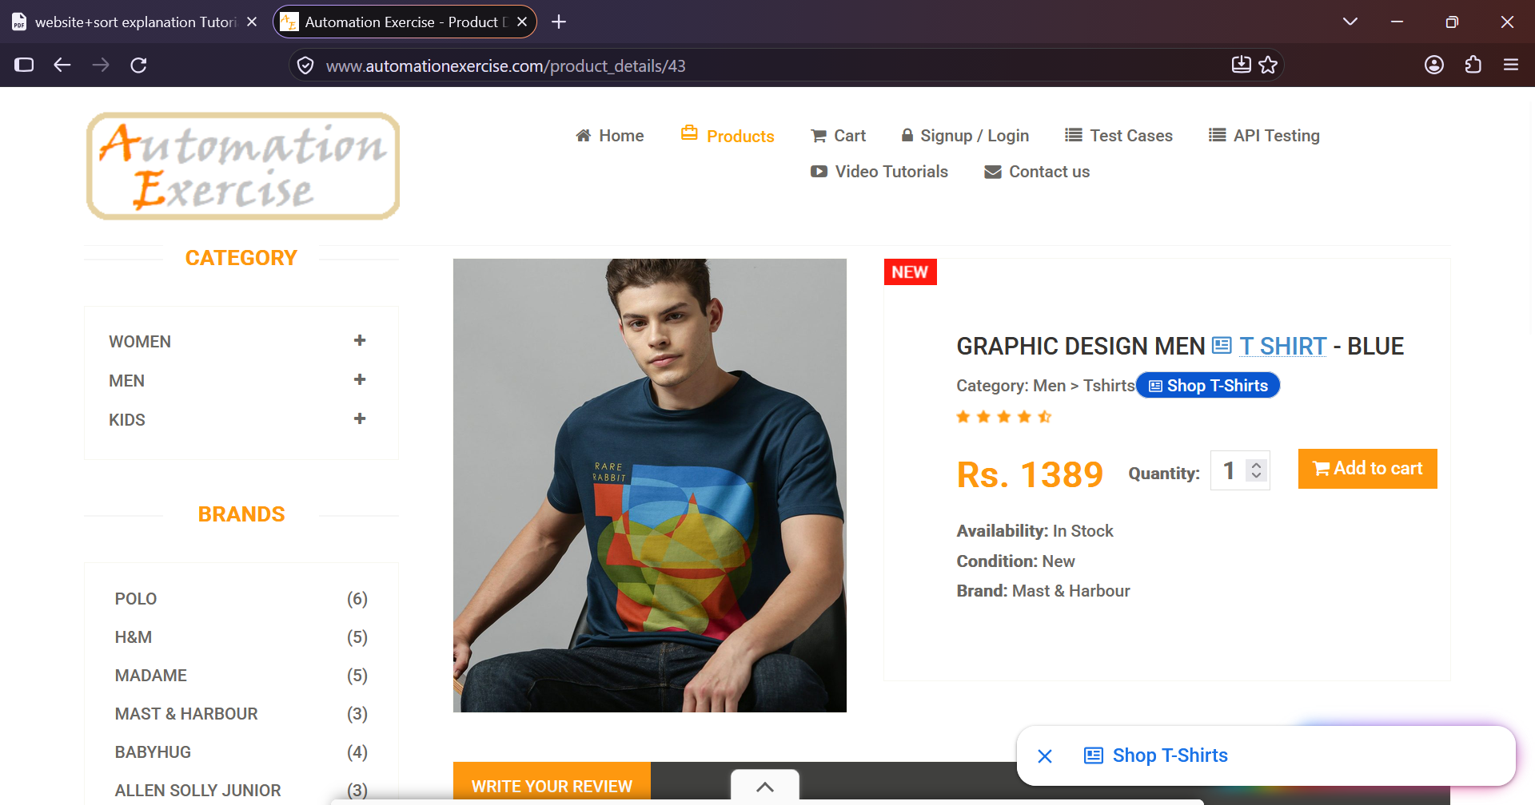
TC-05: Add to cart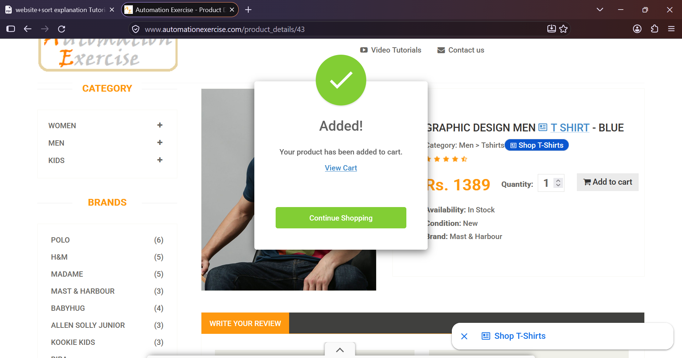
TC-06: Open cart
