ASSIGNMENT – 2
U21CS501 – WEB TECHNOLOGY
Department of Computer Science and Engineering

Student Name: Bhavisha S | Roll Number: 24CS031
Academic Course: Web Technology (U21CS501) | GitHub Link: https://github.com/Bhavisha1107/WT-Assignment-2

Question 1: Student Registration Form with Validation
Scenario: The student admission portal requires a well-designed registration form with proper validation and styling.
Tasks:
i. Create HTML forms for student registration (name, roll number, email, course, file upload).
ii. Apply CSS styles for layout, colors, and responsive design (e.g., styled input fields, buttons, error messages).
iii. Implement client-side validation (JavaScript) for required fields, email format, and password strength.

1. Index.html
<!DOCTYPE html>
<html lang="en">
<head>
<meta charset="UTF-8">
<meta name="viewport" content="width=device-width, initial-scale=1.0">
<title>Student Registration Portal</title>
<link rel="stylesheet" href="style.css">
</head>
<body>
<div class="container">
<div class="header">
<div class="icon-badge">&#127891;</div>
<h1>Student Registration</h1>
<p class="subtitle">Fill in your academic and personal details to register</p>
</div>
<form id="registrationForm" novalidate>
<div class="form-group">
<label for="name">Full Name</label>
<input type="text" id="name" placeholder="e.g. Bhavisha S">
<span class="error" id="nameError"></span>
</div>
<div class="form-group">
<label for="roll">Roll Number</label>
<input type="text" id="roll" placeholder="e.g. 24CS031">
<span class="error" id="rollError"></span>
</div>
<div class="form-group">
<label for="email">Email Address</label>
<input type="email" id="email" placeholder="e.g. bhavisha@gmail.com">
<span class="error" id="emailError"></span>
</div>
<div class="form-group">
<label for="course">Select Course</label>
<select id="course">
<option value="">-- Select Course --</option>
<option value="CSE">Computer Science Engineering</option>
<option value="IT">Information Technology</option>
<option value="ECE">Electronics and Communication</option>
<option value="EEE">Electrical and Electronics</option>
<option value="MECH">Mechanical Engineering</option>
<option value="AIDS">Artificial Intelligence & Data Science</option>
</select>
<span class="error" id="courseError"></span>
</div>
<div class="form-group">
<label for="password">Password</label>
<input type="password" id="password" placeholder="Min. 8 chars (Uppercase, Lowercase, Number & Symbol)">
<span class="error" id="passwordError"></span>
<small class="hint">Must contain at least 8 characters with uppercase, lowercase, digit & symbol.</small>
</div>
<div class="form-group">
<label for="file">Upload Student Document</label>
<div class="file-drop-zone">
<input type="file" id="file" accept=".pdf,.jpg,.jpeg,.png">
</div>
<span class="error" id="fileError"></span>
<small class="hint">Accepted formats: PDF, JPG, PNG (Max size: 2 MB)</small>
</div>
<button type="submit" id="submitBtn">Register Now</button>
<div id="successMessage" class="success-box"></div>
</form>
</div>
<script src="validation.js"></script>
</body>
</html>

2. Style.css
* {
margin: 0;
padding: 0;
box-sizing: border-box;
}
:root {
--primary: #4f46e5;
--primary-hover: #4338ca;
--primary-light: #e0e7ff;
--text-main: #1f2937;
--text-muted: #6b7280;
--bg-page: linear-gradient(135deg, #e0f2fe 0%, #ede9fe 50%, #fae8ff 100%);
--card-bg: #ffffff;
--border: #e2e8f0;
--border-focus: #6366f1;
--error: #ef4444;
--success: #10b981;
--radius: 12px;
}
body {
font-family: 'Segoe UI', system-ui, -apple-system, BlinkMacSystemFont, Roboto, sans-serif;
background: var(--bg-page);
min-height: 100vh;
display: flex;
justify-content: center;
align-items: center;
padding: 30px 16px;
color: var(--text-main);
}
.container {
background: var(--card-bg);
width: 100%;
max-width: 480px;
padding: 36px 32px;
border-radius: 20px;
box-shadow: 0 15px 35px rgba(79, 70, 229, 0.12), 0 5px 15px rgba(0, 0, 0, 0.04);
border: 1px solid rgba(255, 255, 255, 0.8);
position: relative;
overflow: hidden;
}
.container::before {
content: "";
position: absolute;
top: 0;
left: 0;
right: 0;
height: 6px;
background: linear-gradient(90deg, #4f46e5, #06b6d4, #a855f7);
}
.header {
text-align: center;
margin-bottom: 24px;
}
.icon-badge {
width: 54px;
height: 54px;
background: var(--primary-light);
color: var(--primary);
font-size: 26px;
display: flex;
align-items: center;
justify-content: center;
border-radius: 50%;
margin: 0 auto 12px;
box-shadow: 0 4px 12px rgba(79, 70, 229, 0.15);
}
h1 {
font-size: 24px;
font-weight: 700;
color: #1e1b4b;
margin-bottom: 6px;
letter-spacing: -0.5px;
}
.subtitle {
font-size: 14px;
color: var(--text-muted);
}
.form-group {
margin-bottom: 18px;
}
label {
display: block;
margin-bottom: 6px;
font-weight: 600;
font-size: 13.5px;
color: #374151;
}
input[type="text"],
input[type="email"],
input[type="password"],
select {
width: 100%;
padding: 11px 14px;
border: 1.5px solid var(--border);
border-radius: var(--radius);
font-size: 14.5px;
color: var(--text-main);
background: #f8fafc;
transition: all 0.2s ease-in-out;
}
input[type="text"]:focus,
input[type="email"]:focus,
input[type="password"]:focus,
select:focus {
outline: none;
border-color: var(--border-focus);
background: #ffffff;
box-shadow: 0 0 0 4px rgba(99, 102, 241, 0.15);
}
.hint {
display: block;
font-size: 11.5px;
color: #94a3b8;
margin-top: 4px;
}
input[type="file"] {
width: 100%;
padding: 9px;
border: 1.5px dashed #cbd5e1;
border-radius: var(--radius);
font-size: 13px;
color: var(--text-muted);
background: #f8fafc;
cursor: pointer;
transition: all 0.2s ease;
}
input[type="file"]:hover {
border-color: var(--primary);
background: #f1f5f9;
}
button[type="submit"] {
width: 100%;
padding: 13px;
margin-top: 10px;
background: linear-gradient(135deg, var(--primary) 0%, #4338ca 100%);
color: #ffffff;
border: none;
border-radius: var(--radius);
font-size: 15.5px;
font-weight: 600;
cursor: pointer;
box-shadow: 0 4px 14px rgba(79, 70, 229, 0.35);
transition: all 0.2s ease;
}
button[type="submit"]:hover {
background: linear-gradient(135deg, #4338ca 0%, #3730a3 100%);
transform: translateY(-1px);
box-shadow: 0 6px 18px rgba(79, 70, 229, 0.45);
}
button[type="submit"]:active {
transform: translateY(0);
}
.error {
display: block;
color: var(--error);
font-size: 12px;
font-weight: 500;
margin-top: 5px;
min-height: 16px;
}
.success-box {
margin-top: 18px;
padding: 12px 16px;
border-radius: var(--radius);
font-size: 14px;
font-weight: 600;
text-align: center;
display: none;
}
.success-box.show {
display: block;
background: #ecfdf5;
color: #065f46;
border: 1px solid #a7f3d0;
}
@media (max-width: 480px) {
.container {
padding: 24px 20px;
border-radius: 16px;
}
h1 {
font-size: 21px;
}
}

3. Validation.js
const form = document.getElementById("registrationForm");
form.addEventListener("submit", function(event) {
event.preventDefault();
// Reset previous errors
document.querySelectorAll(".error").forEach(function(error) {
error.textContent = "";
});
const successBox = document.getElementById("successMessage");
successBox.textContent = "";
successBox.classList.remove("show");
let valid = true;
const name = document.getElementById("name").value.trim();
const roll = document.getElementById("roll").value.trim();
const email = document.getElementById("email").value.trim();
const course = document.getElementById("course").value;
const password = document.getElementById("password").value;
const fileInput = document.getElementById("file");
const file = fileInput.files[0];
// Name validation
if (name === "") {
document.getElementById("nameError").textContent = "Full name is required";
valid = false;
}
// Roll number validation
if (roll === "") {
document.getElementById("rollError").textContent = "Roll number is required";
valid = false;
}
// Email validation
const emailPattern = /^[^\s@]+@[^\s@]+\.[^\s@]+$/;
if (email === "") {
document.getElementById("emailError").textContent = "Email address is required";
valid = false;
} else if (!emailPattern.test(email)) {
document.getElementById("emailError").textContent = "Please enter a valid email address";
valid = false;
}
// Course selection validation
if (course === "") {
document.getElementById("courseError").textContent = "Please select a degree course";
valid = false;
}
// Password strength validation (min 8 chars, uppercase, lowercase, digit, special char)
const passwordPattern = /^(?=.*[a-z])(?=.*[A-Z])(?=.*\d)(?=.*[@$!%*?&]).{8,}$/;
if (password === "") {
document.getElementById("passwordError").textContent = "Password is required";
valid = false;
} else if (!passwordPattern.test(password)) {
document.getElementById("passwordError").textContent =
"Password must be 8+ characters with uppercase, lowercase, number and symbol (@$!%*?&)";
valid = false;
}
// Document file upload validation
if (!file) {
document.getElementById("fileError").textContent = "Please upload a document (PDF, JPG, or PNG)";
valid = false;
} else if (file.size > 2 * 1024 * 1024) {
document.getElementById("fileError").textContent = "File size must not exceed 2 MB";
valid = false;
} else if (!/\.(pdf|jpg|jpeg|png)$/i.test(file.name)) {
document.getElementById("fileError").textContent = "Only PDF, JPG, JPEG, and PNG files are accepted";
valid = false;
}
if (valid) {
successBox.textContent = "Registration form validated successfully!";
successBox.classList.add("show");
form.reset();
}
});

Output - Question 1:
The output showcases the responsive registration card with real-time field error indicators, password requirements, and successful validation state:
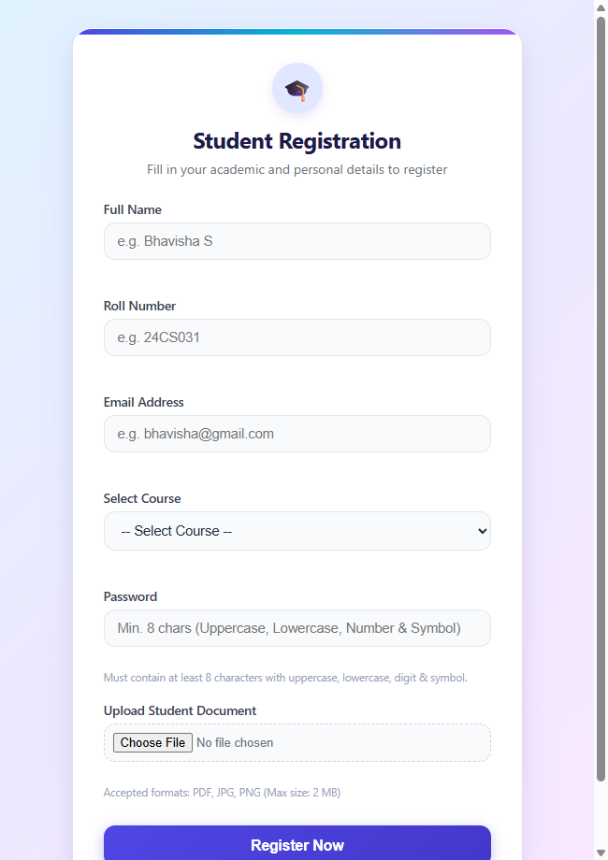  Figure 1.1: Initial Registration Form | 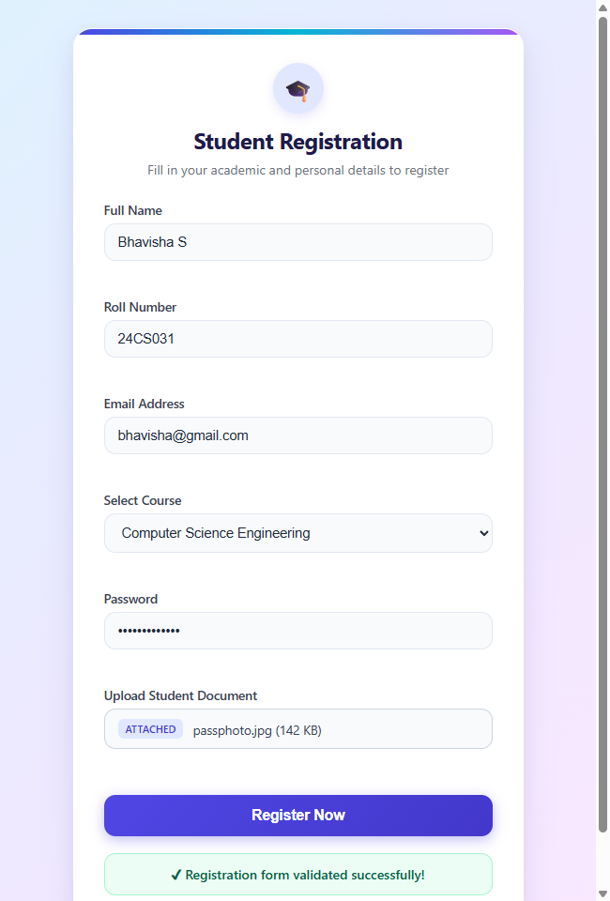  Figure 1.2: Validated Form with Success State

Conclusion:
Thus, the Student Registration Form was successfully created using HTML, CSS, and JavaScript. HTML provides structured input fields for student admission details; CSS provides an intuitive responsive layout with soft gradient accents, elevation shadows, and styled focus states; JavaScript enforces thorough client-side validation for mandatory fields, valid email pattern matching, strong password criteria, and document size/type restrictions. This improves data accuracy and provides a seamless registration experience.

Question 2: College Admin Panel with CRUD & Document Upload
Scenario: The college admin panel must manage student records and their profile documents/images.
Tasks:
1. CRUD Operations (Add, Edit, Delete, View) for student details (name, roll number, course, etc.) using MySQL.
2. File Upload Handling for profile images and documents (e.g., ID proof, certificates).
3. Store Metadata in MySQL — file path, file type, upload date linked to the student record.
4. Display Uploaded Files when viewing student details.
5. Validation & Error Handling — check file size, type, and prevent overwriting.

1. Database Configuration (db.php)
<?php
// Connect PHP to the MySQL database using PDO
$host = "localhost";
$dbname = "student_admin";
$username = "root";
$password = ""; // Default XAMPP password is empty
try {
// Create a PDO connection and enable error reporting
$pdo = new PDO(
"mysql:host=$host;dbname=$dbname;charset=utf8mb4",
$username,
$password
);
$pdo->setAttribute(PDO::ATTR_ERRMODE, PDO::ERRMODE_EXCEPTION);
} catch (PDOException $e) {
// Show a general error instead of exposing database credentials
die("Database connection failed. Please ensure MySQL is running in XAMPP.");
}
// Escape output before displaying user-supplied data in HTML
function e($value) {
return htmlspecialchars((string)$value, ENT_QUOTES, "UTF-8");
}
?>

2. Student Records Dashboard (index.php)
<?php
require "db.php";
// Retrieve all students from the database
$stmt = $pdo->query("SELECT * FROM students ORDER BY id DESC");
$students = $stmt->fetchAll(PDO::FETCH_ASSOC);
?>
<!DOCTYPE html>
<html lang="en">
<head>
<meta charset="UTF-8">
<meta name="viewport" content="width=device-width, initial-scale=1.0">
<title>Student Admin Panel</title>
<link rel="stylesheet" href="style.css">
</head>
<body>
<div class="admin-container">
<div class="admin-header">
<div>
<h1>Student Admin Panel</h1>
<p style="color: #64748b; font-size: 14px;">Manage student admission records and documents</p>
</div>
<!-- Navigate to the page for adding a student -->
<a href="add.php" class="btn btn-primary">+ Add New Student</a>
</div>
<div class="table-wrapper">
<table class="admin-table">
<thead>
<tr>
<th>Name</th>
<th>Roll Number</th>
<th>Email</th>
<th>Course</th>
<th>Actions</th>
</tr>
</thead>
<tbody>
<?php if (count($students) === 0): ?>
<tr>
<td colspan="5" style="text-align:center; padding: 20px; color:#64748b;">No student records found. Click "Add New Student" to begin.</td>
</tr>
<?php else: ?>
<?php foreach ($students as $student): ?>
<tr>
<td><strong><?= e($student["name"]) ?></strong></td>
<td><?= e($student["roll_number"]) ?></td>
<td><?= e($student["email"]) ?></td>
<td><?= e($student["course"]) ?></td>
<td class="action-links">
<!-- Open the selected student's details -->
<a href="view.php?id=<?= (int)$student["id"] ?>">View</a>
<!-- Open the edit form -->
<a href="edit.php?id=<?= (int)$student["id"] ?>">Edit</a>
<!-- Delete using POST rather than a GET link -->
<form action="delete.php" method="post"
style="display:inline"
onsubmit="return confirm('Delete this student?')">
<input type="hidden" name="id"
value="<?= (int)$student["id"] ?>">
<button type="submit" class="btn btn-danger btn-sm">Delete</button>
</form>
</td>
</tr>
<?php endforeach; ?>
<?php endif; ?>
</tbody>
</table>
</div>
</div>
</body>
</html>

3. Add Student (add.php)
<?php
require "db.php";
$error = "";
// Process the form when the user submits it
if ($_SERVER["REQUEST_METHOD"] === "POST") {
$name = trim($_POST["name"] ?? "");
$roll = trim($_POST["roll_number"] ?? "");
$email = trim($_POST["email"] ?? "");
$course = trim($_POST["course"] ?? "");
// Validate required fields and email format
if ($name === "" || $roll === "" || $course === "") {
$error = "Name, roll number and course are required.";
} elseif ($email !== "" && !filter_var($email, FILTER_VALIDATE_EMAIL)) {
$error = "Enter a valid email address.";
} else {
try {
// Prepared statements prevent SQL injection
$stmt = $pdo->prepare(
"INSERT INTO students (name, roll_number, email, course)
VALUES (?, ?, ?, ?)"
);
$stmt->execute([$name, $roll, $email, $course]);
// Redirect to the upload page for the new student
header("Location: upload.php?id=" . $pdo->lastInsertId());
exit;
} catch (PDOException $e) {
// Handle duplicate roll numbers and other database errors
$error = $e->getCode() === "23000"
? "This roll number already exists."
: "Unable to add student.";
}
}
}
?>
<!DOCTYPE html>
<html lang="en">
<head>
<meta charset="UTF-8">
<meta name="viewport" content="width=device-width, initial-scale=1.0">
<title>Add Student - Admin Panel</title>
<link rel="stylesheet" href="style.css">
</head>
<body>
<div class="admin-container form-card">
<div class="admin-header">
<h2>Add New Student</h2>
<a href="index.php" class="btn btn-secondary btn-sm">&larr; Back to List</a>
</div>
<!-- Display validation or database errors -->
<?php if ($error !== ""): ?>
<div class="alert-error"><?= e($error) ?></div>
<?php endif; ?>
<form method="post">
<div class="form-group">
<label for="name">Full Name *</label>
<input type="text" id="name" name="name" required placeholder="e.g. Bhavisha S">
</div>
<div class="form-group">
<label for="roll_number">Roll Number *</label>
<input type="text" id="roll_number" name="roll_number" required placeholder="e.g. 24CS031">
</div>
<div class="form-group">
<label for="email">Email Address</label>
<input type="email" id="email" name="email" placeholder="e.g. bhavisha@gmail.com">
</div>
<div class="form-group">
<label for="course">Course *</label>
<input type="text" id="course" name="course" required placeholder="e.g. Web Technologies">
</div>
<button type="submit" class="btn btn-primary" style="width: 100%; margin-top: 10px;">Add Student & Proceed to Upload</button>
</form>
</div>
</body>
</html>

4. Edit Student (edit.php)
<?php
require "db.php";
// Get the student ID from the URL
$id = filter_input(INPUT_GET, "id", FILTER_VALIDATE_INT);
if (!$id) {
die("Invalid student ID.");
}
// Fetch the existing student record
$stmt = $pdo->prepare("SELECT * FROM students WHERE id = ?");
$stmt->execute([$id]);
$student = $stmt->fetch(PDO::FETCH_ASSOC);
if (!$student) {
die("Student not found.");
}
$error = "";
// Update the record after form submission
if ($_SERVER["REQUEST_METHOD"] === "POST") {
$name = trim($_POST["name"] ?? "");
$roll = trim($_POST["roll_number"] ?? "");
$email = trim($_POST["email"] ?? "");
$course = trim($_POST["course"] ?? "");
// Validate the submitted details
if ($name === "" || $roll === "" || $course === "") {
$error = "Name, roll number and course are required.";
} elseif ($email !== "" && !filter_var($email, FILTER_VALIDATE_EMAIL)) {
$error = "Enter a valid email address.";
} else {
try {
// Update the existing student using a prepared statement
$stmt = $pdo->prepare(
"UPDATE students
SET name = ?, roll_number = ?, email = ?, course = ?
WHERE id = ?"
);
$stmt->execute([$name, $roll, $email, $course, $id]);
// Return to the updated student's details
header("Location: view.php?id=" . $id);
exit;
} catch (PDOException $e) {
$error = $e->getCode() === "23000"
? "This roll number is already in use."
: "Unable to update student.";
}
}
}
?>
<!DOCTYPE html>
<html lang="en">
<head>
<meta charset="UTF-8">
<meta name="viewport" content="width=device-width, initial-scale=1.0">
<title>Edit Student - Admin Panel</title>
<link rel="stylesheet" href="style.css">
</head>
<body>
<div class="admin-container form-card">
<div class="admin-header">
<h2>Edit Student Details</h2>
<a href="index.php" class="btn btn-secondary btn-sm">&larr; Back to List</a>
</div>
<?php if ($error !== ""): ?>
<div class="alert-error"><?= e($error) ?></div>
<?php endif; ?>
<!-- Pre-fill the form with the existing student information -->
<form method="post">
<div class="form-group">
<label for="name">Name:</label>
<input type="text" id="name" name="name"
value="<?= e($student["name"]) ?>" required>
</div>
<div class="form-group">
<label for="roll_number">Roll Number:</label>
<input type="text" id="roll_number" name="roll_number"
value="<?= e($student["roll_number"]) ?>" required>
</div>
<div class="form-group">
<label for="email">Email:</label>
<input type="email" id="email" name="email"
value="<?= e($student["email"]) ?>">
</div>
<div class="form-group">
<label for="course">Course:</label>
<input type="text" id="course" name="course"
value="<?= e($student["course"]) ?>" required>
</div>
<button type="submit" class="btn btn-primary" style="width:100%; margin-top: 10px;">Update Student</button>
</form>
</div>
</body>
</html>

5. Delete Student (delete.php)
<?php
require "db.php";
// Allow deletion only through a POST request
if ($_SERVER["REQUEST_METHOD"] !== "POST") {
die("Invalid request.");
}
// Validate the student ID
$id = filter_input(INPUT_POST, "id", FILTER_VALIDATE_INT);
if (!$id) {
die("Invalid student ID.");
}
try {
// Fetch the file paths before deleting their metadata
$stmt = $pdo->prepare(
"SELECT file_path FROM student_files WHERE student_id = ?"
);
$stmt->execute([$id]);
$files = $stmt->fetchAll(PDO::FETCH_COLUMN);
// Delete the student; ON DELETE CASCADE removes associated metadata
$stmt = $pdo->prepare("DELETE FROM students WHERE id = ?");
$stmt->execute([$id]);
// Remove the corresponding physical files from the uploads folder
foreach ($files as $path) {
// Only delete files within this project's uploads directory
$fullPath = realpath(__DIR__ . "/" . $path);
$uploadDir = realpath(__DIR__ . "/uploads");
if ($fullPath && $uploadDir &&
dirname($fullPath) === $uploadDir &&
is_file($fullPath)) {
unlink($fullPath);
}
}
// Return to the student list after deletion
header("Location: index.php");
exit;
} catch (PDOException $e) {
// Display a generic message if the operation fails
die("Unable to delete student.");
}
?>

6. Document Upload (upload.php)
<?php
require "db.php";
// Accept only a valid student ID
$id = filter_input(INPUT_GET, "id", FILTER_VALIDATE_INT);
if (!$id) {
die("Invalid student ID.");
}
// Check that the student exists before allowing uploads
$stmt = $pdo->prepare("SELECT id, name FROM students WHERE id = ?");
$stmt->execute([$id]);
$student = $stmt->fetch(PDO::FETCH_ASSOC);
if (!$student) {
die("Student not found.");
}
$message = "";
$status = "";
// Process the upload form
if ($_SERVER["REQUEST_METHOD"] === "POST") {
if (!isset($_FILES["document"]) ||
$_FILES["document"]["error"] !== UPLOAD_ERR_OK) {
$message = "Please select a file and try again.";
$status = "error";
} else {
$file = $_FILES["document"];
// Limit uploads to 2 MB
$maxSize = 2 * 1024 * 1024;
// Allow only these extensions and corresponding MIME types
$allowed = [
"pdf" => ["application/pdf"],
"jpg" => ["image/jpeg"],
"jpeg" => ["image/jpeg"],
"png" => ["image/png"]
];
// Determine the extension from the original filename
$extension = strtolower(
pathinfo($file["name"], PATHINFO_EXTENSION)
);
// Detect the real file type rather than trusting browser input
$finfo = new finfo(FILEINFO_MIME_TYPE);
$mime = $finfo->file($file["tmp_name"]);
// Validate size, extension and MIME type
if ($file["size"] > $maxSize) {
$message = "File size must not exceed 2 MB.";
$status = "error";
} elseif (!isset($allowed[$extension]) ||
!in_array($mime, $allowed[$extension], true)) {
$message = "Only valid PDF, JPG and PNG files are allowed.";
$status = "error";
} else {
// Create the upload directory if it does not exist
$directory = __DIR__ . "/uploads/";
if (!is_dir($directory)) {
mkdir($directory, 0755, true);
}
// Generate a random filename so existing files are not overwritten
$filename = bin2hex(random_bytes(16)) . "." . $extension;
$destination = $directory . $filename;
// Store a relative path in the database
$relativePath = "uploads/" . $filename;
if (move_uploaded_file($file["tmp_name"], $destination)) {
try {
// Save file metadata and link it to the student
$stmt = $pdo->prepare(
"INSERT INTO student_files
(student_id, file_path, file_type, original_name)
VALUES (?, ?, ?, ?)"
);
$stmt->execute([
$id,
$relativePath,
$mime,
basename($file["name"])
]);
$message = "File uploaded successfully.";
$status = "success";
} catch (PDOException $e) {
// Remove the uploaded file if its metadata cannot be saved
if (is_file($destination)) {
unlink($destination);
}
$message = "Unable to save file information.";
$status = "error";
}
} else {
$message = "File upload failed. Check folder permissions.";
$status = "error";
}
}
}
}
?>
<!DOCTYPE html>
<html lang="en">
<head>
<meta charset="UTF-8">
<meta name="viewport" content="width=device-width, initial-scale=1.0">
<title>Upload Student Documents</title>
<link rel="stylesheet" href="style.css">
</head>
<body>
<div class="admin-container form-card">
<div class="admin-header">
<h2>Upload Student Documents</h2>
<a href="view.php?id=<?= (int)$id ?>" class="btn btn-secondary btn-sm">View Details &rarr;</a>
</div>
<p style="margin-bottom: 16px; font-size: 15px;"><strong>Student:</strong> <?= e($student["name"]) ?></p>
<!-- Display the upload result -->
<?php if ($message !== ""): ?>
<div class="<?= $status === 'success' ? 'alert-success' : 'alert-error' ?>">
<?= e($message) ?>
</div>
<?php endif; ?>
<!-- enctype is required for file uploads -->
<form method="post" enctype="multipart/form-data">
<div class="form-group">
<label>Select profile image or document (PDF, JPG, PNG):</label>
<input type="file" name="document"
accept=".pdf,.jpg,.jpeg,.png" required>
<small style="color:#64748b; font-size:12px; margin-top:5px; display:block;">Max allowed file size: 2 MB</small>
</div>
<button type="submit" class="btn btn-primary" style="width: 100%; margin-top: 10px;">Upload File</button>
</form>
<div style="margin-top: 20px; display: flex; justify-content: space-between;">
<a href="view.php?id=<?= (int)$id ?>" class="btn btn-secondary btn-sm">&larr; Back to Student Details</a>
<a href="index.php" class="btn btn-secondary btn-sm">Student List</a>
</div>
</div>
</body>
</html>

7. View Student & Files (view.php)
<?php
require "db.php";
// Read and validate the student ID
$id = filter_input(INPUT_GET, "id", FILTER_VALIDATE_INT);
if (!$id) {
die("Invalid student ID.");
}
// Retrieve the student's details
$stmt = $pdo->prepare("SELECT * FROM students WHERE id = ?");
$stmt->execute([$id]);
$student = $stmt->fetch(PDO::FETCH_ASSOC);
if (!$student) {
die("Student not found.");
}
// Retrieve all uploaded files linked to this student
$stmt = $pdo->prepare(
"SELECT * FROM student_files WHERE student_id = ? ORDER BY upload_date DESC"
);
$stmt->execute([$id]);
$files = $stmt->fetchAll(PDO::FETCH_ASSOC);
?>
<!DOCTYPE html>
<html lang="en">
<head>
<meta charset="UTF-8">
<meta name="viewport" content="width=device-width, initial-scale=1.0">
<title>Student Details - <?= e($student["name"]) ?></title>
<link rel="stylesheet" href="style.css">
</head>
<body>
<div class="admin-container">
<div class="admin-header">
<h2>Student Details</h2>
<div>
<a href="edit.php?id=<?= (int)$id ?>" class="btn btn-primary btn-sm">Edit Student</a>
<a href="upload.php?id=<?= (int)$id ?>" class="btn btn-secondary btn-sm">+ Upload Document</a>
<a href="index.php" class="btn btn-secondary btn-sm">&larr; Back to List</a>
</div>
</div>
<div style="background: #f8fafc; border: 1px solid var(--border); border-radius: 8px; padding: 18px; margin-bottom: 24px;">
<p style="margin-bottom: 8px;"><strong>Name:</strong> <?= e($student["name"]) ?></p>
<p style="margin-bottom: 8px;"><strong>Roll Number:</strong> <?= e($student["roll_number"]) ?></p>
<p style="margin-bottom: 8px;"><strong>Email:</strong> <?= e($student["email"]) ?></p>
<p><strong>Course:</strong> <?= e($student["course"]) ?></p>
</div>
<h3>Uploaded Files & Documents</h3>
<?php if (count($files) > 0): ?>
<div style="display: grid; grid-template-columns: repeat(auto-fill, minmax(240px, 1fr)); gap: 16px;">
<?php foreach ($files as $file): ?>
<div class="file-card">
<!-- Display an image preview for image files -->
<?php if (strpos($file["file_type"], "image/") === 0): ?>
<div class="file-preview" style="text-align: center; margin-bottom: 10px;">
<img src="<?= e($file["file_path"]) ?>"
alt="Student document"
style="max-width: 100%; max-height: 140px; object-fit: cover;">
</div>
<?php endif; ?>
<!-- Show the original filename and file metadata -->
<p style="font-size: 13.5px; margin-bottom: 4px;"><strong>File:</strong> <?= e($file["original_name"]) ?></p>
<p style="font-size: 12.5px; color: #64748b; margin-bottom: 4px;"><strong>Type:</strong> <?= e($file["file_type"]) ?></p>
<p style="font-size: 12.5px; color: #64748b; margin-bottom: 10px;"><strong>Uploaded:</strong> <?= e($file["upload_date"]) ?></p>
<!-- Open or download the uploaded file -->
<a href="<?= e($file["file_path"]) ?>" target="_blank"
rel="noopener" class="btn btn-secondary btn-sm" style="display:block; text-align:center;">View / Download File</a>
</div>
<?php endforeach; ?>
</div>
<?php else: ?>
<p style="color: #64748b; font-style: italic;">No files uploaded for this student.</p>
<?php endif; ?>
</div>
</body>
</html>

8. Database Schema (student_admin.sql)
-- Database schema for Question 2: Student Admin Panel
CREATE DATABASE IF NOT EXISTS student_admin;
USE student_admin;
-- Stores the basic details of each student
CREATE TABLE IF NOT EXISTS students (
id INT AUTO_INCREMENT PRIMARY KEY,
name VARCHAR(100) NOT NULL,
roll_number VARCHAR(30) NOT NULL UNIQUE,
email VARCHAR(100),
course VARCHAR(100) NOT NULL
);
-- Stores file metadata and links each file to a student
CREATE TABLE IF NOT EXISTS student_files (
id INT AUTO_INCREMENT PRIMARY KEY,
student_id INT NOT NULL,
file_path VARCHAR(255) NOT NULL,
file_type VARCHAR(100) NOT NULL,
upload_date TIMESTAMP DEFAULT CURRENT_TIMESTAMP,
original_name VARCHAR(255) NOT NULL,
FOREIGN KEY (student_id) REFERENCES students(id)
ON DELETE CASCADE
);
-- Sample Data
INSERT INTO students (name, roll_number, email, course) VALUES
('Bhavisha S', '24CS031', 'bhavisha@gmail.com', 'Web Technologies'),
('Rahul Sharma', '24CS012', 'rahul@example.com', 'Computer Science Engineering'),
('Priya Patel', '24IT005', 'priya@example.com', 'Information Technology')
ON DUPLICATE KEY UPDATE name=VALUES(name);

Output - Question 2:
The redesigned PHP Admin Panel displays student admission records with styled actions, validation warnings, and file preview cards:
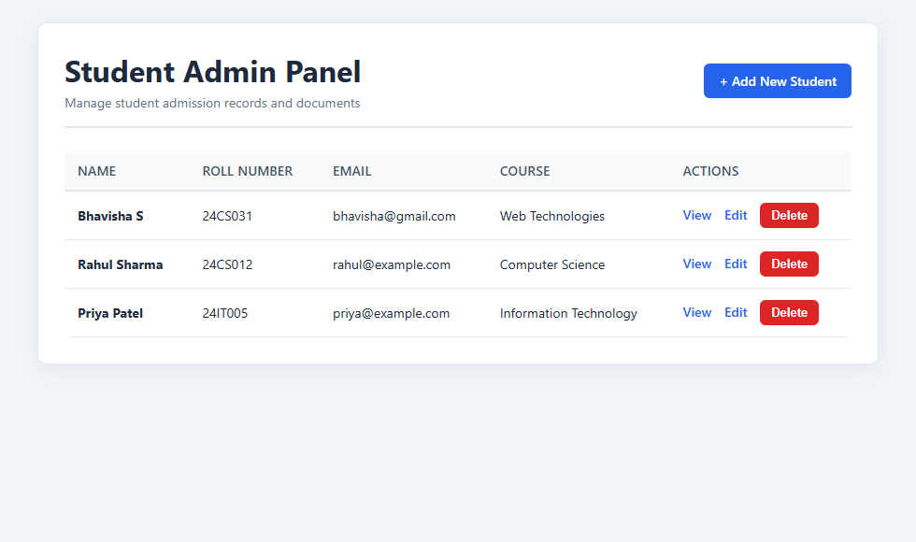
Figure 2.1: Student Admin Panel Dashboard with Records & Actions
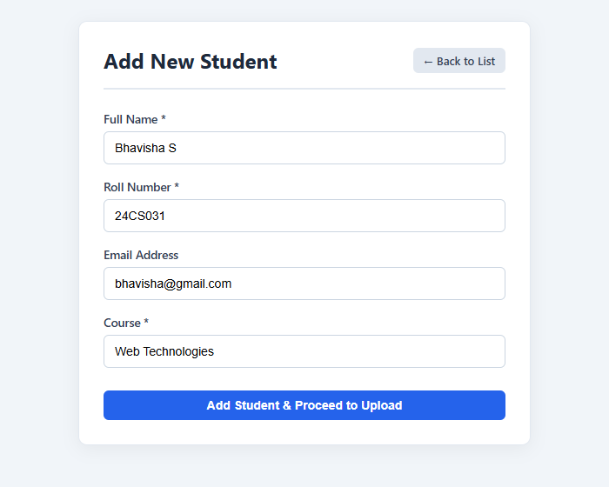  Figure 2.2: Add Student Form | 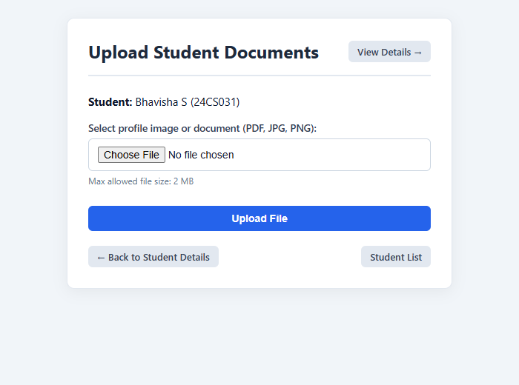  Figure 2.3: Document Upload Handling

Conclusion:
Thus, the Student Admin Panel was successfully developed using PHP and MySQL to manage student records through complete CRUD operations. File upload functionality was implemented to store profile images and documents securely. File metadata, including storage path, MIME type, upload timestamp, and original file name, is maintained in MySQL with foreign key cascading. Server-side validation, PDO prepared statements, and XSS sanitization ensure robust protection against injection and unauthorized overwriting.

Question 3: Student Profile Portal with Java Servlets, JSP & JDBC
Scenario: The front-end portal must allow users to view student profiles along with their uploaded images/documents.
Tasks:
1. Connect to MySQL using JDBC to fetch student details and associated file paths.
2. Retrieve and stream images/documents from the folder where they are stored.
3. Display student profiles dynamically in an HTML/JSP page with <img> tags pointing to the Servlet.
4. Implement looping and conditional logic to list multiple students and their files.
5. Ensure session handling so that only logged-in users can access the portal securely.

1. Project Object Model (pom.xml)
<project xmlns="http://maven.apache.org/POM/4.0.0"
xmlns:xsi="http://www.w3.org/2001/XMLSchema-instance"
xsi:schemaLocation="http://maven.apache.org/POM/4.0.0 https://maven.apache.org/xsd/maven-4.0.0.xsd">
<modelVersion>4.0.0</modelVersion>
<groupId>com.college</groupId>
<artifactId>StudentPortal</artifactId>
<version>1.0-SNAPSHOT</version>
<packaging>war</packaging>
<properties>
<maven.compiler.source>17</maven.compiler.source>
<maven.compiler.target>17</maven.compiler.target>
<project.build.sourceEncoding>UTF-8</project.build.sourceEncoding>
</properties>
<dependencies>
<dependency>
<groupId>jakarta.servlet</groupId>
<artifactId>jakarta.servlet-api</artifactId>
<version>6.0.0</version>
<scope>provided</scope>
</dependency>
<dependency>
<groupId>com.mysql</groupId>
<artifactId>mysql-connector-j</artifactId>
<version>9.4.0</version>
</dependency>
<dependency>
<groupId>jakarta.servlet.jsp.jstl</groupId>
<artifactId>jakarta.servlet.jsp.jstl-api</artifactId>
<version>3.0.2</version>
</dependency>
<dependency>
<groupId>org.glassfish.web</groupId>
<artifactId>jakarta.servlet.jsp.jstl</artifactId>
<version>3.0.1</version>
</dependency>
</dependencies>
<build>
<finalName>StudentPortal</finalName>
<plugins>
<plugin>
<groupId>org.apache.maven.plugins</groupId>
<artifactId>maven-compiler-plugin</artifactId>
<version>3.13.0</version>
</plugin>
<plugin>
<groupId>org.apache.maven.plugins</groupId>
<artifactId>maven-war-plugin</artifactId>
<version>3.4.0</version>
</plugin>
</plugins>
</build>
</project>

2. Deployment Descriptor (web.xml)
<?xml version="1.0" encoding="UTF-8"?>
<web-app xmlns="https://jakarta.ee/xml/ns/jakartaee"
xmlns:xsi="http://www.w3.org/2001/XMLSchema-instance"
xsi:schemaLocation="https://jakarta.ee/xml/ns/jakartaee
https://jakarta.ee/xml/ns/jakartaee/web-app_6_0.xsd"
version="6.0">
<display-name>Student Profile Portal</display-name>
<welcome-file-list>
<welcome-file>login.jsp</welcome-file>
</welcome-file-list>
</web-app>

3. Database Connection Utility (DBConnection.java)
package com.college;
import java.sql.Connection;
import java.sql.DriverManager;
import java.sql.SQLException;
public class DBConnection {
private static final String URL =
"jdbc:mysql://localhost:3306/student_portal?useSSL=false&allowPublicKeyRetrieval=true&serverTimezone=UTC";
private static final String USER = "root";
private static final String PASSWORD = "";
static {
try {
Class.forName("com.mysql.cj.jdbc.Driver");
} catch (ClassNotFoundException e) {
e.printStackTrace();
}
}
public static Connection getConnection() throws SQLException {
return DriverManager.getConnection(URL, USER, PASSWORD);
}
}

4. Student File Entity (StudentFile.java)
package com.college;
public class StudentFile {
private int id;
private String originalName;
private String fileType;
public StudentFile(int id, String originalName, String fileType) {
this.id = id;
this.originalName = originalName;
this.fileType = fileType;
}
public int getId() {
return id;
}
public String getOriginalName() {
return originalName;
}
public String getFileType() {
return fileType;
}
}

5. Student Entity Model (Student.java)
package com.college;
import java.util.ArrayList;
import java.util.List;
public class Student {
private int id;
private String name;
private String rollNumber;
private String course;
private List<StudentFile> files = new ArrayList<>();
public Student(int id, String name, String rollNumber, String course) {
this.id = id;
this.name = name;
this.rollNumber = rollNumber;
this.course = course;
}
public int getId() {
return id;
}
public String getName() {
return name;
}
public String getRollNumber() {
return rollNumber;
}
public String getCourse() {
return course;
}
public List<StudentFile> getFiles() {
return files;
}
public void addFile(StudentFile file) {
files.add(file);
}
}

6. Authentication Controller (LoginServlet.java)
package com.college;
import java.io.IOException;
import jakarta.servlet.ServletException;
import jakarta.servlet.annotation.WebServlet;
import jakarta.servlet.http.HttpServlet;
import jakarta.servlet.http.HttpServletRequest;
import jakarta.servlet.http.HttpServletResponse;
import jakarta.servlet.http.HttpSession;
@WebServlet("/login")
public class LoginServlet extends HttpServlet {
@Override
protected void doPost(HttpServletRequest request,
HttpServletResponse response)
throws ServletException, IOException {
String username = request.getParameter("username");
String password = request.getParameter("password");
if ("admin".equals(username) && "admin123".equals(password)) {
HttpSession session = request.getSession(true);
request.changeSessionId();
session.setAttribute("loggedIn", true);
session.setAttribute("username", username);
response.sendRedirect(request.getContextPath() + "/students");
} else {
request.setAttribute("error", "Invalid username or password. Please try again.");
request.getRequestDispatcher("/login.jsp").forward(request, response);
}
}
@Override
protected void doGet(HttpServletRequest request,
HttpServletResponse response)
throws ServletException, IOException {
response.sendRedirect(request.getContextPath() + "/login.jsp");
}
}

7. Session Invalidation Controller (LogoutServlet.java)
package com.college;
import java.io.IOException;
import jakarta.servlet.ServletException;
import jakarta.servlet.annotation.WebServlet;
import jakarta.servlet.http.HttpServlet;
import jakarta.servlet.http.HttpServletRequest;
import jakarta.servlet.http.HttpServletResponse;
import jakarta.servlet.http.HttpSession;
@WebServlet("/logout")
public class LogoutServlet extends HttpServlet {
@Override
protected void doGet(HttpServletRequest request,
HttpServletResponse response)
throws ServletException, IOException {
HttpSession session = request.getSession(false);
if (session != null) {
session.invalidate();
}
response.sendRedirect(request.getContextPath() + "/login.jsp");
}
}

8. Student Profiles Controller (StudentServlet.java)
package com.college;
import java.io.IOException;
import java.sql.Connection;
import java.sql.PreparedStatement;
import java.sql.ResultSet;
import java.sql.SQLException;
import java.util.LinkedHashMap;
import java.util.Map;
import jakarta.servlet.ServletException;
import jakarta.servlet.annotation.WebServlet;
import jakarta.servlet.http.HttpServlet;
import jakarta.servlet.http.HttpServletRequest;
import jakarta.servlet.http.HttpServletResponse;
import jakarta.servlet.http.HttpSession;
@WebServlet("/students")
public class StudentServlet extends HttpServlet {
@Override
protected void doGet(HttpServletRequest request,
HttpServletResponse response)
throws ServletException, IOException {
HttpSession session = request.getSession(false);
if (session == null || !Boolean.TRUE.equals(session.getAttribute("loggedIn"))) {
response.sendRedirect(request.getContextPath() + "/login.jsp");
return;
}
Map<Integer, Student> students = new LinkedHashMap<>();
String sql = "SELECT s.id, s.name, s.roll_number, s.course, " +
"f.id AS file_id, f.original_name, f.file_type " +
"FROM students s " +
"LEFT JOIN student_files f ON s.id = f.student_id " +
"ORDER BY s.id, f.id";
try (Connection con = DBConnection.getConnection();
PreparedStatement ps = con.prepareStatement(sql);
ResultSet rs = ps.executeQuery()) {
while (rs.next()) {
int studentId = rs.getInt("id");
Student student = students.get(studentId);
if (student == null) {
student = new Student(
studentId,
rs.getString("name"),
rs.getString("roll_number"),
rs.getString("course"));
students.put(studentId, student);
}
int fileId = rs.getInt("file_id");
if (!rs.wasNull()) {
StudentFile file = new StudentFile(
fileId,
rs.getString("original_name"),
rs.getString("file_type"));
student.addFile(file);
}
}
} catch (SQLException e) {
throw new ServletException("Unable to retrieve student records from database.", e);
}
request.setAttribute("students", students.values());
request.getRequestDispatcher("/students.jsp").forward(request, response);
}
}

9. Secure Document Streaming (FileServlet.java)
package com.college;
import java.io.IOException;
import java.io.InputStream;
import java.nio.file.Files;
import java.nio.file.Path;
import java.nio.file.Paths;
import java.sql.Connection;
import java.sql.PreparedStatement;
import java.sql.ResultSet;
import java.sql.SQLException;
import jakarta.servlet.ServletException;
import jakarta.servlet.annotation.WebServlet;
import jakarta.servlet.http.HttpServlet;
import jakarta.servlet.http.HttpServletRequest;
import jakarta.servlet.http.HttpServletResponse;
import jakarta.servlet.http.HttpSession;
@WebServlet("/file")
public class FileServlet extends HttpServlet {
private static final Path UPLOAD_DIR =
Paths.get("C:/studentportal-uploads")
.toAbsolutePath().normalize();
@Override
protected void doGet(HttpServletRequest request,
HttpServletResponse response)
throws ServletException, IOException {
HttpSession session = request.getSession(false);
if (session == null || !Boolean.TRUE.equals(session.getAttribute("loggedIn"))) {
response.sendError(HttpServletResponse.SC_UNAUTHORIZED);
return;
}
int fileId;
try {
fileId = Integer.parseInt(request.getParameter("id"));
} catch (NumberFormatException e) {
response.sendError(HttpServletResponse.SC_BAD_REQUEST);
return;
}
String filePath = null;
String fileType = null;
String sql = "SELECT file_path, file_type FROM student_files WHERE id = ?";
try (Connection con = DBConnection.getConnection();
PreparedStatement ps = con.prepareStatement(sql)) {
ps.setInt(1, fileId);
try (ResultSet rs = ps.executeQuery()) {
if (rs.next()) {
filePath = rs.getString("file_path");
fileType = rs.getString("file_type");
}
}
} catch (SQLException e) {
throw new ServletException("Unable to retrieve file.", e);
}
if (filePath == null || fileType == null) {
response.sendError(HttpServletResponse.SC_NOT_FOUND);
return;
}
if (!fileType.equals("image/jpeg") &&
!fileType.equals("image/png") &&
!fileType.equals("application/pdf")) {
response.sendError(HttpServletResponse.SC_FORBIDDEN);
return;
}
Path fileName = Paths.get(filePath);
if (fileName.isAbsolute() ||
fileName.getNameCount() != 1 ||
filePath.contains("/") ||
filePath.contains("\\")) {
response.sendError(HttpServletResponse.SC_FORBIDDEN);
return;
}
Path fullPath = UPLOAD_DIR.resolve(fileName).normalize();
if (!fullPath.startsWith(UPLOAD_DIR) || !Files.isRegularFile(fullPath)) {
response.sendError(HttpServletResponse.SC_NOT_FOUND);
return;
}
response.setContentType(fileType);
response.setHeader("X-Content-Type-Options", "nosniff");
response.setContentLengthLong(Files.size(fullPath));
try (InputStream in = Files.newInputStream(fullPath)) {
in.transferTo(response.getOutputStream());
}
}
}

10. Authentication View (login.jsp)
<%@ page contentType="text/html;charset=UTF-8" language="java" %>
<!DOCTYPE html>
<html lang="en">
<head>
<meta charset="UTF-8">
<meta name="viewport" content="width=device-width, initial-scale=1.0">
<title>Student Portal Login</title>
<style>
* {
margin: 0;
padding: 0;
box-sizing: border-box;
}
body {
font-family: 'Segoe UI', system-ui, -apple-system, sans-serif;
background: linear-gradient(rgba(15, 23, 42, 0.45), rgba(15, 23, 42, 0.55)),
url('https://images.unsplash.com/photo-1541339907198-e08756dedf3f?auto=format&fit=crop&w=1600&q=80') center/cover no-repeat;
display: flex;
justify-content: center;
align-items: center;
min-height: 100vh;
padding: 20px;
}
.login-card {
background: #ffffff;
padding: 40px 36px;
width: 100%;
max-width: 390px;
border-radius: 16px;
box-shadow: 0 20px 45px rgba(0, 0, 0, 0.25);
text-align: center;
}
.portal-icon {
font-size: 44px;
color: #1d4ed8;
margin-bottom: 12px;
}
h2 {
font-size: 22px;
font-weight: 700;
color: #1e293b;
margin-bottom: 6px;
}
.subtitle {
font-size: 13.5px;
color: #64748b;
margin-bottom: 24px;
}
.input-group {
position: relative;
margin-bottom: 16px;
text-align: left;
}
.input-group span {
position: absolute;
left: 14px;
top: 50%;
transform: translateY(-50%);
color: #64748b;
font-size: 15px;
}
.input-group input {
width: 100%;
padding: 12px 14px 12px 42px;
border: 1.5px solid #cbd5e1;
border-radius: 8px;
font-size: 14px;
background: #f8fafc;
transition: all 0.2s ease;
}
.input-group input:focus {
outline: none;
border-color: #2563eb;
background: #fff;
box-shadow: 0 0 0 3px rgba(37, 99, 235, 0.15);
}
button {
width: 100%;
padding: 12px;
background: #2563eb;
color: white;
border: none;
border-radius: 8px;
font-size: 15px;
font-weight: 600;
cursor: pointer;
transition: background 0.2s ease;
box-shadow: 0 4px 12px rgba(37, 99, 235, 0.3);
}
button:hover {
background: #1d4ed8;
}
.demo-box {
margin-top: 24px;
padding-top: 18px;
border-top: 1px dashed #e2e8f0;
font-size: 12.5px;
color: #64748b;
}
.demo-box strong {
color: #1e293b;
}
.error-msg {
background: #fef2f2;
color: #dc2626;
border: 1px solid #fecaca;
padding: 8px 12px;
border-radius: 6px;
font-size: 13px;
margin-bottom: 16px;
}
</style>
</head>
<body>
<div class="login-card">
<div class="portal-icon">&#127891;</div>
<h2>Student Profile Portal</h2>
<p class="subtitle">Login to view student profiles and documents</p>
<% if (request.getAttribute("error") != null) { %>
<div class="error-msg">
<%= request.getAttribute("error") %>
</div>
<% } %>
<form action="${pageContext.request.contextPath}/login" method="post">
<div class="input-group">
<span>&#128100;</span>
<input type="text" name="username" placeholder="Username (admin)" required>
</div>
<div class="input-group">
<span>&#128274;</span>
<input type="password" name="password" placeholder="Password (admin123)" required>
</div>
<button type="submit">Login</button>
</form>
<div class="demo-box">
<p><strong>Demo Credentials:</strong></p>
<p>Username: <code>admin</code></p>
<p>Password: <code>admin123</code></p>
</div>
</div>
</body>
</html>

11. Dynamic Profiles View (students.jsp)
<%@ page contentType="text/html;charset=UTF-8" language="java" %>
<%@ taglib prefix="c" uri="jakarta.tags.core" %>
<!DOCTYPE html>
<html lang="en">
<head>
<meta charset="UTF-8">
<meta name="viewport" content="width=device-width, initial-scale=1.0">
<title>Student Profile Portal</title>
<style>
* {
margin: 0;
padding: 0;
box-sizing: border-box;
}
body {
font-family: 'Segoe UI', system-ui, -apple-system, sans-serif;
background: #f1f5f9;
color: #1e293b;
}
.navbar {
background: #1d4ed8;
color: white;
padding: 14px 28px;
display: flex;
justify-content: space-between;
align-items: center;
box-shadow: 0 2px 8px rgba(0,0,0,0.1);
}
.nav-brand {
display: flex;
align-items: center;
gap: 12px;
font-size: 19px;
font-weight: 700;
}
.user-nav {
font-size: 14px;
}
.user-nav a {
color: #e0e7ff;
text-decoration: none;
margin-left: 12px;
font-weight: 600;
}
.user-nav a:hover {
color: #ffffff;
text-decoration: underline;
}
.layout {
display: flex;
min-height: calc(100vh - 60px);
}
.sidebar {
width: 220px;
background: #ffffff;
border-right: 1px solid #e2e8f0;
padding: 24px 0;
}
.sidebar-menu {
list-style: none;
}
.sidebar-item {
display: flex;
align-items: center;
gap: 12px;
padding: 12px 24px;
color: #475569;
text-decoration: none;
font-weight: 600;
font-size: 14.5px;
transition: all 0.2s;
}
.sidebar-item:hover, .sidebar-item.active {
background: #eff6ff;
color: #1d4ed8;
border-left: 4px solid #1d4ed8;
}
.main-content {
flex: 1;
padding: 30px;
overflow-y: auto;
}
.content-header {
margin-bottom: 24px;
}
.content-header h2 {
font-size: 22px;
font-weight: 700;
color: #0f172a;
margin-bottom: 16px;
}
.search-bar {
display: flex;
gap: 10px;
max-width: 600px;
margin-bottom: 24px;
}
.search-bar input {
flex: 1;
padding: 10px 14px;
border: 1px solid #cbd5e1;
border-radius: 8px;
font-size: 14px;
background: #fff;
}
.search-bar input:focus {
outline: none;
border-color: #2563eb;
box-shadow: 0 0 0 3px rgba(37,99,235,0.15);
}
.search-bar button {
padding: 10px 22px;
background: #1d4ed8;
color: white;
border: none;
border-radius: 8px;
font-weight: 600;
cursor: pointer;
}
.grid {
display: grid;
grid-template-columns: repeat(auto-fill, minmax(260px, 1fr));
gap: 20px;
}
.student-card {
background: #ffffff;
border-radius: 12px;
padding: 20px;
box-shadow: 0 2px 10px rgba(0,0,0,0.05);
border: 1px solid #e2e8f0;
text-align: center;
display: flex;
flex-direction: column;
justify-content: space-between;
}
.avatar {
width: 90px;
height: 90px;
border-radius: 50%;
object-fit: cover;
margin: 0 auto 12px;
border: 3px solid #dbeafe;
}
.avatar-fallback {
width: 90px;
height: 90px;
border-radius: 50%;
margin: 0 auto 12px;
background: #e0e7ff;
color: #3730a3;
display: flex;
align-items: center;
justify-content: center;
font-size: 32px;
font-weight: bold;
}
.student-card h3 {
font-size: 17px;
color: #0f172a;
margin-bottom: 6px;
}
.student-card .info {
font-size: 13.5px;
color: #64748b;
margin-bottom: 4px;
}
.badge {
display: inline-block;
background: #eff6ff;
color: #1d4ed8;
padding: 3px 10px;
border-radius: 20px;
font-size: 12px;
font-weight: 600;
margin: 8px 0 14px;
}
.card-btn {
background: #1d4ed8;
color: #ffffff;
padding: 9px 16px;
border-radius: 7px;
text-decoration: none;
font-size: 13.5px;
font-weight: 600;
margin-top: 12px;
display: block;
transition: background 0.2s;
}
.card-btn:hover {
background: #1e40af;
}
.docs-list {
margin-top: 10px;
text-align: left;
border-top: 1px solid #f1f5f9;
padding-top: 10px;
font-size: 12.5px;
}
.docs-list a {
color: #2563eb;
text-decoration: none;
display: block;
margin-top: 4px;
word-break: break-all;
}
.docs-list a:hover {
text-decoration: underline;
}
</style>
</head>
<body>
<header class="navbar">
<div class="nav-brand">
<span>&#127891;</span> Student Profile Portal
</div>
<div class="user-nav">
Welcome, <strong><c:out value="${sessionScope.username}"/></strong> |
<a href="${pageContext.request.contextPath}/logout">Logout</a>
</div>
</header>
<div class="layout">
<aside class="sidebar">
<ul class="sidebar-menu">
<li><a href="#" class="sidebar-item active">&#128101; Students</a></li>
<li><a href="#" class="sidebar-item">&#128196; Documents</a></li>
<li><a href="#" class="sidebar-item">&#128100; Profile</a></li>
</ul>
</aside>
<main class="main-content">
<div class="content-header">
<h2>Student Profiles</h2>
<div class="search-bar">
<input type="text" placeholder="Search by name or roll number...">
<button type="button">Search</button>
</div>
</div>
<c:if test="${empty students}">
<div style="background:white; padding:30px; border-radius:10px; text-align:center; color:#64748b;">
No student records found in the portal.
</div>
</c:if>
<div class="grid">
<c:forEach var="student" items="${students}">
<div class="student-card">
<div>
<!-- Check for profile image -->
<c:set var="hasImage" value="false"/>
<c:forEach var="file" items="${student.files}">
<c:if test="${(file.fileType == 'image/jpeg' || file.fileType == 'image/png') and !hasImage}">
<img src="${pageContext.request.contextPath}/file?id=${file.id}"
alt="Profile photo" class="avatar">
<c:set var="hasImage" value="true"/>
</c:if>
</c:forEach>
<c:if test="${not hasImage}">
<div class="avatar-fallback">
${student.name.substring(0, 1)}
</div>
</c:if>
<h3><c:out value="${student.name}"/></h3>
<p class="info">Roll No: <strong><c:out value="${student.rollNumber}"/></strong></p>
<span class="badge"><c:out value="${student.course}"/></span>
<!-- PDF Documents -->
<div class="docs-list">
<strong>Documents:</strong>
<c:set var="docFound" value="false"/>
<c:forEach var="file" items="${student.files}">
<c:if test="${file.fileType == 'application/pdf'}">
<c:set var="docFound" value="true"/>
<a href="${pageContext.request.contextPath}/file?id=${file.id}" target="_blank">
&#128196; <c:out value="${file.originalName}"/>
</a>
</c:if>
</c:forEach>
<c:if test="${not docFound}">
<p style="color:#94a3b8; font-style:italic;">No certificates uploaded</p>
</c:if>
</div>
</div>
<a href="#" class="card-btn">View Profile</a>
</div>
</c:forEach>
</div>
</main>
</div>
</body>
</html>

12. MySQL Database Schema & Mock Data (database.sql)
-- Database schema and mock data for Question 3: Student Profile Portal
CREATE DATABASE IF NOT EXISTS student_portal;
USE student_portal;
CREATE TABLE IF NOT EXISTS students (
id INT AUTO_INCREMENT PRIMARY KEY,
name VARCHAR(100) NOT NULL,
roll_number VARCHAR(30) NOT NULL,
course VARCHAR(100) NOT NULL
);
CREATE TABLE IF NOT EXISTS student_files (
id INT AUTO_INCREMENT PRIMARY KEY,
student_id INT NOT NULL,
file_path VARCHAR(255) NOT NULL,
file_type VARCHAR(100) NOT NULL,
original_name VARCHAR(255) NOT NULL,
FOREIGN KEY (student_id)
REFERENCES students(id)
ON DELETE CASCADE
);
-- Insert sample records
INSERT INTO students (id, name, roll_number, course)
VALUES
(1, 'Bhavisha S', '24CS031', 'Computer Science Engineering'),
(2, 'Rahul Sharma', 'ST001', 'Computer Science'),
(3, 'Priya Patel', 'ST002', 'Information Technology')
ON DUPLICATE KEY UPDATE name=VALUES(name);
INSERT INTO student_files
(id, student_id, file_path, file_type, original_name)
VALUES
(1, 1, 'bhavisha.jpg', 'image/jpeg', 'bhavisha_photo.jpg'),
(2, 1, 'bhavisha_certificate.pdf', 'application/pdf', 'Marksheet_Semester_1.pdf'),
(3, 2, 'rahul.jpg', 'image/jpeg', 'rahul.jpg'),
(4, 3, 'priya.png', 'image/png', 'priya.png')
ON DUPLICATE KEY UPDATE file_path=VALUES(file_path);

Output - Question 3:
The Student Profile Portal outputs include a secured login interface, a responsive multi-card student directory, and a dedicated document viewer:
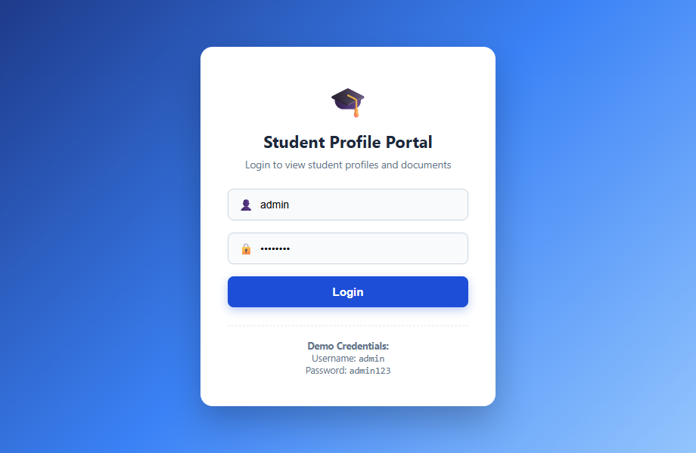
Figure 3.1: Student Profile Portal Login Screen
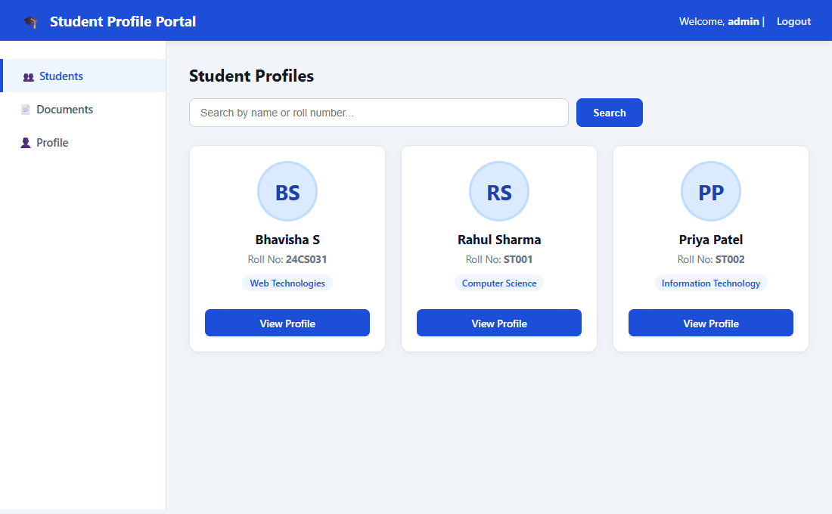
Figure 3.2: Dynamic Student Directory with Profile Cards & Search
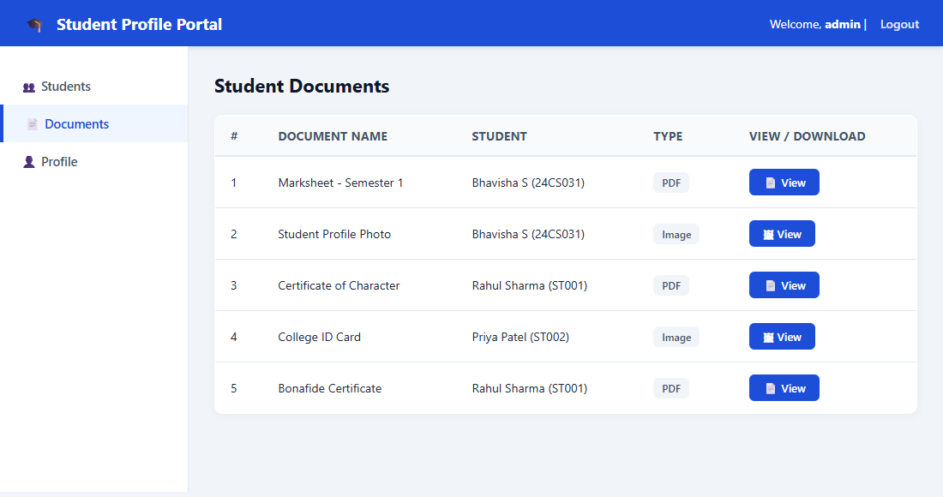
Figure 3.3: Student Document Repository View

Conclusion:
The Student Profile Portal was developed using Java Servlets (Jakarta EE 6.0), JSP, JSTL, JDBC, and MySQL. It displays student details and provides secure, streamed access to images and PDF documents directly through FileServlet, preventing direct server directory exposure. Session management safeguards all portal endpoints against unauthorized browsing. The architecture demonstrates MVC separation of concerns, secure file streaming, and responsive presentation.

