A Project Report
on
Dungeon Explorer
Submitted in partial fulfillment of the requirement of
Project – VI (BIT356CO)
Bachelor in Information Technology

Submitted to

Purbanchal University
Biratnagar, Nepal

Submitted by
Alisha Shahi (360801)
Bhavishek Lama (360805)
Riya Phuyal (360826)

KANTIPUR CITY COLLEGE
Putalisadak, Kathmandu
October,2026
A Project Report
on
Dungeon Explorer
Submitted in partial fulfillment of the requirement of
Project – VI (BIT356CO)
Bachelor in Information Technology

Submitted To
Purbanchal University
Biratnagar, Nepal
Submitted By
Alisha Shahi (360801)
Bhavishek Lama (360805)
Riya Phuyal (360826)

Project Supervisor
Er Maryada Karki
Santosh Sah

KANTIPUR CITY COLLEGE
Putalisadak, Kathmandu
October, 2026

Abstract
Dungeon Explorer is a 2D tile-based action-adventure game developed using Python, designed to provide an engaging and dynamic gaming experience through AI-based procedural map generation. Players create or select an explorer profile explore dynamically generated dungeons, collect resources, find key-and-door objectives, fight monsters, and manage health, stamina, and inventory items. To improve replayability, the game generates a new dungeon for each run using a hybrid procedural generation pipeline. A genetic algorithm produces candidate layouts, cellular automata smooth terrain, breadth-first search repairs disconnected areas and measures reachability, and A* pathfinding validates routes for entities and objectives. The game also incorporates profile persistence through JSON files and uses recent player performance to adjust future monster limits through an explainable rule-based system. This project demonstrates the integration of game development, procedural content generation, pathfinding, artificial intelligence, adaptive difficulty, user interface design, and local data persistence within a single-player desktop application

Acknowledgement
We would like to express our heartfelt gratitude to everyone who has supported and encouraged us throughout the completion of this project.
First and foremost, our sincere thanks go to Purbanchal University for introducing such a practical and insightful course, which has provided us with the platform to explore and enhance our technical and academic capabilities.
We are deeply grateful to the entire team of Kantipur City College (KCC) for providing us with this valuable opportunity. We would especially like to extend our appreciation to the Principal of KCC, whose support and leadership have been instrumental in fostering an environment of learning and growth.
A special note of thanks goes to our respected supervisors, Santosh Sah and Maryada Karki, whose consistent encouragement, guidance and rich knowledge helped us throughout the course of this project. Their mentorship has been invaluable, and we could not have asked for better mentors.
We also acknowledge the contributions of each team member and our classmates, who shared suggestions, advice and experiences that greatly enriched this project.
Finally, we extend our warmest thanks to our friends and family who supported us both directly and indirectly. Your encouragement and help made this journey smoother and more meaningful.

Alisha Shahi (360801)
Bhavishek Lama (360805)
Riya Phuyal (360826)

Declaration
We declare that this project report titled “Dungeon Explorer”, submitted in partial fulfillment of the Bachelor of Information Technology, is a record of original work carried out by us under the supervision of Santosh Sah and Maryada Karki, and has not formed the basis for the award of any other degree or Diploma, in this or any other institution or University. In keeping with the ethical practice of reporting scientific information, due acknowledgments have been made wherever the findings of others have been cited.

Alisha Shahi (360801)
Bhavishek Lama (360805)
Riya Phuyal (360826)

Supervisor’s Approval
This is to certify that the project entitled “Dungeon Explorer”, undertaken and demonstrated by Alisha Shahi, Bhavishek Lama and Riya Phuyal, has been successfully completed under our supervision as a partial fulfillment of the requirements of the degree of Bachelor of Information Technology, sixth semester, under Purbanchal University. We, henceforth, approve this project to be awarded the certificate by the concerned authority. During supervision, we found the students hardworking, skilled and ready to undertake any professional work related to this field in the future.

Mr. Santosh Sah | Er. Maryada Karki
Project Supervisor | Project Supervisor
Department of IT | Department of IT

Certificate From Department
Following the Supervisor’s Approval and Examiner’s Acceptance, the project entitled “Dungeon Explorer”, submitted by Alisha Shahi, Bhavishek Lama and Riya Phuyal as a partial fulfillment of the requirements for the degree of BIT VI, under Purbanchal University, has been officially awarded by this certificate. We wish the students all the best for their future endeavors.

Mr. Saroj Pandey | Mr. Rubim Shrestha
Head of Department | Project Coordinator
Department of IT | Department of IT
Kantipur City College | Kantipur City College

Table of Contents

Abstract iii
Acknowledgement iv
Declaration v
Supervisor’s Approval vi
Certificate From Department vii
List of Figures xi
List of Tables xii
List of Abbreviations xiii
1 Introduction 1
1.1 Overview 1
1.2 Problem Statement 1
1.3 Objectives 2
1.4 Features 2
1.5 Significance 3
1.6 Scope and Limitations 4
1.7 Documentation Organization 5
2 Literature Review 6
2.1 F.E.A.R. (2005) 6
2.2 Pac-Man (1980) 7
2.3 Left 4 Dead 7
2.4 Terraria (2011) 8
3 Methodology 9
3.1 Software Development Life Cycle 9
3.1.1 Iteration 1: Core Engine Development 9
3.1.2 Iteration 2: Procedural Dungeon Generation 10
3.1.3 Iteration 3: Monster AI and Combat 10
3.1.4 Iteration 4: Items, Gameplay and Player Progression 11
3.1.5 Iteration 5: Adaptive Difficulty and Player Analysis 12
3.1.6 Iteration 6: Integration and Final System Development 12
3.2 Technologies and Tools Used 13
3.2.1 Programming Language 13
3.2.2 Game Library 13
3.2.3 Data Storage 13
3.2.4 Development Environment and Version Control 14
3.3 AI and Data Mining Techniques Implemented 14
3.4 Assignment of Roles and Responsibilities 15
4 System Analysis 16
4.1 Requirement Analysis 16
4.1.1 Requirement Gathering 16
4.1.2 Functional Requirements 17
4.2 Feasibility Study 18
4.2.1 Technical Feasibility 18
4.2.2 Operational Feasibility 18
4.2.3 Economic Feasibility 18
4.2.4 Schedule Feasibility 19
5 System Design and Implementation 20
5.1 System Architecture 20
5.1.1 Presentation Layer 20
5.1.2 Gameplay Layer 20
5.1.3 Rendering Layer 21
5.1.4 AI and Procedural Generation Layer 21
5.1.5 Data and Persistence Layer 21
5.2 Procedure Oriented Diagrams 22
5.2.1 Data Flow Diagram — Level 0 22
5.2.2 Data Flow Diagram — Level 1 23
5.2.3 Use Case Diagram 24
6 System Development and Implementation 25
6.1 Programming Platform 25
6.2 Hardware and Software Requirements 25
6.2.1 Hardware Requirements 25
6.2.2 Software Requirements 26
7 Testing and Debugging 27
7.1 Testing Approach 27
7.2 Tools Used in Testing 27
7.3 Test Cases 28
7.3.1 Profile and Session Module 28
7.3.2 Procedural Map Generation and AI Modules 28
7.3.3 Gameplay, Combat and Collision 29
7.3.4 Monster AI 29
7.3.5 Items, Progression and Persistence Module 30
8 Conclusion and Future Work 31
References 32

List of Figures
Figure 4-1:Gantt chart 19
Figure 5-1 System Architecture of Dungeon Explorer 20
Figure 5-2: Data Flow Diagram — Level 0 (Context Diagram) 22
Figure 5-3 Data Flow Diagram — Level 1 23
Figure 5-4 : Use Case Diagram 24

List of Tables
Table 3-1: Core Engine Development 9
Table 3-2: Procedural Dungeon Generation 10
Table 3-3: Monster AI and Combat 10
Table 3-4: Items, Gameplay and Player Progression 11
Table 3-5: Adaptive Difficulty and Player Analysis 12
Table 3-6: :Integration and Final System Development 12
Table 3-7: AI and Data Mining Techniques Used 14
Table 3-8: Assignment of Roles and Responsibilities 15
Table 4-1: Requirement Gathering 16
Table 4-2: Functional Requirements 17
Table 7-1: Tools Used in Testing 27
Table 7-2: Test Cases - Profile and Session Module 28
Table 7-3: Test Cases - Procedural Map Generation and AI Modules 28
Table 7-4: Test Cases - Gameplay, Combat and Collision 29
Table 7-5: Test Cases – Monster AI 29
Table 7-6: Test Cases - Items, Progression and Persistence Module 30

List of Abbreviations
AI : Artificial Intelligence
A* : A-Star (admissible heuristic pathfinding)
BFS : Breadth-First Search
CA : Cellular Automata
CSV : Comma-Separated Values
DFD : Data Flow Diagram
DTD : Document Type Definition
ER : Entity Relationship
FIFO : First In, First Out
FPS : Frames Per Second
GA : Genetic Algorithm
GUI : Graphical User Interface
HUD : Head-Up Display
IDE : Integrated Development Environment
JSON : JavaScript Object Notation
LOD : Level of Detail
NPC : Non-Player Character
PC : Personal Computer
RAM : Random Access Memory
SDLC : Software Development Life Cycle
SPA : Single-Page Application
UI : User Interface
XP : Experience Points

Introduction

Overview
Dungeon Explorer is a 2D procedural action-adventure game developed in Python using the Pygame library. Players create or select an explorer profile, and enter a randomly generated dungeon filled with monsters, treasures, keys, potions, traps, water, lava, and locked objectives.
The game uses a hybrid map-generation system that combines genetic algorithms, cellular automata, breadth-first search, and A* pathfinding. These techniques create different dungeon layouts while ensuring that important areas remain accessible. Players explore the environment, collect items, fight monsters using projectiles, manage health and stamina, and unlock doors by finding the required keys.
Dungeon Explorer also includes inventory management, character progression, persistent player profiles, scheduled monster spawning, and adaptive difficulty. Recent gameplay results influence the number of monsters generated in future runs.

Problem Statement
Most two-dimensional dungeon games rely on maps that were designed by hand or assembled from pre-built rooms. This creates a number of practical problems, which the project set out to address:
▪ Repetitive gameplay: Once a player has memorized a fixed level, replaying it adds nothing. Large hand-authored worlds are also extremely expensive to produce, so most games of this scale reuse a small number of levels.
▪ Poor replay value from randomness alone: Simply filling a grid with random tiles does not produce a good level. The result is usually full of unreachable regions, single-tile artefacts and awkward bottlenecks that make the level frustrating rather than interesting.
▪ Difficulty does not adapt: Fixed maps offer the same challenge to every player, whether they are playing for the first time or have completed the level fifty times.
▪ Behavioral data is not used: Player actions are normally discarded once a session ends, so nothing is learned about how people actually play, and no improvement is made to later content.

Objectives
The objectives of the project are:
- To develop a playable 2D tile-based dungeon game in Python using Pygame, featuring procedurally generated and fully playable cave-like levels using AI techniques.
- To implement an adaptive gameplay system that analyzes player behavior to dynamically adjust monster density and difficulty.

Features
Dungeon Explorer implements the following features:
- Player Profile Management: The system allows players to create, switch, and manage multiple local profiles. Each profile maintains its own progress, inventory, experience, and gameplay history.
- Procedural Dungeon Generation: A new 81 × 81 dungeon is automatically generated whenever a new gameplay run begins, providing different layouts, item placements, and monster positions for each gameplay session.
- Guaranteed Level Playability: The generated dungeon is validated using Breadth-First Search (BFS) to ensure that the areas are connected and accessible from the player’s starting position.
- Player Movement and Collision Detection: The player can move through the dungeon using keyboard controls with tile-based collision detection to prevent movement through walls and other obstacles.
- Sprinting and Stamina Management: Players can sprint to move faster, but sprinting consumes stamina. Stamina automatically regenerates when sprinting is stopped.
- Aiming and Ranged Combat: The player can aim using the mouse and attack enemies with projectiles. Directional shooting animations and a controlled firing rate provide consistent combat behavior.
- Monster Artificial Intelligence: Monsters use a rule based, FSM-like behavior to manage actions such as becoming active, chasing the player, and attacking.
- A* Pathfinding: Monsters use A* pathfinding to navigate through the dungeon and find suitable routes toward the player while avoiding obstacles.
- Environmental Hazards: The dungeon contains hazards such as lava, traps, and water that affect the movement or health of both player and monster.
- Fog of War: Areas outside the player's visibility range remain hidden, creating an exploration challenge. Certain items can improve or remove the visibility limitation.
- Items, Chests, and Keys: The game includes health and stamina items, keys, treasure chests, and special utility items that provide additional abilities or advantages.
- Inventory System: Players can access an inventory during gameplay to view and use available consumable items. A separate inventory view is also available through the menu.
- Experience and Leveling System: Players gain experience by defeating monsters. Accumulated experience allows the player to level up, with increasing experience requirements for subsequent levels.
- Player Statistics: A statistics screen displays information such as player level, experience, games played, completed games, monster kills, item usage, and recent gameplay results.

Significance
- The project demonstrates the practical use of Artificial Intelligence algorithms in 2D game development.
- It provides dynamic and replayable gameplay by generating a different dungeon layout, item placement, and monster arrangement for each new gameplay run.
- It reduces the need for manual designing every dungeon by using procedural map generation and optimization techniques.
- The project helps demonstrate how data mining and player behavior analysis can be used to improve future gameplay and map generation.
- It provides practical learning experience in Python, AI algorithms, procedural generation, and game development for students.

Scope and Limitations
Scope
The project is a single-player desktop game designed to run on Windows, Linux, and macOS. It generates, validates, and runs procedurally generated dungeon levels. Monster behavior uses rule-based, FSM-like logic combined with A* pathfinding. Dungeon selection and monster limits can be adapted using recent gameplay history. The project also includes a local JSON persistence layer that stores player profiles, inventory, experience, monster kills, item usage, and recent game outcomes.
Limitations
The following features were considered but could not be implemented within the time available:
- The game is single-player and does not support multiplayer networking.
- The player behavior data is limited to a small number of recent gameplay sessions, so the data mining results are limited.
- The Genetic Algorithm uses a fixed population of eight candidates and limited generations (four) to reduce map-generation time.
- The map optimization focuses mainly on connectivity and exploration space and does not consider all aspects of game difficulty.
- Monster behavior uses predefined rules and does not include individual learning, reinforcement learning, or advanced group coordination.
- Very large dungeon maps may affect performance.
- The monster system is FSM-like but does not use a formal finite-state-machine class.

Documentation Organization
This report is organized into eight chapters. Chapter 1 introduces the project and states its objectives, features, scope and limitations. Chapter 2 reviews the commercial and academic games that use comparable techniques and identifies what the proposed system borrows from each. Chapter 3 describes the development methodology, the technologies used, the AI and data-mining techniques implemented, and the division of work among the team members. Chapter 4 presents the requirement analysis, the functional requirements and the feasibility study, together with the project schedule. Chapter 5 is the core of the report: it describes the system architecture, the overall game flow, the internal flow of the application and, in detail, the AI subsystem and the monster artificial intelligence, supported by data flow diagrams, a use case diagram and an entity-relationship model. Chapter 6 covers system development and implementation, including the hardware and software environment. Chapter 7 presents the testing approach and the test cases for each module. Finally, Chapter 8 concludes the report and identifies future improvements.

Literature Review
Artificial Intelligence and procedural generation have become important techniques in modern games for creating intelligent enemies, dynamic environments, and replayable gameplay. Different games use AI algorithms and procedural techniques to control enemy behavior, generate game worlds, and adapt gameplay according to player actions. This review examines existing games related to the proposed Dungeon Explorer system, highlighting their advantages and limitations and identifying the concepts adopted in the proposed project.

F.E.A.R. (2005)
F.E.A.R. is a first-person action game known for its intelligent enemy behavior. Its enemies use a Finite State Machine (FSM), Goal-Oriented Action Planning (GOAP), and A* pathfinding to respond to the player's actions. Enemies can patrol, search, attack, take cover, and move strategically through the environment.
Pros:
- Provides realistic and responsive enemy behavior.
- Uses FSM to organize different enemy states.
- Uses A* pathfinding for effective navigation.
- Demonstrates how relatively simple AI techniques can create convincing enemy behavior.
Cons:
- GOAP adds complexity to the AI system.
- Designed for a commercial 3D game and therefore is more complex than required for a small 2D project.
- Its advanced enemy behavior requires considerable development resources.
Relevance to Proposed System:
F.E.A.R. provides a reference for monster AI in Dungeon Explorer. The proposed system uses FSM and A* pathfinding to allow monsters to detect, chase, and attack the player while navigating around obstacles.

Pac-Man (1980)
Pac-Man is a classic arcade game that demonstrates simple but effective artificial intelligence. Ghosts use different movements and target behaviors while sharing basic behavioral states. This allows different enemies to behave differently without requiring highly complex algorithms.
Pros:
- Demonstrates simple and understandable game AI.
- Different enemy behaviors create variety in gameplay.
- Use a tile-based environment suitable for pathfinding.
- Efficient and suitable for resource-limited systems.
Cons:
- Enemy behavior is relatively simple.
- Does not provide complex adaptive difficulty.
- The fixed maze structure limits environmental variation.
Relevance to Proposed System:
Pac-Man demonstrates that different enemy behaviors can be created by modifying parameters within a common AI structure. Dungeon Explorer follows a similar approach by using a common FSM for its monster types while changing their movement and attack characteristics.

Left 4 Dead
Left 4 Dead is a cooperative survival game that introduced the “AI Director”, which monitors player performance and dynamically controls gameplay elements such as enemy spawning and attack intensity. The system aims to maintain an appropriate level of challenge based on the player's current situation.
Pros:
- Provides dynamic difficulty adjustment.
- Responds to player behavior and performance.
- Improves replayability by changing gameplay conditions.
- Combines local enemy AI with global gameplay management.
Cons:
- The AI Director is complex to implement.
- Designed for multiplayer gameplay, while Dungeon Explorer focuses on single-player gameplay.
- Requires continuous monitoring of several gameplay parameters.
Relevance to Proposed System:
Left 4 Dead provides the main inspiration for the adaptive difficulty feature of Dungeon Explorer. The proposed system records player behavior and uses rule base association to adjust monster density in subsequent runs according to the player's demonstrated performance.

Terraria (2011)
Terraria is a 2D sandbox adventure game that uses procedural generation to create unique worlds containing caves, terrain, structures, resources, and enemies. Its procedural approach provides high replayability by generating different environments for different game sessions.
Pros:
- Provides high replayability through procedural world generation.
- Generates natural-looking caves and environments.
- Uses rule-based techniques for placing structures and resources.
- Demonstrates the effectiveness of procedural generation in a 2D game.
Cons:
- The generated world is much larger and more complex than the dungeon required for this project.
- Most gameplay difficulty does not adapt directly to individual player performance.
- Its world-generation system is highly complex for a small-scale project.
Relevance to Proposed System:
Terraria is particularly relevant to the procedural dungeon generation component of Dungeon Explorer. The proposed system similarly uses Cellular Automata to create cave-like environments and connectivity checking to ensure that the generated dungeon remains playable.

Methodology

Software Development Life Cycle
This project follows the Agile Model to ensure the systematic and flexible development of the Dungeon Explorer game. The system is developed through multiple iterations, where each iteration delivers a functional version of the game with additional features and improvements. Continuous testing and refinement are performed throughout the development process to ensure that the gameplay, AI components, procedural generation, and adaptive difficulty work correctly.

Iteration 1: Core Engine Development
Table 3-1: Core Engine Development
Phase | Details
Requirement Gathering & Analysis | Identified the basic requirements of the game, including player movement, dungeon environment, collision detection, game objectives, and basic enemy interaction.
System Design | Designed the basic game structure, tile-based map, player and entity classes, screen management, and game loop.
Implementation | Implemented the Pygame environment, player movement, tile-based collision, basic dungeon map, game screens, and core game loop.
Testing | Tested player movement, collision detection, screen transitions, and basic gameplay to identify and fix initial errors.

Iteration 2: Procedural Dungeon Generation
Table 3-2: Procedural Dungeon Generation
Phase | Details
Requirement Gathering & Analysis | Identified the need for unique and replayable dungeon layouts instead of fixed maps.
System Design | Designed the procedural generation pipeline using Genetic Algorithm, Cellular Automata, BFS connectivity checking, and fitness evaluation.
Implementation | Implemented the 81 × 81 dungeon generation system, cave carving using Cellular Automata, candidate evaluation using a Genetic Algorithm, and BFS-based connectivity validation and repair.
Testing | Generated multiple dungeon layouts and tested their connectivity, structure, playability, and variation.

Iteration 3: Monster AI and Combat
Table 3-3: Monster AI and Combat
Phase | Details
Requirement Gathering & Analysis | Identified the need for intelligent enemies capable of detecting, chasing, and attacking the player.
System Design | Designed the monster with rule-based FSM-like behavior with states such as Dormant, Wake, Chase, and Attack. A* pathfinding was selected for obstacle-aware navigation.
Implementation | Implemented different monster types, FSM-based behavior, A* navigation, player aiming, projectile attacks, enemy attacks, and combat interactions.
Testing | Tested monster state transitions, pathfinding around obstacles, attack behavior, collision, and combat interactions.

Iteration 4: Items, Gameplay and Player Progression
Table 3-4: Items, Gameplay and Player Progression
Phase | Details
Requirement Gathering & Analysis | Identified additional gameplay requirements including items, inventory, keys, treasure chests, environmental hazards, fog of war, experience, and player progression.
System Design | Designed the inventory, item management, experience and levelling system, environmental hazards, fog of war, and game progression mechanisms.
Implementation | Implemented health and stamina items, Door Key, treasure chests, Bow, Light, inventory system, sprinting, environmental hazards, fog of war, experience, and levelling.
Testing | Tested item collection and usage, inventory operations, key and chest interactions, hazard effects, experience calculation, and level progression.

Iteration 5: Adaptive Difficulty and Player Analysis
Table 3-5: Adaptive Difficulty and Player Analysis
Phase | Details
Requirement Gathering & Analysis | Identified the need for the game to adjust difficulty according to the player's actual performance rather than using a fixed difficulty level.
System Design | Designed a player-history system to record kills, item usage, level completion, coins, and recent gameplay results. Association Rule analysis was selected to identify patterns in player behavior.
Implementation | Implemented gameplay history recording, Association Rule analysis, adaptive monster limit, profile statistics, and difficulty adjustment based on recent player performance.
Testing | Tested player-history recording, rule generation, difficulty adjustments, and whether monster limit changed appropriately according to different player performance patterns.

Iteration 6: Integration and Final System Development
Table 3-6: Integration and Final System Development
Phase | Details
Requirement Gathering & Analysis | Identified the need to integrate all game components into a stable and complete system.
System Design | Planned the integration of gameplay, procedural generation, monster AI, combat, inventory, player profiles, persistence, statistics, and adaptive difficulty.
Implementation | Integrated all modules into the complete Dungeon Explorer system and implemented profile management, data persistence, run rollback, statistics, and final game flow.
Testing | Conducted end-to-end testing of complete gameplay sessions, procedural generation, AI behavior, combat, inventory, progression, adaptive difficulty, and data persistence. Bugs were fixed and the final system was refined for stable operation

Technologies and Tools Used

Programming Language
Python is the primary programming language used to develop the Dungeon Explorer system. Python was selected because of its simplicity, flexibility, and extensive standard library support. Libraries such as collections.deque, heapq, random, secrets, json, and data classes support algorithms including BFS, A* pathfinding, random generation, data persistence, and game-world modelling. The project also uses Pygame for game development and graphical rendering. The major AI, procedural generation, and data-mining algorithms are implemented directly in Python rather than relying on pre-built AI or data-mining frameworks.

Game Library
Pygame CE (pygame-ce 2.5.8) is used as the primary game development library. It provides the functionality required for window management, event handling, keyboard and mouse input, sprite rendering, collision detection, image processing, transformations, and font handling. Pygame is mainly used for the presentation and input layers, while the core game logic, procedural generation, and AI algorithms are implemented separately to maintain a modular system.

Data Storage
The system uses JSON for local data storage. Player profiles, progress, inventory, statistics, and gameplay history are stored in a JSON file using Python's built-in json module. JSON was selected because the application is a single player, locally running system and does not require a separate database server. It is lightweight, easy to manage, and human-readable, making it suitable for storing and inspecting game data during development and testing.

Development Environment and Version Control
The project is developed using Visual Studio Code (VS Code) with the Python extension. A dedicated Python virtual environment is used to manage the project dependencies. Git and GitHub are used for version control, allowing changes to be tracked throughout development and providing a reliable way to manage different development stages and maintain previous versions of the project.

AI and Data Mining Techniques Implemented
The Dungeon Explorer system implements several Artificial Intelligence (AI) and Data Mining techniques for procedural dungeon generation, enemy navigation, map evaluation, and adaptive difficulty. These techniques work together to generate playable dungeon layouts and adjust gameplay according to player behavior. Below table presents the techniques, their source modules, and their roles in the system.
Table 3-7: AI and Data Mining Techniques Used
Technique | Source module | Role in the system
Genetic Algorithm | genetic_algorithm.py | Evolves candidate dungeon layouts through multiple generations to produce improved map structures.
Cellular Automata | cellular_automata.py | Converts raw random patterns into natural-looking cave structures using neighborhood-based rules.
Breadth-First Search | bfs.py | Finds reachable cells, calculates distances, evaluates connectivity, and repairs disconnected walkable regions.
A* Pathfinding | astar.py | Finds walkable paths through the dungeon and enables monsters to navigate around obstacles toward the player.
Profile-based Decisions | decision_tree.py | Scores and selects candidate maps using reachability, openness, level, kills, and item usage.
Association Rule Analysis | decision_tree.py | Calculates recent-history confidence values and uses them to adjust the next run’s monster limit.

Assignment of Roles and Responsibilities
Table 3-8: Assignment of Roles and Responsibilities
Group member | Technical responsibilities | Documentation responsibilities
Alisha Shahi | • Game loop and ScreenManager architecture  • Player and Monster classes  • Collision detection and combat system  • A Pathfinding for monster navigation*  • Breadth-First Search (BFS) for connectivity validation  • Level completion and death-state handling | • Chapter 1: Introduction  • Chapter 2: Literature Review  • Chapter 4: System Analysis
Bhavishek Lama | • Procedural dungeon generation  • Genetic Algorithm for dungeon optimization  • Cellular Automata for cave generation  • Decision Tree-based fitness evaluation  • Map-generation integration and testing | • Chapter 5: System Design and AI subsystem  • Chapter 6: Development and Implementation
Riya Phuyal | • User interface and screen modules  • Setup, menu, inventory, profile, and pause screens  • Button and TextInput components  • WorldRenderer and sprite handling  • Association Rule Mining for adaptive difficulty  • Profile and gameplay-data persistence | • Chapter 3: Methodology  • Chapter 7: Testing and Debugging

System Analysis

Requirement Analysis
Requirement analysis is the process of identifying and documenting the functional and non-functional needs of a system. It helps define what the system should do and how it should perform.
In this project, requirement analysis identifies the needs of the Dungeon Explorer game developed using Python and Pygame CE. The analysis focuses on player movement, combat, items, enemy behavior, user interface, profiles, and game progress. It also defines the requirements for AI-based procedural generation using Genetic Algorithm, Cellular Automata, BFS, A* Pathfinding, rule-based Decision, and Association Rule Analysis. A key requirement is that every generated dungeon must be connected and playable.

Requirement Gathering
Requirement gathering is the process of identifying user needs and system expectations. In this project, requirements were gathered through team discussions, game analysis, prototype testing, and supervisor feedback, focusing on gameplay, AI-based generation, enemy behavior, and adaptive difficulty.
Table 4-1: Requirement Gathering
ID | Requirement
R1 | The system shall allow the player to create and manage local game profiles.
R2 | The system shall generate a new playable dungeon using procedural generation techniques.
R3 | The system shall use Genetic Algorithm, Cellular Automata, BFS, A* Pathfinding, and profile-based decision techniques for dungeon generation, validation.
R4 | The system shall check generated dungeons are connected and playable by repairing unreachable areas.
R5 | The system shall provide player movement, combat, items, inventory, and enemy interaction.
R6 | The system shall provide intelligent monster behaviour using FSM-like behaviour and A* Pathfinding.
R7 | The system shall analyse recent player history using Association Rule to adapt monster density and difficulty.
R8 | The system shall store player profiles, progress, inventory, statistics, and gameplay history using local JSON persistent.

Functional Requirements
Table 4-2: Functional Requirements
ID | Function | Cross Reference
F1 | Create, select, and load a local player profile. | R1
F2 | Generate a new dungeon layout for each new gameplay run. | R2, R3
F3 | Evaluate dungeon layouts and select a suitable playable layout. | R3
F4 | Validate dungeon connectivity using BFS and repair unreachable regions. | R4
F5 | Move the player with collision detection, camera following, and fog of war. | R5
F6 | Allow the player to attack monsters using projectiles and receive damage from enemies. | R5
F7 | Manage items, chests, keys, inventory, and the locked exit door. | R5
F8 | Control monster behavior using FSM-like behaviors and A* Pathfinding. | R6
F9 | Record player actions and recent run outcomes for gameplay analysis. | R7
F10 | Apply lightweight Association Rule Analysis to adjust monster density for subsequent levels. | R7
F11 | Save and load player progress, inventory, statistics, and gameplay history using JSON. | R8
F12 | Track experience, level progression, kills, and game statistics. | R8

Feasibility Study
Feasibility study determines whether the proposed system can be developed successfully using the available technology, resources, budget, and time. For Dungeon Explorer, feasibility is evaluated under four main aspects: technical, operational, economic, and schedule feasibility.

Technical Feasibility
Technical feasibility assesses whether the required technologies and skills are available and suitable. For this project:
- Python and Pygame CE are used for game development.
- The project implements BFS, A*, genetic operations, cellular-automata smoothing, and profile-analysis rules directly in Python using standard libraries such as collections, heapq, and random.
- The team has the required skills in programming, AI, and game development.
The system is technically feasible as the required tools and expertise are available.

Operational Feasibility
Operational feasibility evaluates whether the system can be easily operated by its users. For this project:
- The game provides a simple menu and user interface.
- Basic keyboard and mouse controls are used for gameplay.
- The game operates locally without requiring an internet connection.
The system is operationally feasible.

Economic Feasibility
Economic feasibility evaluates whether the project can be developed at a reasonable cost. For this project:
- Python, Pygame CE, VS Code, Git, and GitHub are free to use.
- No special hardware or paid software is required.
- Development is carried out using existing computers.
The project is economically feasible with minimal development cost.

Schedule Feasibility
Schedule feasibility examines whether the project can be completed within the available time frame. For this project:
- Development is completed within the allocated project period.
- Major activities include requirement analysis, design, implementation, testing, and documentation.
- Tasks are divided among team members.
The project is schedule feasible and can be completed within the given time.

Gantt chart
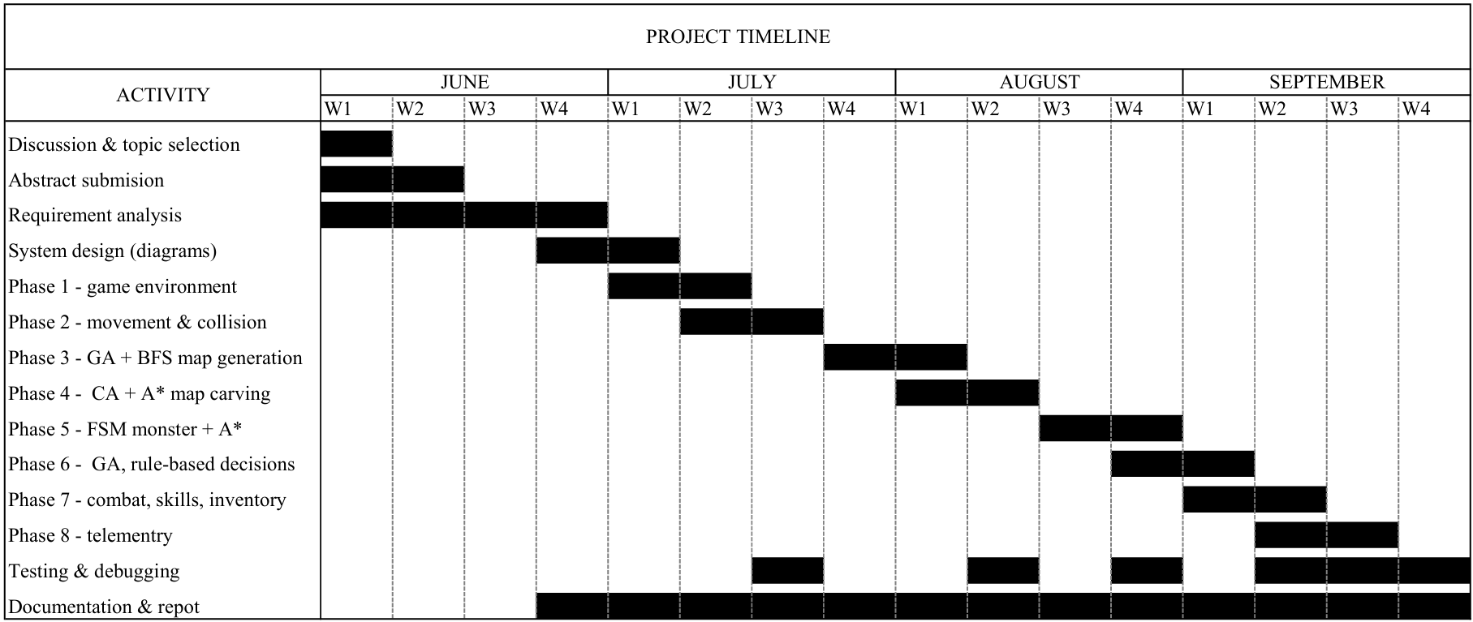
Figure 4-1:Gantt chart

System Design and Implementation

System Architecture
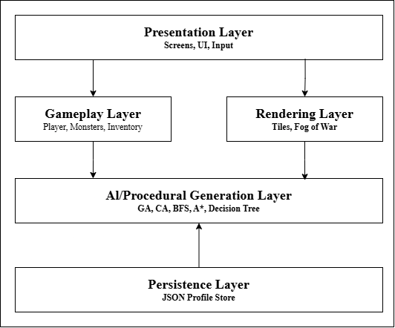
Dungeon Explorer follows a layered architecture that separates the user interface, gameplay, rendering, AI-based dungeon generation, and data persistence. This structure improves modularity and makes the system easier to develop and maintain.
Figure 5-1 System Architecture of Dungeon Explorer

Presentation Layer
- Provides menus, game screens, inventory, profile, and pause interfaces.
- Handles keyboard and mouse input.
- Displays game information to the player.

Gameplay Layer
- Manages player movement, collision, combat, items, inventory, and game progression.
- Controls monster behavior using Finite State Machine ideology.
- Handles level completion, death, and game states.

Rendering Layer
- Renders dungeon tiles, players, monsters, items, effects, and environmental elements.
- Manages camera movement and fog of war.
- Uses Pygame CE for visual rendering.

AI and Procedural Generation Layer
This layer provides the intelligent features of the game:
- Genetic Algorithm (GA): evolves candidate dungeon layouts.
- Cellular Automata (CA): smooths local terrain patterns.
- BFS: checks dungeon connectivity and repairs unreachable areas.
- A* Pathfinding: find paths for monster navigation and assist with entity placement.
- Profile-based Decision evaluates generated layouts using gameplay and level-based criteria.
- Association Rule: lightweight association-rule analysis adjusts the monster limit for the next run.

Data and Persistence Layer
- Stores player profiles, inventory, statistics, progress, and gameplay history.
- Uses JSON for local data storage.
- Supports saving, loading, and rollback of game progress.

Procedure Oriented Diagrams

Data Flow Diagram — Level 0
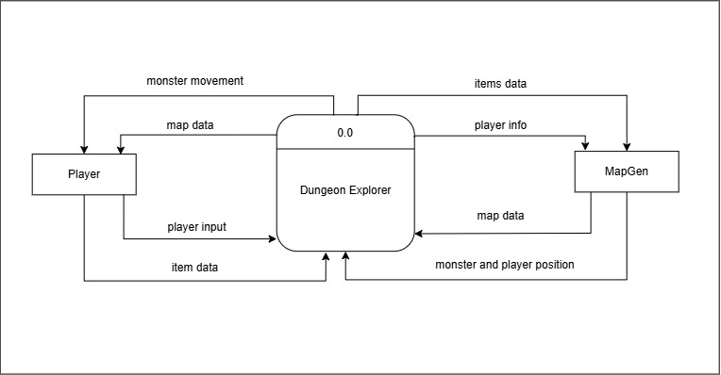
Figure 5-2: Data Flow Diagram — Level 0 (Context Diagram)

Data Flow Diagram — Level 1
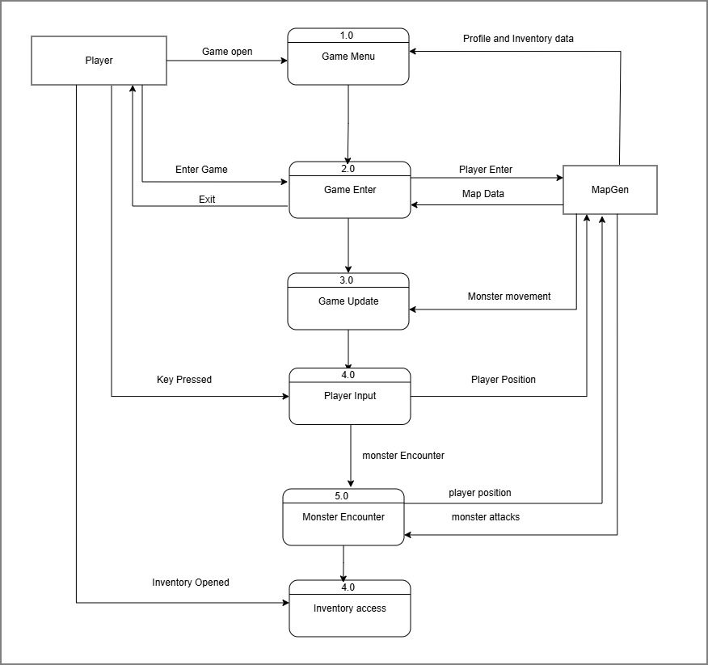
Figure 5-3 Data Flow Diagram — Level 1

Use Case Diagram
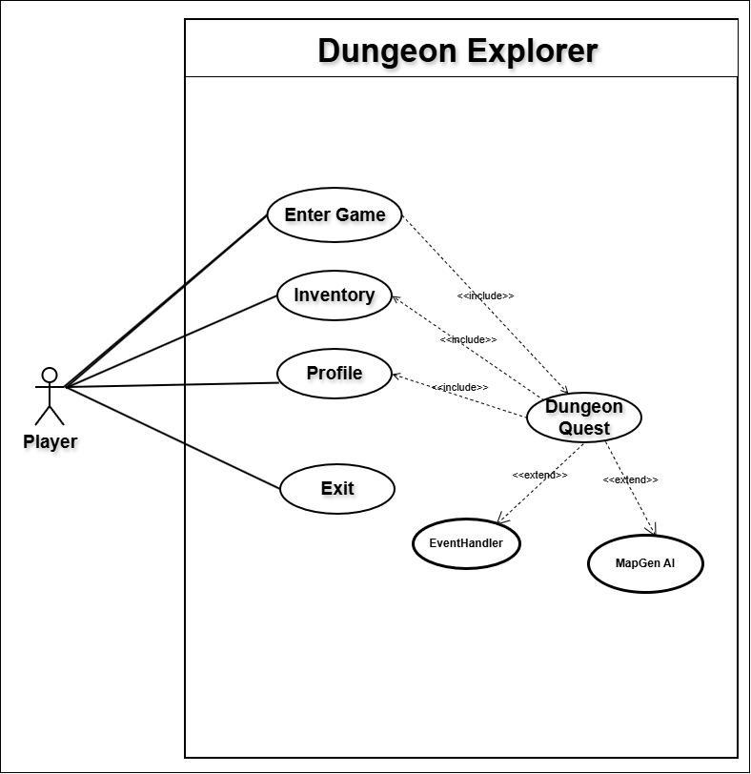
Figure 5-4 : Use Case Diagram

System Development and Implementation

Programming Platform
1. Main Language: Python 3
- Python is used as the main programming language for game development, gameplay logic, AI algorithms, data-mining techniques, and data persistence.
2. Game Library: Pygame CE 2.5.8
- Pygame CE is used for game development, including window management, keyboard and mouse input, game rendering, collision detection, sprites, images, and fonts.
3. Integrated Development Environment: Visual Studio Code
- Visual Studio Code with the Python extension is used for coding, debugging, testing, and project development.
4. Version Control: Git and GitHub
- Git is used to track changes and manage different versions of the project, while GitHub is used to host the project repository.
5. Data Format: JSON
- JSON is used for storing player profiles, game progress, inventory, statistics, and gameplay history. It is suitable because the game is single-player and operates locally without requiring a database server.
6. Asset Pipeline
- PNG-based sprites and tile images are used for the player, monsters, items, and dungeon environment. These assets are managed within the project and loaded during gameplay.

Hardware and Software Requirements

Hardware Requirements
Recommended Requirements
- Processor: Intel Core i5 or AMD Ryzen 5 or faster
- RAM: 8 GB
- Storage: 500 MB free space
- Display: 1920 × 1080 resolution
No dedicated graphics card or internet connection is required to run the game.

Software Requirements
- Operating System: Windows 10 or 11, Linux, or macOS
- Python: 3.10 or later
- Game Library: Pygame CE 2.5.8
- Integrated Development Environment: Visual Studio Code with the Python extension
- Version Control: Git and GitHub
- Environment Management: Python Virtual Environment (venv)

Testing and Debugging
Testing was planned and carried out through module checks, to verify that the game functions correctly, generated dungeons are playable, AI algorithms work as expected, and player progress is properly maintained. Testing included AI validation, gameplay testing, and manual testing.

Testing Approach
The system was tested at three levels:
- AI and Procedural Testing: Generated dungeons were tested for connectivity, valid player spawn, reachable key and door, and proper pathfinding.
- Gameplay Testing: Player movement, collision, combat, items, inventory, monster behavior, level completion, and death/rollback were tested.
- Data and Adaptive Testing: Player profiles, saved progress, gameplay history, and adaptive monster difficulty were tested using different player scenarios.
Failed test cases were identified, corrected, and tested again to verify the fixes.

Tools Used in Testing
Table 7-1: Tools Used in Testing
S.N. | Tool | Specification and purpose
1 | Development hardware | Laptop with an AMD Ryzen 7 processor and 16 GB RAM, running Windows 11, used to run the game
2 | Python 3 | Testing AI algorithms and game logic
3 | Pygame CE 2.5.8 | Testing gameplay, input, rendering, and game behaviour
4 | Visual Studio Code | Debugging and inspecting program execution
5 | profiles.json inspection | Verifying saved profiles, progress, and gameplay history

Test Cases
The major functional and AI components of Dungeon Explorer were tested to verify their correctness and reliability.

Profile and Session Module
Table 7-2: Test Cases - Profile and Session Module
TC ID | Description | Input / Condition | Expected Output | Actual Output | Status
TC-P01 | Create player profile | Enter a valid player name | New profile is created | Profile created successfully | Pass
TC-P02 | Load existing profile | Select a saved profile | Profile data is loaded | Profile loaded successfully | Pass
TC-P03 | Save and restore progress | Play a level and restart the game | Previous progress is restored | Progress restored correctly | Pass

Procedural Map Generation and AI Modules
Table 7-3: Test Cases - Procedural Map Generation and AI Modules
TC ID | Description | Input / Condition | Expected Output | Actual Output | Status
TC-A01 | Generate dungeon | Start a new level | A valid 81 × 81 dungeon is generated | Dungeon generated successfully | Pass
TC-A02 | Check dungeon connectivity | Generate multiple dungeons and apply BFS | All walkable regions are reachable | All tested dungeons were connected | Pass
TC-A03 | Test A* pathfinding | Monster and player placed with obstacles between them | A valid path is found | Monster reached the player | Pass
TC-A04 | Test adaptive difficulty | Provide different recent player histories | Monster limit changes according to the history | Monster count adjusted correctly | Pass

Gameplay, Combat and Collision
Table 7-4: Test Cases - Gameplay, Combat and Collision
TC ID | Description | Input / Condition | Expected Output | Actual Output | Status
TC-G01 | Player movement | Press WASD or arrow keys | Player moves in the selected direction | Player moved correctly | Pass
TC-G02 | Wall collision | Move player into a wall | Player cannot pass through the wall | Collision worked correctly | Pass
TC-G03 | Player attack | Aim and fire at a monster | Monster receives damage | Monster was damaged successfully | Pass
TC-G04 | Environmental hazard | Move player into lava or trap | Player receives the defined damage/effect | Damage/effect applied correctly | Pass

Monster AI
Table 7-5: Test Cases – Monster AI
TC ID | Description | Input / Condition | Expected Output | Actual Output | Status
TC-M01 | Monster activation | Move player near a dormant monster | Monster changes to active state | Monster movement achieved | Pass
TC-M02 | Monster chase | Player is detected by monster | Monster follows the player | Monster chased the player correctly | Pass
TC-M03 | Monster attack | Player enters attack range | Monster attacks the player | Attack and damage worked correctly | Pass

Items, Progression and Persistence Module
Table 7-6: Test Cases - Items, Progression and Persistence Module
TC ID | Description | Input / Condition | Expected Output | Actual Output | Status
TC-I01 | Item collection | Player collects an item | Item is added to inventory | Item added successfully | Pass
TC-I02 | Door Key and level completion | Collect Door Key and open the locked door | Level is completed and progress is saved | Level completed and progress saved | Pass
TC-I03 | Experience and level-up | Defeat monsters and gain required XP | Player level increases | Level increased correctly | Pass
TC-I04 | Inventory persistence | Collect items and restart the game | Saved inventory is restored | Inventory restored correctly | Pass

Conclusion and Future Work
The Dungeon Explorer project successfully demonstrates the use of Artificial Intelligence and Data Mining techniques in a 2D tile-based dungeon game. The system generates different dungeon layouts, checks their connectivity, optimizes the maps, and adapts gameplay based on player behavior. The project also demonstrates practical use of Python, procedural generation, pathfinding, and game development concepts while providing a dynamic and replayable gaming experience.

References
Papp, T. (2020, April 23). F.E.A.R.: shortest path for realistic AI – Tamás P. Papp. https://www.lancaster.ac.uk/stor-i-student-sites/tamas-papp/2020/04/23/fear-shortest-path-for-challenging-ai/
Making sure you’re not a bot! (n.d.). https://developer.valvesoftware.com/wiki/Left_4_Dead_Design_Theory
Sheen, T., & Sheen, T. (2026, April 12). How Pac-Man Ghost AI Works the classic Chase algorithms. AI Ghost. https://aighost.co.uk/how-pac-man-ghost-ai-works-the-classic-chase-algorithms/
Pygame Front Page — pygame v2.6.0 documentation. (n.d.). https://www.pygame.org/docs/

