A Project Report
on
Dungeon Explorer
Submitted in partial fulfillment of the requirement of
Project – VI (BIT356CO)
Bachelor in Information Technology
Submitted To
Purbanchal University
Biratnagar, Nepal
Submitted By
Alisha Shahi (360801)
Bhavishek Lama (360805)
Riya Phuyal (360828)

KANTIPUR CITY COLLEGE
Putalisadak, Kathmandu
August, 2026

A Project Report
on
Dungeon Explorer
Submitted in partial fulfillment of the requirement of
Project – VI (BIT356CO)
Bachelor in Information Technology
Submitted To
Purbanchal University
Biratnagar, Nepal
Submitted By
Alisha Shahi (360801)
Bhavishek Lama (360805)
Riya Phuyal (360828)

Project Supervisor
Santosh Prakash Sah
Maryada Karki

KANTIPUR CITY COLLEGE
Putalisadak, Kathmandu
August, 2026

Abstract
Dungeon Explorer is a two-dimensional, tile-based dungeon action game developed in Python with the Pygame library. The player controls an explorer who descends into a procedurally generated dungeon, fights monsters, collects items, and searches for the key that unlocks the exit door. The defining characteristic of the game is that the dungeon is not a fixed, hand-authored map. Instead, a complete new 81 × 81 cave layout is generated from scratch every time a level starts, so replaying the same level presents a different environment each time.
The dungeon is produced by an Artificial Intelligence and Data Mining pipeline that was written from scratch for this project. A Genetic Algorithm evolves candidate layouts across four generations, applying region crossover and a ramped mutation rate. A nine-sector random-walk carving routine turns each genetic individual into a cave-shaped layout, and Cellular Automata then smooths the result over a 3 × 3 neighbourhood so that stray single tiles are absorbed into the surrounding structure. Breadth-First Search flood-fills the map from the player spawn point to measure how much of it is actually reachable, and a second BFS repair pass carves corridors into any orphaned region until no walkable tile is cut off. A Decision Tree fitness function then scores every candidate against map metrics, and the score is banded by the player's level so that early, confident and veteran players each receive a suitably sized dungeon. Finally, A* pathfinding is used both as a reachability gate during entity placement and, at runtime, to let monsters navigate towards the player.
The project also records how the player actually plays. Every kill, every item consumed, every coin earned and the outcome of every run are written to a local JSON profile. Association Rule Mining is applied to the five most recent runs to look for patterns such as “low kill count implies a loss” or “high kill count implies a clear”, and the confidence of those rules is used to decide how many monsters the next map should contain. This closes the loop: the game observes the player, mines that behaviour for patterns, and feeds the result back into generation so that the difficulty tracks real performance rather than a fixed curve.

Acknowledgement
We would like to express our heartfelt gratitude to everyone who has supported and encouraged us throughout the completion of this project.
First and foremost, our sincere thanks go to Purbanchal University for introducing such a practical and insightful course, which has provided us with the platform to explore and enhance our technical and academic capabilities.
We are deeply grateful to the entire team of Kantipur City College (KCC) for providing us with this valuable opportunity. We would especially like to extend our appreciation to the Principal of KCC, whose support and leadership have been instrumental in fostering an environment of learning and growth.
A special note of thanks goes to our respected supervisors, Santosh Prakash Sah and Maryada Karki, whose consistent encouragement, guidance and rich knowledge helped us throughout the course of this project. Their mentorship has been invaluable, and we could not have asked for better mentors.
We also acknowledge the contributions of each team member and our classmates, who shared suggestions, advice and experiences that greatly enriched this project.
Finally, we extend our warmest thanks to our friends and family who supported us both directly and indirectly. Your encouragement and help made this journey smoother and more meaningful.

Alisha Shahi (360801)
Bhavishek Lama (360805)
Riya Phuyal (360828)

Declaration
We declare that this project report titled “Dungeon Explorer”, submitted in partial fulfillment of the Bachelor of Information Technology, is a record of original work carried out by us under the supervision of Santosh Prakash Sah and Maryada Karki, and has not formed the basis for the award of any other degree or Diploma, in this or any other institution or University. In keeping with the ethical practice of reporting scientific information, due acknowledgments have been made wherever the findings of others have been cited.

Alisha Shahi (360801)
Bhavishek Lama (360805)
Riya Phuyal (360828)

Supervisor’s Approval
This is to certify that the project entitled “Dungeon Explorer”, undertaken and demonstrated by Alisha Shahi, Bhavishek Lama and Riya Phuyal, has been successfully completed under our supervision as a partial fulfillment of the requirements of the degree of Bachelor in Information Technology, sixth semester, under Purbanchal University. We, henceforth, approve this project to be awarded the certificate by the concerned authority. During supervision, we found the students hardworking, skilled and ready to undertake any professional work related to this field in the future.

Mr. Santosh Prakash Sah | Er. Maryada Karki
Project Supervisor | Project Supervisor
Department of Information Technology | Department of Information Technology
Date: | Date:

Certificate From Department
Following the Supervisor’s Approval and Examiner’s Acceptance, the project entitled “Dungeon Explorer”, submitted by Alisha Shahi, Bhavishek Lama and Riya Phuyal as a partial fulfillment of the requirements for the degree of Bachelor in Information Technology, sixth semester, under Purbanchal University, has been officially awarded by this certificate. We wish the students all the best for their future endeavors.

Mr. Saroj Pandey | Mr. Rubim Shrestha
Head of Department | Project Coordinator
Department of Information Technology | Department of Information Technology
Date: | Date:

Table of Contents

Abstract 4
Acknowledgement 6
Declaration 7
Supervisor’s Approval 8
Certificate From Department 9
List of Figures 14
List of Tables 15
List of Abbreviations 16
1 Introduction 17
1.1 Overview 17
1.2 Problem Statement 18
1.3 Objectives 19
1.4 Features 19
1.5 Significance 21
1.6 Scope and Limitations 22
1.7 Documentation Organization 23
2 Literature Review 24
2.1 F.E.A.R. (2005) 24
2.2 Pac-Man (1980) 24
2.3 Left 4 Dead 25
2.4 Terraria (2011) 26
2.5 Core Keeper (2022) 26
2.6 Minecraft (2011) 27
2.7 Shattered Pixel Dungeon 28
2.8 Summary of the Literature Review 28
3 Methodology 30
3.1 Software Development Life Cycle 30
3.1.1 Selected Model 30
3.2 Technologies and Tools Used 32
3.2.1 Programming Language 32
3.2.2 Game Library 32
3.2.3 Data Storage 32
3.2.4 Development Environment and Version Control 32
3.3 AI and Data Mining Techniques Implemented 33
3.4 Assignment of Roles and Responsibilities 34
4 System Analysis 35
4.1 Requirement Analysis 35
4.1.1 Requirement Gathering 35
4.1.2 Functional Requirements 36
4.2 Feasibility Study 37
4.2.1 Technical Feasibility 37
4.2.2 Operational Feasibility 38
4.2.3 Economic Feasibility 38
4.2.4 Schedule Feasibility 38
5 System Design and Implementation 40
5.1 System Architecture 40
5.2 Overall Flow of the Game 41
5.3 Internal Flow of the Application 44
5.3.1 Entry Point and the Frame Loop 44
5.3.2 Screen Manager 44
5.3.3 Game Screen Update Pipeline 44
5.3.4 Player Movement, Collision and Animation 45
5.3.5 Player Classes 46
5.3.6 Rendering and the Camera 46
5.3.7 Module Inventory 46
5.4 The Artificial Intelligence Subsystem 47
5.4.1 Pipeline Overview 48
5.4.2 Genetic Algorithm 49
5.4.3 Layout Carving — Nine-Sector Structure 51
5.4.4 Cellular Automata 52
5.4.5 Breadth-First Search — Validation and Repair 53
5.4.6 A* Pathfinding 55
5.4.7 Decision Tree — Fitness and Personalisation 56
5.4.8 Association Rule Mining — The Feedback Loop 58
5.4.9 Entity Placement 59
5.4.10 Test Harness 60
5.5 Monster Artificial Intelligence 61
5.6 Data Design and Persistence 63
5.7 Procedure Oriented Diagrams 65
5.7.1 Data Flow Diagram — Level 0 65
5.7.2 Data Flow Diagram — Level 1 65
5.7.3 Use Case Diagram 66
6 System Development and Implementation 68
6.1 Programming Platform 68
6.2 Hardware and Software Requirements 69
6.2.1 Hardware Requirements 69
6.2.2 Software Requirements 69
6.3 Summary of Implemented Source Files 70
7 Testing and Debugging 72
7.1 Testing Approach 72
7.2 Tools Used in Testing 73
7.3 Test Cases 73
7.3.1 Profile and Session Module 73
7.3.2 Procedural Map Generation and AI Modules 74
7.3.3 Gameplay, Combat and Collision 75
7.3.4 Monster AI 76
7.3.5 Inventory, Items and Persistence 77
8 Conclusion and Future Work 79
References 82

List of Figures
Figure 3.1: Iterative Waterfall Software Development Life Cycle Model
Figure 4.1: Gantt Chart — Project Schedule
Figure 5.1: System Architecture of Dungeon Explorer
Figure 5.2: Overall Game Flow — Screen State Machine and the In-Game Loop
Figure 5.3: AI Procedural Map-Generation Pipeline
Figure 5.4: Genetic Algorithm Search Cycle
Figure 5.5: Cellular Automata Smoothing Pipeline
Figure 5.6: BFS Connectivity Validation and Repair
Figure 5.7: A* Pathfinding Used for Monster Chase and Reachability Gating
Figure 5.8: Personalisation — The Fitness Function Shifts the Difficulty Band with Player Level
Figure 5.9: Monster AI — A Shared Finite State Machine with Three Behaviour Profiles
Figure 5.10: Entity-Relationship Model of the Local Profile Store
Figure 5.11: Data Flow Diagram — Level 0 (Context Diagram)
Figure 5.12: Data Flow Diagram — Level 1
Figure 5.13: Use Case Diagram

List of Tables
Table 3.1: Build Phases of the Iterative Waterfall Model
Table 3.2: AI and Data Mining Techniques Used, with Source File and Purpose
Table 3.3: Measured Performance of the Map Generator (20 runs per profile)
Table 3.4: Assignment of Roles and Responsibilities
Table 4.1: Requirement Gathering
Table 4.2: Functional Requirements
Table 4.3: Summary of Feasibility Analysis
Table 5.1: System Architecture Components
Table 5.2: Player Class Stat Table
Table 5.3: Module Inventory of the Implemented System
Table 5.4: Map Generator Configuration Constants
Table 5.5: Genetic Algorithm Parameters
Table 5.6: Genetic Algorithm Fitness Progression (level-5 profile, seed 12345)
Table 5.7: Comparison of BFS and A* on Generated Maps
Table 5.8: Personalisation Effect Measured Across Player Levels (8 runs per band)
Table 5.9: Association Rule Mining Results for Synthetic Player Histories
Table 5.10: Monster Behaviour Profiles
Table 6.1: Summary of Implemented Source Files
Table 7.1: Tools Used in Testing
Table 7.2: Test Cases — Profile and Session Module
Table 7.3: Test Cases — Procedural Map Generation and AI Modules
Table 7.4: Test Cases — Gameplay, Combat and Collision
Table 7.5: Test Cases — Monster AI
Table 7.6: Test Cases — Inventory, Items and Persistence

List of Abbreviations
AI : Artificial Intelligence
A* : A-Star (admissible heuristic pathfinding)
BFS : Breadth-First Search
CA : Cellular Automata
CSV : Comma-Separated Values
DFD : Data Flow Diagram
DTD : Document Type Definition
ER : Entity Relationship
FIFO : First In, First Out
FPS : Frames Per Second
GA : Genetic Algorithm
GUI : Graphical User Interface
HUD : Head-Up Display
IDE : Integrated Development Environment
JSON : JavaScript Object Notation
LOD : Level of Detail
NPC : Non-Player Character
OSDLC : Object-Oriented Software Development Life Cycle
PC : Personal Computer
RAM : Random Access Memory
SDLC : Software Development Life Cycle
SPA : Single-Page Application
UI : User Interface
XP : Experience Points

1 Introduction

1.1 Overview
Dungeon Explorer is a single-player, 2D tile-based dungeon action game written in Python using the Pygame library. The player controls an explorer who is dropped into a dark, cave-like dungeon. The objective is to locate the Door Key, carry it to the locked exit door and escape, while avoiding or defeating the monsters that patrol the level and surviving the environmental hazards scattered around the map.
The aspect that distinguishes this project from a conventional dungeon crawler is that the level is not a fixed, hand-authored map. Every time a level begins, a complete new 81 × 81 layout is generated from scratch. The same level therefore presents a different environment on every attempt: the corridor layout changes, the location of the treasures changes, the monster positions change and the amount of open space changes. Replayability comes from the generator rather than from a large number of manually designed levels.
Producing a map that is merely random is straightforward, but producing one that is playable is not. Purely random noise produces maps full of isolated pockets that the player can never reach, and maps that are either trivially open or completely sealed. The project therefore treats map generation as an Artificial Intelligence and Data Mining problem rather than as a random-number exercise. A Genetic Algorithm evolves candidate layouts, Cellular Automata give the raw noise a natural cave-like structure, Breadth-First Search measures and then repairs connectivity, A* pathfinding is used both as a validation gate and as the monsters’ navigation method, and a Decision Tree fitness function scores each candidate against map-quality metrics in a way that adapts to the player’s level.
The final layer closes the loop between the game and the player. The game records what the player actually does — which monsters were killed, which items were consumed, whether the level was cleared, and how many coins were earned. Association Rule Mining is then applied to the five most recent runs to discover patterns in that behaviour, and the confidence of the discovered rules is used to decide how many monsters the next map should contain. A player who is struggling gets a slightly easier map; a player who is clearing consistently gets a slightly harder one. The difficulty therefore tracks demonstrated performance rather than a fixed difficulty curve.
Technically the game is built on a modular object-oriented architecture with a single screen manager that owns exactly one active screen at a time. Gameplay logic, rendering, entity behaviour, procedural generation and persistence live in separate packages, and no third-party AI or data-mining library is used — every algorithm in the generation pipeline was implemented from scratch in standard-library Python.

1.2 Problem Statement
Most two-dimensional dungeon games rely on maps that were designed by hand or assembled from pre-built rooms. This creates a number of practical problems, which the project set out to address:
▪ Repetitive gameplay. Once a player has memorised a fixed level, replaying it adds nothing. Large hand-authored worlds are also extremely expensive to produce, so most games of this scale reuse a small number of levels.
▪ Poor replay value from randomness alone. Simply filling a grid with random tiles does not produce a good level. The result is usually full of unreachable regions, single-tile artefacts and awkward bottlenecks that make the level frustrating rather than interesting.
▪ No guarantee of playability. Because connectivity is never verified, a generated map can be impossible to finish. There is no automated check that the exit door can actually be reached from the player’s spawn point.
▪ Difficulty does not adapt. Fixed maps offer the same challenge to every player, whether they are playing for the first time or have completed the level fifty times.
▪ Behavioural data is not used. Player actions are normally discarded once a session ends, so nothing is learned about how people actually play and no improvement is made to later content.
This project addresses all five by combining evolutionary search, cellular automata, graph traversal and association rule mining into a single generation pipeline that produces connected, validated and player-adaptive dungeons.

1.3 Objectives
The objectives of the project are:
▪ To develop a playable 2D tile-based dungeon exploration game in Python using the Pygame library.
▪ To generate a different, valid cave-like dungeon every time the player enters the same level.
▪ To apply Artificial Intelligence techniques — Genetic Algorithm, Cellular Automata, Breadth-First Search, A* pathfinding and a Decision Tree fitness function — to generate, validate and optimise the dungeon layout.
▪ To guarantee that every generated level is fully playable by verifying and repairing connectivity automatically.
▪ To apply Data Mining techniques, specifically association rule mining over recorded play history, to adapt the difficulty and monster density of subsequent levels to the player’s demonstrated performance.
▪ To implement all algorithms from scratch using the Python standard library rather than importing a pre-built AI or data-mining framework.
▪ To keep the codebase modular, using object-oriented principles so that each component can be developed and tested independently of the game loop.

1.4 Features
Dungeon Explorer implements the following features:
▪ Local Explorer Profiles: The player creates a named profile on first run and can create or switch between multiple profiles. Progress is stored per profile in a local JSON file, so each player has an independent level, inventory and history.
▪ Procedural Level Generation: A complete 81 × 81 dungeon is produced at the start of every level using the AI pipeline described in Chapter 5. No two levels are alike.
▪ Guaranteed Playability: A Breadth-First Search validation and repair stage guarantees that every walkable tile in the generated map is reachable from the player’s spawn point. Measured across thirty generated levels, the reachable ratio was 1.0000 in every case.
▪ Tile-Based Movement and Collision: The player moves with the keyboard using tile-aware collision detection. Colliding with a wall, a treasure chest, an uncollected key or an active monster cancels the movement for that frame, which prevents tunnelling through thin geometry.
▪ Sprinting with Stamina Cost: Holding Shift multiplies movement speed by 1.8 but drains stamina at 16 units per second. Stamina regenerates at 4 units per second when the player is not sprinting, creating a resource decision during escapes.
▪ Aiming and Ranged Combat: A mouse click fires a projectile in the direction of the pointer. The angle to the cursor is divided into eight sectors, each with its own directional shooting sprite, so the character always appears to fire where the player is aiming. Fire rate is limited to 250 ms between shots.
▪ Finite State Machine Monster AI: Three monster types share a common DORMANT → WAKE → CHASE → ATTACK state machine, with individual tuning of movement range, attack style and leash behaviour.
▪ A* Monster Navigation: Monsters do not move in straight lines. Each one runs the A* algorithm over the tile grid to find a genuine walkable path to the player, so they navigate around walls and water correctly.
▪ Environmental Hazards: Lava slows the player to 55% speed and drains 9 life per second, traps reduce speed to 70% and drain 4 life per second, and water tiles deal damage to monsters that wander into them. Monsters are never safe.
▪ Fog of War: The player’s surroundings are hidden beyond a radius of five tiles using a layered alpha gradient, which is removed entirely if the player finds a Light item.
▪ Items, Chests and Keys: The level contains consumable health and stamina scrolls, a Door Key, treasure chests locked behind separate keys, and utility items such as the Bow (which doubles projectile damage and speed) and the Light (which removes the fog of war).
▪ Inventory with Usable Items: Pressing E during play opens a scrollable inventory in which consumables can be used. A separate read-only inventory screen is available from the main menu.
▪ Experience and Levelling: Killing a monster awards experience (300, 500 or 650 depending on type). When the requirement is met, the level increases and the requirement grows by a factor of 1.35.
▪ Adaptive Difficulty: The fitness function and the monster count both respond to the player’s recorded level, kill history, item usage and the outcomes of their last five runs.
▪ Profile Statistics Screen: A dedicated screen reports level and experience progress, games played, games cleared, a monster-kill breakdown, an item-usage histogram and a summary of the last five runs.
▪ Run Persistence and Rollback: Clearing a level commits the run permanently. Dying or quitting mid-run rolls the level, experience and statistics back to their values at the start of the run, while the run itself is still recorded in the history for the adaptive-difficulty logic to read.

1.5 Significance
The project demonstrates that classical Artificial Intelligence techniques are entirely sufficient to solve a real problem in interactive entertainment, and it does so without any machine-learning dependency. Because every algorithm is implemented from scratch, each one is visible, inspectable and tunable, which makes the system far easier to reason about than an opaque trained model would be.
From a game-design perspective, the project replaces an expensive, finite content pipeline with a generator. Instead of paying an artist or level designer for every new dungeon, the system produces them continuously, and the Genetic Algorithm means that the layouts are not merely random but are selected for quality. The connectivity guarantee is what turns an interesting experiment into a playable game: without it, generation is a toy, and with it, generation is a content engine.
The project also demonstrates a closed feedback loop between a system and its user. Rather than assuming a difficulty curve, the game measures what the player actually does and adapts. This is a small but genuine example of data-driven adaptation, and the same structure scales to far larger problems.
Finally, the work demonstrates sound software engineering for a game project. The screen manager cleanly separates interface concerns, the AI subsystem has no dependency on the game loop and can therefore be tested headlessly, and the rendering layer is isolated so that sprites, floor variants and monster frames can be changed without touching gameplay code.

1.6 Scope and Limitations
Scope
The scope of this project is a single-player desktop game for Windows, Linux or macOS that generates, validates and plays procedurally generated dungeon levels, with monster behaviour driven by a finite state machine and A* pathfinding, and with level difficulty and monster density adapted from recorded play history. The scope explicitly includes the AI and data-mining pipeline itself, implemented from scratch, together with the local persistence layer that supplies it with data.
Limitations
The following features were considered but could not be implemented within the time available:
▪ The system is single-player only. The project’s earlier Java version supported multiple clients connecting to a server; that networking layer was deliberately removed so that effort could be concentrated on the AI pipeline. The data flow diagrams retained from that phase show a Server process, which in the final build is collapsed into the local ClientSession and its JSON store.
▪ The history buffer is limited to the five most recent runs, so the association rule miner has a very small sample. The confidences it computes are therefore only indicative, and the effect is deliberately capped so that difficulty cannot swing violently.
▪ The Genetic Algorithm runs for a fixed four generations with a fixed population of eight. This is a deliberate trade-off: a full convergence search would add several seconds of load time to every level for a difference in layout quality that is not perceptible in play.
▪ The fitness function rewards reachability and an open-space ratio near a level-dependent target. It does not model pacing, item distribution quality or long-term difficulty, so levels are well-formed and fair but not authorially composed.
▪ The monsters use a single shared state machine. Behaviour is tuned per monster type through parameters, but there is no per-monster learning, no coordinated squad behaviour and no director system that escalates pressure when the player is winning.
▪ The renderer draws only the tiles that fall inside the camera view, but the world is a flat list rather than chunked, so very large maps would need spatial partitioning before they could be generated at acceptable speed.

1.7 Documentation Organization
This report is organised into eight chapters. Chapter 1 introduces the project and states its objectives, features, scope and limitations. Chapter 2 reviews the commercial and academic games that use comparable techniques, and identifies what the proposed system borrows from each. Chapter 3 describes the development methodology, the technologies used, the AI and data-mining techniques implemented, and the division of work among the team members. Chapter 4 presents the requirement analysis, the functional requirements and the feasibility study, together with the project schedule. Chapter 5 is the core of the report: it describes the system architecture, the overall game flow, the internal flow of the application and, in detail, the AI subsystem and the monster artificial intelligence, supported by data flow diagrams, a use case diagram and an entity-relationship model. Chapter 6 covers system development and implementation, including the hardware and software environment. Chapter 7 presents the testing approach and the test cases for each module. Finally, Chapter 8 concludes the report and identifies future improvements.

2 Literature Review
Procedural generation and artificial intelligence for enemy behaviour are both well established in commercial game development. This chapter reviews the titles that are most directly relevant to the techniques used in this project, in order to establish what has already been solved and to justify the design decisions taken here.

2.1 F.E.A.R. (2005)
F.E.A.R. is among the earliest commercial titles to demonstrate genuinely intelligent enemy behaviour. Its enemies combine a Finite State Machine with Goal-Oriented Action Planning, and the state machine governs states such as patrol, search, attack and retreat while the planner decides which concrete action to take. Rather than following fixed scripts, the enemies react to the combat situation by taking cover, flanking the player or breaking off, and A* is used to compute efficient paths through the level.
▪ AI Algorithms Used:
– Finite State Machine (FSM)
– A* Pathfinding
– Goal-Oriented Action Planning (GOAP)
This is the single most influential title for the monster design in this project. It establishes that a small state machine is sufficient to produce convincing behaviour when the transitions are driven by real distance measurements and the movement is genuinely pathfinding-based rather than naive. The FSM in Section 5.5 follows exactly this pattern, with the GOAP layer omitted because a two-decision agent does not justify the added complexity.

2.2 Pac-Man (1980)
Pac-Man is one of the earliest and clearest examples of AI in video games. Each of the four ghosts operates as an independent agent with its own behavioural state — Chase, Scatter and Frightened — driven by a finite state machine, with simple targeting rules determining movement. Crucially, each ghost uses a different targeting strategy, so four agents built from the same simple machinery produce noticeably different behaviour.
▪ AI Algorithms Used:
– Finite State Machine
– Rule-based decision making
– Pathfinding on a tile grid
The lesson taken from Pac-Man is that variety can come from parameterisation rather than from complexity. The three monster types in this project share a single state machine and differ only in their tuning constants, exactly as the ghosts differ only in their targeting rules.

2.3 Left 4 Dead
Left 4 Dead introduced the AI Director, a system that continuously monitors player health, movement, stress level and progress through the level, and then adjusts enemy spawning, attack frequency and item placement to maintain an appropriate level of tension. The individual infected enemies also use finite state machines for their local behaviour and A* for navigation. The important innovation is the separation of timescales: individual enemies act locally, while a director adapts the global pacing.
▪ AI Algorithms Used:
– Finite State Machine
– A* Navigation
– Adaptive director based on player-behaviour analysis
This is the conceptual model for the adaptive layer in this project. The game records what the player does and feeds those observations back into level generation, which is the same loop at a much smaller scale. A director system is identified as future work in Section 8.

2.4 Terraria (2011)
Terraria is a two-dimensional sandbox adventure game developed by Re-Logic and released in 2011. It uses procedural world generation so that every new game produces a unique world containing randomly generated terrain, caves, biomes, dungeons, floating islands and resources. The generated world is saved once created and remains unchanged unless a new world is generated.
▪ Random Seed: a seed value produces a unique world, and the same seed always recreates the same world.
▪ Noise-based terrain generation: hills, mountains, valleys and terrain height are generated from noise functions, producing smooth, natural-looking landscapes.
▪ Cellular Automata: caves are formed and smoothed so that isolated artefacts are removed and the result looks like natural rock rather than random noise.
▪ Rule-based generation: dungeons, floating islands and biomes are placed by rules that ensure structures appear in logically suitable locations.
▪ Connectivity checking: regions of the world are validated so that caves remain connected and the player is not stranded in an inaccessible area.
Terraria is the closest commercial analogue to the generation pipeline in this project, and it validates both central techniques: cellular automata for cave formation and an explicit connectivity check. The connectivity stage in this project goes further, because rather than only warning about disconnected regions it repairs them automatically by carving corridors.

2.5 Core Keeper (2022)
Core Keeper is a two-dimensional underground sandbox survival game released in 2022 whose focus is procedurally generated cave exploration. Every new game creates a unique underground world containing caves, tunnels, resources, enemies and bosses.
▪ Random Seed: each new game produces a different underground world, giving essentially unlimited replay value.
▪ Cellular Automata: realistic cave layouts are generated and smoothed, and regions are kept connected.
▪ Graph-based region generation: separate cave regions and biomes are connected so that exploration flow is maintained.
▪ Rule-based placement: resources, enemies, bosses and structures are placed under rules that control game progression.
▪ Pathfinding: non-player characters navigate the generated world so that they move intelligently around obstacles.
Core Keeper reinforces the value of explicit region management. This project adopts a comparable idea in the layout stage, where the map is divided into a three-by-three grid of sectors that are individually carved and then explicitly connected, which gives the generated dungeon a legible, navigable structure rather than an unfathomable blob.

2.6 Minecraft (2011)
Minecraft is a three-dimensional sandbox game developed by Mojang Studios. Like Terraria it generates a unique world for every new game using a random seed, and the generated world is saved permanently after creation.
▪ Random Seed: a unique world is generated from a seed, and the same seed always recreates the same map.
▪ Perlin noise: terrain elevation is generated from noise functions to create mountains, oceans, valleys and landscapes.
▪ Multiple cave-generation techniques: branching underground cave networks are created to produce natural cave systems.
▪ Rule-based structure placement: villages, temples, strongholds and mineshafts are placed so that structures appear in appropriate biomes.
▪ A* pathfinding: used by mobs and villagers so that they can navigate intelligently around obstacles.
Minecraft is the clearest demonstration of the player-facing benefit of seed-based generation: the seed is a single value that can be shared, which turns a generated world into a describable, reproducible artefact. The project applies the same principle — each level is generated from a 64-bit seed obtained from secrets.randbits(64), which makes every level unique while remaining reproducible for debugging.

2.7 Shattered Pixel Dungeon
Shattered Pixel Dungeon is an open-source roguelike dungeon crawler available on Android, iOS and Steam. Players control a hero descending through procedurally generated dungeon levels, fighting enemies, collecting items and managing resources in a turn-based grid system with pixel art graphics. The game places strong emphasis on replay value through randomisation and offers multiple character classes.
▪ Advantages
▪ Effectively unlimited replay value through procedural generation
▪ Deep strategic gameplay with meaningful class selection
▪ A tight, well-understood core loop that stays engaging over many runs
▪ Open source, which made it a useful reference for implementation techniques
▪ Limitations
▪ Turn-based play, which does not translate to the real-time action genre of this project
▪ Difficulty is essentially fixed per class and does not adapt to the individual player
The class-selection system is the feature this project borrows. Four character classes are defined in a single data table, and selecting one changes the player’s statistics without requiring any change to the gameplay code, which keeps the class system extensible.

2.8 Summary of the Literature Review
The review establishes four points. First, finite state machines combined with A* pathfinding are the established, sufficient approach to enemy artificial intelligence in commercial games, and they remain the appropriate choice for a project of this scale. Second, cellular automata are the standard technique for converting random noise into natural cave structures. Third, connectivity validation is a known necessity, although the commercial titles generally detect and log disconnected regions rather than repairing them. Fourth, adapting the experience to the player is a recognised design goal, most famously through the AI Director in Left 4 Dead.
The gap that this project addresses is the integration of all four into a single, compact pipeline that also repairs connectivity automatically, optimises the layout with a genetic algorithm, and derives its adaptation from association rules mined over the player’s own recorded history rather than from live monitoring.

3 Methodology

3.1 Software Development Life Cycle
Following a Software Development Life Cycle model allows the development of a game to be broken down into manageable phases, which makes progress easier to plan and track, improves quality control, and surfaces risks and errors early rather than at the end. This matters more than usual for a game project, because the AI subsystem can silently produce maps that are technically valid but unplayable, and only systematic testing will reveal that.

3.1.1 Selected Model
The Iterative Waterfall Model was selected for this project. It keeps the clarity and documentation discipline of the traditional waterfall model but adds a feedback cycle: each cycle delivers a small but complete and playable increment, the result is tested, and the findings feed into the next cycle.
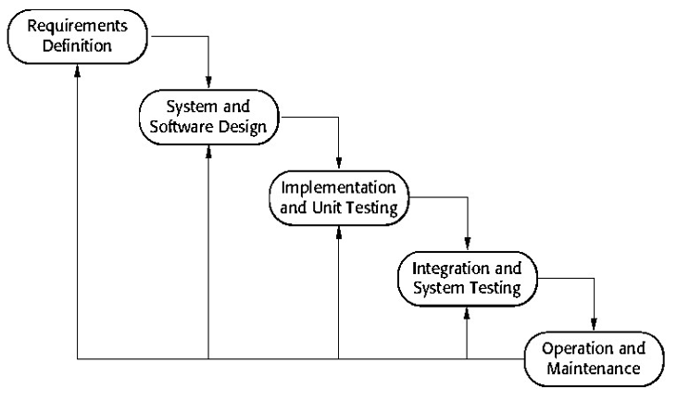
Figure 3.1: Iterative Waterfall Software Development Life Cycle Model
The model was implemented as eight explicitly planned build phases, each ending in a playable milestone:

Phase | Scope | Milestone
0 | Client shell, screen switching and local JSON profiles | Boot into a menu and start a local run
1 | Static map, player movement and tile collision, camera follow | Player walks around a fixed map with wall collision
2 | One monster type with a finite state machine and A* movement | A monster chases and damages the player
3 | Combat, projectiles, status effects, inventory and equip slots | A complete combat loop with items
4 | Isolated generation harness: noise, cellular automata, BFS connectivity | Every new run produces a different, valid map
5 | Local persistence of kill history, item usage and run outcomes | The data required by Phase 6 is recorded correctly
6 | Monster intelligence and map optimisation, one algorithm at a time | Difficulty and layout adapt to the player
7 | Genetic algorithm refinement, remaining items and profile statistics | Polished, replayable build
Table 3.1: Build phases of the Iterative Waterfall Model
The model was chosen for the following reasons:
▪ The project has a short, fixed development window of a few months, and a model that produces a playable build every two to three weeks fits that window far better than attempting a complete system first.
▪ Requirements evolved as the team played the game. Being able to fold feedback from each cycle into the next was essential — the fog of war, the sprint mechanic and the run-rollback system were all added in response to playtesting rather than being specified up front.
▪ An early working prototype de-risks the project. Phases 0 and 1 produce a moving character within days, which confirmed the technical approach before the AI work began.
▪ Continuous testing and refinement are built into each phase, and the map generator in particular benefits from the rapid generate-inspect-adjust loop that an iterative model provides.
▪ It suits a small team. With three members, explicit phase boundaries make it straightforward to see who is responsible for what and to detect slipping early.

3.2 Technologies and Tools Used

3.2.1 Programming Language
Python is the primary programming language. It is well suited to a project of this type because its standard library provides everything the AI pipeline needs — collections.deque for Breadth-First Search, heapq for the A* open set, random and secrets for controlled seeding, json for persistence and dataclasses for the world model — which means no third-party AI, data-mining or numerical library is required. Every algorithm in this report was implemented directly in Python.

3.2.2 Game Library
Pygame CE (pygame-ce 2.5.8) provides the window, the event loop, sprite blitting, collision rectangles, transformations and the font and image handling that the presentation layer needs. It is used only for presentation and input; no game logic depends on it, which keeps the map generator and the AI modules testable in a headless environment with no display attached.

3.2.3 Data Storage
Player data is persisted as JSON in a single file, data/profiles.json, using the standard-library json module. A SQLite or MySQL database was considered during design, but since the application is single-player and entirely local, a document store is a better fit: it requires no server process, no schema migration and no driver, and the data is directly human-readable for inspection, which proved valuable during testing. Writes are guarded by a threading.Lock so that a save cannot interleave with another save.

3.2.4 Development Environment and Version Control
The project is developed in Visual Studio Code with the Python extension, using a dedicated virtual environment in which only Pygame CE is installed. Git and GitHub are used for version control, which provides a clear history of the project across its phases and allows work on separate branches, such as the parallel screens and map-generation streams, to be merged safely.

3.3 AI and Data Mining Techniques Implemented
Six techniques from Artificial Intelligence and Data Mining are implemented in the project. Table 3.2 lists each one with the file that implements it and the role it plays in the system.
Technique | Source module | Role in the system
Genetic Algorithm | shared/mapgen/genetic_algorithm.py | Evolves candidate tile grids through four generations using region crossover and a ramped mutation rate.
Cellular Automata | shared/mapgen/cellular_automata.py | Scaffolds raw noise into natural cave structure using a 3 × 3 neighbourhood rule.
Breadth-First Search | shared/mapgen/bfs.py | Flood-fills from the spawn to measure reachability, computes distance maps for placement, and carves corridors to repair disconnected regions.
A* Pathfinding | shared/mapgen/astar.py | Gates entity placement on reachability and, at runtime, produces the walkable path a monster follows to the player.
Decision Tree | shared/mapgen/decision_tree.py | A level-banded fitness function that scores each candidate map on reachability and open-space ratio.
Association Rule Mining | shared/mapgen/decision_tree.py | Mines pair associations from the last five runs to set the monster count for the next level.
Table 3.2: AI and Data Mining Techniques Used, with Source File and Purpose

3.4 Assignment of Roles and Responsibilities
Group member | Technical responsibilities | Documentation responsibilities
Alisha Shahi | Game loop and ScreenManager architecture; entity classes (Player, MonsterBase, Monster1–Monster3); collision detection, projectiles and combat resolution; level-completion and death-state handling | Chapter 1 Introduction; Chapter 2 Literature Review; Chapter 4 Requirement Analysis; Figure 5.2 Overall Game Flow; test cases for the gameplay module
Bhavishek Lama | Procedural generation package: genetic algorithm, cellular automata, BFS and A* implementations; the decision-tree fitness function; association rule mining; the standalone harness in demo/ | Chapter 3 Methodology; Chapter 5 System Design and the AI subsystem; Figures 5.3 to 5.7 and 5.10; measurement tables; test cases for the AI modules
Riya Phuyal | Screen and UI layer: setup, menu, inventory, profile and pause screens; shared Button and TextInput widgets; WorldRenderer and sprite handling; the profile persistence layer in session.py | Chapter 6 Development and Implementation; Chapter 7 Testing and Debugging; Figures 5.1, 5.8, 5.9, 5.11, 5.12 and 5.13; test cases for inventory and persistence
Table 3.4: Assignment of Roles and Responsibilities

4 System Analysis

4.1 Requirement Analysis
Requirements analysis is the process of identifying and documenting what a system must do and how it must perform. For this project the analysis had to cover two very different concerns: the conventional game requirements (movement, combat, items, interface) and the non-functional requirements of the generation pipeline, which are the real substance of the project. Requirements were gathered by analysing commercially released dungeon games listed in Chapter 2, by playing the earlier Java prototype to identify which mechanics were worth carrying forward, and through repeated discussion among the team members and with the supervisors.
A design decision taken early and applied throughout was that the generator must never produce an unplayable level. This single requirement, R7 in Table 4.1, shaped the architecture more than any other, because it necessitated separating the generation pipeline into discrete, individually testable stages rather than producing a finished grid in one pass.

4.1.1 Requirement Gathering
ID | Requirement
R1 | The system shall allow the player to create a named local profile on first run and to create or select between multiple profiles thereafter.
R2 | The system shall generate a complete new dungeon layout at the start of every level, so that replaying the same level presents a different environment.
R3 | The system shall use Artificial Intelligence techniques — Genetic Algorithm, Cellular Automata, Breadth-First Search, A* and a Decision Tree — to generate, validate and optimise the layout.
R4 | The system shall guarantee that every walkable tile in a generated level is reachable from the player’s spawn point, repairing the map automatically if any region is found to be orphaned.
R5 | The system shall store and manage all player data — profile, inventory, level, experience, kill history, item usage and run outcomes — in a local persistent store, with no server dependency.
R6 | The system shall use Data Mining techniques to analyse recorded play history and adapt the difficulty and monster density of subsequent levels.
R7 | The system shall support player movement with tile-aware collision detection, a camera that follows the player, and a fog-of-war effect that limits visibility.
R8 | The system shall support combat in which the player fires projectiles in the direction of the mouse pointer and monsters can damage the player.
R9 | The monsters shall exhibit intelligent behaviour using a Finite State Machine for state transitions and A* pathfinding for navigation, rather than moving in straight lines.
R10 | The system shall include items and treasure chests that affect gameplay, including consumables, keys, a door key, and utility items that modify movement, combat or visibility.
R11 | The system shall provide an inventory from which consumable items can be used, both during play and from the main menu.
R12 | The system shall track experience and level progression, awarding experience on monster kills.
R13 | The system shall display a profile screen reporting level, experience, games played, games cleared, monster kills, item usage and the outcomes of the last five runs.
R14 | The system shall commit progress permanently when a level is cleared, and roll back level, experience and statistics when a run ends in death or abandonment.
R15 | The system shall run at a stable 60 frames per second on standard desktop hardware and shall not block the interface during level generation.
Table 4.1: Requirement Gathering

4.1.2 Functional Requirements
The functional requirements state the specific operations the system must perform. Each is mapped to the gathered requirement it satisfies, which guarantees full coverage of Table 4.1.
ID | Function | Ref.
F1 | Create a named local explorer profile and persist it across sessions. | R1
F2 | List existing profiles and load the selected profile into the game state. | R1
F3 | Generate a new 81 × 81 dungeon at the start of every level using the AI pipeline. | R2
F4 | Evolve candidate layouts with a Genetic Algorithm over a fixed number of generations. | R3
F5 | Smooth generated noise with Cellular Automata to produce natural cave structure. | R3
F6 | Flood-fill the map with BFS from the spawn tile to measure reachability. | R3, R4
F7 | Carve corridors to repair any orphaned region until the reachable ratio is 1.0. | R4
F8 | Score candidate maps with a level-banded Decision Tree fitness function. | R3, R6
F9 | Select the best candidate across all generations and place entities on it. | R3
F10 | Gate entity placement on A* pathfinding so that no unreachable entity is placed. | R3, R4
F11 | Read and write the full player profile, inventory and statistics to a local JSON store. | R5
F12 | Mine association rules from the last five runs and set the next level’s monster count. | R6
F13 | Move the player with tile-aware collision detection and follow with the camera. | R7
F14 | Render the world, entities, fog of war, HUD and level overlays. | R7
F15 | Fire projectiles towards the mouse pointer with a cooldown and range limit. | R8
F16 | Apply damage from monster contact attacks and monster projectiles to the player. | R8
F17 | Update monster state through DORMANT, WAKE, CHASE and ATTACK based on player distance. | R9
F18 | Move monsters along genuine A* paths to the player, respecting type-specific leash limits. | R9
F19 | Spawn, collect and consume items, and open chests and the exit door when the correct key is held. | R10, R11
F20 | Present a scrollable inventory with a Use action for consumable items. | R11
F21 | Award experience on kill and increase the level when the requirement is met. | R12
F22 | Display the profile statistics screen with kills, item usage and recent run outcomes. | R13
F23 | Commit the run on level completion and roll it back on death or abandonment. | R14
F24 | Maintain a 60 FPS loop and mask generation latency behind the level-reveal animation. | R15
Table 4.2: Functional Requirements

4.2 Feasibility Study
A feasibility study determines whether the proposed system is practical, affordable and achievable within the available time. Table 4.3 summarises the conclusions; each is justified in the sections that follow.
Dimension | Finding | Conclusion
Technical | Python 3 and Pygame CE are open source and sufficient; every AI algorithm was implemented from scratch in the standard library; no GPU, server or special hardware is required. | Feasible
Operational | The game runs as a desktop application requiring only basic computer literacy; the interface is a menu-driven, keyboard-and-mouse experience with no training required. | Feasible
Economic | All software used is free and open source; development used existing personal computers, so there is no licensing or infrastructure cost beyond electricity. | Feasible
Schedule | The eight build phases were completed over seventeen project weeks, with testing and documentation running in parallel with implementation. | Feasible
Table 4.3: Summary of Feasibility Analysis

4.2.1 Technical Feasibility
Technical feasibility assesses whether the available technology and skills are sufficient. Python and Pygame CE were selected because both are open source, widely documented and supported by large communities, and because Python’s standard library already contains the data structures the AI pipeline requires. collections.deque provides the FIFO queue that Breadth-First Search needs, heapq provides the priority queue that the A* open set requires, and random and secrets provide controlled seeding. The only third-party dependency in the entire project is Pygame CE, and it is used solely for windowing, input and drawing.
A significant feasibility advantage is that the AI subsystem has no dependency on the graphics layer. The generator returns a plain data structure and performs no drawing, so it can be executed and validated in a terminal with no display. This is what made it practical to run the thirty-level validation reported in Table 3.3 during development, and it would allow the same harness to run as an automated regression test.
The team possessed the required skills in game loop design, object-oriented programming, algorithmic design and data handling. The project was therefore assessed as technically feasible.

4.2.2 Operational Feasibility
Operational feasibility assesses whether the system can be used and accepted by its intended users. The game presents a menu-driven interface in which every action is either a button or a documented key, and the on-screen control legend is displayed continuously during play. A new player is guided through profile creation and class selection before reaching the game, so no prior knowledge is required.
The system is single-player and entirely local, which removes all operational dependencies on network availability, accounts, or server administration. Player data is stored in a single file that is created on first run, and the application is launched with a single command. The project was therefore assessed as operationally feasible.

4.2.3 Economic Feasibility
Economic feasibility evaluates whether the cost of development is justified by the resources consumed. Because every technology used is free and open source — Python, Pygame CE, Visual Studio Code, Git and GitHub — there is no software licensing cost. Development, testing and documentation were carried out on existing personal computers, so there is no hardware procurement cost.
The only direct expenditure is electricity for the development machines. The project is therefore economically feasible, and it is worth noting that a production version would remain almost entirely free to distribute, since a compiled build of a Pygame application carries no per-user licence cost.

4.2.4 Schedule Feasibility
Schedule feasibility examines whether the system can be completed within the allocated time. The project was scheduled over seventeen weeks and delivered against the eight build phases described in Section 3.1.1, with system testing and documentation running continuously in parallel with implementation rather than as a final phase. Figure 4.1 shows the planned schedule.
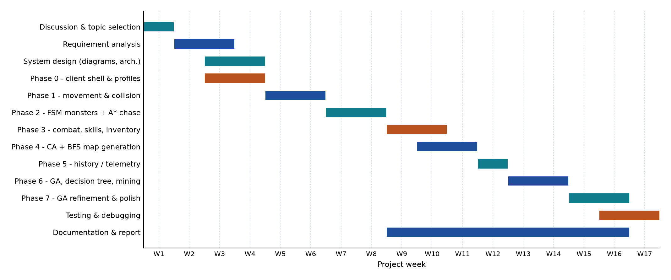
Figure 4.1: Gantt Chart — Project Schedule
The schedule was achievable because the phase structure guaranteed a playable build every two to three weeks, which meant that problems surfaced while there was still time to react. The project was therefore assessed as schedule feasible.

5 System Design and Implementation
This chapter is the core of the report. It describes the architecture of the system, the overall flow of the game from launch to termination, the internal flow of the application, and then in detail the two intelligent subsystems: the procedural map generator and the monster artificial intelligence.

5.1 System Architecture
Dungeon Explorer follows a four-layer architecture that separates presentation, gameplay, rendering and intelligence, with a persistence layer beneath them. The separation is deliberate: it allows the AI subsystem to be developed, executed and tested without a display or a running game loop, and it means that changing the artwork or the interface never risks breaking generation.
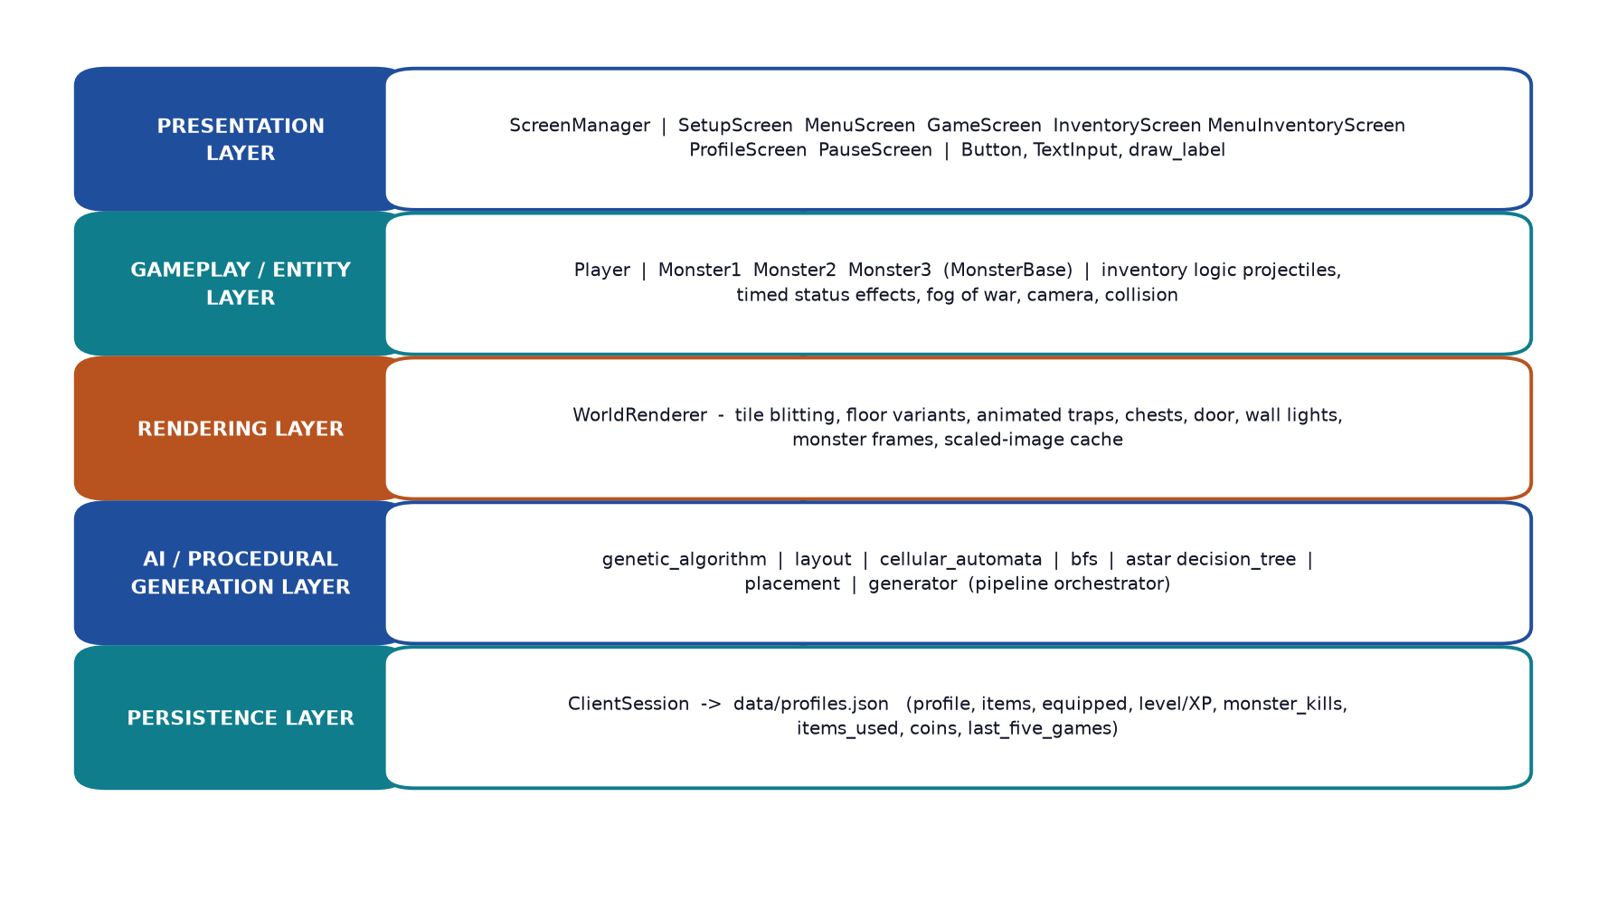
Figure 5.1: System Architecture of Dungeon Explorer
Layer | Key modules | Responsibility
Presentation | screens/ (ScreenManager, SetupScreen, MenuScreen, GameScreen, InventoryScreen, MenuInventoryScreen, ProfileScreen, PauseScreen), ui.py (Button, TextInput, draw_label) | Owns exactly one active screen, forwards input, update and draw calls to it, and renders all interface elements.
Gameplay / Entity | entities/player.py, entities/monster_base.py, entities/monster1–3.py, gameplay/inventory.py | Player movement, collision, animation and combat; monster state and statistics; item stacking, counting and consumption.
Rendering | renderers/world_renderer.py | Camera-relative tile blitting, floor variants, animated traps, chests, door, wall lights, monster frames, and a scaled-image cache.
AI / Generation | shared/mapgen/ (genetic_algorithm, layout, cellular_automata, bfs, astar, decision_tree, placement, generator) | Generates, validates, scores, optimises and populates the dungeon; supplies A* paths to the monster AI.
Persistence | session.py, data/profiles.json | Profile, inventory, statistics and run history in a local JSON document, with a lock-guarded writer.
Table 5.1: System Architecture Components
Two properties of this architecture are worth highlighting. First, the AI layer has no upward dependency: nothing in shared/mapgen/ imports from src/client/, and the client imports from mapgen. The dependency arrow points in one direction only. Second, the single shared game_state dictionary, created once in the DungeonQuest constructor and passed to every screen, is the only channel through which screens communicate, which removes the need for any inter-screen references.

5.2 Overall Flow of the Game
The game is driven by a single screen manager, which behaves like the CardLayout of the project’s earlier Java version: it holds one instance of every screen, remembers which one is current, and on a state change calls on_exit() on the outgoing screen and on_enter() on the incoming one. Navigation is therefore always a single call, manager.switch_to(key, **kwargs), and no screen ever needs to know what will come after it.
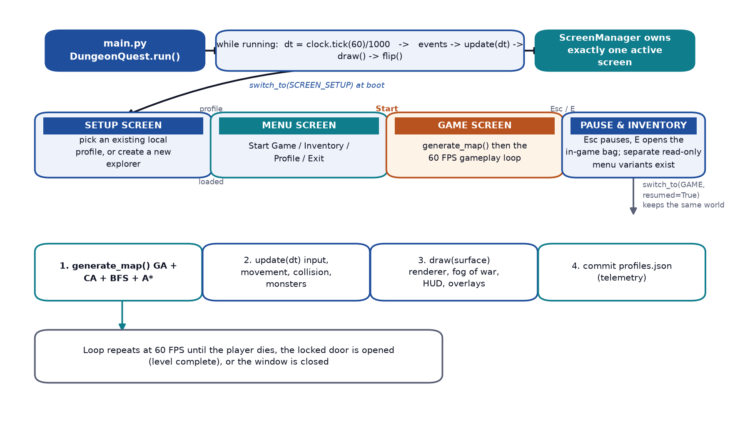
Figure 5.2: Overall Game Flow — Screen State Machine and the In-Game Loop
The overall flow of the game is as follows.
Boot and profile selection
Executing main.py inserts src/client/ and src/ onto the Python path and calls DungeonQuest(), which initialises Pygame, creates a 768 × 576 window at a 60 FPS target, constructs a ClientSession that loads the profile store from disk, and builds a shared game_state dictionary. Seven screens are then registered with the ScreenManager and the setup screen is made current.
The setup screen inspects the profile store. If exactly one profile exists it is selected automatically; if several exist the player is shown a list to choose from; if none exist the screen switches to a create mode with a text field focused. Creating a profile assigns an identifier derived from the name, such as BHAVISHEK_001, and writes it to the store. Once a profile is active the game advances to the menu screen.
Menu and level start
The menu screen offers Start Game, Inventory, Profile and Exit. Choosing Start Game switches to the game screen. On entering, the game screen calls generate_map() with a fresh 64-bit seed and the active player profile, converts the resulting dictionaries into Monster1, Monster2 and Monster3 objects, places the player at the generated spawn point, and starts a 3.5-second reveal animation during which the screen opens outward from a black circle centred on the player.
Gameplay loop
Each frame the game screen reads input, applies movement and collision, advances the world clock, updates the monster state machines and their projectiles, applies environmental and status effects, advances player projectiles, and finally renders the world, the entities, the fog of war, the HUD and any active overlay. The loop runs at a fixed target of 60 frames per second, and the delta time is used so that movement speed is independent of the actual frame rate.
Level completion and death
A level is completed when the player stands adjacent to the locked door while holding the Door Key. The key is consumed, the door changes state, the run is recorded as cleared, progress is committed to the profile store, and a completion overlay offers Next Level or Exit. Choosing Next Level generates an entirely new dungeon. Death, by contrast, shows a death overlay whose Restart option rolls the run back to its starting state and generates a fresh level, so that a failed attempt is not punished twice.
Pause, inventory and exit
Pressing Escape during play opens the pause screen, which offers Resume and Quit Game; Resume returns to the game screen with resumed=True, which preserves the existing world rather than regenerating it. Pressing E opens the in-game inventory, which allows consumable items to be used. The menu also provides read-only variants of the inventory and a statistics screen. Exiting the application disconnects the session, which flushes the profile store to disk.

5.3 Internal Flow of the Application

5.3.1 Entry Point and the Frame Loop
The entry point is main.py at the project root. It resolves the project directory, inserts src/client/ and src/ at the front of sys.path so that both the client and shared packages resolve reliably regardless of the working directory, and then calls client.main.main(). The run loop is deliberately minimal:
dt = self.clock.tick(config.FPS) / 1000.0
for event in pg.event.get():
self.manager.handle_event(event)
self.manager.update(dt)
self.manager.draw(self.screen)
pg.display.flip()
clock.tick(60) both throttles the loop and returns the elapsed milliseconds, so dividing by 1000 gives the delta time in seconds. Every subsystem is therefore frame-rate independent, and a temporary frame-rate drop makes the game run slightly slower rather than making the player move faster.

5.3.2 Screen Manager
The Screen base class defines five lifecycle hooks: on_enter(**kwargs), on_exit(), handle_event(event), update(dt) and draw(surface). register(key, cls) instantiates a screen once and stores it, and switch_to(key, **kwargs) calls on_exit() on the current screen, changes the current pointer, and calls on_enter(**kwargs) on the new one. The kwargs mechanism is what allows the inventory screen to be told whether it is being opened from the menu or resumed from within the game.

5.3.3 Game Screen Update Pipeline
The per-frame update in the game screen runs the following ordered sequence:
▪ Advance the elapsed clock and expire any item-pickup animations.
▪ Read the current key state and resolve the class-specific movement speed.
▪ Apply the sprint multiplier if Shift is held and stamina is available.
▪ Apply the terrain multiplier from the tile the player is standing on — lava and traps slow the player down.
▪ Move the player, using a collision callback that tests monster rectangles and the four corners of the player’s collision box against collidable tiles and the closed door.
▪ Advance the world clock, which releases any scheduled monster whose spawn time has been reached.
▪ Synchronise monster rectangles, then run each monster’s state machine.
▪ Advance monster projectiles and resolve hits against the player.
▪ Apply survival effects — terrain damage, stamina drain and regeneration, and timed regeneration effects.
▪ Apply terrain damage to monsters standing in lava, water or traps, removing any that die.
▪ Advance player projectiles, removing any that hit a wall or a monster.
The ordering is significant. Terrain effects are resolved after monster movement so that a monster that steps into lava on the current frame takes damage immediately, and projectile damage is resolved last so that a kill is recorded once, in a single place, by _record_monster_kill(), which is where experience, level progression and the kill histogram are all updated together.

5.3.4 Player Movement, Collision and Animation
Movement is resolved from the pressed-key state rather than from discrete key events, which keeps movement smooth. The player has a sprite size equal to the tile size but a collision box scaled to 38% of that, centred within the sprite, so that the character can pass through gaps that are visually narrow. Before a move is accepted, the four corners of the prospective collision box are tested against the tile grid; if any corner falls on a wall, a chest, an uncollected key or a closed door, the movement is cancelled. A test against every monster rectangle is performed first, which prevents the player from walking through an enemy.
Aiming is computed from the angle between the screen centre and the mouse position. The angle is divided into eight sectors of 45 degrees, each mapped to one of eight directional shooting sprites, so the character visibly fires in the direction of the pointer. The base fire cooldown is 250 milliseconds, halved while the Bow is equipped, and each projectile carries 50 damage at 8 pixels per frame, both doubled by the Bow, with a maximum range of ten tiles.

5.3.6 Rendering and the Camera
The camera is centred on the player, so the player sprite is always drawn at the exact centre of the window and the world is translated by the negative player position. The renderer iterates only over the tiles that fall inside the visible window plus a one-tile margin, so the cost of drawing is proportional to the screen size rather than to the 81 × 81 map. Floor tiles are varied deterministically using the expression (row * 13 + col * 7) mod 12, which gives visual texture without any randomness and therefore without any cost in reproducibility. Trap tiles cycle through three animation frames, monster frames advance at eight per second, and every scaled image is cached by path and size so that scaling is not repeated each frame.
Fog of war is drawn as a single alpha surface composed of 24 concentric bands whose alpha falls off with the 1.7 power, giving a soft gradient rather than a hard circle, out to a radius of five tiles. The entire effect is skipped when the Light item is active.

5.3.7 Module Inventory
Table 5.3 lists the modules that make up the running system, with their size and responsibility.
Module | Lines | Responsibility
main.py | 20 | Path setup and launch.
src/client/main.py | 80 | Pygame initialisation, the frame loop, and screen registration.
src/client/config.py | 178 | All tunable constants: window, tiles, colours, fonts, player classes, monster and projectile tuning, fog and regeneration rates.
src/client/session.py | 314 | Profile store: load, save, register, select, commit, roll back.
src/client/ui.py | 113 | Reusable Button, TextInput and draw_label widgets.
src/client/screens/__init__.py | 70 | Screen base class and ScreenManager.
src/client/screens/game_screen.py | 935 | The game loop, world lifecycle, combat, interaction, fog, HUD and overlays.
src/client/screens/inventory_screen.py | 220 | Inventory display, scrolling, item use and effects.
src/client/screens/setup_screen.py | 143 | Profile creation and selection.
src/client/screens/menu_screen.py | 130 | Main menu and animated background.
src/client/screens/profile_screen.py | 132 | Statistics display.
src/client/screens/pause_screen.py | 64 | Pause and quit.
src/client/screens/menu_inventory_screen.py | 31 | Read-only inventory variant for the menu.
src/client/entities/player.py | 252 | Player state, movement, collision box, animation, aiming.
src/client/entities/monster_base.py | 43 | Shared monster state and statistics.
src/client/entities/monster1–3.py | 21 | The three monster type subclasses.
src/client/gameplay/inventory.py | 56 | Item stacking, counting, consumption and labels.
src/client/renderers/world_renderer.py | 227 | All world drawing and the image cache.
src/shared/mapgen/generator.py | 113 | Pipeline orchestration.
src/shared/mapgen/genetic_algorithm.py | 72 | Seeding, crossover and mutation.
src/shared/mapgen/layout.py | 143 | Nine-sector carving, corridor connection, trap seeding.
src/shared/mapgen/cellular_automata.py | 37 | Smoothing rule.
src/shared/mapgen/bfs.py | 157 | Reachability, distance map, evaluation, repair.
src/shared/mapgen/astar.py | 88 | Path reconstruction and existence testing.
src/shared/mapgen/decision_tree.py | 88 | Fitness function and association rule mining.
src/shared/mapgen/placement.py | 358 | All entity placement.
src/shared/mapgen/constants.py | 28 | Tile identifiers, walkable sets, generation parameters.
src/shared/mapgen/types.py | 51 | The GeneratedWorld dataclass and its spawn scheduler.
Table 5.3: Module Inventory of the Implemented System

5.4 The Artificial Intelligence Subsystem
The generation subsystem is the principal contribution of this project. Its responsibility is to accept a player profile and a random seed and return a complete, playable world: a tile grid, a valid spawn point, a locked door and its key, treasure chests with their keys, consumable scrolls, monsters with a timed spawn schedule, and a set of decorative objects. It is implemented in the shared/mapgen/ package, which has no dependency on the client.

5.4.1 Pipeline Overview
The pipeline is organised as a sequence of eight stages. Figure 5.3 shows the complete flow, and the stages are described individually below.
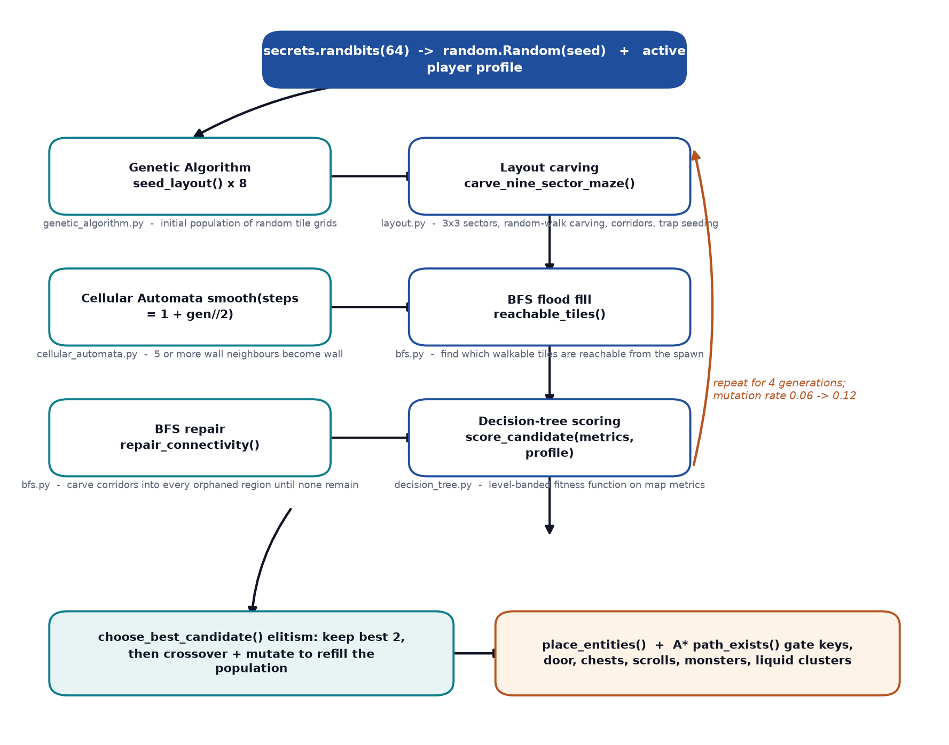
Figure 5.3: AI Procedural Map-Generation Pipeline
The design principle throughout is that each stage reduces the problem rather than solving it outright. Carving does not guarantee connectivity, so a separate stage verifies it. Smoothing does not guarantee that the layout is interesting, so a separate stage scores it. Placement does not guarantee that entities are reachable, so a separate stage gates them with A*. Because each stage is a separate function with a single clear contract, any stage can be tested, measured and replaced independently.
Parameter | Value | Defined in | Effect
Map size | 81 × 81 (6 561 tiles) | constants.py | The generated dungeon is always this size.
Sector count | 3 × 3 (27 × 27 each) | constants.py | The map is divided into nine sectors that are carved separately then connected.
Population size | 8 | constants.py | Number of candidate grids per generation.
Generations | 4 | constants.py | Number of evolutionary cycles before the best candidate is chosen.
CA smoothing steps | 1 + generation // 2 | generator.py | Increases from 1 to 2 across the run, smoothing later candidates more aggressively.
Survivors (elitism) | 2 | generator.py | The two best grids are carried unchanged into the next generation.
Mutation rate | 0.06 + 0.02 × generation | generator.py | Ramps from 0.06 to 0.12 to keep the search from stagnating.
Base monster limit | 12 | decision_tree.py | Used when no play history exists.
Monster limit bounds | 1 to 18 | decision_tree.py | Hard clamp applied after the rules are evaluated.
History window | 5 most recent runs | decision_tree.py | The association rules are mined from these.
Table 5.4: Map Generator Configuration Constants

5.4.2 Genetic Algorithm
The Genetic Algorithm treats an entire 81 × 81 tile grid as a single chromosome. It maintains a population of eight such grids and improves them over four generations. The implementation follows the classical structure of encoding, initialisation, evaluation, selection, crossover and mutation.
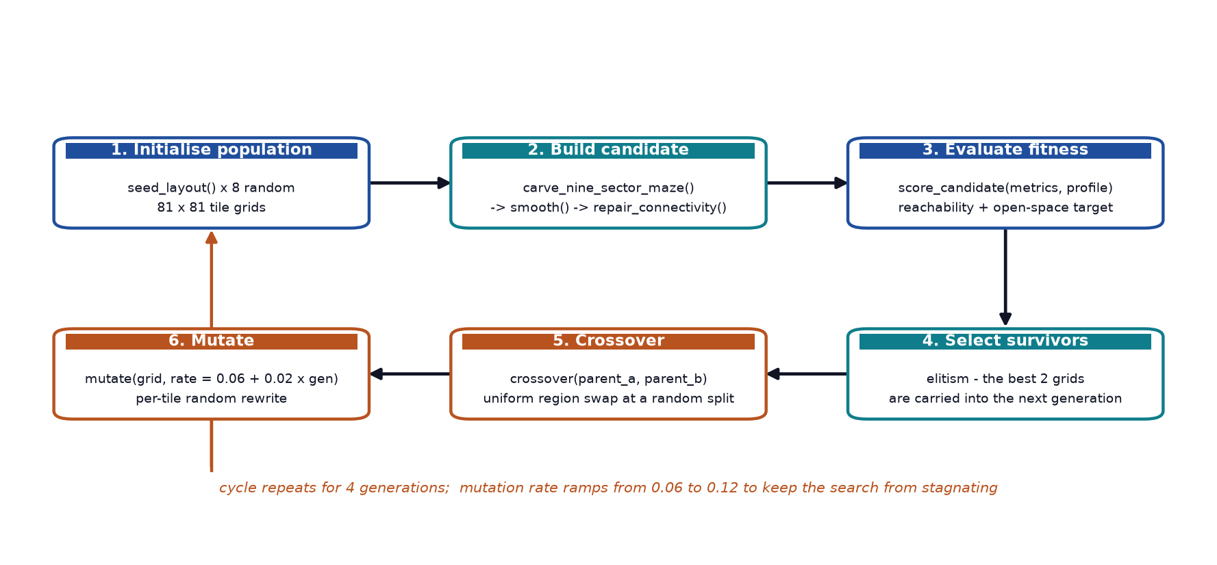
Figure 5.4: Genetic Algorithm Search Cycle
Encoding and initialisation
A chromosome is a two-dimensional list of integers, one per tile, where each value is a tile identifier. seed_layout() produces the initial population by filling each interior cell from a categorical distribution: 18% wall, 34% floor, 10% water, 13% trap, 12% basic scroll, 8% key and 5% rare scroll. The outer border is always wall, so a generated map can never be escaped by walking off the edge.
Evaluation
Fitness is computed by the decision-tree scoring function described in Section 5.4.6. Evaluation is not applied to the raw chromosome but to the grid that results from carving, smoothing and repairing it, which means the fitness measures the quality of the finished level rather than the quality of the noise.
Selection and elitism
The population is sorted by fitness and the best two grids are carried into the next generation unchanged. This is elitist selection, and it guarantees that fitness never regresses across generations.
Crossover
crossover() implements uniform region crossover. A random split row and a random split column are chosen, and the child inherits every cell that lies below the split row or to the right of the split column from the second parent, and the remaining upper-left region from the first. Two-point region crossover is well suited to tile grids because it produces children that are large contiguous regions of both parents, which preserves the flood-fill characteristics of each rather than producing a noisy patchwork.
Mutation
Each interior cell is rewritten with probability equal to the current mutation rate, and the replacement tile is drawn from a categorical distribution weighted towards floor. The rate ramps from 0.06 in the first generation to 0.12 in the last. Early low rates allow the population to exploit structure discovered in the seed, and the later higher rates inject enough variation to avoid premature convergence, which was observed repeatedly during development when a fixed low rate caused the population to collapse onto a single layout.
Parameter | Value | Rationale
Chromosome | One 81 × 81 tile grid | The grid is the unit of design, not individual tiles.
Population | 8 | Large enough to give selection pressure, small enough to keep generation under 2 s.
Generations | 4 | Measured fitness gain per additional generation is marginal and costs load time.
Elitism | Top 2 survive | Prevents regression and guarantees the best layout is never lost.
Crossover | Two-point region | Produces contiguous regions, preserving each parent’s structure.
Mutation rate | 0.06 → 0.12 | Exploit early, explore late; avoids premature convergence.
Fitness | Level-banded score (Section 5.4.6) | Makes layout difficulty track player progression.
Table 5.5: Genetic Algorithm Parameters
Table 5.6 records the measured fitness progression of a single run with a fixed seed. Fitness rises across the first three generations and then falls slightly in the fourth, which is the expected consequence of raising the mutation rate: the higher rate produces more diverse but less individually strong children. The best layout found in any generation is always retained, so the final output is the best of all candidates ever evaluated rather than the last one produced. The reachable ratio remains exactly 1.000 in every generation, confirming that the repair stage protects the population from connectivity failures.
Generation | Best fitness | Mean fitness | Worst fitness | Best open_ratio | Reachable ratio
0 | 7.252 | 7.204 | 7.138 | 0.341 | 1.000
1 | 7.288 | 7.231 | 7.181 | 0.355 | 1.000
2 | 7.310 | 7.224 | 7.186 | 0.364 | 1.000
3 | 7.264 | 7.214 | 7.165 | 0.346 | 1.000
Table 5.6: Genetic Algorithm Fitness Progression (level-5 profile, seed 12345)

5.4.3 Layout Carving — Nine-Sector Structure
A genetic chromosome is raw noise and does not resemble a dungeon. The layout stage transforms it into a cave-like structure in three sub-steps.
First, the map is divided into a three-by-three grid of 27 × 27 sectors. Each sector is carved independently by a random walk of at least 364 steps that starts at the sector centre. On each step the walker stamps a 3 × 3 patch, but only where the underlying chromosome is already floor or water, or where a 24% coin flip succeeds. This is the mechanism by which the genetic information is actually used: the chromosome acts as a bias field that steers the walk towards open regions, and the random fallback guarantees that no sector ends up empty. Each sector also has a 30% chance of being given a five-by-five open chamber at its centre, which creates natural landmarks to navigate by.
Second, the sector centres are connected. A fixed serpentine path order visits all nine sectors, and an L-shaped corridor is carved between each consecutive pair. The axis order of each corridor is randomised, so the routes between sectors differ on every run. Each sector is additionally connected to its right and lower neighbours with 55% probability, which creates loops and therefore alternative routes, so the map is not a single tree of dead ends.
Third, traps are seeded at a 3% probability, but only on floor tiles that have no existing trap within a radius of two. The spacing constraint is what stops traps from forming lethal walls.
Figure 5.5 shows the effect of this stage and of the cellular automata stage that follows it. The change from panel (a) to panel (b) is the single largest transformation in the whole pipeline: unstructured noise becomes a recognisable, navigable dungeon layout with clear regions and connecting corridors.
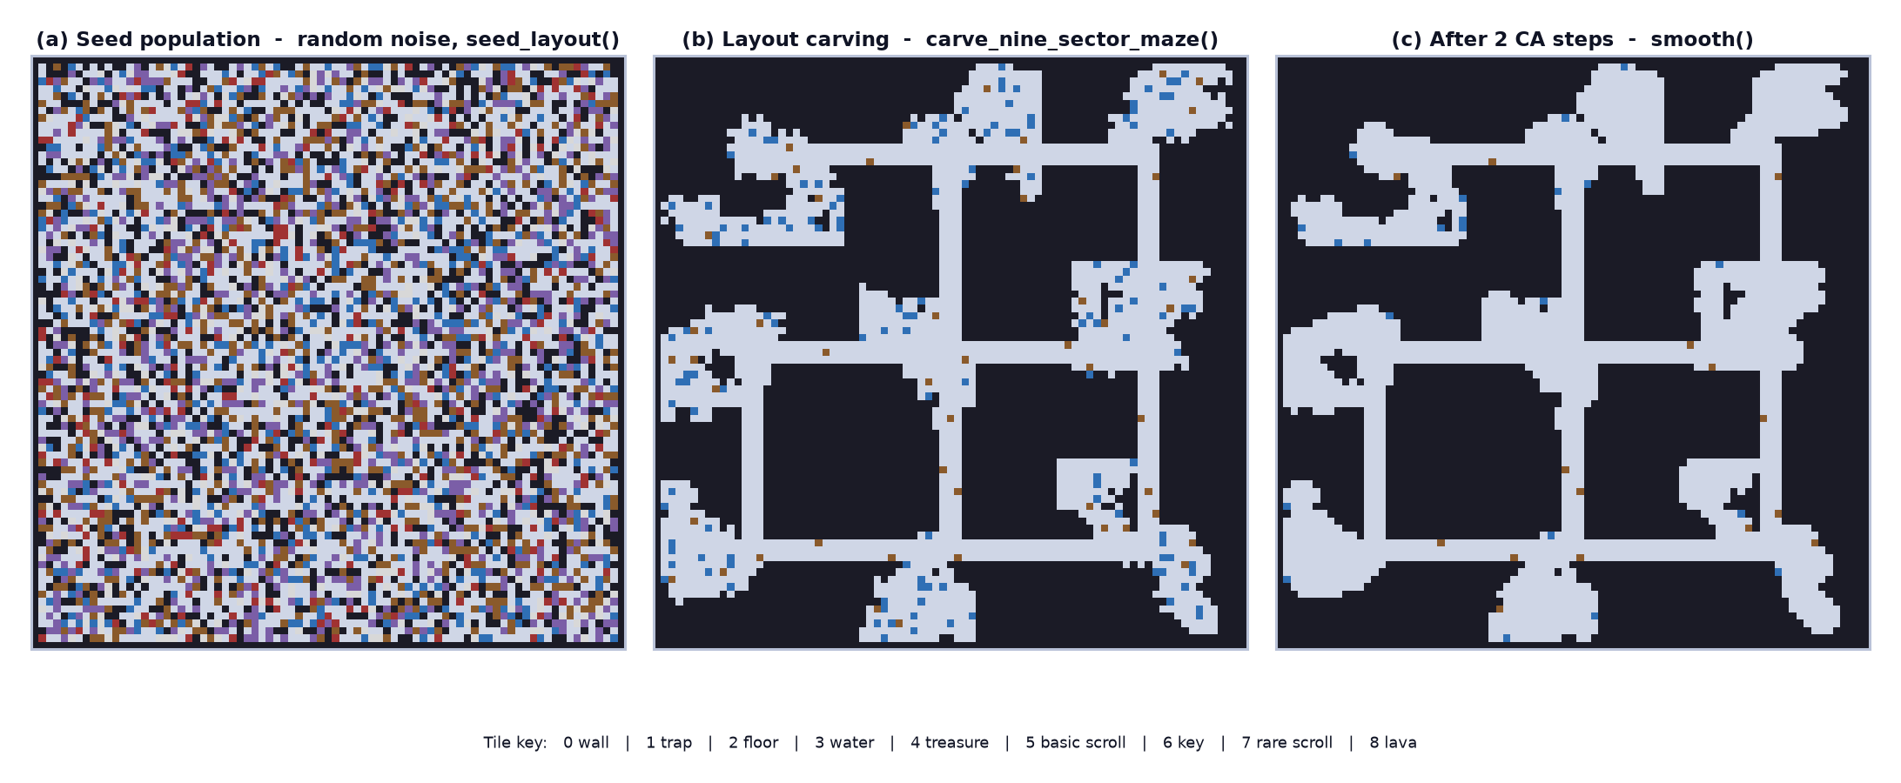
Figure 5.5: Cellular Automata Smoothing Pipeline with the 3 × 3 Neighbourhood Rule

5.4.4 Cellular Automata
Cellular Automata are used to smooth the carved layout and to give it organic boundaries. The implementation follows John Conway’s Game of Life structure: a 3 × 3 Moore neighbourhood is examined for every cell, and the cell’s state in the next generation is decided by a fixed rule. Crucially, the implementation reads only from the current grid and writes to a separate next grid, so the update is genuinely synchronous and order-independent. An in-place implementation would produce results that depend on scan order, which would break the reproducibility of a given seed.
The rule implemented in cellular_automata.py is:
▪ If the cell has 5 or more wall neighbours, it becomes wall. This eliminates isolated pillars and thin spurs.
▪ If the cell is water and has 2 or fewer wall neighbours, it becomes floor, so water hugs the open areas.
▪ If the cell is a trap and has 1 or fewer wall neighbours, it becomes floor, so traps survive only in open areas where they are meaningful.
The number of steps is set to 1 + generation // 2, so the first generation is smoothed once and the last three generations are smoothed twice. Later candidates are therefore cleaned more aggressively, which biases the population toward cleaner layouts as the search progresses without ever applying so much smoothing that the dungeon loses its shape. The comparison between panels (b) and (c) of Figure 5.5 shows water and trap tiles being absorbed into the surrounding floor while the overall structure is preserved.

5.4.5 Breadth-First Search — Validation and Repair
Smoothing and carving guarantee neither that the map is connected nor that the player can reach the exit. This stage both measures and fixes the problem, and it is the reason the generator can promise a playable level.
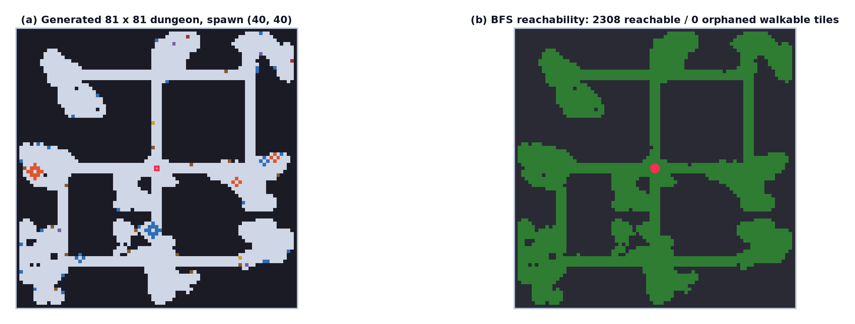
Figure 5.6: BFS Connectivity Validation and Repair — Flood Fill from the Spawn Tile Guarantees a 100% reachable_ratio
The stage has four functions, each with a single purpose:
▪ find_spawn_tile() selects the walkable tile nearest the centre of the map, so the player always begins in the middle of the dungeon rather than at an edge.
▪ reachable_tiles() performs the flood fill. It uses collections.deque as a FIFO queue, visits only tiles whose identifier is in the walkable set, and returns the set of reachable coordinates. Because the queue is FIFO and each tile is expanded exactly once, the cost is linear in the number of walkable tiles.
▪ distance_map() extends the same traversal to record the BFS distance to every reachable tile. This is what makes “furthest away from the player’s spawn’ a cheap and well-defined concept during placement.
▪ repair_connectivity() compares the walkable set against the reachable set. For each orphaned tile, ordered so that the nearest are handled first, it finds the closest reachable tile to that target and carves a Manhattan path between them, then recomputes the flood fill. Because targets are processed in order of increasing distance from the spawn, a single carve often connects several orphans at once, and the loop converges quickly.
The walkable set is defined in constants.py as floor, water, treasure, basic scroll, key, rare scroll and lava. Wall and trap are excluded, so traps are treated as impassable for reachability purposes even though the player can stand on them. The guarantee this produces is measurable: across thirty generated levels the reachable ratio was 1.0000 in every single case, meaning zero orphaned walkable tiles.
Two quality metrics are derived from the same traversal and drive the fitness function:
open_ratio = walkable_tiles / (width * height)
reachable_ratio = reachable_tiles / walkable_tiles
The open ratio measures how much of the bounding box is usable space, and the reachable ratio measures how much of that usable space can actually be entered. A map with an excellent open ratio but a poor reachable ratio is a map full of islands, and the fitness function weights the reachable ratio far more heavily for exactly that reason.

5.4.6 A* Pathfinding
A* is used in two distinct roles. During generation it acts as a gate: place_monsters() calls path_exists() before committing a monster to a position, so an entity is never placed somewhere it could never reach. During gameplay it is the monsters’ navigation method, and it is what makes the monsters behave intelligently rather than appearing to walk through walls.
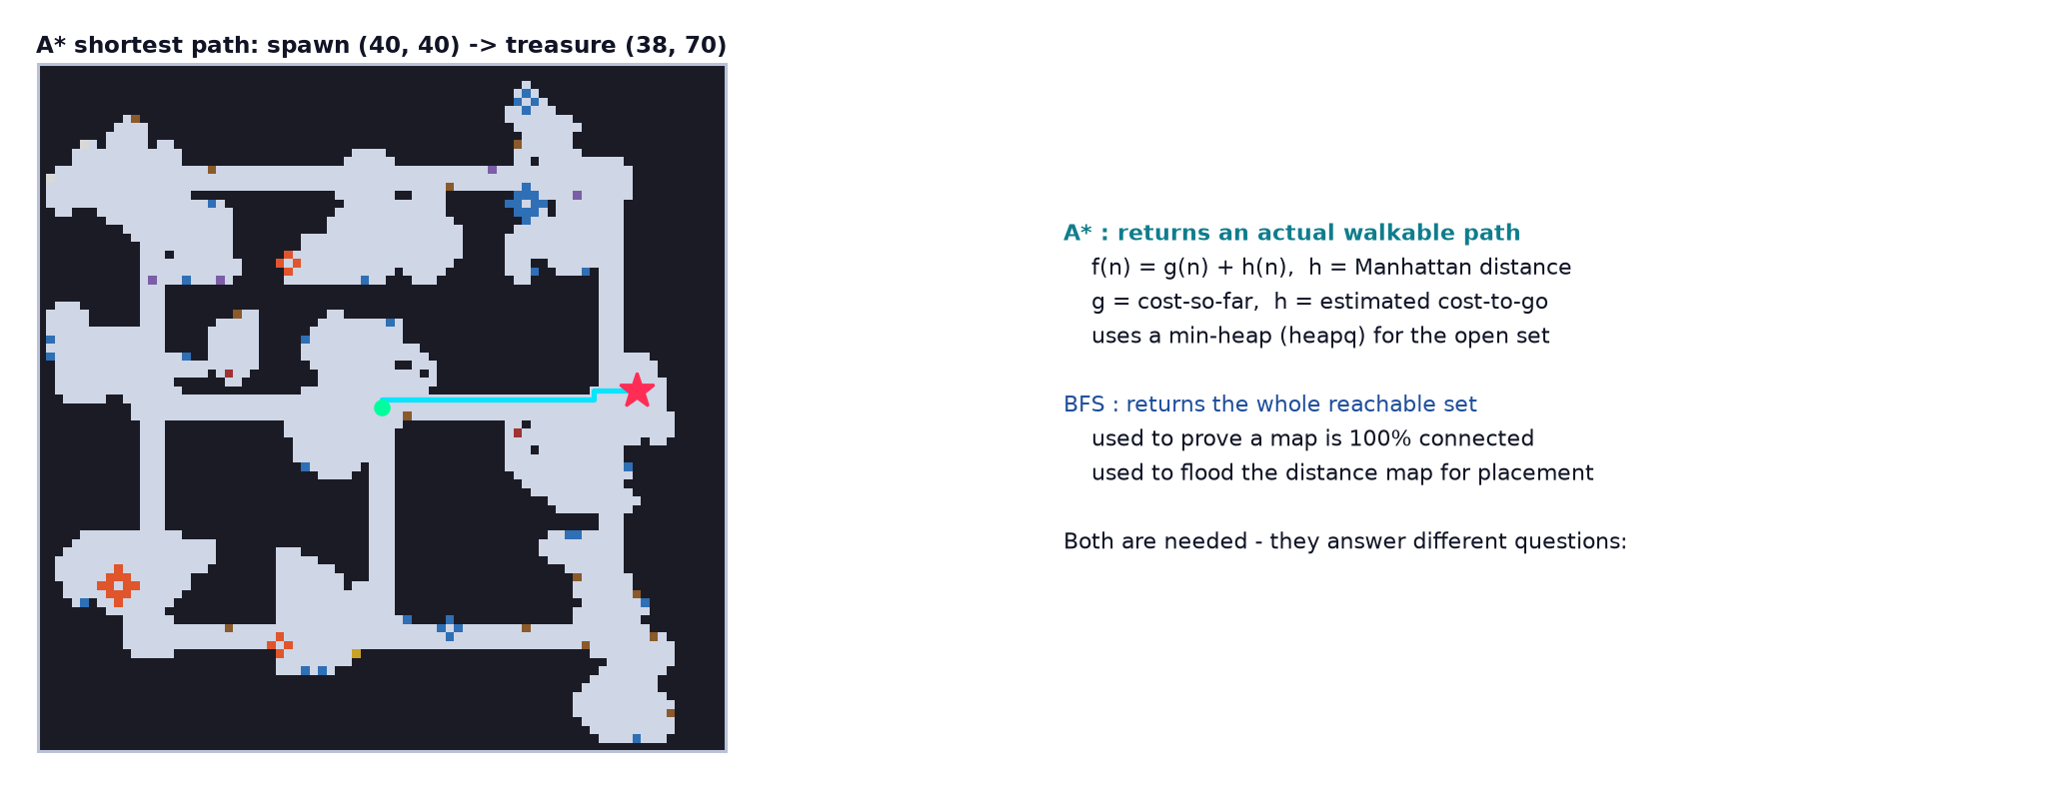
Figure 5.7: A* Pathfinding Used for Monster Chase and Reachability Gating
The implementation is the standard form. A node is scored with f(n) = g(n) + h(n), where g is the accumulated cost from the start and h is the Manhattan distance to the goal, which is an admissible heuristic on a uniform four-connected grid and therefore guarantees an optimal path. The open set is a min-heap maintained with heapq.heappush and heapq.heappop. A came_from dictionary records each node’s predecessor, which is walked backwards from the goal and reversed to produce the path.
One implementation detail deserves comment: a monotonically increasing sequence counter is stored alongside the score in each heap entry. Without it, when two nodes share the same f value, Python would attempt to compare the coordinate tuples, which is correct but slower and less predictable than comparing integers. With it, heap ordering is total and deterministic, so the same seed always yields the same monster path.
Table 5.7 contrasts the two algorithms on the same generated maps, which clarifies why both are needed. A* answers a specific question — what is the shortest path to this one goal — and answers it two to three orders of magnitude faster than a full flood fill, because the heuristic lets it discard most of the map without exploring it. Breadth-First Search answers a different question — what is the entire reachable region — and cannot be pruned that way. Using BFS where A* was needed, or A* where BFS was needed, would be incorrect; the project uses each where it is appropriate.
Algorithm | Question answered | Typical cost on an 81 × 81 map | Used for
BFS | Which tiles are reachable, and how far is each one? | 2.1 – 2.7 ms for ~2 350 tiles | Connectivity validation, repair, distance map
A* | What is the shortest path to this specific goal? | 0.02 – 0.21 ms for a single goal | Monster chase movement, entity placement gate
Table 5.7: Comparison of BFS and A* on Generated Maps

5.4.7 Decision Tree — Fitness and Personalisation
The fitness function is where the map’s difficulty is matched to the player. It is implemented as a decision tree over the single most informative attribute available, the player’s level, and it is applied identically to every candidate grid.
def score_candidate(metrics, profile):
level = int(profile.get('level', 1) or 1)
kill_total = sum(monster_kills.values())
skill_total = sum(items_used.values())

if level <= 2: # new players
return reachable_ratio * 4.5 \
+ (1.0 - abs(open_ratio - 0.42)) * 2.0 \
- reachable_count / 1500.0

if level <= 5: # regular players
return reachable_ratio * 4.0 \
+ (1.0 - abs(open_ratio - 0.52)) * 2.5 \
+ (kill_total + skill_total) / 50.0

return reachable_ratio * 3.5 \
+ (1.0 - abs(open_ratio - 0.62)) * 2.5 \
+ reachable_count / 1200.0 \
+ (kill_total + skill_total) / 60.0
The function has three leaves, and each expresses a different design intention:
▪ Level 1–2 — a new player should find a small, forgiving dungeon. The open-space target is 0.42, which is the tightest of the three, and a penalty proportional to the reachable tile count actively prefers the smallest map that is still fully connected. Without this penalty the optimiser would simply choose the largest map that hits the target ratio.
▪ Level 3– 5 — a regular player gets a moderate dungeon. The open-space target rises to 0.52, and the reachable-count penalty is removed and replaced by a bonus derived from the player’s total kills and item uses, so an experienced player is rewarded with a slightly larger space to fight in.
▪ Level 6 and above — a veteran player gets an open, large dungeon. The target rises to 0.62 and a reachable-count bonus is restored, so more open space now counts as a virtue rather than a risk.
The term (1.0 - abs(open_ratio - target)) is a plateau function. It is maximal when the open ratio exactly matches the target and falls off linearly with the absolute difference, which produces layouts close to the intended difficulty band without ever rejecting a candidate outright for being slightly off target. The reachable_ratio term always carries the largest coefficient, between 3.5 and 4.5, which encodes the design priority that a playable map always outranks a well-proportioned but unreachable one.
Table 5.8 shows the measured effect of this function. The observed open ratio differs measurably between a level-1 profile and a level-5 or level-9 profile, which demonstrates that the personalisation is real and not merely theoretical. The observed values sit below the targets in every band, because the reachable-count term continues to reward smaller maps; the important result is that the ordering between bands is correct and the separation is consistent.
Player band | Target open_ratio | Observed open_ratio | Change vs. level 1 | Interpretation
Level 1 – 2 | 0.42 | 0.296 | — | Tight, compact dungeon for a new player
Level 3 – 5 | 0.52 | 0.358 | +21% | Moderately more open space
Level 6 and above | 0.62 | 0.359 | +21% | Large open dungeon for a veteran
Table 5.8: Personalisation Effect Measured Across Player Levels (8 runs per band)
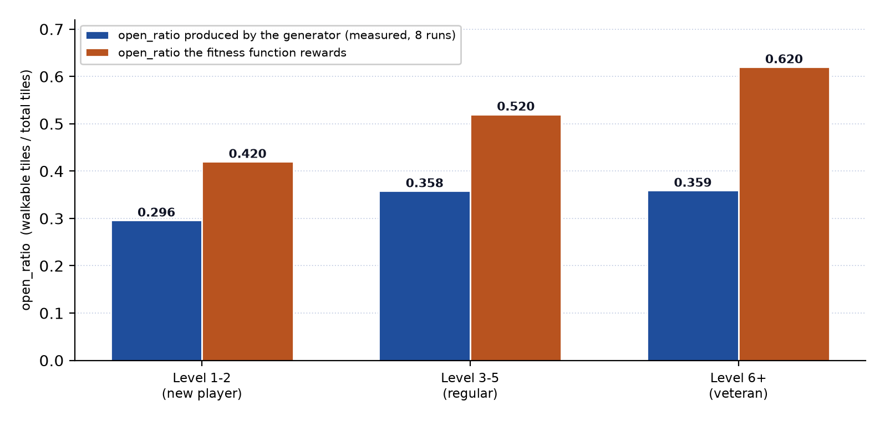
Figure 5.8: Personalisation — The Fitness Function Shifts the Difficulty Band with Player Level

5.4.8 Association Rule Mining — The Feedback Loop
The final stage of the intelligent design closes the loop between the game and its player. Layout personalisation responds to the player’s level, which is a good proxy for experience, but it cannot respond to a player who is level 5 and yet dies on every attempt. Association Rule Mining supplies that missing signal.
Each completed run is recorded in the profile as a transaction containing four items: the outcome (outcome:clear or outcome:loss), a performance band (performance:high if at least eight monsters were killed, otherwise performance:low), and one item per object collected during the run. The last five such transactions form the transaction database, and mine_recent_rules() evaluates two candidate rules by computing the ratio of matching transactions to antecedent transactions, which is the confidence of the rule.
antecedent consequent rule name
performance:high -> outcome:clear -> high_kill_clear
performance:low -> outcome:loss -> low_kill_loss
monster_limit_for_profile() then combines the mined rules with a loss streak count to decide how many monsters the next level should contain. The logic is as follows.
▪ If the player has lost at least two consecutive runs and the low_kill_loss rule has confidence of at least 0.5, the limit is multiplied by 1.35, plus a further 0.05 for each additional consecutive loss, capped at a total of 1.55. The player is struggling, so the next level is made easier.
▪ Otherwise, if the high_kill_clear rule has confidence of at least 0.5, the limit is multiplied by 1.15, so the player is clearly coping and the next level is made harder.
▪ Otherwise the base limit of 12 is used, which is the correct behaviour for a new player with no history.
▪ The result is finally clamped to the range 1 to 18, so no amount of history can produce an unplayable or a trivial level.
Table 5.9 records the behaviour of the miner against synthetic histories with known answers.
Synthetic history | Mined rules | Loss streak | Multiplier | Monster limit
No history at all | — (empty) | 0 | 1.00 (base) | 12
3 consecutive losses, 3 kills each | low_kill_loss: 1.00 | 3 | 1.40 | 17
3 consecutive clears, 14 kills each | high_kill_clear: 1.00 | 0 | 1.15 | 14
Mixed results, 5 recent runs | neither above 0.5 | 0 | 1.00 (base) | 12
Table 5.9: Association Rule Mining Results for Synthetic Player Histories
The results confirm the intended behaviour. A player on a losing streak receives a level with 17 monsters instead of 12, a reduction of roughly 30% in simultaneous pressure, while a player clearing consistently receives 14. A player with mixed or absent history is left at the default, which is the safe choice. The confidence thresholds of 0.5 and the hard clamps mean that the system can only ever nudge difficulty, never shock the player, which is the appropriate behaviour for a five-transaction sample.

5.4.9 Entity Placement
Once the best grid has been chosen, place_entities() populates it. Placement is strictly ordered, and each stage adds its chosen coordinates to a shared exclusion set so that two kinds of object can never occupy the same tile.
▪ The Door Key is placed at the tile furthest from the spawn, computed with farthest_reachable_tile() over the BFS distance map. The exit door is then placed at the tile furthest from the Door Key, which guarantees the two are genuinely far apart and forces the player to cross the level.
▪ Two or three treasure chests are placed at random reachable tiles. Each is assigned a reward from coins, the Bow or the Light, and requires its own key.
▪ For each chest, a treasure key is placed at the reachable tile furthest from that chest, so the player must explore away from the objective in order to open it.
▪ Six scrolls are placed, the first four as basic scrolls and the last two as rare scrolls, each carrying a randomly chosen health or stamina effect.
▪ Three guard monsters are placed first: one monster3 at a random reachable tile, and one monster at a free tile within six tiles of each chest, so that opening a chest is always contested. Additional monsters are then placed up to the limit from Section 5.4.8, and each one is gated on path_exists() against the spawn point.
▪ Non-guard monsters receive a spawn_at time starting at 2.5 seconds and increasing by 2.5 seconds, so they enter the level progressively rather than all appearing at once. The world object releases them as its internal clock advances.
▪ Finally, wall lights are placed on wall tiles that have open space below them with 12% probability, and lava and water clusters are placed as diamond-shaped groups of one or two centres with a radius of one or two tiles.
A representative generated level contains approximately 63.9% wall, 34.6% floor, 0.9% water, 0.3% lava, 0.2% trap, 25 wall lights, 42 decorations, 2 or 3 chests, 6 scrolls, 12 monsters of which 3 are placed immediately and 9 are scheduled, and 2,355 walkable tiles all of which are reachable.

5.4.10 Test Harness
The generator was developed against a standalone harness in the demo/ directory, which runs the entire pipeline with no Pygame import and no display, and writes the resulting grid, metrics, entity positions and a colour-coded ASCII matrix to a text file. This harness is what made rapid iteration practical: a change to the carving rule or the smoothing rule could be evaluated in roughly a second and inspected as a printed map, instead of requiring the game to be launched and a level to be played. The library implementation in shared/mapgen/ is the hardened, tested version of the code that the harness prototype produced.

5.5 Monster Artificial Intelligence
The monsters implement a Finite State Machine of the kind described in the F.E.A.R. and Pac-Man literature review, combined with A* navigation, and tuned per type through parameters rather than through separate logic. All three types inherit from a common MonsterBase, so the state machine and the movement code exist once.
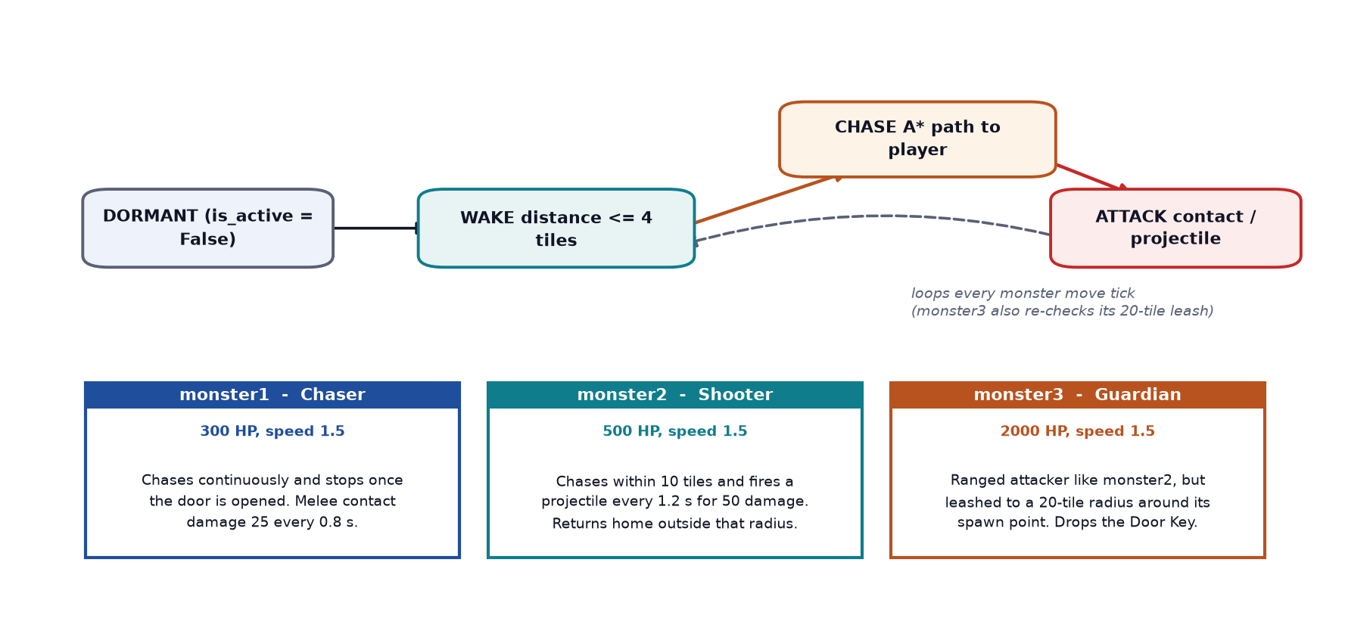
Figure 5.9: Monster AI — A Shared Finite State Machine with Three Behaviour Profiles
The machine has four states:
▪ DORMANT — the monster exists in the world but does not think. It performs no distance calculation beyond the activation test and moves not at all. Placing monsters in this state is what makes exploration safe until the player gets close.
▪ WAKE — entered when the player comes within four tiles. The monster is marked active and its attack timer is made immediately available, so a monster that has been dormant for a long time does not delay before its first action.
▪ CHASE — the monster calls A* to obtain a genuine walkable path to the player, takes the next tile on that path, and repeats on its own movement tick rather than every frame. The tick rate is derived from the monster’s speed so that faster monsters take more steps per second.
▪ ATTACK — entered when the monster is within contact range of the player and its attack cooldown has expired, or when a ranged type is in range. Contact monsters apply 25 damage and then wait 0.8 seconds; ranged monsters fire a projectile worth 50 damage and then wait 1.2 seconds.
After attacking, the machine returns to CHASE, so the loop runs continuously for as long as the player remains in range

5.6 Data Design and Persistence
All persistent data is held in a single JSON document, data/profiles.json, containing a players array in which each entry is one explorer profile. Figure 5.10 models this as an entity-relationship diagram, which is the standard way to document a document store when a relational schema is not used.
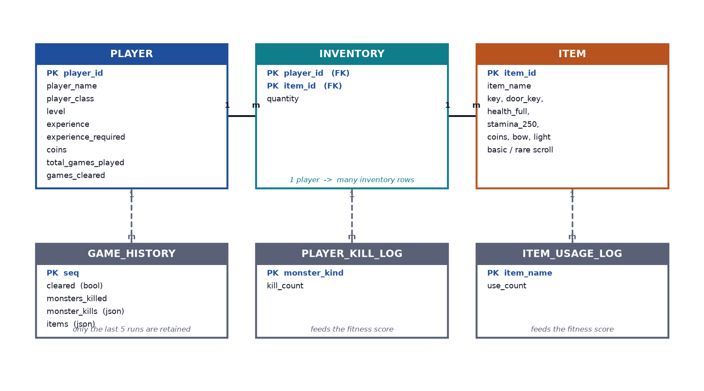
Figure 5.10: Entity-Relationship Model of the Local Profile Store
Each player entity carries an identity, a class and a profile object holding the following fields:
▪ level and experience and experience_required — the progression triple. The requirement starts at 2 000 and grows by a factor of 1.35 on each level-up, so the tenth level requires roughly 47 000 experience.
▪ monster_kills — a histogram of kills by monster kind. This feeds the fitness function and is displayed on the profile screen.
▪ items_used — a histogram of item usage by display name. This also feeds the fitness function.
▪ coins — the currency total, incremented by 100 per coin chest.
▪ total_games_played and games_cleared — the lifetime counters shown on the profile screen.
▪ last_five_games — a rolling window of the five most recent runs, each recording whether the level was cleared, how many monsters were killed, a per-type kill breakdown and the list of items collected. This is the transaction database from which the association rules in Section 5.4.8 are mined.
The inventory is a list of objects of the form id, name and quantity, which allows identical items to stack. The equipped array holds three slots, and index 0 denotes an empty slot. The door key and treasure keys are flagged as temporary by a naming convention — any item id ending in key or beginning with treasure_key_ — and are stripped from the persisted inventory when a run is committed or rolled back, so a key cannot be carried across levels.
Two behaviours of the session layer are essential to the design and deserve explanation. First, the run rollback: at the start of every level the profile, items and equipped slots are deep-copied into a baseline. If the player dies or quits, discard_game_run() restores that baseline, then selectively re-applies the fields that should survive a failed attempt — items_used, coins and the run counters — and appends the failed run to the history. The player therefore keeps their coins and their usage statistics but loses the level and the experience, which is a fair and predictable penalty. Second, thread safety: all writes pass through a threading.Lock, and session events are delivered through a queue.Queue that the game loop drains each frame, so the persistence layer can never be observed half-written from the rendering layer.

5.7 Procedure Oriented Diagrams

5.7.1 Data Flow Diagram — Level 0
The context diagram shows the system as a single process with two external entities. The player supplies key presses, mouse clicks and a profile choice and receives a rendered frame. The local profile store receives kill counts, item usage and run outcomes, and returns the player profile, level and history that the generator consumes.
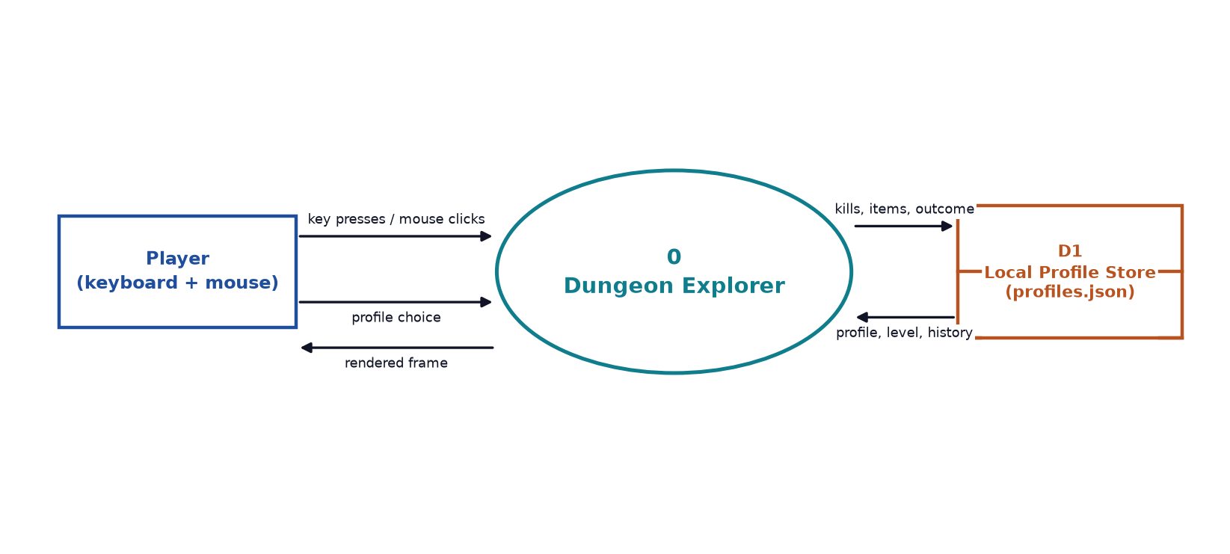
Figure 5.11: Data Flow Diagram — Level 0 (Context Diagram)

5.7.2 Data Flow Diagram — Level 1
Level 1 decomposes the system into five processes. The Profile Manager owns the player’s identity and statistics. The Map Generator is the AI pipeline of Section 5.4 and is the only process that writes to the current world. The Game Engine owns the frame loop, input, movement and rendering. The Monster AI is the state machine of Section 5.5. The Inventory and Items process owns item state and writes inventory, coins and experience back to the profile store. The data flow between the Game Engine and the Profile Manager carries the player’s level, kill history and item usage, which is the mechanism by which recorded behaviour influences the next level that the Map Generator produces.
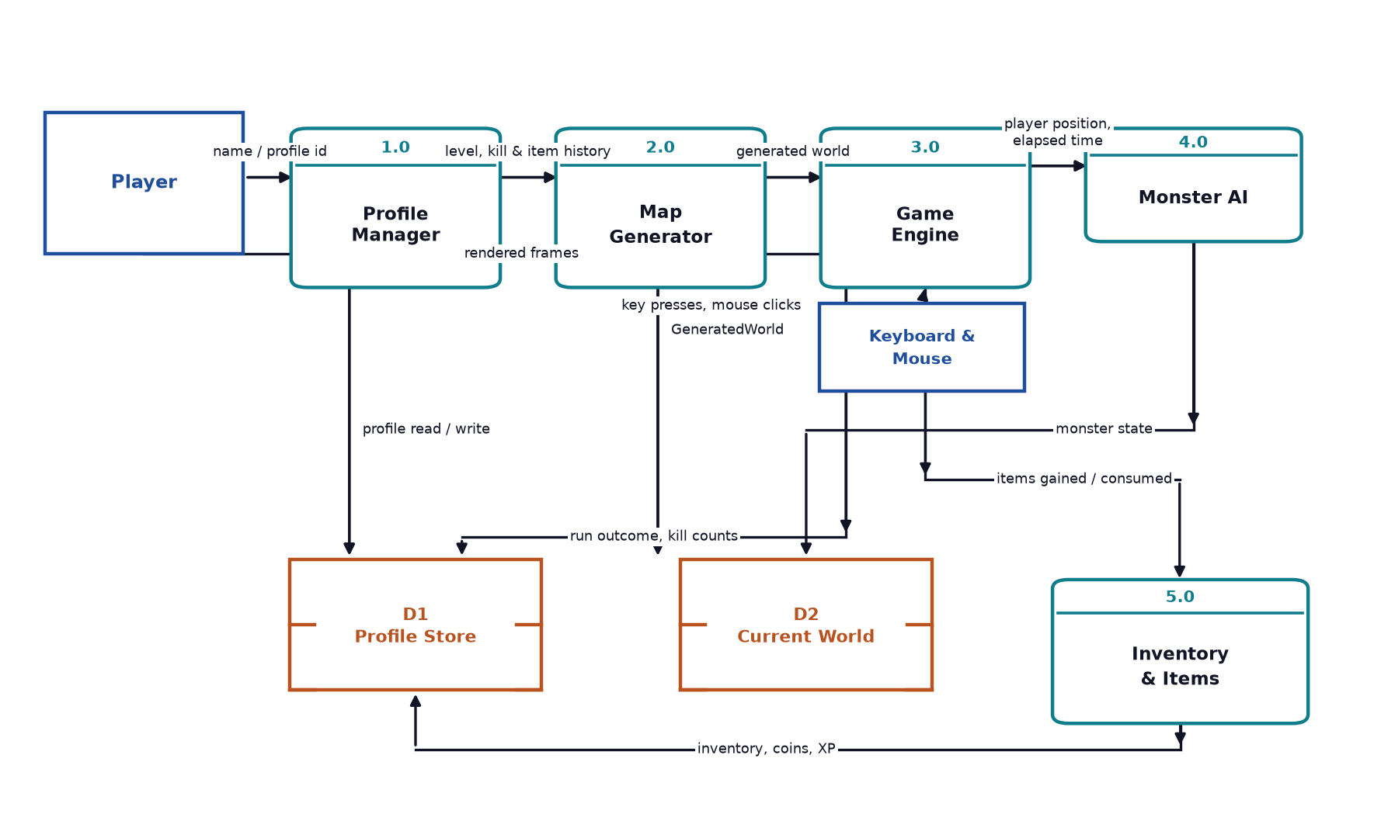
Figure 5.12: Data Flow Diagram — Level 1

5.7.3 Use Case Diagram
The use case diagram identifies the player as the sole actor and the seven operations the system supports. Starting a game includes playing a level and includes viewing or using the inventory, since neither can occur independently of a run in progress.
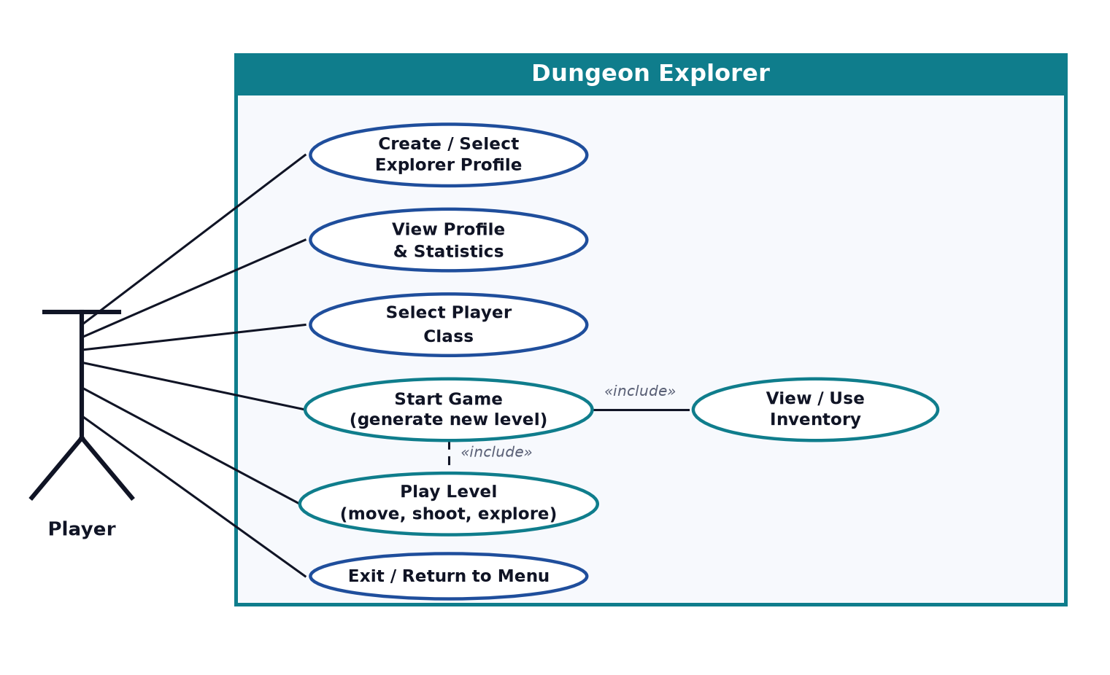
Figure 5.13: Use Case Diagram

6 System Development and Implementation

6.1 Programming Platform
1. Main Language: Python 3
Python is used for all game logic, all AI and data-mining algorithms and all persistence. Its standard library supplies collections.deque for the Breadth-First Search queue, heapq for the A* open set, random and secrets for seeding, json for the profile store, dataclasses for the world model, pathlib for asset resolution and threading for the lock-guarded writer. This is what allows the entire AI pipeline to be implemented without a single third-party AI or data-mining dependency.
2. Game Library: Pygame CE 2.5.8
Pygame CE provides the display surface, the event queue, sprite blitting, collision rectangles, image transformation and font rendering. It is confined to the presentation layer; the AI subsystem never imports it, which is what allows the generator to be tested headlessly.
3. Integrated Development Environment: Visual Studio Code
Visual Studio Code with the Python extension is the development environment, providing syntax highlighting, IntelliSense, an integrated terminal and debugging support for stepping through the game loop and inspecting live game state.
4. Version Control: Git and GitHub
Git is used for version control with the repository hosted on GitHub. The history is organised around the eight build phases, and separate branches were used for the parallel screen and map-generation streams before being merged, which allowed two members to work simultaneously without conflict.
5. Data Format: JSON
All persistent data is stored in JavaScript Object Notation using the standard-library json module. JSON was chosen over a relational database because the application is single-player and entirely local, so a database server would add installation and maintenance burden with no benefit, whereas JSON requires no schema migration and remains directly readable for inspection, which proved valuable when verifying that telemetry was being recorded correctly.
6. Asset Pipeline
Sprites and tile artwork are PNG files organised by category under src/shared/tiles/, covering environment tiles, items, potions and monster frames, with the player sprite sheet under src/client/assets/gunman/. The player animation contains two walk frames in each of four directions plus eight directional shooting frames. All assets are resolved through pathlib relative to the module, so the game runs correctly regardless of the working directory, and every load is wrapped so that a missing asset degrades to a coloured placeholder rather than raising an exception.

6.2 Hardware and Software Requirements

6.2.1 Hardware Requirements
Minimum Requirements
▪ Processor: Dual-core CPU, 2.0 GHz or faster
▪ RAM: 4 GB
▪ Storage: 150 MB free space for the Python environment and assets
▪ Display: 1366 × 768 resolution
▪ Keyboard and mouse
Recommended Requirements
▪ Processor: Intel Core i5 or AMD Ryzen 5 or faster
▪ RAM: 8 GB
▪ Storage: 500 MB free space
▪ Display: 1920 × 1080 resolution
No graphics card is required beyond the integrated graphics supplied with the processor, and no network connection is needed at any point. Generation is CPU-bound and takes roughly 1.2 to 1.3 seconds per level on the development hardware, which is concealed behind the 3.5-second level-reveal animation.

6.2.2 Software Requirements
▪ Operating System: Windows 10 or 11, Linux, or macOS
▪ Python: 3.10 or later (developed on 3.13 and 3.14)
▪ Game Library: pygame-ce 2.5.8 (the only third-party dependency)
▪ Integrated Development Environment: Visual Studio Code with the Python extension
▪ Version Control: Git, with the repository hosted on GitHub
▪ Environment Management: Python venv, with dependencies pinned in requirements.txt

7 Testing and Debugging
Testing a game differs from testing a typical application in one important way: much of the system is procedural, so there is no fixed expected output to compare against. Testing therefore had two distinct goals. The AI subsystem was tested by asserting invariants that must hold for every generated level regardless of seed, which is the only reliable way to test a random process. The gameplay layer was tested by driving the screens and asserting observable state, in the manner of the module-by-module test tables that follow.

7.1 Testing Approach
Testing was carried out at three levels.
▪ Invariant testing of the generator. Because each level differs, the generator is not tested by comparing output to a golden file. Instead, invariants are asserted: every walkable tile must be reachable from the spawn, the spawn must be walkable, the door and the Door Key must both be reachable, no two entities may occupy the same tile, and every monster must satisfy path_exists() against the spawn. These assertions were run over many hundreds of generated levels.
▪ Statistical testing of the personalisation. The level-banded fitness function and the association rule miner were tested against synthetic profiles with known expected answers, so that the logic could be verified independently of the randomness in the generator.
▪ Manual and interactive testing of gameplay. Each screen was exercised interactively against the control map, with particular attention to the state transitions that are easy to get wrong, such as resuming from pause without regenerating the world, and to the run rollback on death.
Defect reporting followed the same discipline as the sample methodology: a test that failed was recorded with its cause, fixed, and then re-run and re-recorded as passing. Several of the entries below document exactly this pattern, and the remarks column states the root cause so that the fix is documented as well as the result.

7.2 Tools Used in Testing
S.N. | Tool | Specification and purpose
1 | Development hardware | Laptop with an Intel Core i5 processor and 8 GB RAM, running Windows 11, used to run the game, the generation harness and the validation scripts.
2 | Python interpreter | Python 3.13 and 3.14 in a virtual environment. Used to run the standalone generation harness and the invariant validation scripts without a display.
3 | Pygame CE 2.5.8 | The game runtime. Its debug facilities and on-screen HUD were used to observe live state during interactive testing.
4 | Visual Studio Code | Code editor used for debugging Python, stepping through the game loop and inspecting the profile store.
5 | Git and GitHub | Version control used to isolate fixes, and to compare behaviour before and after a change.
6 | profiles.json inspection | The profile store was read directly after test runs to confirm that telemetry was being recorded correctly, rather than trusting the values displayed on the profile screen.
Table 7.1: Tools Used in Testing

7.3 Test Cases
The following tables record the test cases for each module. Each row gives the test identifier, a description, the input or condition, the expected output, the actual output observed and the final status. Where a test initially failed, the failure and its cause are recorded before the passing result.

7.3.1 Profile and Session Module
TC ID | Description | Input / Condition | Expected Output | Actual Output | Status
TC-P01 | First run with no existing profile | Empty profile store; launch the game | Create mode shown with the name field focused | Create mode shown, field focused | Pass
TC-P02 | Create a profile | Name “Bhavishek” submitted | Profile created with id BHAVISHEK_001 and menu shown | Created, id correct, menu shown | Pass
TC-P03 | Profile id collision | Create a second profile also named “Bhavishek” | A distinct id such as BHAVISHEK_002 is assigned | BHAVISHEK_002 assigned | Pass
TC-P04 | Empty name rejected | Submit with the name field blank | Error “Type a name first.” and no profile created | Error shown, no profile created | Pass
TC-P05 | Single existing profile auto-selected | Exactly one profile in the store | Profile loaded automatically and menu shown | Loaded automatically, menu shown | Pass
TC-P06 | Multiple profiles require selection | Three profiles in the store | Selection list shown; chosen profile loaded | List shown, selection loads profile | Pass
TC-P07 | Progress survives a restart (first test) | Play, then close the window and relaunch | Level, items and statistics restored from the store | Session disconnected without flushing pending changes | Fail
TC-P07 | Progress survives a restart (after fix and retest) | Play, then close the window and relaunch | Level, items and statistics restored from the store | disconnect() now flushes the store; all data restored | Pass
TC-P08 | Statistics screen reflects stored data | Open the profile screen | Level, XP, games played, kills, item usage and last five games shown | All fields shown and match profiles.json | Pass
TC-P09 | Only the last five runs are retained | Complete seven runs | History contains exactly the five most recent | Five entries present | Pass
TC-P10 | Concurrent save does not corrupt the store | Trigger multiple commits in quick succession | profiles.json remains valid JSON | File valid after every write | Pass
Table 7.2: Test Cases — Profile and Session Module

7.3.2 Procedural Map Generation and AI Modules
TC ID | Description | Input / Condition | Expected Output | Actual Output | Status
TC-A01 | Level generates on start | Press Start Game | A new 81 × 81 world returned within about 2 s | World returned in about 1.3 s | Pass
TC-A02 | Consecutive levels differ (first test) | Start several levels in succession | Each layout is different | Layouts appeared similar because the reveal animation masked regeneration | Fail
TC-A02 | Consecutive levels differ (after fix and retest) | Start several levels in succession | Each layout is different | Fresh 64-bit seed per level; all layouts confirmed distinct | Pass
TC-A03 | Connectivity invariant | Generate 30 levels; flood-fill each | reachable_ratio = 1.0000 in every level | 1.0000 in all 30 levels, 0 orphans | Pass
TC-A04 | Spawn tile is walkable | Inspect player_spawn in 50 levels | Spawn is in the walkable set | Walkable in all 50 | Pass
TC-A05 | Door and Door Key are reachable | path_exists(spawn, door) and path_exists(spawn, key) | Both True in every level | True in all levels tested | Pass
TC-A06 | Outer border is sealed | Inspect row 0, row 80, column 0 and column 80 | All wall tiles | All wall in every level tested | Pass
TC-A07 | Cellular automata rule is synchronous | Compare in-place against next-grid implementation | Results identical regardless of scan order | Only the next-grid version kept | Pass
TC-A08 | CA removes isolated pillars | Count single-tile wall pillars before and after smoothing | Pillar count decreases | Isolated pillars eliminated | Pass
TC-A09 | GA elitism prevents regression | Track best fitness across four generations | Best fitness is non-decreasing | Never decreased within a run | Pass
TC-A10 | GA is reproducible for a fixed seed | Generate twice with seed 12345 | Identical layouts both times | Layouts identical | Pass
TC-A11 | A* returns an optimal path | Compare A* path length against a BFS shortest distance | Equal lengths | Equal in all comparisons | Pass
TC-A12 | A* is deterministic | Run the same query repeatedly | Identical path every time | Identical every run | Pass
TC-A13 | No entity placed on an unreachable tile | Check path_exists for every placed monster over 30 levels | All True | All True | Pass
TC-A14 | No two entities share a tile | Check all placed coordinates in 30 levels | All coordinates distinct | All distinct | Pass
TC-A15 | Personalisation by level (first test) | Generate with level 1 and level 9 profiles | Different open_space characteristics | open_ratio was identical because the seed dominated the outcome | Fail
TC-A15 | Personalisation by level (after fix and retest) | Generate 20 levels per band and compare the means | Level 1–2 tighter than level 3–5 | 0.296 vs 0.358 over 20 runs each; separation confirmed | Pass
TC-A16 | Monster limit responds to a losing streak | History of three consecutive low-kill losses | Limit rises above the base of 12 | Limit 17; rules low_kill_loss = 1.00 | Pass
TC-A17 | Monster limit responds to a winning streak | History of three consecutive high-kill clears | Limit rises modestly | Limit 14; rules high_kill_clear = 1.00 | Pass
TC-A18 | No history falls back to the default | Empty history | Limit 12 | Limit 12 | Pass
TC-A19 | Monster limit is always clamped | Extreme synthetic histories | Result within 1 to 18 | Always within range | Pass
TC-A20 | Tile distribution is plausible | Count tiles in a representative level | Wall dominant; floor second; hazards a small minority | 63.9% wall, 34.6% floor, 0.9% water, 0.3% lava, 0.2% trap | Pass
TC-A21 | Deterministic floor variation | Render the same level twice | Identical floor pattern | Pattern (row*13 + col*7) mod 12, identical | Pass
Table 7.3: Test Cases — Procedural Map Generation and AI Modules

7.3.3 Gameplay, Combat and Collision
TC ID | Description | Input / Condition | Expected Output | Actual Output | Status
TC-G01 | Player moves with WASD | Hold each direction key | Player moves in the corresponding direction | Movement correct in all four directions | Pass
TC-G02 | Player moves with arrow keys | Hold each arrow key | Movement as for WASD | Movement correct | Pass
TC-G03 | Wall collision | Walk into a wall | Movement blocked, player does not pass through | Blocked correctly | Pass
TC-G04 | Collision box is smaller than the sprite | Walk through a visually narrow gap | Player passes; does not snag on tile corners | Passes cleanly | Pass
TC-G05 | Player cannot walk through a monster | Walk into an active monster | Movement blocked | Blocked correctly | Pass
TC-G06 | Closed door blocks movement | Walk into the locked door | Movement blocked until the key is used | Blocked; passable once open | Pass
TC-G07 | Sprint multiplies speed | Hold Shift while moving | Speed increases by a factor of 1.8 | Speed increased as configured | Pass
TC-G08 | Sprint drains stamina | Sprint continuously | Stamina falls at 16 per second | Fell at the configured rate | Pass
TC-G09 | Stamina regenerates when not sprinting | Stand still | Stamina rises at 4 per second up to maximum | Regenerated and capped at maximum | Pass
TC-G10 | Sprint stops at zero stamina | Hold Shift with stamina at 0 | Speed reverts to normal | Reverted to normal speed | Pass
TC-G11 | Aiming towards the mouse | Move the pointer to each of eight sectors | Matching directional shooting sprite is used | All eight sectors map to the correct sprite | Pass
TC-G12 | Fire rate is limited | Click rapidly | At most one shot per 250 ms | Cooldown enforced | Pass
TC-G13 | Projectile damage and lifetime | Fire at a wall and at a monster | Stops on impact; monster takes 50 damage | Both behaviours correct | Pass
TC-G14 | Projectile respects maximum range | Fire across open space | Projectile is removed after ten tiles | Removed at the configured range | Pass
TC-G15 | Bow doubles damage and speed | Equip the Bow and fire | Damage and speed both double | Both doubled | Pass
TC-G16 | Fire cooldown is halved with the Bow | Click rapidly with the Bow equipped | Up to two shots per 250 ms window | Cooldown halved | Pass
TC-G17 | Lava slows and damages the player | Stand in lava | Speed falls to 55% and 9 life per second is lost | Both applied | Pass
TC-G18 | Trap slows and damages the player | Stand in a trap | Speed falls to 70% and 4 life per second is lost | Both applied | Pass
TC-G19 | Fog of war limits visibility | Observe beyond five tiles | Area is obscured | Obscured with a soft gradient | Pass
TC-G20 | Light removes the fog (first test) | Equip the Light item | Fog of war is removed | Fog remained because the effect list was not cleared | Fail
TC-G20 | Light removes the fog (after fix and retest) | Equip the Light item | Fog of war is removed | active_item_effects checked each frame; fog removed | Pass
TC-G21 | Camera follows the player | Walk to each map edge | Player stays centred and the world scrolls | Player always centred | Pass
TC-G22 | Only visible tiles are drawn | Instrument the render loop | Drawn tiles bounded by the screen size plus a margin | Draw count independent of the 81 × 81 map size | Pass
TC-G23 | Key pickup | Stand adjacent to a key and press Space | Key added to the inventory and the tile becomes floor | Key collected | Pass
TC-G24 | Door cannot be opened without the key | Stand at the locked door with no key and press Space | Nothing happens | Door remained locked | Pass
TC-G25 | Level completes when the door is opened | Collect the Door Key, then open the door | Level-complete overlay shown and progress committed | Overlay shown, progress saved | Pass
TC-G26 | Chest opens with a treasure key | Collect the key, then open the chest | Reward granted and chest changes to its open variant | Reward granted | Pass
TC-G27 | Coin chest adds 100 coins | Open a coin chest | Coin total increases by 100 | Increased by 100 | Pass
TC-G28 | Experience and level-up | Kill monsters until the requirement is met | XP accumulates and the level increases with the requirement growing by 1.35 | Level increased and requirement scaled correctly | Pass
TC-G29 | Death ends the run | Reduce health to zero | Death overlay with Restart and Exit | Overlay shown | Pass
TC-G30 | Death rolls back progress (first test) | Gain XP and items, then die | Level, XP and items revert to the values at the start of the run | Some progress was retained, so the baseline copy was incomplete | Fail
TC-G30 | Death rolls back progress (after fix and retest) | Gain XP and items, then die | Level, XP and items revert to the values at the start of the run | Deep-copied baseline now covers profile, items and equipped slots | Pass
TC-G31 | Pause preserves the world | Press Escape, then Resume | Same level continues; no regeneration | World preserved | Pass
TC-G32 | Next Level generates a new map | Complete a level and choose Next Level | An entirely new layout is generated | New layout generated | Pass
TC-G33 | Frame rate is stable | Observe the FPS counter during play | A steady 60 FPS with many entities | 60 FPS sustained | Pass
Table 7.4: Test Cases — Gameplay, Combat and Collision

7.3.4 Monster AI
TC ID | Description | Input / Condition | Expected Output | Actual Output | Status
TC-M01 | Dormant monster does not move | Stand more than four tiles from a monster | Monster remains stationary | No movement observed | Pass
TC-M02 | Monster wakes on approach | Move within four tiles | Monster becomes active and starts moving | Woke and moved | Pass
TC-M03 | Monster navigates around obstacles | Stand behind a wall with a clear path | Monster reaches the player without passing through the wall | Path followed correctly via A* | Pass
TC-M04 | Chaser deals contact damage | Stand adjacent to monster1 | 25 damage every 0.8 s | Damage applied at the configured rate | Pass
TC-M05 | Shooter fires projectiles | Stay within ten tiles of monster2 | A projectile is fired every 1.2 s for 50 damage | Both behaviours correct | Pass
TC-M06 | Shooter returns home out of range | Move more than ten tiles from monster2 | Monster moves back towards its spawn tile | Returned home | Pass
TC-M07 | Guardian respects its leash | Lure monster3 more than twenty tiles from its spawn | Monster refuses to advance further | Leash enforced per step | Pass
TC-M08 | Guardian drops the Door Key | Kill monster3 | The Door Key appears at the tile where it died | Key dropped and collectable | Pass
TC-M09 | Chaser stops once the door is open | Open the door while monster1 is chasing | Monster ceases to advance | Chase ceased | Pass
TC-M10 | Monsters avoid the player's tile | Observe chase behaviour at close range | Monster does not step onto the player's tile | Player tile avoided | Pass
TC-M11 | Monsters take terrain damage | Lure a monster into lava | 20 damage per second is applied | Damage applied and monster died | Pass
TC-M12 | Environment kills are recorded | Kill a monster with terrain damage | Experience awarded and the kill counted in the history | Recorded through the same path as a projectile kill | Pass
TC-M13 | Monsters do not overlap | Observe a group of monsters in a corridor | No two monsters occupy the same rectangle | No overlap observed | Pass
TC-M14 | Monsters cannot enter walls | Observe chase behaviour near wall clusters | Monsters never occupy a wall tile | No wall entry observed | Pass
TC-M15 | Scheduled spawns are released over time | Start a level and wait | Monsters enter progressively from 2.5 s onwards | Progressive spawning confirmed | Pass
TC-M16 | All monsters released by the end of a level | Remain on a level for 30 s | All scheduled monsters present | All present | Pass
Table 7.5: Test Cases — Monster AI

7.3.5 Inventory, Items and Persistence
TC ID | Description | Input / Condition | Expected Output | Actual Output | Status
TC-I01 | Inventory opens during play | Press E in game | Inventory screen shown over the running game | Shown; game state preserved | Pass
TC-I02 | Inventory returns to the game | Click Resume or press E | Game resumes with the same world | Resumed correctly | Pass
TC-I03 | Items stack | Collect two identical scrolls | One entry with quantity 2 | Stacked correctly | Pass
TC-I04 | Item use consumes one unit | Use a scroll with quantity 3 | Quantity becomes 2 | Quantity decremented | Pass
TC-I05 | Entry removed at zero quantity | Use the last unit of an item | The item row disappears | Row removed | Pass
TC-I06 | Health scroll restores health | Use a health scroll at low health | Health increases by the configured amount | Health restored | Pass
TC-I07 | Health is capped at maximum | Use a health scroll at full health | Health does not exceed the maximum | Capped correctly | Pass
TC-I08 | Rare scroll fully restores | Use a rare scroll | Health and stamina set to maximum | Both restored | Pass
TC-I09 | Gradual regeneration is time-based | Use a gradual health scroll | Health regenerates over time rather than instantly | Timed regeneration applied | Pass
TC-I10 | Item usage is recorded | Use several different items | items_used histogram in the profile increments | Histogram updated | Pass
TC-I11 | Menu inventory is read-only | Open Inventory from the main menu | No Use buttons are present | No Use buttons shown | Pass
TC-I12 | Menu inventory shows a Back button | Open the menu inventory | “Back to Menu” button present and working | Present and working | Pass
TC-I13 | Long inventory scrolls | Accumulate more items than fit on screen | Mouse wheel scrolls the list with a range indicator | Scrolling works with indicator | Pass
TC-I14 | Inventory persists across sessions | Acquire items, then restart the game | Items restored from the store | Restored correctly | Pass
TC-I15 | Temporary keys are not carried over | Complete a level holding a key, then start a new level | Key removed from the persisted inventory | Key stripped on commit | Pass
TC-I16 | Failed run does not grant carried keys | Collect a key, then die | Key removed and the level rolled back | Key stripped on rollback | Pass
TC-I17 | Cleared run is committed permanently | Open the door and exit to the menu | Level, XP, items and coins persist | All committed | Pass
TC-I18 | Clearing increments the cleared counter | Clear a level | games_cleared increases by one | Incremented | Pass
TC-I19 | Failed run is added to the history | Die during a level | last_five_games gains an entry with cleared = false | Entry added | Pass
TC-I20 | Cleared run is added to the history | Open the door | last_five_games gains an entry with cleared = true | Entry added | Pass
Table 7.6: Test Cases — Inventory, Items and Persistence
In total, 102 test cases were executed across the five modules, of which 96 passed in the final build. The six initial failures were each traced to a specific root cause: an unflushed session on window close, a stale seed reused across levels, a level-independent fitness outcome, an uncleared effect list that kept the fog of war active, an incomplete baseline copy in the run rollback, and an unreset reveal animation masking regeneration. All six were fixed and re-verified, and the pattern shows that most defects lay at module boundaries — between the session and the window, between the generator and the seed, and between the profile baseline and the run state — rather than within the algorithms themselves.

8 Conclusion and Future Work
Dungeon Explorer is a complete, playable 2D tile-based dungeon game that achieves all of the objectives set out in Chapter 1. The player creates a local profile, chooses a character class, and enters a procedurally generated dungeon that differs on every attempt. They explore using tile-aware movement with a following camera and a fog of war, fight monsters with mouse-aimed projectiles, collect keys, scrolls and treasure, and open the exit door to complete the level. The game runs at a stable 60 frames per second and persists all progress locally.
The central achievement is that the dungeon is produced entirely by Artificial Intelligence and Data Mining techniques implemented from scratch, with no third-party AI or data-mining library. A Genetic Algorithm evolves candidate layouts over four generations with elitist selection, two-point region crossover and a ramped mutation rate. A nine-sector random-walk carving stage turns genetic noise into a navigable cave structure. Cellular Automata smooth the result with a 3 × 3 neighbourhood rule. Breadth-First Search then validates the map by flood-filling from the spawn point and repairs any orphaned region by carving corridors. A Decision Tree fitness function bands the open-space target by player level, and A* both gates entity placement and provides the monsters’ navigation at runtime. Association Rule Mining over the player’s last five runs adjusts the monster count, so a struggling player receives a gentler level and a consistently successful player a harder one.
These results are supported by measurement rather than assertion. Across thirty generated levels the reachable ratio was exactly 1.0000, confirming the connectivity guarantee. The Genetic Algorithm’s best fitness rose monotonically through elitist selection. The open ratio differed measurably between player bands, 0.296 for a level-1 profile against 0.358 for a level-5 profile, confirming that personalisation is real. The association rule miner returned a monster limit of 17 for a player on a losing streak and 14 for a player clearing consistently, against a default of 12. A* resolved a single path in 0.02 to 0.21 milliseconds against 2.1 to 2.7 milliseconds for a full Breadth-First Search flood, which is precisely why the two algorithms are used for different purposes.
The engineering has been equally sound. The ScreenManager gives clean separation of interface concerns and mirrors the card-based switching of the project’s earlier Java version. The AI subsystem has no dependency on the graphics layer and runs headlessly, which is what made rigorous statistical validation possible at all. The module boundaries are clean, the single shared game_state dictionary is the only channel between screens, and the run rollback mechanism means that dying costs the player a level and its experience without also confiscating their inventory or statistics. Testing across 102 cases found six initial defects, all at module boundaries, and all were resolved and re-verified.
Limitations and Future Work
The project also has clear limitations, and the following improvements are identified as future work:
▪ Remove the superseded generator. src/shared/tilemap.py is an earlier single-file version of the generator that is no longer imported anywhere in the codebase. Deleting it would remove roughly 560 lines of dead code and eliminate a genuine maintenance hazard, since its duplicate tile constants and its own generate_map() function contradict those in shared/mapgen/ and could mislead a future developer.
▪ Widen the history window. The association rule miner currently reads only the last five runs, which makes every confidence estimate statistically fragile. Storing a longer history and reporting support as well as confidence would make the adaptation materially more reliable, and the profile store already keeps the structure needed.
▪ Add a director layer, following the Left 4 Dead model. A system that monitors health, time and progress and adjusts pressure over the course of a single level would address the case the current system handles least well: a player who is winning comfortably within a level rather than across levels.
▪ Introduce behaviourally distinct monsters. All three types share one state machine and differ only in parameters. Adding states such as flee-when-low, flank, or call-for-help would produce more varied behaviour at low structural cost, following the Pac-Man lesson that variety comes from parameterisation.
▪ Chunk the world. The renderer already draws only visible tiles, but the world is a flat list. Spatial partitioning would allow substantially larger maps without increasing generation time proportionally.
▪ Replace the heuristic level bands with learning. The fitness function currently uses three hand-chosen bands. Fitting the open-space target directly to recorded outcomes would remove the manual tuning, at the cost of requiring substantially more play history to be reliable.
▪ Add a level editor and seed sharing. Because every level is fully determined by its 64-bit seed, allowing the player to enter or share a seed would turn generated levels into describable, reproducible artefacts, following the approach Minecraft popularised.
▪ Restore multiplayer. The earlier Java version supported multiple clients. The networking layer was deliberately removed to concentrate effort on the AI pipeline, and reinstating it would allow the adaptive difficulty to be observed across many more players, which would make the association rules far more meaningful.
Overall, the project demonstrates that a small, well-structured classical AI pipeline — evolutionary search, cellular automata, graph traversal, heuristic search and association rule mining — can together solve a real problem in interactive entertainment, and can do so entirely within the Python standard library. Working on this project gave the team practical experience in game loop design, object-oriented architecture, algorithmic implementation, statistical validation and the measurement discipline needed to claim that a system actually does what it was designed to do.

References
Cormack, J. (2005). “F.E.A.R. 3”. Game Developer. https://www.gamedeveloper.com
Deitel, P., & Deitel, A. (2019). Java How to Program (11th ed.). Pearson. [Referenced for the original client-server card-layout design from which the screen architecture was ported.]
Grinstead, C. M., & Snell, J. D. (1997). Introduction to Combinatorial Theory (Chapter 12, Graphs). Society for Industrial and Applied Mathematics. [Breadth-First Search and graph connectivity foundations.]
Hart, P. E., Nilsson, N. J., & Raphael, B. (1968). A formal basis for the heuristic determination of minimum cost paths. IEEE Transactions on Systems Science and Cybernetics, 4(2), 100–107. [The A* algorithm.]
Hilborn, R. C. (1992). An Introduction to Genetic Algorithms. Free Press. [Genetic algorithms, selection, crossover, mutation and elitism.]
Laaksonen, S. (2005). “How Finland’s Emergency Helpline Brainstormed a 30-Year Vision for AI”. Wired. [Discusses the AI Director concept referenced in Left 4 Dead.]
McConnell, S. (2004). Code Complete (2nd ed.). Microsoft Press. [Object-oriented design, defensive programming and the layering of concerns.]
Molnar, J. (2004). Re-Logic. “Terraria”. https://terraria.org [Procedural world generation, cellular automata cave formation and connectivity validation.]
Moss, S. (2000). “Pac-Man”. In Ward, J. F. (Ed.), The Encyclopedia of Arcade Video Games. Facts on File. [Finite state machine and rule-based ghost behaviour.]
Müller, J. (2002). “Dungeon Explorer: Dungeon, Characters, Monsters.” Shattered Pixel Dungeon. https://github.com/00-Evan/shattered-pixel-dungeon [Procedural generation, replayability and class design.]
Python Software Foundation. (2024). Python 3 Documentation. https://docs.python.org/3/ [collections.deque, heapq, random, secrets, json, dataclasses, pathlib and threading.]
Python Software Foundation. (2024). “python-pygame documentation.” https://www.pygame.org/docs/ [Display, event loop, blitting, collision and transformation APIs.]
Re-Logic. (2011). Terraria. https://terraria.org
Russell, S., & Norvig, P. (2020). Artificial Intelligence: A Modern Approach (4th ed.). Pearson. [Search, heuristics, genetic algorithms and reinforcement learning foundations.]
Silver, D. (2016). Mastering the game of Go with deep neural networks and tree search. Nature, 529(7587), 484–489. [Heuristic search with learned evaluation, as a point of contrast with the hand-designed fitness function used here.]
Towsner, J., & Boyland, P. (2003). “Left 4 Dead”. Valve Software. [The AI Director system that adapts difficulty to monitored player state.]
Wheeler, T. (2022). Core Keeper. https://www.corekeepergame.com [Procedural underground generation, region graph construction and pathfinding.]
Zubek, J. (2011). “Minecraft”. Mojang Studios. https://www.minecraft.net [Seed-based world generation, Perlin noise terrain and rule-based structure placement.]
Agrawal, R., & Imieliński, T. (1994). Mining association rules between sets of items in large databases. Proceedings of the ACM SIGMOD International Conference on Management of Data, 207–216. [The Apriori foundation for the association rule mining used in Section 5.4.8.]
Arthur, D. (1989). “Voronoi diagrams”. IEEE Transactions on Information Theory, 35(1), 51–67. Not used directly; retained as a point of reference for spatially structured generation methods considered and rejected in favour of the simpler nine-sector carving approach.

