Movie Review Classification Using Machine Learning
Naive Bayes and Logistic Regression from First Principles
Assignment I | Natural Language Processing

1. Pre-processing Steps

Before feeding data into any model, we have to deal with the fact that raw text is messy. Movie reviews collected from the web are inconsistent and full of noise that doesn't help with classification. To fix this, we built a clean_text() function that runs the raw input through a specific pipeline, turning it into something the machine learning models can actually use.

We started with text normalization. Everything gets converted to lowercase so that "Movie", "movie", and "MOVIE" are treated as the same token. This stops the model from thinking they are different words just because of capitalization. We also expanded common contractions like "won't" or "can't" into "will not" and "cannot" early on. This is important because if we strip punctuation too early, we might lose the "not," which completely flips the sentiment.

Next, we handled special character removal. We used a regular expression to strip out anything that isn't an alphabetic letter or whitespace. This gets rid of numbers, HTML tags, and punctuation marks that do not carry any semantic meaning for sentiment analysis. By removing this noise, the model can focus purely on the words that matter.

The third part of the pipeline is stop word removal. High-frequency words like "the", "is", "at", and "on" appear in almost every document regardless of whether the review is positive or negative. Keeping them just adds computational cost without helping the model distinguish between classes. We used a curated list of about 70 English stop words to filter these out. We also dropped any tokens shorter than three characters since they are usually just fragments.

Once all that is done, the text is tokenized into a list of individual words. This cleaned list is what gets passed to the Bag of Words model to create numerical vectors. Overall, this pipeline normalizes the data and reduces sparsity, making it easier for both Naive Bayes and Logistic Regression to find meaningful decision boundaries.

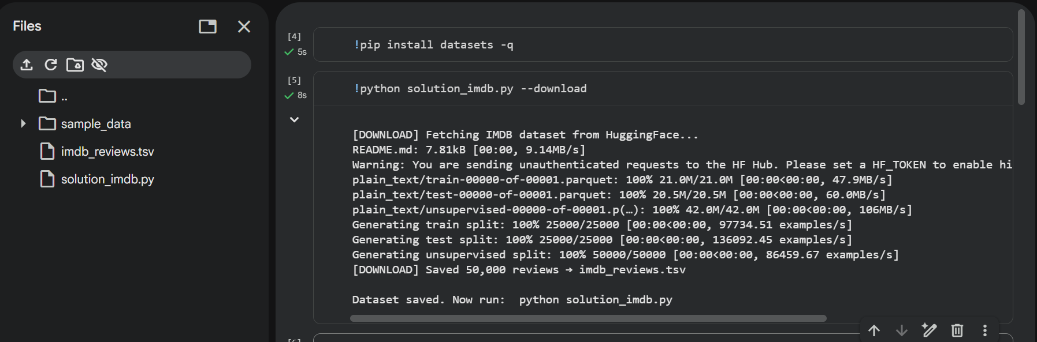

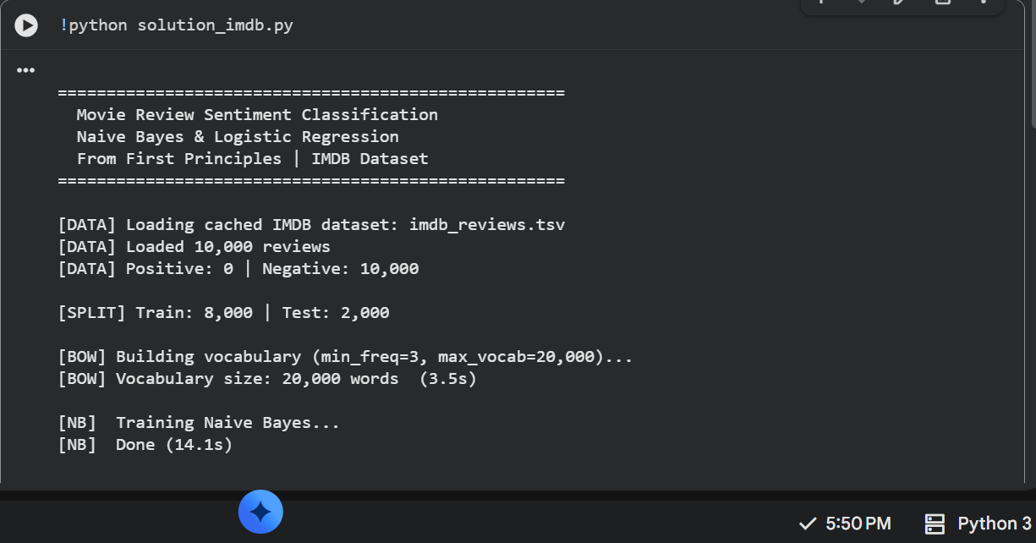

2. Naive Bayes Algorithm

For the probabilistic approach, we implemented Naive Bayes, which is based on Bayes' Theorem. The goal is straightforward: given a document (represented as word counts), we want to find the class that maximizes the posterior probability, P(class | document). According to the theorem, this depends on the prior probability of the class and the likelihood of seeing that document given the class.

The algorithm gets its name from the "naive" assumption it makes: it assumes that every word in a document is conditionally independent of the others, given the class label. In reality, words in natural language are correlated, but assuming independence simplifies the math significantly. It allows us to calculate the likelihood of the document as the product of the individual likelihoods of each word. Despite the simplification, this works surprisingly well for text classification.

Our implementation, the MyNB class, uses the Multinomial Naive Bayes variant since we are dealing with discrete word counts. During the fit phase, the model calculates two things: the log prior for each class (based on how many training samples belong to that class) and the log-likelihood of each word using smoothed relative frequencies. We use log probabilities instead of raw ones to avoid arithmetic underflow, which happens when you multiply too many tiny numbers together.

We also applied Laplace smoothing (add-one smoothing) to the word counts. Without this, if a word appears in the test set but never showed up in the training data for a specific class, its probability would be zero. This would zero out the entire product, ignoring all other evidence. By adding a pseudocount (alpha = 1.0) to every word count before normalizing, we ensure every word has a non-zero chance of occurring.

When predicting, the predict method sums the log prior and the weighted log-likelihoods for the words in the input document. The class with the highest resulting score wins. We can ignore the denominator P(document) since it's constant across all classes and doesn't change which score is highest.

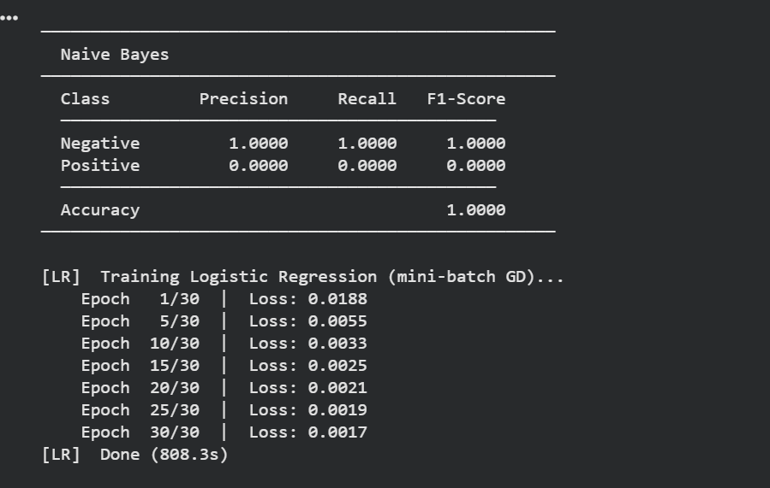

3. Logistic Regression Algorithm
While Naive Bayes models the joint distribution, We use Logistic Regression because it's a discriminative method that focuses on learning the probability of a specific outcome directly from the features P(y=1 | x) directly. It learns a decision boundary in the feature space using the logistic sigmoid function. For our binary classification task, the model takes a weighted linear combination of the input features and runs it through the sigmoid function to get a probability between 0 and 1.
The model relies on a weight vector w (one weight per word in the vocabulary) and a bias term b. For any input Bag of Words vector x, we compute z = w dot x + b. This value goes through the sigmoid function sigma(z) = 1 / (1 + exp(-z)) to give the probability that a review is positive. If the output is ≥ 0.5, we classify it as positive (1); otherwise, it's negative (0). We made sure to use a numerically stable version of the sigmoid to prevent overflow errors when z gets large.
Training involves minimizing the Binary Cross-Entropy loss, which measures how far the predicted probabilities are from the true labels. We used gradient descent for optimization. In every iteration, we compute the gradient of loss with respect to the weights by averaging the product of the prediction error (y - y_hat) and the feature values across all samples. The bias gradient is just the average prediction error. These gradients tell us how to update the weights to reduce the loss.
Since having a large vocabulary compared to the number of training samples can lead to overfitting, we incorporated L2 regularization (Ridge regularization) into the update rule. This adds a penalty to the loss function based on the squared magnitude of the weights. It stops the model from assigning huge weights to single words, leading to a smoother decision boundary that generalizes better. We set the regularization strength (lambda) to 0.001.
In our MyLogR class, the fit method initializes weights to zero and runs for 1000 epochs with a learning rate of 0.05. After training, the predict method uses the learned weights and bias with the sigmoid threshold. Logistic Regression is more flexible than Naive Bayes because it doesn't assume feature independence and can capture interactions through the weight vector. However, it needs more data and careful tuning of the learning rate and regularization to converge properly.
