MEDICARE: AN OFFLINE MEDICATION REMINDER APPLICATION FOR ELDERLY PATIENTS
A REPORT
Submitted by
BHAVISHYA SINGH (70022400569)
JASMAN RAI (70022400571)
in partial fulfilment of the requirements of the course
Mobile Application Development (702AI0E002)
of
BACHELOR OF TECHNOLOGY
IN
COMPUTER ENGINEERING
Under the guidance of
Dr. Preetjot Kaur

DEPARTMENT OF COMPUTER SCIENCE AND ENGINEERING
SCHOOL OF TECHNOLOGY MANAGEMENT AND ENGINEERING, CHANDIGARH, 160114, U.T. (INDIA)
OCT 2026

TABLE OF CONTENTS
CHAPTER NO. |  | TITLE | PAGE NO.
1. | INTRODUCTION |  | 1
 | 1.1 | GENERAL | 1
 | 1.2 | PROBLEM STATEMENT | 1
 | 1.3 | OBJECTIVES | 1
 | 1.4 | SCOPE | 2
 | 1.5 | ORGANISATION OF THE REPORT | 2
2. | LITERATURE REVIEW |  | 3
 | 2.1 | GENERAL | 3
 | 2.2 | EXISTING SOLUTIONS | 3
 | 2.3 | ANDROID PLATFORM CONCEPTS | 3
 | 2.4 | GAP IDENTIFIED | 4
3. | SYSTEM DESIGN |  | 5
 | 3.1 | SYSTEM ARCHITECTURE | 5
 | 3.2 | MODULE DESCRIPTION | 6
 | 3.3 | DATABASE DESIGN | 6
 | 3.4 | APPLICATION FLOW | 7
4. | IMPLEMENTATION |  | 9
 | 4.1 | TOOLS AND TECHNOLOGIES | 9
 | 4.2 | COURSE TOPICS APPLIED | 9
 | 4.3 | NEW CONCEPTS (SELF-LEARNING) | 10
 | 4.4 | KEY IMPLEMENTATION DETAILS | 10
5. | RESULTS AND TESTING |  | 12
 | 5.1 | APPLICATION SCREENS | 12
 | 5.2 | UNIT TESTING | 12
 | 5.3 | FUNCTIONAL TEST CASES | 13
6. | CONCLUSION AND FUTURE SCOPE |  | 14
 | 6.1 | CONCLUSION | 14
 | 6.2 | LIMITATIONS | 14
 | 6.3 | FUTURE SCOPE | 14
 | REFERENCES |  | 15

CHAPTER 1

INTRODUCTION

1.1 GENERAL
Long-term illnesses such as diabetes, hypertension and heart disease are managed largely through daily medication taken at home. The World Health Organization reports that, in developed countries, adherence to long-term therapies averages only about 50 percent, and that poor adherence leads to worse health outcomes and higher costs (World Health Organization, 2003). Elderly patients are especially affected because they often take several medicines at different times of the day.
Smartphones are now common in Indian households, including among older adults and their caregivers. This makes the phone a practical place to keep a patient’s medication schedule, reminders and health records. MediCare is an Android application, written in Java in Android Studio, that turns the phone into a personal medication assistant designed for elderly users.

1.2 PROBLEM STATEMENT
Patients who take several medicines every day face three recurring problems:
- Missed or repeated doses: the patient forgets the dose time, or cannot remember whether a dose was already taken.
- Unnoticed stock run-out: the strip or bottle runs out before the patient or caregiver notices, interrupting treatment.
- Scattered records: paper prescriptions, doctor advice and appointment dates are kept in different places and are easily lost.
A normal phone alarm does not solve these problems: it does not know the medicine name, dosage or remaining stock, and it keeps no record of whether a dose was taken or missed.

1.3 OBJECTIVES
- To remind the patient at the exact dose time every day, even when the application is closed or the phone is locked, using a full-screen alert and a spoken reminder.
- To record every dose as Taken, Snoozed or Missed and present this history to the patient.
- To track the remaining stock of each medicine and warn the patient before it runs out, with a one-tap search for nearby pharmacies.
- To store doctor appointments, notes and prescription photographs in one place.
- To provide a simple interface with large text and buttons suitable for elderly users.
- To keep all data on the device so that the application works without an internet connection.

1.4 SCOPE
The application targets Android smartphones and supports one patient account per device. All data is stored locally in a Room (SQLite) database and in SharedPreferences. Each medicine has one daily reminder time. Cloud synchronisation, caregiver notifications and multiple dose times per medicine are outside the scope of this version and are discussed as future work in Chapter 6.

1.5 ORGANISATION OF THE REPORT
Chapter 2 reviews existing approaches and the Android platform features used. Chapter 3 describes the system architecture, modules, database design and application flow. Chapter 4 explains the implementation, including the course topics applied and the new concepts learned. Chapter 5 presents the application screens and testing. Chapter 6 concludes the report and lists limitations and future scope.

CHAPTER 2

LITERATURE REVIEW

2.1 GENERAL
Medication non-adherence has many causes, but simple forgetfulness is one of the most common for patients on long-term therapy (World Health Organization, 2003). Reminder systems, from pill organisers to mobile phone alerts, are a widely used way to address it. Mobile applications add the ability to combine reminders with logging, stock tracking and record keeping on a device the patient already carries.

2.2 EXISTING SOLUTIONS
Table 2.1 compares the common approaches a patient might use today.
Table 2.1: Comparison of existing approaches
Approach | Strengths | Limitations
Paper chart / pill organiser | Cheap, no technology needed | No alert at dose time; no record of missed doses; no stock warning
Phone alarm clock | Reliable sound at a fixed time | Does not know medicine, dosage or stock; no adherence history
General medication-reminder apps | Reminders and logs in one app | Many depend on online accounts and feature-dense screens that can be difficult for elderly users
MediCare (this project) | Reminder with voice, adherence log, stock alert, records, offline | Single user per device; one dose time per medicine

2.3 ANDROID PLATFORM CONCEPTS
The design relies on standard Android components documented by Google:
- Activities and Intents: each screen is an Activity; explicit Intents move between screens and implicit Intents hand work to other apps such as the dialer, camera and Google Maps (Android Developers, n.d.-a).
- Room persistence library: an abstraction over SQLite in which entity classes define tables and DAO interfaces define queries checked at compile time (Android Developers, n.d.-b).
- AlarmManager: a system service that starts the application at a set time, even when it is not running; exact alarms can fire in battery-saving Doze mode (Android Developers, n.d.-c).
- Notifications: notification channels, action buttons and full-screen intents allow an urgent, interactive alert (Android Developers, n.d.-d).
- TextToSpeech: the built-in speech engine converts text to spoken audio (Android Developers, n.d.-e).
- FileProvider: shares a file with another application through a secure content URI, used here for camera capture (Android Developers, n.d.-f).

2.4 GAP IDENTIFIED
No single low-cost approach combines an alert that cannot be missed, a spoken reminder, an automatic record of taken and missed doses, stock warnings and medical records, while working fully offline with an interface suited to elderly users. MediCare is designed to fill this gap.

CHAPTER 3

SYSTEM DESIGN

3.1 SYSTEM ARCHITECTURE
The application is organised into four layers, each in its own Java package. Screens never access the database directly through SQL; they call DAO methods. All alarm handling is done by one utility class, and all work that must happen when the application is closed is done by broadcast receivers. Figure 3.1 shows how the layers interact.
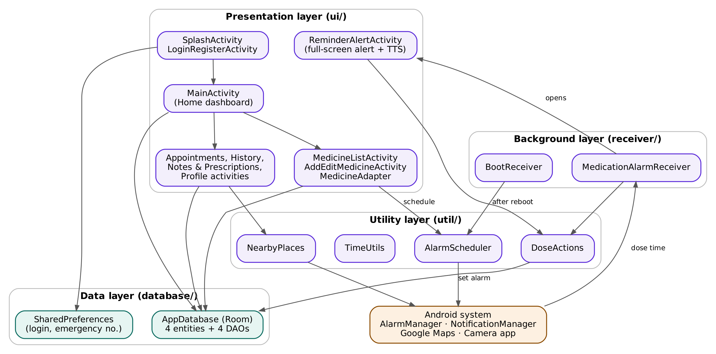
Figure 3.1: System architecture of MediCare
Table 3.1: Layers of the application
Layer | Package | Responsibility
Presentation | ui/ | 10 Activities with XML layouts, a RecyclerView adapter and shared dialogs
Data | database/ | Room database: 4 entity classes, 4 DAO interfaces and AppDatabase
Background | receiver/ | MedicationAlarmReceiver (dose-time handling) and BootReceiver (restore alarms after restart)
Utility | util/ | AlarmScheduler, DoseActions, TimeUtils and NearbyPlaces: logic shared by several screens

3.2 MODULE DESCRIPTION
Each screen is made of an XML layout, which defines its appearance, and a Java Activity, which defines its behaviour. Table 3.2 lists the modules.
Table 3.2: Screens and their files
Module | Layout XML | Java class | Function
Splash | activity_splash | SplashActivity | Shows logo for 2 s; routes to Login or Home
Login / Register | activity_login_register | LoginRegisterActivity | Creates the account; checks the SHA-256 password hash
Home | activity_main | MainActivity | Next dose, doses logged, quick actions, today’s medicines
Medicines | activity_medicine_list, item_medicine_card | MedicineListActivity, MedicineAdapter | List, edit, delete and mark medicines taken
Add / Edit Medicine | activity_add_edit_medicine | AddEditMedicineActivity | Form with time picker; saves and schedules the alarm
Reminder Alert | activity_reminder_alert | ReminderAlertActivity | Full-screen alert over lock screen; speaks; Taken / Snooze
Appointments | activity_appointments, item_appointment_card | AppointmentsActivity | Book, list and delete doctor appointments
History | activity_history, item_history_log | HistoryActivity | Colour-coded log of taken, snoozed and missed doses
Notes & Prescriptions | activity_notes_prescriptions, item_medical_record | NotesPrescriptionsActivity | Doctor notes and prescription photos
Profile | activity_profile | ProfileActivity | Emergency dial, nearest hospital, log out

3.3 DATABASE DESIGN
The Room database medireminder_db (version 1) contains four tables. Every table has an auto-generated integer primary key named id. Table 3.3 shows the schema.
Table 3.3: Database tables
Table (entity) | Columns | Purpose
medicines (Medicine) | id, name, dosage, frequency, doseHour, doseMinute, stockCount | One row per medicine and its daily dose time
dose_logs (DoseLog) | id, medicineId, medicineName, timestamp, status | One row per event: TAKEN, SNOOZED or MISSED
appointments (Appointment) | id, doctorName, appointmentDate, appointmentTime, notes | Doctor appointments
medical_records (MedicalRecord) | id, noteText, imagePath, timestamp | Doctor notes and prescription photo paths

The medicine name is copied into each dose log so that history remains readable after a medicine is deleted. Stock is reduced with the SQL expression MAX(0, stockCount - 1), so it can never become negative. Login details and the emergency number are stored separately in SharedPreferences, with the password stored only as a SHA-256 hash.

3.4 APPLICATION FLOW
Figure 3.2 shows how the user moves between screens. Home is the central screen; four further tabs are reached from the bottom navigation bar, and the remaining screens open from buttons or from the reminder notification.
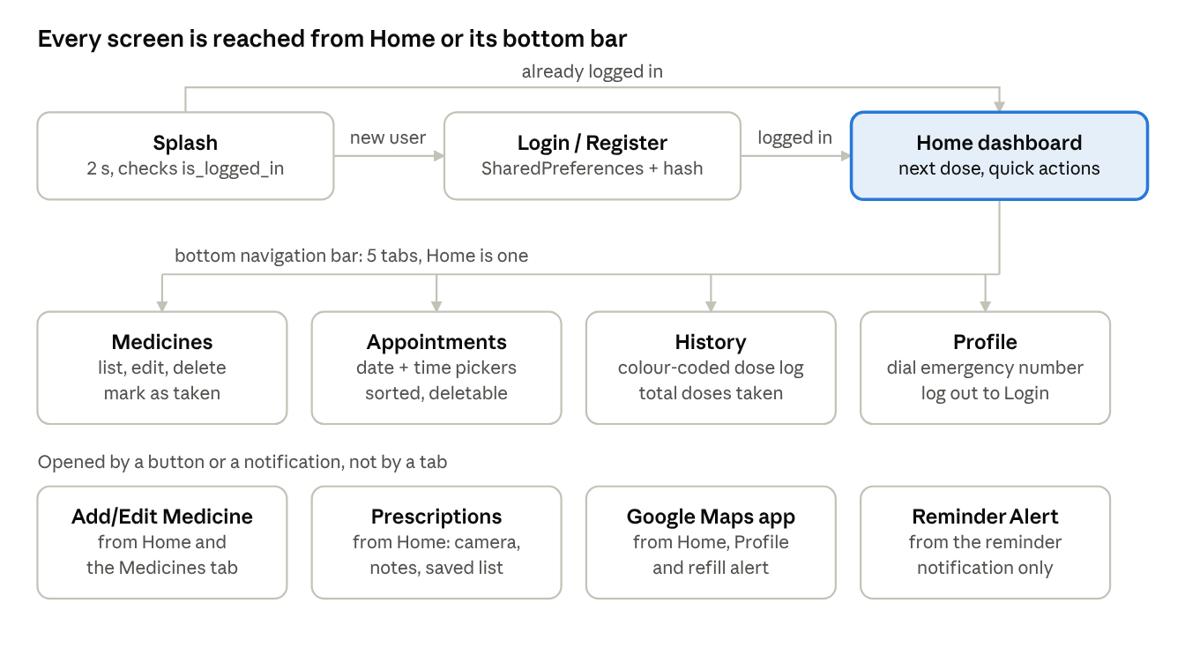
Figure 3.2: Screen navigation
Figure 3.3 shows the reminder flow, which runs in the background even when the application is closed.
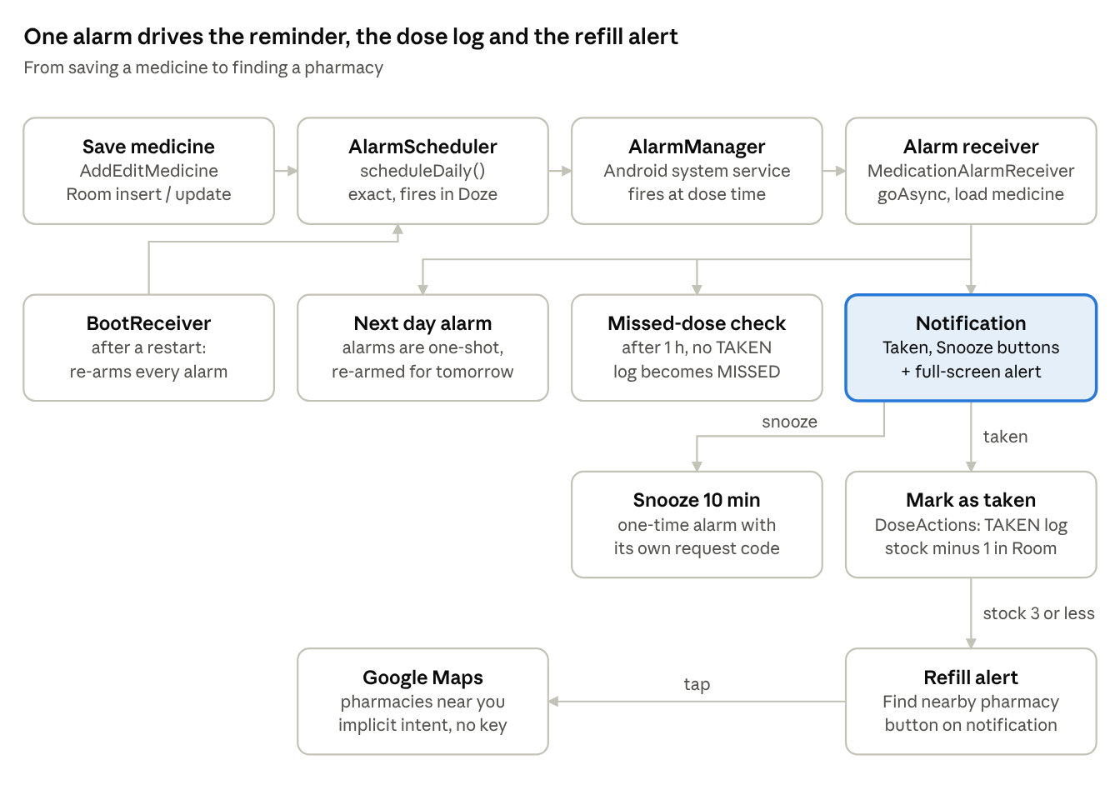
Figure 3.3: Reminder flow from saving a medicine to finding a pharmacy
- When a medicine is saved, AlarmScheduler sets an exact daily alarm with AlarmManager.
- At the dose time, Android delivers the alarm to MedicationAlarmReceiver, which schedules the next day’s alarm and a missed-dose check one hour later.
- The receiver posts a high-priority notification with Mark as Taken and Snooze buttons and a full-screen intent that opens ReminderAlertActivity over the lock screen, where the medicine name is spoken.
- Taken records a TAKEN log and reduces stock; when three or fewer doses remain, a refill notification offers to find nearby pharmacies.
- Snooze sets a one-time alarm ten minutes later. If no TAKEN log exists after one hour, the dose is recorded as MISSED.
- After a phone restart, BootReceiver re-creates every alarm from the database.

CHAPTER 4

IMPLEMENTATION

4.1 TOOLS AND TECHNOLOGIES
Table 4.1: Tools and technologies
Area | Technology used
Language and IDE | Java, Android Studio
User interface | XML layouts, Material Components (MaterialCardView, TextInputLayout, BottomNavigationView, ExtendedFloatingActionButton), ConstraintLayout, RecyclerView
Database | Room persistence library over SQLite; SharedPreferences for login data
Background work | AlarmManager with exact alarms, BroadcastReceiver, goAsync()
Alerts | NotificationCompat with channels, action buttons and full-screen intent; TextToSpeech
Camera and files | ACTION_IMAGE_CAPTURE intent with FileProvider; app-specific storage
Maps | Implicit intent to Google Maps (geo: URI) with browser fallback
Security | SHA-256 password hashing with MessageDigest; runtime permissions
Testing | JUnit unit tests

4.2 COURSE TOPICS APPLIED
Table 4.2 maps the units of the course to the features where they are used in MediCare.
Table 4.2: Course units applied in the project
Unit | Course topic | Where it is used in MediCare
2 | Simple controls | Buttons and text fields on every form
2 | Screen layout | ConstraintLayout, LinearLayout and ScrollView
2 | Menus | Bottom navigation built from bottom_nav_menu.xml
2 | Date picker | Appointment date; TimePicker for dose and appointment time
2 | Toasts and pop-up dialog boxes | Confirmation toasts; AlertDialog before every delete
2 | Multiscreen applications | 10 Activities connected with explicit Intents
3 | Displaying images stored on the device | Prescription photos saved in app storage and shown as thumbnails
4 | Location using Google Maps | Nearest pharmacy and hospital opened in Google Maps
6 | Database connectivity using SQLite | Room database on SQLite with four tables

4.3 NEW CONCEPTS (SELF-LEARNING)
The following concepts are not part of the course units and were learned independently for this project:
- AlarmManager and BroadcastReceiver: reminders that fire when the application is closed and are restored after a reboot.
- Notification actions and full-screen intent: Taken and Snooze buttons on the notification, and an alert screen shown over the lock screen.
- TextToSpeech: the medicine name and dosage are spoken aloud for elderly users.
- RecyclerView with Adapter and ViewHolder: efficient lists on four screens.
- FileProvider camera capture: full-resolution prescription photos shared securely with the camera app.
- Runtime permissions: camera and notification permissions requested at the time of use.

4.4 KEY IMPLEMENTATION DETAILS

4.4.1 Daily reminder scheduling
AlarmManager alarms fire only once. AlarmScheduler sets the next occurrence of the dose time, and MedicationAlarmReceiver schedules the following day’s alarm each time it fires. Separate request codes are used for the daily alarm (medicine id), the snooze alarm (100000 + id) and the missed-dose check (200000 + id), so the three never overwrite one another.
public static void scheduleDaily(Context context, int medicineId, String name,
String dosage, int hour, int minute) {
long triggerAt = TimeUtils.nextTriggerMillis(
System.currentTimeMillis(), hour, minute);
Intent intent = baseIntent(context, MedicationAlarmReceiver.ACTION_ALARM,
medicineId, name, dosage);
setExact(context, triggerAt, pending(context, medicineId, intent));
}

setExactAndAllowWhileIdle() is used so that the alarm fires in Doze mode. If the user has turned off exact alarms on Android 12 or later, the scheduler falls back to an inexact alarm instead of crashing.

4.4.2 Background processing and missed-dose detection
The receiver calls goAsync() so that the process stays alive while it reads the database and speaks. All database work runs on a single shared background thread, AppDatabase.DB_EXECUTOR, because Room does not allow queries on the main thread. One hour after each alarm, a check counts TAKEN logs since the alarm time; if there are none, a MISSED log is written.

4.4.3 Stock tracking and nearby pharmacy
Marking a dose taken reduces the stock by one. When three or fewer doses remain, the medicine card shows the stock in red and a refill notification appears with a Find nearby pharmacy button. NearbyPlaces opens Google Maps with the query geo:0,0?q=pharmacy, which searches around the phone’s current location without requiring an API key or location permission in MediCare. If Google Maps is not installed, another maps application or the web browser is used.

4.4.4 Prescription capture
An empty image file is created in the application’s Pictures folder and shared with the camera application through FileProvider. The camera writes the full-resolution photo into that file. If the capture is cancelled, the empty file is deleted. Photos are decoded at reduced size for display to avoid running out of memory.

4.4.5 Login and permissions
Passwords are hashed with SHA-256 before being stored. The camera and notification permissions are requested at runtime. The manifest declares a FileProvider, a boot receiver and the package queries needed on Android 11 and later to detect the camera and dialer applications.

CHAPTER 5

RESULTS AND TESTING

5.1 APPLICATION SCREENS
Figures 5.1 to 5.3 show the application running on an Android device.
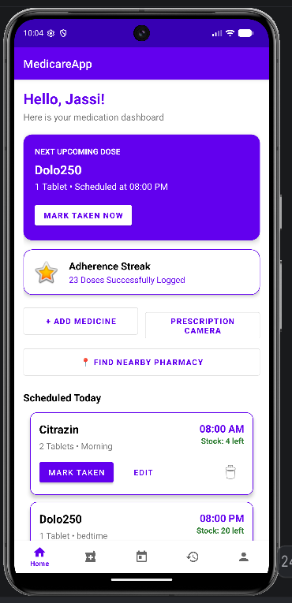  Figure 5.1: Home dashboard | 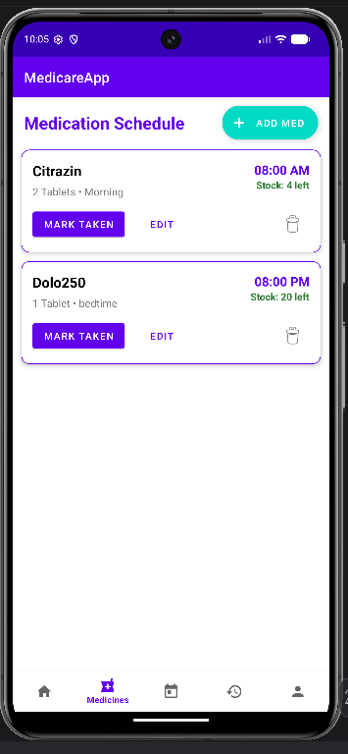  Figure 5.2: Medication schedule | 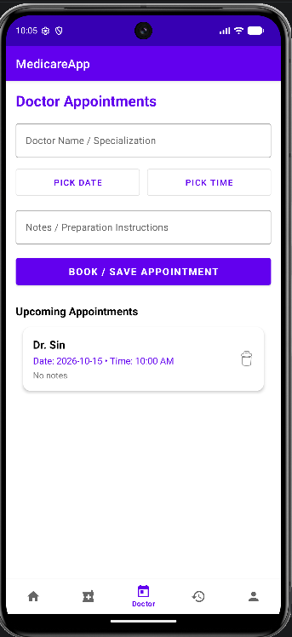  Figure 5.3: Doctor appointments

The Home dashboard shows the next upcoming dose with a one-tap Mark Taken button, the number of doses logged and quick actions. The Medicines screen lists each schedule with its time and remaining stock. The Appointments screen uses date and time pickers and lists saved appointments.

5.2 UNIT TESTING
The time calculations used for reminders are kept in TimeUtils, a pure Java class, so that they can be tested with JUnit without a device. All eight tests in TimeUtilsTest passed.
Table 5.1: Unit tests
No. | Test | What it checks | Result
1 | format12h | Midnight, noon and zero-padding (e.g. 08:05 AM) | Pass
2 | minutesUntil | Time to next dose wraps past midnight | Pass
3 | nextTrigger_laterToday | Alarm later today stays today | Pass
4 | nextTrigger_alreadyPassed | Passed time moves to tomorrow | Pass
5 | nextTrigger_exactlyNow | Rescheduling at fire time does not ring again immediately | Pass
6 | nextTrigger_crossesMonthAndYear | 31 Dec 23:00 → 1 Jan 06:00 | Pass
7 | appointmentSortKey_ordersAmPm | AM/PM times sort in the correct order | Pass
8 | appointmentSortKey_badInput | Invalid dates sort last instead of crashing | Pass

5.3 FUNCTIONAL TEST CASES
Table 5.2 lists the functional test cases for the main features and the expected behaviour.
Table 5.2: Functional test cases
ID | Scenario | Expected result
TC1 | Register and log in | Home screen opens; wrong password shows an error
TC2 | Add a medicine due in 2 minutes | Medicine listed; reminder fires at the set time
TC3 | Reminder with phone locked | Full-screen alert opens and speaks the medicine name
TC4 | Tap Mark as Taken | TAKEN log in History; stock reduces by 1
TC5 | Tap Snooze | SNOOZED log; reminder rings again after 10 minutes
TC6 | Ignore the reminder for 1 hour | MISSED log appears in History
TC7 | Stock falls to 3 | Refill notification with Find nearby pharmacy button
TC8 | Restart the phone | Reminders still fire at their times
TC9 | Delete a medicine | Confirmation dialog; no further reminders for it
TC10 | Capture a prescription photo | Photo and notes saved and listed with thumbnail
TC11 | Deny camera permission | Message shown; application does not crash
TC12 | Find nearest hospital | Google Maps opens with hospitals nearby

CHAPTER 6

CONCLUSION AND FUTURE SCOPE

6.1 CONCLUSION
MediCare meets its objectives of helping elderly patients take their medicines on time and keep their health information in one place. Exact daily reminders with a full-screen alert and spoken message address missed doses. Automatic logging of taken, snoozed and missed doses gives a clear adherence history. Stock tracking with refill alerts and a one-tap pharmacy search prevents treatment gaps. Appointments and prescription photos are stored alongside the schedule, and all data stays on the device.
The project applies the course topics on user interface design, multiscreen applications, images, Google Maps and SQLite databases, and extends them with independently learned concepts: AlarmManager with broadcast receivers, interactive and full-screen notifications, and text-to-speech.

6.2 LIMITATIONS
- Each medicine has one reminder time per day; the frequency field is descriptive only.
- One patient account per device, stored locally.
- Data is not backed up; uninstalling the application removes it.
- Blood group and allergy details on the Profile screen are not yet editable.

6.3 FUTURE SCOPE
- Alert a caregiver by SMS or Firebase notification when a dose is missed.
- Support several dose times per day for one medicine.
- Back up and synchronise data with Firebase.
- Adherence charts by week and month.
- Hindi and regional-language interface and voice reminders.
- Editable medical profile with blood group, allergies and conditions.

REFERENCES
- World Health Organization (2003) ‘Adherence to Long-Term Therapies: Evidence for Action’, World Health Organization, Geneva.
- Android Developers (n.d.-a) ‘Intents and intent filters’. Available at: https://developer.android.com/guide/components/intents-filters (Accessed: 15 October 2026).
- Android Developers (n.d.-b) ‘Save data in a local database using Room’. Available at: https://developer.android.com/training/data-storage/room (Accessed: 15 October 2026).
- Android Developers (n.d.-c) ‘Schedule alarms’. Available at: https://developer.android.com/develop/background-work/services/alarms/schedule (Accessed: 15 October 2026).
- Android Developers (n.d.-d) ‘Create a notification’. Available at: https://developer.android.com/develop/ui/views/notifications/build-notification (Accessed: 15 October 2026).
- Android Developers (n.d.-e) ‘TextToSpeech’. Available at: https://developer.android.com/reference/android/speech/tts/TextToSpeech (Accessed: 15 October 2026).
- Android Developers (n.d.-f) ‘FileProvider’. Available at: https://developer.android.com/reference/androidx/core/content/FileProvider (Accessed: 15 October 2026).
- Android Developers (n.d.-g) ‘Create dynamic lists with RecyclerView’. Available at: https://developer.android.com/develop/ui/views/layout/recyclerview (Accessed: 15 October 2026).
- Material Design (n.d.) ‘Material Components for Android’. Available at: https://github.com/material-components/material-components-android (Accessed: 15 October 2026).

