Heart Disease Prediction System
HELP FILE

Table of Contents
- Introduction
- Getting Started
- Navigation
- Prediction Tab
- Visualizations Tab
- Model Comparison Tab
- How It Works
- Technical Information

Introduction
The Heart Disease Prediction System is a powerful Shiny application designed to help healthcare professionals predict the likelihood of heart disease in patients based on various health parameters. The system utilizes two machine learning models - Logistic Regression and Random Forest - to provide accurate predictions and insights.
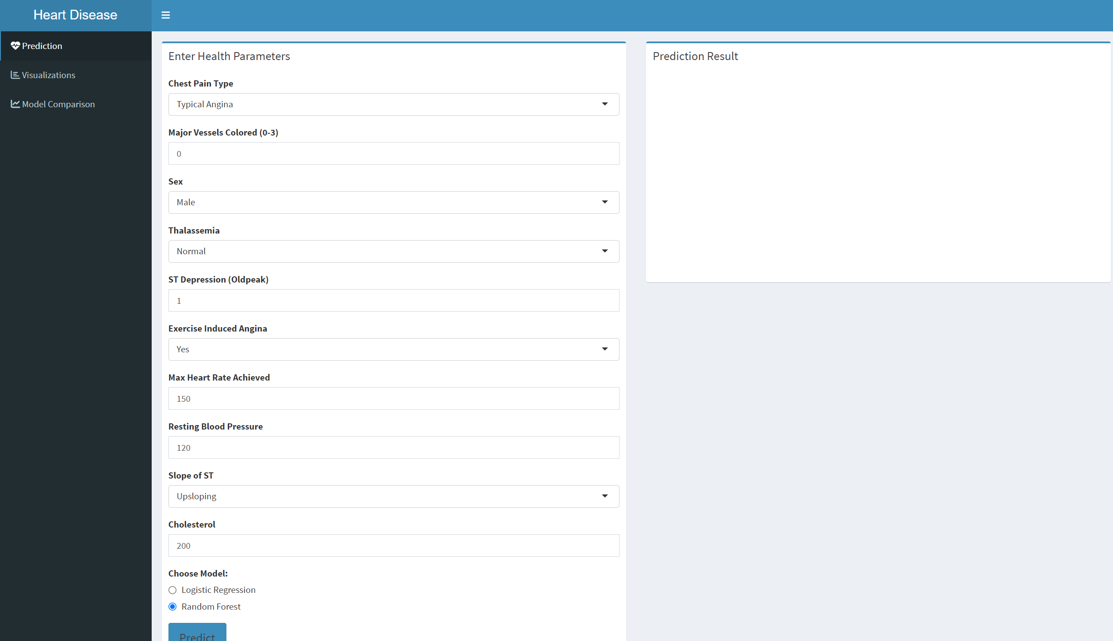

Getting Started

System Requirements
- R and RStudio installed
- Required R packages: caret, e1071, tidyverse, shiny, pROC, shinythemes, randomForest, plotly, DT, shinydashboard, corrplot, reshape2

Installation Steps
- Install all required packages in R:

install.packages(c("caret", "e1071", "tidyverse", "shiny", "pROC",
"shinythemes", "randomForest", "plotly", "DT",
"shinydashboard", "corrplot", "reshape2"))
- Download the heart.csv dataset
- Update the file path in the code to point to your dataset location
- Execute the R script to launch the application

Navigation
The application features a user-friendly dashboard interface with a blue sidebar for navigation. The sidebar menu contains three main sections:
- Prediction - Enter patient data to get heart disease predictions
- Visualizations - Explore data patterns and relationships
- Model Comparison - Compare the performance of machine learning models
Click on any menu item to navigate to that section of the application.
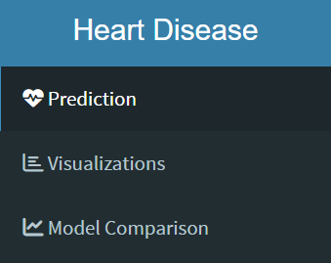

Prediction Tab
This tab allows you to input patient health parameters and receive a heart disease prediction.

How to Use:
- Enter Patient Health Parameters:
  - Chest Pain Type (0-3)
  - Major Vessels Colored (0-3)
  - Sex (Male/Female)
  - Thalassemia (Normal/Fixed Defect/Reversible Defect)
  - ST Depression (Oldpeak)
  - Exercise Induced Angina (Yes/No)
  - Max Heart Rate Achieved (60-220)
  - Resting Blood Pressure (80-200)
  - Slope of ST (Upsloping/Flat/Downsloping)
  - Cholesterol (100-600)
- Select Prediction Model:
  - Choose between "Logistic Regression" or "Random Forest"
- Generate Prediction:
  - Click the "Predict" button to process the inputs
- View Results:
  - The prediction appears in the box on the right
  - A green box indicates no heart disease
  - A red box indicates likelihood of heart disease
  - The prediction includes a probability percentage
  - Below the prediction, a feature importance chart shows the most influential factors
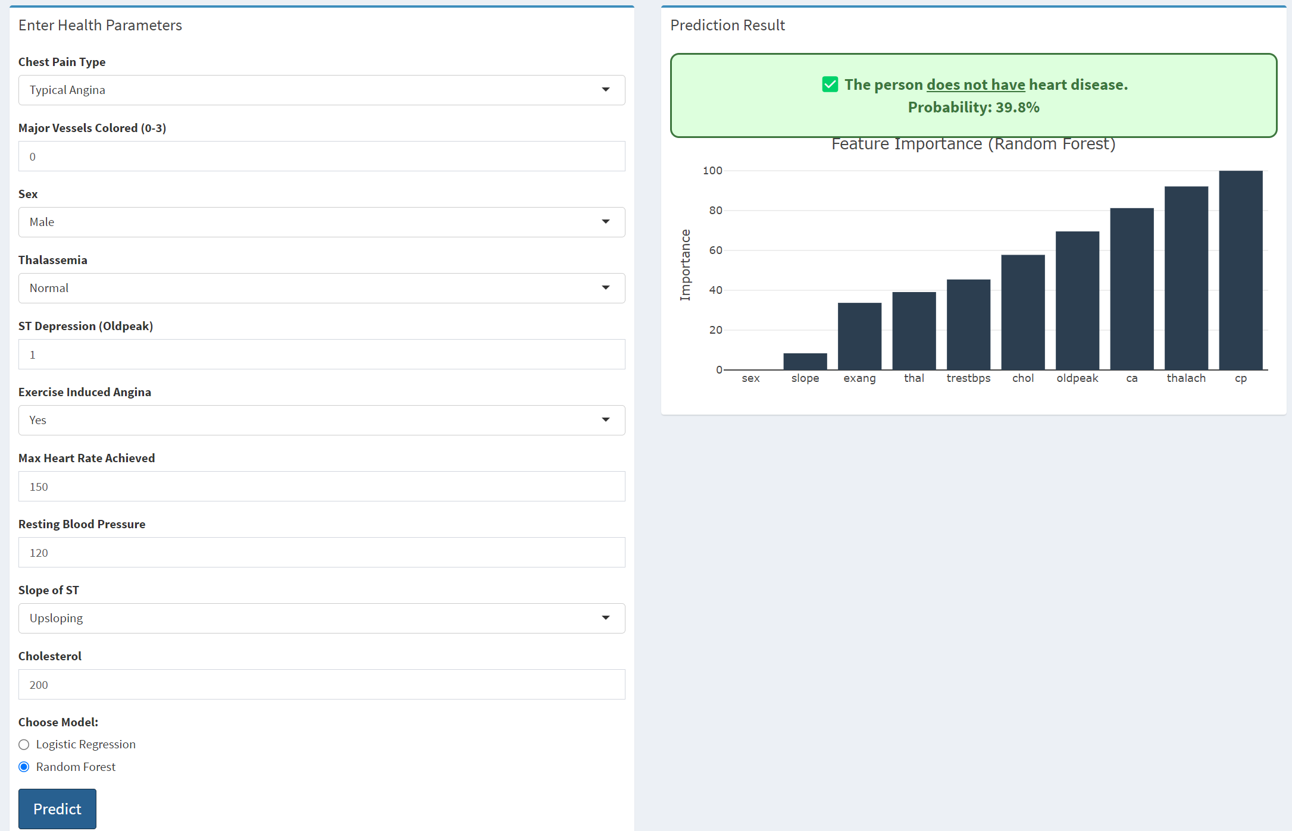
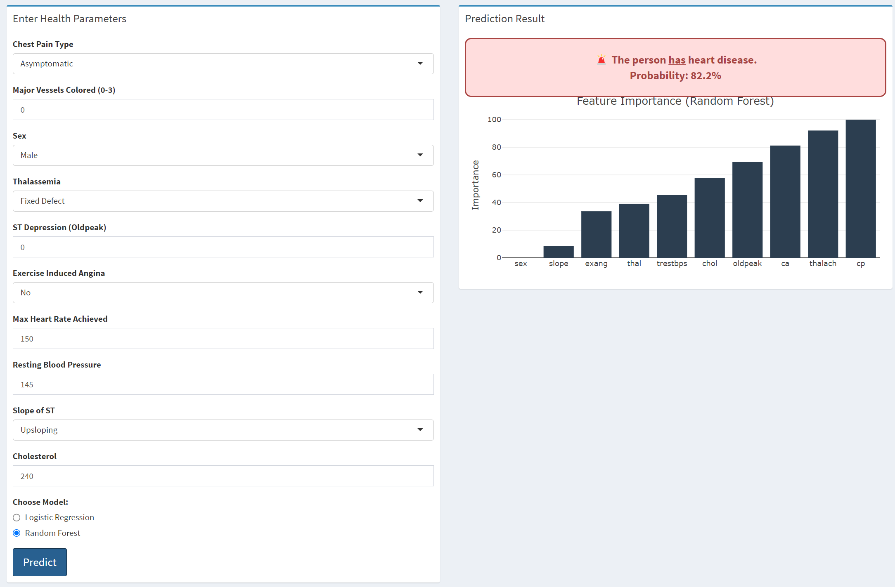

Visualizations Tab
This tab provides interactive data visualizations to better understand heart disease patterns.

Available Visualizations:
- Distribution of Heart Disease:
  - Pie chart showing the percentage of patients with and without heart disease
  - Blue represents no disease, red represents disease cases
- Correlation Heatmap:
  - Shows relationships between different health parameters
  - Red indicates positive correlations, blue indicates negative correlations
  - Stronger colors represent stronger relationships
- Numeric Features by Heart Disease:
  - Box plots comparing different health measurements between patients with and without heart disease
  - Use the dropdown menu to select different health parameters for comparison
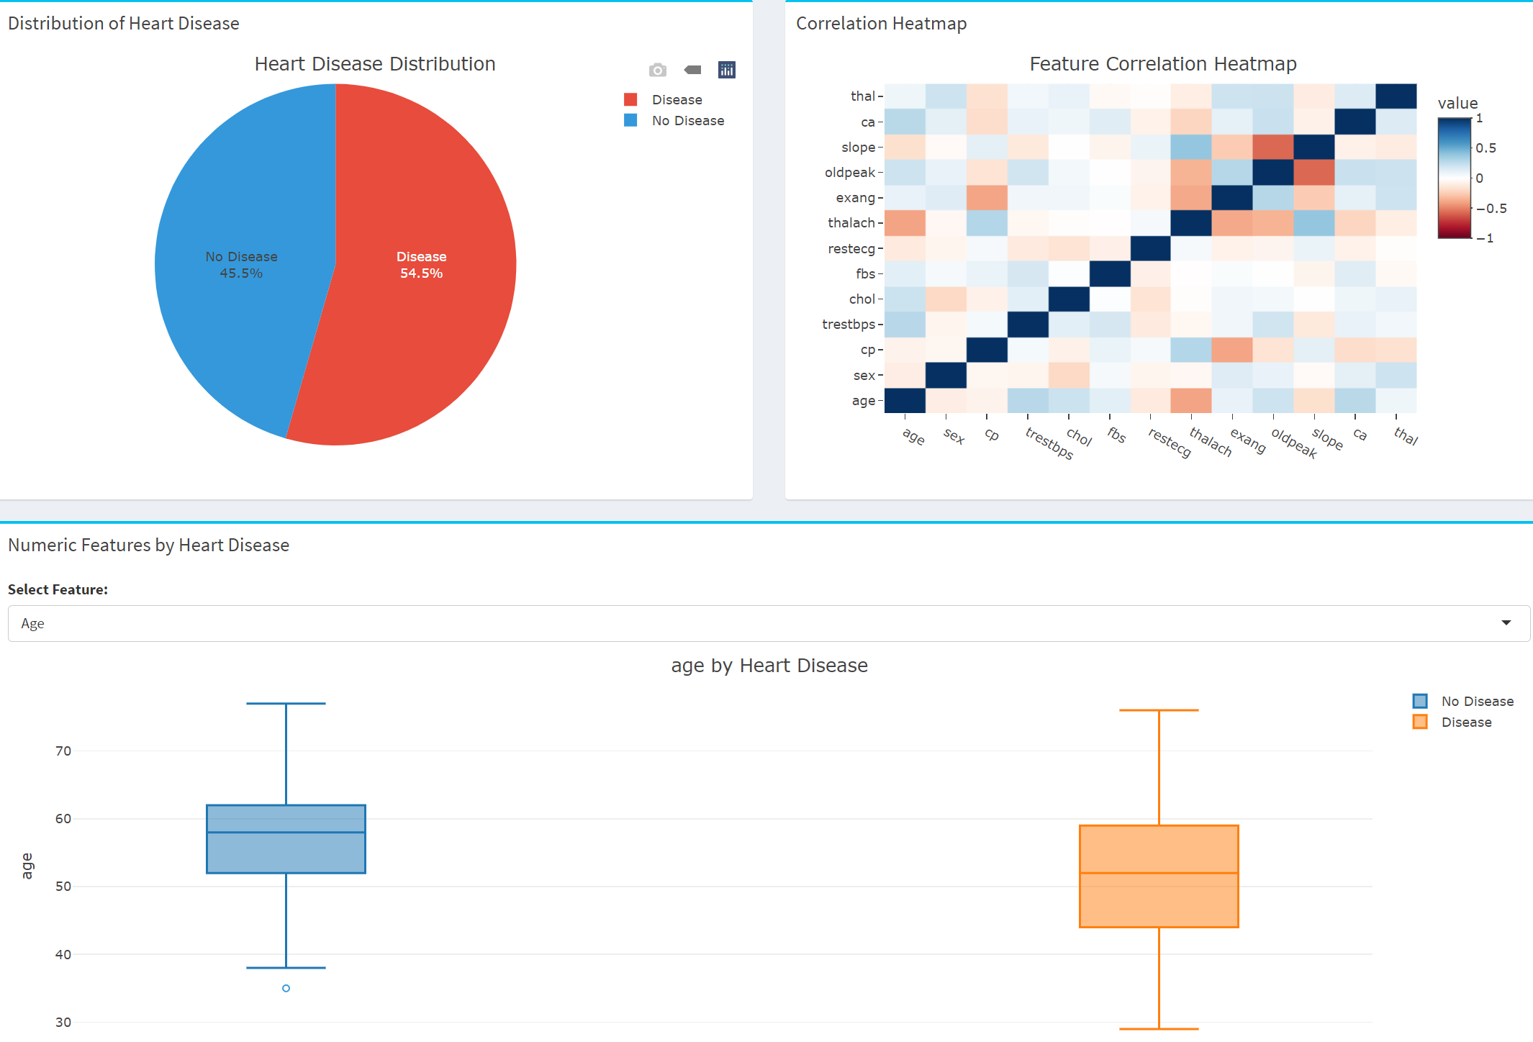

Model Comparison Tab
This tab allows you to compare the performance of the two machine learning models used in the system.

Performance Metrics:
- Model Performance Comparison Table:
  - Displays Accuracy, Precision, Recall, F1 Score, and AUC for both models
  - Higher values indicate better performance
- ROC Curves:
  - Visual representation of the trade-off between sensitivity and specificity
  - Curves closer to the top-left corner indicate better performance
  - AUC (Area Under Curve) values are displayed in the legend
- Performance Metrics Chart:
  - Bar chart comparing key metrics between Logistic Regression and Random Forest
  - Helps identify strengths and weaknesses of each model
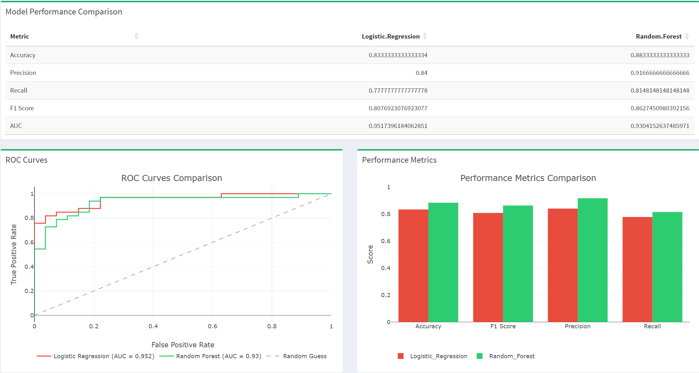

How It Works

Integration of Frontend and Backend with Shiny
The Heart Disease Prediction System leverages Shiny's reactive programming model to connect user inputs with powerful statistical analyses:

Frontend (UI)
- Built using shinydashboard for a modern, responsive layout
- Interactive input controls capture user data
- Plotly integration provides dynamic, interactive visualizations
- Bootstrap styling ensures a consistent and attractive appearance

Backend (Server)
- Data processing using tidyverse packages
- Machine learning models built with caret, e1071, and randomForest
- Real-time prediction generation based on user inputs
- Statistical calculations for visualization and model comparison

Data Flow
- User enters health parameters in the UI
- When the "Predict" button is clicked, inputs are passed to the server
- Server processes inputs and applies the selected model
- Prediction results and visualizations are generated
- UI updates to display the results

Technical Information

Features and Limitations
- Dataset Used: UCI Heart Disease dataset with feature selection
- Models: Logistic Regression and Random Forest
- Feature Selection: Recursive Feature Elimination (RFE)
- Performance Evaluation: 10-fold cross-validation
- Maximum Patients: The system can handle datasets of up to 1000 patients efficiently

System Architecture
The application follows a standard Shiny architecture:
- ui component: Defines the user interface using dashboardPage
- server component: Contains the application logic
- shinyApp component: Loads data and packages

