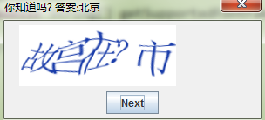 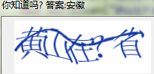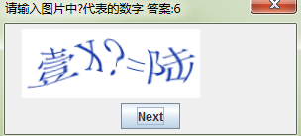 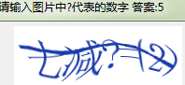

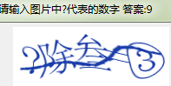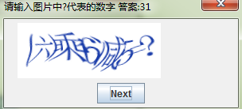 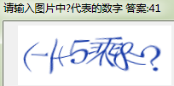 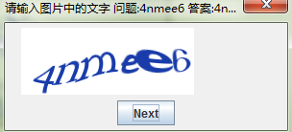

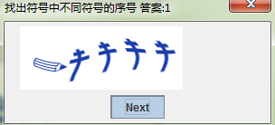 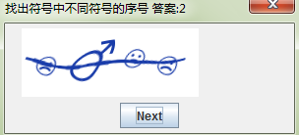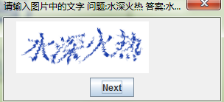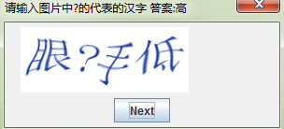

1千米=1000米

1米=10分米

1分米=10厘米

1米=100厘米

1厘米=10毫米

**重量单位换算**

1吨=1000千克

1千克=1000克

1千克=1公斤

人民币单位换算

1元=10角

1角=10分

1元=100分

1年=12月

1日=24小时

1时=60分

1分=60秒

1时=3600秒







找出其中两个不同图案的序号

 答案15

 答案26

  答案27

2600-2601-2602-2603-2604-2605,2606-2607,2608-2609-260a,260b-260c,260d-260e,260f-

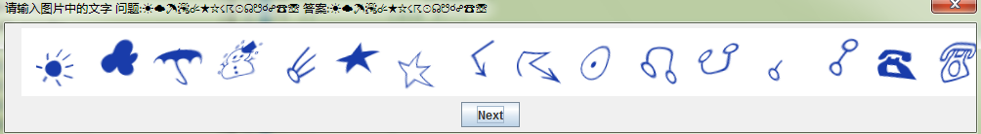

2610*-2611-2612-2613-2614*-2615*-2616*-2617-2618*-2619*-261a,261b,261c,261d,261e,261f-

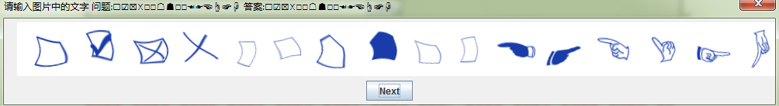

2620-2621,2622,2623,2624,2625,2626,2627,2628,2629-262a-262b,262c-262d-262e-262f-

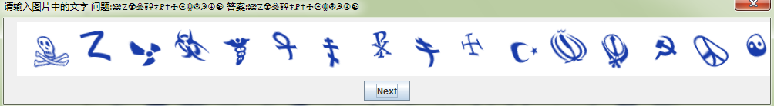

2630,2631,2632,2633,2634,2635,2636,2637-2638-2639,263a,263b-263c-263d,263e-263f,

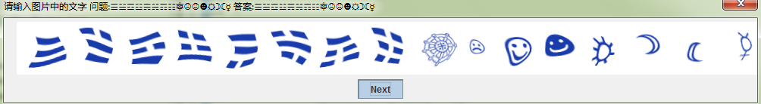

2640,2641-2642-2643-2644,2645,2646,2647,2648,2649,264a,264b,264c,264d,264e,264f-

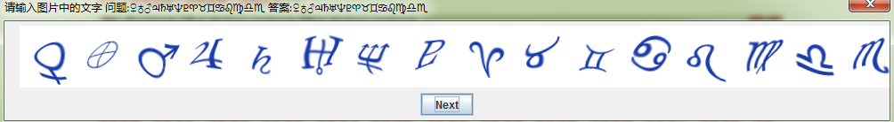

2650,2651,2652,2653,2654,2655,2656,2657,2658,2659,265a,265b,265c,265d,265e,265f-

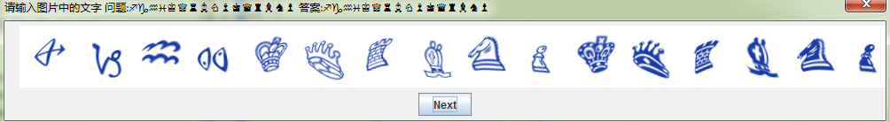

2660,2661,2662,2663,2664,2665,2666,2667-2668,2669,266a,266b,266c,266d,266e-266f-

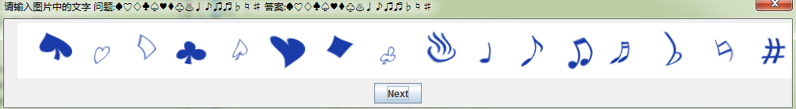

2700*-2701,2702,2703,2704-2705*-2706-2707-2708-2709-270a*-270b*-270c,270d-270e,270f,

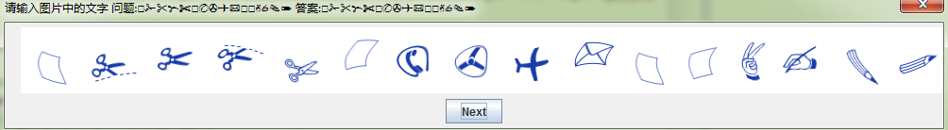

2710-2711,2712-2713,2714-2715,2716,2717,2718-2719,271a,271b,271c,271d,271e,271f-

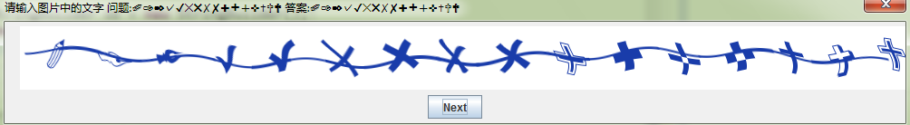

2720,2721,2722,2723,2724,2725,2726,2727,2728,2729,272a,272b,272c,272d,272e,272f,

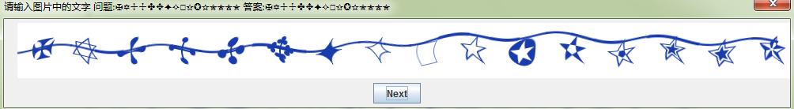 2730,2731,2732,2733,2734,2735,2736,2737,2738,2739,273a,273b,273c,273d,273e,273f,

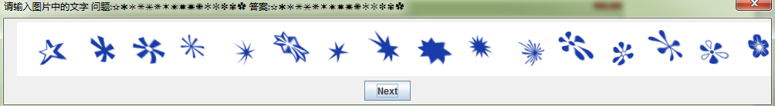

2740,2741,2742,2743,2744,2745,2746,2747,2748,2749,274a,274b,274c*,274d*-274e*-274f*-

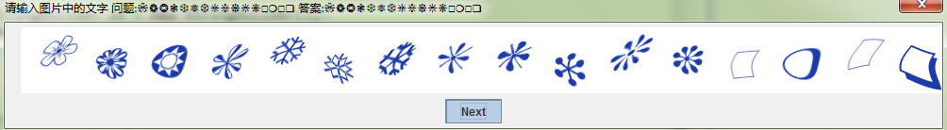 2750,2751,2752-2753*-2754*-2755*-2756-2757*-2758,-2759,-275a,275b,275c,275d,275e-275f*-

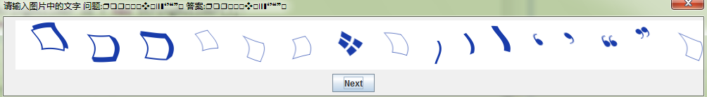

2760*-2761,2762,2763-2764,2765-2766,2767-2768*-2769*-276a*-276b*-276c*-276d*-276e*-276f*-

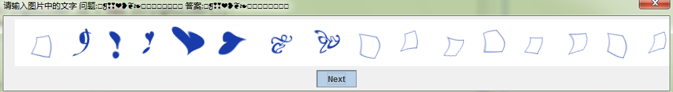

2770*-2771*-2772*-2773*-2774*-2775*-2776,2777,2778,2779,277a,277b,277c,277d,277e,277f,

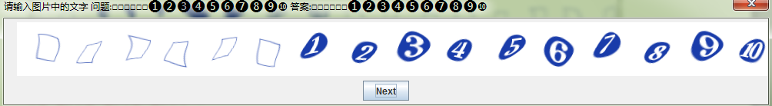

2780,2781,2782,2783,2784,2785,2786,2787,2788,2789,278a,278b,278c,278d,278e,278f,

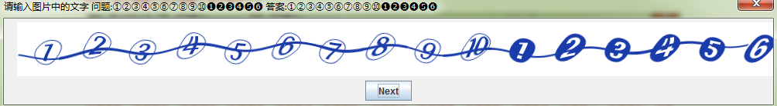

2790,2791,2792,2793-2794*-2795*-2796*-2797*-2798,2799,279a,279b,279c,279d,279e,279f,

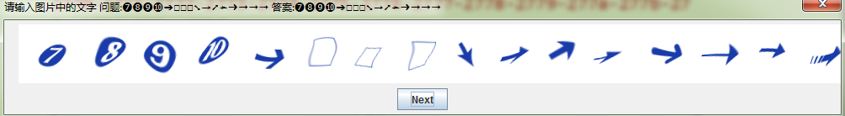

27a0,27a1,27a2,27a3,27a4,27a5,27a6,27a7,27a8,27a9,27aa,27ab,27ac,27ad,27ae,27af,

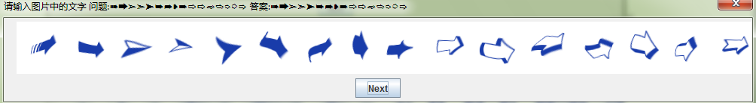

27b0*,27b1,27b2,27b3,27b4,27b5,27b6,27b7,27b8,27b9,27ba,27bb,27bc,27bd,27be-27bf*-

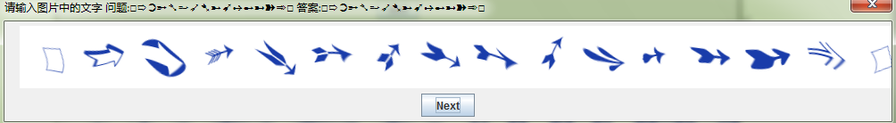

com.github.bingoohuang.patchca.background.MyCustomBackgroundFactory

