Wind power estimation using deep learning models

*Bhavitha katari*

*M.Tech, Department of IT*

*Velagapudi Ramakrishna Siddhartha Engineering College*

*Vijayawada, Andhra Pradesh*

*bhavithakatari02@gmail.com*

*Dr. sita kumari kotha*

*Associate professor*

*Velagapudi Ramakrishna Siddhartha Engineering College*

*Vijayawada, Andhra Pradesh*

*sitakumari.kotha@gmail.com*

**Abstract - One of the important concerns in any Educational Institutions is Attendance. Most of the Educational institutions are spending an abundance of time to mark attendance for huge number of students manually. Many technologies like Radio Frequency Identification (RFID), Biometric system were introduced to overcome the manual attendance system. But all these technologies are not automatic, smart enough and students need to be stand in queue to make them happen. To overcome such situations, in this paper attendance monitoring is achieved through Face Recognition using Deep Learning. Many Face detection techniques using like Harcascade classifier, Local Binary Patterns Histograms (LBPH), MTCNN were implemented but they are not up to the satisfactory performance. To improve the accuracy and performance of the application, Face detection and recognition is performed using Deep Learning techniques. State of art algorithms Dual shot face detector, FaceNet are used to implement in this application. The Video which taken from high resolution camera of the smartphone will be given to the Model. The Recognized faces will be verified with the faces of students stored in the Database. On matching respective student will be marked present to the class in the Database. The report of total number of students present and absent will be sent to the respective faculty. This application is accurate and efficient in monitoring Attendance system.**

***Keywords: Dual shot face Detector (DSFD), FaceNet, Softmax, Django, Attendance system.***

# INTRODUCTION

Wind power is the energy obtained from the wind. It is one of the oldest energy sources exploited by humans and today is the most established and efficient renewable energy source. Wind power consists of converting the energy produced by the movement of wind turbine blades driven by the wind into electrical energy. Wind energy is a source of renewable energy. It does not contaminate, it is inexhaustible and reduces the use of fossil fuels, which are the origin of greenhouse gasses that cause global warming. In addition, wind energy is a “native” energy, because it is available practically everywhere on the plant, which contributes to reducing energy imports and to creating wealth and local employment. [1] Wind forecast depends on several factors like temperature, humidity, direction of wind etc. Increasing wind energy penetrations in power systems creating a great challenge to its operation. Nature of wind makes its prediction difficult and advanced forecasting methods[2] temperature and pressure difference, air density, topography and other factors, wind speed is one of the most difficult meteorological parameters to predict. As a result, the power generated from WT will be difficult to predict. Therefore, the prediction model will inevitably be non-linear and must be more accurate meteorological parameters to predict, where the prediction models of wind power generation are categorized into direct and indirect models. Direct prediction models use historical information of wind power output as the prediction model’s input and the output of the prediction model is the predicted value of wind power generation. Where, indirect prediction models predict wind power generation by predicting wind speed and then use the power curve to convert wind speed into power output.[3] Forecasting of the wind power generation may be considered at different time scales, depending on the intended application. From milliseconds up to a few minutes, forecasts can be used for the turbine active control. Such type of forecasts are usually referred to as very short-term forecasts. For the following 48–72 hours, forecasts are needed for the power system management or energy trading. They may serve for deciding on the use of conventional power plants (Unit commitment) and for the optimization of the scheduling of these plants (Economic dispatch). Bids for energy to be supplied on a day are usually required during the morning of the previous day. These forecasts are called short-term forecasts. For longer time scales (up to 5–7 days ahead), forecasts may be considered for planning the maintenance of wind farms, or conventional power plants or transmission lines. Maintenance of offshore wind farms may be particularly costly, so optimal planning of maintenance operations is of particular importance.For the last two possibilities, the temporal resolution of wind power predictions ranges between 10 minutes and a few hours (depending on the forecast length). Improvements of wind power forecasting has focused on using more data as input to the models involved, and on providing uncertainty estimates along with the traditionally provided predictions.[4]

1. LITERATURE SURVEY
2. PROPOSED METHODOLOGY
3. RESULTS AND DISCUSSION

This model is applied over the database [20] consisting of 27 students images with various facial poses. Figure 4 shows an option of uploading already captured image using the Django web application. Figure 5 and table 1 illustrates the results of face detection using DSFD. The same image of the students sitting in the classroom is given to the various other models such as Haarcascade, LBPH, and MTCNN in which they detected the faces 21, 21, 22 respectively. The state of art DSFD model detects all the faces of the students in the classroom. These detected faces will be cropped and saved as an individual facial images. Figure 6 shows the results of the cropped individual facial images.



Fig. 4. Result of web application enabling to upload the media.

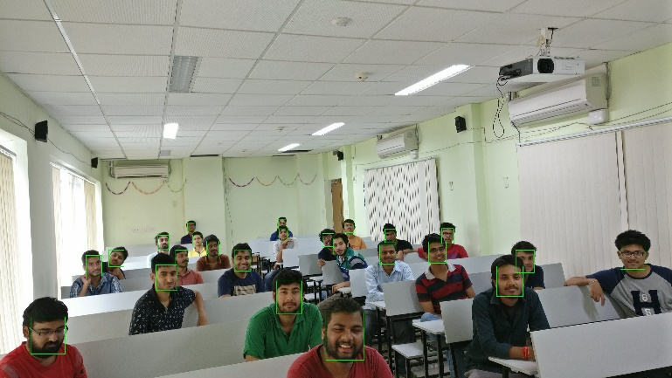

Fig. 5. Result of Face Detection using DSFD



Fig. 6. Result of cropped detected faces

1. RESULTS OF VARIOUS FACE DETECTION MODELS

|  |  |  |  |
| --- | --- | --- | --- |
| ***Method*** | ***Total number of faces in an image*** | ***Detected Faces*** | ***Un detected Faces*** |
| Haarcascade | 24 | 21 | 3 |
| LBPH | 24 | 21 | 3 |
| MTCNN | 24 | 22 | 2 |
| **DSFD** | **24** | **24** | **0** |

Further these detected facial images are given to the classifier which is trained over the registered facial images of students. The features from the facial images are extracted using the FaceNet. These features are trained over the neural network which consists of Rectified linear unit (ReLU) function as the hidden layer and the softmax as the activation layer. Figure 5 shows the results of the faces recognized using the classifier. The images labelled with “face detected” are the images detected by the DSFD, images labelled with “Predicted” are the recognized images with the database.

The results of the face detection and face recognition are illustrated in the Table II. It shows the different cases where the images are tested consisting of different poses and variable number of students. In the case1, there are 20 students in the classroom. All the 20 student faces are detected and recognized. In the case2, there are 22 number of students in the classroom. All the 22 student’s faces are detected and recognized. Similarly, in the case 3 also all the student images are detected and recognized.

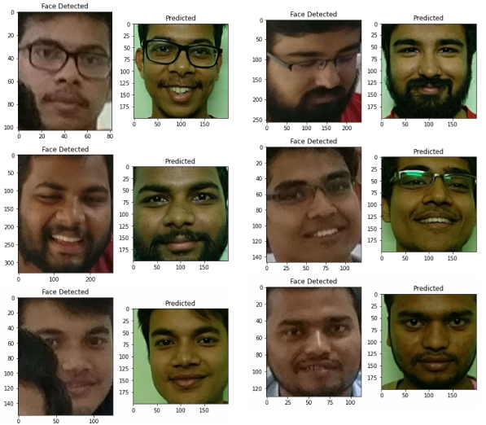

Fig. 6. Result of Face Recognition using FaceNet, Softmax

1. RESULTS OF FACE DETECTION AND FACE RECGONITION IN VARIOUS CASES

|  |  |  |  |
| --- | --- | --- | --- |
| **cases** | **Number of faces** | **Face Detection**  **DSFD** | **Face Recognition**  **FaceNet, Softmax** |
| Case 1 | 20 | 20 | 20 |
| Case 2 | 22 | 22 | 22 |
| Case 3 | 24 | 24 | 24 |

References:

[1] <https://www.acciona.com/renewable-energy/wind-energy/>

[2] 013 International Conference on Power, Energy and Control (ICPEC) 978-1-4673-6030-2/13/$31.00 ©2013 IEEE 630 A Detailed Literature Review on Wind Forecasting

[3] A hybrid neuro-fuzzy power prediction system for wind energy generation Ahmed E. Saleh a , Mohamed S. Moustafa a , Khaled M. Abo-Al-Ez b,⇑ , Ahmed A. Abdullah c,[https://doi.org/10.1016/j.ijepes.2015.07.039](https://doi.org/10.1016/j.ijepes.2015.07.039" \o "Persistent link using digital object identifier" \t "_blank)

[4]https://en.wikipedia.org/wiki/Wind\_power\_forecasting