ServiceNow Documentation: Configure Events and Email Notifications
This document explains how to configure Event Registry and Email Notifications for the Sports Hall Bookings application to send booking reminder emails.

Activity 1: Open Event Registry
Navigate to the Application Navigator. Search for 'Event Registry'. Under System Notification, select Event Registry.
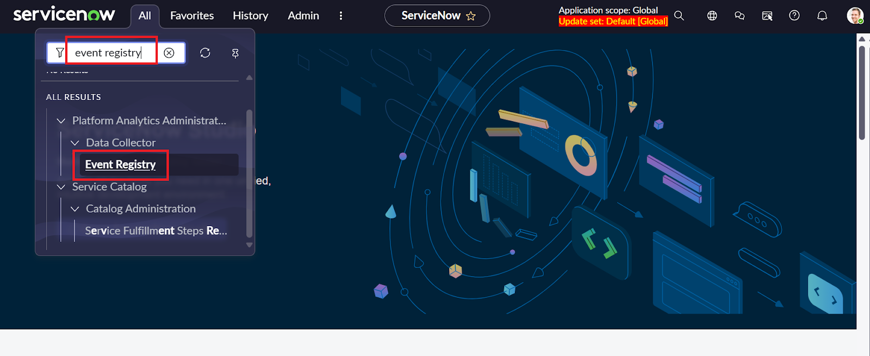

Activity 2: Create a New Event
Click the New button to create a new Event Registry record.
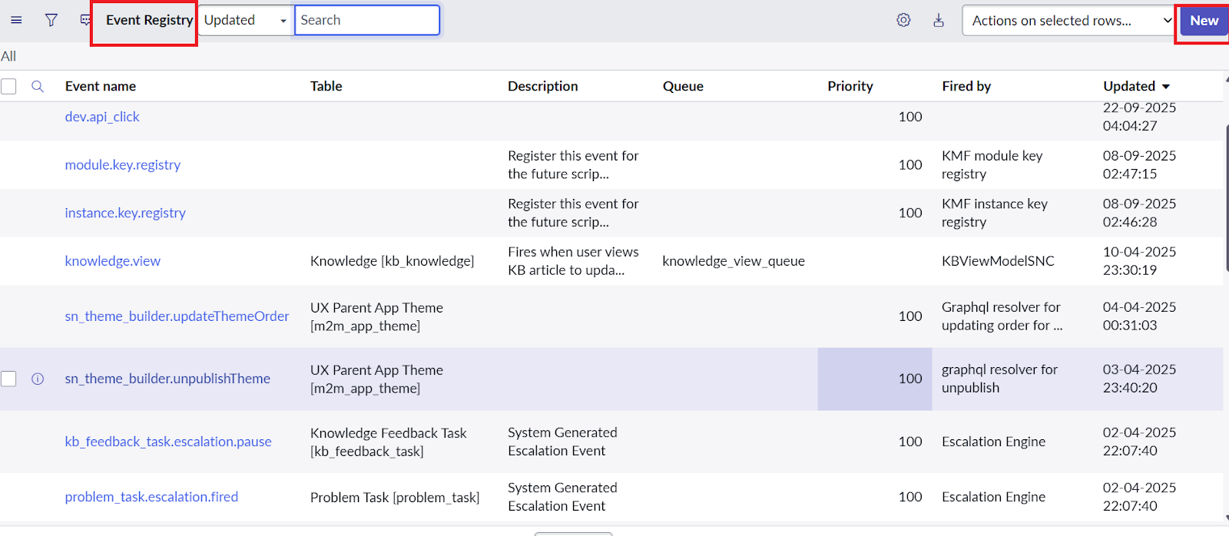

Activity 3: Configure Event Details
Enter the required event details as shown below, then click Submit or Update.
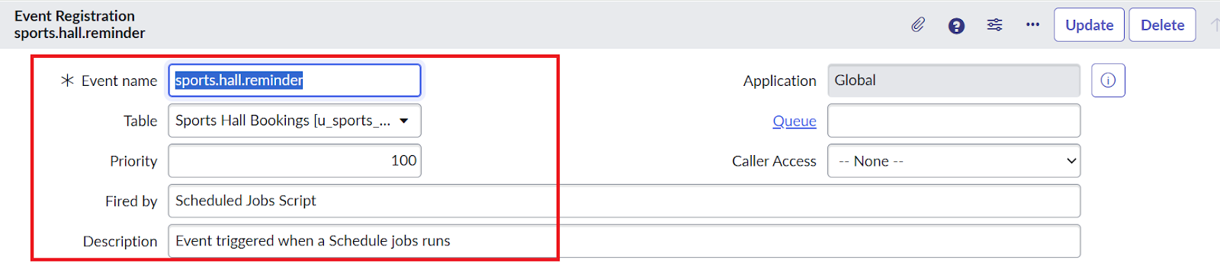

Event Configuration
Property | Value
Event Name | sports.hall.reminder
Table | u_sports_hall_bookings
Priority | 100 (Default)
Fired By | Scheduled Jobs Script
Description | Event triggered when a Schedule jobs runs
Application | Global

Activity 2: Configure Email Notifications
Navigate to Application Navigator → System Notification → Email → Notifications.
Click New and configure the notification using the following values.
Property | Value
Name | Booking confirmation reminder
Table | u_sports_hall_bookings
When to Send | Event is fired
Event Name | sports.hall.reminder
Active | True

Expected Outcome
When the scheduled job fires the event 'sports.hall.reminder', the 'Booking confirmation reminder' notification is triggered and an email is sent to the appropriate recipient.

