ServiceNow Documentation: Creation of Sports Hall Bookings Table and Fields
This document describes the steps to create the Sports Hall Bookings table and its custom fields in ServiceNow.

Activity 1: Navigate to Tables
Open the Application Navigator, search for 'Tables', and navigate to System Definition > Tables.
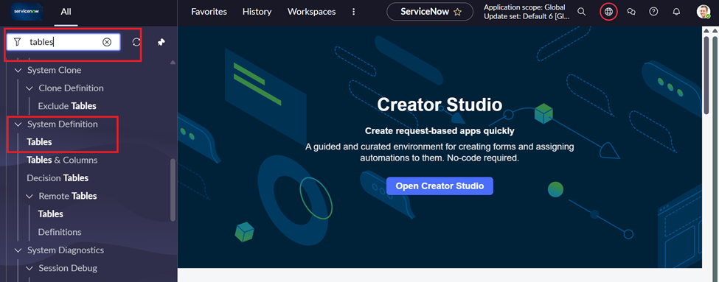

Activity 2: Create a New Table
Click New to create a new table.
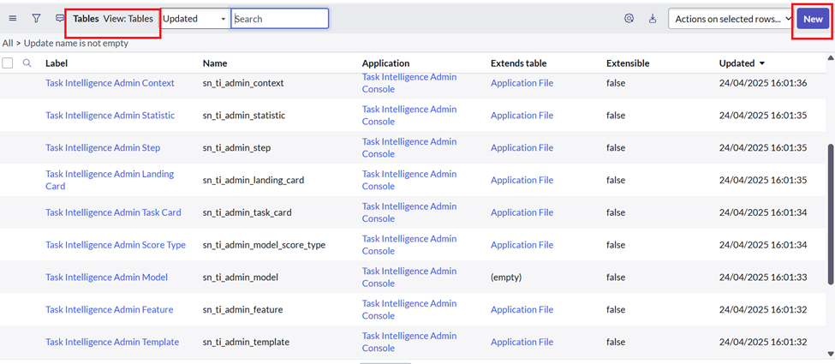

Activity 3: Enter Table Details
Enter Label = Sports Hall Bookings and Name = u_sports_hall_bookings, then submit.
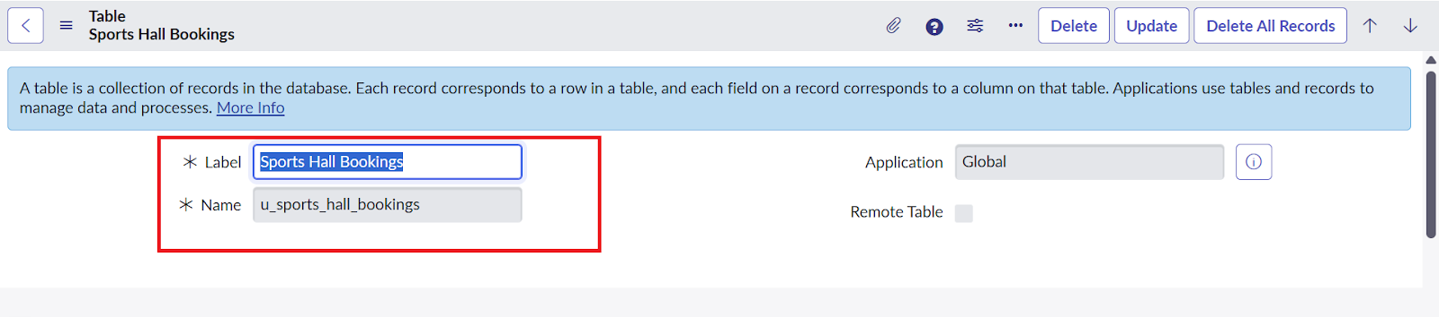

Activity 4: Create Table Fields
Open the table Columns and create the required custom fields.
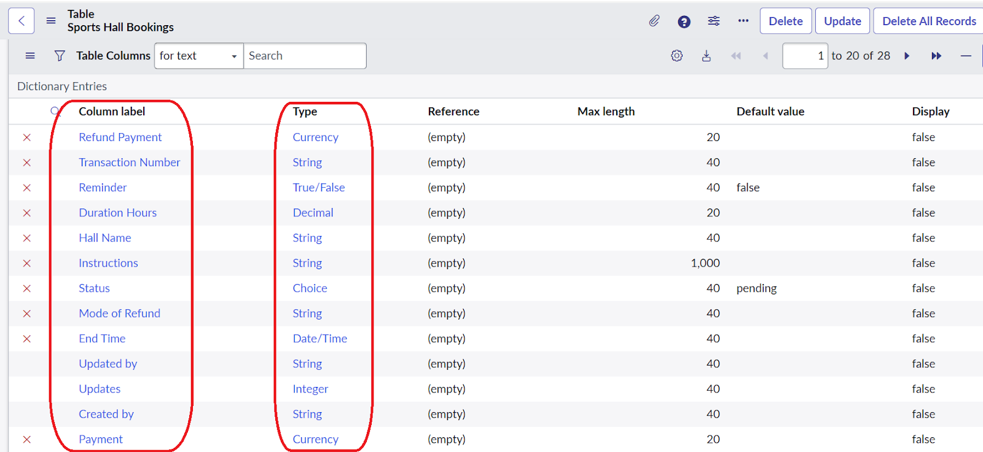

Fields to Create
Field Label | Field Name | Type | Max Length | Default
Refund Payment | u_refund_payment | Currency | 20
Transaction Number | u_transaction_number | String | 40
Reminder | u_reminder | True/False |  | False
Duration Hours | u_duration_hours | Decimal | 20
Hall Name | u_hall_name | String | 40
Instructions | u_instructions | String | 1000
Status | u_status | Choice | 40 | Pending
Mode of Refund | u_mode_of_refund | String | 40
End Time | u_end_time | Date/Time
Updated by | u_updated_by | String | 40
Updates | u_updates | Integer
Created by | u_created_by | String | 40
Payment | u_payment | Currency | 20

Status Choice Values
Configure the Status choice field with the following values:
Label | Value
Pending | pending
Approved | approved
Rejected | rejected
Cancelled | cancelled
Completed | completed

Conclusion
The Sports Hall Bookings table has been successfully created with all required custom fields and configuration.

