Data Analytics Capstone
A Data-Driven Analysis of United States Domestic Flight Delays, Capacity Utilization, and Passenger Demand Using Bureau of Transportation Statistics TranStats Data
Final Report

Bhavna Jaggi
Walsh College
QM640: Data Analytics Capstone
Keya Choudhury Ganguli
Third Term
30 October 2026

GitHub Repository
The data files, code, notebooks, database scripts, deployment prototype, figures and tables for this project are in the following repository:
https://github.com/BhavnaJaggi/airline-delay-capstone
The repository folders are data (raw and processed data), notebooks (numbered 00 to 07), scripts (shared code, database build and checks), sql (database schema), app (scoring module, dashboard and programming interface), outputs (figures, tables and the saved results file) and report (this document).

Abstract
Late flights disrupt passengers, crews, aircraft and airports, yet the on-time statistics that airlines and travelers use describe the past and do not show which flights are likely to arrive late. This study builds one reproducible pipeline that predicts and explains late arrival (15 or more minutes behind schedule), tests whether fuller routes run later, segments carrier-airport operations and forecasts route passenger demand. The approach combines statistical tests (logistic regression, correlation, chi-square, Kruskal-Wallis, paired t-tests), machine learning (random forest, extreme gradient boosting, k-means) and deep learning (a long short-term memory network); agentic language-model systems are reviewed as related work and not implemented. The data are free public Bureau of Transportation Statistics tables with 14,080,680 scheduled domestic flights of 15 reporting carriers (January 2024 to December 2025) and 793,291 carrier-segment-months of capacity and passenger counts (January 2022 to July 2026). Units of analysis are the flight (N = 400,000 sampled for modelling), the route-month (N = 148,241), the carrier-airport operation (N = 1,598) and the route passenger series (150 routes). All work ran on the central processing unit of an Apple M4 computer with 24 gigabytes of memory and no graphics processing unit, in Python with scikit-learn, statsmodels, TensorFlow and DuckDB. On 80,000 held-out flights, extreme gradient boosting reached an area under the curve of .678 (training .720), against .500 for the majority-class baseline, and .573 for the historical airline-route late rate used today. The riskiest tenth of flights was late 44.8% of the time and the safest tenth 7.4%. Load factor had a small positive association with late-arrival rate (r = .108, p < .001), and carrier-airport clusters differed in cancellation rate (Cramér's V = .012). For demand forecasting, the seasonal naive forecast had the lowest mean scaled error and the long short-term memory network was significantly less accurate than seasonal autoregressive integrated moving average models (paired p < .001). The best classifier is packaged as a scoring module with a dashboard and programming interface for airline operations planners, airport managers and travelers, who see a flight's risk band and main drivers before departure.

Introduction

Background and Context
Scheduled air travel in the United States works as a tightly connected network. The same aircraft and crew fly several segments a day, so a late arrival at one airport often becomes a late departure from the next. In the data used here, 21.6% of the 13.8 million operated domestic flights in 2024 and 2025 arrived 15 or more minutes late, the threshold the Bureau of Transportation Statistics uses to define a late arrival, and 1.4% of scheduled flights were cancelled (Bureau of Transportation Statistics, n.d.-a). Passengers lose time and connections, airlines carry the cost of disrupted crews and aircraft, airports manage gates and congestion, and regulators watch reliability. Mayer and Sinai (2003) showed that the structure of a carrier's network, in particular hubbing, explains more of the extra travel time at hub airports than congestion does, so carrier and airport belong in any model of delay.
Delay is one side of operations. Airlines also decide how many seats to offer and how fully to fill them. Load factor, the passengers carried divided by the seats available, measures how well capacity is used, and monthly passenger counts drive schedule, fleet and staffing plans. A fuller aircraft takes longer to board and leaves less room to absorb disruption, so higher utilization might come with later flights, while demand on a route follows a strong seasonal cycle that a forecasting model can learn. Competition and market structure also influence service quality (Mazzeo, 2003), which is why delay, utilization and demand are better examined together than one at a time.
The Bureau of Transportation Statistics publishes data for all of this at no cost. The Reporting Carrier On-Time Performance table records every scheduled flight of the reporting carriers, and the T-100 Domestic Segment table adds monthly departures, seats and passengers by carrier and segment (Bureau of Transportation Statistics, n.d.-a, n.d.-b). Earlier work on such data includes a systematic review of flight delay research (Carvalho et al., 2021), random forest and gradient boosting classifiers (Chakrabarty et al., 2019; Rebollo & Balakrishnan, 2014) and deep learning models (Kim et al., 2016; Yu et al., 2019). Few studies connect delay with load factor, operating profiles and demand forecasting in one reproducible workflow, and fewer still test whether a complex model beats the historical on-time percentages used today or turn the result into a usable tool. This study addresses these gaps.

Problem Statement
Airlines, airports and travelers mostly follow reliability through after-the-fact on-time percentages. These do not show which flights are at higher risk before departure, whether fuller routes run later, whether some operations cancel more often, or how route demand will move. The objective of this study is to predict and explain Y = late arrival (arrival 15 or more minutes after the scheduled time) for scheduled domestic flights using X = month, day of week, scheduled departure block, carrier, origin airport, destination airport, route distance and the route's prior-month load factor over January 2024 to December 2025. Three related outcomes are studied with the same data: the route-month late-arrival rate explained by load factor, cancellation across clusters of carrier-airport operations, and monthly route passengers forecast from their own history for January 2022 to July 2026. Success will be evaluated using the area under the receiver operating characteristic curve, accuracy, precision, recall and F1-score on held-out flights; Pearson's r with a 95% confidence interval; silhouette width and Cramér's V; and mean absolute error, root mean squared error and mean absolute scaled error on a held-out 12 months.

Purpose of the Study
The study has four analytical aims and one practical aim. It classifies flights as late or on time before departure and explains which factors raise the risk (prediction and explanation). It tests whether route load factor is associated with the late-arrival rate (explanation). It segments carrier-airport operations and compares cancellation across the segments (segmentation). It forecasts monthly route passengers (forecasting). The practical aim is to package the best classifier as a tool that returns a risk band and its main drivers.

Research Questions
Research Question 1: Which scheduled-flight characteristics (month, day of week, scheduled departure block, carrier, origin airport, destination airport, route distance and prior-month route load factor) are associated with a flight arriving 15 or more minutes late, and how accurately can logistic regression, random forest and extreme gradient boosting predict late arrival before departure compared with the historical on-time rates used today?
Research Question 2: Is route-month load factor associated with the route-month late-arrival rate, and how large is the association?
Research Question 3: Do carrier-airport operations fall into distinct groups by operating profile (load factor, departures, distance and seasonal variability), and do the groups differ in cancellation rate?
Research Question 4: Does a long short-term memory network forecast monthly route passengers more accurately than seasonal autoregressive integrated moving average models over a held-out 12 months, and how do both compare with simpler forecasts?

Contributions and Expected Value
Practical contribution. A tested scoring tool that places a planned flight in a typical, elevated or high risk band, a database that answers operational questions in structured query language, and quantified benchmarks (for example, the riskiest tenth of flights is late 44.8% of the time against 7.4% for the safest tenth) that a planner can use directly.
Technical contribution (methods and models). A single pipeline that joins two public tables on stable identification numbers, compares interpretable and flexible classifiers with both random and time-based validation, reports training and test results side by side, checks the association tests with route-clustered errors, and tests a long short-term memory network against statistical forecasts with a paired design. All code, notebooks and the database build are public.
Value to stakeholders and target users. Airline planners can place buffers and spare aircraft where risk is highest, airport managers can anticipate congested periods, travelers can judge the risk of a flight, and regulators and students get a reproducible template built on free public data.

Literature Review

Literature Review Approach
Sources were found on publisher pages, the Research Papers in Economics index, arXiv and university repositories with terms such as flight delay prediction, airline on-time performance, load factor, gradient boosting, long short-term memory, air passenger demand forecasting and large language model agents. A source was kept if it was a peer-reviewed article, proceedings paper, book or recognized survey bearing on a research question or modelling choice; one university thesis was kept as the only direct comparison of statistical and neural forecasts of United States route demand found. Sources whose details could not be confirmed were dropped.

Summary of Key Literature
Table 1 summarizes the context, data, method, findings and relevance of 19 sources, and the paragraphs after it organize them by theme.
Table 1
Literature Relevance Matrix
Author (Year) | Domain / context | Dataset / setting | Method(s) | Key findings | How it supports the research questions and project decisions
Carvalho et al. (2021) | Flight delay research | Published delay studies | Systematic literature review and taxonomy | Groups delay research by scope, data and method; predicting delays helps decisions, but prescribing action for delays already in progress remains hard | Frames Research Question 1 and the choice to pair a machine learning model with an interpretable one
Rebollo & Balakrishnan (2014) | United States air traffic delays | 2007–2008 operations; 100 most delayed links | Random forests using local and network delay states | At a 2-hour horizon the average test error was 19% for classifying delay above or below 60 minutes, and the median error was 21 minutes for delay values | Supports a random forest as a comparison model (Research Question 1) and shows that network effects matter
Tu et al. (2008) | Departure delay distributions | United Airlines at Denver, 2000–2001 | Nonparametric daily and seasonal trend with a mixture of residuals fitted by an expectation-maximization variant | Good fit, robust to parameter choice and good predictive capability | Supports time-of-day and month predictors (Research Question 1) and seasonal variability as a clustering feature (Research Question 3)
Chakrabarty et al. (2019) | Arrival delay classification | Bureau of Transportation Statistics data, American Airlines, 2015–2016, five busy airports | Random forest, support vector machine, gradient boosting, k-nearest neighbors | Gradient boosting performed best at 79.7% | Closest precedent for Research Question 1 (same source and 15-minute rule), but limited to one carrier and five airports
Kim et al. (2016) | Air traffic delay prediction | Day-to-day sequences of departure and arrival delays at a single airport | Long short-term memory recurrent networks; four ways of building deep recurrent networks | Deeper architectures improved accuracy, and the model outperformed earlier prediction methods | Early deep learning precedent for delay and for sequence models in Research Question 4
Yu et al. (2019) | Airport delay prediction | High-dimensional flight data, Beijing International Airport | Deep belief network with support vector regression for fine-tuning | Handles large data sets and captures the main delay factors | Shows the deep learning alternative and motivates keeping an interpretable model as the primary one (Research Question 1)
Chen & Guestrin (2016) | Machine learning method | Method paper; large-scale benchmarks | Extreme gradient boosting with a sparsity-aware algorithm and weighted quantile sketch | A scalable tree boosting system that gives strong results on many machine learning tasks and handles billions of examples | Basis for the extreme gradient boosting classifier in Research Question 1
Breiman (2001) | Machine learning method | Method paper | Random forests | Ensembles of random trees classify accurately and do not overfit as trees are added | Comparison classifier in Research Question 1
Lundberg & Lee (2017) | Model interpretation | Method paper | Shapley additive explanation values | A unified, additive way to attribute a prediction to each feature | Explains the flexible models at factor level in Research Question 1 and in the deployed tool
Mayer & Sinai (2003) | Airline network economics | United States air traffic | Empirical test of hub-network and congestion-externality explanations | The hubbing effect is stronger; hub carriers absorb most of the extra time by scheduling in tight windows | Carrier and airport structure matters, so both enter Research Question 1 and define the unit of Research Question 3
Mazzeo (2003) | Competition and service quality | 2000 flights; about 770,000 flights, 50 airports, 10 carriers | Ordinary least squares and probit with airport, carrier, month and day fixed effects | Single-carrier routes ran about 1.35 minutes later and were 1 to 2 points more likely to be late; weather, congestion and hubs also mattered | Supports route-level analysis with Bureau of Transportation Statistics data and carrier and month controls
Jain (2010) | Clustering | Method review | k-means and its extensions | k-means is simple and widely used, but choosing k and the cluster shape are known weaknesses | Method and cautions for Research Question 3
Rousseeuw (1987) | Cluster validation | Method paper | Silhouette width | A graphical and numeric measure of how well each object fits its cluster | Used to choose k in Research Question 3
Hochreiter & Schmidhuber (1997) | Neural networks | Method paper | Long short-term memory network | Gated memory cells let a recurrent network learn long time lags | Deep learning model for Research Question 4
Hyndman & Athanasopoulos (2021) | Forecasting | Textbook | Seasonal autoregressive integrated moving average, exponential smoothing, accuracy measures | Defines the models and scaled error measures used to compare forecasts across series | Statistical baselines and error measures for Research Question 4
Adraos Gay (2025) | Air passenger demand forecasting | Passengers between Los Angeles and San Francisco and between Los Angeles and New York (John F. Kennedy) | Seasonal autoregressive integrated moving average, two-stage least squares, feedforward and long short-term memory networks, Shapley values | The long short-term memory network was best on the first route and the seasonal model on the second | Direct precedent for Research Question 4, but only two routes, so no general conclusion
Wang et al. (2024) | Large language model agents | Survey of agent studies | Unified architecture of profile, memory, planning and action modules; applications and evaluation | Language models can act as autonomous agents across social science, natural science and engineering, with open challenges for future research | Background for the agentic extension: an agent that calls the scoring tool (future scope, not implemented)
Yao et al. (2023) | Language model reasoning and acting | Question answering and interactive decision benchmarks | ReAct prompting that interleaves reasoning steps with tool actions | Reduced errors from reasoning alone and beat imitation and reinforcement learning by 34 and 10 points of success on two interactive benchmarks | Design pattern for an assistant that queries the scoring programming interface and the database (future scope)
Gruver et al. (2023) | Time series forecasting with language models | Standard forecasting benchmarks | Numbers written as digit strings and forecast by pretrained language models without training | Zero-shot forecasts were comparable to or better than purpose-built models | Candidate comparison model for Research Question 4 in later work
Note. Findings are paraphrased from the cited sources. Adraos Gay (2025) is a bachelor's thesis; the others are journal articles, conference papers, a survey or books.
Flight delay prediction has moved from describing delay to predicting it. Carvalho et al. (2021) review the field and note that predicting delays helps decisions even when acting on delays in progress is difficult. Rebollo and Balakrishnan (2014) used random forests with network delay states and reached a 19% classification error at a two-hour horizon, and Chakrabarty et al. (2019) found gradient boosting best among four classifiers on Bureau of Transportation Statistics arrival data. Extreme gradient boosting (Chen & Guestrin, 2016) is a refined, scalable form of gradient boosting, so the first research question compares logistic regression, a random forest (Breiman, 2001) and extreme gradient boosting on all reporting carriers and many airports, whereas the closest precedent covers one carrier and five airports.
Deep learning has also been applied to delay. Kim et al. (2016) modelled airport delay sequences with long short-term memory networks and Yu et al. (2019) used a deep belief network on high-dimensional flight data; both report gains over earlier methods but at the price of interpretability. For that reason, this study keeps logistic regression as the primary explanatory model for flights, explains the flexible models with Shapley values (Lundberg & Lee, 2017), and uses the long short-term memory network (Hochreiter & Schmidhuber, 1997) only for the fourth question, where the data are time series.
A second line of work shows that who flies and where matters. Mayer and Sinai (2003) found that hubbing, more than congestion, explains extra travel time at hubs, Mazzeo (2003) linked route competition to service quality with carrier, airport and month effects, and Tu et al. (2008) showed that departure delays follow daily and seasonal patterns. These findings justify carrier, airport, month and departure time as predictors in the first question and carrier-airport operations as the unit of the third, which uses k-means (Jain, 2010) with the silhouette width (Rousseeuw, 1987) to choose the number of groups.
For demand, Hyndman and Athanasopoulos (2021) describe the seasonal autoregressive integrated moving average and exponential smoothing models and the scaled error measures that allow comparison across series. The only direct comparison with neural forecasts for United States routes is Adraos Gay (2025), where the long short-term memory network won on one of two routes and the seasonal model on the other, so the evidence is mixed and too narrow to generalize. The fourth question therefore tests the two approaches on 150 routes with a paired design.
Language-model and agentic work is the newest strand. Wang et al. (2024) survey agents that combine a language model with memory, planning and tools, Yao et al. (2023) show that interleaving reasoning with tool actions reduces errors that reasoning alone makes, and Gruver et al. (2023) report that pretrained language models can forecast numeric series without training. None of these studies deals with flight reliability, and a language model adds cost, variability and little transparency to a task that tabular models already handle, so no language model is implemented here. The agentic literature instead guides the deployment design: the scoring module and database are exposed as tools that an assistant could call, and this is treated as future scope.
Taken together, the literature supports each modelling choice but leaves a gap: no reviewed study combines delay prediction on all reporting carriers, a test of load factor, segmentation, demand forecasting and a deployable tool on public data, or compares a flexible model with the historical on-time rates used in practice. This project fills that gap.

Materials and Method

Data Source and Acquisition
Two free public tables from the Bureau of Transportation Statistics TranStats library are used and nothing from another provider. The Reporting Carrier On-Time Performance table has one record per scheduled domestic flight of the reporting carriers (Bureau of Transportation Statistics, n.d.-a). The T-100 Domestic Segment (All Carriers) table has monthly non-stop segment records with departures, seats and passengers by carrier, origin, destination, aircraft type and service class (Bureau of Transportation Statistics, n.d.-b). No web scraping was needed: both tables were downloaded from the TranStats download pages, which need no account, using the field-selection pages at:
- On-Time Performance: https://www.transtats.bts.gov/DL_SelectFields.asp?gnoyr_VQ=FGJ&QO_fu146_anzr=b0-gvzr
- T-100 Domestic Segment (All Carriers): https://transtats.bts.gov/DL_SelectFields.asp?gnoyr_VQ=GEE&QO_fu146_anzr=Nv4%20Pn44vr45
The On-Time table was downloaded as 24 monthly files for 2024 and 2025 (31 of its 109 fields were kept), and the T-100 table as yearly files for 2022 to 2026, the latest month then published being July 2026. A download script in the repository repeats the process. Because airline and airport codes can be reused over the years (Bureau of Transportation Statistics, n.d.-b), the tables are joined on identification numbers for month, carrier, origin and destination, and 99.96% of On-Time route-months found a T-100 record.
Table 2
Dataset Overview
Item | On-Time Performance (Research Questions 1 to 3) | T-100 Domestic Segment (Research Questions 2 to 4)
Records read | 14,080,680 | 2,006,801
Period | January 2024 to December 2025 | January 2022 to July 2026
Unit of analysis | Scheduled flight | Carrier × segment × month
Outcomes | Late arrival (ArrDel15); cancellation (Cancelled) | Passengers; load factor (passengers ÷ seats)
Records after cleaning | 14,080,680 | 793,291
Records by year | 2024: 7,079,061; 2025: 7,001,619 | 2022: 411,573; 2023: 427,427; 2024: 440,939; 2025: 458,793; 2026 (to July): 268,069 (rows read)
Operated, cancelled and diverted flights | 13,844,731 operated; 199,191 cancelled; 36,757 diverted | Not applicable
Analysis units | 400,000 flights sampled (Research Question 1); 148,241 route-months (Research Question 2); 1,598 carrier-airport operations (Research Question 3) | 150 routes × 55 months (Research Question 4)
Note. Counts come from notebook 01 and are saved in outputs/results.json.
Table 3 lists, for each research question, the table that was used and how many records it held at each step.
Table 3
Data Used for Each Research Question
Research question | Table used | Records available | Records analyzed
1 | On-Time Performance (flights), plus prior-month load factor from T-100 | 14,080,680 flights read; 13,844,731 operated | 400,000 flights sampled (320,000 train, 80,000 test); time-based check 201,303 (2024) and 198,697 (2025)
2 | On-Time Performance joined to T-100 (route-month table) | 234,892 route-months formed from 13,844,731 operated flights; 96 had no T-100 match | 148,241 route-months (118,488 train and 29,753 test, split by route)
3 | On-Time Performance joined to T-100 (carrier-airport table) | 14,080,680 flights, including cancelled | 1,598 carrier-airport operations covering 14,044,433 flights
4 | T-100 Domestic Segment (route passengers) | 793,291 carrier-segment-months; 5,101 routes with a complete series | 150 routes × 55 months = 8,250 route-months (6,450 train, 1,800 test)
Note. Counts follow the dataset overview and the inclusion and exclusion table and are saved in outputs/results.json; of the 234,796 matched route-months, 86,555 had fewer than 30 flights and were excluded, leaving 148,241.

Data Dictionary
Table 4 defines each variable. Field names follow the Bureau tables; the last four rows are derived variables.
Table 4
Data Dictionary
Variable | Definition | Type | Allowed values | Missing values | Use
Year, Month | Calendar year and month of the flight or reporting month | Integer | 2022–2026; 1–12 | None expected | Both tables
DayOfWeek | Day of the week of the scheduled departure | Integer (category) | 1 (Monday) to 7 (Sunday) | None | Research Question 1 predictor
FlightDate | Date of the scheduled departure | Date | January 2024 to December 2025 | None | Duplicate check
Reporting_​Airline | Two-character code of the operating airline | Text (category) | 15 codes | None | Research Question 1 predictor; labels
DOT_​ID_​Reporting_​Airline | Stable airline identification number assigned by the Department of Transportation | Integer identifier | Positive integers | None | Join key to T-100 AirlineID
OriginAirportID, DestAirportID | Stable identification numbers of the origin and destination airports | Integer identifier | Positive integers | None | Join keys
Origin, Dest | Three-letter origin and destination airport codes | Text (category) | Three-letter codes | None | Research Question 1 predictors (25 busiest airports, rest grouped)
CRSDepTime, DepTimeBlk | Scheduled departure time (four digits, hour then minute) and its hourly block | Integer; text (category) | 0000–2359; 0001–0559, 0600–0659, …, 2300–2359 | Invalid values reported (none found) | Research Question 1 predictor (block)
Distance | Distance between origin and destination airports, in miles | Numeric | Greater than 0 | Rows with distance of 0 or less dropped (none found) | Research Question 1 predictor; Research Question 3 feature
ArrDelay | Arrival delay in minutes (negative = early) | Numeric | −128 to 4,336 in the data | Missing for 235,949 flights (199,191 cancelled, 36,757 diverted, 1 unexplained); kept but excluded from delay analyses | Extreme values retained
ArrDel15 | Indicator that the arrival was 15 or more minutes late | Binary | 0 or 1 | Missing when ArrDelay is missing (235,949 flights) | Research Questions 1 and 2 outcome
Cancelled, Diverted | Flight-cancelled and flight-diverted indicators | Binary | 0 or 1 | None | Research Question 3 outcome (Cancelled)
CancellationCode | Reason a flight was cancelled | Text (category) | A carrier, B weather, C national air system, D security | Blank when not cancelled | Exploratory analysis
CarrierDelay, WeatherDelay, NASDelay, SecurityDelay, LateAircraftDelay | Delay minutes assigned to each cause | Numeric | 0 or more | Recorded only for delays of 15 or more minutes | Exploratory analysis only; never a predictor
DepDelay, DepDel15 | Departure delay in minutes and its 15-minute indicator | Numeric; binary | — | — | Not a predictor (unknown before departure)
UniqueCarrier, AirlineID (T-100) | Carrier code and airline identification number in the T-100 table | Text; integer | — | None | AirlineID joins to DOT_​ID_​Reporting_​Airline
DepScheduled, DepPerformed | Departures scheduled and performed in the month | Integer | 0 or more | Missing scheduled departures treated as unknown | Capacity; Research Question 3 feature
Seats, Passengers | Seats available and passengers carried on the segment in the month | Integer | 0 or more | Seats of 0 give a missing load factor | Load factor; Research Question 4 series
Class (T-100) | Service class | Text | F = scheduled passenger and cargo service | Other classes dropped | Filter
is_​late (derived) | Late-arrival flag for operated flights | Binary | 0 or 1 | Cancelled and diverted flights excluded | Research Questions 1 and 2 outcome
load_​factor (derived) | Passengers divided by seats, times 100, for a carrier-route-month | Numeric | 0–100 | Values above 100 set to missing (77 T-100 rows) | Research Question 2 predictor; Research Question 3 feature
late_​rate (derived) | Share of operated flights on a route-month that arrived 15 or more minutes late | Numeric (percent) | 0–100 | Route-months with fewer than 30 operated flights excluded | Research Question 2 outcome
lf_​prev (derived) | Load factor of the same carrier-route in the previous month | Numeric | 0–100 | Missing indicator added; median used in the model | Research Question 1 predictor

Inclusion and Exclusion Criteria
Table 5 lists the rules applied and how many records each affected.
Table 5
Inclusion and Exclusion Criteria
Step | Rule | Effect
Carriers and period | Include all flights of the reporting carriers, January 2024 to December 2025 | 14,080,680 flights, 15 carriers
Duplicates and invalid records | Exclude repeated flights, distance of 0 or less, origin equal to destination | 0 records removed
Cancelled flights | Keep in the cleaned table (needed for Research Question 3); exclude from delay analyses | 199,191 flights
Diverted flights | Keep in the cleaned table; exclude from delay analyses (no arrival delay) | 36,757 flights
Research Question 1 sample | Operated flights only; random sample with a fixed seed | 400,000 of 13,844,731 operated flights
Leakage control | Exclude departure delay, taxi times, actual times and cause minutes as predictors (known only after departure) | Variables excluded
T-100 service class | Include class F (scheduled passenger and cargo service) only | 1,532,260 of 2,006,801 rows
T-100 key fields | Exclude rows lacking a carrier or airport identification number | 24 rows
Join | Exclude On-Time route-months with no T-100 match | 96 route-months
Research Question 2 volume rule | Include route-months with 30 or more operated flights; set load factor above 100% to missing | 86,555 route-months excluded; 148,241 kept
Research Question 3 volume rule | Include carrier-airport operations with at least 12 months and 120 flights | 1,598 units
Research Question 4 series rule | Include routes with a complete monthly series, then the 150 busiest | 5,101 complete; 150 used

Exploratory Data Analysis
The flights data show clear structure. The late-arrival rate was 21.6% overall, but it rose and fell with the season (Figure 1): from 13.2% in October 2024 to 29.6% in July 2024. Within a day it climbed from about 17% for mid-morning departures to 31.3% at 19:00 (Figure 2), which fits the knock-on effect described by Mayer and Sinai (2003): delays accumulate as aircraft fly their daily rotation. Sunday was the worst weekday (24.5%) and Tuesday the best (18.2%).
Figure 1
Monthly Late-Arrival and Cancellation Rates, 2024–2025
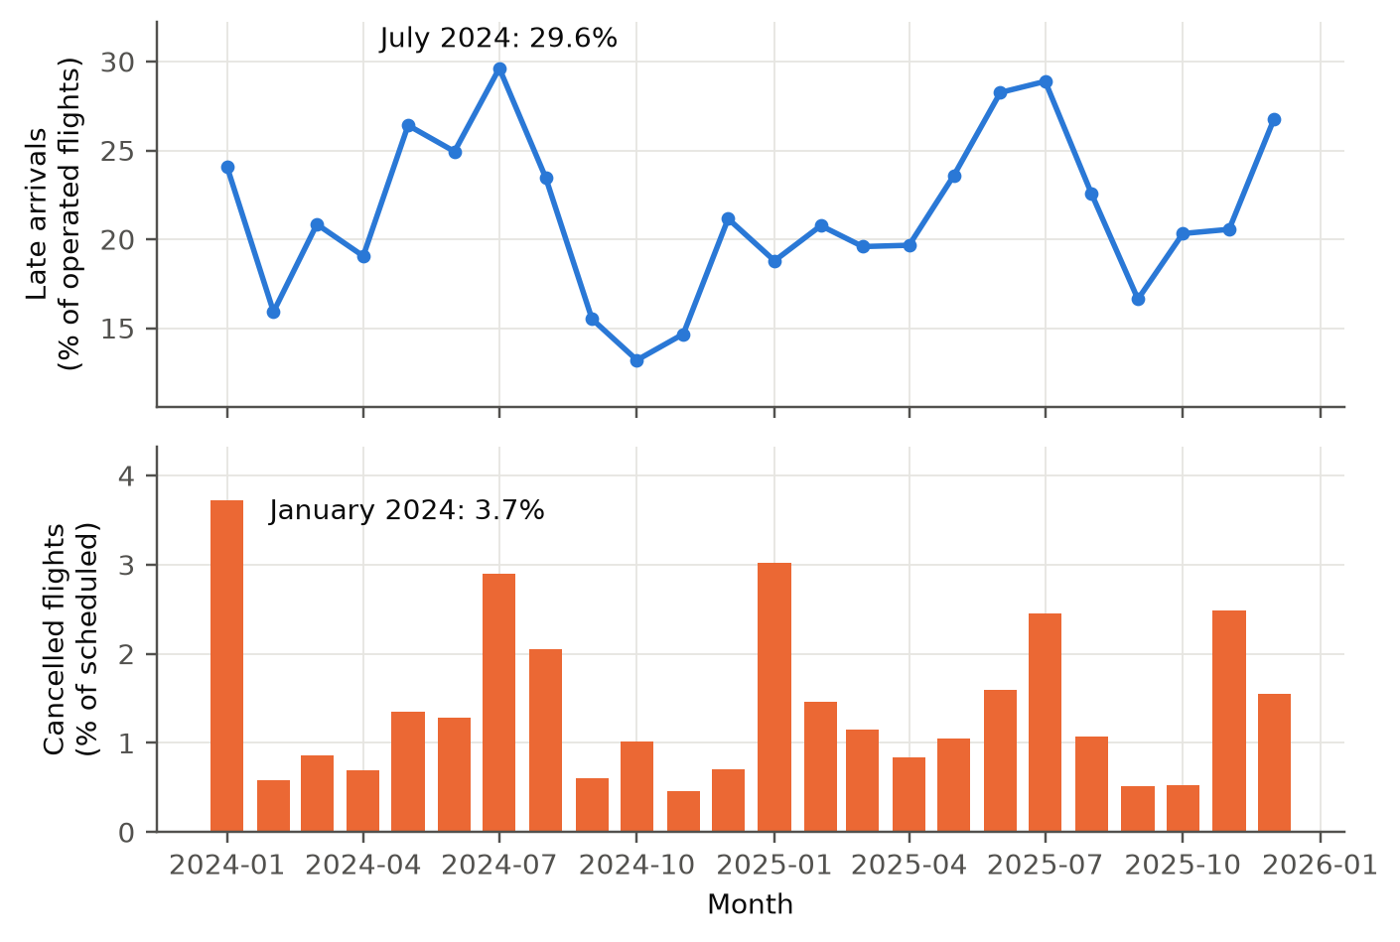
Note. Late arrival is 15 or more minutes behind schedule. Rates are percentages of operated (late) or scheduled (cancelled) flights.
Figure 2
Late-Arrival Rate by Scheduled Departure Hour
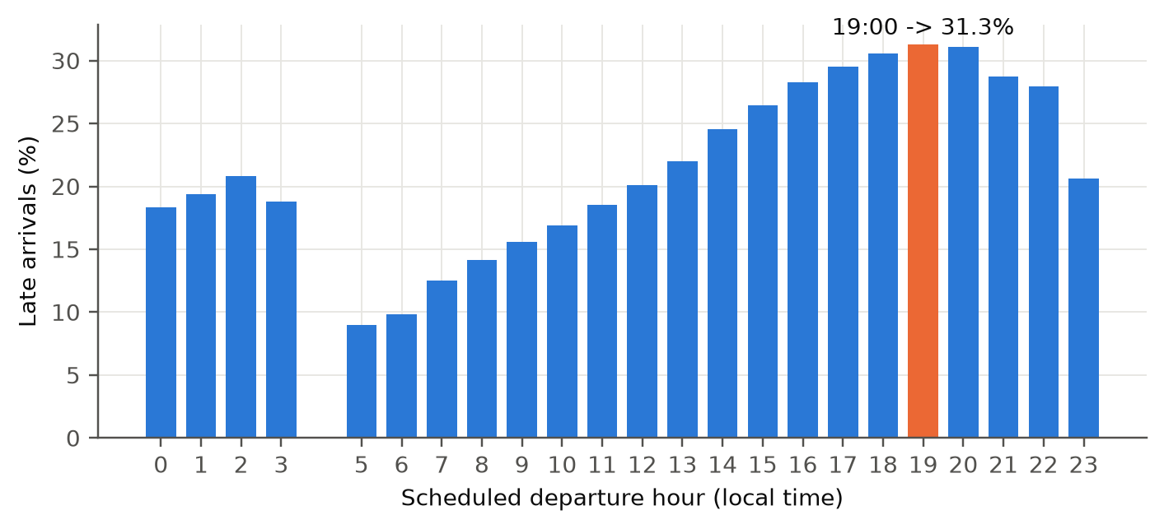
Note. The rate rises through the day.
Carriers differed widely (Figure 3): late-arrival rates ran from 15.8% for Endeavor Air to 28.3% for Frontier Airlines, and origin airports from 18.2% (Los Angeles International) to 27.9% (Dallas/Fort Worth). Arrival delay is strongly right-skewed (Figure 4): the median flight arrived 6 minutes early, the mean was 7.80 minutes late, and 7.6% of flights were more than an hour late. These extreme delays are real events and were kept. Late-arriving aircraft (39.8%) and the airline itself (33.4%) account for most delay minutes, extreme weather for only 6.2% (Figure 5). So rotation and schedule structure are central, and weather, which is not in the tables, is a limitation.
Figure 3
Late-Arrival Rate by Carrier
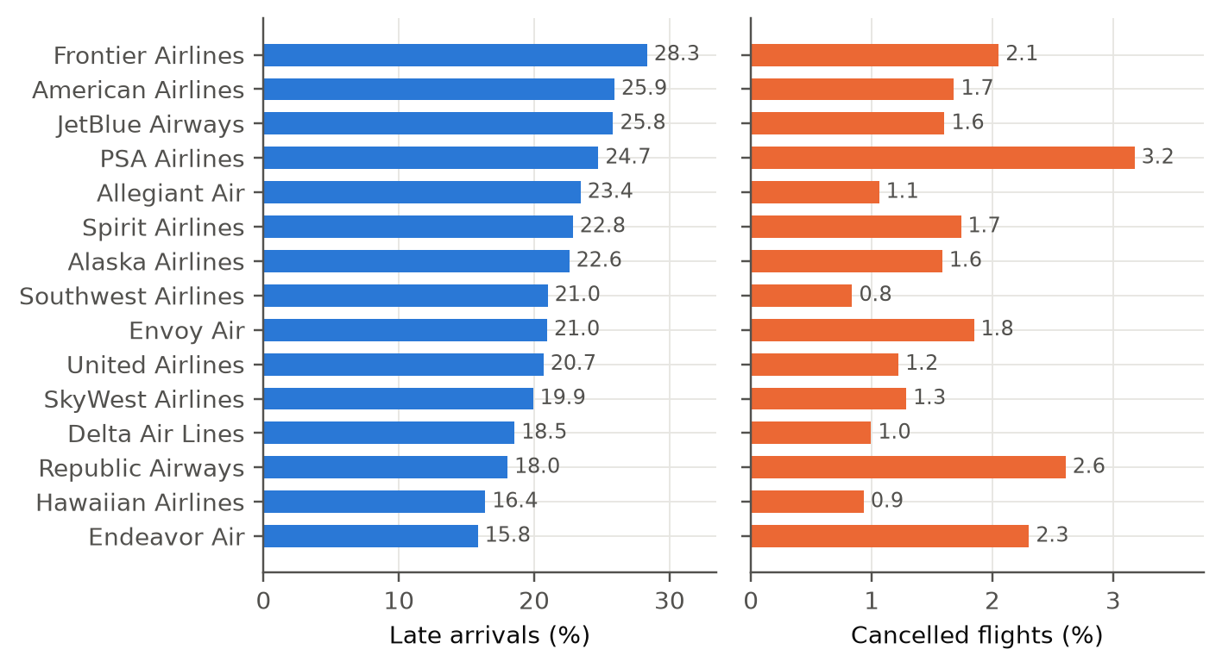
Note. Carriers: 9E = Endeavor Air; AA = American Airlines; AS = Alaska Airlines; B6 = JetBlue Airways; DL = Delta Air Lines; F9 = Frontier Airlines; G4 = Allegiant Air; HA = Hawaiian Airlines; MQ = Envoy Air; NK = Spirit Airlines; OH = PSA Airlines; OO = SkyWest Airlines; UA = United Airlines; WN = Southwest Airlines; YX = Republic Airways.
Figure 4
Distribution of Arrival Delay
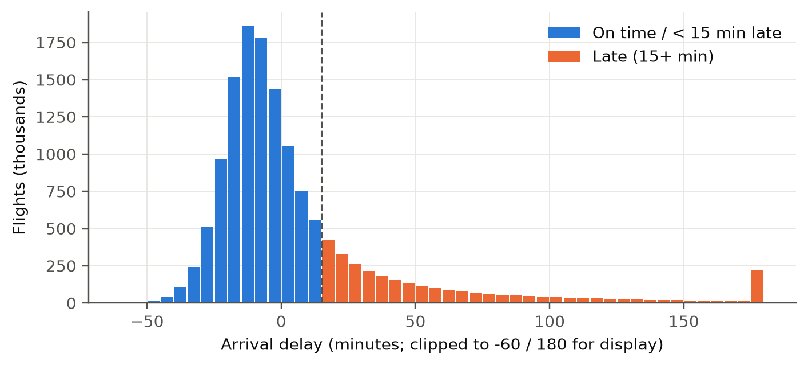
Note. Minutes relative to schedule; negative values are early arrivals.
Figure 5
Share of Delay Minutes by Cause
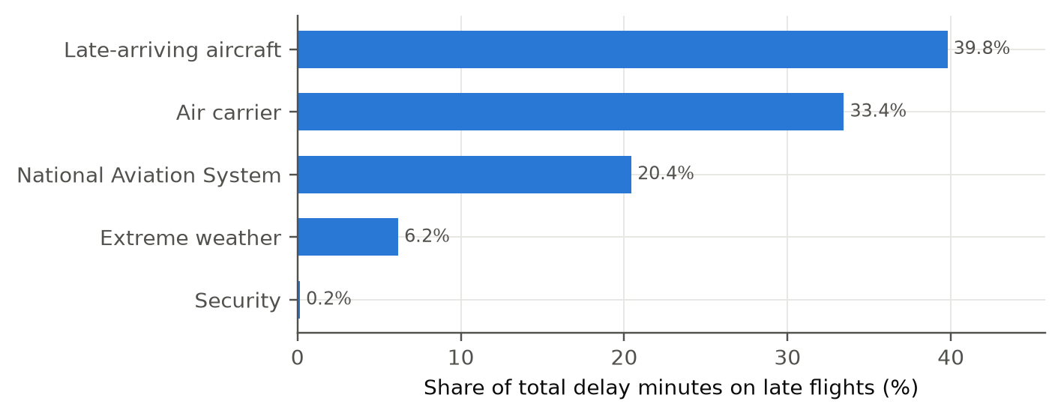
Note. Cause minutes are recorded only for delays of 15 or more minutes.
For capacity, the median route-month load factor was 81.9% and most route-months are well filled, with a long tail of lightly filled routes (skewness -1.35). Routes in the lowest load-factor decile (mean 57.9%) had a late-arrival rate of 18.6%, against 22.4% in the highest (Figure 6), a rise of nearly four points that motivates Research Question 2. Monthly passengers swing by 27% between the low month (February) and the peak (July) (Figure 7), which motivates seasonal models for Research Question 4. Finally, the daily cancellation rate correlates .70 with the daily late rate, so disruption days hit both outcomes together.
Figure 6
Late-Arrival Rate by Load-Factor Decile
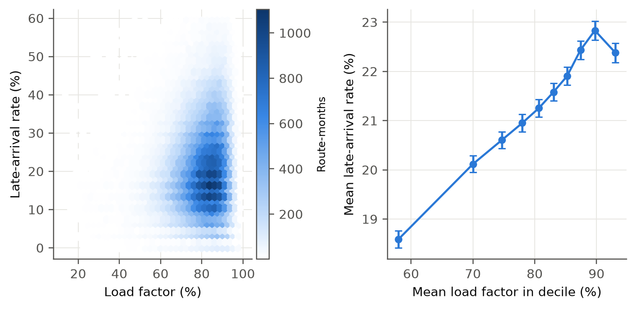
Note. Each point is a tenth of route-months ordered by load factor.
Figure 7
Monthly Passengers and Seasonal Pattern
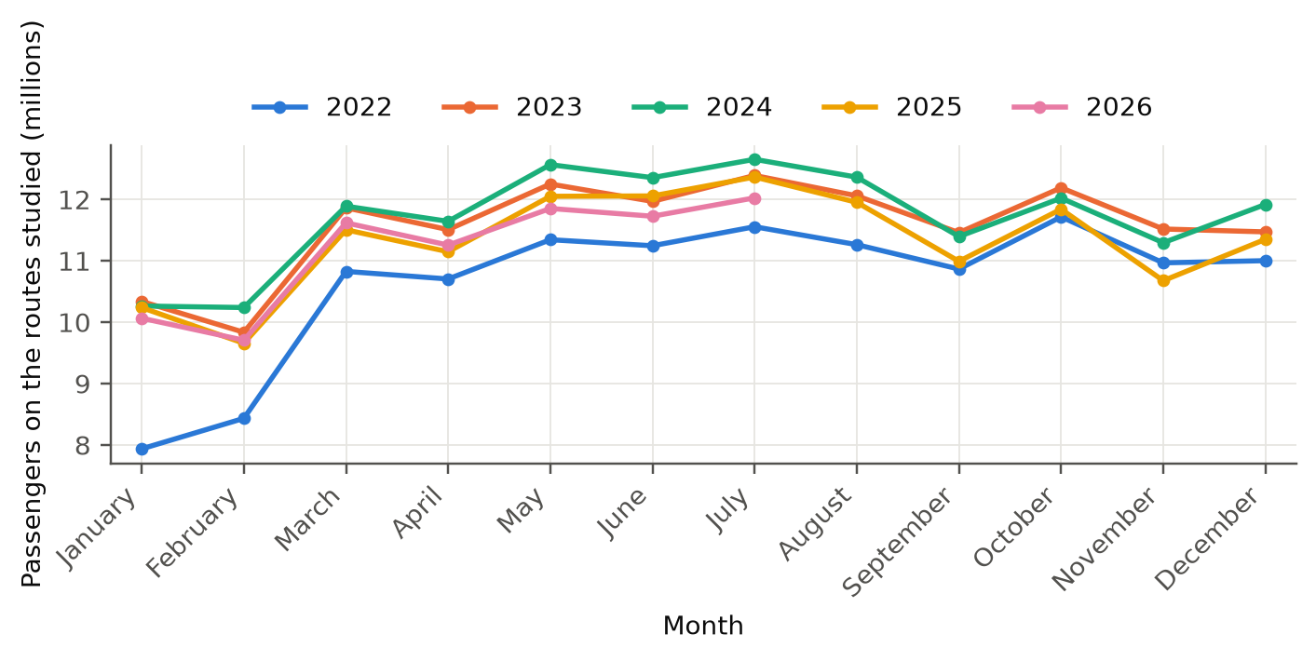
Note. Passengers on all domestic segments of the reporting carriers, by month.

Research Hypotheses
Table 6 states the null (H₀) and alternative (H_{a}) hypotheses for each research question. Every test uses a significance level of α = .05, and the decision rule is to reject H₀ when p < .05.
Table 6
Hypotheses and Statistical Tests
Research question | Null hypothesis (H₀) | Alternative hypothesis (H_{a}) | Test (α = .05)
1 | All coefficients of the logistic model are zero: β₁ = β₂ = … = β_{p} = 0 (no scheduled-flight characteristic is related to late arrival). For each factor, all of its coefficients are zero. | At least one β_{j} ≠ 0 (overall and for each factor) | Likelihood-ratio χ² test, overall and by factor; test-set area under the curve compared with .5
2 | ρ = 0: load factor and late-arrival rate are not correlated (slope β₁ = 0) | ρ ≠ 0 (β₁ ≠ 0) | Pearson correlation with Fisher z interval; regression with route-clustered errors
3 | Cancellation rate is the same in all clusters: π₁ = π₂ = π₃ = π₄ | At least one π_{k} differs | Chi-square test of independence; Kruskal-Wallis test of unit rates; two-proportion z-test of the highest and lowest clusters
4 | μ_{d} = 0, where d = error of the long short-term memory network − error of the seasonal autoregressive integrated moving average model on the same route | μ_{d} ≠ 0 | Paired t-test (Wilcoxon signed-rank as a check) on mean absolute error, root mean squared error and mean absolute scaled error

Minimum Sample Size
The minimum sample for each question uses α = .05 (two-sided, z_{α/2} = 1.96) and, where power applies, power of .80 (z_{β} = 0.8416). The calculations are the following.
Research Question 1: n = z²p(1 − p) / E² = (1.96)²(0.5)(0.5) / (0.01)² = 9603.65 → 9,604 flights
Research Question 2: n = [(z_{α/2} + z_{β}) / C]² + 3, with C = ½ ln[(1 + r)/(1 − r)] = 0.1003 for r = 0.10, so n = 782.65 → 783 route-months
Research Question 3: n per group = [z_{α/2}√(2p̄(1 − p̄)) + z_{β}√(p₁(1 − p₁) + p₂(1 − p₂))]² / (p₁ − p₂)², with p₁ = .015, p₂ = .025, p̄ = .02, so n = 3,075.6 → 3,076 per group, 6,152 flights
Research Question 4: n = [(z_{α/2} + z_{β}) / d]² = (2.8016 / 0.30)² = 87.2 → 88 routes
The inputs are the most cautious conventional choices: a margin of error of one percentage point with p = .5 (the largest variance) for Research Question 1 (Fleiss et al., 2003), a small correlation of .10 for Research Question 2, cancellation rates of 1.5% and 2.5% for Research Question 3, and a small-to-medium paired effect of 0.30 for Research Question 4 (Cohen, 1988). Table 7 compares each minimum with the data collected (code in Appendix A). Every question has far more data than needed, from 1.7 times the minimum for Research Question 4 to 2,283 times for Research Question 3. The large volume is deliberate: the minimums guarantee that a small effect would be detected, and the larger samples give stable estimates for the many carrier, airport and departure-block categories in Research Question 1 and for rare events such as cancellations. With samples this large almost any association is significant, so effect sizes are reported beside every p value.
Table 7
Minimum Sample Size and Data Collected
Research question | Unit | Minimum required | Data collected | Requirement met
Research Question 1 | flights in modelling sample | 9,604 | 400,000 | Yes
Research Question 2 | route-months | 783 | 148,241 | Yes
Research Question 3 | flights in clustered carrier-airports | 6,152 | 14,044,433 | Yes
Research Question 4 | routes with complete series | 88 | 150 | Yes
Note. Minimums are from the equations above; data collected are counts after cleaning and volume rules.

Statistical Methods and Model Selection
Research Question 1 is a binary outcome with many categorical predictors. A logistic regression is the primary model because it gives an odds ratio, confidence interval and p value for every term and a likelihood-ratio test for each factor. A random forest (Breiman, 2001) and extreme gradient boosting (Chen & Guestrin, 2016) are added because they capture interactions that main effects cannot, and both did well in earlier delay studies (Chakrabarty et al., 2019; Rebollo & Balakrishnan, 2014). Tuned versions of the flexible models are compared with their defaults, and a majority-class baseline and two historical on-time benchmarks (the late rate of the airline, and of the airline on the route, estimated from training flights only) represent current practice. The classification threshold is the training prevalence of late flights (.216), because .5 would label nearly every flight on time. The area under the curve is the main metric because it does not depend on the threshold.
Research Question 2 uses the Pearson correlation and a simple regression, with Spearman correlation, a weighted fit, a fit without influential points and a model adding distance, carrier, month and year as checks; standard errors are clustered by route because flights on a route share conditions. Research Question 3 uses k-means on standardized load factor, log departures, distance and seasonal variability, with k chosen by silhouette width and cancellation left out of the clustering to avoid circular tests. Research Question 4 compares a seasonal naive forecast, exponential smoothing, a seasonal autoregressive integrated moving average model (0,1,1)(0,1,1)₁₂ on log passengers (Hyndman & Athanasopoulos, 2021) and one global long short-term memory network (Hochreiter & Schmidhuber, 1997) averaged over three seeds, scored by mean absolute error, root mean squared error and mean absolute scaled error.

Original Work: Data Splitting
Table 8 gives the splitting procedure for each question. The test data never influence fitting or tuning, and one random seed (42) is used throughout; the code is in Appendix B.
Table 8
Data Splitting Procedure
Research question | Training data | Test data | Purpose
1 (main) | 320,000 flights (80%), stratified on late arrival; 3-fold cross-validation inside this set | 80,000 flights (20%) | Fit, tune and compare classifiers
1 (tuning) | Random search with 3-fold cross-validation on 90,000 training flights | Not used | Choose settings without touching the test flights
1 (time-based) | 201,303 flights from 2024 | 198,697 flights from 2025 | Check performance on a later year
2 | 118,488 route-months from 7,998 routes (80% of routes) | 29,753 route-months from 2,000 unseen routes | Split by route so no route is in both sets
3 | All units (unsupervised); 200 bootstrap resamples | Agreement of refits with the full clustering | Cluster stability
4 | First 43 months (January 2022 to July 2025); last 4 windows of each route for early stopping of the neural network | Last 12 months (August 2025 to July 2026) | Chronological split; no shuffling across time

Original Work: Database Set-Up and Data Access
A DuckDB database holds the analysis tables (Figure 8). DuckDB is an embedded columnar database that runs inside the Python process, so it needs no server. The layout is star-style: two dimension tables (airlines and airports, keyed by the stable identification numbers) and three fact tables, one for each analysis unit (route-month, carrier-airport and route passenger series). The 14,080,680-row flight table stays in a compressed Parquet file and is exposed to queries as a view, which keeps the database file small (about 19 megabytes) while every question can still be asked in structured query language. The schema is in Appendix C. Table 9 gives the number of rows in every table.
Table 9
Database Tables and Row Counts
Table | Type | Rows | One row is
dim_​carrier | Dimension | 15 | One airline
dim_​airport | Dimension | 358 | One airport
fact_​route_​month | Fact | 148,241 | One carrier-route-month (Research Question 2)
fact_​carrier_​airport | Fact | 1,598 | One carrier-airport operation (Research Question 3)
fact_​route_​passengers | Fact | 8,250 | One route-month of passengers: 150 routes × 55 months (Research Question 4)
flight (view over Parquet) | View | 14,080,680 | One scheduled flight
Note. Counts are printed by scripts/build_database.py and checked by scripts/db_verify.py.
Figure 8
Analytical Database Schema
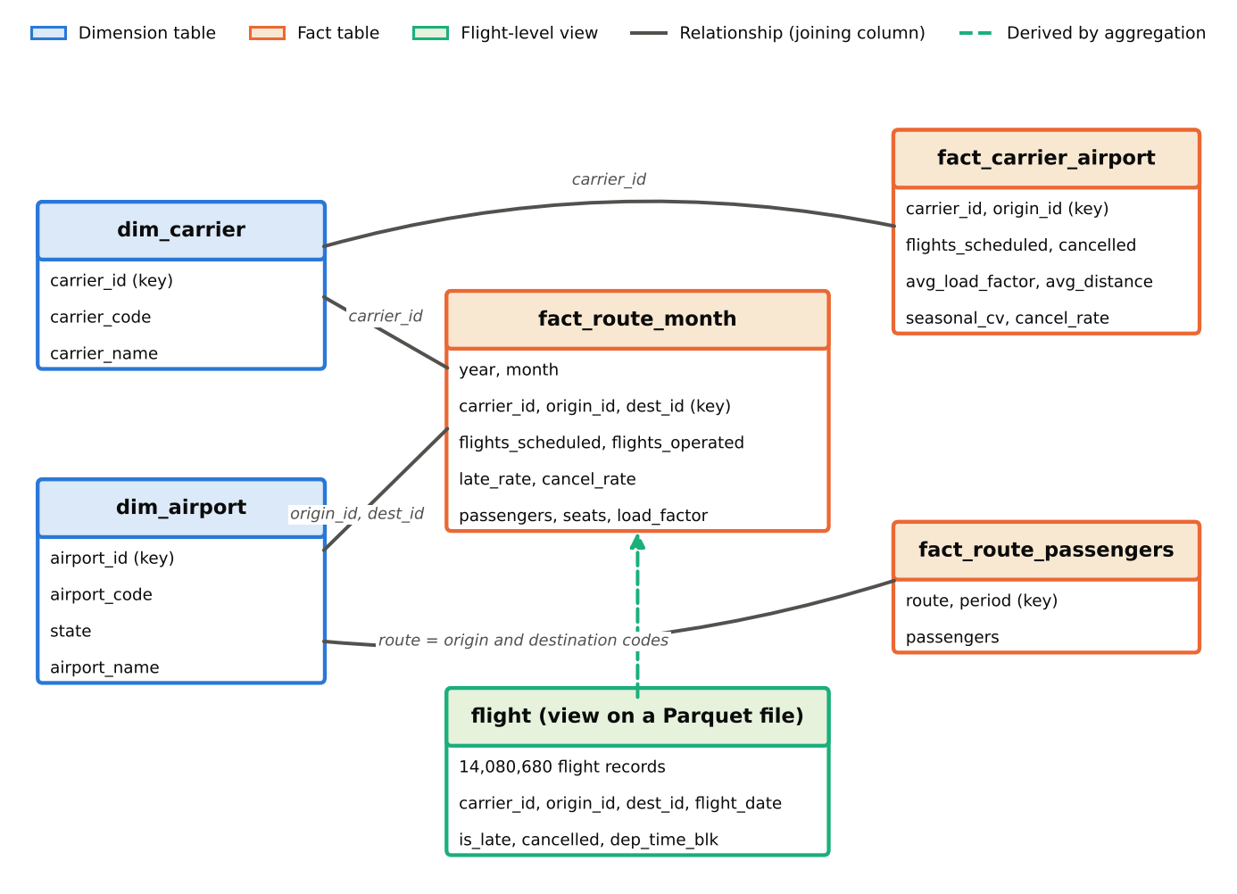
Note. Blue = dimension tables; orange = fact tables; green = flight-level view over the Parquet file. Lines show joining columns.
The notebooks read the same tables with pandas, and the dashboard and programming interface query the database with structured query language (Appendix C shows examples). To check that the database and the pandas pipeline agree, ten queries were run and compared with the saved results (Table 10); all agreed, and each ran in well under a second on the whole 14-million-row table.
Table 10
Database Verification Queries
Query | Database result | Pipeline value | Agree | Seconds
Flights in the cleaned flight table | 14,080,680 | 14,080,680 | Yes | 0.004
Operated flights | 13,844,731 | 13,844,731 | Yes | 0.009
Late-arrival rate of operated flights (%) | 21.5577 | 21.5577 | Yes | 0.020
Cancellation rate (%) | 1.4146 | 1.4146 | Yes | 0.008
Late-arrival rate in July 2024 (%) | 29.6227 | 29.6200 | Yes | 0.014
Route-months in the research question 2 table | 148,241 | 148,241 | Yes | 0.001
Pearson correlation of load factor and late rate | 0.1078 | 0.1078 | Yes | 0.006
Carrier-airport units in the research question 3 table | 1,598 | 1,598 | Yes | 0.000
Routes with monthly passengers (research question 4) | 150 | 150 | Yes | 0.002
Flights per carrier-airport unit, total | 14,044,433 | 14,044,433 | Yes | 0.001
Note. Database results come from scripts/db_verify.py.

Architecture and Workflow

System Overview
The pipeline turns two public tables into four analyses and one deployable tool. Raw monthly files enter at one end; cleaned tables, a database, fitted models, figures and a results file leave at the other, and a scoring module, dashboard and programming interface sit on top (Figure 9). The purpose is one reproducible path, so that any number in this report can be traced to a notebook cell and the best classifier can be used outside the notebooks.

Architecture Diagram
Figure 9 shows the seven stages. Data, preprocessing, exploratory analysis, feature engineering and modelling run in notebooks 01 to 07; evaluation compares models on held-out data; deployment wraps the chosen model. The colors in the legend separate data stages, analysis stages, modelling stages and delivery.
Figure 9
End-to-End Workflow of the Proposed System
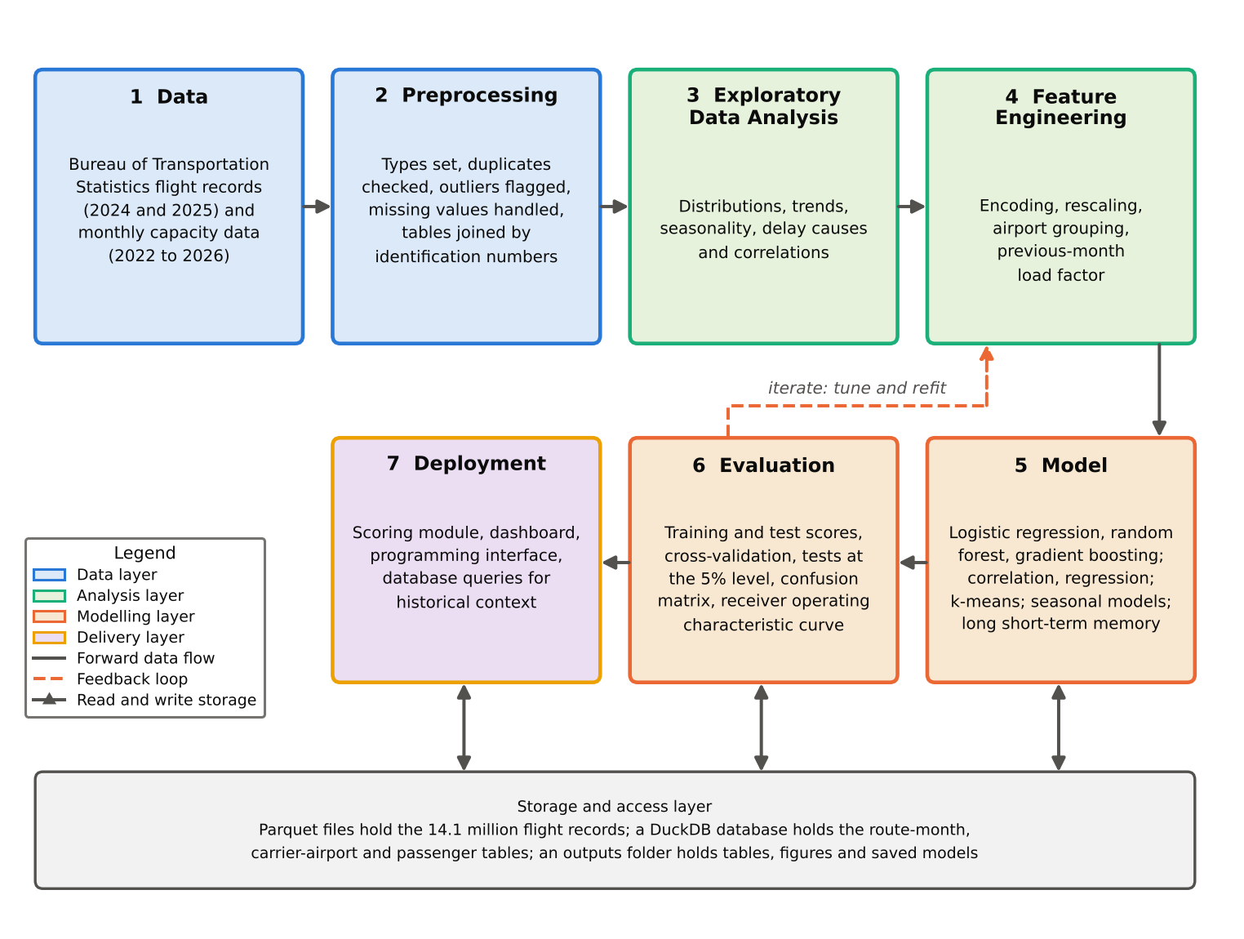
Note. Stages follow the order of the arrows. The legend identifies the stage type.

Workflow Components

Data Ingestion
A download script fetches the 24 monthly On-Time files and the yearly T-100 files from the TranStats site into the data folder as compressed comma-separated files. Notebook 01 reads them with pandas, keeps 31 fields, standardizes names and writes the cleaned flight table to a Parquet file, and the build script then loads the aggregated tables into DuckDB. The data are structured, tabular and public.

Data Preprocessing
Missing values: arrival delay is missing only for cancelled and diverted flights, so they stay in the table but are excluded from delay analyses. Prior-month load factor is missing for 1.2% of Research Question 1 flights (new routes) and is replaced by the training median with a missing-value indicator; load factors above 100% are set to missing. Outliers: delays up to 4,336 minutes are real events and are kept; they cannot distort the binary outcome in Research Question 1, and rank correlations and a fit without influential points handle them elsewhere. Encoding and scaling: factors are one-hot encoded with the most common level as reference, the 25 busiest airports are kept and the rest grouped, distance is expressed per 1,000 miles and prior-month load factor per 10 points around its median, k-means features are standardized with departures on a log scale, and each route in the neural network is divided by its own training mean. Tree models need no scaling.

Exploratory Data Analysis
Notebook 02 profiles delay, cancellation, causes, carriers, airports, time of day, load factor and demand and produces the figures shown earlier; its findings decided which predictors and models to use.

Feature Engineering
The shared feature module builds 102 model columns from eight factors that are all known before departure: month, day of week, scheduled departure block, carrier, origin, destination, distance and the previous month's route load factor. One module serves training and the deployed tool, so the columns are identical; delay, taxi and cause fields are excluded to prevent leakage.

Model Development
Notebook 03 fits the logistic regression, random forest and extreme gradient boosting classifiers (stratified 80/20 split, 3-fold cross-validation, time-based check); notebook 07 tunes the flexible models with random search, scores training and test data side by side and saves the chosen model. Notebooks 04 and 05 fit the regression and the k-means clusters, and notebook 06 fits the four forecasting models.

Model Evaluation
Classifiers are scored on held-out flights with area under the curve, accuracy, precision, recall and F1-score, confusion matrices and risk deciles. Associations are tested at the 5% level with effect sizes. Forecasts are scored on the held-out 12 months with three error measures and a paired test. Training and test results are reported together to expose overfitting.

Deployment
The chosen model is saved with its feature specification. A scoring module returns the probability of lateness, a risk band and the factors behind the score; a Streamlit dashboard and a FastAPI interface expose it and read historical rates from the database (Appendix D; Figure 18).

Tools and Technologies
Table 11 lists the languages, libraries and platforms.
Table 11
Tools and Technologies
Purpose | Tool | Version
Language and notebooks | Python; Jupyter notebooks run with nbconvert | 3.12.16
Data handling | pandas; NumPy; PyArrow (Parquet) | 3.1.0; 2.5.4; 26.0.0
Statistics | SciPy; statsmodels (logistic regression, ordinary least squares, seasonal autoregressive integrated moving average, exponential smoothing) | 1.18.1; 0.15.0
Machine learning | scikit-learn (random forest, k-means, metrics, splitting); extreme gradient boosting; Shapley additive explanations | 1.9.1; 3.4.1; 0.54.1
Deep learning | TensorFlow (Keras long short-term memory network) | 2.21.0
Database | DuckDB with Parquet | 2.0.0
Deployment | Streamlit dashboard; FastAPI interface | 1.66.1; 0.162.0
Graphics | Matplotlib | 3.11.2
Compute | Apple M4; 24 gigabytes of memory; 10 logical cores | No graphics processing unit used
Version control | Git and GitHub | —

Results

Model Performance
Table 12 compares every model on held-out data. For classification, extreme gradient boosting has the highest test area under the curve (.678), so it is the best model, but the margin over the logistic regression (.665) is small. The best forecast on mean absolute scaled error is seasonal naive (.798).
Table 12
Model Performance Comparison
Model | Features used | Validation method | Metric 1 | Metric 2 | Key observation
Research Question 1 Majority-class baseline | None (always predicts on time) | 80,000 test flights | Area under the curve .500 | Accuracy .784 | No discrimination; high accuracy only because 78% of flights are on time
Research Question 1 Historical late rate by airline (current practice) | Airline | 80,000 test flights | Area under the curve .548 | — | Rates from training flights only; scored by ranking
Research Question 1 Historical late rate by airline and route (current practice) | Airline, origin, destination | 80,000 test flights | Area under the curve .573 | — | Weaker than the models: route histories are thin and ignore time of day
Research Question 1 Logistic regression | 102 columns, 8 factors | Stratified 80/20; 3-fold cross-validation | Area under the curve .665 | F1-score .413 | Interpretable; training and test agree
Research Question 1 Random forest | Same | Same | Area under the curve .652 | F1-score .403 | No gain over logistic regression
Research Question 1 extreme gradient boosting (best model) | Same | Same | Area under the curve .678 | F1-score .423 | Highest test discrimination; training area .720 shows some overfitting
Research Question 1 extreme gradient boosting (tuned) | Same | Random search, 3-fold cross-validation | Area under the curve .672 | F1-score .417 | Smaller train-test gap, but no gain on the test flights
Research Question 1 Random forest (tuned) | Same | Random search, 3-fold cross-validation | Area under the curve .661 | F1-score .409 | Tuning helps training fit more than test fit
Research Question 2 Linear regression of late rate on load factor | Load factor | Fit on 80% of routes; test on 2,000 unseen routes | R² (test) .012 | Root mean squared error 11.17 versus 11.24 for the mean | Small positive association; weak for prediction
Research Question 3 k-means, k = 4 | Load factor, departures, distance, seasonal variability | 200 bootstrap refits | Silhouette .320 | Adjusted Rand index .908 | Clear, stable groups of operations
Research Question 4 Seasonal naive (best model) | Own history, 12-month season | Train 43 months; test last 12 | Mean absolute scaled error .798 | Mean absolute error 5,247 | Strong simple benchmark
Research Question 4 Exponential smoothing | Own history, 12-month season | Train 43 months; test last 12 | Mean absolute scaled error .806 | Mean absolute error 5,322 | Statistical model
Research Question 4 seasonal autoregressive integrated moving average | Own history, 12-month season | Train 43 months; test last 12 | Mean absolute scaled error .817 | Mean absolute error 5,449 | Statistical model
Research Question 4 long short-term memory network | Own history, 12-month season | Train 43 months; test last 12 | Mean absolute scaled error 1.074 | Mean absolute error 7,085 | Least accurate, 150 routes; short series
Note. research question = research question. Area under the curve: 0.5 is chance and 1 is perfect. Mean absolute scaled error below 1 is better than the in-sample seasonal naive forecast. Forecast errors are means over 150 routes.
Training and test results are shown side by side in Table 13. The classifiers separate training from test flights by at most .042 in area under the curve, so overfitting is small, largest for the default extreme gradient boosting (.042), which is why the tuned version was tried. The regression behaves the same on training and unseen routes. Exponential smoothing fits its training months far more closely (mean absolute scaled error .406) than it forecasts the test months (.806), as expected when a forecast must look 12 months ahead; the seasonal naive model is the reference, with a training error of 1 by definition.
Table 13
Training and Test Results
Model | Training result | Test result | Metric
Logistic regression | .601 | .603 | Accuracy (Research Question 1)
 | .662 | .665 | Area under the curve (Research Question 1)
Random forest | .591 | .589 | Accuracy (Research Question 1)
 | .655 | .652 | Area under the curve (Research Question 1)
Extreme gradient boosting (best model) | .644 | .624 | Accuracy (Research Question 1)
 | .720 | .678 | Area under the curve (Research Question 1)
Extreme gradient boosting (tuned) | .622 | .615 | Accuracy (Research Question 1)
 | .687 | .672 | Area under the curve (Research Question 1)
Random forest (tuned) | .610 | .599 | Accuracy (Research Question 1)
 | .685 | .661 | Area under the curve (Research Question 1)
Regression, load factor (Research Question 2) | .011 | .012 | R² (by route split)
Exponential smoothing (Research Question 4) | .406 | .806 | Mean absolute scaled error (one-step-ahead fit; forecast of 12 months)
Long short-term memory network (Research Question 4) | .830 | 1.074 | Mean absolute scaled error (one-step-ahead fit; forecast of 12 months)
Seasonal autoregressive integrated moving average (Research Question 4) | .701 | .817 | Mean absolute scaled error (one-step-ahead fit; forecast of 12 months)
Seasonal naive (Research Question 4) | 1.000 | .798 | Mean absolute scaled error (one-step-ahead fit; forecast of 12 months)
Note. Training results for Research Question 4 are one-step-ahead fits on months after the first 13 and are not directly comparable with 12-month-ahead forecasts.

Visual Evidence
Figure 10 shows the receiver operating characteristic curves, Figure 11 the confusion matrix of the best model at the training-prevalence threshold, Figure 12 the factor importance, and Figure 13 the observed late rate by predicted-risk decile. The three curves lie close together, as the small gaps in Table 12 suggest. At the threshold, the best model finds 64% of late flights (recall) but only 32% of flights it flags are late (precision), given a 22% base rate and modest signal. Departure block is the most important factor, then month and carrier. Observed lateness rises steadily from 7.4% in the lowest-risk tenth to 44.8% in the highest, a lift of 2.1 over the average.
Figure 10
Receiver Operating Characteristic Curves of the Classifiers
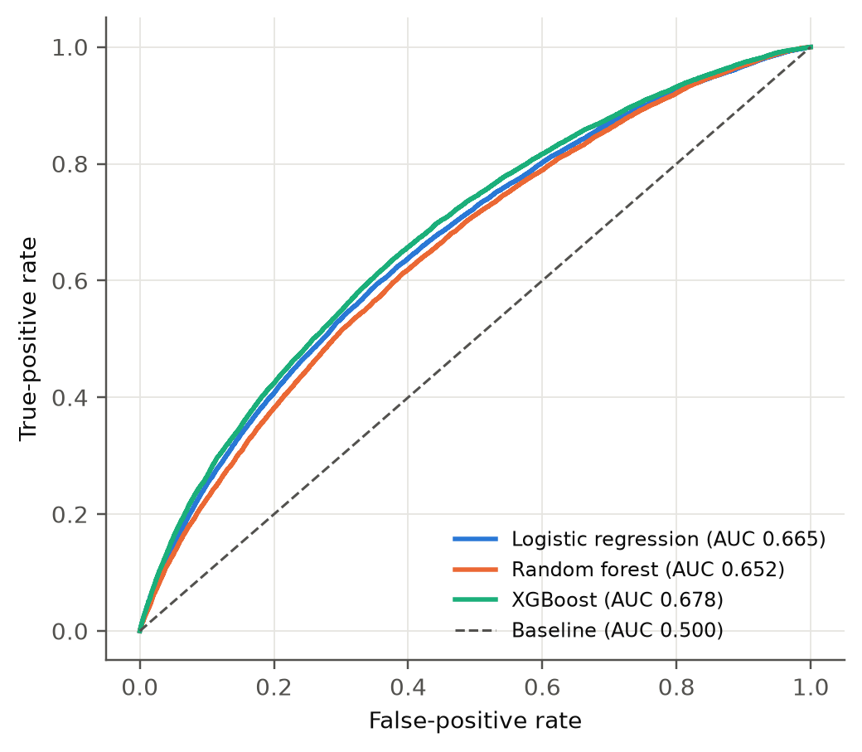
Note. Test flights. The diagonal is chance.
Figure 11
Confusion Matrix of the Best Classifier
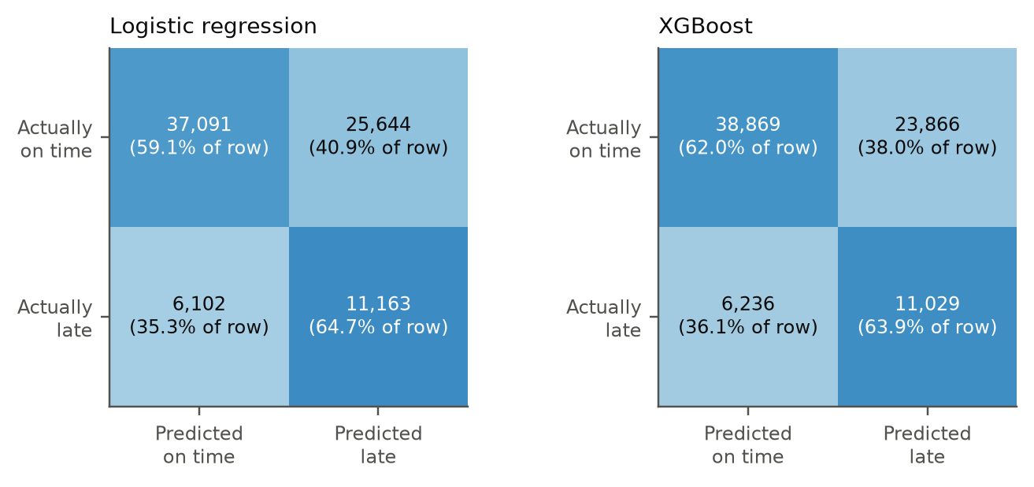
Note. Positive class = late arrival; threshold = training prevalence.
Figure 12
Factor Importance for Late Arrival
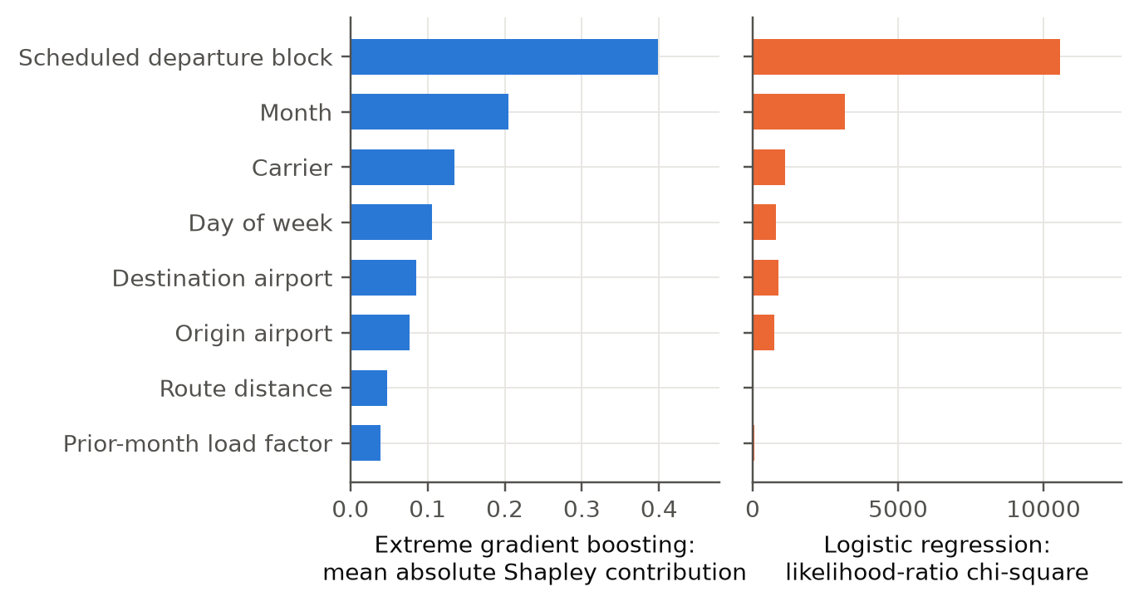
Note. Mean absolute contribution of each factor (Shapley values) in the extreme gradient boosting model.
Figure 13
Observed Late-Arrival Rate by Predicted-Risk Decile
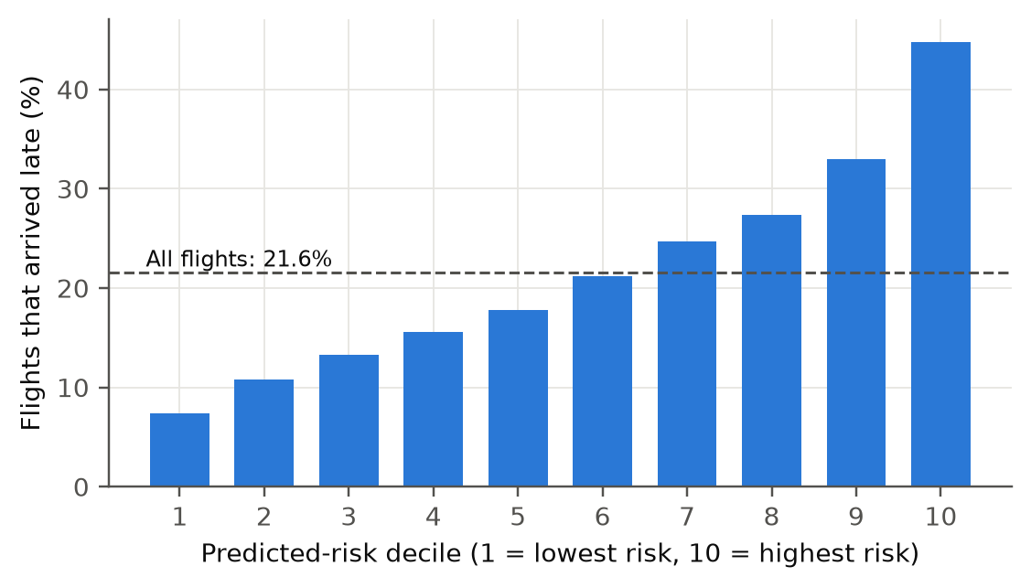
Note. Deciles of the 80,000 test flights, lowest risk to highest.

Results by Research Question
Table 14
Hypothesis Test Results at the 5% Significance Level
Research question | Test statistic | p value | Effect size | Decision on H₀
1 | Likelihood-ratio χ²(102) = 17,898 | < .001 | McFadden R² = .054 | Reject
2 | r = .108, t = 41.8; slope = .118 points per point | < .001 | R² = .012 (small) | Reject
3 | χ²(3) = 1,917; Kruskal-Wallis H = 40.9 | < .001 | Cramér's V = .012; ε² = .024 | Reject
4 | Paired t(149) = 5.51 (mean absolute scaled error) | < .001 | d_{z} = .45 | Reject
Note. Effect sizes follow Cohen (1988). For Research Question 4 the decision is the same for mean absolute error and root mean squared error.
Research Question 1. Departure block was the strongest factor (likelihood-ratio χ²(18) = 10,568), then month (3,164) and carrier (1,120); all factors except route distance (p = .191) were significant. Flights scheduled to leave between 15:00 and 20:00 had odds of lateness about three times those of the 07:00 block, for example scheduled departure 18:00 block (odds ratio 3.30) and scheduled departure 19:00 block (odds ratio 3.34). Prior-month load factor was significant but weak (odds ratio 1.04 per 10 points). Because tests on 320,000 flights detect tiny effects, the model-level result matters more: the area under the curve is only .678, and on a split trained on 2024 and tested on 2025 it was .643, lower than on the random split because 2025 had a higher late rate. H₀ is rejected, and the prediction beats current practice (.573 for route histories).
Research Question 2. Load factor and late-arrival rate were positively correlated (r = .108, 95% confidence interval .103 to .113; Spearman ρ = .099). Each additional point of load factor went with 0.12 points of late-arrival rate (route-clustered 95% interval .11 to .13), so a route 20 points fuller ran about 2.4 points later. The association stayed positive after adding distance, carrier, month and year (slope .08). It explains only 1.2% of the variance (R² .012 on unseen routes), a small effect (Figure 14). H₀ is rejected.
Figure 14
Late-Arrival Rate and Load Factor by Route-Month
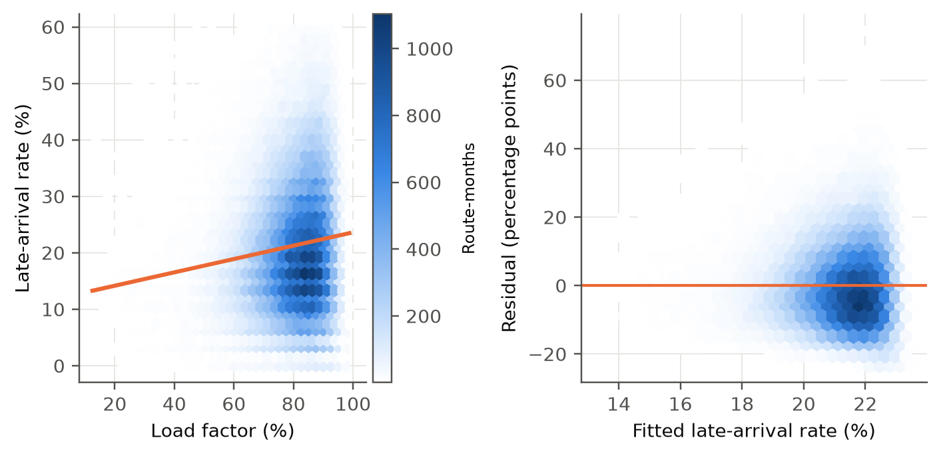
Note. Fitted line with confidence band; binned means.
Research Question 3. The silhouette width chose 4 clusters of the 1,598 carrier-airport operations (Figure 15; silhouette .320), and 200 bootstrap refits agreed with them (adjusted Rand index .908). One cluster holds 91% of all flights: busy operations with 253 monthly departures. The clusters differed in cancellation rate (χ²(3) = 1,917; Kruskal-Wallis H = 40.9, both p < .001): the highest was 1.95% and the lowest 1.28% (z = 23.3). The low-cancellation cluster is long-haul (about 2,320 miles) with high load factor. The effect is small (Cramér's V = .012), so clusters describe operations more than they predict cancellation. H₀ is rejected.
Figure 15
Carrier-Airport Clusters
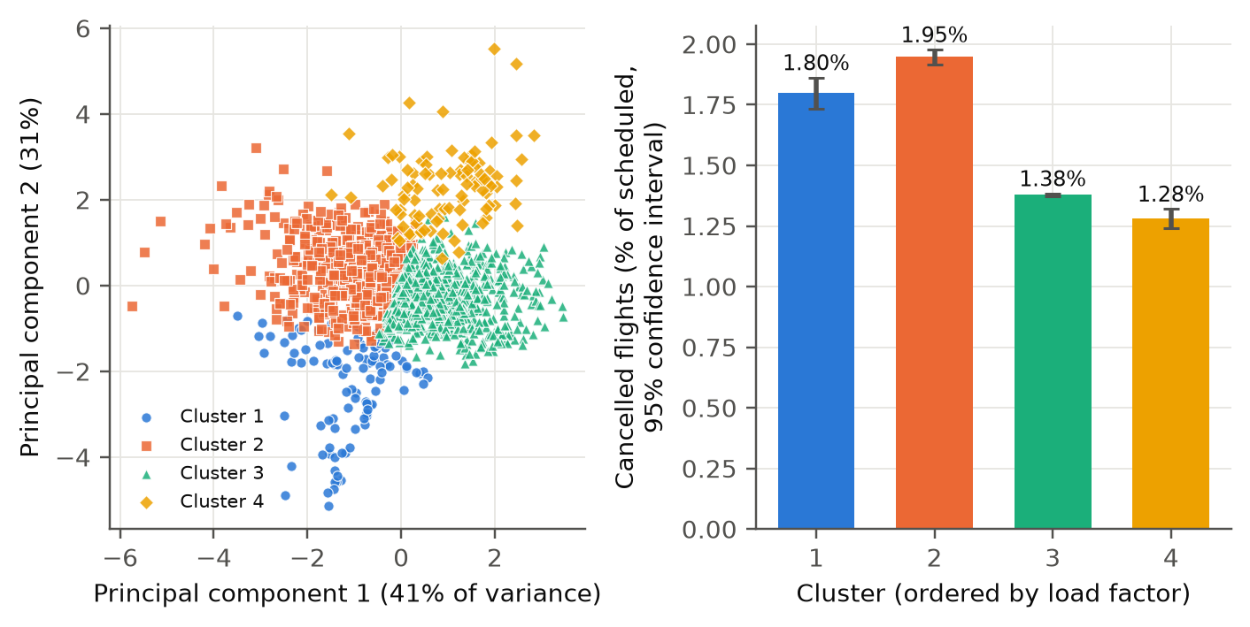
Note. Projection onto the first two principal components; colors are clusters.
Research Question 4. On the held-out 12 months, mean absolute scaled errors were .798 for seasonal naive, .806 for exponential smoothing, .817 for the seasonal autoregressive integrated moving average model, 1.074 for the long short-term memory network (Figure 16). The long short-term memory network was less accurate than the seasonal autoregressive integrated moving average model by 0.26 in scaled error (paired t(149) = 5.51, p < .001, d_{z} = .45), and was better on only 29% of routes. The seasonal naive and exponential smoothing forecasts were as good as the statistical model, so the annual cycle carries most of the information in 43 training months. H₀ is rejected, in favor of the statistical model.
Figure 16
Forecast Error by Model
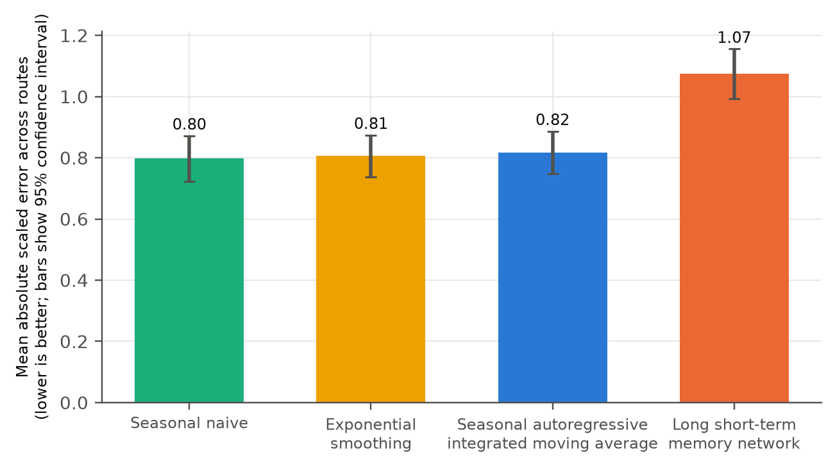
Note. Held-out 12 months; mean over 150 routes.
Figure 17
Example Route Forecasts
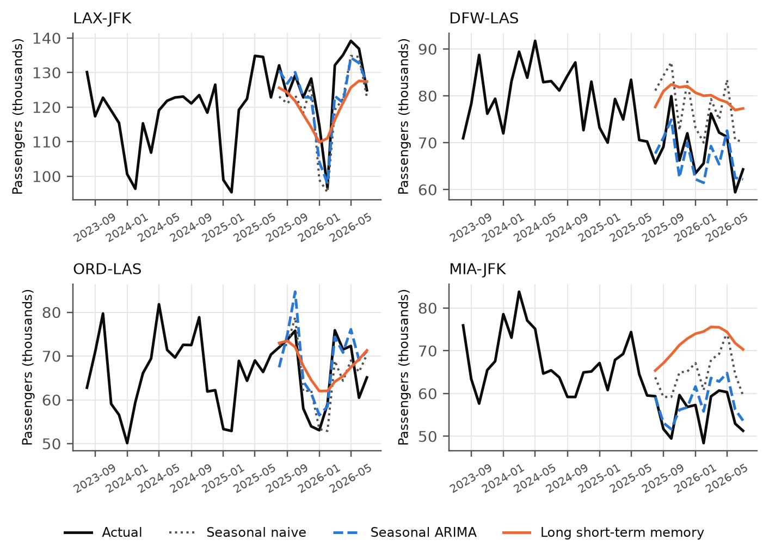
Note. Actual passengers and forecasts of the four models for four routes.

Overall Interpretation
Three results stand out. First, the timing and structure of a flight (departure block, month, carrier) carry most of the predictable information about lateness, and a flexible model adds only a little to a logistic regression; the ceiling near .68 is expected because weather, air-traffic restrictions and aircraft rotation are not in the public tables, and late-arriving aircraft are the largest delay cause. Second, associations that are statistically significant can be practically small: load factor and cluster membership explain little variation, so they inform planning but do not drive prediction. Third, more complex is not better: the long short-term memory network lost to simple statistical forecasts on short monthly series, and tuning did not beat default settings on the test flights.

Practical Significance
The decile result is the most useful for decisions. A planner who flags the top tenth of flights would be right 45% of the time against a base rate of 22%, and could leave the safest tenth, late only 7% of the time, alone. Schedulers can move buffers to evening departures and peak months, and capacity planners can rely on seasonal naive or statistical forecasts without the cost of a neural network. The small load-factor effect says that filling aircraft is not by itself a large delay risk.

Implementation and User Benefit

Deployment Approach
The chosen classifier is saved together with its feature specification, and a scoring module turns a flight description (airline, origin, destination, month, day of week, scheduled departure time and, optionally, last month's load factor) into the same 102 columns used in training. It returns the probability of a late arrival, a risk band, and the contribution of each factor to the score. A Streamlit dashboard and a FastAPI interface both call this one module (Figure 18), and both read the history of the airline, route and departure block from the DuckDB database (code in Appendix D). Risk bands come from the test predictions: the top 10% of scores form the high band, the next 20% the elevated band, and the rest the typical band. In the held-out flights, 15.8% of typical flights, 30.2% of elevated flights and 44.8% of high-risk flights arrived late.
Figure 18
Deployment Architecture
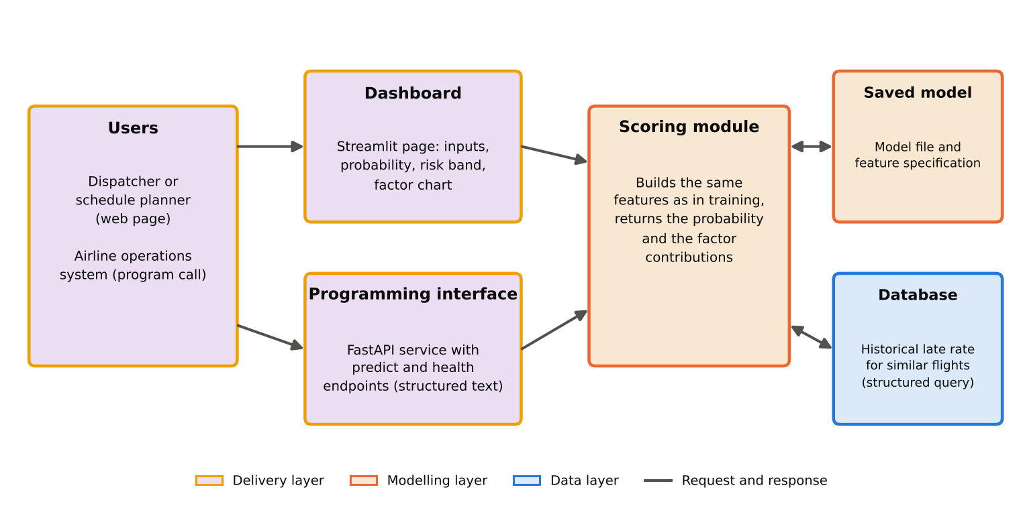
Note. Users reach the scoring module through the dashboard or the programming interface; both read history from the database.

System Integration
The programming interface returns the probability, band and factor contributions as structured text, so a scheduling, crew-planning or passenger-information system can call it for any planned flight without using the dashboard. New months are added by downloading the latest files and running the run_final script, which rebuilds the database, refits the models and refreshes the scoring files. The prototype runs on one computer, and the same code can be placed in a container on a cloud platform. The scoring module and database queries are also the natural tools for an assistant built on a language model (Wang et al., 2024; Yao et al., 2023), which is left as future scope.

User Interaction
The user picks the airline, origin, destination, month, weekday and departure time, optionally enters last month's load factor, and presses a button (Figure 19). The page returns the probability, the band, the comparison with the average flight, a bar chart of what pushes the estimate up or down, and the late rate of comparable flights in the past two years.
Figure 19
Dashboard Screenshot for an Example Flight
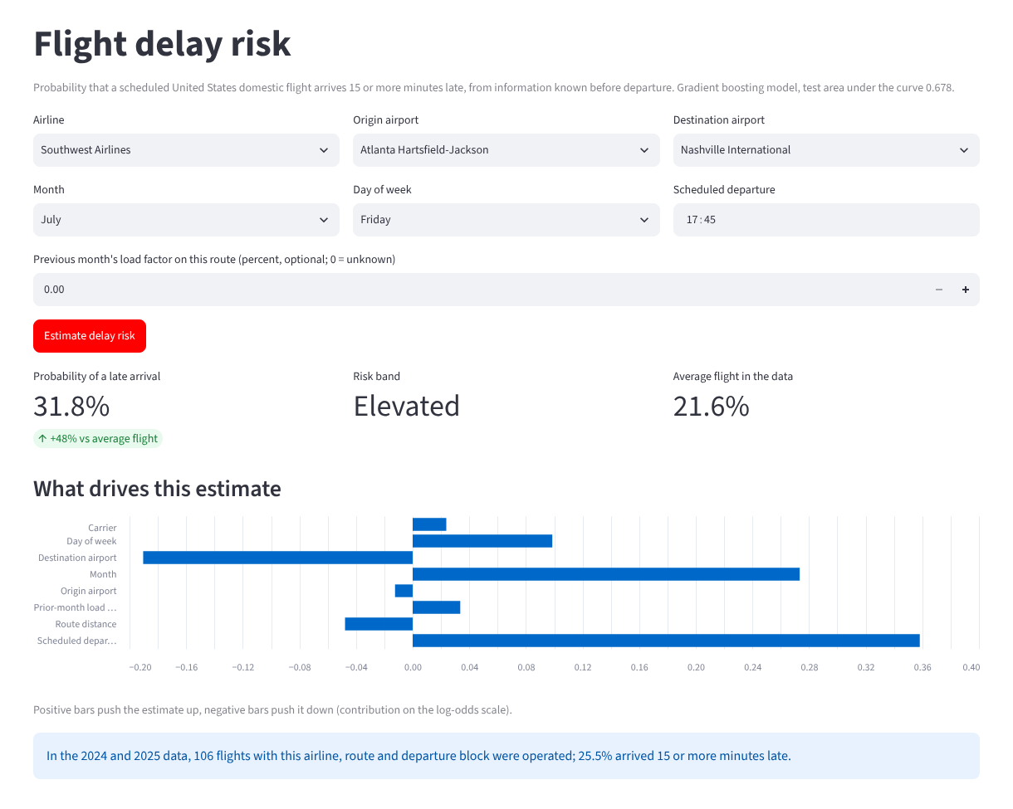
Note. Southwest Airlines, Atlanta to Nashville, Friday 17:45 in July. Output of app/streamlit_app.py.

Benefits to Users
For operations, the risk band lets planners put buffers, spare aircraft and staff where late arrivals concentrate, instead of spreading them evenly. For finances, avoiding even a small share of misconnections and crew disruptions at high-risk departures saves compensation and rebooking cost, although the saving was not measured here. Strategically, the factor chart shows why a flight is risky, so a carrier can reconsider a schedule. Travelers gain a clearer picture than an on-time percentage: the same route can be typical in the morning and high risk in the evening.

Example Use Case
A network planner at American Airlines reviews the Chicago O'Hare to New York LaGuardia flight in two scenarios (Table 15). On a Friday departing at 18:45 in July the model gives a 50% chance of a late arrival, 2.3 times the average flight, in the high band, and the main drivers are scheduled departure block (raises risk), month (raises risk), carrier (raises risk). A Tuesday departure at 07:45 in October scores 19%, in the typical band. The planner moves a spare aircraft and a standby crew to the evening bank in July and does not hold extra resources in October. The database shows that the past 54 comparable evening flights in July were late 69% of the time, which supports the model while being based on far fewer flights.
Table 15
Example Use Case: Two Scenarios for the Same Flight
Item | Friday evening in July | Tuesday morning in October
Flight | American Airlines, Chicago O'Hare to New York LaGuardia | American Airlines, Chicago O'Hare to New York LaGuardia
Scheduled departure | 18:45 | 07:45
Probability of a late arrival | 49.6% | 18.5%
Risk band | high | typical
Compared with the average flight | 2.30 times | 0.86 times
Largest drivers | scheduled departure block (raises risk), month (raises risk), carrier (raises risk) | scheduled departure block (lowers risk), month (lowers risk), carrier (raises risk)
Comparable flights in 2024–2025 (late rate) | 54 (69%) | 49 (14%)
Note. Output of scripts/make_use_case.py. Comparable flights are those of the same airline, route, month and departure block.

Limitations and Further Improvements

Limitations
Data: the tables cover reporting carriers only and two years of flights, so one-off events, such as a major outage, can shape the results; weather, air-traffic restrictions and the actual rotation of aircraft are not recorded, and 1.2% of flights lack a prior-month load factor. Load factor describes a route in a month, not a flight. Method: the studies are observational, so associations are not causes; flights on the same route and day are not independent, which makes flight-level p values too small (route-clustered errors address this only for Research Question 2); the classification of a late arrival uses a fixed 15-minute rule; k-means assumes compact clusters; and the forecasts use a single 12-month test window. Model: the best classifier reaches an area under the curve of .678, so most of the variation in lateness is not explained, and the deployed tool was built and tested on historical data only, with no live trial.

Impact of Limitations
The missing causes of delay limit accuracy: the models can rank flights but cannot say which will be late, as precision is near .316 at the chosen threshold. Because the data cover two years and one network, findings may not hold in other years, countries or for other carriers, and the lower area on the time-based split shows that performance can drift. The small effect sizes mean that load factor and cluster membership are context, not levers. The forecast comparison covers 150 busy routes, so it says little about smaller routes or longer histories.

Future Improvements
Adding free public weather observations and aircraft-rotation information (the previous flight of the same aircraft) is the most promising way to raise accuracy. The models can be refitted on more years, tuned with time-aware validation, and compared with calibrated probabilities and with sequence models over each aircraft's day. The forecasting comparison can be repeated with rolling origins, exponential smoothing with covariates, and pretrained time series models such as the language-model forecasters of Gruver et al. (2023). The dashboard can be tested with planners for usefulness.

Future Scope
The work can be extended to a monitoring service that refreshes monthly and tracks drift, to airport-level congestion forecasts, and to disruption-recovery decisions such as aircraft swaps. An agentic assistant could combine the scoring interface, the database and a language model in a reasoning-and-acting loop (Yao et al., 2023; Wang et al., 2024) to answer planners' questions in plain language, provided its answers are checked against the database and the model's limits are stated.

Bibliography
Adraos Gay, S. (2025). Comparative analysis of traditional and AI-based methods for air passenger demand forecasting [Bachelor's thesis, Universitat Politècnica de Catalunya]. UPCommons. https://hdl.handle.net/2117/432848
Breiman, L. (2001). Random forests. Machine Learning, 45(1), 5–32. https://doi.org/10.1023/A:1010933404324
Bureau of Transportation Statistics. (n.d.-a). Reporting carrier on-time performance (1987–present) [Data set]. U.S. Department of Transportation. Retrieved October 27, 2026, from https://www.transtats.bts.gov/Tables.asp?QO_VQ=EFI
Bureau of Transportation Statistics. (n.d.-b). T-100 domestic segment (all carriers) [Data set]. U.S. Department of Transportation. Retrieved October 27, 2026, from https://transtats.bts.gov/Tables.asp?QO_VQ=EEE
Carvalho, L., Sternberg, A., Gonçalves, L. M., Cruz, A. B., Soares, J. A., Brandão, D., Carvalho, D., & Ogasawara, E. (2021). On the relevance of data science for flight delay research: A systematic review. Transport Reviews, 41(4), 499–528. https://doi.org/10.1080/01441647.2020.1861123
Chakrabarty, N., Kundu, T., Dandapat, S., Sarkar, A., & Kole, D. K. (2019). Flight arrival delay prediction using gradient boosting classifier. In A. Abraham, P. Dutta, J. K. Mandal, A. Bhattacharya, & S. Dutta (Eds.), Emerging technologies in data mining and information security (Advances in Intelligent Systems and Computing, Vol. 813). Springer. https://doi.org/10.1007/978-981-13-1498-8_57
Chen, T., & Guestrin, C. (2016). XGBoost: A scalable tree boosting system. In Proceedings of the 22nd ACM SIGKDD International Conference on Knowledge Discovery and Data Mining (pp. 785–794). Association for Computing Machinery. https://doi.org/10.1145/2939672.2939785
Cohen, J. (1988). Statistical power analysis for the behavioral sciences (2nd ed.). Lawrence Erlbaum Associates.
Fleiss, J. L., Levin, B., & Paik, M. C. (2003). Statistical methods for rates and proportions (3rd ed.). Wiley.
Gruver, N., Finzi, M., Qiu, S., & Wilson, A. G. (2023). Large language models are zero-shot time series forecasters. Advances in Neural Information Processing Systems, 36. https://papers.neurips.cc/paper_files/paper/2023/file/3eb7ca52e8207697361b2c0fb3926511-Paper-Conference.pdf
Hochreiter, S., & Schmidhuber, J. (1997). Long short-term memory. Neural Computation, 9(8), 1735–1780. https://doi.org/10.1162/neco.1997.9.8.1735
Hyndman, R. J., & Athanasopoulos, G. (2021). Forecasting: Principles and practice (3rd ed.). OTexts. https://otexts.com/fpp3/
Jain, A. K. (2010). Data clustering: 50 years beyond K-means. Pattern Recognition Letters, 31(8), 651–666. https://doi.org/10.1016/j.patrec.2009.09.011
Kim, Y. J., Choi, S., Briceno, S., & Mavris, D. (2016). A deep learning approach to flight delay prediction. In 2016 IEEE/AIAA 35th Digital Avionics Systems Conference (DASC) (pp. 1–6). IEEE. https://doi.org/10.1109/DASC.2016.7778092
Lundberg, S. M., & Lee, S.-I. (2017). A unified approach to interpreting model predictions. Advances in Neural Information Processing Systems, 30, 4765–4774.
Mayer, C., & Sinai, T. (2003). Network effects, congestion externalities, and air traffic delays: Or why not all delays are evil. American Economic Review, 93(4), 1194–1215. https://doi.org/10.1257/000282803769206269
Mazzeo, M. (2003). Competition and service quality in the U.S. airline industry. Review of Industrial Organization, 22(4), 275–296. https://doi.org/10.1023/A:1025565122721
Rebollo, J. J., & Balakrishnan, H. (2014). Characterization and prediction of air traffic delays. Transportation Research Part C: Emerging Technologies, 44, 231–241. https://doi.org/10.1016/j.trc.2014.04.007
Rousseeuw, P. J. (1987). Silhouettes: A graphical aid to the interpretation and validation of cluster analysis. Journal of Computational and Applied Mathematics, 20, 53–65. https://doi.org/10.1016/0377-0427(87)90125-7
Tu, Y., Ball, M. O., & Jank, W. S. (2008). Estimating flight departure delay distributions—A statistical approach with long-term trend and short-term pattern. Journal of the American Statistical Association, 103(481), 112–125. https://doi.org/10.1198/016214507000000257
Wang, L., Ma, C., Feng, X., Zhang, Z., Yang, H., Zhang, J., Chen, Z., Tang, J., Chen, X., Lin, Y., Zhao, W. X., Wei, Z., & Wen, J. (2024). A survey on large language model based autonomous agents. Frontiers of Computer Science, 18(6), Article 186345. https://doi.org/10.1007/s11704-024-40231-1
Yao, S., Zhao, J., Yu, D., Du, N., Shafran, I., Narasimhan, K., & Cao, Y. (2023). ReAct: Synergizing reasoning and acting in language models. The Eleventh International Conference on Learning Representations. https://arxiv.org/abs/2210.03629
Yu, B., Guo, Z., Asian, S., Wang, H., & Chen, G. (2019). Flight delay prediction for commercial air transport: A deep learning approach. Transportation Research Part E: Logistics and Transportation Review, 125, 203–221. https://doi.org/10.1016/j.tre.2019.03.013

Appendix A
Code for the Sample-Size Calculations and Evaluation Metrics
The formulas behind the sample-size table (notebook 00_sample_size.ipynb) and the forecast-error metrics (scripts/metrics.py) are shown here; the complete code is in the GitHub repository.
from math import sqrt, log, ceil
from scipy.stats import norm
za, zb = norm.ppf(0.975), norm.ppf(0.80) # 1.96 and 0.8416
n_rq1 = ceil(za**2 * 0.5 * 0.5 / 0.01**2) # 9,604 flights
C = 0.5 * log((1 + 0.10) / (1 - 0.10))
n_rq2 = ceil(((za + zb) / C) ** 2 + 3) # 783 route-months
p1, p2 = 0.015, 0.025; pbar = (p1 + p2) / 2
n_rq3 = ceil((za * sqrt(2 * pbar * (1 - pbar))
+ zb * sqrt(p1 * (1 - p1) + p2 * (1 - p2))) ** 2
/ (p1 - p2) ** 2) # 3,076 per group
n_rq4 = ceil(((za + zb) / 0.30) ** 2) # 88 routes

import numpy as np
def mae(y, yhat):
return float(np.mean(np.abs(np.asarray(y) - np.asarray(yhat))))
def rmse(y, yhat):
return float(np.sqrt(np.mean((np.asarray(y) - np.asarray(yhat)) ** 2)))
def mase(y, yhat, y_train, m=12):
y_train = np.asarray(y_train)
return mae(y, yhat) / np.mean(np.abs(y_train[m:] - y_train[:-m]))

Appendix B
Code for Data Splitting, Model Fitting and Tuning (Research Question 1)
The extract is from notebook 07_final_extensions.ipynb and scripts/rq1_features.py. It builds the model columns, makes the stratified split, fits the models, tunes the flexible models on training data only and scores training and test flights.
df, X, y, spec = fit_design(raw, TOP_AIRPORTS_RQ1) # 102 model columns
X_tr, X_te, y_tr, y_te = train_test_split(
X, y, test_size=0.2, stratify=y, random_state=42) # 320,000 / 80,000
prev = float(y_tr.mean()) # threshold = training rate

logit = sm.Logit(y_tr, sm.add_constant(X_tr.astype('float64'))).fit(method='newton')
rf = RandomForestClassifier(n_estimators=150, max_depth=14, min_samples_leaf=100,
n_jobs=-1, random_state=42).fit(X_tr, y_tr)
xg = xgb.XGBClassifier(n_estimators=300, max_depth=6, learning_rate=0.1, subsample=0.8,
colsample_bytree=0.8, tree_method='hist',
random_state=42).fit(X_tr, y_tr)

# tuning: 3-fold random search on 90,000 training flights only
idx = np.random.RandomState(42).choice(len(X_tr), 90_000, replace=False)
search = RandomizedSearchCV(xgb.XGBClassifier(tree_method='hist', random_state=42),
xgb_space, n_iter=14, scoring='roc_auc',
cv=StratifiedKFold(3, shuffle=True, random_state=42))
search.fit(X_tr.iloc[idx], y_tr[idx])

# training and test scores side by side
a = classification_report_dict(y_tr, p_train, prev)
b = classification_report_dict(y_te, p_test, prev)

# research question 2: split by route so that no route is in both sets
gss = GroupShuffleSplit(n_splits=1, test_size=0.2, random_state=42)
itr, ite = next(gss.split(rma, groups=rma['route']))

# research question 4: chronological split (last 12 months held out)
train, test = series.iloc[:-12], series.iloc[-12:]

Appendix C
Database Schema and Example Queries
The schema is in sql/schema.sql and is created by scripts/build_database.py. The extract shows the main tables and three example queries; every query is run through DuckDB.
CREATE TABLE dim_carrier (carrier_id BIGINT PRIMARY KEY, carrier_code VARCHAR NOT NULL,
carrier_name VARCHAR NOT NULL);
CREATE TABLE dim_airport (airport_id BIGINT PRIMARY KEY, airport_code VARCHAR NOT NULL,
state VARCHAR, airport_name VARCHAR);
CREATE TABLE fact_route_month (
year INTEGER, month INTEGER,
carrier_id BIGINT REFERENCES dim_carrier(carrier_id),
origin_id BIGINT REFERENCES dim_airport(airport_id),
dest_id BIGINT REFERENCES dim_airport(airport_id),
flights_operated INTEGER, late DOUBLE, passengers DOUBLE, seats DOUBLE,
load_factor DOUBLE, late_rate DOUBLE, cancel_rate DOUBLE,
PRIMARY KEY (year, month, carrier_id, origin_id, dest_id));
-- also: fact_carrier_airport, fact_route_passengers, and the view
-- flight = SELECT * FROM read_parquet('data/processed/otp_clean.parquet')

-- Example 1: late-arrival rate by month
SELECT year, month, 100.0 * SUM(is_late) / SUM(operated) AS late_rate
FROM flight GROUP BY year, month ORDER BY year, month;

-- Example 2: correlation of load factor and late rate (research question 2)
SELECT corr(load_factor, late_rate) FROM fact_route_month WHERE flights_operated >= 30;

-- Example 3: late rate of one airline on one route in one month and departure block
SELECT COUNT(*), 100.0 * AVG(is_late) FROM flight
WHERE operated = 1 AND carrier = 'AA' AND origin = 'ORD' AND dest = 'LGA'
AND month = 7 AND dep_time_blk = '1800-1859';

Appendix D
Scoring Module and Programming Interface
The extract is from app/delay_model.py and app/api.py. The same scoring function serves the dashboard and the interface.
class DelayRiskModel:
def predict(self, carrier, origin, dest, month, day_of_week, dep_time,
distance=None, lf_prev=None):
row = pd.DataFrame([{...}]) # one flight, known before departure
X = transform(row, self.spec) # the same columns as in training
d = xgb.DMatrix(X.values.astype('float32'), feature_names=list(X.columns))
p = float(self.booster.predict(d)[0]) # probability of late arrival
contrib = self.booster.predict(d, pred_contribs=True)[0][:-1]
# log-odds contribution of every column
# summed by factor, ranked, returned with the risk band

@app.post('/predict')
def predict(f: Flight): # validated request body
return model.predict(f.carrier, f.origin, f.dest, f.month, f.day_of_week,
f.dep_time, f.distance, f.lf_prev)

# run: uvicorn app.api:app --port 8000 streamlit run app/streamlit_app.py

