Data Analytics Capstone
A Data-Driven Analysis of United States Domestic Flight Delays, Capacity Utilization, and Passenger Demand Using Bureau of Transportation Statistics TranStats Data
Interim Report

Bhavna Jaggi
Walsh College
QM640: Data Analytics Capstone
Keya Choudhury Ganguli
Third Term
28 October 2026

GitHub Repository
All data files, code, notebooks, figures and tables for this project are in the following public GitHub repository:
https://github.com/BhavnaJaggi/airline-delay-capstone
Repository layout in brief: data/raw_sample (random sample of the raw On-Time file), data/processed (cleaned analysis tables), notebooks (00 to 06, run in order), scripts (shared code and settings), outputs (figures, tables and results.json), and report (this document). The complete tree and the data availability statement are in the Data Description section.

Table of Contents
Introduction 4
Background and Context 4
Problem Statement 4
Purpose of the Study 5
Interim Project Status 5
Scope and Objectives 6
Research Questions and Hypotheses 6
Variables and Sample Size Plan 7
Literature Survey 9
Literature Review Approach 9
Summary of Key Literature 9
Synthesis and Research Gaps 12
Data Description 14
Data Sources and Access 14
Dataset Overview 14
Data Completeness and Limitations 16
Data Dictionary 16
GitHub Data Availability Statement 19
Screenshots and Evidence 19
Analysis 21
Data Cleaning 21
Exploratory Data Analysis Results 23
Modelling 32
Choice of Models with Justification 32
Features Included and Feature Engineering 34
Evaluation Metrics 36
Preliminary Results 38
Preliminary Findings by Research Question 38
Preliminary Model Performance 46
Interim Limitations and Risks 48
Next Steps 49
Bibliography 50
Appendix A 52

Introduction

Background and Context
Scheduled air travel in the United States is a tightly coordinated network. An aircraft flies several segments a day and crews and passengers move between flights, so a delay on one flight can spread to the next. Mayer and Sinai (2003) found that hubbing, where a carrier schedules many flights into short windows, explains more of the extra travel time at hub airports than congestion does. Late flights matter to airlines (crew and aircraft disruption), airports (gates and congestion), passengers (lost time) and the United States Department of Transportation, which monitors reliability as a service-quality measure.
The Bureau of Transportation Statistics publishes the data needed to study this problem for free. The Reporting Carrier On-Time Performance table records every scheduled domestic flight of the reporting carriers, the United States carriers that each earn at least half a percent of domestic passenger revenue (Bureau of Transportation Statistics, n.d.-a), including delay, cancellation and diversion information. The T-100 Domestic Segment table adds monthly departures, seats and passengers for each carrier and segment (Bureau of Transportation Statistics, n.d.-b). Stable airline and airport identification numbers let the two be joined.
Delay prediction from this kind of data has its own systematic review (Carvalho et al., 2021) and uses random forests (Rebollo & Balakrishnan, 2014) and gradient boosting (Chakrabarty et al., 2019), but little of it links delay to load factor, to the operating profile of carriers and airports, or to demand through the year. This project examines these four angles together in one reproducible pipeline built only on public data.

Problem Statement
Airlines, airports and regulators mostly follow reliability through after-the-fact statistics such as the monthly share of flights arriving on time. These do not show which flights are at higher risk before departure, whether fuller routes run later, whether some carrier-airport operations cancel more often, or how route demand will move. The gap addressed here is the lack of one connected, reproducible analysis that answers these four questions with the same public data.

Purpose of the Study
The study has four aims: to explain which pre-departure characteristics are associated with a late arrival of 15 minutes or more and predict it with an interpretable model compared against machine learning models; to test whether route-month load factor, the share of available seats that are filled, is associated with the late-arrival rate; to group carrier-airport operations by operating and capacity features and test whether cancellation rates differ between groups; and to compare the forecast accuracy of a long short-term memory network with a seasonal autoregressive integrated moving average baseline for monthly route passenger demand. Each aim is measurable: the area under the receiver operating characteristic curve on a held-out test set (aim 1), the correlation coefficient with its 95% confidence interval (aim 2), the silhouette width, a chi-square test and an effect size (aim 3), and the mean absolute scaled error with a paired test (aim 4), all judged at the 5% significance level.

Interim Project Status
The bullets below summarize the status of the project at the time of this report.
- Completed: study design and sample-size planning; literature survey; download, cleaning (with a documented log) and joining of the Bureau of Transportation Statistics On-Time and T-100 files; exploratory data analysis; first-pass models for all four research questions; reproducible repository with seven notebooks.
- In progress: review of the first model results and interpretation of the preliminary findings.
- Pending: hyperparameter tuning, robustness checks, validation on a later period, a check against 2026 On-Time data, and recommendations.

Scope and Objectives
The project covers United States domestic scheduled flights. Research Questions 1 to 3 use the 2024 and 2025 On-Time Performance files, with capacity and passenger measures from the T-100 Domestic Segment (All Carriers) table. Research Question 4 needs a longer history and uses T-100 monthly passengers from 2022 to the latest month released in 2026. The project does not cover international flights, cargo-only operations, carriers below the reporting threshold, or flight delay causes that need data outside the two tables, such as weather, air traffic control restrictions and aircraft rotation. It also does not claim causal effects: the results describe associations in observational data. The work is feasible because the data far exceed every required sample size, the tools (Python libraries) are free, and the plan fits the capstone term.

Research Questions and Hypotheses
Research Question 1. Which pre-departure flight, carrier and route characteristics influence whether a United States domestic flight arrives late (15 minutes or more)?
Null hypothesis: None of the pre-departure predictors (scheduled departure block, day of week, month, distance, carrier, origin airport, destination airport and prior-month route load factor) is associated with late arrival; all logistic regression coefficients equal zero (β = 0).
Alternative hypothesis: At least one predictor is associated with late-arrival status; at least one logistic regression coefficient differs from zero (β ≠ 0).
Research Question 2. Is route-level monthly load factor, the share of available seats that are filled, significantly associated with the route-level monthly late-arrival rate?
Null hypothesis: The population correlation between route-month load factor and route-month late-arrival rate is zero (ρ = 0).
Alternative hypothesis: The population correlation between route-month load factor and route-month late-arrival rate differs from zero (ρ ≠ 0).
Research Question 3. Are flight cancellation rates associated with the operating and capacity profile of carrier-airport clusters identified through unsupervised clustering?
Null hypothesis: Flight cancellation is independent of carrier-airport cluster membership.
Alternative hypothesis: Flight cancellation depends on carrier-airport cluster membership.
Research Question 4. Does a long short-term memory neural network achieve a significantly different forecast error from a seasonal autoregressive integrated moving average baseline when forecasting monthly route-level passenger demand?
Null hypothesis: The mean paired difference in forecast error between the long short-term memory network and the seasonal autoregressive integrated moving average baseline across routes is zero (μd = 0).
Alternative hypothesis: The mean paired difference in forecast error between the long short-term memory network and the seasonal autoregressive integrated moving average baseline differs from zero (μd ≠ 0).

Variables and Sample Size Plan
Each question has one dependent variable. Table 1 lists the independent and dependent variables; forecast error in Research Question 4 is a metric for comparing models, not a second outcome.
Table 1
Independent and Dependent Variables by Research Question
Research question | Variable | Role | Type | Unit / measurement
Research Question 1 | Scheduled departure block, day of week, month, carrier, origin airport, destination airport, distance, prior-month route load factor | Independent | Categorical and continuous | Codes; miles; percent
Research Question 1 | Late arrival (field ArrDel15) | Dependent | Binary | 1 = arrived 15 or more minutes late, 0 = otherwise
Research Question 2 | Route-month load factor | Independent | Continuous | Percent (passengers ÷ seats × 100)
Research Question 2 | Route-month late-arrival rate | Dependent | Continuous | Percent of operated flights that arrived 15 or more minutes late
Research Question 3 | Cluster of the carrier-airport (from load factor, monthly departures, distance, seasonal variability) | Independent | Categorical (nominal) | Cluster 1 to k
Research Question 3 | Flight cancelled | Dependent | Binary | 1 = cancelled, 0 = operated
Research Question 4 | Past monthly passengers (lags) and forecasting method | Independent | Continuous; categorical | Passengers per month; long short-term memory network or seasonal autoregressive integrated moving average
Research Question 4 | Monthly route passengers (the series being forecast) | Dependent | Continuous | Passengers per month
Note. ArrDel15 and Cancelled are fields of the Reporting Carrier On-Time Performance table; load factor is computed from the T-100 Domestic Segment table.
A different sample-size method was used for each question because the four questions use different tests. Table 2 gives the method, parameters and required minimum. The formulas follow Cohen (1988) for the correlation and paired tests and Fleiss et al. (2003) for the two-proportion test, with a 95% confidence level (z = 1.96) and 80% power (z = 0.8416) where power applies.
Table 2
Sample Size Method, Parameters and Required Minimum by Research Question
Research question | Method | Parameters | Calculation | Minimum sample size
Research Question 1 | Confidence interval for a proportion | z = 1.96; p = 0.5; E = 0.01 | n = z² p(1 − p) / E² = 3.8416 × 0.25 / 0.0001 | 9,604 flights
Research Question 2 | Correlation power analysis (Fisher z) | α = .05; power = .80; r = 0.10 | C = 0.5 ln[(1 + r)/(1 − r)] = 0.1003; n = [(1.96 + 0.8416)/C]² + 3 = 782.7 | 783 route-months
Research Question 3 | Two-proportion z-test | α = .05; power = .80; p₁ = .015; p₂ = .025 | n = [1.96√(2p̄(1 − p̄)) + 0.8416√(p₁(1 − p₁) + p₂(1 − p₂))]² / (p₁ − p₂)² = (0.3881 + 0.1665)² / 0.0001 = 3,075.6 | 3,076 per group (6,152 total)
Research Question 4 | Paired difference (Cohen's d) | α = .05; power = .80; d = 0.30 | n = [(1.96 + 0.8416)/0.30]² = 87.2 | 88 routes
Note. p̄ = (p₁ + p₂)/2 = .02. All values are recomputed in notebook 00_sample_size.ipynb (code in Appendix A) and saved to outputs/tables/sample_size.csv.
The largest requirement is 9,604 flights (Research Question 1). The Bureau of Transportation Statistics tables contain far more records than this, and the achieved sample for each question is compared with its minimum in the Data Description section.

Literature Survey

Literature Review Approach
Sources were searched on publisher pages, the Research Papers in Economics index, arXiv and university repositories, using terms such as flight delay prediction, airline on-time performance, load factor, random forest, gradient boosting and air passenger demand forecasting. A source was kept if it was a peer-reviewed article, a book or a proceedings paper from a recognized publisher, or, in one case, the only direct comparison of the two forecasting methods on United States route demand found, a university thesis. Sources with unconfirmed details were dropped, and the last column of the matrix ties each source to a research question.

Summary of Key Literature
Table 3 summarizes the context, data, method, findings and relevance of 14 sources. The paragraphs after the table organize them by theme.
Table 3
Literature Relevance Matrix
Author (Year) | Domain / context | Dataset / setting | Method(s) | Key findings | How it supports the project
Carvalho et al. (2021) | Flight delay research | Published delay studies | Systematic literature review and taxonomy | Organizes delay research by scope, data and method; predicting delays supports decisions, but prescribing actions for delays in progress is hard | Frames Research Question 1 and the use of machine learning next to an interpretable model
Rebollo & Balakrishnan (2014) | United States air traffic delays | 2007–2008 operations; 100 most delayed links | Random forests with local and network delay states | At a 2-hour horizon, average test error of 19% classifying delay above or below 60 minutes; median error of 21 minutes for delay values | Supports random forest as a comparison model (Research Question 1); shows network effects matter
Tu et al. (2008) | Departure delay distributions | United Airlines at Denver, 2000–2001 | Nonparametric daily and seasonal trend with mixture residuals fitted by an expectation-maximization variant | Good fit, robust to parameter choice, good predictive capability | Supports time-of-day and seasonal features (Research Question 1) and a seasonal variability feature (Research Question 3)
Chakrabarty et al. (2019) | Arrival delay classification | Bureau of Transportation Statistics data, American Airlines 2015–2016, five busy airports | Random forest, support vector machine, gradient boosting, k-nearest neighbors | Gradient boosting best at 79.7% performance | Closest precedent for Research Question 1 (same Bureau of Transportation Statistics source and 15-minute rule) but limited to one carrier and five airports
Yu et al. (2019) | Airport delay prediction | High-dimensional flight data, Beijing International Airport | Deep belief network with support vector regression fine-tuning | Handles large data sets and captures key delay factors | Shows the deep learning alternative; motivates keeping an interpretable model as primary in Research Question 1
Mayer & Sinai (2003) | Airline network economics | United States air traffic (empirical test) | Tests hub-network and congestion-externality explanations of delay | Hubbing effect is stronger; hub carriers absorb most of the extra time by scheduling in tight windows | Carrier and airport structure matters, so these enter Research Question 1 and define the unit in Research Question 3
Mazzeo (2003) | Competition and service quality | Bureau of Transportation Statistics flights 2000; about 770,000 flights, 50 airports, 10 carriers | Ordinary least squares and probit with airport, carrier, month and day fixed effects | Single-carrier routes were later by about 1.35 minutes and 1–2 points more likely to be late; weather, congestion and hubs also matter | Supports route analysis with Bureau of Transportation Statistics data and the use of carrier and month controls in later analysis
Breiman (2001) | Machine learning method | Methodological | Random forests | Ensembles of random trees give accurate classification that does not overfit as trees are added | Comparison model in Research Question 1
Lundberg & Lee (2017) | Model interpretation | Methodological | Shapley additive explanation values | Unified, additive way to attribute a prediction to each feature | Explains the machine learning models in Research Question 1 at factor level
Jain (2010) | Clustering | Methodological review | k-means and its extensions | k-means is simple and widely used; choosing k and the cluster shape are known weaknesses | Method and cautions for Research Question 3
Rousseeuw (1987) | Cluster validation | Methodological | Silhouette width | Graphical and numeric measure of how well each object fits its cluster | Used to choose k in Research Question 3
Hochreiter & Schmidhuber (1997) | Neural networks | Methodological | Long short-term memory network | Gated memory cells let a recurrent network learn long time lags | Model for Research Question 4
Hyndman & Athanasopoulos (2021) | Forecasting | Textbook | Seasonal autoregressive integrated moving average, forecast accuracy measures, time-series evaluation | Defines seasonal autoregressive integrated moving average and accuracy measures including scaled errors for comparing series | Seasonal autoregressive integrated moving average baseline and the error measures in Research Question 4
Adraos Gay (2025) | Air passenger demand forecasting | Passenger demand between Los Angeles and San Francisco and between Los Angeles and New York (John F. Kennedy) | Seasonal autoregressive integrated moving average, ordinary least squares and two-stage least squares, feedforward network, long short-term memory network, Shapley additive explanations | Long short-term memory network best on the Los Angeles–San Francisco route; seasonal autoregressive integrated moving average best on the Los Angeles–New York route | Direct precedent for Research Question 4; only two routes, so no general conclusion
Note. Findings are paraphrased from the cited sources. Adraos Gay (2025) is a bachelor's thesis; all other entries are articles, book chapters, proceedings papers or books.

Synthesis and Research Gaps
Delay prediction. Rebollo and Balakrishnan (2014) used random forests with network-wide delay states to predict delays two to 24 hours ahead on the 100 most delayed links, and Tu et al. (2008) modelled departure delay distributions for one airline at one airport. Chakrabarty et al. (2019) used the same Bureau of Transportation Statistics source and 15-minute definition as this project and found gradient boosting best among four classifiers, while Yu et al. (2019) applied a deep belief network to one Beijing airport. Tree ensembles are therefore a practical choice for tabular data like this, which is why Research Question 1 compares a random forest and a gradient boosting model. Carvalho et al. (2021) note that explaining what to do is harder than predicting delay, which supports an interpretable logistic regression as the main Research Question 1 model, with Shapley additive explanations (Lundberg & Lee, 2017) for the others.
Structure and service quality. Mayer and Sinai (2003) found that hubbing is the stronger source of extra travel time, and Mazzeo (2003), using flights from 2000, found that routes served non-stop by one airline had later and more frequently late flights, even after controlling for weather, congestion and carrier, airport, month and day-of-week effects. Carrier and airport identity must therefore be controlled: Research Question 1 includes carrier and airport factors and Research Question 3 uses the carrier at an airport as its unit.
Forecasting and method choice. For Research Question 4, Hyndman and Athanasopoulos (2021) describe seasonal autoregressive integrated moving average models and scaled error measures that allow routes of different size to be compared, and Hochreiter and Schmidhuber (1997) introduced the long short-term memory network. The only direct comparison found for United States route demand, Adraos Gay (2025), reports that the long short-term memory network was best on one route and seasonal autoregressive integrated moving average on the other, so a test across many routes is needed. For Research Question 3, Jain (2010) explains why k-means is popular but sensitive to the choice of k, and Rousseeuw (1987) supplies the silhouette measure used to choose k.
Gaps. Four gaps stand out. First, none of the sources relates route-month load factor to on-time performance, which Research Question 2 does. Second, the prediction studies cover one carrier, one airport or limited links, whereas Research Question 1 samples all reporting carriers and airports over two full years. Third, none relates cancellation to the operating profile of carrier-airport operations, the focus of Research Question 3. Fourth, the one comparison of the two forecasting methods for United States demand covers two routes, whereas Research Question 4 tests them across 150 routes with a paired test.
Justification of our approach. Because tree ensembles predict delay well but explain it poorly, carrier and airport identity must be controlled, and long short-term memory networks are untested against seasonal baselines across many United States routes, this project pairs an interpretable logistic regression with two machine learning models, uses a simple baseline for every question, and tests each result on all public routes.

Data Description
This project uses two free, public tables from the Bureau of Transportation Statistics TranStats library and no data from any other provider; every file needed to repeat the work is documented in the GitHub repository.

Data Sources and Access
The first source is the Reporting Carrier On-Time Performance (1987–present) table, with one record per scheduled domestic flight (Bureau of Transportation Statistics, n.d.-a); the 24 monthly files for 2024 and 2025 are used for Research Questions 1 to 3. The second is the T-100 Domestic Segment (All Carriers) table, with monthly non-stop segment data by carrier, origin, destination, aircraft type and service class, including departures, seats and passengers (Bureau of Transportation Statistics, n.d.-b); files for 2022 to the latest month released in 2026 are downloaded. Both tables are free and need no account:
- On-Time Performance: https://www.transtats.bts.gov/DL_SelectFields.asp?gnoyr_VQ=FGJ&QO_fu146_anzr=b0-gvzr
- T-100 Domestic Segment (All Carriers): https://transtats.bts.gov/DL_SelectFields.asp?gnoyr_VQ=GEE&QO_fu146_anzr=Nv4%20Pn44vr45
The Bureau advises using airline and airport identification numbers, not codes, for multi-year work, because codes can be reused (Bureau of Transportation Statistics, n.d.-b), so the two tables are joined on month, carrier, origin airport and destination airport identification numbers. Only T-100 service class F, scheduled passenger and cargo service, is kept.

Dataset Overview
The 2024 and 2025 On-Time files contain 14,080,680 flight records. Of the 109 fields in the table, 31 are used. After cleaning, 14,080,680 records remain, of which 13,844,731 were operated and 199,191 were cancelled. The T-100 files contain 2,006,801 segment-aircraft rows for 2022 to 2026, which reduce to 793,291 carrier-segment-months after keeping class F and summing aircraft types. Table 4 gives the main facts, and Table 5 compares the achieved sample for each research question with the minimum from the sample-size plan.
Table 4
Dataset Overview
Item | On-Time Performance (used for Research Questions 1 to 3) | T-100 Domestic Segment (used for Research Questions 2 to 4)
Records (rows) read | 14,080,680 | 2,006,801
Variables (columns) used | 31 | Ten required fields plus optional carrier, airport-code, scheduled-departure and aircraft fields
Time period | January 2024 to December 2025 (24 monthly files) | 2022-01 to 2026-07 (monthly)
Unit of analysis | One scheduled flight | Carrier × non-stop segment × month (after summing aircraft types)
Target variable(s) | Late arrival, meaning arrival 15 or more minutes late (field ArrDel15; Research Questions 1 and 2); flight cancelled (field Cancelled; Research Question 3) | Passengers per route-month (Research Question 4); passengers divided by seats (load factor)
Records after cleaning | 14,080,680 | 793,291
Note. Counts come from notebook 01_download_clean.ipynb (outputs/results.json, key data_overview).
Table 5
Achieved Sample Size Compared with the Required Minimum
Research question | Unit | Available | Minimum required | Requirement met
Research Question 1 | flights in modelling sample | 400,000 | 9,604 | Yes
Research Question 2 | route-months | 148,241 | 783 | Yes
Research Question 3 | flights in clustered carrier-airports | 14,044,433 | 6,152 | Yes
Research Question 4 | routes with complete series | 150 | 88 | Yes
Note. Available counts are after cleaning and after applying the minimum-volume rules in scripts/config.py.
Every research question has far more records than its required minimum, so the project is feasible with the data at hand.

Data Completeness and Limitations
The data are largely complete. The main gap is the missing arrival delay for 235,949 flights (1.68%), almost all of which were cancelled or diverted. Delay-cause minutes exist only for delays of 15 or more minutes, and 24 T-100 rows could not be joined for lack of a carrier or airport identification number; 99.96 percent of On-Time route-months matched a T-100 record. Only reporting carriers are covered, load factor describes a route-month and not a flight, and weather is in neither table.

Data Dictionary
Table 6 defines every variable used. Field names are exactly as they appear in the Bureau of Transportation Statistics tables (Bureau of Transportation Statistics, n.d.-a, n.d.-b); the last four rows are variables derived in notebook 01.
Table 6
Data Dictionary
Variable name | Definition | Data type | Allowed values / range | Missing values handling | Notes
Year, Month | Calendar year and month of the flight or reporting month | Integer | 2022–2026; 1–12 | No missing values expected | Both tables
DayOfWeek | Day of the week of the scheduled departure | Integer (categorical) | 1 (Monday) to 7 (Sunday) | None | On-Time; Research Question 1 predictor
FlightDate | Date of the scheduled departure | Date | January 2024 to December 2025 | None | On-Time; duplicate check
Reporting_Airline | Two-character code of the reporting (operating) airline | Text (category) | Two-character codes | None | On-Time; Research Question 1 predictor; label only
DOT_ID_Reporting_Airline | Stable Department of Transportation identification number of the airline | Integer identifier | Positive integers | None | Join key to T-100 AirlineID
OriginAirportID, DestAirportID | Stable Department of Transportation identification numbers of origin and destination airports | Integer identifier | Positive integers | None | Join keys
Origin, Dest | Airport codes of origin and destination | Text (category) | Three-letter codes | None | Research Question 1 predictors (25 busiest airports, others grouped)
CRSDepTime | Scheduled departure time in local time, written as four digits (hour then minute) | Integer | 0000–2359 | Invalid values reported | On-Time; exploratory analysis
DepTimeBlk | Scheduled departure time in hourly blocks | Text (category) | 0001–0559, 0600–0659, …, 2300–2359 | None | Research Question 1 predictor
Distance | Distance between origin and destination airports, miles | Numeric | Greater than 0 | Rows with distance ≤ 0 dropped | Research Question 1 predictor; Research Question 3 feature
ArrDelay | Arrival delay in minutes (negative = early) | Numeric | Whole minutes; negative = early | Missing for cancelled and diverted flights; kept, excluded from delay analyses | Outliers retained
ArrDel15 | Indicator that arrival was 15 minutes or more late (1 = late) | Binary | 0 or 1 | Missing when ArrDelay is missing | Research Questions 1 and 2 outcome
Cancelled, Diverted | Flight cancelled and flight diverted indicators | Binary | 0 or 1 | None | Research Question 3 outcome (Cancelled)
CancellationCode | Reason for cancellation | Text (category) | A carrier, B weather, C national air system, D security | Blank when not cancelled | Exploratory analysis
CarrierDelay, WeatherDelay, NASDelay, SecurityDelay, LateAircraftDelay | Minutes of delay by cause | Numeric | 0 or more | Only recorded for delays of 15 or more minutes; blank otherwise | Exploratory analysis only, never a predictor
DepDelay, DepDel15 | Departure delay in minutes and its 15-minute indicator | Numeric; binary | — | — | Not used as predictors (not known before departure)
UniqueCarrier, AirlineID (T-100) | Carrier code and Department of Transportation airline identification number in the T-100 table | Text; integer identifier | — | None | AirlineID joins to DOT_ID_Reporting_Airline
DepScheduled, DepPerformed | Departures scheduled and departures performed in the month | Integer | 0 or more | Missing scheduled departures treated as unknown | Capacity; Research Question 3 feature
Seats, Passengers | Available seats and passengers on the segment in the month | Integer | 0 or more | Seats = 0 gives missing load factor | Load factor; Research Question 4 series
Class (T-100) | Service class | Text | F = scheduled passenger or cargo service; others dropped | None | Filter
is_late (derived) | Late arrival flag (15 or more minutes late) for operated flights | Binary | 0 or 1 | Cancelled and diverted flights excluded | Research Questions 1 and 2 outcome
load_factor (derived) | Passengers divided by seats, times 100, for a carrier-route-month | Numeric | 0–100 | Values above 100 set to missing | Research Question 2 predictor; Research Question 3 feature
late_rate (derived) | Share of operated flights on a route-month that arrived 15 or more minutes late | Numeric (percent) | 0–100 | Route-months with fewer than 30 operated flights excluded | Research Question 2 outcome
lf_prev (derived) | Load factor of the same carrier-route in the previous month | Numeric | 0–100 | Missing flag added; median used for the model | Research Question 1 predictor

GitHub Data Availability Statement
The raw and processed data are available in the GitHub repository given after the title page, under the following paths:
- Raw data: data/raw/otp and data/raw/t100_segment (not committed because a full year of flight-level data is far larger than GitHub allows; the exact download links and field lists are in data/README.md and scripts/download_bts_otp.py). A random sample of 100,000 raw On-Time records is committed in data/raw_sample.
- Processed / clean data: data/processed (route_month_analysis.csv, carrier_airport.csv, route_monthly_passengers.csv, airport_lookup.csv; larger intermediate files are rebuilt by notebook 01).
- Code / notebooks: notebooks (00_sample_size to 06_rq4_forecasting) and scripts (config.py, bts_io.py and helper modules). Results are saved in outputs/figures, outputs/tables and outputs/results.json.

Screenshots and Evidence
Figure 1 shows the folder structure of the repository, so that the raw, processed and code locations named above can be found.
Figure 1
Repository Folder Structure
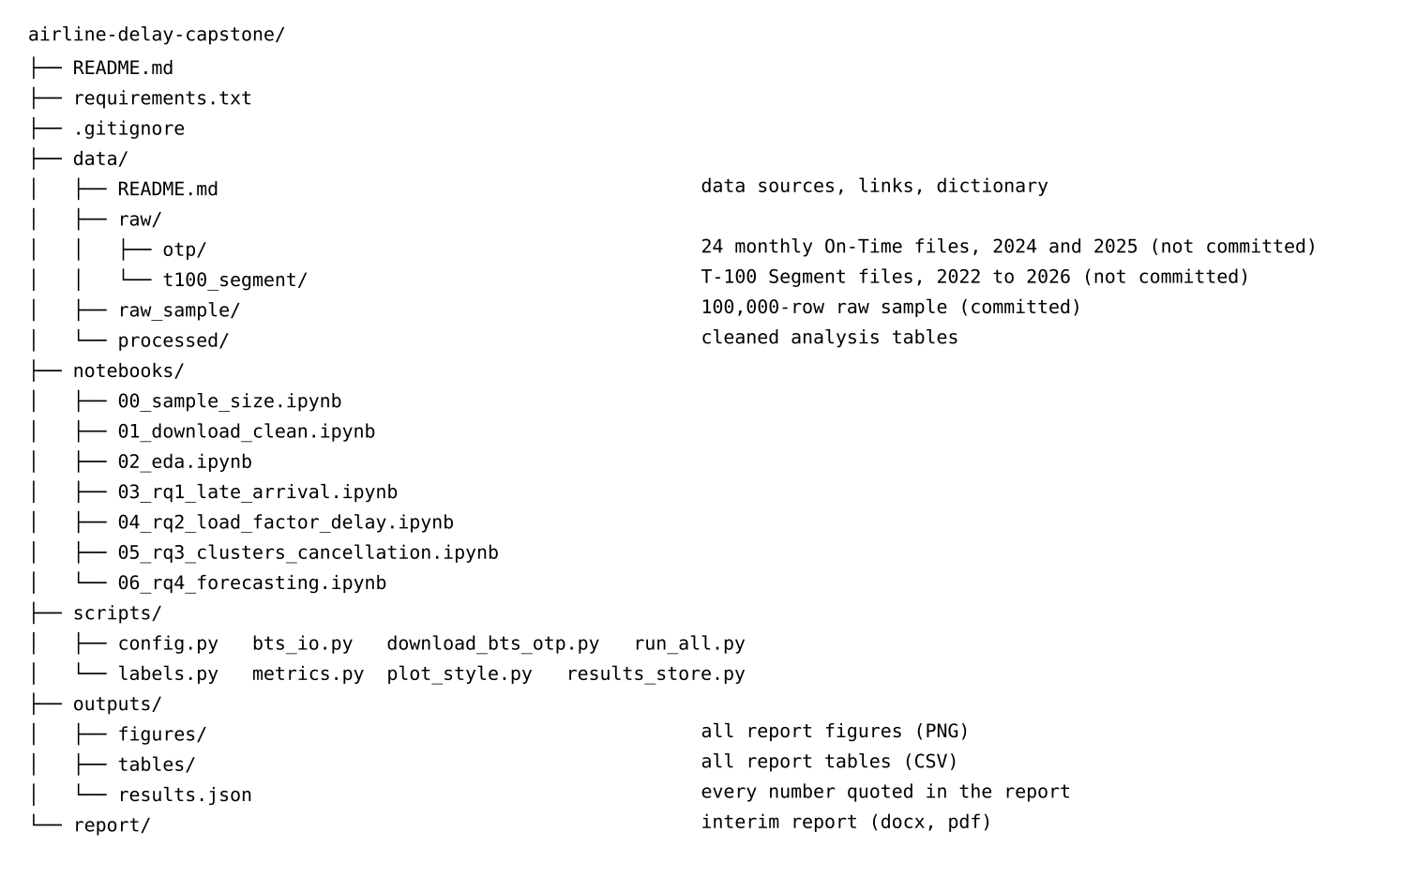
Note. The raw monthly files are listed in the structure but excluded from version control by .gitignore.
Table 7 shows the first rows of the cleaned flight-level table written by notebook 01. Arrival delay and the late flag are missing for the cancelled flight, as described in the cleaning section.
Table 7
Preview of the Cleaned On-Time Table (First Eight Rows)
Date | Carrier | Origin | Destination | Departure block | Distance (miles) | Arrival delay (minutes) | Late (15 or more minutes) | Cancelled
2024-01-08 | 9E | LGA | OMA | 0800-0859 | 1148 | -11 | 0 | 0
2024-01-09 | 9E | LGA | OMA | 0800-0859 | 1148 | -28 | 0 | 0
2024-01-10 | 9E | LGA | OMA | 0800-0859 | 1148 | -25 | 0 | 0
2024-01-11 | 9E | LGA | OMA | 0800-0859 | 1148 | 27 | 1 | 0
2024-01-12 | 9E | LGA | OMA | 0800-0859 | 1148 | 2 | 0 | 0
2024-01-15 | 9E | LGA | OMA | 0800-0859 | 1148 | 10 | 0 | 0
2024-01-16 | 9E | LGA | OMA | 0800-0859 | 1148 | missing | missing | 1
2024-01-17 | 9E | LGA | OMA | 0800-0859 | 1148 | 31 | 1 | 0
Note. Output of notebook 01_download_clean.ipynb (outputs/tables/otp_clean_preview.csv). Late = 1 if the flight arrived 15 minutes or more late. Carriers: 9E = Endeavor Air. Airports: LGA = New York LaGuardia; OMA = Omaha Eppley Airfield.

Analysis

Data Cleaning
Cleaning was done in notebook 01 and every step is logged in Table 8. The raw 2024 and 2025 On-Time files contained 14,080,680 flights. The most common gap was a missing arrival delay, for 235,949 flights (1.68%). Nearly all of them were cancelled or diverted flights, for which the Bureau of Transportation Statistics reports no normal arrival, so this missingness is structural and not random. These flights were kept, flagged as not operated, and left out of every analysis of arrival delay; cancelled flights are used in Research Question 3. One flight had a missing arrival delay without being cancelled or diverted and was excluded from the delay analyses.
Duplicates were checked on the flight key (date, carrier, flight number, origin, destination, scheduled departure time); none were found. No record had a non-positive distance or identical origin and destination, and the 15-minute delay flag agreed with the minutes field for every operated flight. Outliers were identified with Tukey's rule (third quartile + 3 × interquartile range): arrival delays above 85 minutes were flagged for 707,202 operated flights (5.1%), and the largest was 4,336 minutes. They were not removed, because very long delays are genuine events that Research Questions 1 and 2 are meant to explain; median-based summaries and the Spearman correlation are used instead.
In the T-100 table, rows split by aircraft type were summed to carrier-segment-months; 24 rows without a carrier or airport identification number could not be joined and were removed, no exact duplicates were found, and 77 carrier-segment-months with a load factor above 100% were set to missing. After joining, 99.96% of On-Time route-months matched a T-100 record, and 86,555 route-months with fewer than 30 operated flights were excluded from Research Question 2 because their late rates are unstable.
Table 8
Data Cleaning Log
Issue | Variables affected | Detection method | Treatment applied | Rationale | Count (%)
Missing values (arrival delay) | Arrival delay, late-arrival indicator | Count of missing values; cross-tabulation with the cancelled and diverted flags | Kept; excluded from delay analyses via the 'operated' flag | Missing arrival delay is structural: cancelled and diverted flights never arrive normally | 235,949 (1.676%)
Missing values (unexplained) | Arrival delay | Missing value on a flight that was neither cancelled nor diverted | Excluded from delay analyses | True data gaps cannot be imputed without bias | 1 (0.0%)
Missing values (delay causes) | Delay minutes by cause (carrier, weather, national air system, security, late aircraft) | Missing values among late flights | Kept missing; treated as 0 minutes only inside late flights (exploratory analysis) | Bureau of Transportation Statistics records causes only for delays of 15 or more minutes | 2
Duplicates | Flight date, carrier, flight number, origin airport, destination airport, scheduled departure time | Duplicate check on the flight key | Dropped (first kept) | A flight can occur once per scheduled departure | 0 (0.0%)
Invalid distance / route | Distance, origin airport, destination airport | Distance of zero or less, or origin the same as destination | Dropped | Not a real flight leg | 0 (0.0%)
Logical inconsistency | Late-arrival indicator versus arrival delay | arr_del15 != (Arrival delay >= 15) | Reported (no correction needed if 0) | Confirms the binary flag matches the minutes field | 0 (0.0%)
Outliers (extreme delay) | Arrival delay | Tukey fence: third quartile + 3 × interquartile range | Retained; robust statistics and clipped display ranges used | Extreme delays are real operational events, not errors | 707,213 (5.108%)
T-100 rows without carrier or airport identification number | Carrier, origin airport, destination airport (identification numbers) | Missing key field | Dropped (cannot be joined to the On-Time table) | Stable identification numbers are the join keys; passengers on these rows are a negligible share | 24 (0.002%)
T-100 duplicates | all fields | Duplicate check on the whole row | Dropped | Exact repeats are reporting artefacts | 0 (0.0%)
T-100 impossible load factor | Passengers, seats | Load factor above 100% after summing aircraft types | Set to missing for load-factor analyses | Passengers cannot exceed seats offered | 77 (0.01%)
Note. Percentages use the raw On-Time row count, except outliers (percentage of operated flights) and the T-100 rows (percentage of T-100 rows).

Exploratory Data Analysis Results
The exploratory analysis used the 14,080,680 cleaned flights, of which 13,844,731 were operated. Table 9 gives the main summary statistics. Overall, 21.6% of operated flights arrived 15 minutes or more late, 1.41% of scheduled flights were cancelled and 0.26% were diverted. The mean arrival delay (7.8 minutes) is much larger than the median (-6.0 minutes), so a minority of very late flights pulls the average up. All tables and figures in this report are the author's own analysis of the Bureau of Transportation Statistics files (notebooks 00 to 06), so none is reproduced from another source.
Table 9
Summary Statistics of Key Numeric Variables
Variable | Count | Mean | Standard deviation | Minimum | First quartile | Median | Third quartile | 99th percentile | Maximum
Arrival delay (minutes) | 13,844,731 | 7.8 | 58.9 | -128.0 | -15.0 | -6.0 | 10.0 | 220.0 | 4,336.0
Distance (miles) | 14,080,680 | 839.2 | 599.1 | 11.0 | 402.0 | 689.0 | 1,073.0 | 2,611.0 | 5,095.0
Scheduled elapsed time (minutes) | 14,080,677 | 147.8 | 72.7 | -160.0 | 95.0 | 131.0 | 179.0 | 375.0 | 1,510.0
Route-month load factor (%) | 148,241 | 80.0 | 10.3 | 12.5 | 74.8 | 81.9 | 87.4 | 95.3 | 98.8
Route-month late rate (%) | 148,241 | 21.3 | 11.3 | 0.0 | 13.0 | 19.7 | 27.9 | 54.4 | 96.7
Route-month cancellation rate (%) | 148,241 | 1.2 | 2.4 | 0.0 | 0.0 | 0.0 | 1.7 | 11.3 | 48.0
Flights per route-month | 148,241 | 84.9 | 63.6 | 30.0 | 39.0 | 62.0 | 107.0 | 315.0 | 678.0
Note. Arrival delay is computed for operated flights only; load factor is computed per carrier-segment-month. Scheduled elapsed time contains implausible negative values (minimum −160 minutes) that are present in the source data; the variable is not used in any model.
Figure 2 shows the seasonal pattern. The late-arrival rate was lowest in October 2024 (13.2%) and highest in July 2024 (29.6%), a gap of 16.4 percentage points. Cancellations peaked in January 2024 at 3.73%. The Spearman correlation between daily late-arrival and cancellation rates is .70, because both rise on days of severe disruption, but they measure different outcomes and are analyzed separately (Research Questions 1 and 3), and month is kept as a control.
Figure 2
Late-Arrival and Cancellation Rates by Month, 2024 and 2025
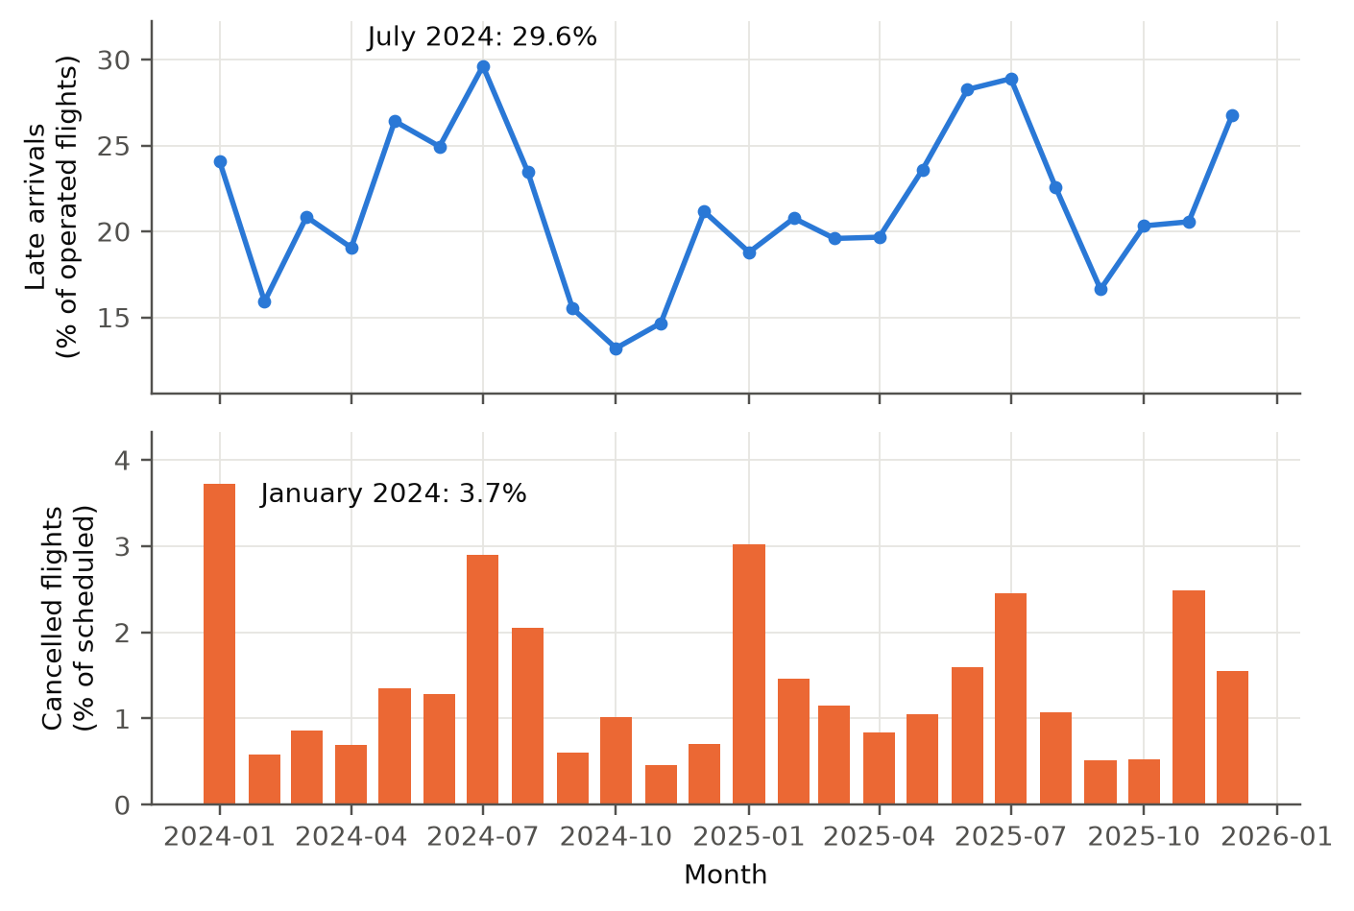
Note. Late rate is the share of operated flights arriving 15 or more minutes late; cancellation rate is the share of scheduled flights cancelled.
Figure 3 shows the late-arrival rate by scheduled departure hour: it is 18.4% at 00:00 and 31.3% at 19:00. The rate rises through the day (Spearman correlation between hour and rate across hours = .74), consistent with delays building up through the day. Departure time is a key candidate predictor for Research Question 1.
Figure 3
Late-Arrival Rate by Scheduled Departure Hour
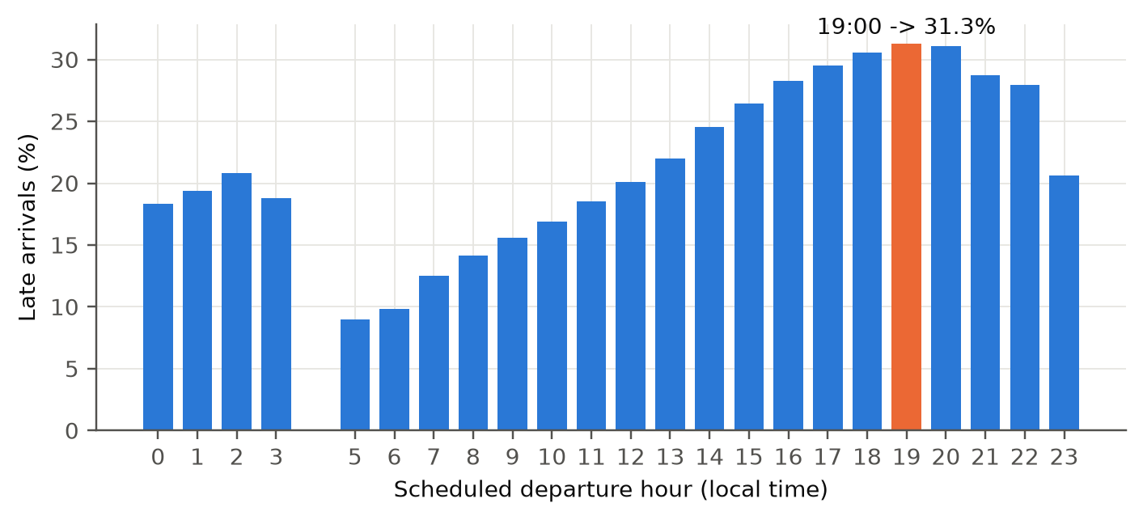
Note. Hours with very few flights are not shown.
Figure 4 compares the 15 reporting carriers. Late-arrival rates range from 15.8% (Endeavor Air) to 28.3% (Frontier Airlines), and the highest cancellation rate is 3.18% (PSA Airlines). These differences support carrier as a factor in Research Question 1 and carrier-airports as the unit in Research Question 3.
Figure 4
Late and Cancellation Rates by Carrier
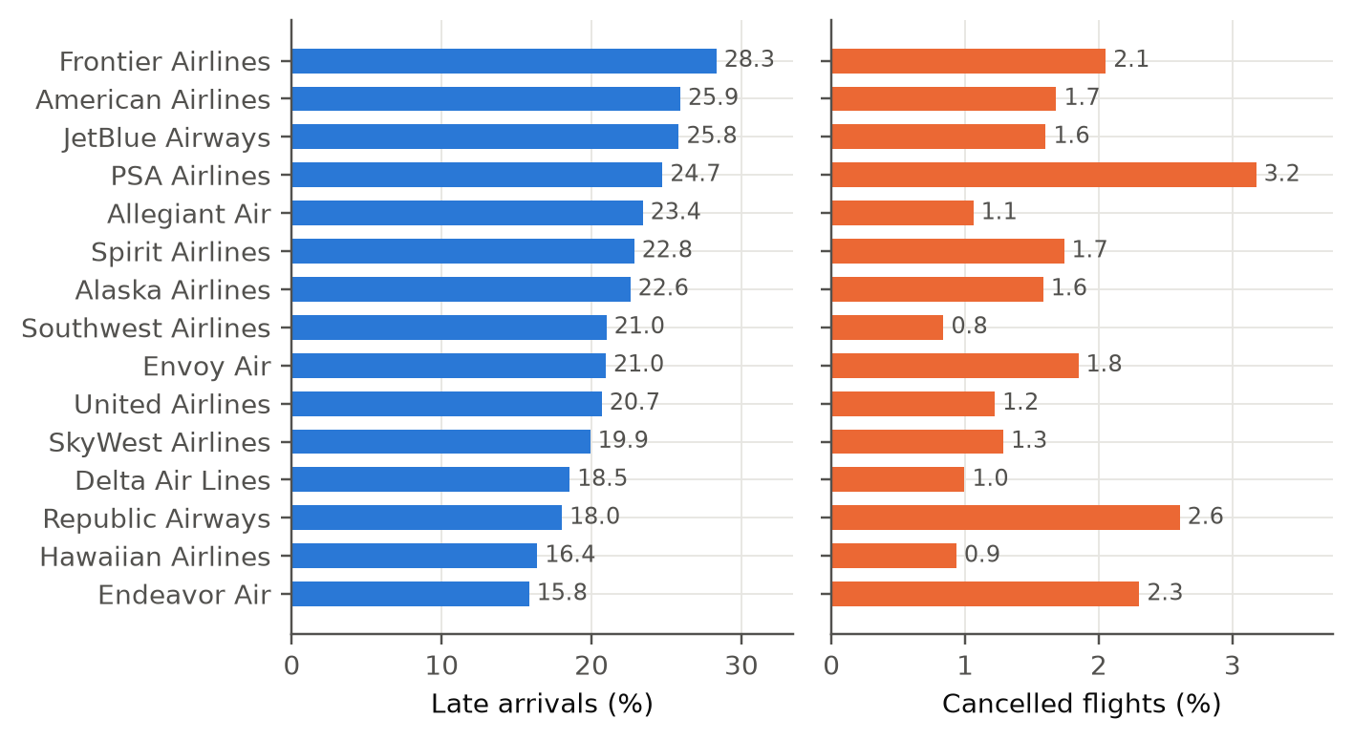
Note. Carriers are ordered by the late-arrival rate.
Figure 5 breaks down the minutes of delay by the five Bureau of Transportation Statistics cause categories. Late-arriving aircraft accounts for 39.8% of delay minutes and Air carrier for 33.4%, while Security accounts for only 0.2%. The large share for late-arriving aircraft shows that delays pass along from earlier flights; cause minutes are not used as predictors because they are known only after the delay.
Figure 5
Share of Delay Minutes by Cause (Flights Delayed 15 or More Minutes)
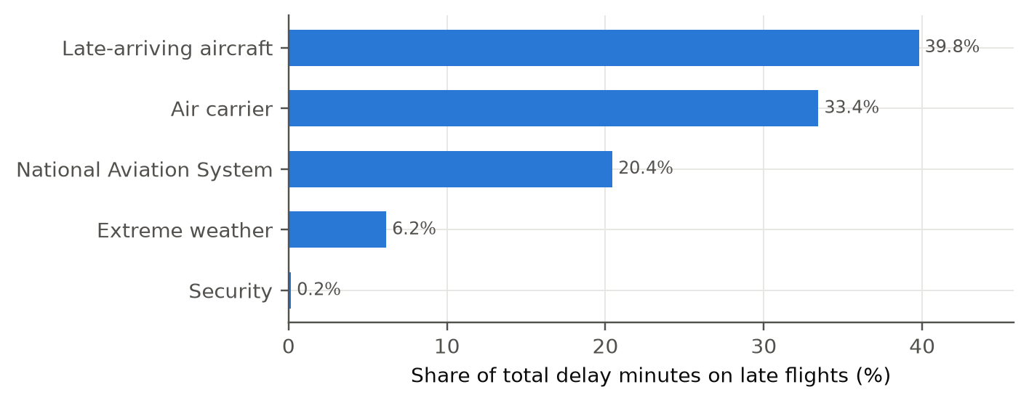
Note. Cause minutes are recorded by Bureau of Transportation Statistics only for delays of 15 minutes or more.
Figure 6 shows the late-arrival rate for the busiest origin airports, from 18.2% (Los Angeles International) to 27.9% (Dallas/Fort Worth), which justifies airport factors in Research Question 1.
Figure 6
Late-Arrival Rate by Origin Airport (Busiest Airports)
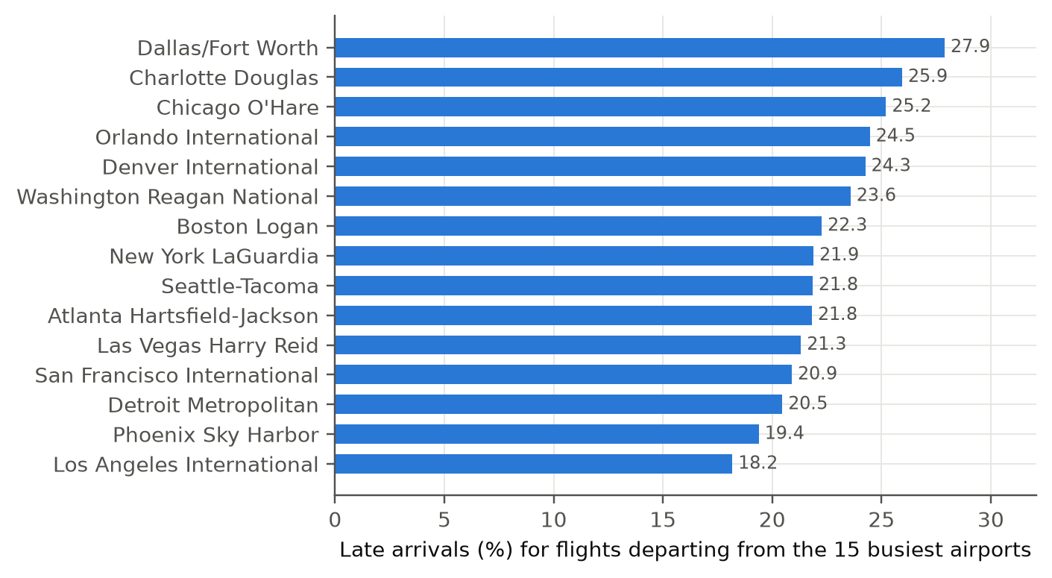
Note. Only the busiest origin airports are shown.
Figure 7 shows that cancellations are concentrated on a few days. The median daily cancellation rate is 0.54%, while the worst day, 2024-07-19, reached 16.53% (3,548 flights), so cancellation is event-driven.
Figure 7
Daily Cancellation Rate and the Worst Days
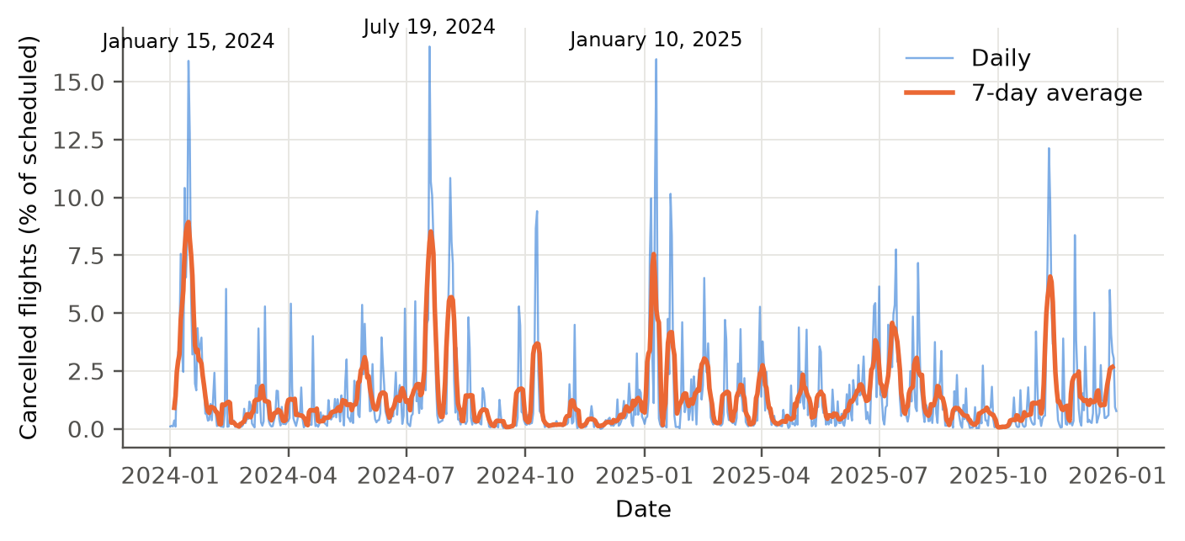
Note. The labeled days are the five highest cancellation days.
Figure 8 previews the Research Question 2 relationship. The mean late-arrival rate goes from 18.6% in the lowest load-factor decile to 22.4% in the highest (Spearman correlation .10).
Figure 8
Load Factor and Late-Arrival Rate by Route-Month
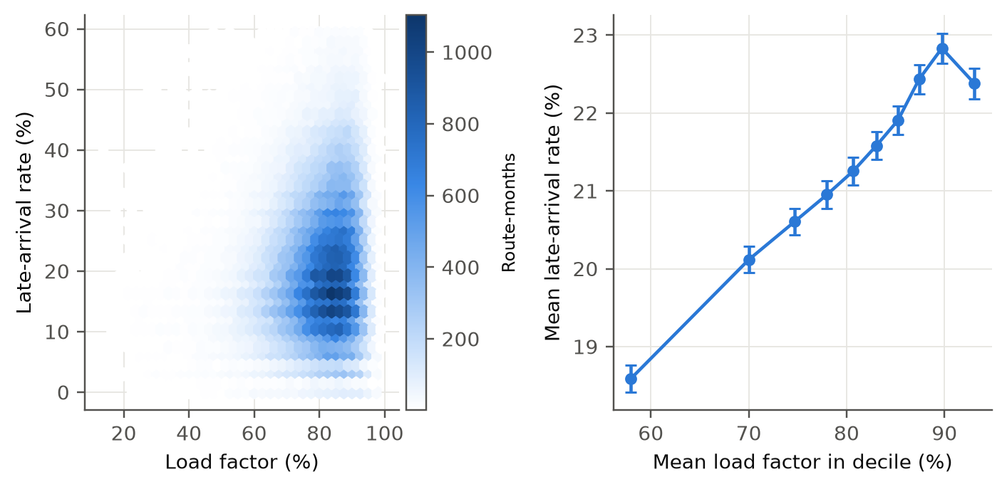
Note. Left: density of route-months. Right: mean late-arrival rate by decile of load factor.
Figure 9 shows the demand series used in Research Question 4. Passengers peak in July and are lowest in February, a seasonal swing of about 27% between the low and high month. A long short-term memory network must learn something beyond this seasonal shape to beat seasonal-naive and seasonal autoregressive integrated moving average models.
Figure 9
Monthly Passengers, 2022 to 2026 (Busiest Routes)
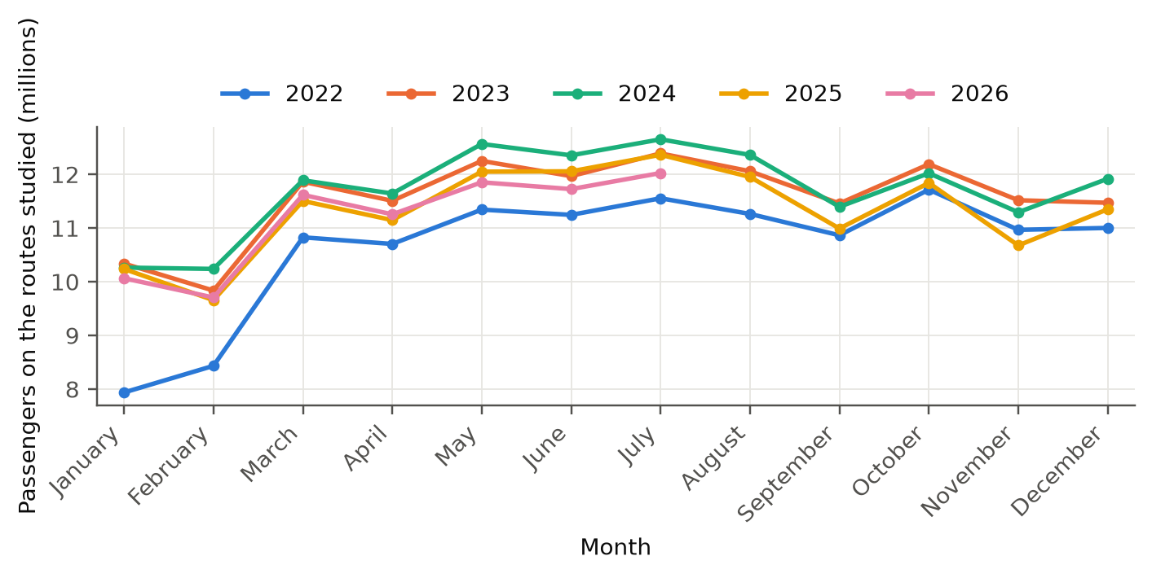
Note. Passengers are summed over the routes used in Research Question 4.
Table 10 collects the main insight from each figure and states how it links to the research questions.
Table 10
Exploratory Data Analysis Insight Summary
Figure / table | What it shows | Key insight | Why it matters (link to research question) | Decision / next step
Figure 2 | Late and cancellation rates by month | Late rate 13.2% to 29.6%; cancellations peak in January 2024 | Season matters (Research Question 1, Research Question 2) | Keep month as a factor
Figure 3 | Late rate by departure hour | 18.4% at 00:00 versus 31.3% at 19:00 | Time of day is a strong candidate predictor (Research Question 1) | Use hourly blocks
Figure 4 | Rates by carrier | Late arrivals 15.8%–28.3%; cancellations up to 3.18% | Carrier differences (Research Question 1, Research Question 3) | Carrier factor; carrier-airport unit
Figure 5 | Delay minutes by cause | Late-arriving aircraft 39.8% | Delays are passed from earlier flights (Research Question 1) | Exclude cause minutes (leakage)
Figure 6 | Late rate by origin airport | 18.2%–27.9% | Airport effects (Research Question 1) | Use the 25 busiest airports as factors
Figure 7 | Daily cancellation rate | Worst day 16.53% versus median 0.54% | Cancellation is event-driven (Research Question 3) | Cluster by profile, test cancellation
Figure 8 | Load factor and late rate | Decile means 18.6% to 22.4%; ρ = .10 | Preview of Research Question 2 | Formal correlation and regression
Figure 9 | Monthly passengers | Seasonal swing about 27% | Strong seasonality (Research Question 4) | Seasonal-naive and seasonal autoregressive integrated moving average baselines
Table 9 | Summary statistics | Mean delay 7.8 minutes versus median -6.0 minutes | Skewed delays (Research Question 1, Research Question 2) | Rank correlation; robust checks
Note. ρ = Spearman rank correlation between route-month load factor and late-arrival rate.

Modelling

Choice of Models with Justification

Research Question 1: Late arrival (classification)
Model 1 is a logistic regression and is the primary model. The outcome is binary and the question asks which characteristics influence it, and a logistic regression gives an odds ratio with a confidence interval and a p-value for every term, plus a likelihood-ratio test of the model as a whole.
Model 2 is a random forest (Breiman, 2001), which can capture non-linear effects and interactions that main effects in a logistic regression cannot, and has worked well for delay prediction (Rebollo & Balakrishnan, 2014). Model 3 is extreme gradient boosting, which was the best of four classifiers on Bureau of Transportation Statistics arrival delays in Chakrabarty et al. (2019). A majority-class baseline (every flight predicted on time) is included because accuracy alone can look high for a model that learns nothing.
Assumptions and alternatives. The logistic regression assumes independent flights, a straight-line effect of each continuous predictor on the log-odds, and no strong collinearity. Independence holds only approximately, because flights on the same route and day share weather and congestion, so the p-values are probably too small and odds ratios are best read as descriptions of association. The tree-based models need no straight-line assumption but give no odds ratios. A support vector machine was not used because it is slow on 320,000 flights and gives no readable coefficients.

Research Question 2: Load factor and late-arrival rate (association)
The outcome (late-arrival rate) and the predictor (load factor) are both continuous, so the main method is the Pearson correlation with a Fisher z confidence interval, supported by the Spearman rank correlation, which does not depend on a straight-line relationship or on outliers. A simple linear regression gives the slope in percentage points. The assumptions are a roughly linear relationship, independent observations and residuals of roughly constant spread, which the residual plot checks. Weighted regression and route-clustered standard errors are alternatives for the final report, because route-months from one route are not independent.

Research Question 3: Carrier-airport clusters and cancellation
Carrier-airport operations are grouped with k-means (Jain, 2010) on standardized operating and capacity features. The number of clusters is chosen with the silhouette width (Rousseeuw, 1987) and a rule that no cluster may hold fewer than five percent of the units. Cancellation is not used to form the clusters, so the test is not circular. The association is tested with a chi-square test of independence on all flights (Cramér's V as effect size) and, because flights within a carrier-airport are not independent, with a Kruskal-Wallis test on carrier-airport cancellation rates. A two-proportion z-test compares the highest and lowest clusters. K-means assumes roughly round clusters, so hierarchical clustering is an alternative for the final report.

Research Question 4: Forecasting route passenger demand
Three models are compared on the same held-out final 12 months. A seasonal-naive forecast (the value of the same month a year earlier) is the floor any model should beat. Seasonal autoregressive integrated moving average with orders (0,1,1)(0,1,1)12 on log passengers is the statistical baseline; this standard form (Hyndman & Athanasopoulos, 2021) avoids searching orders for each of 150 routes and assumes stationarity after one regular and one seasonal difference. The machine learning model is one global long short-term memory network (Hochreiter & Schmidhuber, 1997) trained on all routes from the previous 12 months, with each route rescaled by its own training mean. Its forecast averages three random seeds and is made recursively, so no test-period value is used as an input. With only 43 training months per route the network has little to learn from, so exponential smoothing is an alternative for the final report.

Features Included and Feature Engineering
The features are listed in Table 11. Three decisions shaped them. First, only information known before departure is used for Research Question 1: departure delay, taxi times, actual times and delay-cause minutes are excluded because they are recorded after the flight starts and would leak the answer into the model. Second, only the 25 busiest origin and destination airports are kept as separate levels and the rest become “Other”. Third, the load factor for Research Question 1 comes from the previous month, because the current month's value is not known at departure; flights without a match receive the median and a missing-value flag. Categorical features (month, day of week, departure block, carrier and airport) are one-hot encoded, and the most common level of each is dropped as the reference level. Continuous features are rescaled so coefficients are easy to read: distance is in units of 1,000 miles and the prior-month load factor is centred at its median and expressed per 10 percentage points. The same design matrix is used for all three models.
Table 11
Feature Set and Usage
Feature | Original / engineered | Type | Reason for inclusion | Used in
Month | Original | Categorical (12 levels) | Seasonal weather and demand cycles | Research Question 1 (all three models)
Day of week | Original | Categorical (7 levels) | Weekly demand and schedule patterns | Research Question 1 (all three models)
Scheduled departure block | Original | Categorical (hourly) | Delays build up through the day through knock-on effects | Research Question 1 (all three models)
Carrier | Original | Categorical | Operating practices differ by airline (Mazzeo, 2003) | Research Question 1 (all three models)
Origin and destination airport | Engineered: 25 busiest of each, others grouped | Categorical | Congestion and weather exposure differ by airport; grouping avoids sparse levels | Research Question 1 (all three models)
Route distance (per 1,000 miles) | Original, rescaled | Continuous | Longer flights have more schedule slack | Research Question 1 (all three models); Research Question 3 (clustering)
Prior-month route load factor (per 10 percentage points) | Engineered: T-100 join, previous month, missing flag | Continuous | Fuller aircraft take longer to board; previous month is known before departure | Research Question 1 (all three models)
Route-month load factor | Engineered: passengers divided by seats, times 100 | Continuous | Capacity utilization, the predictor of Research Question 2 | Research Question 2 (correlation and regression)
Route-month late-arrival rate | Engineered: share of operated flights that arrived 15 or more minutes late | Continuous | Outcome of Research Question 2, kept continuous | Research Question 2
Average load factor, mean monthly departures (log), average distance, seasonal variability of departures | Engineered per carrier-airport | Continuous, standardized | Operating and capacity profile used to form clusters; the logarithm reduces skew | Research Question 3 (k-means)
Monthly route passengers, 12-month window | Original, aggregated; windows engineered | Continuous | The series being forecast; the 12-month window captures the annual season | Research Question 4 (seasonal autoregressive integrated moving average and long short-term memory network)
Note. The three models for Research Question 1 are the logistic regression, the random forest and extreme gradient boosting. Only the T-100 service class F is used.

Feature importance and leakage control
Research Question 1 feature importance is measured by a likelihood-ratio test for each factor in the logistic regression and by the mean absolute Shapley additive explanations value of each factor in the extreme gradient boosting model (Lundberg & Lee, 2017); results are in Table 13 and Figure 11. Leakage is controlled by excluding variables recorded after departure begins, using the previous month's load factor, and never using test flights for fitting or for choosing the threshold.

Evaluation Metrics
The metrics, formulae and meaning are in Table 12. For Research Question 1 the classification threshold is the training prevalence of late flights, not 0.5, because a threshold of 0.5 would label almost every flight on time. The area under the receiver operating characteristic curve does not depend on the threshold and is the main comparison metric. Models are scored on a stratified 20% test set, and the area under the curve is also computed by three-fold cross-validation on a 90,000-flight subsample to show its stability. For Research Question 4 the mean absolute error, root mean squared error and mean absolute scaled error are computed for every model on the same 12 held-out months (Hyndman & Athanasopoulos, 2021), and the long short-term memory network and seasonal autoregressive integrated moving average are compared route by route with a paired t-test, the Wilcoxon signed-rank test and Cohen's d for paired data. The code is shown in Appendix A.
Table 12
Evaluation Metrics and Formulae
Metric | Formula | Interpretation | Used for
Accuracy | (true positives + true negatives) / all flights classified | Share of flights classified correctly | Research Question 1 (supplementary)
Precision | true positives / (true positives + false positives) | Of flights predicted late, the share that were late | Research Question 1
Recall | true positives / (true positives + false negatives) | Of flights that were late, the share found | Research Question 1
F1-score | 2 × precision × recall / (precision + recall) | Balance of precision and recall | Research Question 1
Area under the curve | Area under the curve of true-positive rate against false-positive rate | Probability that a random late flight gets a higher score than a random on-time flight; 0.5 = chance | Research Question 1 (main)
Odds ratio | Odds ratio = exp(β), where β is the regression coefficient | Multiplicative change in the odds of arriving late for a one-unit change in the predictor | Research Question 1 (logistic regression)
Likelihood-ratio test | 2 × (log-likelihood of the full model − log-likelihood of the model without predictors); compared with χ² on the degrees of freedom | Tests whether the predictors as a whole improve the fit | Research Question 1
Pearson r | Σ(x − x̄)(y − ȳ) / √[Σ(x − x̄)² Σ(y − ȳ)²]; confidence interval: tanh(arctanh r ± 1.96/√(n − 3)) | Strength and direction of the linear association | Research Question 2
R²; slope | R² = r²; slope b = r × s_y / s_x | Share of variance explained; change in late rate per point of load factor | Research Question 2
Silhouette width | s(i) = (b(i) − a(i)) / max(a(i), b(i)) | How well a unit fits its own cluster compared with the nearest other cluster; −1 to 1 | Research Question 3
Chi-square; Cramér's V | χ² = Σ (O − E)² / E; V = √[χ² / (N × (the smaller of r and c, minus 1))] | Test of independence; effect size (small ≈ 0.1, medium ≈ 0.3; Cohen, 1988) | Research Question 3
Mean absolute error | (1/n) Σ |y − ŷ| | Average size of forecast error in passengers | Research Question 4
Root mean squared error | √[(1/n) Σ (y − ŷ)²] | Like the mean absolute error but penalizes large errors more | Research Question 4
Mean absolute scaled error | Mean absolute error of the forecast ÷ in-sample mean absolute error of the seasonal-naive forecast (lag 12) | Below 1 beats seasonal naive; comparable across routes | Research Question 4
Paired t-test; Cohen's d for paired data | t = d̄ / (s_d / √n); d_z = d̄ / s_d | Tests whether the mean difference d̄ in error between two models over the same routes is zero; effect size (small ≈ 0.2, medium ≈ 0.5) | Research Question 4
Note. “Late” is the positive class: a true positive is a late flight predicted late, a false positive an on-time flight predicted late, a false negative a late flight predicted on time and a true negative an on-time flight predicted on time. In the formulae, d̄ and s_d are the mean and standard deviation of the route-by-route differences in error and n is the number of routes, and O and E are observed and expected counts, N is the number of flights, r and c are the numbers of table rows and columns, a(i) is the average distance from unit i to its own cluster and b(i) the average distance to the nearest other cluster.

Preliminary Results

Preliminary Findings by Research Question

Research Question 1: Which characteristics are associated with late arrival?
The modelling sample had 400,000 operated flights drawn at random from 2024 and 2025, split into 320,000 for training and 80,000 for testing, with a late rate of 21.6%, far above the minimum of 9,604 flights from the sample-size plan. The logistic regression as a whole was highly significant (likelihood-ratio χ²(102) = 17,898.4, p < .001), but McFadden's pseudo-R² is only .054, so characteristics known before departure explain a small part of why flights are late. The strongest terms are scheduled departures from 14:00 to 22:59, whose odds of a late arrival are 2.4 to 3.3 times those of the reference departure block (07:00 to 07:59), and September, October, November, February and April, whose odds are lower than in the reference month (July). Figure 10 plots the strongest terms.
Figure 10
Odds Ratios of the Strongest Terms in the Logistic Regression
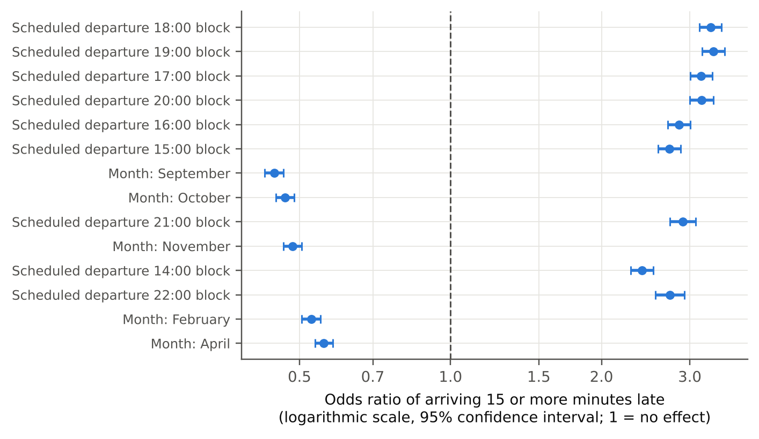
Note. Odds ratios above 1 mean higher odds of arriving 15 or more minutes late than the reference level. Bars are 95% confidence intervals. Reference levels: Southwest Airlines, Monday, July, the 07:00 to 07:59 departure block, and the grouped “Other” origin and destination airports.
Table 13 and Figure 11 show which factors matter most. The likelihood-ratio tests show that 7 of the 8 factors are significantly associated with late arrival (route distance is not, p = .190), and the scheduled departure block is by far the strongest (χ²(18) = 10,568), followed by month and carrier. The Shapley additive explanations ranking from the extreme gradient boosting model gives the same top three factors in the same order, so the conclusion does not depend on one model. The previous month's load factor is significant but its odds ratio is close to 1 and it ranks last in importance, so with 400,000 flights effect size matters more than the p-value.
Table 13
Likelihood-Ratio Test for Each Factor in the Logistic Regression
Factor | Degrees of freedom | Likelihood-ratio chi-square | p-value | Significant at .05
Scheduled departure block | 18 | 10,567.9 | < .001 | Yes
Month | 11 | 3,163.9 | < .001 | Yes
Carrier | 14 | 1,119.7 | < .001 | Yes
Destination airport | 25 | 896.4 | < .001 | Yes
Day of week | 6 | 799.9 | < .001 | Yes
Origin airport | 25 | 734.1 | < .001 | Yes
Prior-month load factor | 2 | 53.6 | < .001 | Yes
Route distance | 1 | 1.7 | .190 | No
Note. Each test compares the full model with the model that leaves out one factor.
Figure 11
Importance of Each Factor for Late Arrival in Two Models
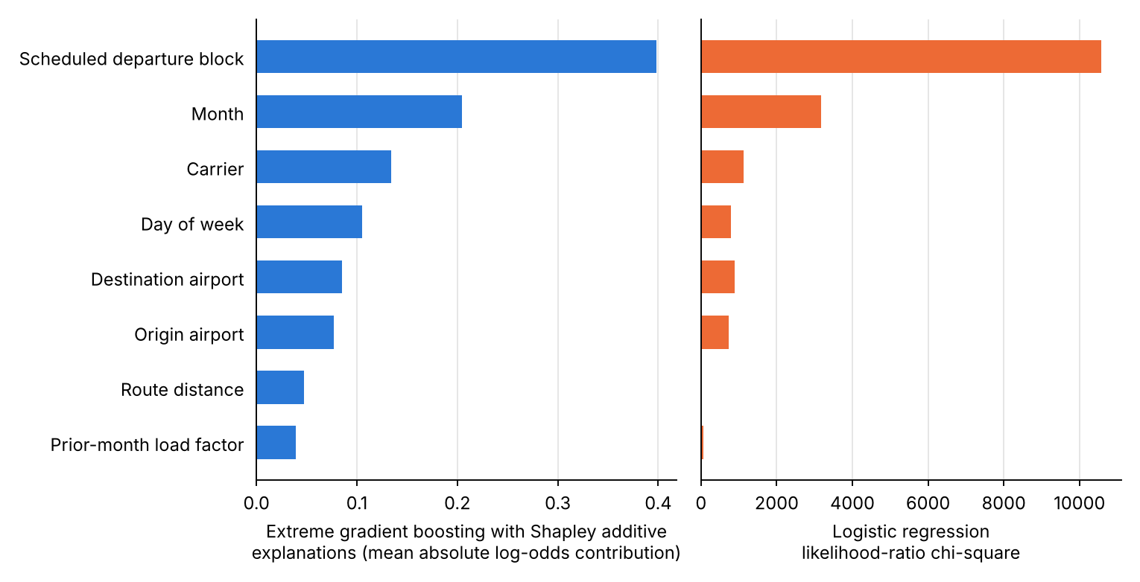
Note. Left: extreme gradient boosting. Right: logistic regression. Both rank the scheduled departure block first.
Answer so far. The null hypothesis of no association is rejected (p < .001). Late arrival is associated mainly with the scheduled departure time, the month and the carrier, but the characteristics known before departure predict it only weakly (area under the curve .678 at best), so they help to rank risk but not to predict individual delays. Remaining work: tuning the random forest and extreme gradient boosting, validating on a later period and using route-clustered standard errors.

Research Question 2: Is load factor associated with late-arrival rate?
The Research Question 2 sample had 148,241 route-months across 9,998 carrier-routes, far above the minimum of 783 from the sample-size plan. The Pearson correlation between load factor and late-arrival rate was r = .11 (95% confidence interval .10 to .11; t(148,239) = 41.76, p < .001), and the Spearman correlation was ρ = .10 (p < .001), so the association is statistically significant. The size of the association is small by Cohen's (1988) conventions: load factor explains 1.2% of the variance in late-arrival rate. In the simple linear regression, each additional percentage point of load factor is associated with 0.12 percentage points of late-arrival rate (95% confidence interval 0.11 to 0.12). Figure 12 shows the fitted line and the residuals. The association is between route-month averages and does not show that fuller aircraft cause later arrivals.
Checking the assumptions. The residuals are moderately right-skewed (skewness 0.81) and the Breusch-Pagan test shows that their spread is not constant (p < .001), and route-months from one route are not independent, so the confidence interval is probably too narrow. The Spearman correlation (.10) is close to the Pearson correlation (.11), so the result does not depend on outliers. Robust standard errors are planned for the final report.
Figure 12
Load Factor and Late-Arrival Rate: Regression Line and Residuals
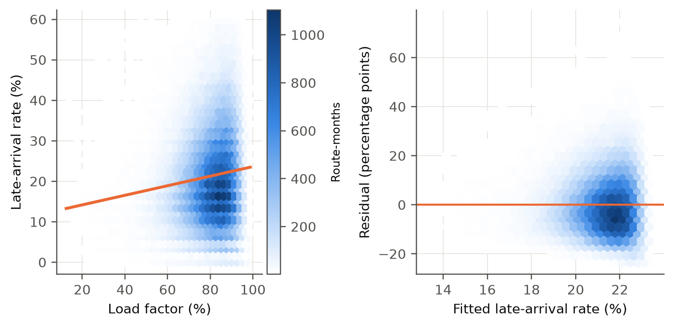
Note. Left: route-months with the fitted line. Right: residuals against the fitted late-arrival rate.
Answer so far. The null hypothesis of no linear association is rejected (p < .001). Fuller route-months have a slightly higher late-arrival rate, but load factor explains only 1.2% of the variation, so the association is small. Remaining work: robust standard errors and a check for carrier and month effects.

Research Question 3: Are cancellation rates associated with cluster membership?
The 1,598 carrier-airport units (those with at least 120 scheduled flights in at least 12 of the 24 months; 14,044,433 flights, against a minimum of 6,152 from the sample-size plan) were grouped by k-means on load factor, monthly departures, distance and seasonal variability. The silhouette analysis (Figure 13) selected k = 4 (silhouette = 0.32, a moderate value); Table 14 describes the clusters. The chi-square test of independence on all flights gave χ²(3) = 1,917.0, p < .001, so the association between cluster and cancellation is statistically significant at the flight level; the effect size is negligible (Cramér's V = .012). Highest and lowest cancellation rates were observed in clusters 2 (1.95%) and 4 (1.28%; two-proportion z = 23.30, p < .001). Because flights within a carrier-airport are not independent, the Kruskal-Wallis test on carrier-airport cancellation rates is the more conservative check: H(3) = 40.94, p < .001, ε² = .024, so the association is statistically significant at the unit level. Figure 14 shows the clusters and their cancellation rates.
Table 14
Cluster Profiles and Cancellation Rates
Cluster | Units | Flights | Load factor (%) | Monthly departures (median) | Distance (miles) | Cancellation rate (%) [95% confidence interval] | Most frequent carriers
1 | 106 | 163,909 | 55.3 | 53 | 385 | 1.80 [1.73, 1.86] | SkyWest Airlines, Alaska Airlines, Frontier Airlines
2 | 623 | 777,800 | 79.7 | 53 | 659 | 1.95 [1.92, 1.98] | Envoy Air, Allegiant Air, SkyWest Airlines
3 | 771 | 12,812,387 | 80.3 | 253 | 699 | 1.38 [1.37, 1.38] | SkyWest Airlines, Delta Air Lines, Southwest Airlines
4 | 98 | 290,337 | 84.5 | 70 | 2,320 | 1.28 [1.24, 1.32] | Alaska Airlines, Hawaiian Airlines, JetBlue Airways
Note. Wilson 95% confidence intervals for the cancellation rate. Clusters are numbered by increasing average load factor.
Figure 13
Choosing the Number of Clusters
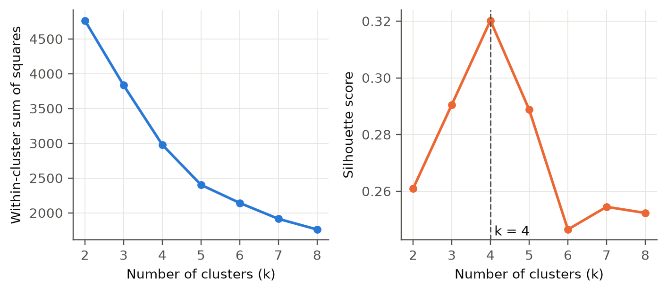
Note. Elbow plot (left) and silhouette score (right).
Figure 14
Carrier-Airport Clusters (Principal Components) and Cancellation Rate by Cluster
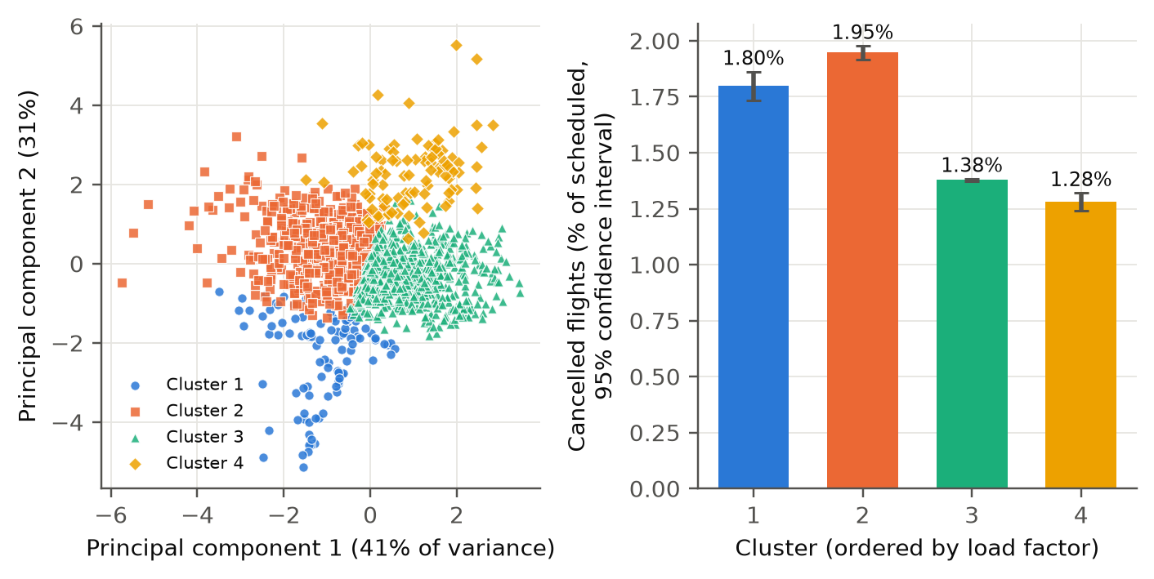
Note. Left: the four clustering features projected on two principal components. Right: cancelled flights as a percentage of scheduled flights.
Answer so far. The null hypothesis of equal cancellation rates is rejected at the flight level and the unit level, but the effect size is negligible (Cramér's V = .012), so the operating profile distinguishes cancellation only slightly. Remaining work: other numbers of clusters and a different minimum unit size.

Research Question 4: Does the long short-term memory network forecast better than seasonal autoregressive integrated moving average?
The forecasting comparison used 150 routes with monthly passengers from 2022-01 to 2026-07, with the last 12 months held out for testing. Table 15 gives the errors. The seasonal-naive forecast had the lowest mean absolute error (5,247 passengers), followed by the seasonal autoregressive integrated moving average forecast (5,449) and the long short-term memory network forecast (7,085). Averaged across routes, the mean absolute scaled error was 1.07 for the long short-term memory network, 0.82 for seasonal autoregressive integrated moving average and 0.80 for the seasonal-naive forecast (Figure 15). A mean absolute scaled error above 1 means that the long short-term memory network did worse than repeating last year's value, probably because the series are short (43 training months) and strongly seasonal. A paired comparison over the same 150 routes (the plan required at least 88) shows that the long short-term memory network error was higher than the seasonal autoregressive integrated moving average error by 1,636 passengers on average (95% confidence interval 1,056 to 2,216; paired t(149) = 5.53, p < .001; Wilcoxon signed-rank p < .001; Cohen's d for paired data = 0.45), and the long short-term memory network was better on only 28.7% of routes.
Table 15
Forecast Error on the Held-Out 12 Months (Mean and Median across Routes)
Model | Mean absolute error (mean) | Mean absolute error (median) | Root mean squared error (mean) | Mean absolute scaled error (mean) | Mean absolute scaled error (median)
Seasonal naive | 5,247 | 4,514 | 6,160 | 0.80 | 0.71
Seasonal autoregressive integrated moving average | 5,449 | 4,705 | 6,449 | 0.82 | 0.72
Long short-term memory network | 7,085 | 6,553 | 8,337 | 1.07 | 0.92
Note. Mean absolute error and root mean squared error are in passengers per month; mean absolute scaled error is scaled by the in-sample seasonal-naive error, so values below 1 beat it.
Figure 15
Mean Absolute Scaled Error by Model
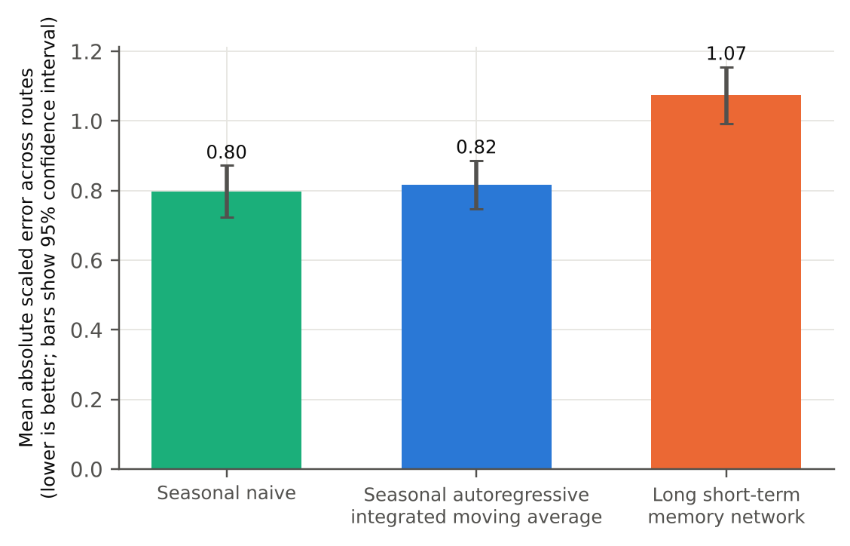
Note. Bars show the mean across routes with 95% confidence intervals; values below 1 beat the seasonal-naive forecast.
Answer so far. The null hypothesis of equal accuracy is rejected, but in the opposite direction to the alternative hypothesis: seasonal autoregressive integrated moving average was significantly more accurate than the long short-term memory network, and neither beat the seasonal-naive forecast. The long short-term memory network is not yet tuned, so this result is preliminary. Remaining work: tuning, rolling-origin evaluation and exponential smoothing as another baseline.

Preliminary Model Performance
Table 16 compares every model. For Research Question 1, the models are judged mainly on area under the curve because the late class is a minority. The best test area under the curve was .678 (extreme gradient boosting), compared with .500 for the majority-class baseline; the interpretable logistic regression is within .013 of the best model, so little predictive accuracy is lost by using it as the primary model. Absolute predictive performance is modest for all three models, as the small pseudo-R² already suggested.
As a worked example of the formulae in Table 12, the logistic regression classified the 80,000 test flights with true positives = 11,163, false positives = 25,644, false negatives = 6,102 and true negatives = 37,091, so accuracy = .603, precision = .303, recall = .647 and F1 = .413. The majority-class baseline has the highest accuracy (.784) but finds none of the late flights, which is why accuracy is not used to rank the models.
Table 16
Preliminary Model Performance Comparison
Model | Feature set | Validation approach | Metric 1 | Metric 2 | Key takeaway
Research Question 1 majority-class baseline | None | 20% test set | Area under the curve .500 | Accuracy .784 | Finds no late flights
Research Question 1 logistic regression | Eight factors (Table 11) | 20% test set; three-fold cross-validation | Area under the curve .665 (cross-validated .662) | F1 .413; recall .647 | Interpretable; primary model
Research Question 1 random forest | Same | 20% test set; three-fold cross-validation | Area under the curve .652 (cross-validated .646) | F1 .403; recall .643 | Comparison model
Research Question 1 extreme gradient boosting | Same | 20% test set; three-fold cross-validation | Area under the curve .678 (cross-validated .660) | F1 .423; recall .639 | Comparison model
Research Question 2 simple regression | Load factor | Full sample | r = .11 | R² = .012 | small association
Research Question 3 k-means with chi-square and Kruskal-Wallis tests | Four profile features | Silhouette; chi-square; Kruskal-Wallis | Silhouette 0.32 | V = .012 | negligible effect
Research Question 4 seasonal naive | 12-month lag | Last 12 months held out | Mean absolute error 5,247 | Mean absolute scaled error 0.80 | Benchmark
Research Question 4 seasonal autoregressive integrated moving average | Log passengers | Last 12 months held out | Mean absolute error 5,449 | Mean absolute scaled error 0.82 | Statistical baseline
Research Question 4 long short-term memory network | 12-month window | Last 12 months held out; three random seeds | Mean absolute error 7,085 | Mean absolute scaled error 1.07 | Higher error than seasonal autoregressive integrated moving average
Note. Cross-validated values are the three-fold cross-validated area under the curve on a subsample. The classification threshold is the training prevalence of late flights.

Interim Limitations and Risks
- Association, not causation. Research Questions 1 to 3 are observational. A significant result shows an association, not that a characteristic causes late arrival or cancellation. Mitigation: conclusions are worded as associations, and adjusted analyses are planned for the final report.
- Two years of flight-level data. The On-Time analysis covers 2024 and 2025, so two seasonal cycles are available, but one-off events such as a major outage can still influence results. Mitigation: report results by year and add 2026 once complete.
- Missing explanatory variables. Weather, air traffic control restrictions and aircraft rotation are not in the two tables, so modest predictive performance is expected. The final report may add a public weather source.
- Clustering and forecasting choices. k-means assumes roughly round clusters, and the long short-term memory network depends on random initialization and a single 12-month test window. Mitigation: several values of k and several seeds were compared, and rolling-origin evaluation will be added for Research Question 4.
- Reliability and validity. The three-fold cross-validated area under the curve is within .02 of the test-set value for every Research Question 1 model, which supports reliability. Validity is limited to the reporting carriers and to 2024 and 2025, and with very large samples tiny effects become significant, so effect sizes are reported next to p-values. Mitigation: validation on a later period and sensitivity checks.
- Model assumptions. Flights on the same route and day are not independent, so logistic regression and correlation p-values are probably too small. Mitigation: route-clustered standard errors and sensitivity checks in the final report.

Next Steps
- Tune the hyperparameters of the random forest, extreme gradient boosting and long short-term memory network with time-aware validation, and report the tuned results next to the current ones.
- Validate the Research Question 1 models on a later period than they were trained on and repeat the Research Questions 1 to 3 analyses on the 2026 On-Time months once they are complete.
- Run sensitivity checks: different minimum flight counts for Research Questions 2 and 3, different numbers of clusters, rolling-origin forecasts for Research Question 4, and route-clustered standard errors for Research Question 2.
- Translate the findings into recommendations for schedule planning, capacity planning and disruption management, state their limits, and finalize the repository, final report and presentation.

Bibliography
Adraos Gay, S. (2025). Comparative analysis of traditional and AI-based methods for air passenger demand forecasting [Bachelor's thesis, Universitat Politècnica de Catalunya]. UPCommons. https://hdl.handle.net/2117/432848
Breiman, L. (2001). Random forests. Machine Learning, 45(1), 5–32. https://doi.org/10.1023/A:1010933404324
Bureau of Transportation Statistics. (n.d.-a). Reporting carrier on-time performance (1987–present) [Data set]. U.S. Department of Transportation. Retrieved October 27, 2026, from https://www.transtats.bts.gov/Tables.asp?QO_VQ=EFI
Bureau of Transportation Statistics. (n.d.-b). T-100 domestic segment (all carriers) [Data set]. U.S. Department of Transportation. Retrieved October 27, 2026, from https://transtats.bts.gov/Tables.asp?QO_VQ=EEE
Carvalho, L., Sternberg, A., Gonçalves, L. M., Cruz, A. B., Soares, J. A., Brandão, D., Carvalho, D., & Ogasawara, E. (2021). On the relevance of data science for flight delay research: A systematic review. Transport Reviews, 41(4), 499–528. https://doi.org/10.1080/01441647.2020.1861123
Chakrabarty, N., Kundu, T., Dandapat, S., Sarkar, A., & Kole, D. K. (2019). Flight arrival delay prediction using gradient boosting classifier. In A. Abraham, P. Dutta, J. K. Mandal, A. Bhattacharya, & S. Dutta (Eds.), Emerging technologies in data mining and information security (Advances in Intelligent Systems and Computing, Vol. 813). Springer. https://doi.org/10.1007/978-981-13-1498-8_57
Cohen, J. (1988). Statistical power analysis for the behavioral sciences (2nd ed.). Lawrence Erlbaum Associates.
Fleiss, J. L., Levin, B., & Paik, M. C. (2003). Statistical methods for rates and proportions (3rd ed.). Wiley.
Hochreiter, S., & Schmidhuber, J. (1997). Long short-term memory. Neural Computation, 9(8), 1735–1780. https://doi.org/10.1162/neco.1997.9.8.1735
Hyndman, R. J., & Athanasopoulos, G. (2021). Forecasting: Principles and practice (3rd ed.). OTexts. https://otexts.com/fpp3/
Jain, A. K. (2010). Data clustering: 50 years beyond K-means. Pattern Recognition Letters, 31(8), 651–666. https://doi.org/10.1016/j.patrec.2009.09.011
Lundberg, S. M., & Lee, S.-I. (2017). A unified approach to interpreting model predictions. Advances in Neural Information Processing Systems, 30, 4765–4774.
Mayer, C., & Sinai, T. (2003). Network effects, congestion externalities, and air traffic delays: Or why not all delays are evil. American Economic Review, 93(4), 1194–1215. https://doi.org/10.1257/000282803769206269
Mazzeo, M. (2003). Competition and service quality in the U.S. airline industry. Review of Industrial Organization, 22(4), 275–296. https://doi.org/10.1023/A:1025565122721
Rebollo, J. J., & Balakrishnan, H. (2014). Characterization and prediction of air traffic delays. Transportation Research Part C: Emerging Technologies, 44, 231–241. https://doi.org/10.1016/j.trc.2014.04.007
Rousseeuw, P. J. (1987). Silhouettes: A graphical aid to the interpretation and validation of cluster analysis. Journal of Computational and Applied Mathematics, 20, 53–65. https://doi.org/10.1016/0377-0427(87)90125-7
Tu, Y., Ball, M. O., & Jank, W. S. (2008). Estimating flight departure delay distributions—A statistical approach with long-term trend and short-term pattern. Journal of the American Statistical Association, 103(481), 112–125. https://doi.org/10.1198/016214507000000257
Yu, B., Guo, Z., Asian, S., Wang, H., & Chen, G. (2019). Flight delay prediction for commercial air transport: A deep learning approach. Transportation Research Part E: Logistics and Transportation Review, 125, 203–221. https://doi.org/10.1016/j.tre.2019.03.013

Appendix A
Code for the Sample-Size Calculation and the Evaluation Metrics
The complete code is in the GitHub repository. Two short extracts are shown here: the sample-size formulas (notebook 00_sample_size.ipynb), which reproduce the figures in Table 2, and the forecast-error metrics (scripts/metrics.py) used in Research Question 4 and defined in Table 12.
from math import sqrt, log, ceil
from scipy.stats import norm

za, zb = norm.ppf(0.975), norm.ppf(0.80) # 1.96 and 0.8416

# Research Question 1: confidence interval for a proportion, margin of error 0.01
n_rq1 = ceil(za**2 * 0.5 * 0.5 / 0.01**2) # 9,604

# Research Question 2: correlation power analysis (Fisher z) for r = 0.10
C = 0.5 * log((1 + 0.10) / (1 - 0.10))
n_rq2 = ceil(((za + zb) / C) ** 2 + 3) # 783

# Research Question 3: two-proportion z-test
p1, p2 = 0.015, 0.025; pbar = (p1 + p2) / 2
n_rq3 = ceil((za * sqrt(2 * pbar * (1 - pbar))
+ zb * sqrt(p1 * (1 - p1) + p2 * (1 - p2))) ** 2
/ (p1 - p2) ** 2) # 3,076 per group

# Research Question 4: paired effect size 0.30
n_rq4 = ceil(((za + zb) / 0.30) ** 2) # 88

import numpy as np

def mae(y, yhat):
return float(np.mean(np.abs(np.asarray(y) - np.asarray(yhat))))

def rmse(y, yhat):
return float(np.sqrt(np.mean((np.asarray(y) - np.asarray(yhat)) ** 2)))

def mase(y, yhat, y_train, m=12):
y_train = np.asarray(y_train)
scale = np.mean(np.abs(y_train[m:] - y_train[:-m])) # in-sample error
return mae(y, yhat) / scale

