**ASSIGNMENT -04**

1. Write a select command that produces the order number, amount, and date for

all rows in the Orders table.

select Onum, Amt,Odate from Orders;

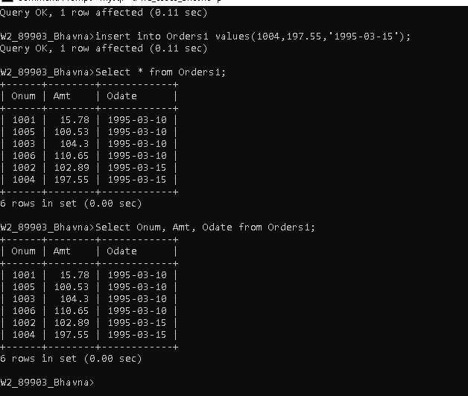

2. Write a query that produces all rows from the Customers table for which the

salesperson’s number is 1001. select * from Customers where Snum = 1001;

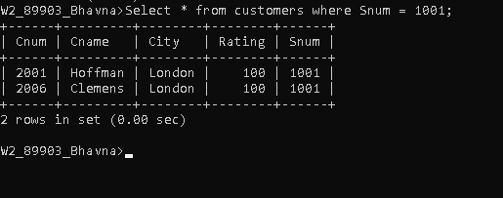

3. Write a query that displays the Salespeople table with the columns in the following order: city, sname, snum, comm.

select City,Sname,Comm from salespeople;

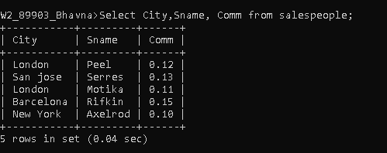

4. Write a select command that produces the rating followed by the name of each customer in San Jose. select Rating,Cname from Customers where city = ‘San Jose’;

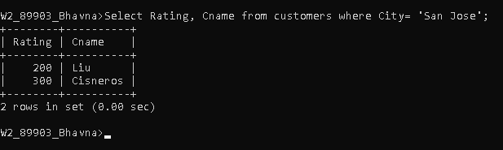

5. Write a query that will produce the snum values of all salespeople (suppress the duplicates) with orders in the Orders table.

select distinct Snum from Orders;

