**ASSIGNMENT -05**

**Relational and Logical Operators.**

**1. Write a query that will give you all orders for more than Rs. 1,000.**

→ Command = select * from Orders where Amt > 1000;

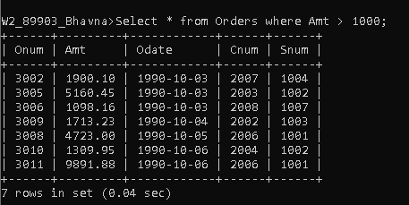

**2.Write a query that will give you the names and cities of all salespeople in London with a commission above .10.**

→Command = select Sname,City from salspeople where City ='London' and Comm > .10;

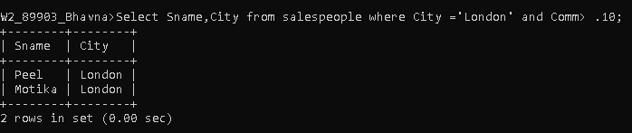

**3. Write a query on the Customers table whose output will exclude all customers with a rating <= 100, unless they are located in Rome**.

→Command = select * from Customers where Rating > 100 or City = 'Rome';

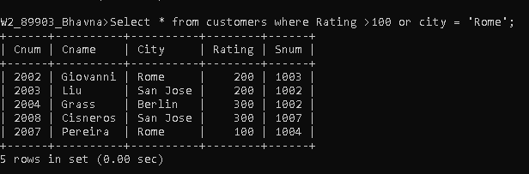

**4. What will be the output from the following query?** Select * from Orders where (amt < 1000 OR NOT (odate = ‘1990-10-03’ AND cnum > 2003));

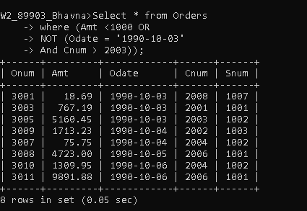

**5. What will be the output of the following query?** Select * from Orderswhere NOT ((odate = ‘1990-10-03’ OR snum>1006) AND amt >= 1500);

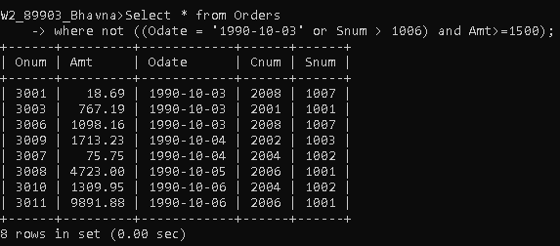

**6. What is a simpler way to write this query?** Select snum, sname, city, comm From Salespeoplewhere (comm > .12 OR comm <.14);

→Command = select * from salspeople;

