**Assignment 6**

1.Write two different queries that would produce all orders taken on October 3rd or 4 th, 1990.

select * from orders where Odate = ‘1990-10-03’ OR ‘1990-10-04’;

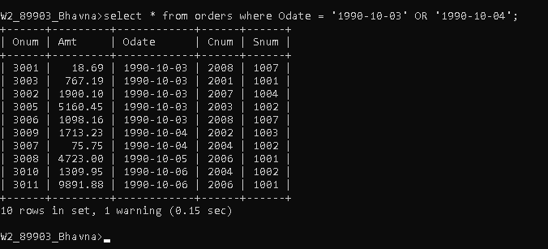

2) Write a query that selects all of the customers serviced by Peel or Motika. (Hint: the snum field relates the two tables to one another).

Select * from customers where Snum=1001 or Snum = 1004;

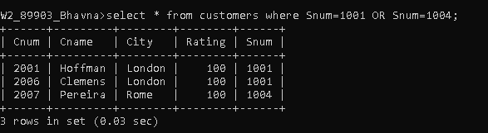

3) Write a query that will produce all the customers whose names begin with a letter from ‘A’ to ‘G’.

Select Cname from customers where Cname >=’A’ and Cname<=’H’;

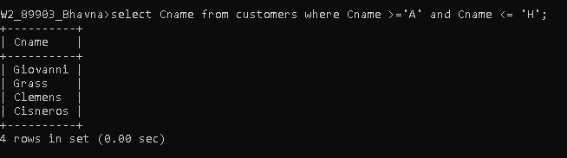

4) Write a query that selects all customers whose names begin with the letter ‘C’.

select Cname from customers where Cname >=’B’ and Cname <= ‘D’;

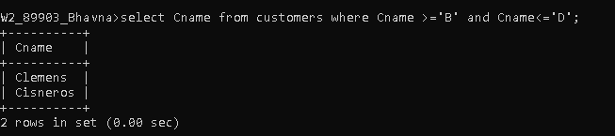

5) Write a query that selects all orders except those with zeroes or NULLs in the amt field.

select * from orders where Amt>0 or Amt!=null;

