Algorithm Visualization

Algorithms are a fundamental learning tool to problem-solving. Whenever there is a problem which presents itself, we always prefer to go step by step to resolve that problem. But, sometimes, the steps seem to be so complicated that it becomes difficult to understand the algorithm. And, for a beginner in this field, understanding the concept of pseudo code and algorithms is a difficult concept as I, myself, faced the same problems when I first started learning about algorithms and different data structures.

1. Home Page of the Dashboard: This is the entry point of the project. In this page, there are options to navigate to the respective algorithms to visualize. On clicking in the box of the respective algorithm, it is redirected to the respective algorithm page. Also, if the pointer is hovered over the image, a different image is rendered. hierarchy.html is the home page of the project.
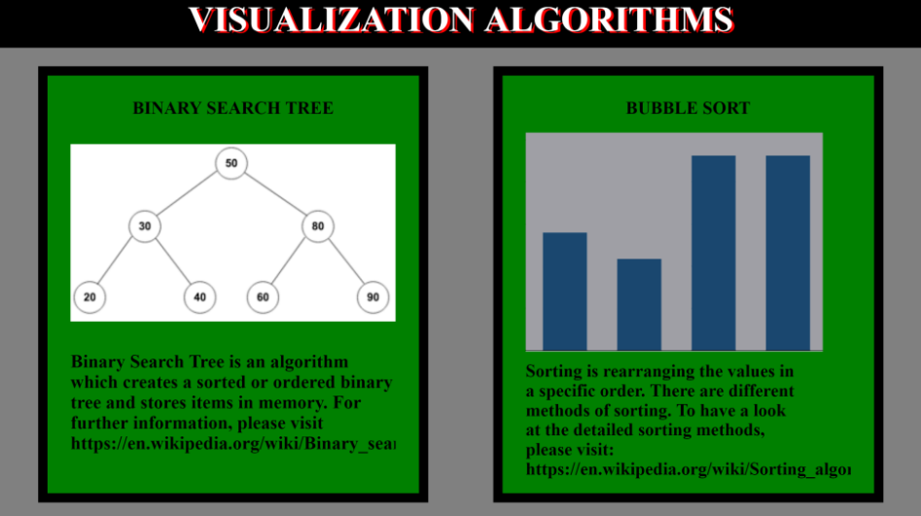
Figure 1: Dashboard

2. Binary Search Tree (Algorithm 1): Once, the Binary Search Tree box is clicked, it is redirected to the BST page. In this page, there is one text box to enter the node of the tree to be created, and another to clear the tree and to start a new tree. Once a number is entered, it is appended to the tree. The first value entered is automatically the root of the tree, and the subsequent values entered are inserted into the tree according to the algorithm.

The algorithm states that if a value entered is less than the parent node, then it is inserted to the left of the parent, otherwise it is inserted to the right of the parent. After the completion of the BST, the left side to the root will have all values less than the root and the right side will have all the values greater than the root. Figure 2 shows the initial state of the page, and figure 3 shows the generated BST and displays the order in which the numbers were entered and where they are placed.
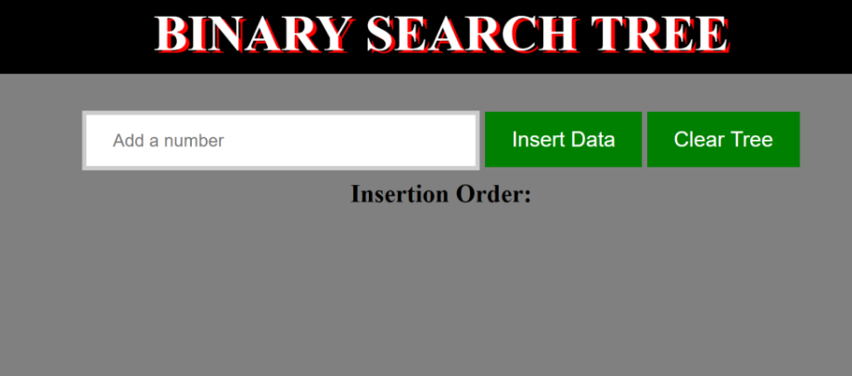
Figure 2: Home page for BST
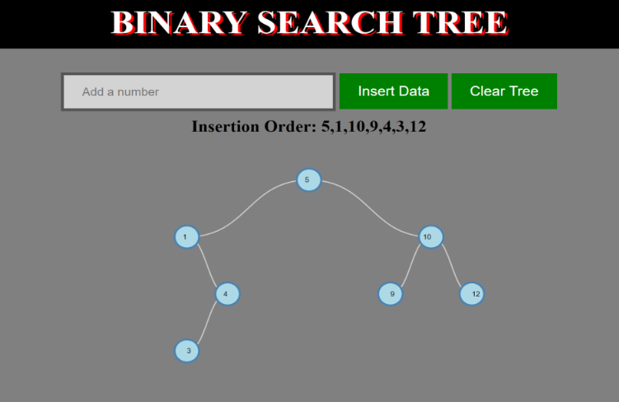
Figure 3: BST

3. Bubble Sorting (Algorithm 2): Once the bubble sort box is clicked, it is redirected to the bubble sort page. Like the BST implementation, bubble sort also has one text box to enter the numbers to sort. It also has a few buttons for various tasks like inserting the numbers, creating bar chart, sorting the data in both ascending and descending order, and to reset the sorted array to the initial unsorted array.
Bubble sort is the method of sorting data in either ascending or descending order by swapping the adjacent numbers if they are in wrong order. This swapping is repeated till the complete dataset is in correct order. It iterates multiple times over the list till it is completely sorted.
In this implementation, the swapping of the bars is shown by highlighting the two bars to be swapped in red and they are then exchanged according to the logic written.
Figure 4 shows the initial bar chart page with the unsorted array displayed as initial dataset entered and the bar chart created. Figure 5 shows the swapping of the bars according to the descending order and the final output is also displayed in the Sorted Array field.
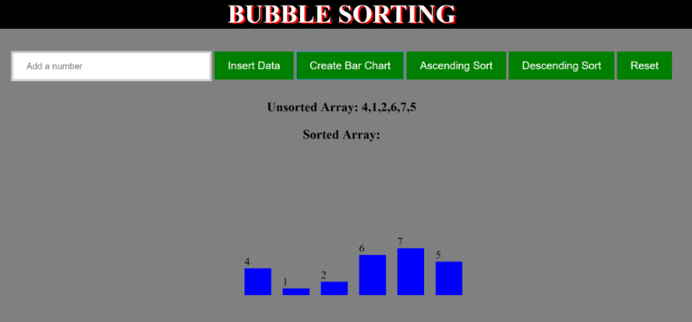
Figure 4: Initial Bar Chart
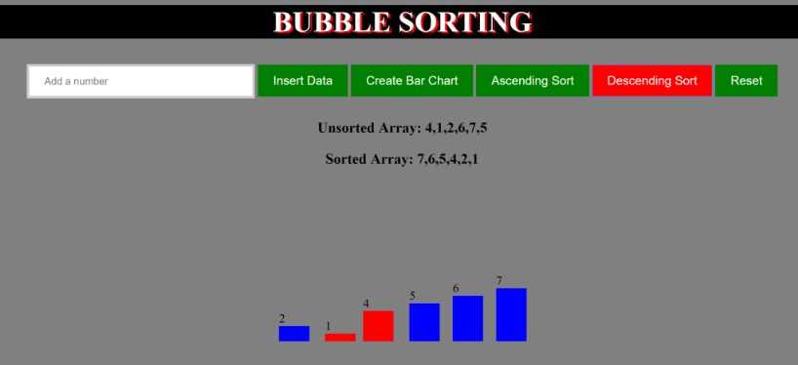
Figure 5: Sorted Bar Chart

