Jaypee Institute of Information Technology, Noida
Department of Computer Applications



Project Title: Air Quality Prediction in Indian Cities

Enrollment No. Name of Student
992509260003 Bhavninder Virk

Course Name: Introduction to Data Science
Program: MS in Data and Business Analytics
1st Sem

2025 – 2026
Contents
1. Summary 3
Brief Overview of the Project 3
Objectives 3
Key Findings 3
2. Introduction 4
2.1 Background and Context 4
2.2 Problem Statement 4
2.3 Project Objectives 4
2.4 Scope of the Project 4
3. Tools and Libraries Used 5
3.1 Software Requirements 5
3.2 Python Packages / Libraries 5
4. Data Collection and Preprocessing 5
4.1 Data Sources 5
4.2 Data Cleaning Techniques 5
5. Analysis and Implementation 6
5.1 Data Exploration and Visualization 6
5.2 Algorithms and Models Used 9
5.3 Code Snippets with Explanation 9
6. Results and Discussion 10
6.1 Model Evaluation 10
6.2 Findings and Feature Importance 10
6.3 Discussion 11
7. Conclusion 12
7.1 Summary and Achievement of Objectives 12
7.2 Future Work and Recommendations 12
8. References 12

1. Summary

Brief Overview of the Project
This project addresses the critical environmental and health challenge of air pollution in India by employing data science techniques to analyze and forecast short-term Air Quality Index (AQI) levels in major Indian cities. The methodology involved EDA, regression modeling, and ensemble learning (Random Forest) to integrate and interpret heterogeneous data on pollutants and weather factors.

Objectives
- To collect and preprocess AQI and pollutant data from multiple sources (CPCB, OpenAQ, AccuWeather).
- To analyze pollution patterns and identify the most influential features affecting AQI.
- To develop and evaluate a robust predictive model for short-term AQI forecasting.

Key Findings
- The Random Forest Regressor model (R² = 0.950) significantly outperformed the Linear Regression baseline (R² = 0.814).
- PM2.5 was identified as the most influential feature for AQI prediction.
- PM10 had the highest average concentration among all measured pollutants.
- The city with the highest average combined pollutant levels was Delhi.

2. Introduction

2.1 Background and Context
Air pollution is a pressing environmental and health challenge in India, with major cities frequently reporting unhealthy AQI levels due to high concentrations of PM2.5 and PM10. The availability of data from sources like the Central Pollution Control Board (CPCB) [1] allows for the application of machine learning to understand and predict these trends, which is crucial for public health and environmental governance.

2.2 Problem Statement
The need for a reliable, data-driven system to forecast short-term AQI trends is critical to enable timely preventative measures by policymakers and public awareness efforts. This project aims to solve this by creating a highly accurate predictive model.

2.3 Project Objectives
The main objectives of this study are: - To establish a clean, integrated dataset of AQI, pollutant concentrations, and weather data.
- To perform EDA to study city-wise and seasonal pollution trends.
- To apply and compare Linear Regression and Random Forest Regressor models to predict the AQI_proxy.

2.4 Scope of the Project
The scope is focused on the data collected for the five cities of Chennai, Bengaluru, Kolkata, Delhi, and Mumbai. The primary deliverable is the evaluation and comparison of supervised learning models for AQI prediction.

3. Tools and Libraries Used

3.1 Software Requirements
- Programming Language: Python
- Development Environment: Jupyter Notebook / Google Colab

3.2 Python Packages / Libraries
- Data Handling: pandas, numpy
- Visualization: matplotlib, seaborn
- Machine Learning: scikit-learn (LinearRegression, RandomForestRegressor)
- Evaluation: sklearn.metrics (MAE, RMSE, R²)
- Data Collection: BeautifulSoup, requests, selenium

4. Data Collection and Preprocessing

4.1 Data Sources
Data was collected from three primary sources: - Central Pollution Control Board (CPCB) [1]: Official AQI and pollutant readings.
- OpenAQ [2]: Global air quality data.
- AccuWeather [3]: Meteorological data (Temperature, Humidity, WindSpeed) obtained via web scraping.

4.2 Data Cleaning Techniques
- The initial integrated dataset had a shape of (65288, 16).
- Data Type Conversion: The ‘Datetime’ column was converted to datetime objects.
- Missing Value Handling: Rows with missing ‘City’ or ‘Datetime’ were dropped. Remaining missing numerical values (e.g., in PM2.5, NO₂, Temperature_C) were handled by median imputation.
- Duplicate Removal: Duplicate records were removed to ensure data quality.

5. Analysis and Implementation

5.1 Data Exploration and Visualization
- City Distribution: A count plot showed a balanced distribution of data points across the five included cities.

- Pollutant Trends: A bar plot of mean concentration confirmed that PM10 had the highest average level, followed by PM2.5.

- AQI Classification: AQI was classified into standard categories (Good, Satisfactory, Moderate, Poor, etc.). The majority of the air quality was categorized as Satisfactory and Moderate.

- Correlation: A heatmap visualized the relationships between pollutants and weather factors.

5.2 Algorithms and Models Used
- The dataset was split into 80% training and 20% testing sets.
- Linear Regression (LR): Used as a baseline predictive model.
- Random Forest Regressor (RF): Used for improved prediction, leveraging its ability to handle non-linearity.

5.3 Code Snippets with Explanation
def eval_model(y_true, y_pred, model_name):
# Calculates and prints MAE, RMSE, and R² for a model
print(f"\n {model_name} Evaluation:")
print("MAE :", round(mean_absolute_error(y_true, y_pred), 2))
print("RMSE:", round(np.sqrt(mean_squared_error(y_true, y_pred)), 2))
print("R² :", round(r2_score(y_true, y_pred), 3))

6. Results and Discussion

6.1 Model Evaluation
The models were evaluated using MAE, RMSE, and R²:
Model | MAE | RMSE | R²
Linear Regression | 18.06 | 28.52 | 0.814
Random Forest | 9.07 | 15.01 | 0.950
The Random Forest Regression demonstrated significantly better performance, achieving an R² of 0.950. This high value indicates that the RF model is exceptionally accurate in capturing the complex relationships required to predict AQI.

6.2 Findings and Feature Importance
- Feature Importance: Analysis from the Random Forest model showed that PM2.5 was the most influential feature for AQI prediction.
- 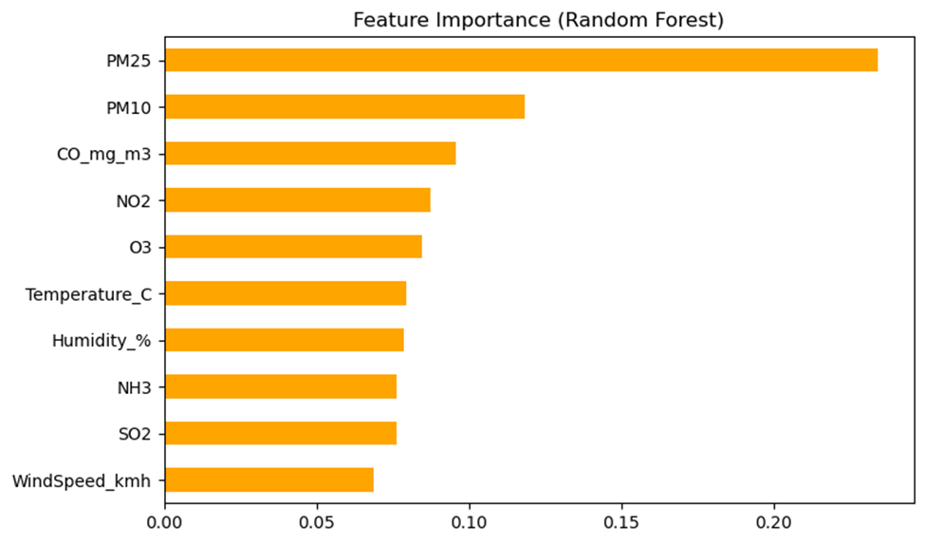City-Wise Insights: The city of Delhi was identified as having the highest average combined pollutant levels, suggesting it should be a priority for mitigation efforts.

6.3 Discussion
The successful implementation of the RF model validated the use of pollutant and meteorological factors for short-term AQI prediction. The confirmed high importance of PM2.5 aligns with established environmental science and provides a clear focus for pollution control strategies. The visualization of actual vs. predicted values demonstrated a strong fit, reinforcing the model’s reliability.

7. Conclusion

7.1 Summary and Achievement of Objectives
This project successfully applied data science methods to air quality prediction, achieving its core objectives. By integrating multi-source data and developing a highly accurate Random Forest Regressor model (R² = 0.950), the project provides a robust tool for forecasting short-term AQI and generating data-driven insights.

7.2 Future Work and Recommendations
To further extend this work, it is recommended to: - Time Series Modeling: Implement and compare dedicated time series models (e.g., ARIMA, Prophet) for more accurate long-range AQI forecasting.
- Advanced Feature Engineering: Incorporate and analyze derived features such as seasonal indicators and time-based variables to capture deeper temporal patterns.
- Deployment: Develop a user-friendly dashboard or web application to make the AQI forecasts and insights publicly accessible for greater impact.

8. References
[1] Central Pollution Control Board, National Air Quality Monitoring Programme (NAMP).
[2] OpenAQ, Open Air Quality Data Platform.
[3] AccuWeather, Weather and Air Quality Data.
[4] G. E. P. Box, G. M. Jenkins, and G. C. Reinsel, Time Series Analysis: Forecasting and Control, 5th ed., Wiley, 2015.
[5] C. M. Bishop, Pattern Recognition and Machine Learning. Springer, 2006.
[6] J. Brownlee, Introduction to Time Series Forecasting with Python. Machine Learning Mastery, 2017.

