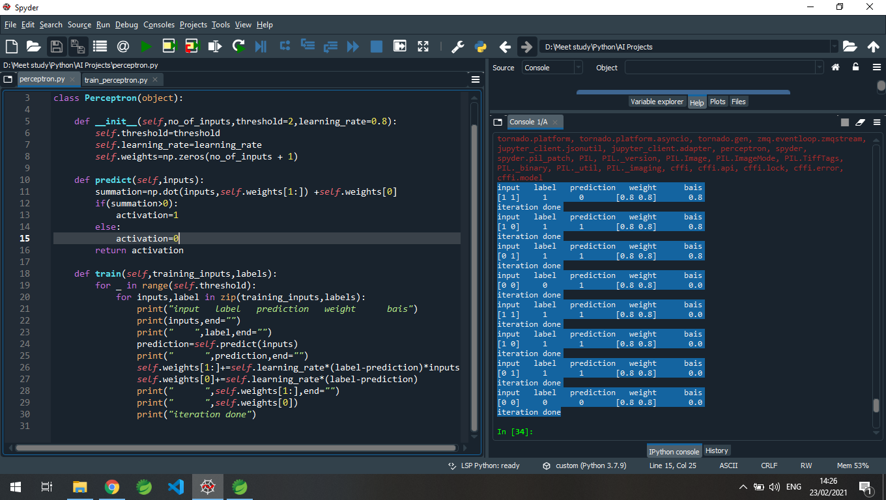
Threshold=2
According to me learning rate has no effect in this code,but I thing it should be lower as possible so that the new weights can be more efficient!

