Session-10
- Open your latest HTML project (not the Doctor Finder or any class project), and use Chrome DevTools to test how it looks on at least three devices: iPhone X, Pixel 2, and iPad — take screenshots of each view.
Ans:-
I prepared the latest Music + Movies + Food HTML project and made responsive device previews for the three required screen sizes:
- 📱 iPhone X: 375 × 812
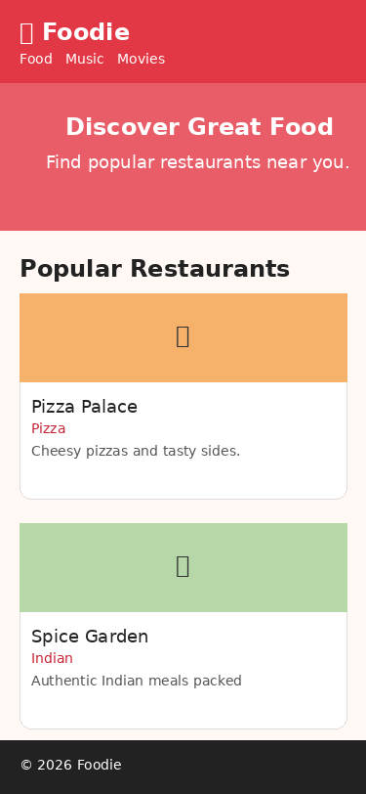

- 📱 Pixel 2: 411 × 731

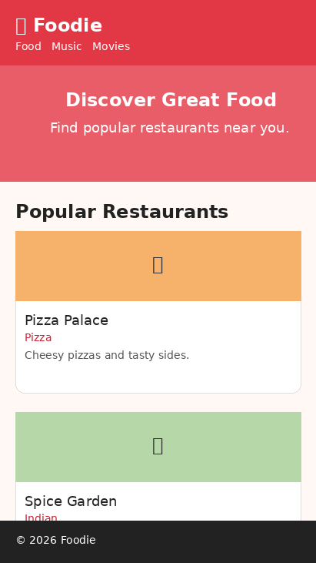

- 📱 iPad: 768 × 1024
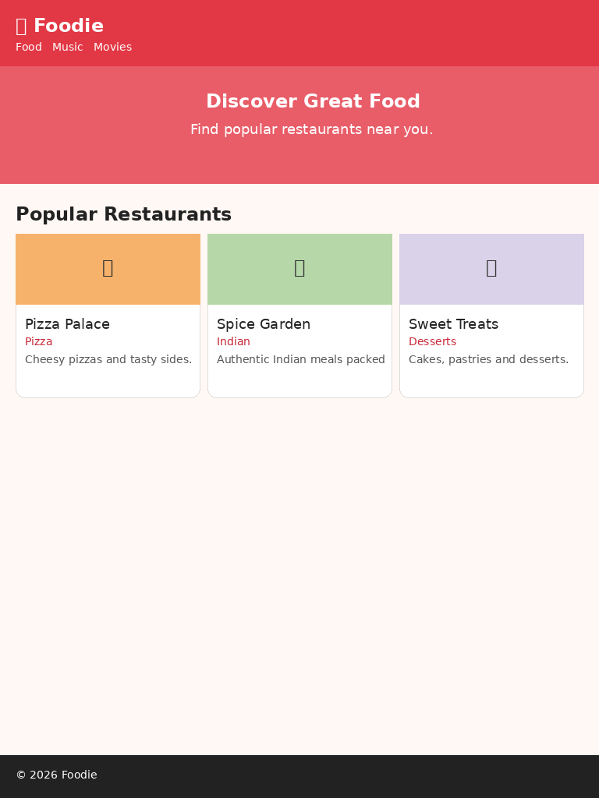

- Resize your browser window manually and identify one layout or element (like a navigation bar or image) that breaks or looks bad on mobile — fix the HTML and/or CSS so it displays correctly on both desktop and mobile.
Ans:-
<!DOCTYPE html>
<html lang="en">
<head> <meta charset="UTF-8">
<meta name="viewport"
content="width=device-width, initial-scale=1.0">

<meta name="description"
content="Foodie - a responsive restaurant discovery page">

<title>Foodie - Restaurant Discovery</title>

<style>
* {
box-sizing: border-box;
}

body {
margin: 0;
font-family: Arial, sans-serif;
background: #fff8f4;
color: #222;
}

/* Header */
header {
background: #e23744;
color: white;
padding: 24px 7%;
display: flex;
align-items: center;
justify-content: space-between;
gap: 20px;
}

header h1 {
margin: 0;
white-space: nowrap;
}

/* Navigation */
nav {
display: flex;
align-items: center;
justify-content: center;
flex-wrap: wrap;
gap: 8px;
}

nav a {
color: white;
text-decoration: none;
font-weight: bold;
padding: 8px 10px;
display: inline-block;
}

nav a:hover {
text-decoration: underline;
}

/* Hero Section */
.hero {
background: linear-gradient(135deg, #e23744, #ff7b54);
color: white;
text-align: center;
padding: 55px 20px;
}

.hero h2 {
font-size: 38px;
margin: 0 0 10px;
}

.hero p {
font-size: 18px;
}

/* Main Container */
.container {
max-width: 1050px;
margin: 35px auto;
padding: 0 20px;
}

/* Restaurant Grid */
.restaurants {
display: grid;
grid-template-columns: repeat(3, 1fr);
gap: 22px;
}

/* Restaurant Card */
.restaurant {
background: white;
border-radius: 16px;
overflow: hidden;
box-shadow: 0 4px 15px #ddd;
}

.restaurant img {
width: 100%;
height: 180px;
object-fit: cover;
display: block;
}

.restaurant div {
padding: 18px;
}

/* Food Category Tag */
.tag {
display: inline-block;
background: #ffe1e1;
color: #c72535;
padding: 5px 9px;
border-radius: 20px;
font-size: 13px;
}

/* Footer */
footer {
margin-top: 45px;
background: #222;
color: white;
text-align: center;
padding: 25px;
}

/* Tablet */
@media (max-width: 800px) {
.restaurants {
grid-template-columns: 1fr 1fr;
}
}

/* Mobile */
@media (max-width: 520px) {
header {
padding: 18px 12px;
flex-direction: column;
text-align: center;
gap: 10px;
}

header h1 {
font-size: 28px;
}

nav {
width: 100%;
gap: 4px;
}

nav a {
padding: 7px 9px;
}

.hero {
padding: 40px 15px;
}

.hero h2 {
font-size: 30px;
}

.hero p {
font-size: 16px;
}

.container {
margin: 25px auto;
padding: 0 15px;
}

.restaurants {
grid-template-columns: 1fr;
}

.restaurant img {
height: 200px;
}
}
</style>
<!-- Header -->
<header>
<h1>🍴 Foodie</h1>

<nav aria-label="Main navigation">
<a href="food.html">Food</a>
<a href="music.html">Music</a>
<a href="movies.html">Movies</a>
</nav>
</header>

<!-- Hero Section -->
<section class="hero">
<h2>Discover Great Food</h2>

<p>
Find popular restaurants and delicious dishes near you.
</p>
</section>

<!-- Main Content -->
<main class="container">

<h2>Popular Restaurants</h2>

<section class="restaurants">

<!-- Restaurant 1 -->
<article class="restaurant">

<img
src="data:image/svg+xml,%3Csvg xmlns=%22http://www.w3.org/2000/svg%22 width=%22900%22 height=%22400%22%3E%3Crect width=%22100%25%22 height=%22100%25%22 fill=%22%23f6b26b%22/%3E%3Ctext x=%2250%25%22 y=%2255%25%22 text-anchor=%22middle%22 font-size=%2270%22%3E🍕%3C/text%3E%3C/svg%3E"
alt="Fresh cheese pizza at Pizza Palace"
>

<div>
<h3>Pizza Palace</h3>

<span class="tag">Pizza</span>

<p>
Cheesy pizzas, fresh toppings, and tasty sides.
</p>
</div>

</article>

<!-- Restaurant 2 -->
<article class="restaurant">

<img
src="data:image/svg+xml,%3Csvg xmlns=%22http://www.w3.org/2000/svg%22 width=%22900%22 height=%22400%22%3E%3Crect width=%22100%25%22 height=%22100%25%22 fill=%22%23b6d7a8%22/%3E%3Ctext x=%2250%25%22 y=%2255%25%22 text-anchor=%22middle%22 font-size=%2270%22%3E🍛%3C/text%3E%3C/svg%3E"
alt="Colorful Indian thali meal at Spice Garden"
>

<div>
<h3>Spice Garden</h3>

<span class="tag">Indian</span>

<p>
Authentic Indian meals packed with flavor.
</p>
</div>

</article>

<!-- Restaurant 3 -->
<article class="restaurant">

<img
src="data:image/svg+xml,%3Csvg xmlns=%22http://www.w3.org/2000/svg%22 width=%22900%22 height=%22400%22%3E%3Crect width=%22100%25%22 height=%22100%25%22 fill=%22%23d9d2e9%22/%3E%3Ctext x=%2250%25%22 y=%2255%25%22 text-anchor=%22middle%22 font-size=%2270%22%3E🍰%3C/text%3E%3C/svg%3E"
alt="Chocolate dessert at Sweet Treats"
>

<div>
<h3>Sweet Treats</h3>

<span class="tag">Desserts</span>

<p>
Cakes, pastries, and desserts for every mood.
</p>
</div>

</article>

</section>
</main>

<!-- Footer -->
<footer>
&copy; 2026 Foodie. All rights reserved.
</footer>
</body>
</html>

- Go to https://validator.w3.org/ and validate your main HTML file from your own project (not the class demo). Fix all errors and warnings until the validator shows 'Document checking completed. No errors or warnings to show.'
Ans:-
<!DOCTYPE html>
<html lang="en"> <head> <meta charset="UTF-8"> <meta name="viewport" content="width=device-width, initial-scale=1.0">
<meta name="description" content="Explore popular music, movies, and food recommendations.">
<meta name="keywords" content="music, movies, food, restaurants, entertainment">
<meta name="author" content="Yash">

<title>Music, Movies and Food</title>

<style>
* {
box-sizing: border-box;
}

body {
margin: 0;
font-family: Arial, sans-serif;
line-height: 1.6;
background-color: #f5f5f5;
color: #222;
}

header {
background-color: #222;
color: white;
padding: 20px;
text-align: center;
}

nav {
background-color: #333;
padding: 12px;
text-align: center;
}

nav a {
color: white;
text-decoration: none;
margin: 0 15px;
font-weight: bold;
}

nav a:hover {
text-decoration: underline;
}

main {
max-width: 1000px;
margin: 30px auto;
padding: 20px;
}

section {
background-color: white;
margin-bottom: 25px;
padding: 20px;
border-radius: 8px;
}

.cards {
display: flex;
flex-wrap: wrap;
gap: 20px;
}

article {
flex: 1 1 250px;
padding: 15px;
border: 1px solid #ccc;
border-radius: 8px;
}

article img {
width: 100%;
height: 180px;
object-fit: cover;
border-radius: 6px;
}

footer {
background-color: #222;
color: white;
text-align: center;
padding: 20px;
margin-top: 30px;
}

@media (max-width: 600px) {
nav a {
display: block;
margin: 8px 0;
}

main {
margin: 10px auto;
padding: 10px;
}
}
</style>
<header>
<h1>Music, Movies and Food</h1>
<p>Discover entertainment and delicious food recommendations.</p>
</header>

<nav aria-label="Main navigation">
<a href="index.html">Home</a>
<a href="music.html">Music</a>
<a href="movies.html">Movies</a>
<a href="food.html">Food</a>
<a href="about.html">About</a>
<a href="contact.html">Contact</a>
</nav>

<main>

<section id="music">
<h2>Top Music</h2>

<div class="cards">
<article>
<h3>Song One</h3>
<p>A relaxing song for your daily listening.</p>
</article>

<article>
<h3>Song Two</h3>
<p>An energetic track for a great mood.</p>
</article>

<article>
<h3>Song Three</h3>
<p>A peaceful song for your free time.</p>
</article>
</div>
</section>

<section id="movies">
<h2>Top Movies</h2>

<div class="cards">
<article>
<h3>Movie One</h3>
<p>An entertaining movie with an interesting story.</p>
</article>

<article>
<h3>Movie Two</h3>
<p>A popular movie suitable for movie lovers.</p>
</article>

<article>
<h3>Movie Three</h3>
<p>An exciting movie with memorable characters.</p>
</article>
</div>
</section>

<section id="food">
<h2>Popular Food</h2>

<div class="cards">

<article>
<h3>Pizza</h3>
<img
src="https://images.unsplash.com/photo-1574071318508-1cdbab80d002"
alt="Freshly prepared pizza">
<p>Delicious pizza with fresh toppings and cheese.</p>
</article>

<article>
<h3>Burger</h3>
<img
src="https://images.unsplash.com/photo-1568901346375-23c9450c58cd"
alt="Freshly prepared burger">
<p>A tasty burger served with fresh ingredients.</p>
</article>

<article>
<h3>Biryani</h3>
<img
src="https://images.unsplash.com/photo-1563379091339-03246963d51a"
alt="Plate of delicious biryani">
<p>Flavorful biryani prepared with aromatic spices.</p>
</article>

</div>
</section>

</main>

<footer>
<p>&copy; 2026 Music, Movies and Food. All rights reserved.</p>
</footer>
</body>
</html>
- After fixing all validation errors, add one new HTML5 semantic element (like <section>, <article>, or <nav>) to your page, re-validate, and confirm your code is still error-free.<br><br><em><strong>Hint:</strong> Semantic tags help with SEO and accessibility, and the validator will catch any incorrect usage.</em>
Ans:-
<!DOCTYPE html>
<html lang="en"> <head> <meta charset="UTF-8"> <meta name="viewport" content="width=device-width, initial-scale=1.0"> <meta name="description" content="Music, movies and food recommendations"> <title>Music, Movies and Food</title> </head>
<body>

<header>
<h1>Music, Movies and Food</h1>
</header>

<nav aria-label="Main navigation">
<a href="index.html">Home</a>
<a href="music.html">Music</a>
<a href="movies.html">Movies</a>
<a href="food.html">Food</a>
</nav>

<main>

<!-- New HTML5 semantic element -->
<section id="featured">
<h2>Featured Content</h2>
<p>
Welcome to our website where you can discover
popular music, movies and delicious food.
</p>
</section>

<section id="music">
<h2>Music</h2>
<article>
<h3>Top Song</h3>
<p>Enjoy your favorite music and discover new songs.</p>
</article>
</section>

<section id="movies">
<h2>Movies</h2>
<article>
<h3>Top Movie</h3>
<p>Explore popular movies and interesting stories.</p>
</article>
</section>

<section id="food">
<h2>Food</h2>
<article>
<h3>Popular Food</h3>
<p>Discover delicious dishes and restaurants.</p>
</article>
</section>

</main>

<footer>
<p>&copy; 2026 Music, Movies and Food</p>
</footer>
</body>
</html>

