CONTAINER HEALTH MONITOR
Automated Container Health Monitoring and Real-Time Event Notifications via Webhooks and Discord API Integration
Detailed Project Report
Submitted by
[Student Name] - [Roll Number]
[Partner Name] - [Roll Number]
B.Tech Computer Engineering, Final Year
K.J. Somaiya School of Engineering, Mumbai
DevOps Mini Project
October 2026
Project folder: devops-container-monitor

Abstract
Containers make deployment repeatable, but a running container is not necessarily a healthy application. Without continuous observation, failures can remain unnoticed until a user reports them. This project implements an automated monitoring service that watches selected Docker containers and reports health and lifecycle changes as soon as they occur.
The solution is a Flask and Gunicorn service packaged with Docker Compose. It combines Docker event streaming with periodic health polling, records every accepted event in SQLite, exposes a live browser dashboard and REST API, and posts structured notifications to Discord through the Discord Webhook API. Only containers carrying the label health-monitor.enabled=true are observed, which prevents alerts from unrelated local containers.
A healthy Nginx service and an intentionally unhealthy Alpine service make the complete workflow repeatable in the laboratory. Shared-secret authentication protects inbound webhook and test-alert routes, a cooldown suppresses repeated matching alerts, and network requests use a fixed timeout. The report documents the architecture, monitoring logic, container deployment, configuration, security controls, tests, demonstration procedure and limitations.
Keywords: Docker, container health, event monitoring, Flask, SQLite, webhooks, Discord API, Docker Compose, real-time notifications.

Table of contents
1. Introduction 6
1.1 Background 6
1.2 Problem statement 6
1.3 Objectives 6
1.4 Scope 7
2. Background and related concepts 8
2.1 Docker health checks 8
2.2 Docker event stream 8
2.3 Webhook notifications 8
2.4 Persistent event records 8
2.5 Controlled operational response 8
3. Technology stack 9
3.1 Components 9
3.2 Python dependencies 10
4. System architecture 11
4.1 Monitoring architecture 11
4.2 Service dependencies 12
4.3 Event triggers 12
4.4 Repository structure 12
5. Monitoring application design 13
5.1 Features 13
5.2 Endpoints 13
5.3 Event data model 14
5.4 Event lifecycle 15
6. Automated monitoring and notification pipeline 16
6.1 Stage 1: event collection and health polling 16
6.2 Stage 2: normalization and Discord delivery 16
6.3 Stage 3: persistence and dashboard update 17
6.4 Alert behaviour 17
7. Containerisation and demonstration services 18
7.1 Dockerfile 18
7.2 Demonstration services 18
7.3 Reset and test tooling 19
8. Environment configuration 20
9. End-to-end workflow 22
10. Conclusion and future work 23
10.1 Conclusion 23
10.2 Future work 23
References 24

List of figures
Figure 1: Technology stack by layer
Figure 2: High-level monitoring architecture
Figure 3: Service dependency graph
Figure 4: Endpoint map and request handling
Figure 5: Persistent event data model
Figure 6: Container event lifecycle
Figure 7: Demonstration state transitions
Figure 8: Secrets and configuration sources
Figure 9: End-to-end monitoring workflow

List of tables
Table 1: Technology components and roles
Table 2: Dependency matrix
Table 3: Event triggers
Table 4: Route summary
Table 5: Collection and polling steps
Table 6: Notification delivery steps
Table 7: Reliability and security summary
Table 8: Dockerfile instructions
Table 9: Demonstration container states
Table 10: Demonstration profiles
Table 11: Configuration reference

1. Introduction

1.1 Background
Containerisation shortens the path from development to deployment by packaging an application with its runtime and dependencies. Operational visibility still needs separate automation. A process may remain running while its service is unable to answer requests, a dependency has failed, or an internal health check is reporting an error. Docker health checks expose this difference by classifying a container as starting, healthy or unhealthy.
Manual commands such as docker ps provide only a snapshot when an operator asks for it. They do not create a history or alert anyone at the time of failure. Docker events, periodic inspection and a notification channel can close that gap. Discord is used in this project because its webhook API accepts structured HTTPS messages and gives the lab team an immediate, visible alert without operating a separate messaging server.

1.2 Problem statement
A small DevOps team needs to know when a selected container becomes unhealthy, stops, restarts, is killed or experiences another important lifecycle event. The project addresses three gaps:
- Health and lifecycle failures require repeated manual checking.
- Events are lost when they are not stored in an audit history.
- Notifications must be timely without flooding the channel with duplicates.

1.3 Objectives
- Build a containerised monitoring service for a local Docker Engine.
- Combine the Docker event stream with periodic polling for reliable detection.
- Send structured real-time alerts through the Discord Webhook API.
- Persist event details and delivery outcomes in SQLite.
- Provide a dashboard, authenticated webhook intake and repeatable lab demonstration.

1.4 Scope
The project targets one local Docker Engine and explicitly labelled containers. It is designed for a classroom demonstration rather than a production cluster. The dashboard is available on localhost, the monitor mounts the Docker socket read-only, and SQLite stores the event history. Production deployment would require a restricted socket proxy, authenticated read endpoints, TLS termination, centralised storage and managed secret rotation.

2. Background and related concepts

2.1 Docker health checks
A Docker health check runs a command inside a container at a configured interval and records the result as starting, healthy or unhealthy. This gives application-level information that the running flag cannot provide. The lab uses an Nginx HTTP check as the passing example and a deliberate exit code 1 as the failing example [1].

2.2 Docker event stream
The Docker daemon publishes lifecycle and health-status events. The monitor subscribes to start, stop, die, kill, restart, out-of-memory and health-status actions. Streaming provides low latency, while a separate poller restores context after a temporary Docker connection failure and detects unhealthy containers that existed before the monitor started [2].

2.3 Webhook notifications
A webhook is an HTTPS endpoint that accepts a message from another system. Discord webhooks can publish embeds containing a title, colour, fields and timestamp. The monitor sends the container name, event type, status and JSON details, disables mention parsing and treats a timeout or non-success HTTP response as a failed delivery [4].

2.4 Persistent event records
Notifications alone are not an audit trail. Each accepted event is therefore stored in SQLite with its occurrence time, container name, event type, status, details and notification result. The dashboard reads this history even when Discord is unavailable.

2.5 Controlled operational response
Automation reports the fault but does not restart or delete containers automatically. A human operator decides how to respond after checking the dashboard, logs and alert details. This boundary keeps the classroom demonstration safe and makes every recovery action observable.

3. Technology stack
The stack is grouped into five layers (Figure 1): Docker supplies container state, the Python service collects and processes events, SQLite preserves history, Flask exposes the dashboard and API, and Discord delivers real-time notifications. Docker Compose starts the complete lab as one repeatable unit.
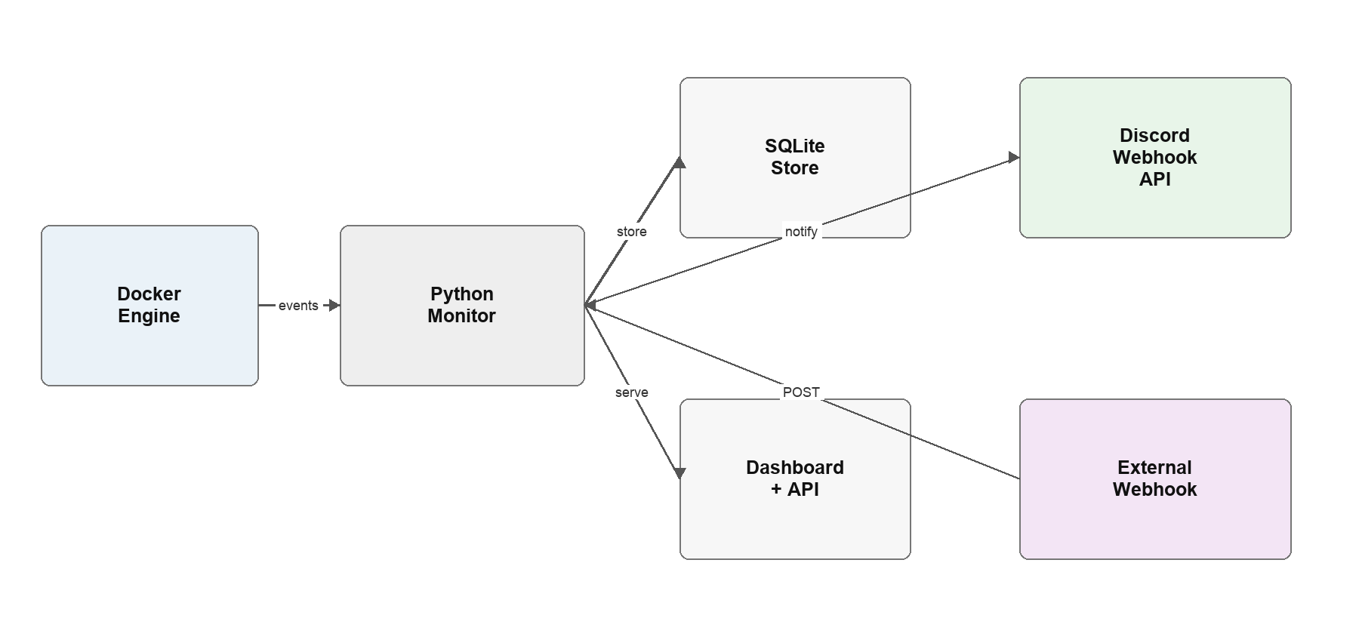
Figure 1: Technology stack by layer

3.1 Components
Table 1: Technology components and roles
Component | Role in the project
Flask 3.0.3 | Dashboard, REST routes and JSON responses
Gunicorn 22.0.0 | Production WSGI server inside the monitor container
Python 3.12 | Runtime for monitoring, storage and notification logic
Docker Engine | Container events, inspection and health status
Docker Compose | Three-service lab orchestration
Docker SDK for Python | Docker event stream and container API client
SQLite | Persistent local event audit trail
Discord Webhook API | Real-time structured alert delivery
pytest | Automated API and storage verification
Nginx and Alpine | Healthy and deliberately unhealthy demo services

3.2 Python dependencies
Table 2: Dependency matrix
Package | Version | Purpose
Flask | 3.0.3 | Dashboard, routes and JSON API
Gunicorn | 22.0.0 | Threaded WSGI server
docker | 7.1.0 | Docker Engine client
requests | 2.32.3 | Discord webhook HTTP client
pytest | 8.3.3 | Automated test runner
python-dotenv | 1.0.1 | Optional local environment loading
Werkzeug | 3.0.4 | Flask HTTP utilities

4. System architecture

4.1 Monitoring architecture
Figure 2 shows the complete flow. Labelled containers emit lifecycle and health-status events through the Docker Engine. ContainerMonitor receives the stream and also polls current state. A normalized event passes through cooldown logic, is written to SQLite and is sent to Discord. The Flask application exposes the same stored records through the dashboard and REST API. Authenticated external tools can enter the flow through the webhook endpoint.
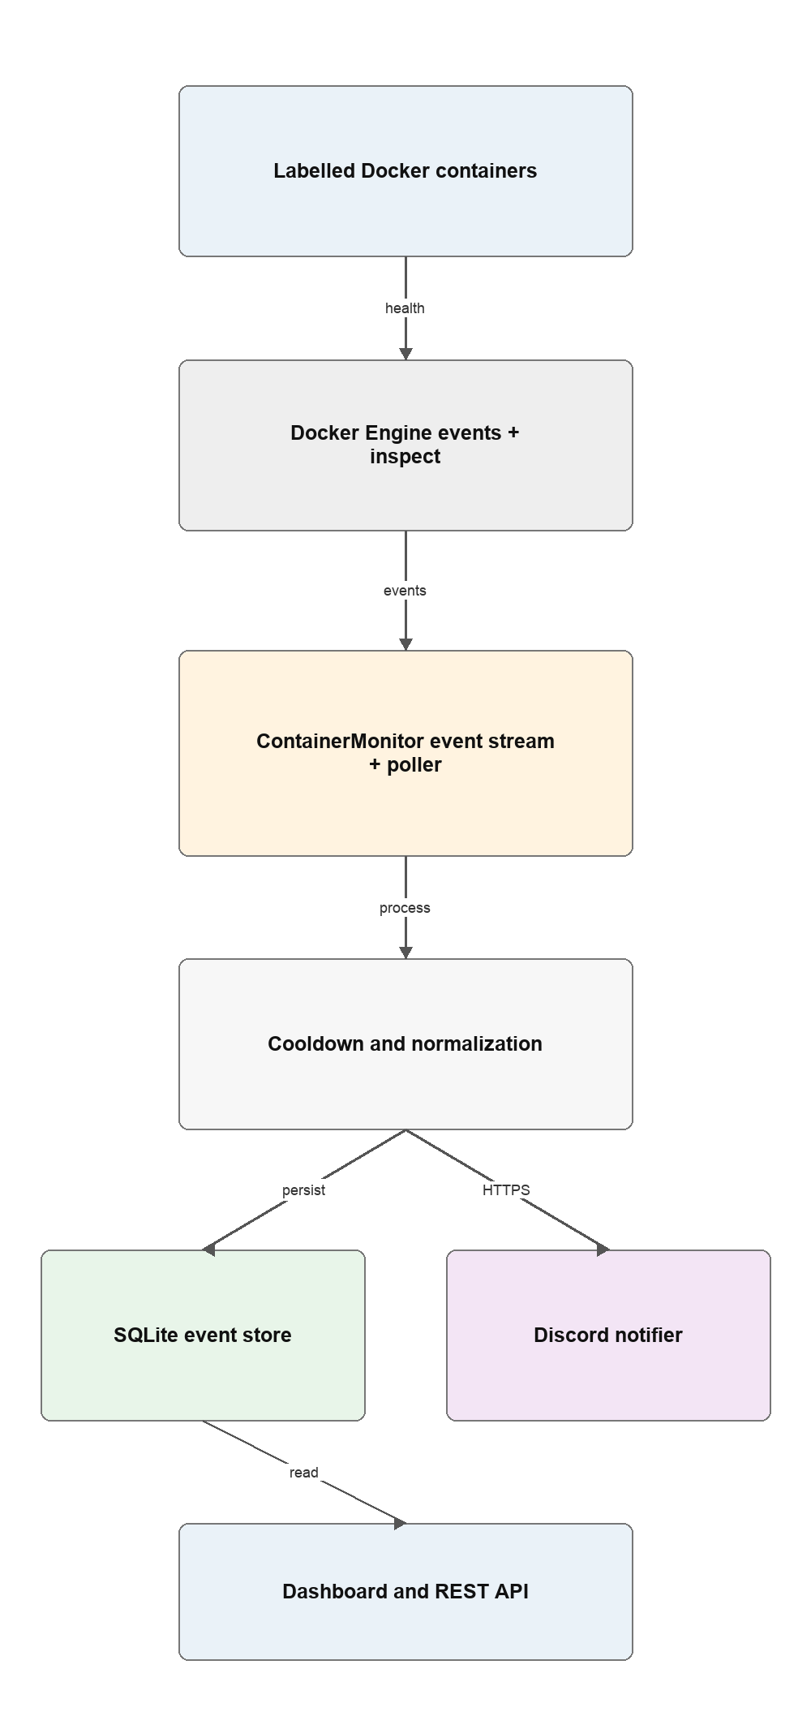
Figure 2: High-level monitoring architecture

4.2 Service dependencies
The monitoring service depends on the Docker API for container state, SQLite for local persistence and the Discord webhook endpoint for outbound notifications (Figure 3). The browser depends only on Flask endpoints, while external tools use the protected webhook route. A Discord outage does not stop event storage or dashboard access.
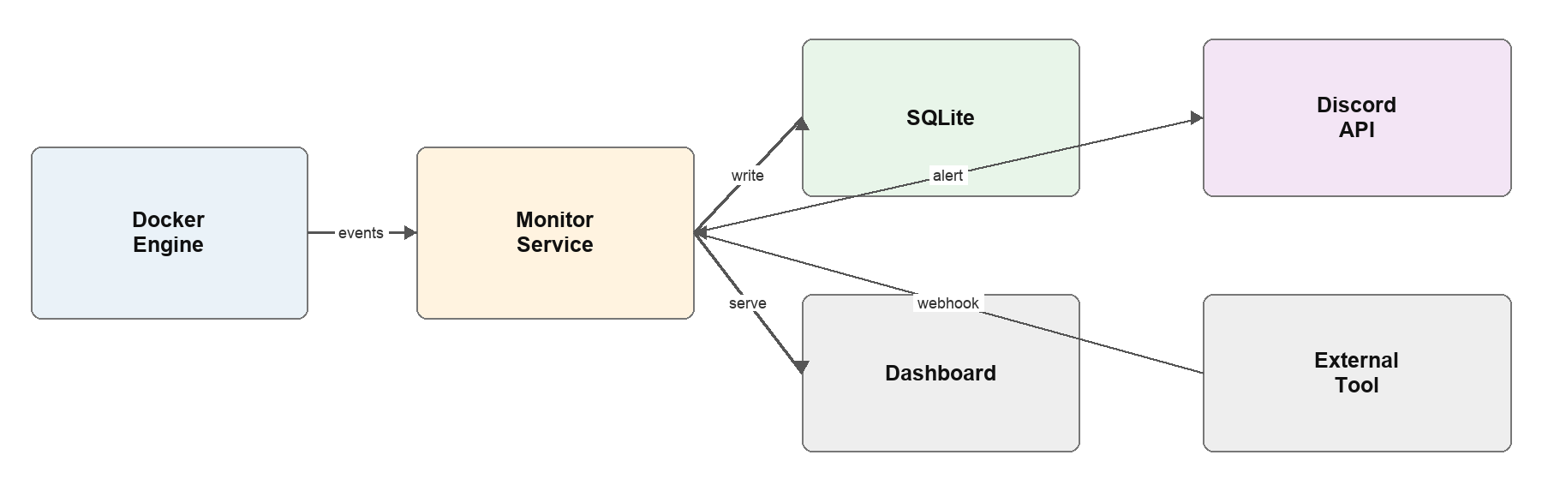
Figure 3: Service dependency graph

4.3 Event triggers
Table 3: Event triggers
Trigger | Description
Docker lifecycle event | start, stop, die, kill, restart or out-of-memory
Docker health event | health status changes to healthy or unhealthy
Periodic poll | Compares current and previous state every configured interval

4.4 Repository structure
The repository separates monitoring code, the dashboard, container configuration, tests and local data:
devops-container-monitor/
monitor.py Flask API and monitoring core
Dockerfile Monitor container image
docker-compose.yml Three-service lab stack
requirements.txt Runtime dependencies
requirements-dev.txt Test dependencies
.env.example Safe configuration example
templates/index.html Live event dashboard
tests/test_monitor.py Automated API and storage tests
README.md Setup and demonstration guide
monitor-data volume Persistent SQLite database
healthy-demo Nginx passing health check
unhealthy-demo Alpine failing health check
webhook/events External event intake
api/test-alert Manual Discord test route
api/events Recent event history

5. Monitoring application design

5.1 Features
- Label-based scope: only containers with health-monitor.enabled=true are observed.
- Dual detection: Docker events provide speed and polling provides recovery.
- Persistent history: SQLite stores event details and Discord delivery results.
- Service health: /health reports service, Docker and Discord readiness.
- Dashboard: recent events are refreshed in the browser and values are HTML-escaped.
- Webhook intake: external events and manual alerts require X-Webhook-Secret.

5.2 Endpoints
The application exposes five routes (Figure 4). Read routes serve the dashboard, readiness and recent history. The two POST routes verify a shared secret with a timing-safe comparison before accepting an external event or sending a manual test alert. Every accepted event follows the same notification and storage path.
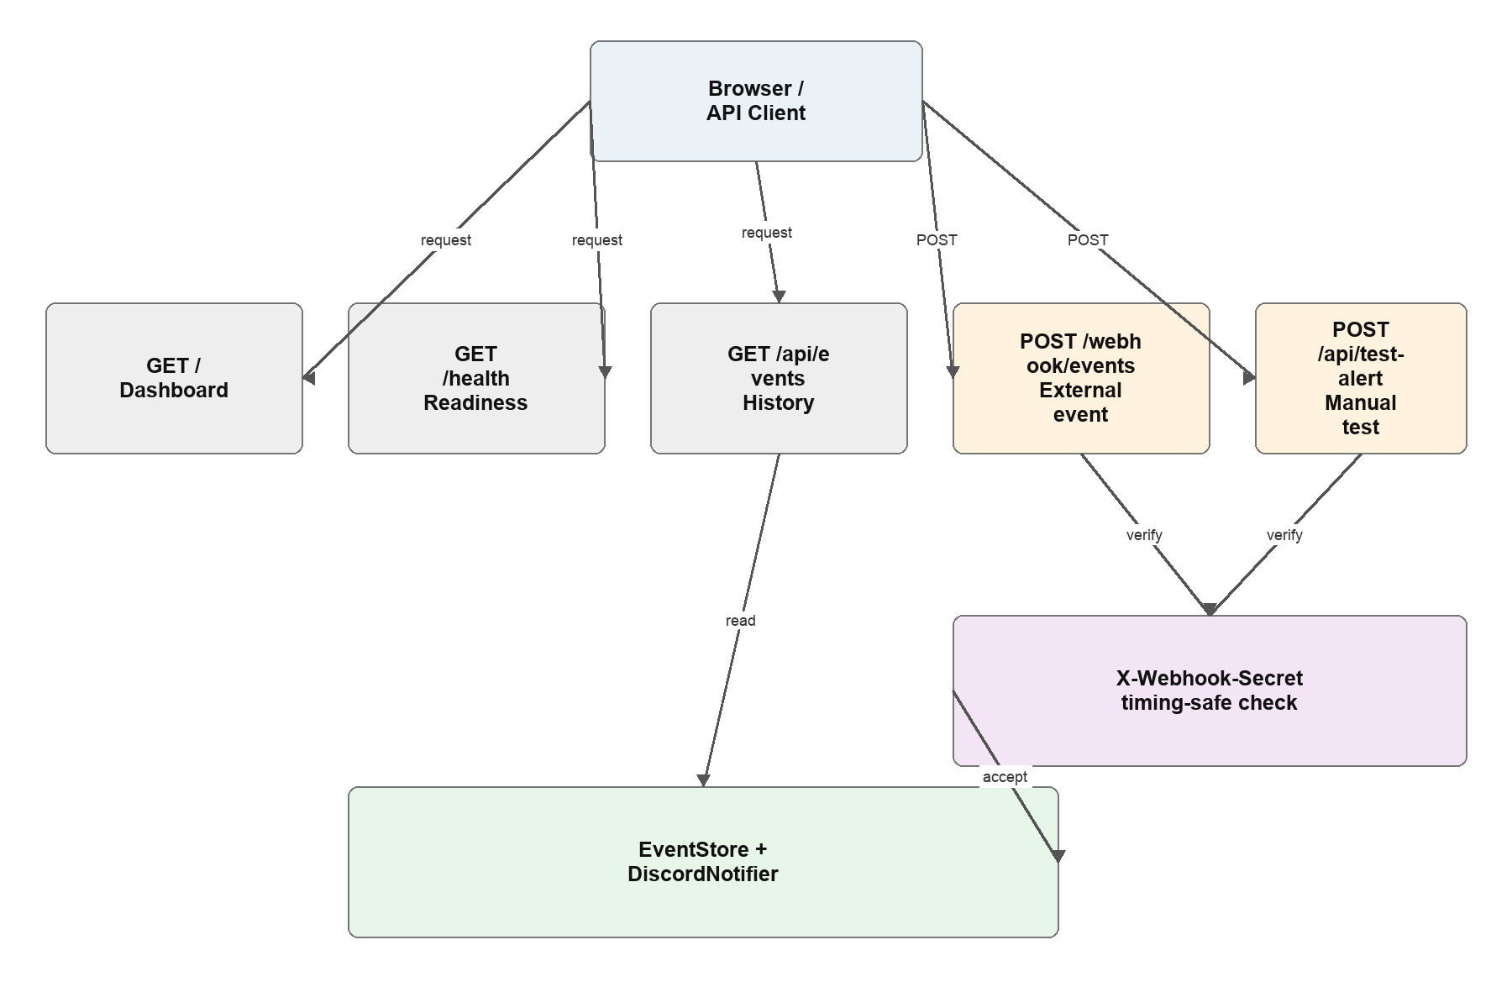
Figure 4: Endpoint map and request handling
Table 4: Route summary
Method | Route | Behaviour
GET | / | Live dashboard for service readiness and recent events
GET | /health | Returns service, Docker and Discord readiness
GET | /api/events | Returns bounded recent event history
POST | /webhook/events | Accepts a shared-secret authenticated external event

5.3 Event data model
Each event receives an auto-incrementing identifier and a UTC occurrence time (Figure 5). The record stores the source container or service, normalized event type and status, compact JSON details and a Boolean notification result. Parameterized SQL statements are executed under a thread lock, and recent events are returned newest first with a bounded limit.
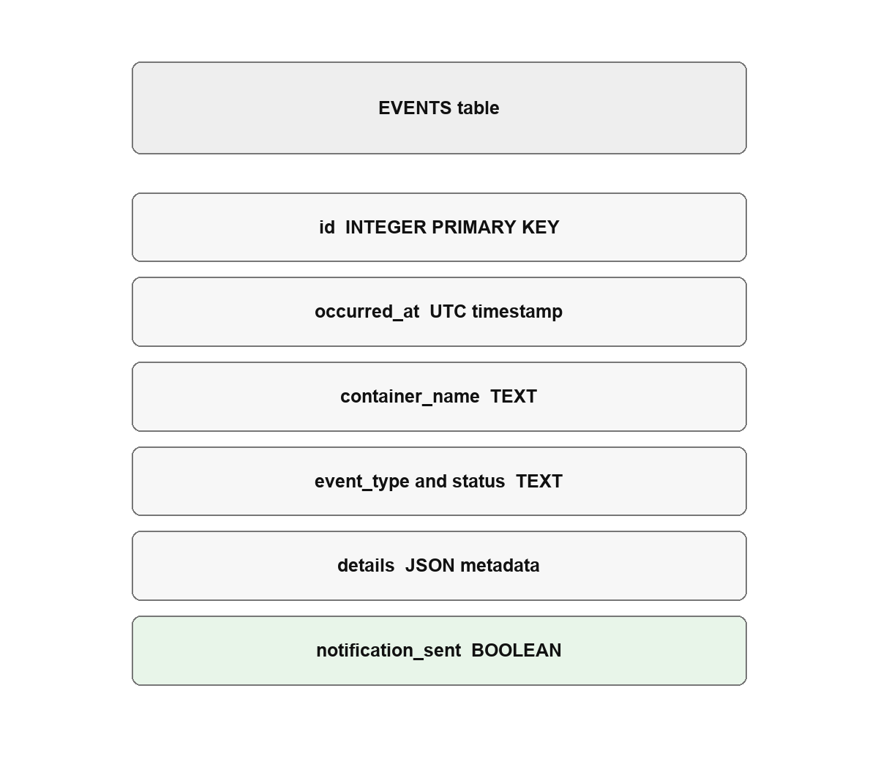
Figure 5: Persistent event data model

5.4 Event lifecycle
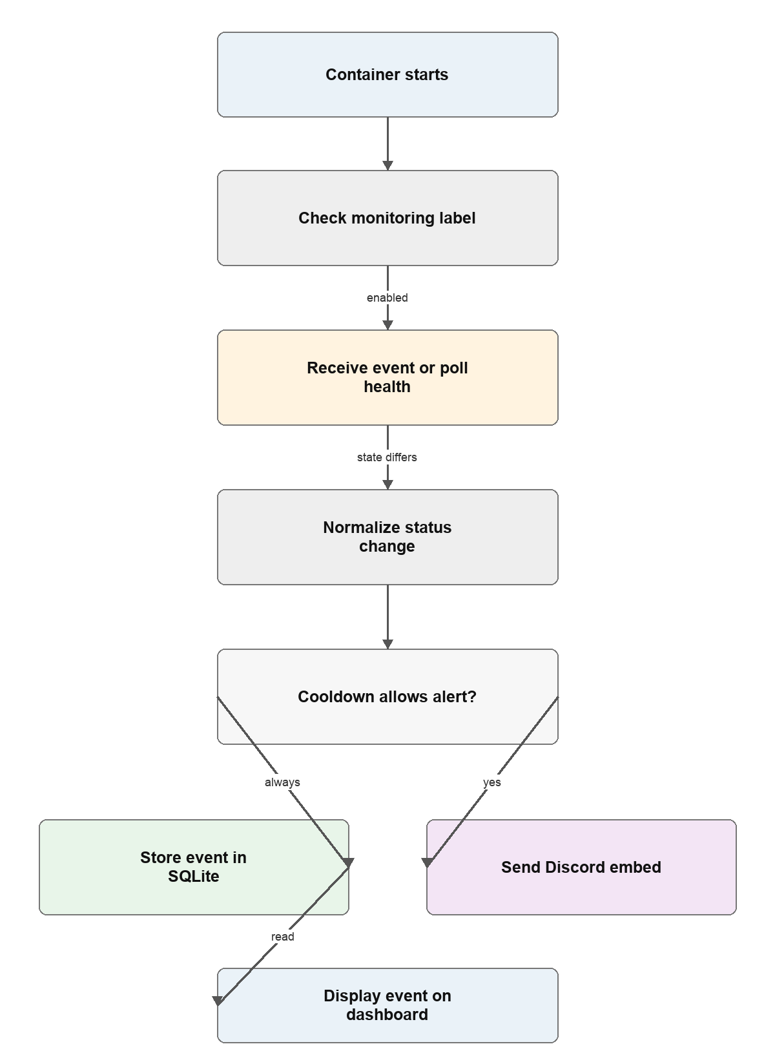
Figure 6: Container event lifecycle

6. Automated monitoring and notification pipeline

6.1 Stage 1: event collection and health polling
The monitoring service connects to Docker using the local socket. One background loop consumes the event stream and filters for important lifecycle and health actions. A second loop reloads labelled containers every ten seconds by default and compares the current state with the previous observation. If Docker becomes unavailable, the client is cleared and the next cycle reconnects.
Table 5: Collection and polling steps
No. | Action | Purpose
1 | Connect and ping Docker | Confirm engine availability
2 | Subscribe to container events | Receive low-latency lifecycle changes
3 | Filter important actions | Ignore unrelated Docker noise
4 | Check monitoring label | Restrict collection to opted-in containers
5 | Poll and reload containers | Recover state after a missed event
6 | Compare current and previous status | Create an event only for a meaningful change

Initial unhealthy, exited or dead containers are recorded even when no previous state exists. Later transitions produce a health_change event. Container labels provide an explicit opt-in boundary, so unrelated development containers do not generate alerts.

6.2 Stage 2: normalization and Discord delivery
The notifier converts the internal event into a Discord embed. It includes the container, status and event as fields, adds formatted JSON details, selects a colour based on status and records a UTC timestamp. The HTTPS request uses an eight-second timeout and successful delivery requires a non-error response. Real webhook URLs are loaded from the environment and are never written to logs or the database.
Table 6: Notification delivery steps
No. | Action | Purpose
1 | Normalize container, event and status | Create a consistent internal record
2 | Check cooldown key | Suppress repeated matching alerts
3 | Build a Discord embed | Add fields, details, colour and timestamp
4 | POST with an eight-second timeout | Keep monitoring responsive
5 | Record delivery result | Preserve success or failure in SQLite
6 | Return event through dashboard API | Make the outcome visible locally

6.3 Stage 3: persistence and dashboard update
The event store writes the normalized record and notification result to /data/events.db. A named Docker volume keeps this history when the monitoring container restarts. The dashboard and /api/events endpoint then expose recent records without depending on Discord availability.

6.4 Alert behaviour
The pipeline treats every observation as data but suppresses repeated matching notifications for the configured cooldown period. Table 7 summarises the main reliability and security layers and the behaviour when a dependency fails.
Table 7: Reliability and security summary
Layer | Control | Protects against | On failure
Detection | Events plus polling | Missed or delayed state changes | Poller restores current state
Notification | Timeout and cooldown | Blocking calls and alert floods | Event remains stored locally
Webhook boundary | Timing-safe shared secret | Unauthorized external events | Request receives HTTP 401

Direct Docker socket access remains privileged even with a read-only mount, so it is acceptable for this local lab but should be replaced by a restricted socket proxy in production.

7. Containerisation and demonstration services

7.1 Dockerfile
Table 8: Dockerfile instructions
Instruction | Effect
FROM python:3.12-slim | Small maintained Python runtime
WORKDIR /app | Sets the application directory
COPY requirements.txt . | Copies dependency manifest first
RUN pip install --no-cache-dir | Installs runtime packages without cache
COPY monitor.py . | Adds monitoring application
COPY templates ./templates | Adds dashboard template
CMD gunicorn --bind 0.0.0.0:5000 | Starts one worker with four threads

Table 9: Demonstration container states
State | Container | Health check | Expected result
Healthy | healthy-demo | Local Nginx HTTP request succeeds | Healthy status, normal lifecycle alerts
Unhealthy | unhealthy-demo | Command deliberately exits with code 1 | Unhealthy event stored and sent

The commands for building and running the complete lab are:
docker compose up --build -d
docker compose ps
open http://localhost:5001
docker compose logs -f monitor

7.2 Demonstration services
Docker Compose creates three services. The monitoring service exposes host port 5001 and mounts the Docker socket and named data volume. healthy-demo runs Nginx with a passing HTTP health check. unhealthy-demo runs Alpine with a deliberate failing health command so that the initial unhealthy event and Discord message can be demonstrated repeatedly (Figure 7, Table 10).
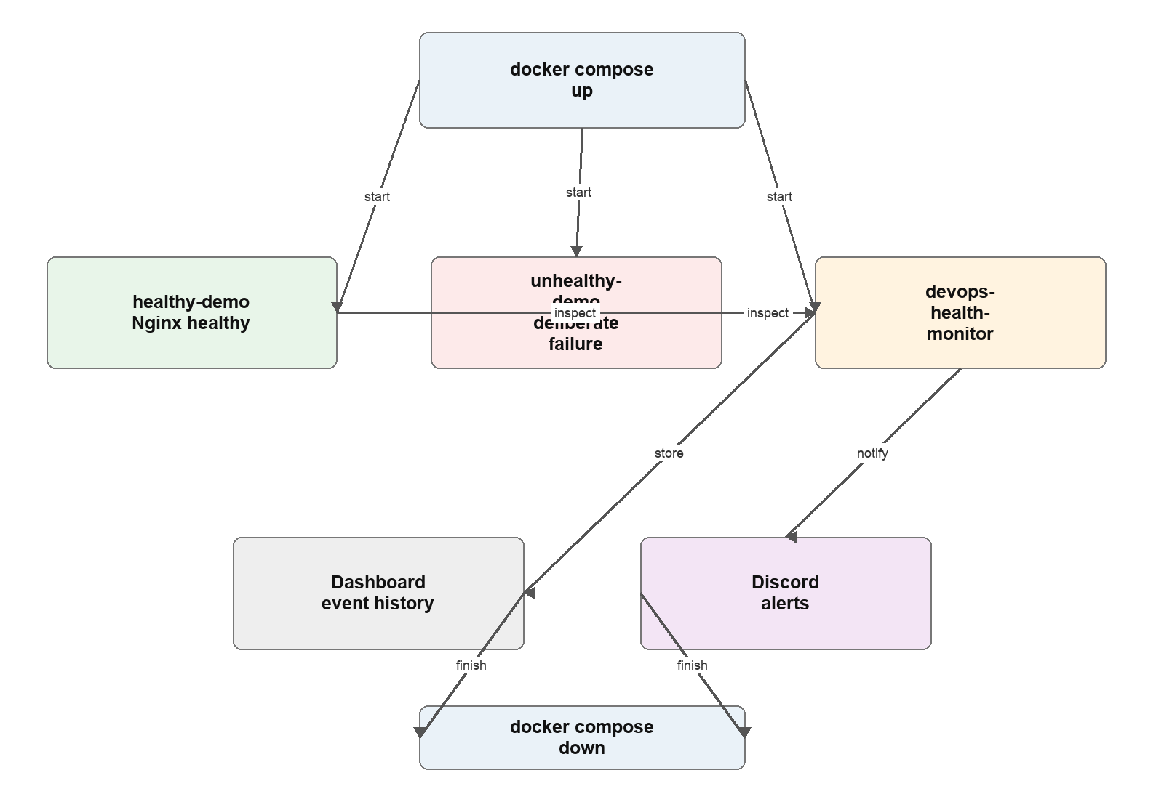
Figure 7: Demonstration state transitions
Table 10: Demonstration profiles
Profile | Service | Image or build | Health behaviour | Validation
monitor | devops-health-monitor | Local Dockerfile | GET /health | Dashboard and notifier ready
healthy | healthy-demo | nginx:1.27-alpine | HTTP check passes | Status becomes healthy
unhealthy | unhealthy-demo | alpine:3.21 | exit 1 | Status becomes unhealthy
external | payment-api example | Webhook JSON | critical event | Accepted with valid secret

7.3 Reset and test tooling
The lab can be exercised with the following commands:
# Start or rebuild the complete stack
docker compose up --build -d
docker stop healthy-demo
docker start healthy-demo
curl http://localhost:5001/health

# Stop containers but keep event history
docker compose down
docker compose down -v # also remove the SQLite volume

8. Environment configuration
Runtime configuration is supplied through environment variables. The committed .env.example documents safe placeholders, while the real .env file is excluded from version control. The Discord webhook URL acts like a password and must not be shown in screenshots, committed to Git or stored in the event database (Figure 8).
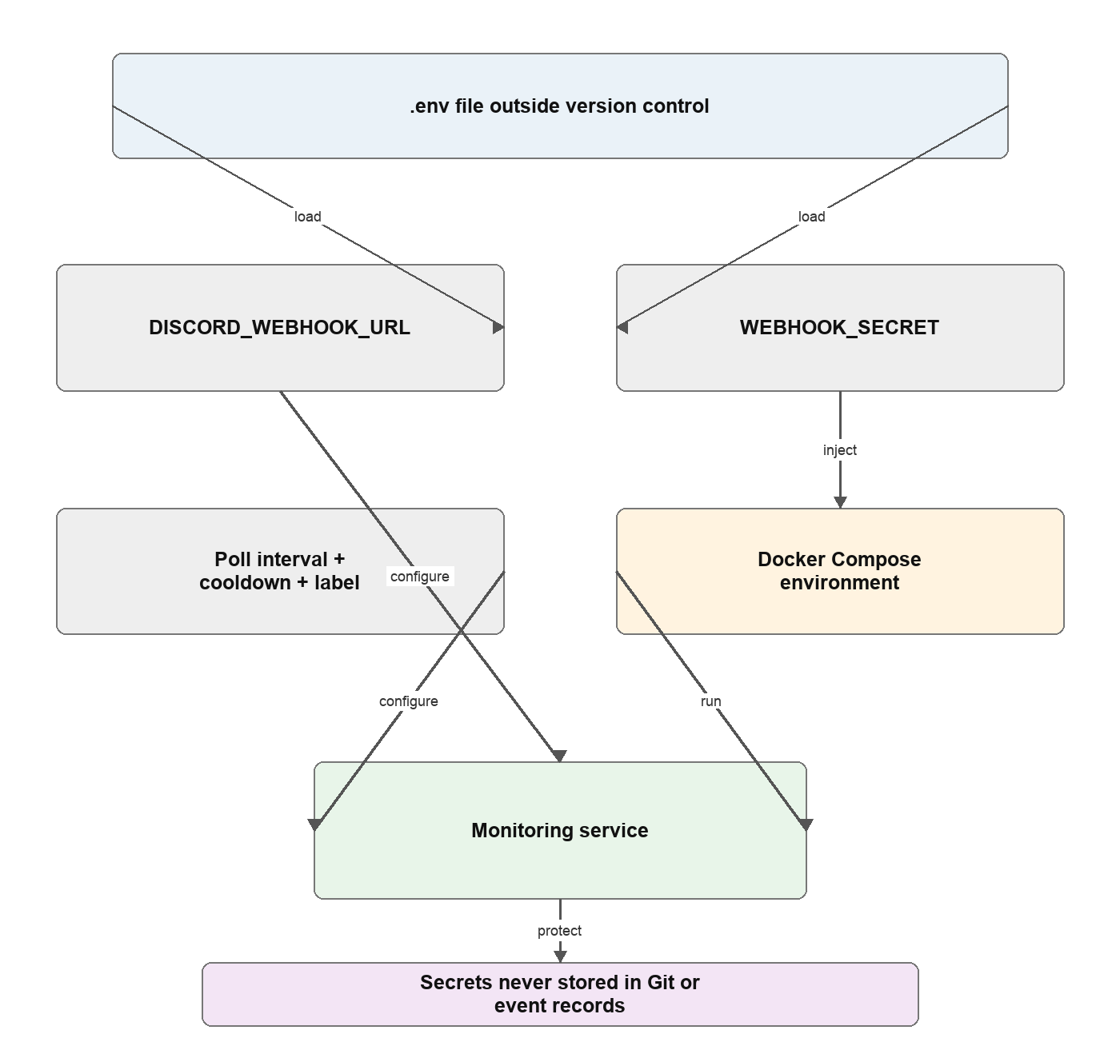
Figure 8: Secrets and configuration sources
Table 11: Configuration reference
Variable | Required | Default | Purpose
DISCORD_WEBHOOK_URL | For Discord | empty | Private Discord webhook URL
WEBHOOK_SECRET | For POST routes | lab placeholder | Authenticates inbound events
POLL_INTERVAL_SECONDS | No | 10 | Seconds between health polls
ALERT_COOLDOWN_SECONDS | No | 60 | Suppresses duplicate notifications
MONITOR_LABEL | No | health-monitor.enabled | Opt-in Docker label
START_MONITOR | No | true | Enables background monitor loops
DB_PATH | No | /data/events.db | SQLite event database
HOST_PORT | No | 5001 | Dashboard port on the host
LOG_LEVEL | No | INFO | Runtime logging level

9. End-to-end workflow
Figure 9 follows one event through every participant. Docker emits a lifecycle or health signal, the monitor consumes or discovers it, normalizes the status and checks cooldown state. The event is persisted in SQLite and, when permitted, posted to Discord. The dashboard reads the stored history, while the operator uses the alert and container logs to decide the recovery action. Authenticated external tools can enter the same path through /webhook/events.
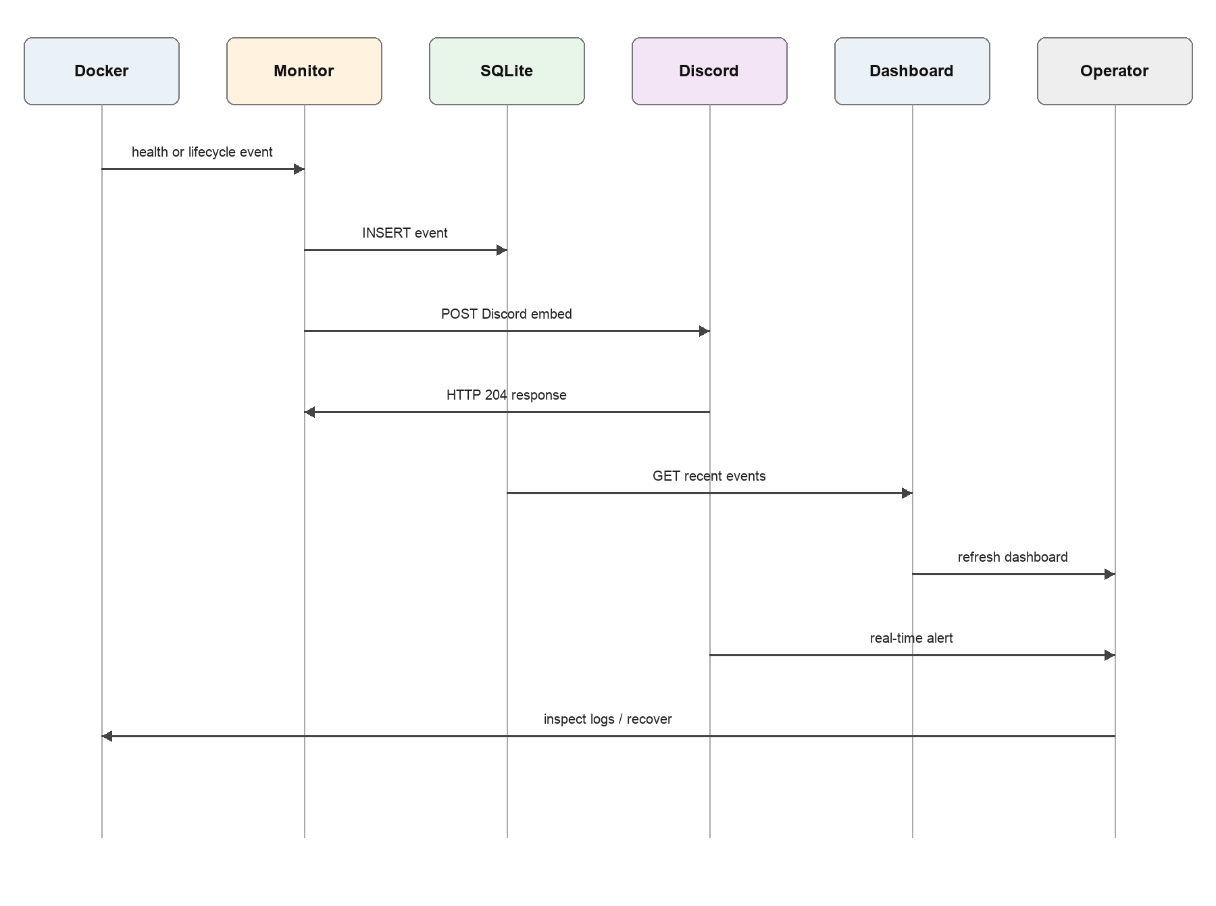
Figure 9: End-to-end monitoring workflow

10. Conclusion and future work

10.1 Conclusion
The project implements a complete local monitoring loop for Docker containers. It detects selected health and lifecycle events, stores an audit record, exposes a dashboard and REST API, and sends structured real-time Discord notifications. Event streaming provides low latency, polling restores context after connection gaps, labels limit monitoring scope and cooldown prevents repeated matching alerts. The healthy and intentionally unhealthy demonstration services make the result easy to verify during a DevOps lab.

10.2 Future work
- Export Prometheus metrics and add a Grafana dashboard.
- Move suppression state and event history to a shared production database.
- Add email, Slack and Microsoft Teams notification adapters.
- Use signed webhook payloads with timestamp and replay protection.
- Add alert acknowledgement, escalation and recovery notifications.
- Replace the Docker collector with Kubernetes watch APIs for cluster use.

References
[1] Docker, Inc., “Dockerfile HEALTHCHECK reference,” https://docs.docker.com/reference/dockerfile/#healthcheck.
[2] Docker, Inc., “Docker system events reference,” https://docs.docker.com/reference/cli/docker/system/events/.
[3] Docker, Inc., “Docker Compose documentation,” https://docs.docker.com/compose/.
[4] Discord, “Webhook resource documentation,” https://discord.com/developers/docs/resources/webhook.
[5] Pallets Projects, “Flask documentation,” https://flask.palletsprojects.com/.
[6] Docker SDK for Python documentation, https://docker-py.readthedocs.io/.
[7] Python Software Foundation, “sqlite3 documentation,” https://docs.python.org/3/library/sqlite3.html.
[8] Gunicorn documentation, https://docs.gunicorn.org/.

