Lab Practical #11:
Study the concept of routing using packet tracer. (Static Routing)
Practical Assignment #11:
- Connect the two different routers based on the calculated IP addresses and subnet using a packet tracer.

- To connect two different routers using Cisco Packet Tracer and configure static routing to enable communication between different networks.

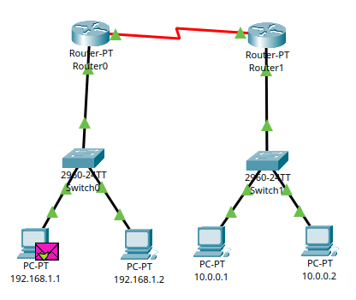
IP Address Table

Device | Interface | IP Address | Subnet Mask | Network ID
192.168.1.1 | FastEthernet0 | 192.168.1.1 | 255.255.255.0 | 192.168.1.0
192.168.1.2 | FastEthernet0 | 192.168.1.2 | 255.255.255.0 | 192.168.1.0
Router 0 | FastEthernet0/0 | 192.168.1.3 | 255.255.255.0 | 192.168.1.0
Router 0 | Serial2/0 | 20.0.0.1 | 255.0.0.0 | 20.0.0.0
Router 1 | Serial2/0 | 20.0.0.2 | 255.0.0.0 | 20.0.0.0
Router 1 | FastEthernet0/0 | 10.0.0.3 | 255.0.0.0 | 10.0.0.0
10.0.0.1 | FastEthernet0 | 10.0.0.1 | 255.0.0.0 | 10.0.0.0
10.0.0.2 | FastEthernet0 | 10.0.0.2 | 255.0.0.0 | 10.0.0.0

Network ID Table
Network | Network ID | Subnet Mask
Left LAN | 192.168.1.0 | 255.255.255.0
Router-to-Router Link | 20.0.0.0 | 255.0.0.0
Right LAN | 10.0.0.0 | 255.0.0.0

Static Routing Configuration
For communication between the two different LAN networks, static routes are configured on both routers.
Router0:
- Destination Network: 10.0.0.0
- Subnet Mask: 255.0.0.0
- Next Hop: 20.0.0.2
Router1:
- Destination Network: 192.168.1.0
- Subnet Mask: 255.255.255.0
- Next Hop: 20.0.0.1
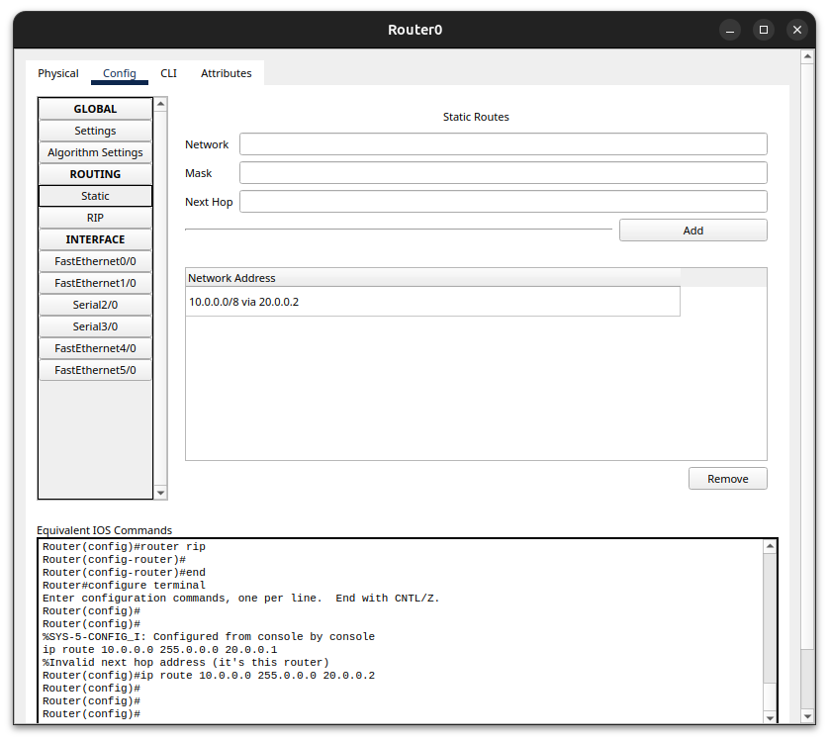
Routing Table
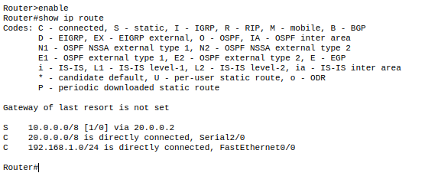
PDU Transfer
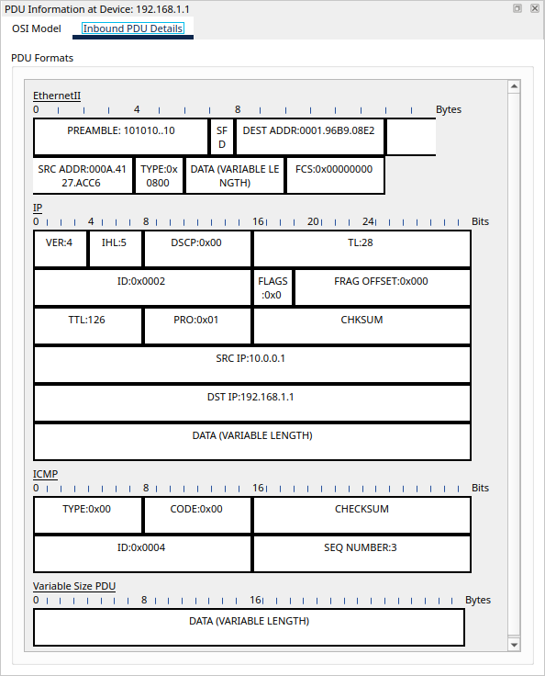
Result
- The two routers were successfully connected using Cisco Packet Tracer.
- The IP addresses and subnet masks were configured for all devices.
- Static routing was successfully configured between the 192.168.1.0/24 and 10.0.0.0/8 networks.
- Communication between the different networks was successfully verified using the Packet Tracer PDU.

- Connect the three different routers based on the calculated IP addresses and subnet using a packet tracer.

- To connect three different routers using Cisco Packet Tracer and configure static routing to enable communication between different networks.

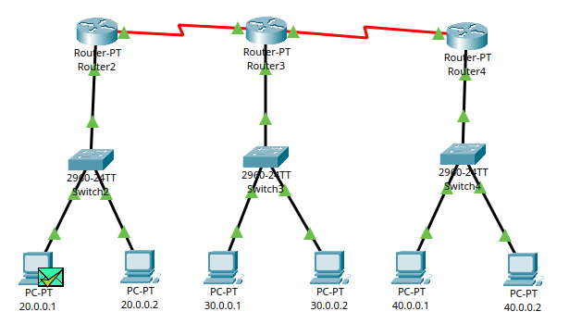

IP Address Table

Device | Interface | IP Address | Subnet Mask | Network ID
20.0.0.1 | FastEthernet0 | 20.0.0.1 | 255.0.0.0 | 20.0.0.0
20.0.0.2 | FastEthernet0 | 20.0.0.2 | 255.0.0.0 | 20.0.0.0
Router 2 | FastEthernet0/0 | 20.0.0.3 | 255.0.0.0 | 20.0.0.0
Router 2 | Serial2/0 | 50.0.0.1 | 255.0.0.0 | 50.0.0.0
Router 3 | Serial2/0 | 50.0.0.2 | 255.0.0.0 | 50.0.0.0
Router 3 | FastEthernet0/0 | 30.0.0.3 | 255.0.0.0 | 30.0.0.0
30.0.0.1 | FastEthernet0 | 30.0.0.1 | 255.0.0.0 | 30.0.0.0
30.0.0.2 | FastEthernet0 | 30.0.0.2 | 255.0.0.0 | 30.0.0.0
Router 3 | Serial3/0 | 60.0.0.1 | 255.0.0.0 | 60.0.0.0
Router 4 | Serial2/0 | 60.0.0.2 | 255.0.0.0 | 60.0.0.0
Router 4 | FastEthernet0/0 | 40.0.0.3 | 255.0.0.0 | 40.0.0.0
40.0.0.1 | FastEthernet0 | 40.0.0.1 | 255.0.0.0 | 40.0.0.0
40.0.0.2 | FastEthernet0 | 40.0.0.2 | 255.0.0.0 | 40.0.0.0

Network ID Table
Network | Network ID | Subnet Mask
First LAN | 20.0.0.0 | 255.0.0.0
Router-to-Router Link 1 | 50.0.0.0 | 255.0.0.0
Second LAN | 30.0.0.0 | 255.0.0.0
Router-to-Router Link 2 | 60.0.0.0 | 255.0.0.0
Third LAN | 40.0.0.0 | 255.0.0.0

Static Routing Configuration
For communication between the three different LAN networks, static routes are configured on all three routers.
Router2:
- Destination Network: 30.0.0.0
- Subnet Mask: 255.0.0.0
- Next Hop: 50.0.0.2
- Destination Network: 40.0.0.0
- Subnet Mask: 255.0.0.0
- Next Hop: 50.0.0.2
Router3:
- Destination Network: 20.0.0.0
- Subnet Mask: 255.0.0.0
- Next Hop: 50.0.0.1
- Destination Network: 40.0.0.0
- Subnet Mask: 255.0.0.0
- Next Hop: 60.0.0.2
Router4:
- Destination Network: 20.0.0.0
- Subnet Mask: 255.0.0.0
- Next Hop: 60.0.0.1
- Destination Network: 30.0.0.0
- Subnet Mask: 255.0.0.0
- Next Hop: 60.0.0.1
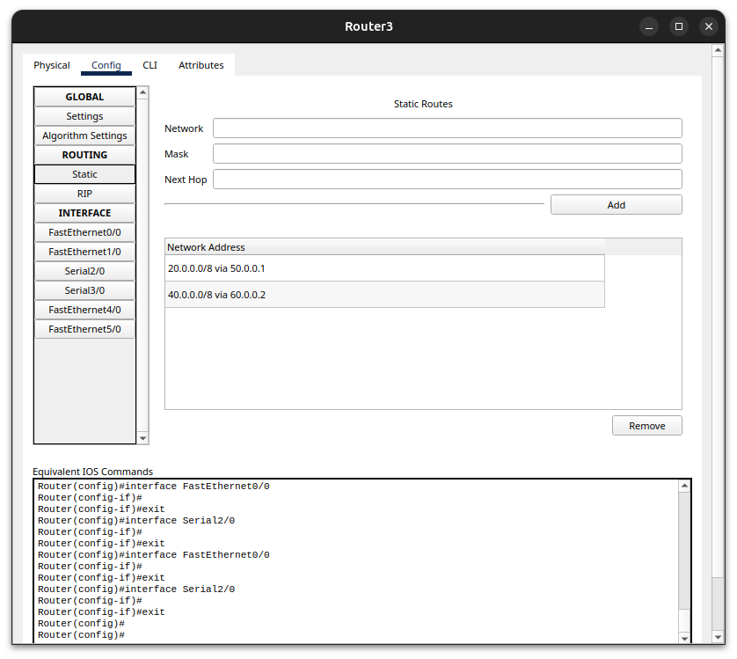
Routing Table
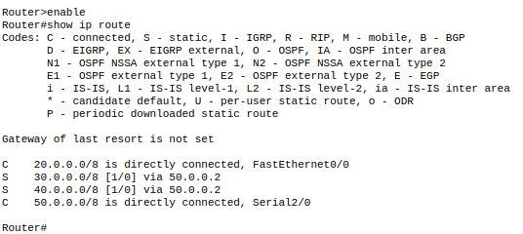
PDU Transfer
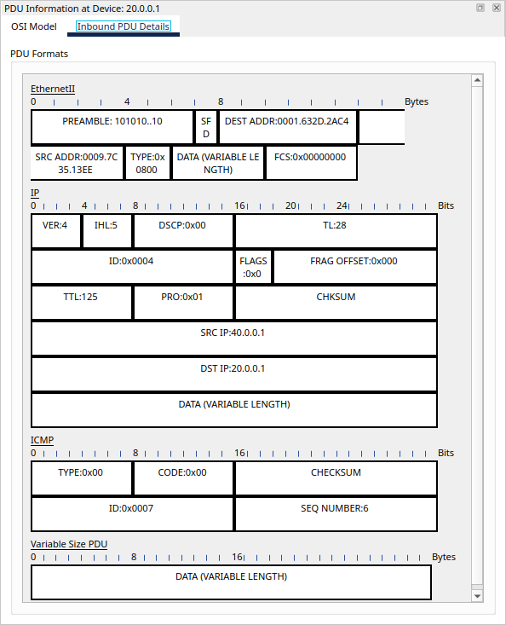
Result
- The three routers were successfully connected using Cisco Packet Tracer.
- The IP addresses and subnet masks were configured for all devices.
- Static routing was successfully configured between the 20.0.0.0/8, 30.0.0.0/8, and 40.0.0.0/8 networks.
- Communication between the different networks was successfully verified using the Packet Tracer PDU.

