


To DATE:

bhavy gajjar 18/05/2026
Enroll: - 2204030100306

lnternship- Offer Letter

Dear bhavy gajjar , we are pleased to offer you internship at Vibrant Technology in the domain of Java. Your internship will be from 18/05/2026 to 17/06/2026 with flexible timings. During this period, you will gain practical experience through live projects and guidance from our mentors. This internship is for training purposes.

I welcome to you on the behalf of Vibrant Technology.
I hope you will find Vibrant Technology. as a place to Best work

Regards,
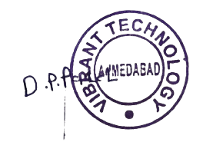
'
Team Leader



info@vibranttechnology.in

+91 8511110213

801, Silicon Tower, Law Garden, opp. Axis Bank, Ellisbridge,
Ahmedabad, Gujarat 380006

