**Course-Android Section: 2 PM to 3:20 PM**

**Group Members:**

**Bhavya Deepthi Gorrepati**

**Venkat Prudhvi Dommaraju**

**Kamal Reddy DonthiReddy**

**Dheeraj Edupuganti**

**Application Name: Jobs Made Easy**

**Purpose of the Application:**

There is no on Campus placement portal to encourage students with the numerous jobs offered by recruiters in our University for the students getting graduated every year. As of now HR department is sending a job description emails received from recruiters to respective department coordinators to spread a word to the students to apply for the job vacancies received from Companies.

Our app will overcome this problem and provide a privilege to HR Employees to post a job directly in this app and enables students to apply for the jobs they dream for. Our app makes students life easier during the phase of their job search**.**

**Screens involved in the App:**

**1. Launch Screen:**

This page provides user a means to either login or Sign Up if not registered.

**2. Login Screen:**

Either student or staff should input a registered email id as Username and a Password to login.

**3. Sign up Screen**

**Assumption:** HR staff varies from one department to the other

**HR Staff**: Each HR employee can register with their Employee id and University email id and password to post and maintain the job vacancies received from recruiters related to their respective domain.(Example: HR employee of finance will post jobs related to the same domain).

**Students**: Our University students can register with their university mail id and password.

**4. Home Screen**

This page displays a Welcome message at the center top. Our app allows users to **search by title or role** of the job

**Staff Page**: Staff screen has two options

**Post a Job**

**List All Jobs**

**Student page:** This page displays a list of five Majors (Computer Science, Information Systems, Biomedical Science, Agricultural Science and Business) at the center of the screen.

**5. Screen for posting a job by faculty**

On clicking Post a job button in the Faculty home page, they will be redirected to this page. This screen will have the below fields w.r.t the job vacancy.

Job Title

Job Description

Major

Qualifications

Deadline

Post Button

Faculty has to enter the above details and click on the post button.

**6. List all Jobs Screen:**

**Faculty Screen**: This screen shows all the jobs added by them. Two options provided to the faculty below each job vacancy to either update the content or to delete it if they think it as inappropriate at any time.

**Students Screen**: When students click on anyone of the five majors displayed, will retrieve all the jobs related to the filtered major and display it to them .For whichever the jobs the deadline is over, those jobs will be automatically removed from the view list and will not be seen by students.

Each Job vacancy will have an Apply Now button which upon clicking will ask for a resume file and gets submitted on clicking submit button.

**Rough Sketches:**

1. **Launch/Login Screen:**

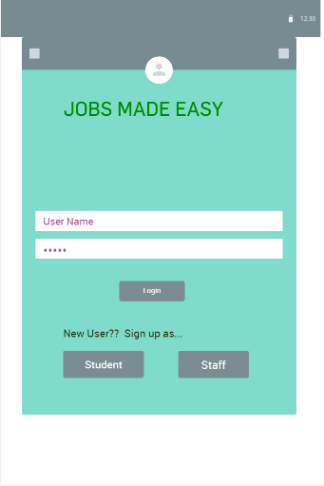

1. **Signup Screens:**

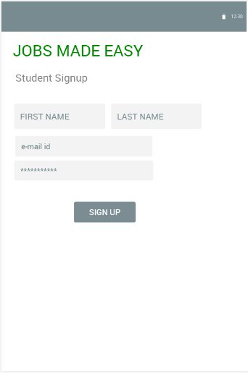 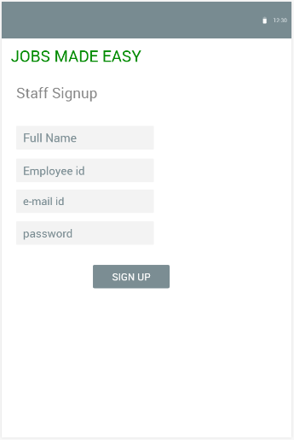

1. **Home Screen:**

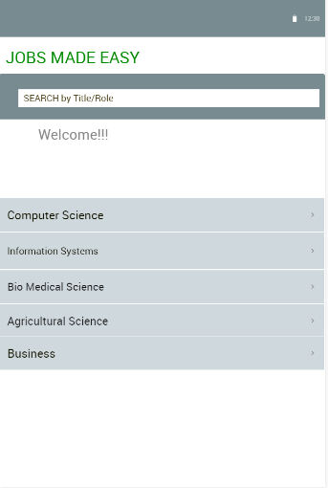 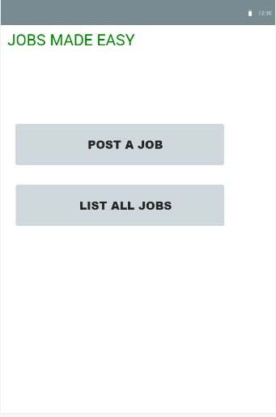

**a. Student b. Staff**

**4. Screen for posting a job by faculty:**

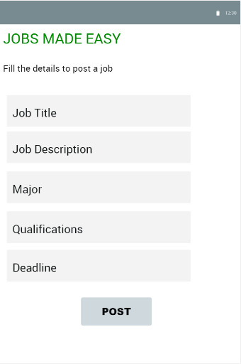

**5 . List all jobs Screen:**

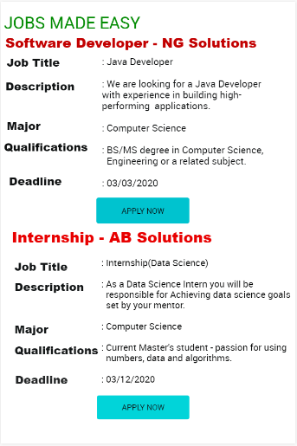 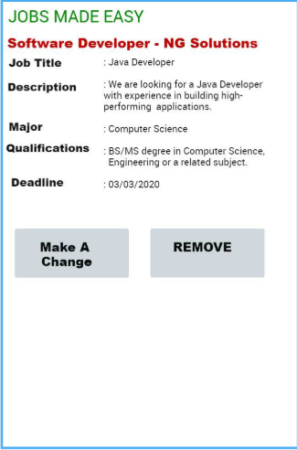

1. **Student B. Staff**

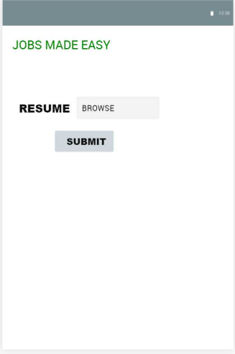

**C . Screen for uploading Resume**

**Note:** For this application we will be using dummy data which we store it over the network.