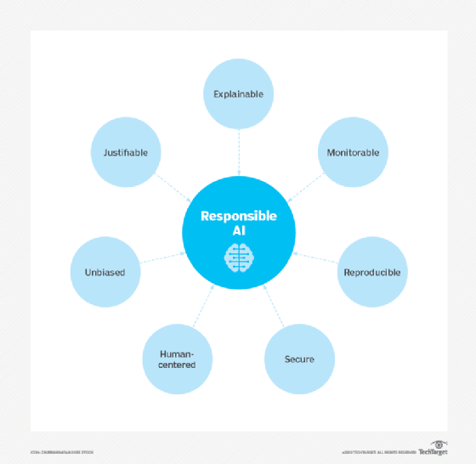**1.What Responsible AI is?**

Responsible AI is a governance framework that documents how a specific organization is addressing the challenges around artificial intelligence (AI) from both an ethical and legal point of view.

**2.Find instances where AI has failed? Or been used maliciously or incorrectly.**

**Amazon’s Recruiting Tool**

Using AI to streamline talent acquisition is common currently, however, it hasn’t always been the case. Once upon a time, if you were a woman seeking a technical role at Amazon, your chances were extremely slim.

Amazon had been building software that would automate the process of reviewing job applicants’ resumes with the intention of finding the top 5 talents since 2014. It was not until 2015, Amazon’s machine learning specialists discovered that their AI-powered recruiting tool was hiring for technical roles (i.e. software developer) in a way that was not gender-neutral.It turns out Amazon had trained their machine learning algorithms on resumes that had been submitted to the company over a 10-year period.

The majority of resumes came from men, since this is what was most common in technical roles, and the algorithms learned this pattern and determined women are not good suitors for technical roles.

**3.Implications of when AI fails. There is a specific article in the GDPR Law that covers this, especially with automated decision making. (opt in and out options).**

**Article 22(1)**

The UK GDPR restricts you from making solely automated decisions, including those based on profiling, that have a legal or similarly significant effect on individuals.

For something to be solely automated there must be no human involvement in the decision-making process.

The restriction only covers solely automated individual decision-making that produces legal or similarly significant effects. These types of effect are not defined in the UK GDPR, but the decision must have a serious negative impact on an individual to be caught by this provision.

A legal effect is something that adversely affects someone’s legal rights. Similarly significant effects are more difficult to define but would include, for example, automatic refusal of an online credit application, and e-recruiting practices without human intervention.

**4.What should organisations do to ensure that they are being responsible with AI and the wider use of data in general?**

If you use an AI system to infer data about people, in order for this processing to be fair, you need to ensure that:

* the system is sufficiently statistically accurate and avoids discrimination; and
* you consider the impact of individuals’ reasonable expectations.

For example, an AI system used to predict loan repayment rates is likely to breach the fairness principle if it:

* makes predictions which frequently turn out to be incorrect;
* leads to disparities in outcomes between groups (eg between men and women) which could not be justified as a proportionate means of achieving a legitimate aim; or
* uses personal data in ways which individuals would not reasonably expect.

Then, you need to be transparent about how you process personal data in an AI system, to comply with the principle of transparency. The core issues regarding AI and the transparency principle are addressed in ‘Explaining decisions made with AI’ guidance, so are not discussed in detail here.

Whenever you are processing personal data – whether to train a new AI system, or make predictions using an existing one – you must have an appropriate lawful basis to do so.

Different lawful bases may apply depending on your particular circumstances. However, some lawful bases may be more likely to be appropriate for the training and / or deployment of AI than others. In some cases, more than one lawful basis may be appropriate.

At the same time, you must remember that:

* it is **your responsibility** to decide which lawful basis applies to your processing;
* you must always choose the lawful basis that **most closely reflects the true nature of your relationship** with the individual and the purpose of the processing;
* you should make this determination **before** you start your processing;
* you should **document** your decision;
* you **cannot swap** lawful bases at a later date without good reason;
* you must **include** **your lawful basis** in your privacy notice (along with the purposes); and
* if you are processing **special categories of data** you need **both** a lawful basis **and** an additional condition for processing.