Software Requirements Specification (SRS)
Automated Banking System
1. Introduction
Purpose
This document describes the software requirements for the Automated Banking System (ABS). It provides a detailed description of system functionalities, constraints, and interfaces required for development and evaluation.
Scope
The Automated Banking System enables customers to perform banking operations digitally through web and mobile platforms. The system supports secure login, basic banking transactions, transaction history, balance inquiry, loan processing with EMI management, and information on insurance schemes such as term and health insurance.
Definitions, Acronyms, and Abbreviations
- ABS – Automated Banking System
- EMI – Equated Monthly Installment
- OTP – One Time Password
- KYC – Know Your Customer
References
- IEEE 830 Software Requirements Specification
- Banking Software Standards

2. Overall Description
Product Perspective
The Automated Banking System is a centralized application that integrates banking services, loan management, EMI handling, and insurance information within a single digital platform.
Product Functions
- Secure authentication and login history
- Basic banking transactions (deposit, withdrawal, fund transfer)
- Transaction history and balance inquiry
- Loan application, approval, and management
- EMI calculation, viewing, and addition
- Display of insurance schemes
User Classes and Characteristics
- Customers: End users performing banking and loan-related activities
- Administrators: Authorized users managing system data and approvals
Stakeholders
- Customers: Use the system for banking, loans, EMI, and insurance services
- Bank Management: Oversees system operations and compliance
- Loan Officers: Review and approve loan applications
- Insurance Managers: Maintain insurance scheme information
- System Administrators: Manage system maintenance and security
Operating Environment
- Web browsers (Chrome, Firefox, Edge)
- Mobile devices (Android, iOS)
- Backend server with relational database
Design and Implementation Constraints
- Must comply with banking and financial regulations
- High-level security and data privacy requirements
Assumptions and Dependencies
- Active internet connection
- Integration with existing banking databases
- Availability of third-party notification services

3. Functional Requirements
Authentication and Login
- The system shall authenticate users using valid credentials.
- The system shall maintain user login history.
- The system shall log out inactive users automatically.
Basic Banking Transactions
- The system shall allow users to deposit funds.
- The system shall allow withdrawals.
- The system shall support fund transfers.
- The system shall record all transactions.
Transaction History
- The system shall display detailed transaction history.
- The system shall allow filtering by date and transaction type.
Balance Inquiry
- The system shall display current account balance.
- The system shall show available and ledger balance.
Loan Management
- The system shall allow users to apply for new loans.
- The system shall display different loan types.
- The system shall allow administrators to approve or reject loans.
- The system shall display loan status to users.
EMI Management
- The system shall calculate EMI based on loan amount, interest rate, and tenure.
- The system shall allow users to view EMI details.
- The system shall display paid and pending EMI installments.
- The system shall allow administrators to add new EMI schedules.
- The system shall notify users of upcoming EMI payments.
Insurance Services
- The system shall display available insurance schemes.
- The system shall provide details of term insurance.
- The system shall provide details of health insurance.
- The system shall show premium amount and policy tenure.

Account Management
- The system shall allow users to view their account profile details.
- The system shall allow users to update personal and contact information.
- The system shall support multiple bank accounts linked to a single user.
- The system shall display account type and account status information.

Notification Management
• The system shall send notifications for successful and failed transactions.
• The system shall notify users when the account balance falls below a minimum limit.
• The system shall send reminders for loan due dates and EMI payments.
• The system shall support notifications through SMS and email.

User Session Management
• The system shall restrict the number of concurrent logins per user.
• The system shall automatically log out users after a defined period of inactivity.
• The system shall securely manage user sessions to prevent unauthorized access.

Audit and Monitoring
• The system shall maintain audit logs for all critical system operations.
• The system shall record user activities such as login, logout, and transactions.
• The system shall allow administrators to view and monitor system activity logs.

Insurance Enrollment
• The system shall allow users to apply for available insurance schemes online.
• The system shall allow administrators to approve or reject insurance applications.
• The system shall display insurance policy status and coverage details to users.
• The system shall store insurance enrollment history for each user.

4. Non-Functional Requirements
Performance Requirements
- The system shall respond within 2 seconds.
- The system shall support multiple concurrent users.
Security Requirements
- All sensitive data shall be encrypted.
- Secure authentication and authorization shall be enforced.
Reliability
- The system shall ensure data accuracy and consistency.
- Backup and recovery mechanisms shall be implemented.
Usability
- The system shall be user-friendly and easy to navigate.

Scalability
- The system shall support growth in users and transactions without performance degradation.

Availability
• The system shall be available 99.5% of the time.

Maintainability
• The system shall support modular design for easy updates.

Portability
• The system shall be deployable across different operating systems and cloud platforms.

Compliance
• The system shall comply with KYC and AML regulations.

5. External Interface Requirements
User Interface
- Responsive design for web and mobile platforms.
Software Interfaces
- Payment gateway integration
- SMS/Email notification services

7. Product Functions
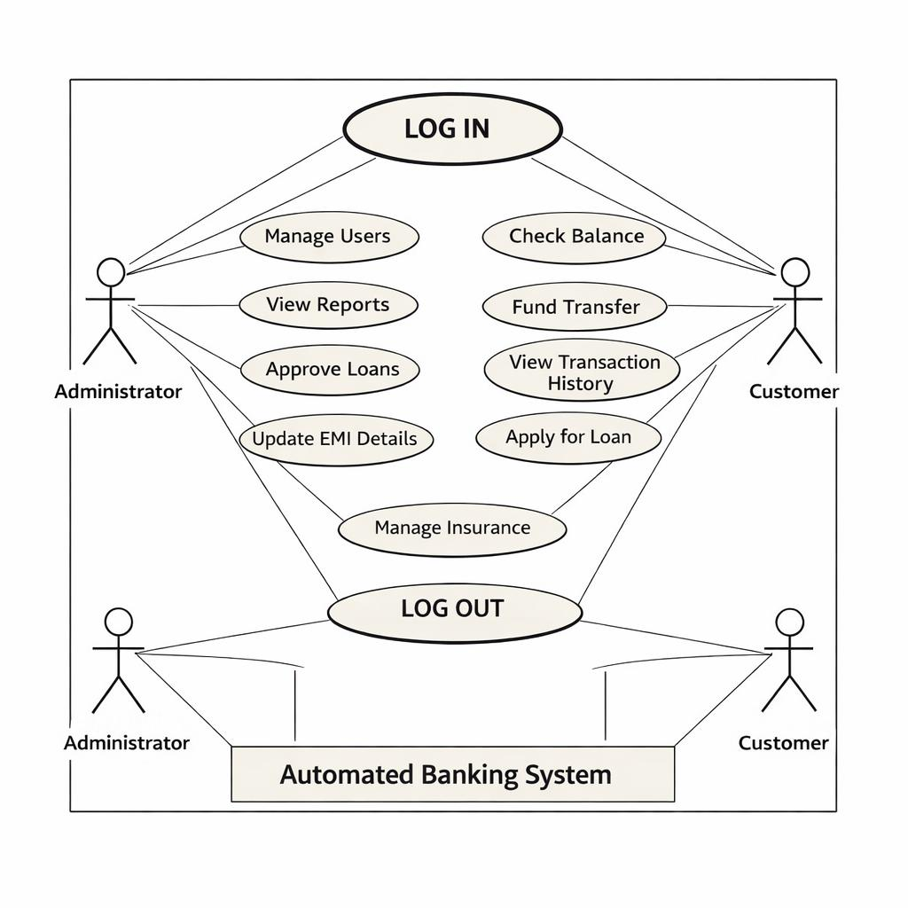

6. Future Enhancements
- Automatic EMI payment feature
- AI-based loan eligibility checking
- Chatbot support

8. References
1. Reserve Bank of India (RBI) – Banking Regulations and Guidelines
https://www.rbi.org.in
2. OWASP – Web Application Security Project
https://owasp.org
3. National Payments Corporation of India (NPCI)
https://www.npci.org.in
4. ISO/IEC 27001 – Information Security Management Systems
https://www.iso.org/isoiec-27001-information-security.html
5. Oracle Financial Services – Banking Technology Solutions
https://www.oracle.com/industries/financial-services/banking/
6. IBM Digital Banking Solutions
https://www.ibm.com/banking

9. Conclusion
This SRS document defines the functional and non-functional requirements of the Automated Banking System, ensuring clarity and completeness for development and evaluation.

