**Practical - 1**

**Code:**#include <iostream>

#include <unordered_map>

#include <vector>

using namespace std;

int main()

{

int inSymbol, state;

char currState, finalState;

cout << "Enter the number of Input Symbols: ";

cin >> inSymbol;

vector<char> symbols(inSymbol);

cout << "Enter the Symbols: ";

for (char &symbol : symbols)

cin >> symbol;

cout << "Enter the number of States: ";

cin >> state;

vector<char> states(state);

cout << "Enter the States: ";

for (char &stateChar : states)

cin >> stateChar;

cout << "Enter the Initial State: ";

cin >> currState;

int numFinalStates;

cout << "Enter the number of Final States: ";

cin >> numFinalStates;

vector<char> finalStates(numFinalStates);

cout << "Enter the Final States: ";

for (char &finalStateChar : finalStates)

cin >> finalStateChar;

unordered_map<string, char> table;

for (const char &stateChar : states)

{

for (const char &symbol : symbols)

{

char nextState;

cout << stateChar << " -> " << symbol << " ";

cin >> nextState;

table[string(1, stateChar) + symbol] = nextState;

}

}

string inpString;

cout << "Enter input String: ";

cin >> inpString;

for (char inputChar : inpString)

currState = table[string(1, currState) + inputChar];

cout << (currState == finalState ? "String is Valid" : "String is Invalid");

return 0;

}

**Output Screenshot:**

**Test Case-1:**

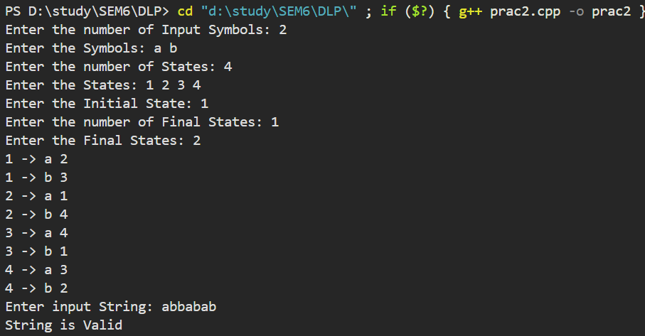

**Test Case-2:**

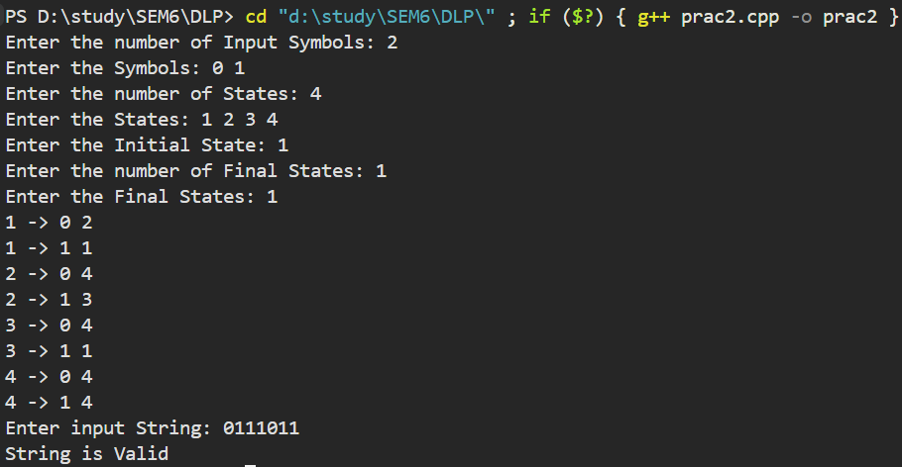

**Test Case-3:**

