Spring
Sambhav jain:
https://www.youtube.com/watch?v=Ga5kRSu-W5Y
Api gateway-:
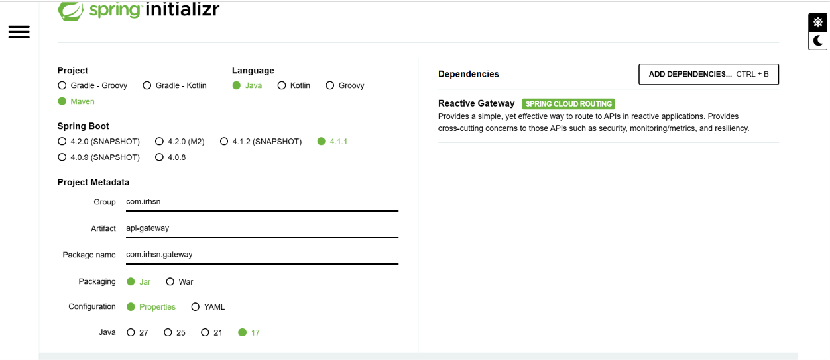
Medicine-service:
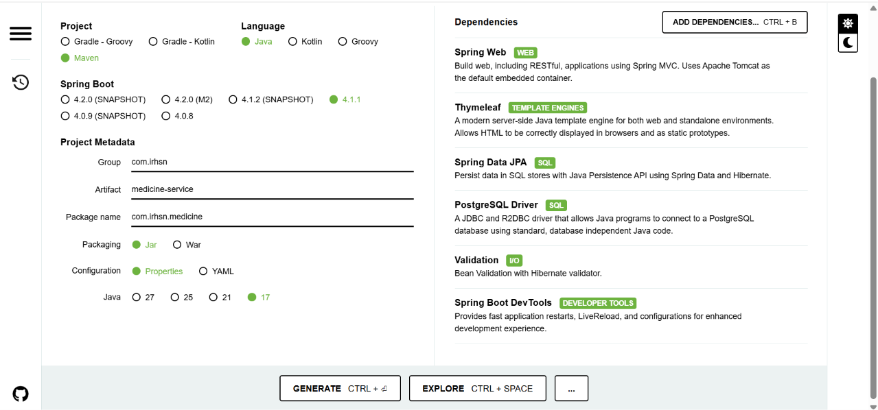

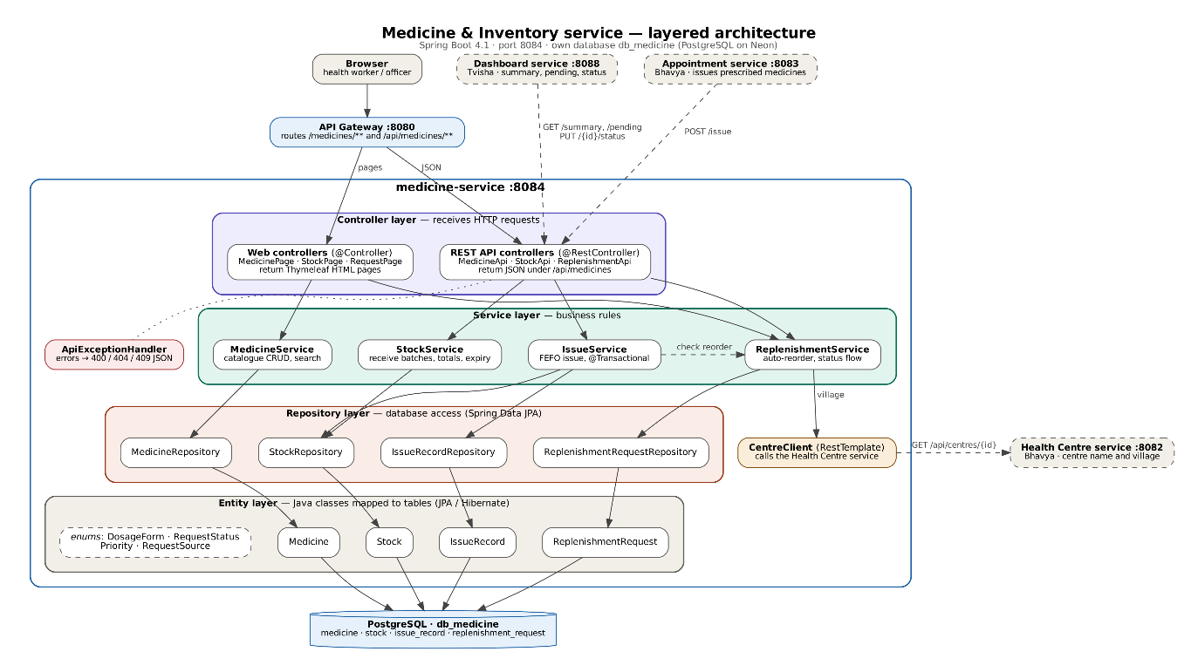

Medicine service:
Postgresql
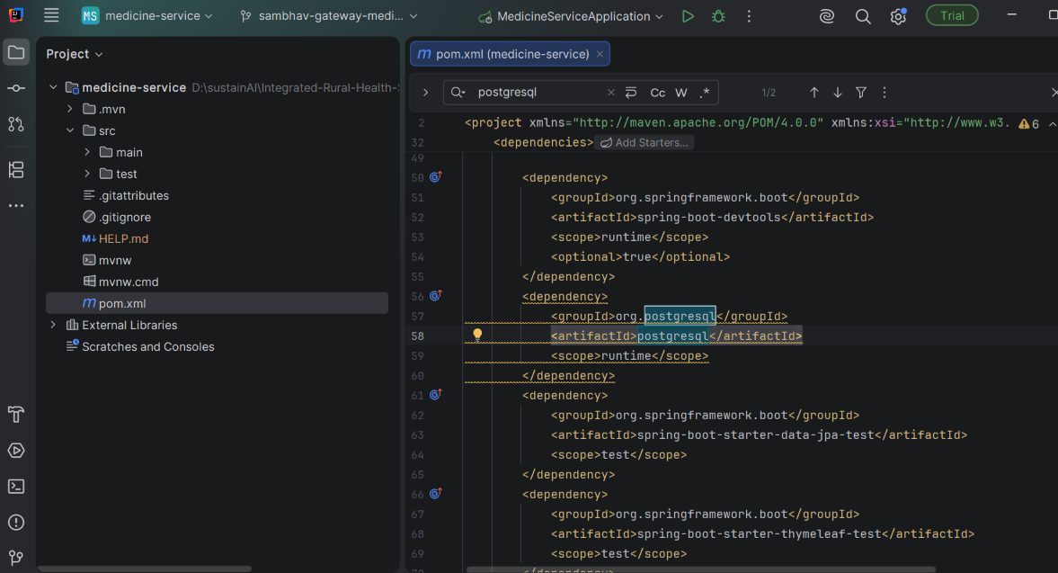

Database setup:
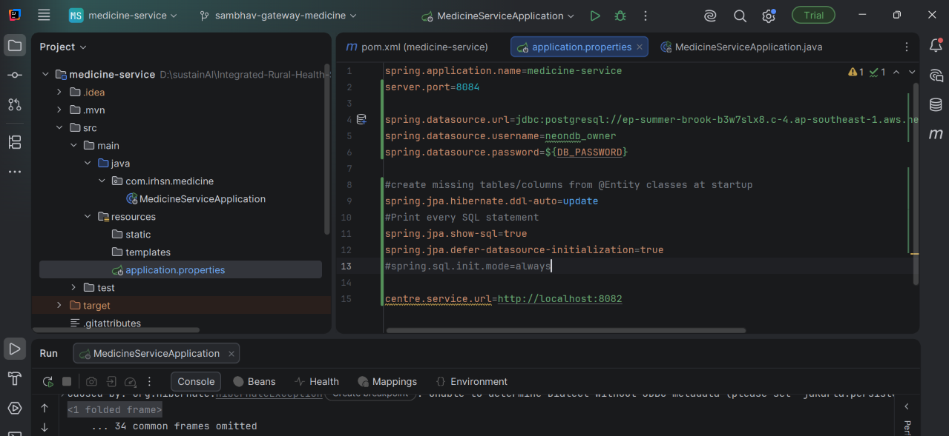
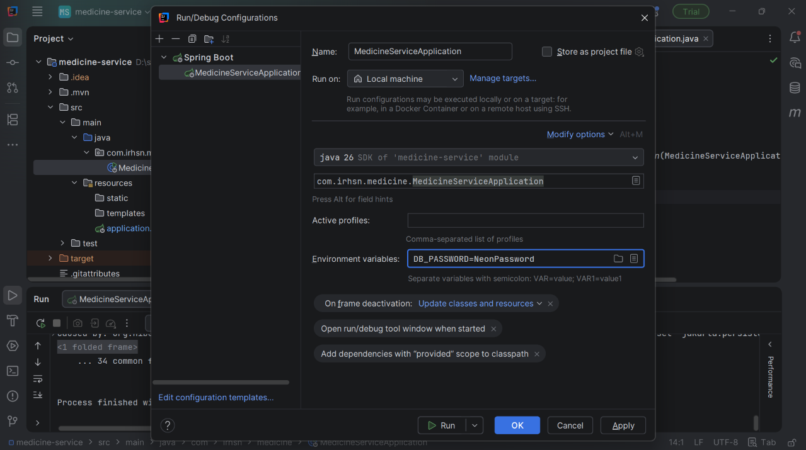
Enumerations
The Medicine & Inventory service uses four Java enums to restrict certain fields to a fixed set of valid values. Each enum is stored in PostgreSQL as readable text using @Enumerated(EnumType.STRING), so the database holds values like PENDING rather than position numbers, and adding or reordering values later does not corrupt existing rows. Invalid values are rejected at compile time instead of causing errors at runtime.
- DosageForm (medicine.form): the physical form of a medicine. Values: TABLET, CAPSULE, SYRUP, INJECTION, OINTMENT, CONSUMABLE (for supplies such as gauze or ORS sachets). It supports filtering the medicine catalogue by form.
- RequestStatus (replenishment_request.status): the life cycle of a stock replenishment request (an indent), following the real-world flow from a health centre to the district store:
  - PENDING: raised and waiting for an authorized officer.
  - APPROVED: accepted by the officer.
  - DISPATCHED: sent from the store.
  - RECEIVED: arrived at the centre, which adds a new stock batch.
  - REJECTED: declined by the officer.
The service allows only forward transitions (PENDING → APPROVED or REJECTED, APPROVED → DISPATCHED, DISPATCHED → RECEIVED), and any other change is refused.
- Priority (replenishment_request.priority): how urgently a request needs action, so the officer’s dashboard can sort it.
  - HIGH: the medicine is out of stock, or it is on the essential medicines list.
  - MEDIUM: stock is below half the reorder level.
  - LOW: stock is otherwise below the reorder level.
- RequestSource (replenishment_request.source): who created the request.
  - AUTO: generated by the system when issuing a medicine dropped the centre’s total stock below the reorder level.
  - MANUAL: reported by a health worker through the request form (as in the problem statement’s illustrative example).
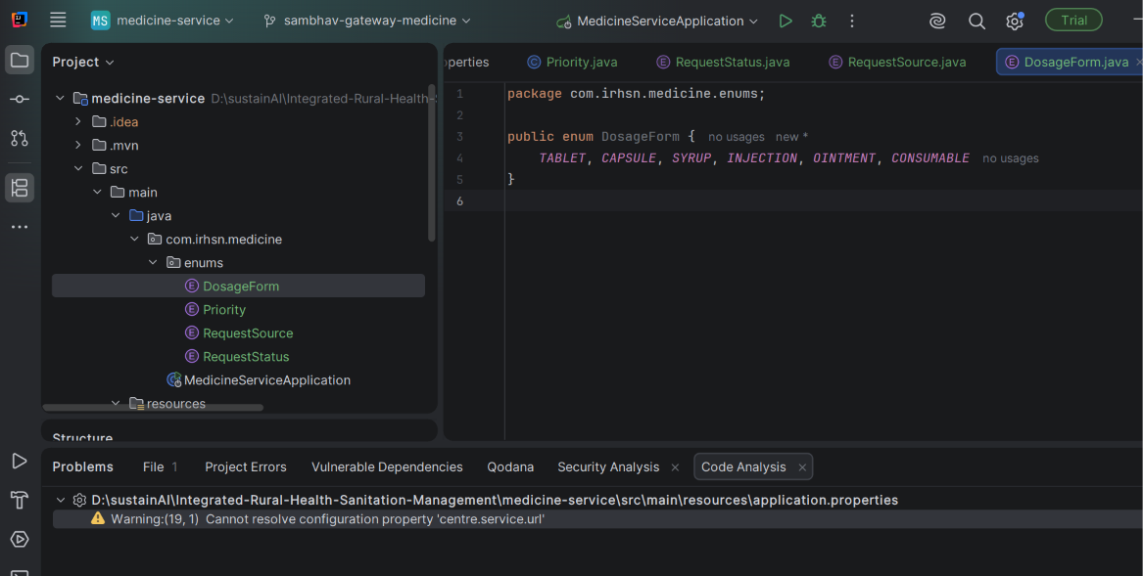

Entity
an entity is a Java class that represents one database table. Each object of that class is one row, and each field is one column.
You write the class with labels like @Entity, @Id and @Column, and Spring (through Hibernate) does two things for you automatically:
- It creates the table in PostgreSQL from the class, so you never write CREATE TABLE.
- It converts between Java objects and rows. When you save a Medicine object, it becomes a row; when you read a row, it comes back as a Medicine object.
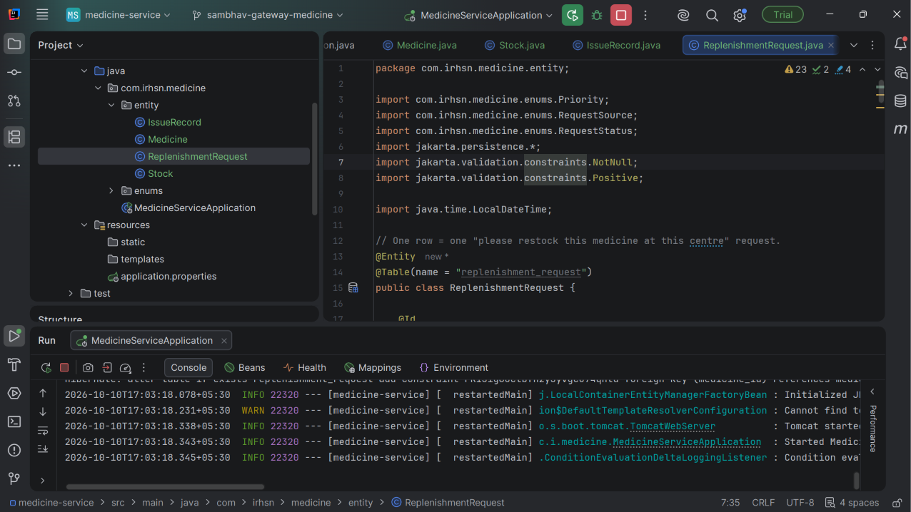
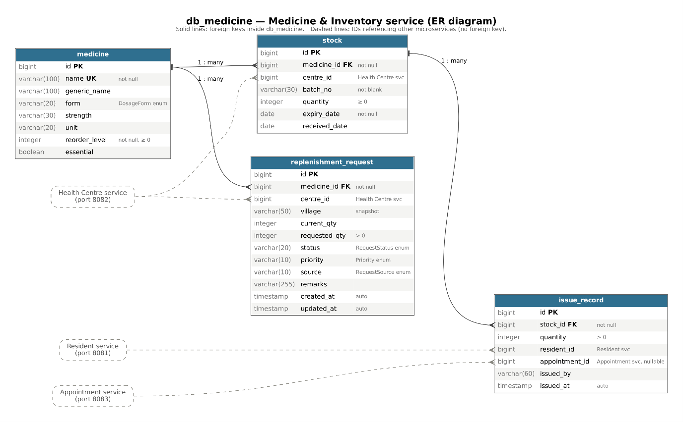
Repository layer
