Module – 1
231fa04975@gmail.com
Exercise 1: Implementing the Singleton Pattern
Logger.cs:
using System;
namespace SingletonPatternExample
{
public sealed class Logger
{
private static Logger? instance;
private Logger()
{
Console.WriteLine("Logger Instance Created");
}
public static Logger GetInstance()
{
if (instance == null)
{
instance = new Logger();
}
return instance;
}

public void Log(string message)
{
Console.WriteLine("LOG: " + message);
}
}
}

Program.cs:
using SingletonPatternExample;
Logger logger1 = Logger.GetInstance();
Logger logger2 = Logger.GetInstance();
logger1.Log("Application Started");
logger2.Log("User Logged In");
Console.WriteLine();
if (logger1 == logger2)
{
Console.WriteLine("Both objects are the same instance.");
}
else
{
Console.WriteLine("Different instances created.");
}

Output:

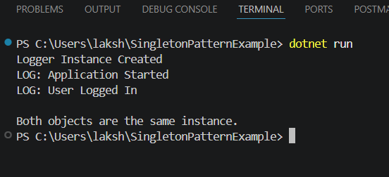

Exercise 2: Implementing the Factory Method Pattern
Program.cs:
using FactoryMethodPatternExample;
DocumentFactory wordFactory = new WordFactory();
IDocument word = wordFactory.CreateDocument();
word.Open();
DocumentFactory pdfFactory = new PdfFactory();
IDocument pdf = pdfFactory.CreateDocument();
pdf.Open();
DocumentFactory excelFactory = new ExcelFactory();
IDocument excel = excelFactory.CreateDocument();
excel.Open();
DocumentFactory.cs:
namespace FactoryMethodPatternExample
{
public abstract class DocumentFactory
{
public abstract IDocument CreateDocument();
}
}
IDocument.cs:
namespace FactoryMethodPatternExample
{
public interface IDocument
{
void Open();
}
}

WordDocument.cs:
using System;

namespace FactoryMethodPatternExample
{
public class WordDocument : IDocument
{
public void Open()
{
Console.WriteLine("Word Document Opened");
}
}
}
PdfDocument.cs:
using System;
namespace FactoryMethodPatternExample
{
public class PdfDocument : IDocument
{
public void Open()
{
Console.WriteLine("PDF Document Opened");
}
}
}
ExcelDocument.cs:
using System;
namespace FactoryMethodPatternExample
{
public class ExcelDocument : IDocument
{
public void Open()
{
Console.WriteLine("Excel Document Opened");
}
}
}
WordFactory.cs:
namespace FactoryMethodPatternExample
{
public class WordFactory : DocumentFactory
{
public override IDocument CreateDocument()
{
return new WordDocument();
}
}
}
PdfFactory.cs:
namespace FactoryMethodPatternExample
{
public class PdfFactory : DocumentFactory
{
public override IDocument CreateDocument()
{
return new PdfDocument();
}
}
}

ExcelFactory.cs:
namespace FactoryMethodPatternExample
{
public class ExcelFactory : DocumentFactory
{
public override IDocument CreateDocument()
{
return new ExcelDocument();
}
}
}
Output:
