Module-2
231fa04975@gmail.com
Exercise-2: E-commerce Platform Search Function
Program.cs:
using System;
public class Product
{
public int ProductId { get; set; }
public string ProductName { get; set; }
public string Category { get; set; }
public Product(int productId, string productName, string category)
{
ProductId = productId;
ProductName = productName;
Category = category;
}
}
class SearchOperations
{
public static Product LinearSearch(Product[] products, int targetId)
{
foreach (Product product in products)
{
if (product.ProductId == targetId)
{
return product;
}
}
return null;
}

public static Product BinarySearch(Product[] products, int targetId)
{
int left = 0;
int right = products.Length - 1;
while (left <= right)
{
int mid = (left + right) / 2;
if (products[mid].ProductId == targetId)
{
return products[mid];
}
else if (products[mid].ProductId < targetId)
{
left = mid + 1;
}
else
{
right = mid - 1;
}
}
return null;
}
}
class Program
{
static void Main()
{
Product[] products =
{
new Product(101, "Laptop", "Electronics"),
new Product(102, "Mobile", "Electronics"),
new Product(103, "Shoes", "Fashion"),
new Product(104, "Watch", "Accessories"),
new Product(105, "Bag", "Fashion")
};
Console.WriteLine("Available Product IDs:");
foreach (Product p in products)
{
Console.WriteLine($"{p.ProductId} - {p.ProductName}");
}
Console.Write("\nEnter Product ID to search: ");
int searchId = Convert.ToInt32(Console.ReadLine());
Product linearResult = SearchOperations.LinearSearch(products, searchId);
Console.WriteLine("\n----- Linear Search Result -----");
if (linearResult != null)
{
Console.WriteLine("Product Found");
Console.WriteLine("Product ID : " + linearResult.ProductId);
Console.WriteLine("Product Name : " + linearResult.ProductName);
Console.WriteLine("Category : " + linearResult.Category);
}
else
{
Console.WriteLine("Product not found");
}
Product binaryResult = SearchOperations.BinarySearch(products, searchId);
Console.WriteLine("\n----- Binary Search Result -----");
if (binaryResult != null)
{
Console.WriteLine("Product Found");
Console.WriteLine("Product ID : " + binaryResult.ProductId);
Console.WriteLine("Product Name : " + binaryResult.ProductName);
Console.WriteLine("Category : " + binaryResult.Category);
}
else
{
Console.WriteLine("Product not found");
}
}
}
Output:
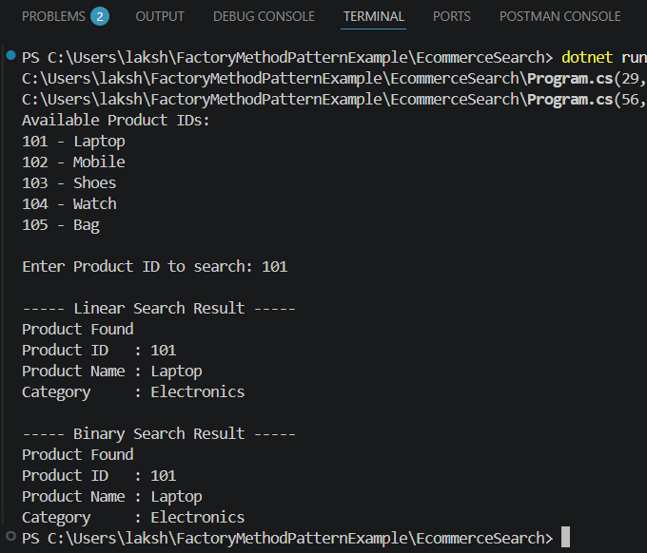
Exercise 7: Financial Forecasting
using System;
class FinancialForecast
{
public static double PredictFutureValue(double currentValue, double growthRate, int years)
{
if (years == 0)
{
return currentValue;
}
return PredictFutureValue(currentValue, growthRate, years - 1) * (1 + growthRate);
}
static void Main()
{
Console.Write("Enter Current Value: ");
double currentValue = Convert.ToDouble(Console.ReadLine());
Console.Write("Enter Annual Growth Rate (%): ");
double growthRate = Convert.ToDouble(Console.ReadLine()) / 100;
Console.Write("Enter Number of Years: ");
int years = Convert.ToInt32(Console.ReadLine());
double futureValue =
PredictFutureValue(currentValue, growthRate, years);
Console.WriteLine("\nPredicted Future Value: " +
futureValue.ToString("F2"));
}
}
Output:
