**DEOLDIFY:**

This process of colorizing black and white images can also be done through an open-source model called

**DEOLDIFY.**

The name by itself suggests that old images can be brought back to life using color

The way it does this is through Self-Attention General Adversarial Networks. In this particular GAN, the discriminator and the generator are trained separately and fine-tuned as opposed to a normal GAN in which this is done separately.

Using convolution models is computationally inefficient for modelling long-range dependencies

Self attention exhibits a better balance between the ability to model long range dependencies and computational efficiency.

Similar to the transformer model in language tasks like translation, the self-attention module is complementary to convolutions and helps with modelling long range, multi-level dependencies across image regions.

This helps the generator to draw the image with very fine details as it is taking into consideration the details in the distant portions of the image.

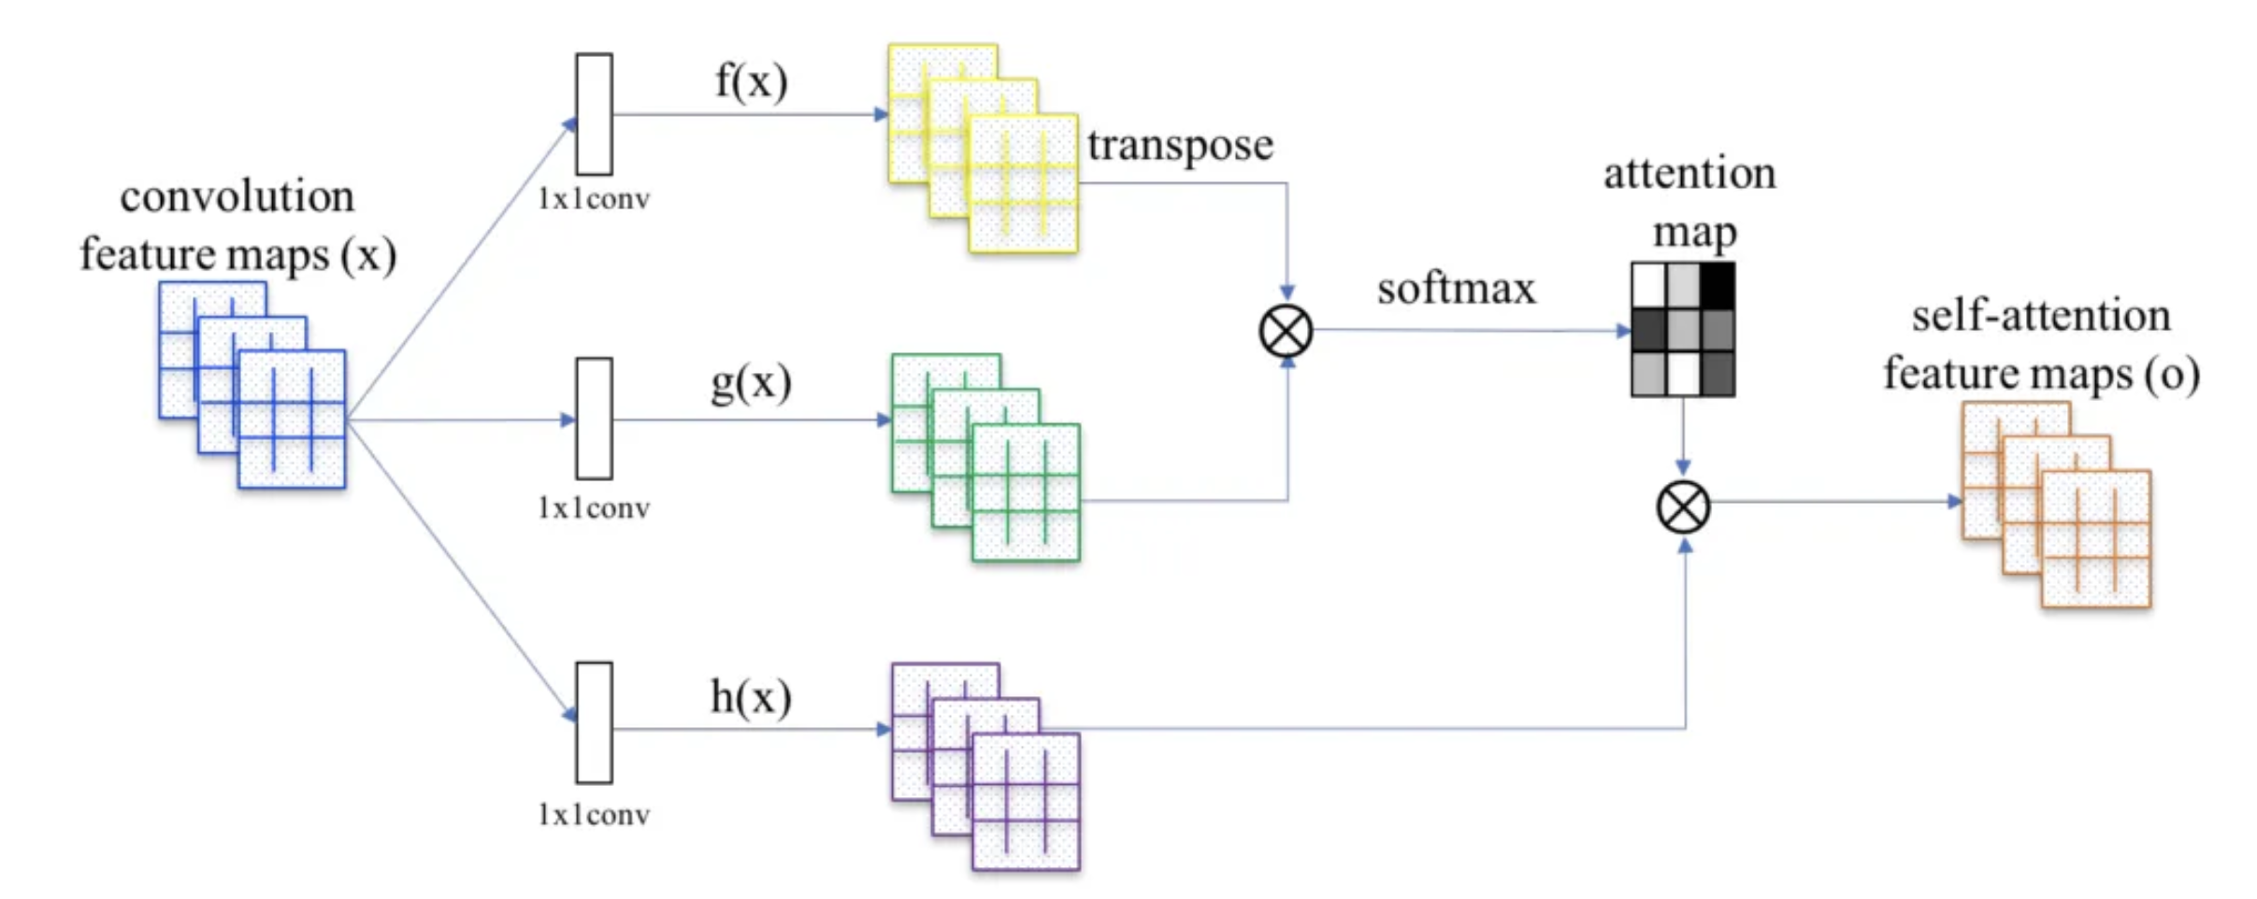

If x is a vector representing the features from the previous hidden layer. The features are transformed into two feature spaces f and g. Wf and Wg being the weights of the features spaces respectively.

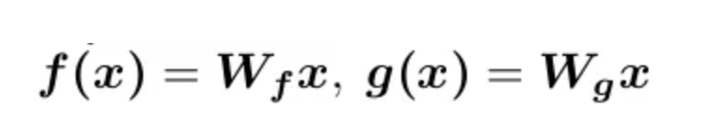

The formula that governs the influence of the ith location pixel when processing the jth location pixel is given by:

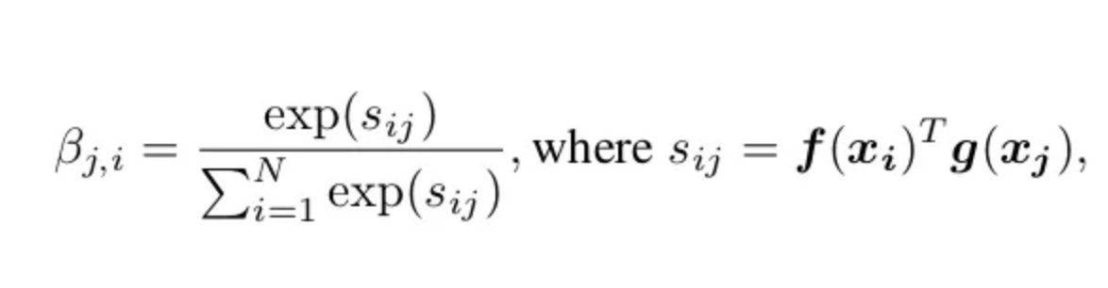

And the whole attention span of the model is given by :

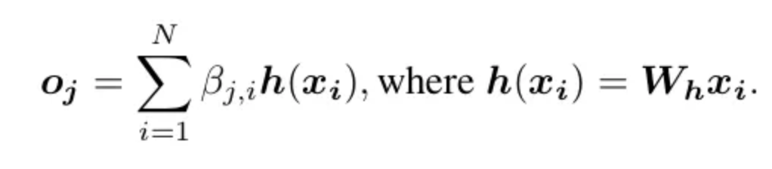

Implementation of the Self-Attention module: How does a model give attention to a particular part of the image?

Q : Query

K : Key

V : Value

Value is the vector representation of the image that is passed without self-attention.

The matrix multiplication of Query and Key gives us a distribution which tells us the amount that can be exposed to the next layer. This distribution is called **attention**

The attention is then passed to the softmax and the resukt is multiplied with the value vector to get a final value which is passed on to next layers

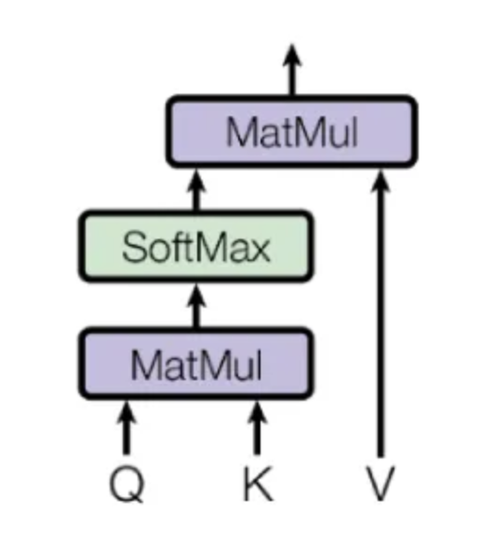

Some GANs also need progressive growing. This means that when GANs start with low-resolution images, then the resolution is increase by progressively adding layers to both the critic network(discriminator) and the generator networks

So the solution to improve quality, stability and variation of GANs is progressively adding layers to the training process that helps the networks to notice more fine details.

**One change in DeOldify is that the number of layers remain constant while increasing the image resolution progressively and that reduces computation power tremendously**

***Then why is DEOLDIFY better?***

Learning rate is a setting that controls how much the model changes its behavior in response to the error during training.

Generally, when the learning rates of the G and D are the same, the D often learns faster. This means the discriminator quickly gets very good at spotting fake data, which makes it harder for the generator to improve.

This affects the ability of the Generator to learn from its mistakes and imrove

**DeOldify solves this problem completely because it trains its models separately and not dependent on each other. By adjusting learning rates accordingly, we can make sure that both the networks are learning according to their own pace and thus leading to better overall performance**