**Set up in PYCharm—--------**

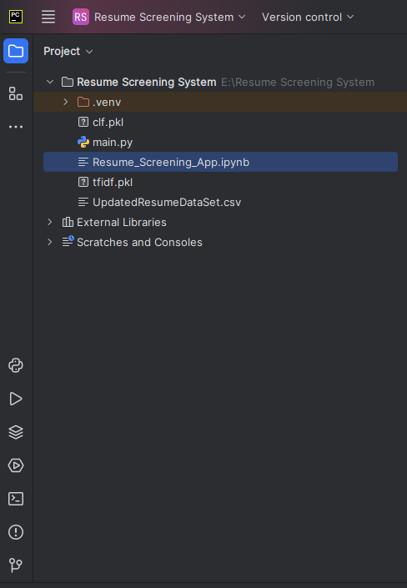

**Run in terminal—---**

streamlit run main.py

Output—-----

