**Handwritten Math Operation Solver in IML (4350702)**

Presented by: Bhavya N. Gohil

Enrollment No: ************

Semester: 5th

Class: CO51

Batch: 512

Course: Computer Engineering Diploma

Institution: R. C. Technical Institute

# 1. Introduction

The **Handwritten Math Operation Solver** is a deep learning-based system designed to simplify the recognition and solving of handwritten mathematical expressions. Using **Convolutional Neural Networks (CNNs)**, the system accurately identifies handwritten digits and arithmetic operators, including addition ('+'), subtraction ('-'), multiplication ('*'), and division ('/'). The CNN model is trained on a diverse dataset to recognize handwritten numerals and symbols, enabling the system to process input from images or live drawings.

Once the system identifies the digits and operators, it parses the expression and evaluates it using a custom logic engine to deliver the correct result. To enhance usability, a **Graphical User Interface (GUI)** allows users to input expressions via a touchscreen or other input devices, offering real-time, interactive problem-solving. This tool aims to be efficient, accurate, and user-friendly, making it suitable for educational and personal use.

# 2. Objective

The primary objective of this project is to develop a robust and intelligent system that can efficiently recognize, interpret, and solve handwritten mathematical expressions. The system is designed to process a wide range of mathematical inputs, including digits (0-9) and common arithmetic operators such as addition ('+'), subtraction ('-'), multiplication ('*'), and division ('/'). By utilizing advanced machine learning techniques, particularly Convolutional Neural Networks (CNNs), the system aims to accurately classify each component of the handwritten input, ensuring precise identification of both numerical values and mathematical symbols.

Once the expression is recognized, the system further processes and evaluates the mathematical operation to deliver the correct solution. This involves parsing the recognized symbols into a coherent mathematical expression and performing the necessary computations to provide accurate results. The goal is to create a system that not only identifies handwritten input with high accuracy but also offers a seamless user experience, enabling users to enter complex arithmetic expressions by hand and receive immediate solutions. This project has practical applications in educational tools, learning aids, and interactive interfaces where handwriting recognition is a key feature.

# 3. Technologies Used

- Python  
- OpenCV  
- TensorFlow  
- Keras  
- Tkinter  
- NumPy  
- Pandas

# 4. Project Flow

The project involves the following key steps:

**1. Data Collection**

Data collection is a critical first step in the development of the Handwritten Math Operation Solver. In this phase, a large dataset of handwritten images of digits (0-9) and mathematical symbols (such as '+', '-', '*', '/') is gathered. This dataset may be sourced from publicly available databases such as MNIST for digits or created by collecting handwritten samples from multiple users to ensure variability in handwriting styles. For the project to succeed, the dataset must represent a wide variety of handwriting patterns, including differences in slant, thickness, and writing speed. Each image is then meticulously labeled to associate it with the correct numerical digit or symbol. Labeling ensures that the model can learn the correct mappings during training. This data serves as the foundation on which the entire recognition system is built, and the quality and diversity of the data significantly impact the model's ability to generalize across different handwriting styles.

**2. Data Preprocessing**

Once the handwritten images are collected, the next critical step is data preprocessing. The raw images cannot be directly fed into the model as they often vary in size, quality, and format. The preprocessing pipeline includes a series of steps to standardize the images for optimal model training. Some key preprocessing techniques are:

**Resizing:** All images are resized to a standard dimension (e.g., 28x28 pixels), which ensures uniformity across the dataset. This allows the model to focus on essential features without being biased by size variations.

**Grayscale Conversion:** Converting color images to grayscale simplifies the data and reduces computational complexity, as color information is not needed for digit recognition.

**Thresholding/Binarization:** Images are often thresholded to convert them into binary images, where the pixel values are set to either 0 (black) or 1 (white). This process highlights the characters and removes background noise, improving the clarity of the digits and symbols.

**Normalization:** Normalizing pixel values (e.g., scaling them between 0 and 1) helps improve the convergence of the deep learning model during training.

**Augmentation:** In some cases, augmentation techniques like rotating, shifting, or flipping the images are applied to artificially increase the dataset size and improve the model's robustness to variations in handwriting.

These preprocessing steps ensure that the CNN receives clean, standardized input, allowing it to focus on learning relevant features of the handwritten digits and symbols.

**3. Model Training**

In this step, a Convolutional Neural Network (CNN), a type of deep learning model specifically designed for image recognition tasks, is employed to train the system to recognize handwritten digits and mathematical symbols. CNNs excel at identifying spatial patterns in images, making them ideal for this task. The architecture of the CNN typically consists of several layers, including:

**Convolutional Layers:** These layers apply filters to the input images to detect important features like edges, corners, and curves. By learning these features, the model can begin to recognize patterns unique to specific digits or symbols.

**Pooling Layers:** Pooling layers reduce the spatial dimensions of the feature maps generated by the convolutional layers, helping to decrease computational load while retaining critical features.

**Fully Connected Layers:** After the convolution and pooling layers, fully connected layers interpret the extracted features and make predictions based on the likelihood of each digit or symbol.

**Activation Functions:** Non-linear activation functions, such as ReLU, are applied throughout the network to introduce non-linearity, enabling the CNN to model complex patterns in handwriting.

**Softmax Output Layer:** The final output layer typically uses the softmax function to assign a probability to each possible class (digits 0-9 or mathematical symbols), allowing the model to classify the input image.

The CNN is trained using a labeled dataset, where the model learns to associate input images with their corresponding digits or symbols. During training, the model optimizes its weights by minimizing a loss function, often using an optimization algorithm like Stochastic Gradient Descent (SGD) or Adam. The training process is iterative, and the model continuously improves as it is exposed to more data. By the end of this stage, the CNN will have learned to recognize and classify handwritten digits and symbols with high accuracy.

**4. Prediction**

Once the CNN is trained, it can be deployed for prediction tasks. In this phase, users can provide input in the form of handwritten mathematical expressions, either as live drawings (e.g., using a touchscreen or mouse) or by uploading scanned images. The system processes these images, segmenting them into individual components (digits and symbols) and passing each component through the trained CNN for recognition. The CNN predicts the identity of each digit or symbol based on its learned patterns.

After recognizing the components, the system reconstructs the entire mathematical expression in its original form. To ensure the correct evaluation of the expression, the system employs a custom logic engine that follows standard mathematical rules (such as operator precedence in PEMDAS/BODMAS). This engine parses the recognized symbols and computes the final result. The prediction stage is designed to operate in real time, meaning users receive immediate feedback and solutions as soon as they input their handwritten expressions.

**5. GUI Development**

To make the Handwritten Math Operation Solver user-friendly and accessible, a Graphical User Interface (GUI) is developed, using tools such as Tkinter for Python. The GUI is designed to allow users to interact with the system seamlessly, either by drawing their mathematical expressions directly on a touchscreen or using a mouse, or by uploading images of handwritten math problems. Key features of the GUI include:

**Drawing Canvas:** A canvas where users can write mathematical expressions using a stylus, mouse, or finger. This is ideal for real-time recognition of handwritten input.

**Upload Functionality:** Users can also upload pre-existing images containing handwritten mathematical expressions. The system will process these images similarly to live input.

**Real-time Feedback:** As users draw or upload their input, the system processes the data in real time, displaying both the recognized expression and the computed result instantly.

**Clear and Intuitive Layout:** The interface is designed to be simple and clean, with clear buttons for actions like "Solve" and "Clear", making it easy for users to correct and solve their input.

**Cross-Platform Compatibility:** Built with Tkinter, the GUI is lightweight and compatible across multiple platforms, including Windows, MacOS, and Linux, ensuring broad accessibility for users.

The GUI not only makes the system more accessible but also enhances the overall user experience by providing a smooth, interactive way to input and solve handwritten mathematical problems. The real-time processing and feedback offered by the interface make the system particularly appealing for educational and personal use.

# 5. Dataset

The dataset used in this project consists of images of handwritten digits and arithmetic symbols, categorized into the following classes:

* **Digits (0-9):** Images of handwritten numbers from 0 to 9, covering a variety of handwriting styles.
* **Arithmetic Operators ('+', '-', '*', '/')**: Handwritten images of basic mathematical symbols for addition, subtraction, multiplication, and division.

By training the model with this categorized dataset, which covers both numbers and arithmetic symbols, the system becomes capable of recognizing and interpreting handwritten mathematical expressions of varying complexity. This dataset forms the backbone of the learning process, enabling the model to differentiate between digits and operators and to handle a variety of handwriting styles with high accuracy.

This dataset is essential for training the system to accurately recognize and process different handwritten mathematical expressions.

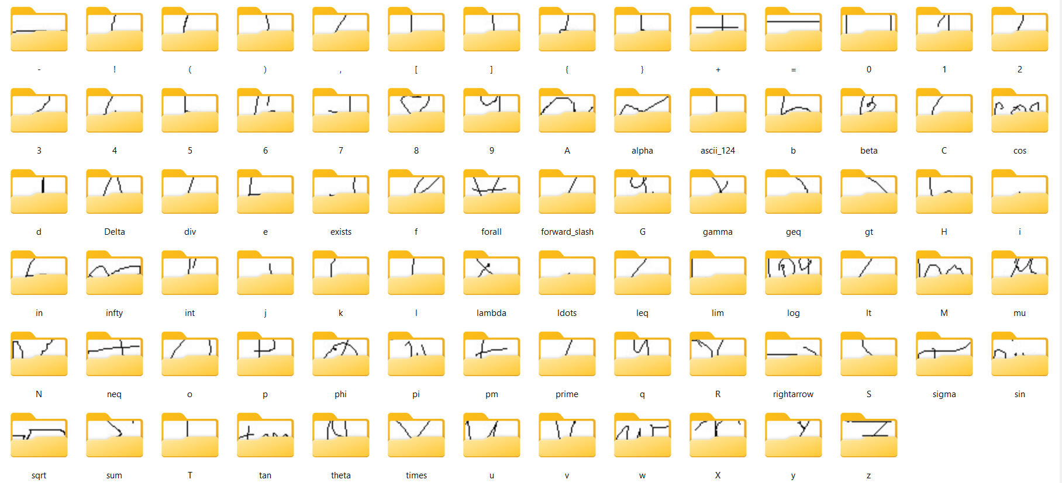

# 6. Data Preprocessing

To ensure optimal model performance, the following preprocessing steps are applied:

* **Resizing:** All images are resized to 28x28 pixels to standardize input size.
* **Thresholding:** Binary thresholding is applied to distinguish the symbols from the background.
* **Contour Detection:** Contours are used to detect and focus on the key regions containing the digits or symbols.
* **Reshaping:** The processed images are reshaped into a format suitable for CNN input, typically a 28x28 matrix.

## Preprocessing Code:

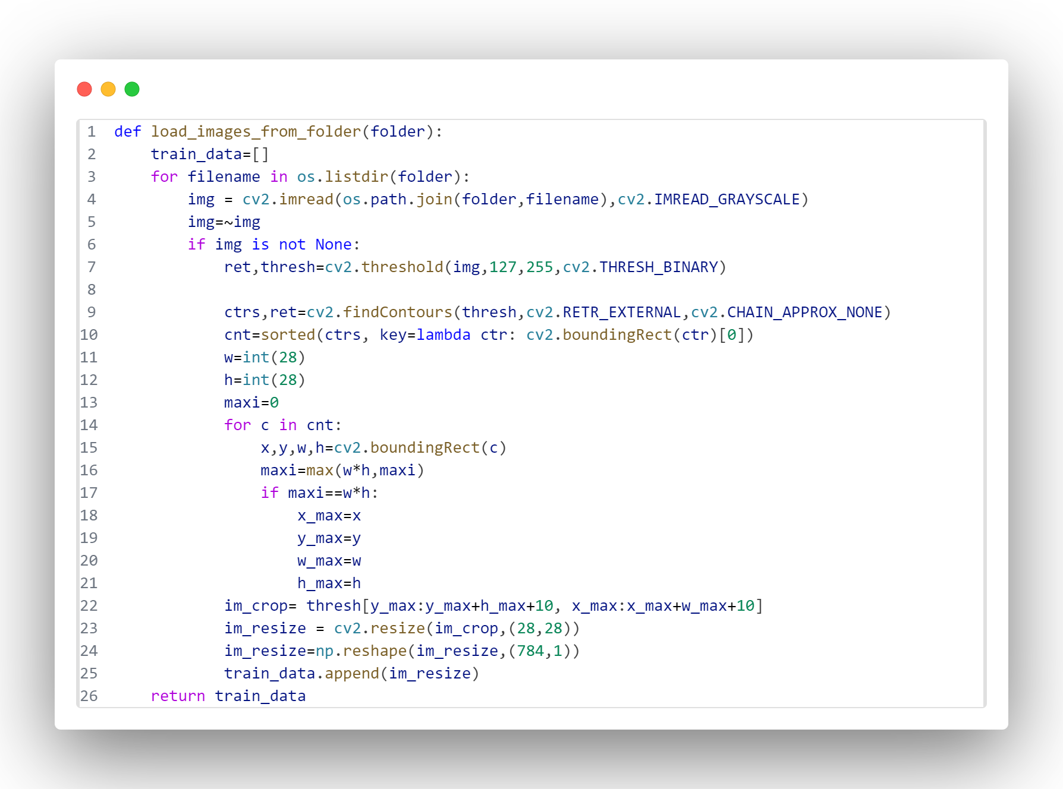

# 7. Model Architecture

The model architecture used in this project is a Convolutional Neural Network (CNN), designed specifically to recognize and classify handwritten digits and arithmetic symbols. It comprises the following key layers:

* **Convolutional Layers:** These layers are responsible for extracting essential features from the input images by applying filters (kernels) that detect patterns like edges and curves. Multiple convolutional layers help capture increasingly complex features, such as shapes and strokes, critical for distinguishing digits and symbols.
* **MaxPooling Layers:** After each convolutional layer, max pooling is applied to reduce the spatial dimensions of the feature maps. This operation helps to down-sample the image, reducing computational complexity while retaining the most important features. It also helps in making the model more robust to variations like slight rotations or shifts in the input images.
* **Flatten Layer:** The feature maps generated by the convolutional and pooling layers are multi-dimensional arrays. The flatten layer reshapes this data into a one-dimensional vector, preparing it for input into the fully connected layers that follow.
* **Dense (Fully Connected) Layers:** These layers perform the actual classification of the input. Each neuron in these layers is connected to every neuron in the previous layer, enabling the model to combine the extracted features to recognize specific patterns corresponding to each digit or arithmetic symbol.
* **Softmax Output Layer:** The final layer is a softmax layer that generates probabilities for each possible class (0-9, '+', '-', '*', '/'). The class with the highest probability is selected as the model's prediction, identifying the corresponding digit or arithmetic symbol in the input.

# 8. Model Training

The CNN is trained using the categorical crossentropy loss function and the Adam optimizer. The model is trained for 10 epochs with a batch size of 200, using data augmentation techniques to improve generalization.

## Training Code:

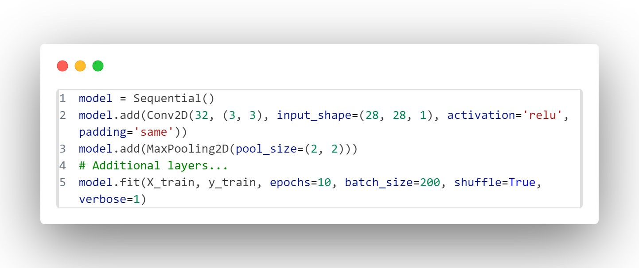

# 9. Model Evaluation

The trained model is evaluated using a test dataset. The confusion matrix is used to visualize the performance of the model in terms of correct and incorrect predictions. Accuracy and other metrics such as precision, recall, and F1-score are computed.

# 10. Graphical User Interface (GUI)

A user-friendly interface is developed using Tkinter, allowing users to either draw mathematical expressions or upload images for recognition. The system predicts the result of the expression and displays it to the user.

Features of the GUI:

- Drawing canvas: Users can handwrite their math expressions.  
- Image upload: Users can upload an image of a handwritten expression.  
- Result display: The predicted result of the expression is shown.

# 11. Challenges Faced

Some challenges encountered during the development of the project include:  
- Data diversity: Ensuring that the dataset includes a wide variety of handwriting styles.  
- Model accuracy: Improving the model to handle noisy or unclear images.  
- Real-time prediction: Optimizing the system for real-time recognition and prediction.

# 12. Future Work

Possible improvements and future directions for this project include:  
- Expanding the dataset: Incorporating more samples of diverse handwriting styles to improve model robustness.  
- Support for more operations: Adding support for complex operations such as parentheses or fractions.  
- Mobile deployment: Extending the system for use on mobile devices for greater accessibility.

# 13. Conclusion

The Handwritten Math Operation Solver successfully recognizes and solves basic arithmetic expressions. It can be used as an educational tool or integrated into systems that require handwritten math input. With further refinement, the system could be expanded to support more advanced mathematical expressions and improve accuracy.

# 14. References

1. TensorFlow Documentation  
2. OpenCV Documentation  
3. Keras Documentation  
4. Python Official Documentation

# 15. Accuracy & loss

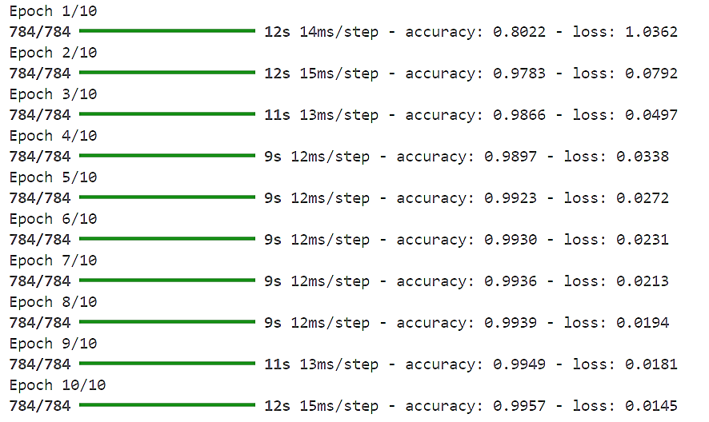

**Accuracy:** 99.5% **Loss:** 1.45%

# 16. Output

