Create a public load balancer to load balance VMs using the Azure portal

Diagram:

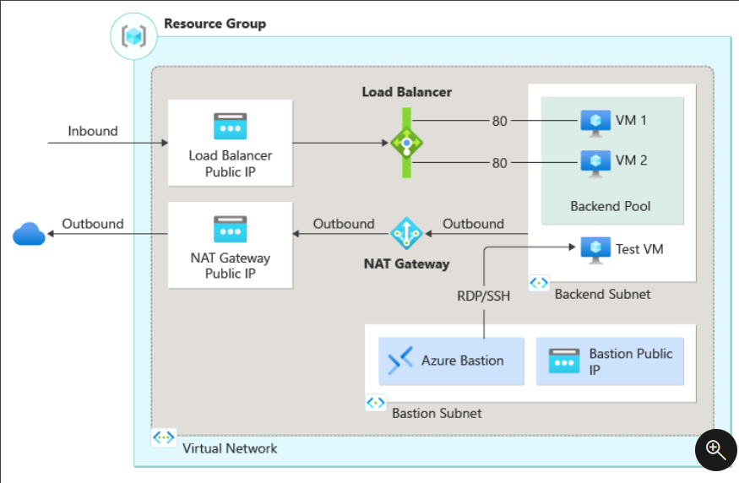

# Create NAT gateway

1. Sign in to the [Azure portal](https://portal.azure.com/).
2. In the search box at the top of the portal, enter **NAT gateway**. Select **NAT gateways** in the search results.
3. Select **+ Create**.
4. In the **Basics** tab of **Create network address translation (NAT) gateway** enter or select the following information:

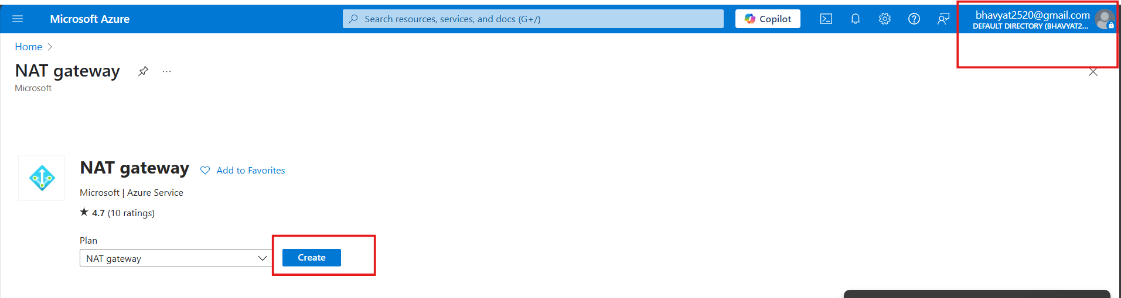

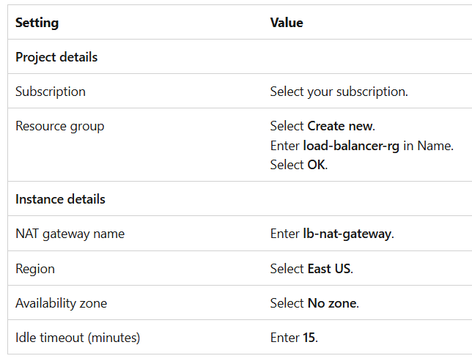

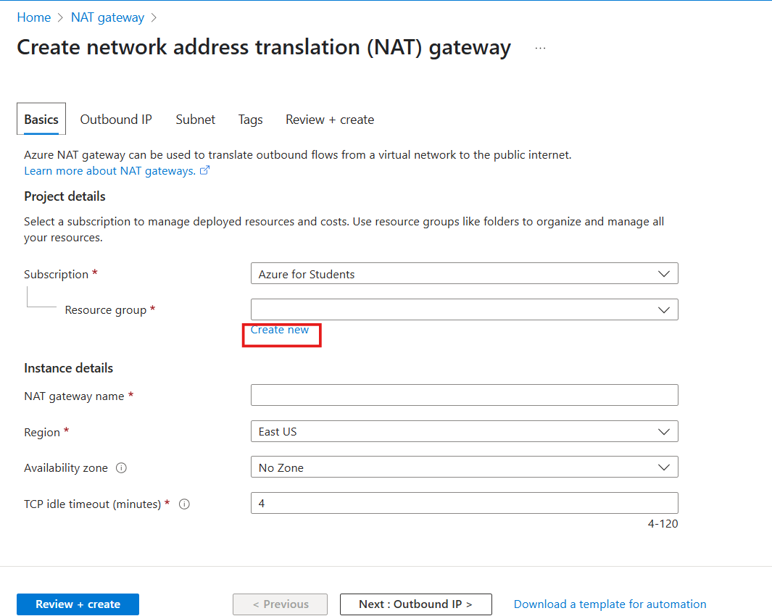

Fill up following details

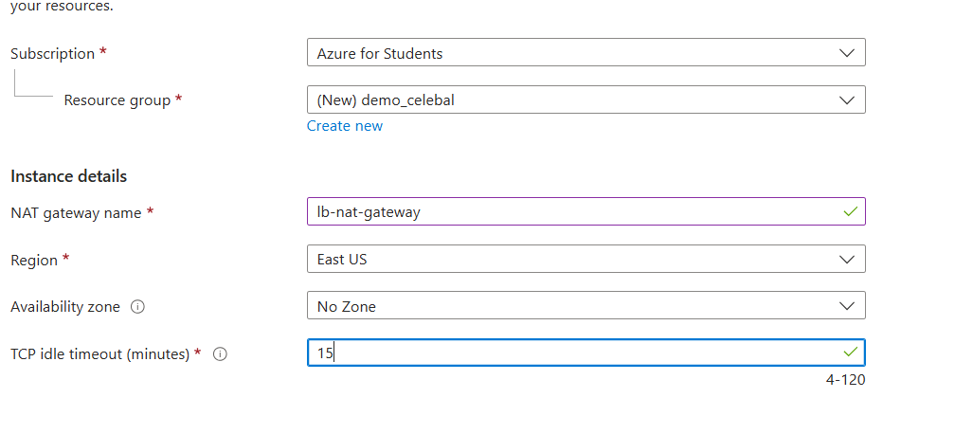

1. Select the **Outbound IP** tab or select the **Next: Outbound IP** button at the bottom of the page.
2. Select **Create a new public IP address** under **Public IP addresses**.
3. Enter **nat-gw-public-ip** in **Name** in **Add a public IP address**.
4. Select **OK**.
5. Select the blue **Review + create** button at the bottom of the page, or select the **Review + create** tab.
6. Select **Create**.

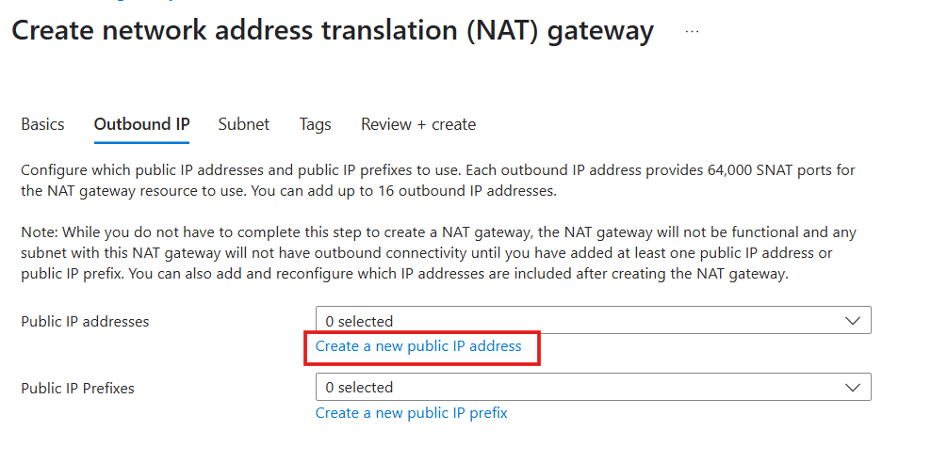

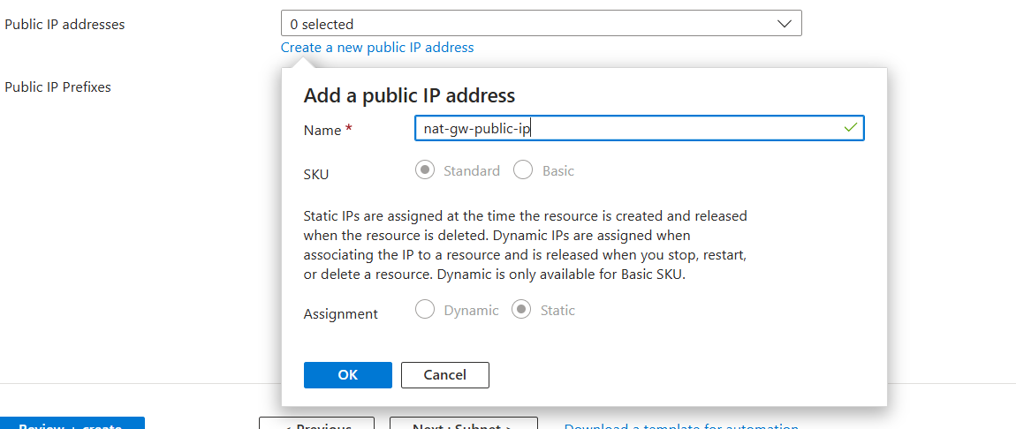

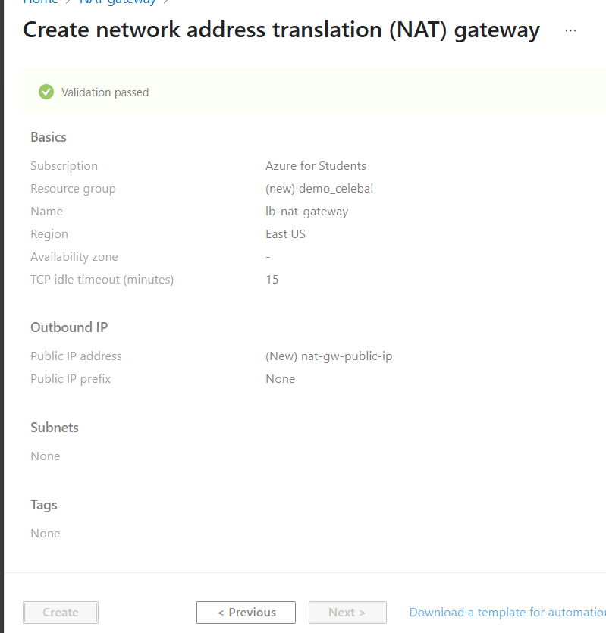

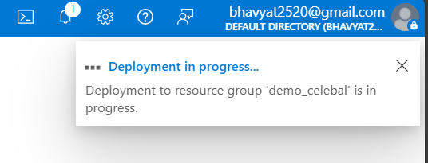

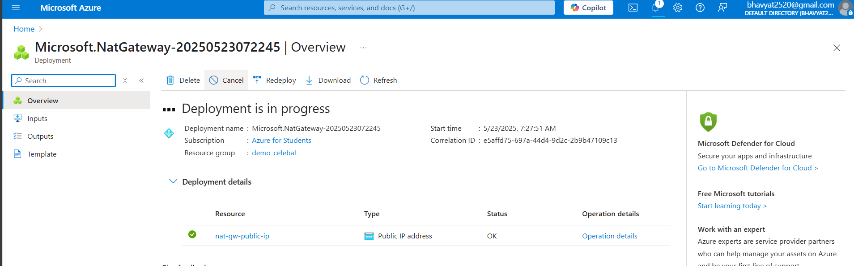

# Create a virtual network and bastion host

1. In the portal, search for and select **Virtual networks**.
2. On the **Virtual networks** page, select **+ Create**.
3. On the **Basics** tab of **Create virtual network**, enter or select the following information:

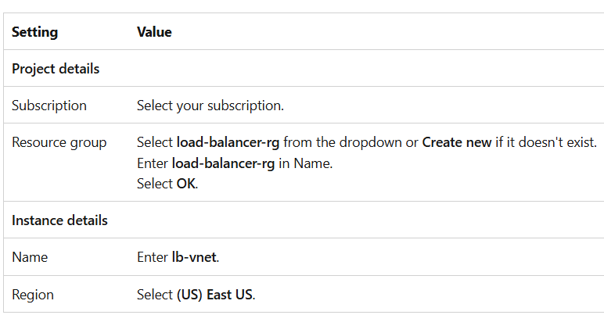

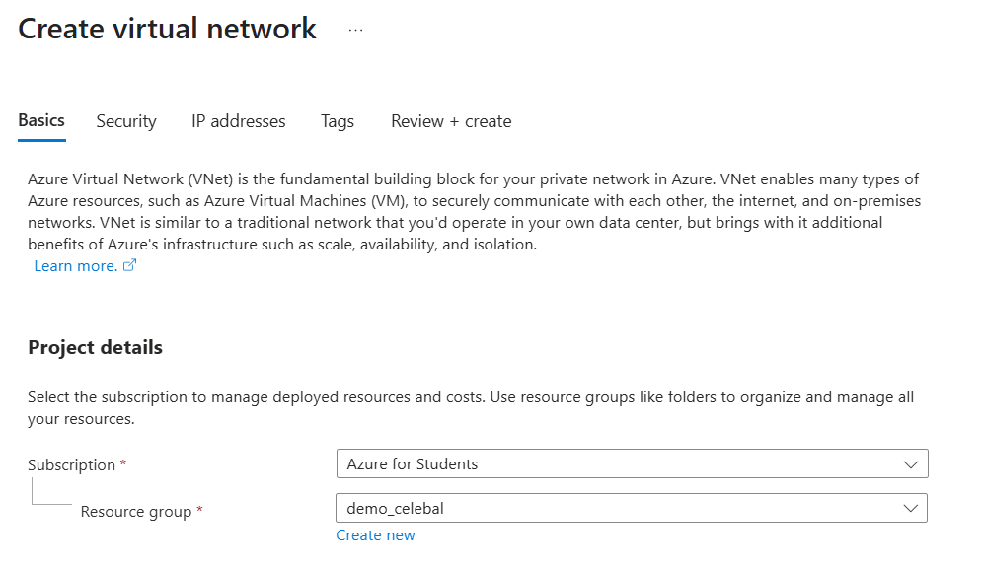

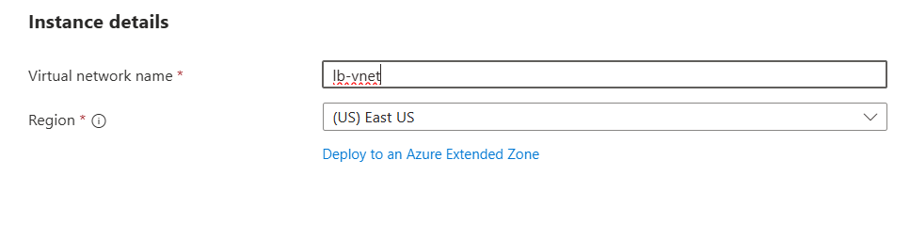

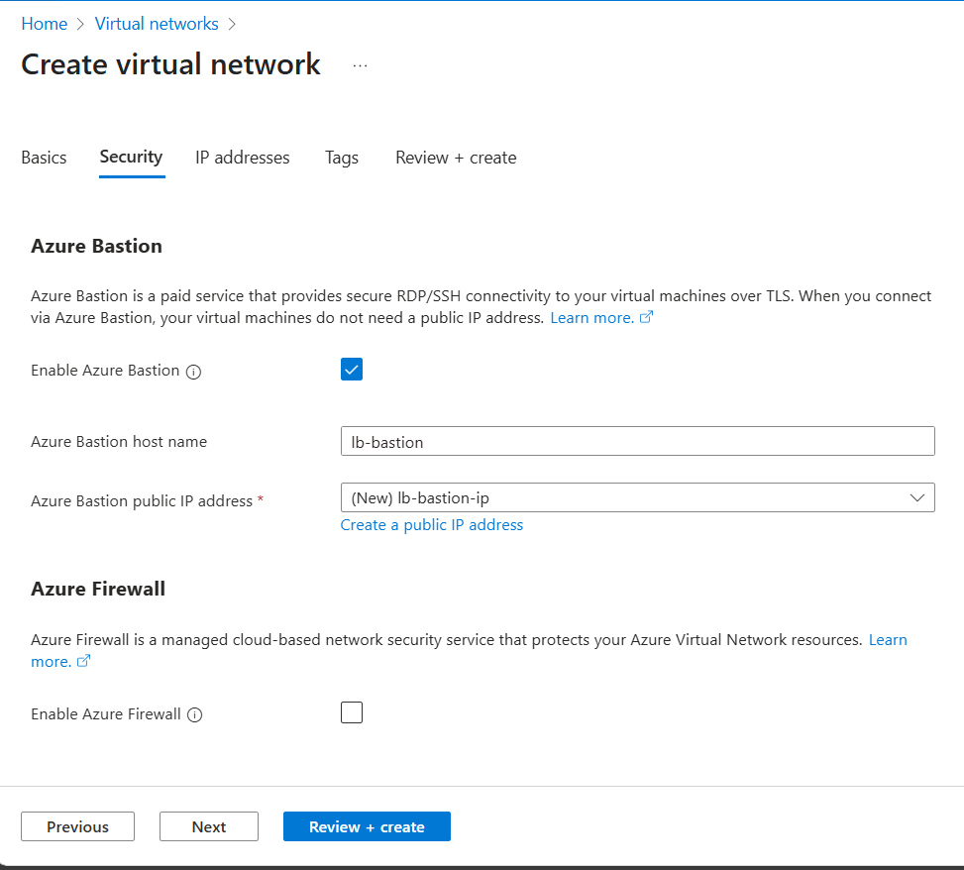

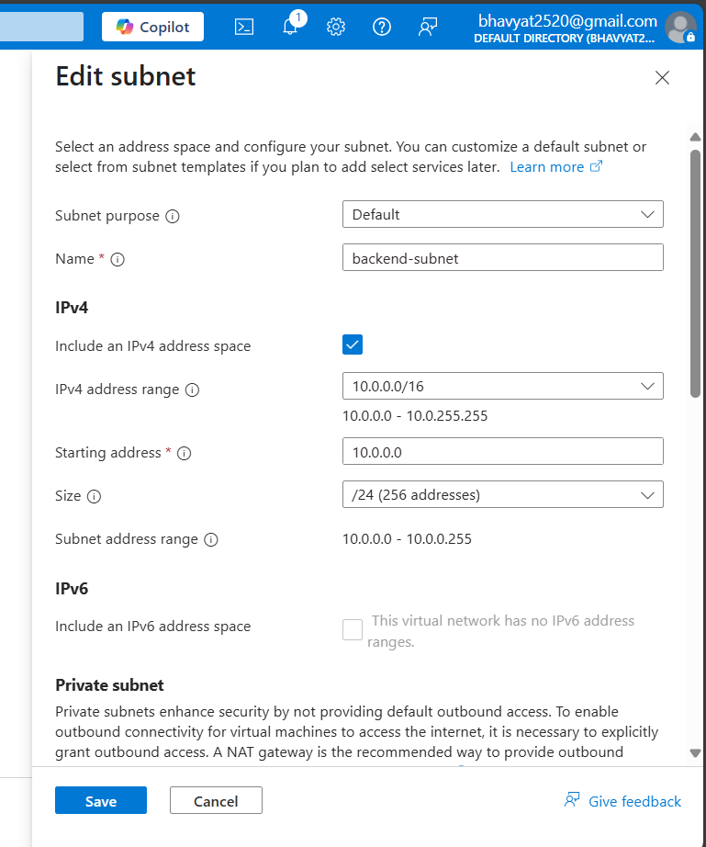

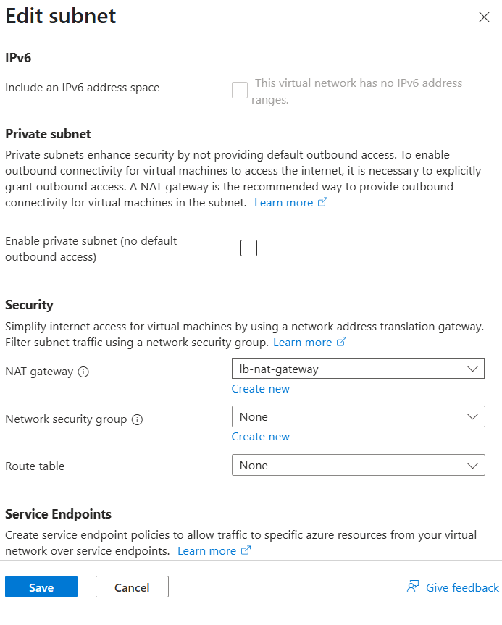

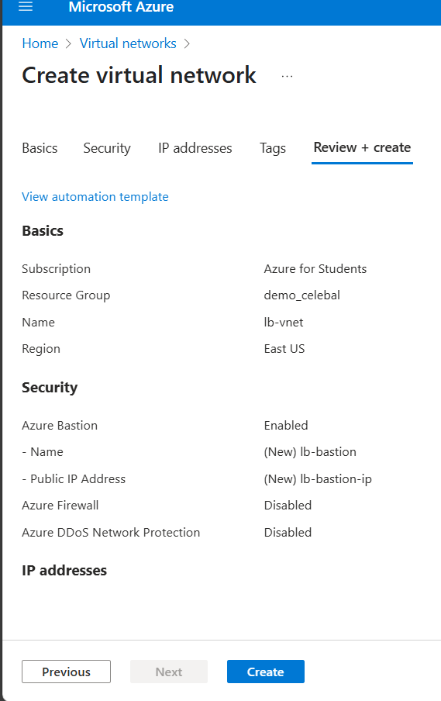

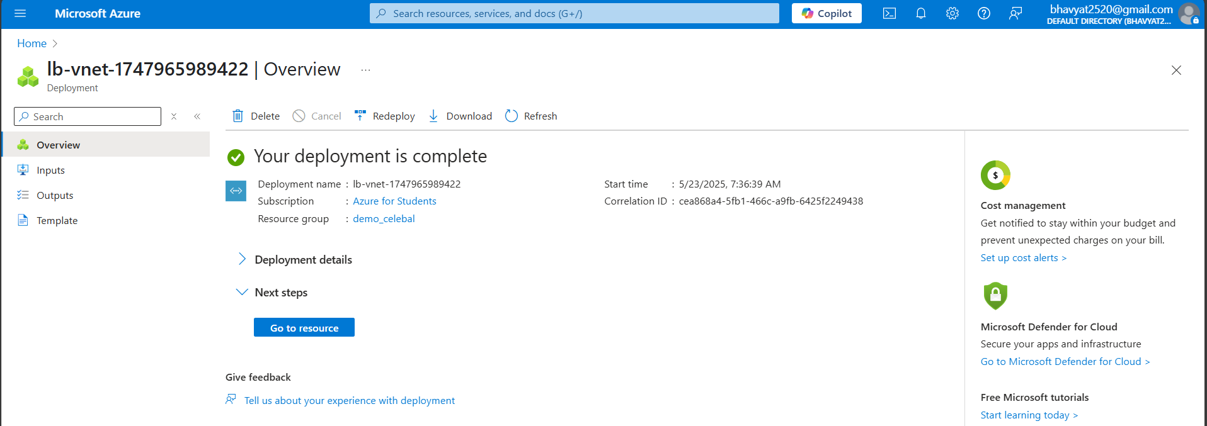

# Create load balancer

During the creation of the load balancer, you configure:

* Frontend IP address
* Backend pool
* Inbound load-balancing rules
* Health probe

1. In the search box at the top of the portal, enter **Load balancer**. Select **Load balancers** in the search results.
2. In the **Load balancer** page, select **+ Create**.
3. In the **Basics** tab of the **Create load balancer** page, enter or select the following information:
4. Select **Next: Frontend IP configuration** at the bottom of the page.
5. In **Frontend IP configuration**, select **+ Add a frontend IP configuration**.
6. Enter **lb-frontend** in **Name**.
7. Select **IPv4** for the **IP version**.
8. Select **IP address** for the **IP type**.
9. Select **Create new** in **Public IP address**.
10. In **Add a public IP address**, enter **lb-frontend-ip** for **Name**.
11. Select **Zone-redundant** in **Availability zone**.
12. Leave the default of **Microsoft Network** for **Routing preference**.
13. Select **Save**.
14. Select **Save**.
15. Select **Next: Backend pools** at the bottom of the page.
16. In the **Backend pools** tab, select **+ Add a backend pool**.
17. Enter **lb-backend-pool** for **Name** in **Add backend pool**.
18. Select **lb-vnet** in **Virtual network**.
19. Select **IP Address** for **Backend Pool Configuration**.
20. Select **Save**.
21. Select **Next: Inbound rules** at the bottom of the page.
22. Under **Load balancing rule** in the **Inbound rules** tab, select **+ Add a load balancing rule**.
23. In **Add load balancing rule**, enter or select the following information:

Expand table

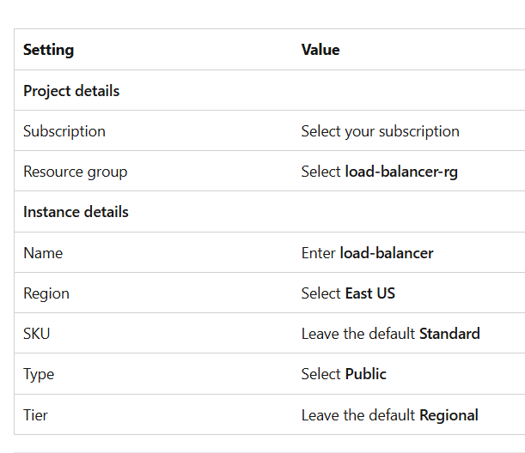

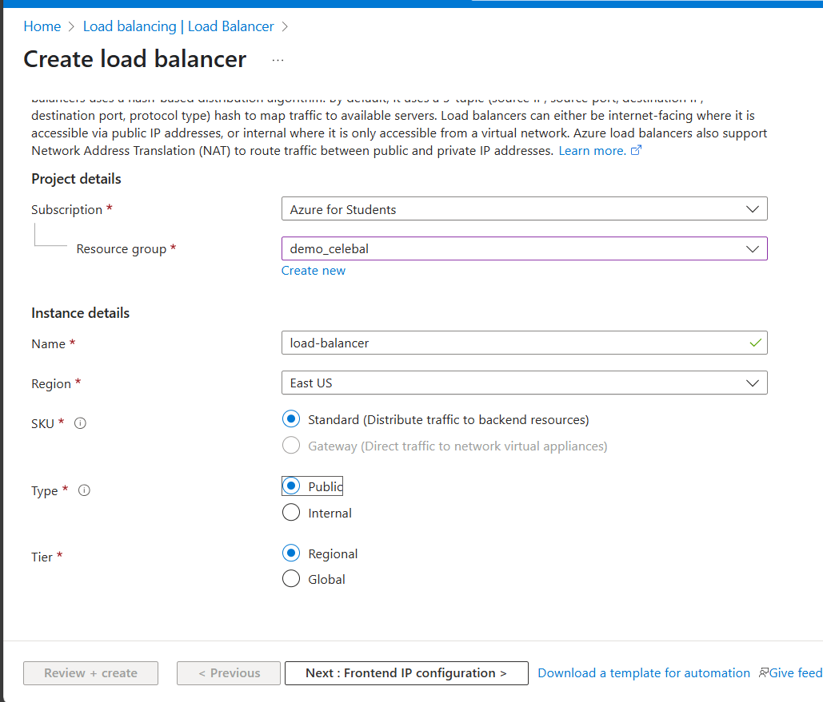

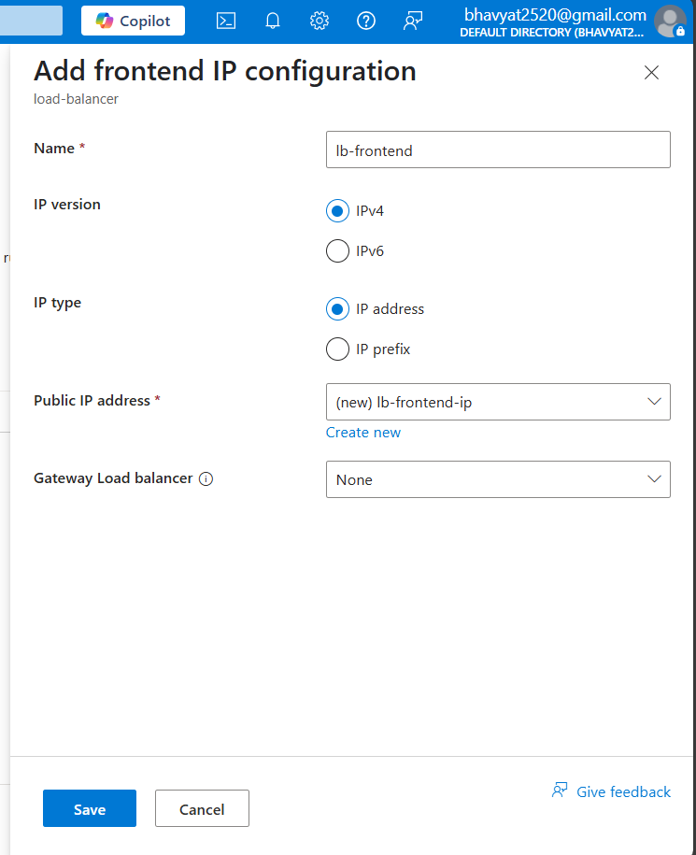

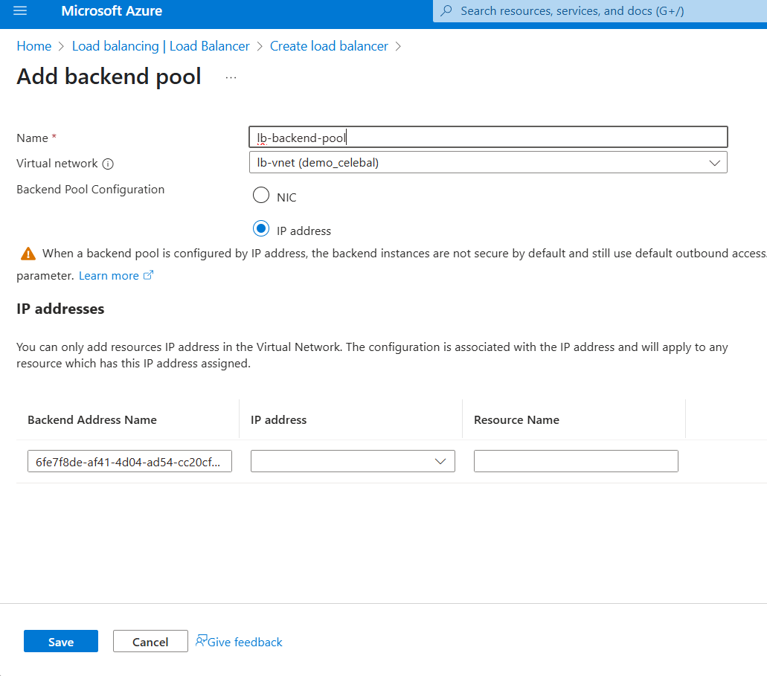

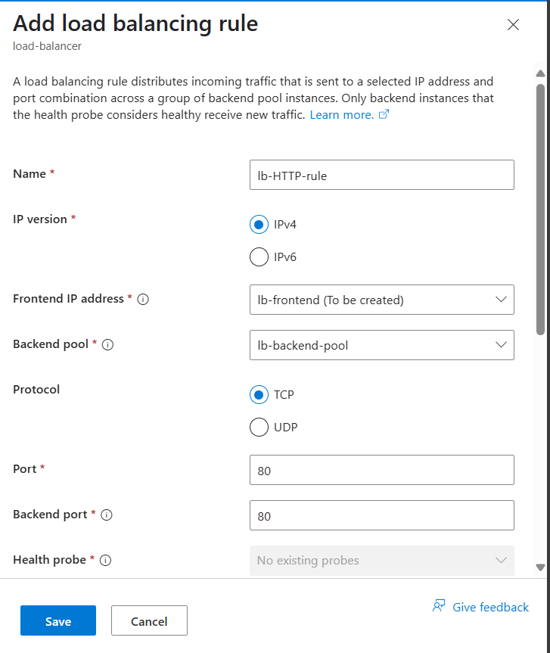

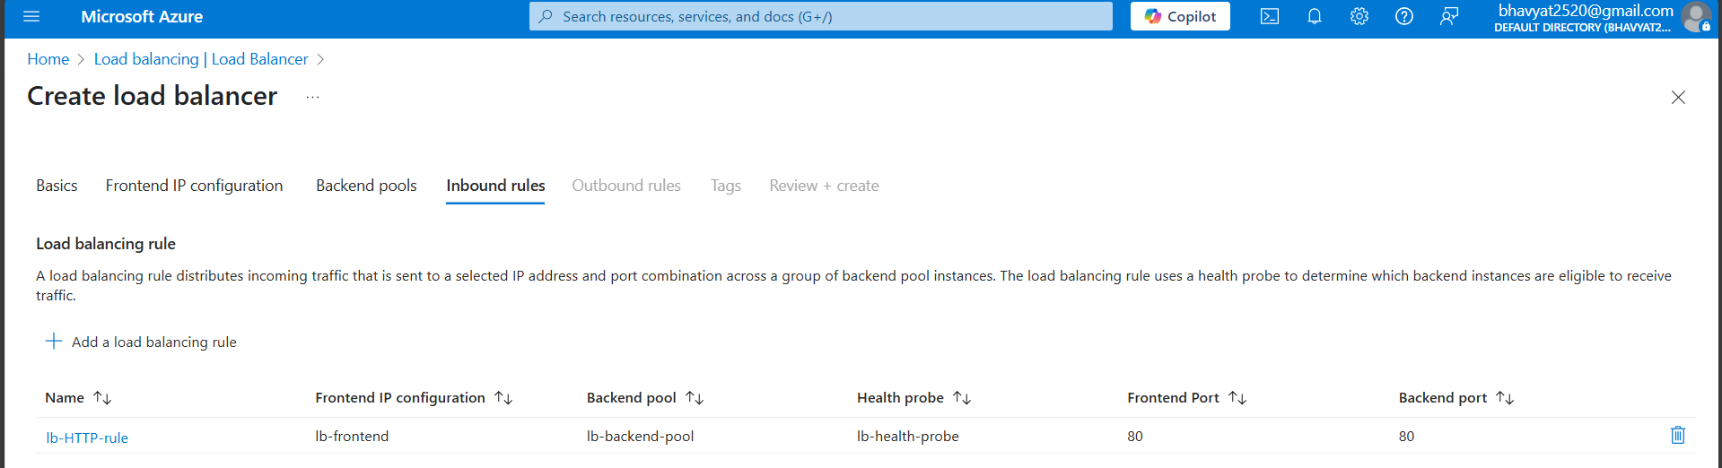

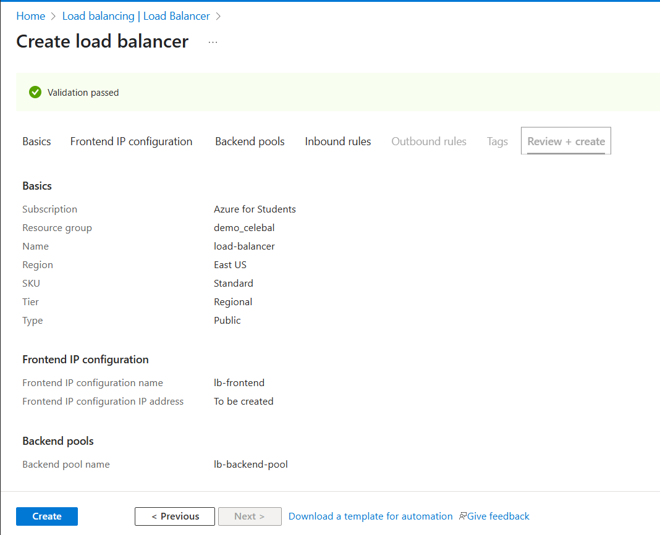

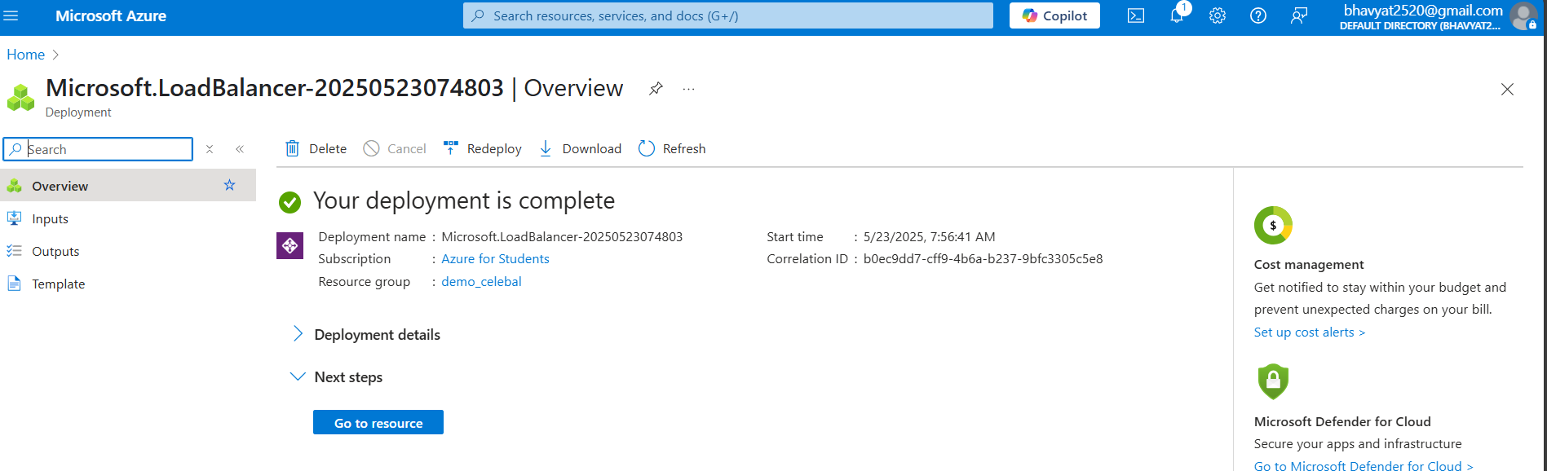

# Create virtual machines

1. In the search box at the top of the portal, enter **Virtual machine**. Select **Virtual machines** in the search results.
2. In **Virtual machines**, select **+ Create** > **Azure virtual machine**.
3. In **Create a virtual machine**, enter or select the following values in the **Basics** tab:
4. Select the **Networking** tab, or select **Next: Disks**, then **Next: Networking**.

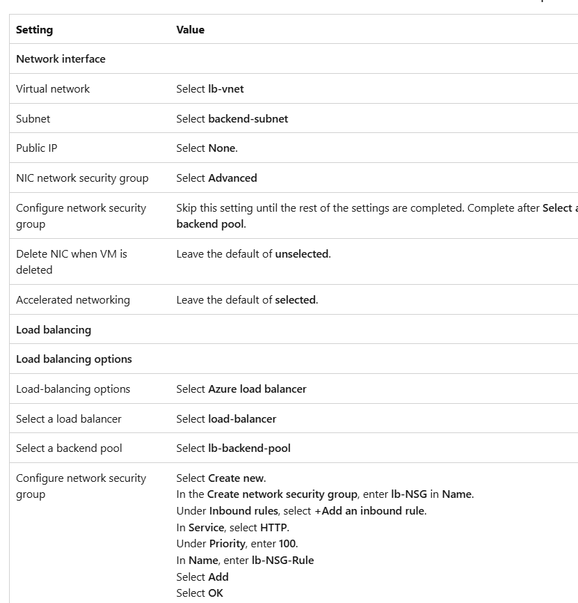

1. In the Networking tab, select or enter the following information:

Expand table

1. Select **Review + create**.
2. Review the settings, and then select **Create**.
3. Follow the steps 1 through 7 to create another VM with the following values and all the other settings the same as **lb-VM1**:

Expand table

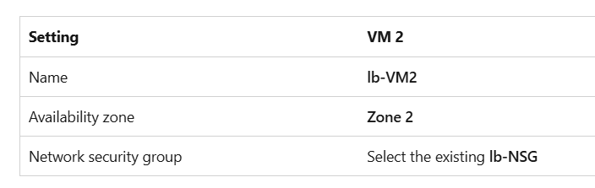

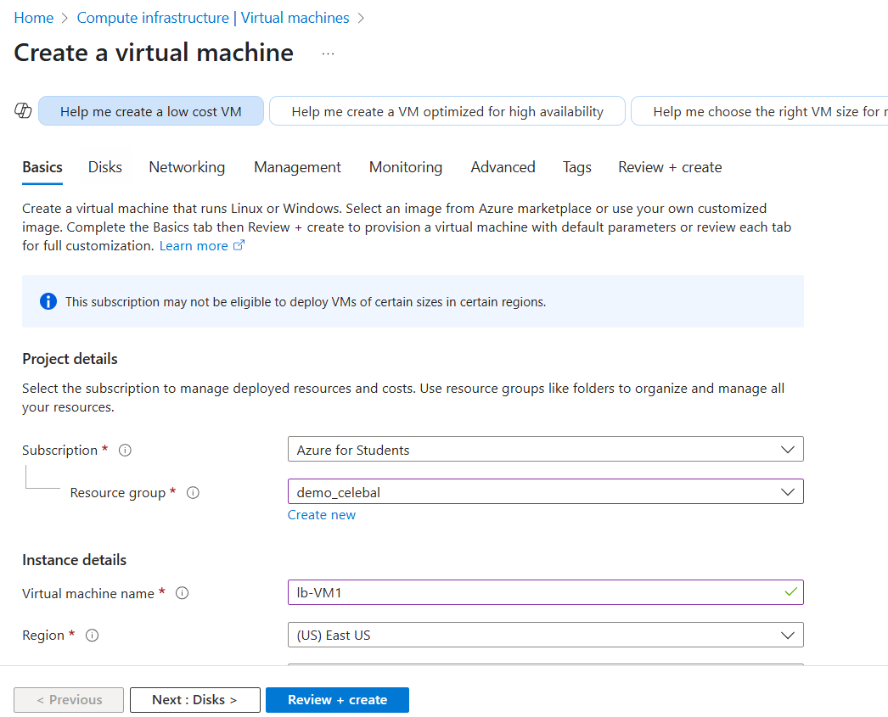

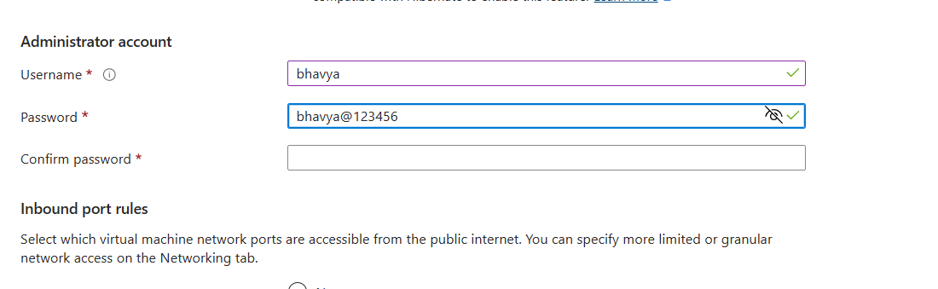

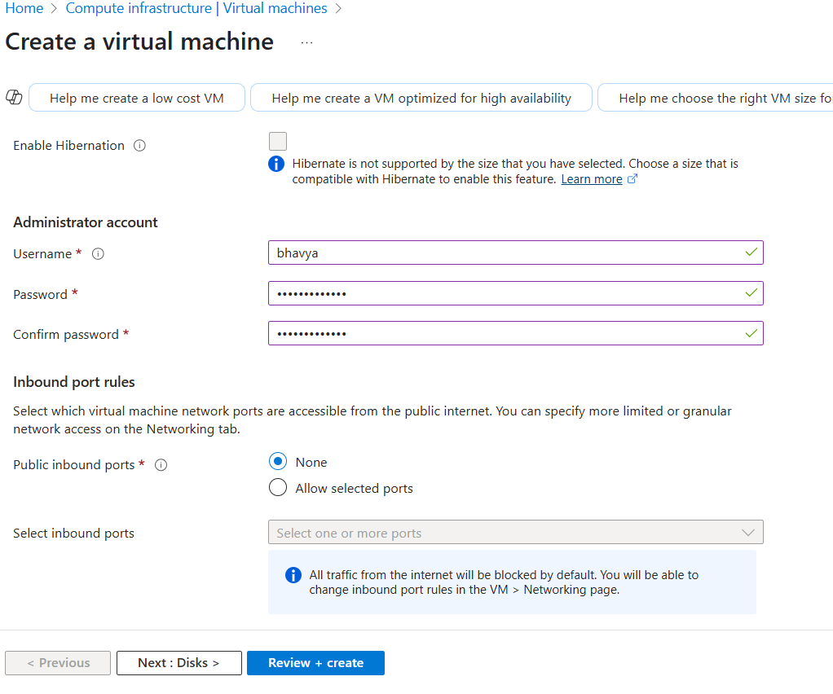

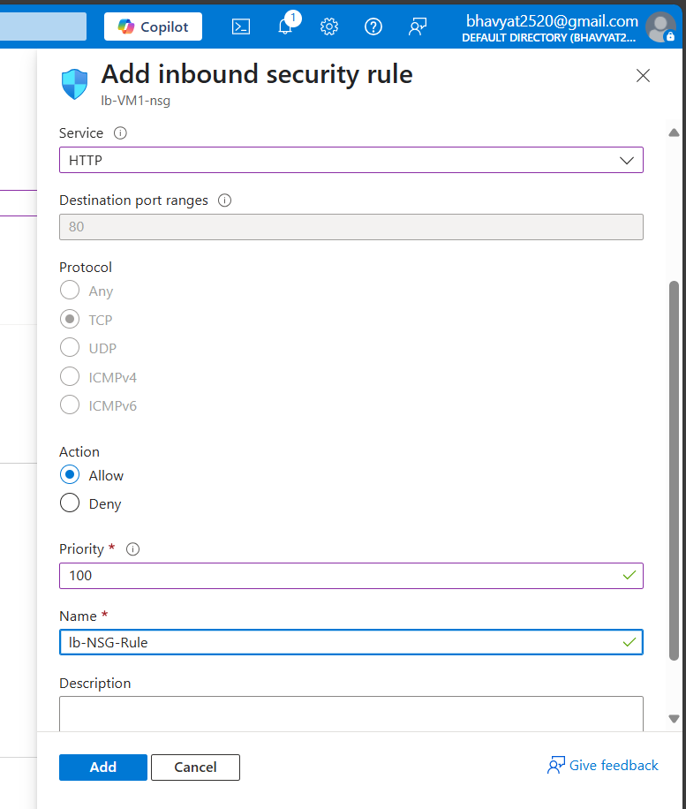

# Install IIS

1. In the search box at the top of the portal, enter **Virtual machine**. Select **Virtual machines** in the search results.
2. Select **lb-VM1**.
3. On the **Overview** page, select **Connect**, then **Bastion**.
4. Enter the username and password entered during VM creation.
5. Select **Connect**.
6. On the server desktop, navigate to **Start** > **Windows PowerShell** > **Windows PowerShell**.
7. In the PowerShell Window, run the following commands to:
   * Install the IIS server.
   * Remove the default iisstart.htm file.
   * Add a new iisstart.htm file that displays the name of the VM:

Script:

# Install IIS server role

Install-WindowsFeature -name Web-Server -IncludeManagementTools

# Remove default htm file

Remove-Item C:\inetpub\wwwroot\iisstart.htm

# Add a new htm file that displays server name

Add-Content -Path "C:\inetpub\wwwroot\iisstart.htm" -Value $("Hello World from " + $env:computername)

# Test the load balancer

1. In the search box at the top of the page, enter **Public IP**. Select **Public IP addresses** in the search results.
2. In **Public IP addresses**, select **frontend-ip**.
3. Copy the item in **IP address**. Paste the public IP into the address bar of your browser. The custom VM page of the IIS Web server is displayed in the browser.

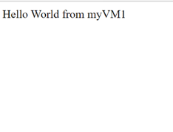

Reference: https://learn.microsoft.com/en-us/azure/load-balancer/quickstart-load-balancer-standard-public-portal