TITLE: “CritiCall: Unified Doctor–Lab Coordination App with Smart Alerting”

App name:Criticall

Description:
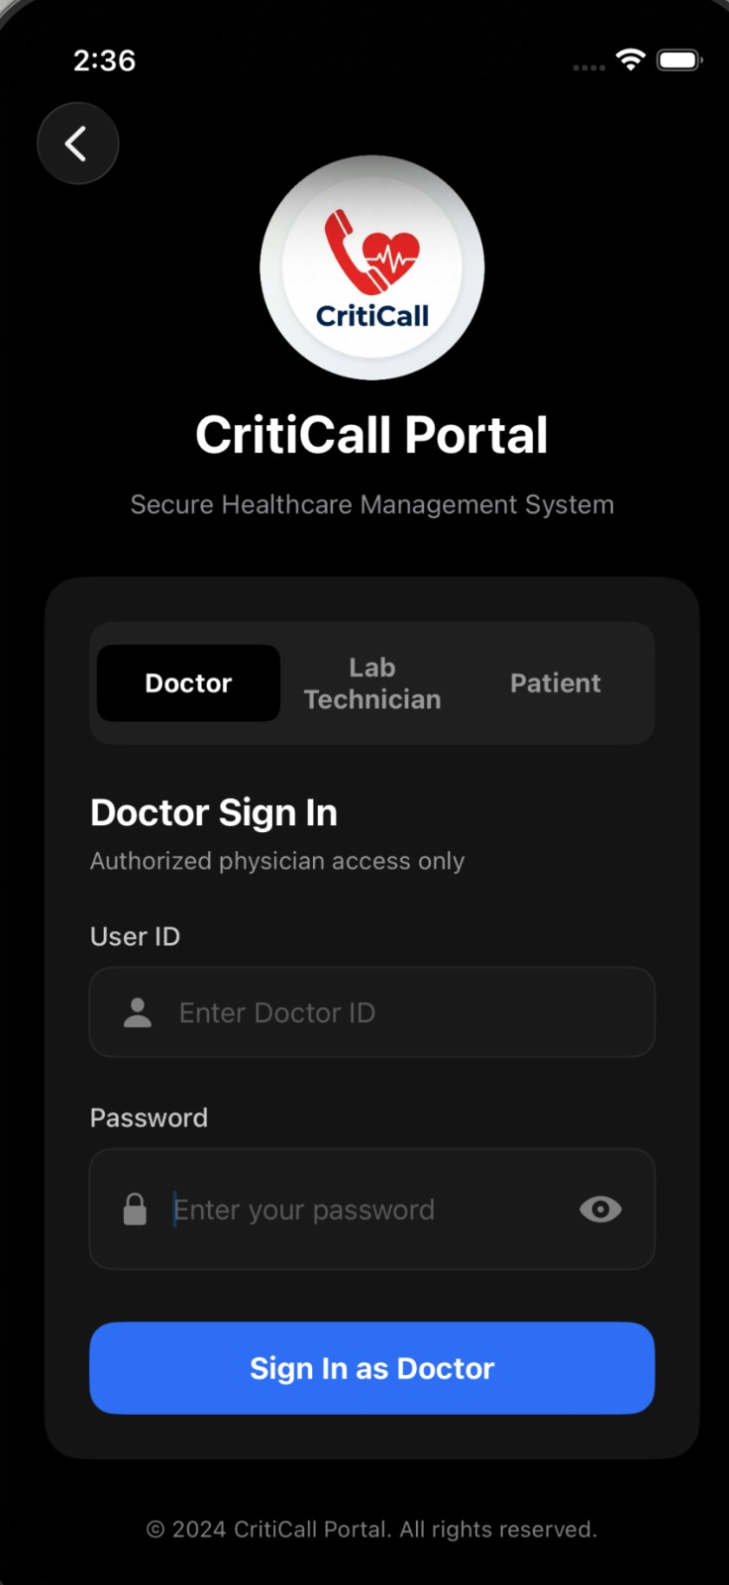
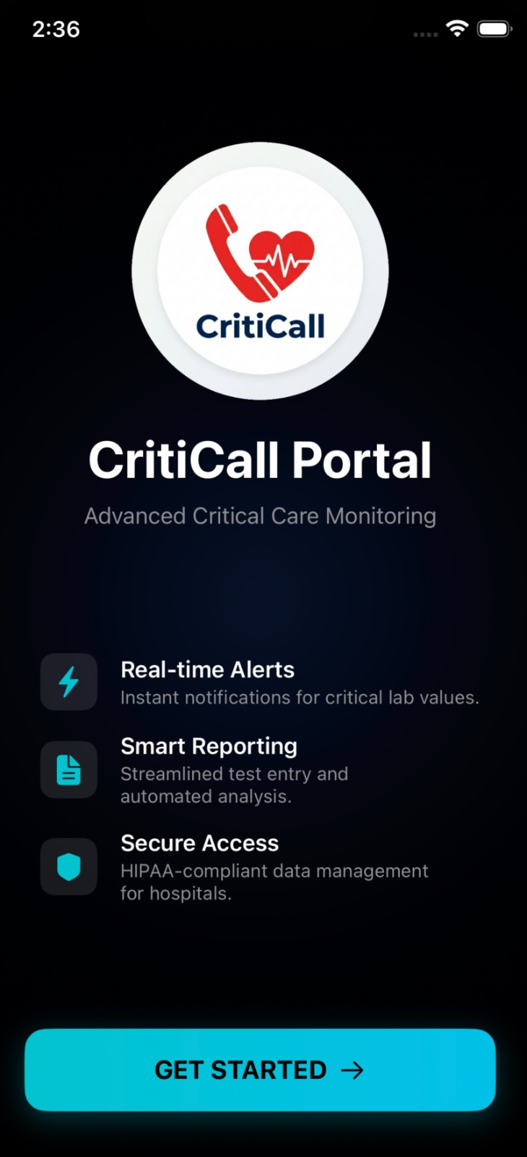
CritiCall is a smart healthcare application that connects doctors and lab technicians on a single platform to improve coordination and patient care. Doctors can add and manage patient records, while lab technicians from departments like Hematology, Biochemistry, and Radiology update diagnostic reports. The system continuously analyzes patient data and automatically detects critical values, triggering real-time alerts to doctors for immediate action. It also features a patient profile module that provides complete medical history along with recommended medications, helping doctors make faster and more accurate decisions. Built using Xcode for the frontend and PHP for the backend, the app ensures secure, efficient, and streamlined healthcare workflow.

